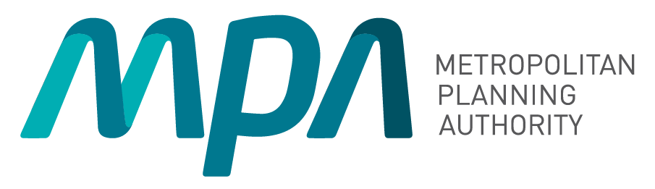
Metropolitan Planning Authority

Business Plan 2015-2016

partners in planning and infrastructure coordination

© State of Victoria, Metropolitan Planning Authority 2016. This publication is copyright. No part may be reproduced by any process except in accordance with the provisions of the Copyright Act 1968.

Contents

Mission and values 2
Introduction 3
Overview of MPA’s work program 4
Members of the Authority 5
Chief Executive Officer: Summary of primary priorities 6
Delivering on our objectives 8
Key performance measures for 2015-2016 10
Our organisation 12
Our resources 14
Our prioritised annual work program 15

Mission and values

Mission of the Metropolitan Planning Authority

To be an active partner in ensuring Melbourne’s and Victoria’s affordable, sustainable and liveable new communities are of the highest international standard.

Values and behaviours of the Metropolitan Planning Authority

In all its work, the MPA demonstrates the following values and behaviours:

Value | Behaviours
Leadership | We provide clarity and certainty, develop new and innovative solutions to problems, provide authoritative advice and lead by example to get things done and make a positive difference.
Partnership | We work in collaboration with our stakeholders through genuine consultation, sharing of information, and harnessing their expertise and resources.
Professionalism | We act with honesty and openness, are accountable for our actions, are respected for our expertise and high quality and balanced advice.
Responsiveness | We are aware of the needs of our stakeholders and strive to provide a high level of service and advice at all times.

Introduction

Minister for Planning

Victoria is expected to be home to 10 million residents by 2050. In-depth planning is necessary to manage significant growth and ensure we continue to have access to affordable homes, key
services, infrastructure, business and employment opportunities and great public spaces.

The State Government has a long term vision for Victoria and for the growth of Melbourne. Maintaining a good supply of affordable, quality housing is a key consideration.

The Metropolitan Planning Authority (MPA) has an important role to play in planning for
future growth, setting the foundations for the next 10, 20, 30 and 40 years. Planning
will focus on ensuring equitable access to key infrastructure
and services, attractive public spaces, housing affordability, minimising the effects of climate change, business growth,
social housing, sustainability and overall, managing growth in a responsible manner.

As a statutory authority reporting to my office, the MPA works in partnership with the Department of Environment, Land, Water
and Planning, other Government agencies and local councils in precincts, and plans for the future in accordance with section 46AR of the Planning and Environment Act 1987.
Housing affordability and quality is at the heart of the MPA’s planning and infrastructure coordination activities. Identifying strategically important places for growth across Melbourne will have a positive impact on housing
affordability. Detailed growth area planning has also had a significant effect on housing affordability, maintaining median lot prices below levels seen in 2011.

Victoria’s growing regional centres have a role in the delivery of affordable housing and accommodating the State’s increasing population.

Community consultation is an important part of the planning process, right from the setting out of a vision for new developments or development opportunities through to formal consultation
on detailed plans. The MPA will continue to consult widely with the community and provide
a range of opportunities for the public to have a say on
important planning issues. There are a number of considerations involved in planning for the future, but the main focus is
that new and reborn areas need to be attractive places.

Growth will be sustainable provided housing affordability is kept in check, while planning for growth and change can
generate sustainable employment opportunities and access to
better public spaces and services.



Plans for the growth of Melbourne and Victoria’s major regional centres are geared towards creating sustainable, vibrant communities with employment opportunities close to home. Managing Melbourne’s and Victoria’s growth requires diversity, a mix of greenfield, urban renewal and regional growth, quality design and
more efficient use of land.

Growth will be dispersed between growth areas and established centres through planned development in strategic locations based around planned activity centres, employment nodes, public transport
networks and open space.

The MPA has a busy program in 2015-16 and I am confident
the authority will deliver on the government’s vision for sustainable and liveable communities.

The Hon. Richard Wynne MP Minister for Planning

Introduction (continued)

Chair’s message

Melbourne is growing at a significant pace and it is the MPA’s role to ensure that we continue to enjoy our world renowned liveability, by retaining access to jobs, affordable and quality housing, public transport, cycling and walking paths and the services we need.

In the year ahead, the MPA will focus on key issues that affect the liveability of Melbourne and Victoria’s growing regional
centres. We will strategically plan for the future with a revamped board, which has benefited from the strong foundations set by our previous chairman Chris Banks.
The MPA enjoys positive and constructive working relationships with our key
stakeholders – Local Government, State Government authorities and the planning and development industry. Our organisation
also has a strong focus on the
community and the needs of
the community as ultimately it is people who are at the heart of all planning and development.

The CEO’s report provides a clear summary of our priorities for the year ahead, echoing the expectations of our Minister.

The new MPA Board is acutely aware of our responsibilities and the importance of our work as we embark on a busy planning



program to help manage the growth of Melbourne and other strategically important areas of Victoria on behalf of the Minister for Planning, the Hon. Richard Wynne MP.

Leonie Hemingway Chair

Overview of MPA’s work program

The map below sets out the key areas in metropolitan Melbourne where the MPA will be focusing its effort over the coming years.

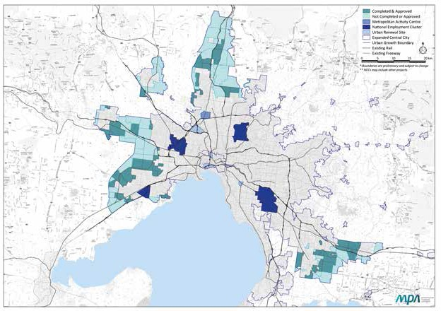

Members of the Authority
The MPA is overseen by a highly experienced board, chaired by Leonie Hemingway that brings together a broad range of disciplines, including planning, development, economics, financial management, education and housing. The Authority reports to the Minister for Planning, The Hon. Richard Wynne MP. The six Authority Members were appointed by the Minister for Planning, effective from 1 July 2014.

A profile of each Authority Member is below.

Leonie Hemingway (Chair)


Leonie Hemingway (formerly Leonie Burke) has dedicated her life to working within all three spheres of Australian government, and the people and businesses with
which they interact. Recently, she has focused more on sharing her skills in legislation, good governance and business relations, as a Director/Member of both civic and government boards.

Laurinda Gardner (Deputy Chair)


Laurinda Gardner is an organisational change consultant, board director and career coach. Laurinda has over 25 years senior executive experience and was formerly
a Deputy Secretary with the Victorian Department of Treasury and Finance and a Director at the City of Melbourne. She has led large operational teams in diverse areas, including: organisational reform, human resources, strategic and business planning, communications, town planning, stakeholder engagement, IT, finance and risk. Laurinda has performed the role of ‘trusted adviser’ to several CEOs and has extensive governance experience on not for profit boards.

Bill Kusznirczuk


Bill Kusznirczuk brings extensive experience and knowledge in urban planning and building, and on how cities should look in the future. He is Managing Director of Clement-Stone Town Planners. He gives advice on urban planning issues across Australia. He is also a broadcaster on Fairfax radio 3AW. Bill is Chairman and Chief Commissioner of the Victorian Building Authority, an independent governing body responsible for setting and enforcing building industry regulation and practice in the State of Victoria.

Brian Haratsis


Brian Haratsis is MacroPlan Dimasi’s founder and Executive Chairman. Brian is an economist and future strategist with over 30 years of experience as an advisor to governments and major corporate clients throughout Australia. Brian commands an unparalleled, on-the-ground knowledge of residential markets across Australia, having worked extensively and regularly in all capital cities and key regional markets.

Freya Marsden


Freya Marsden is Managing Director of the Acuity Group, which provides governance, strategy, policy and economic advice, and is a former Director of the Business Council of Australia. Freya is a Non-Executive Director on several government and not-for-profit boards, and provides the MPA with increased governance and strategy skills. Freya brings policy and economic experience gained across industry and the Victorian and Australian governments, including the Victorian Premier’s Department, the (former) Victorian Department of Infrastructure and the Commonwealth Treasury.

Theo Theophanous


Theo Theophanous is a former Victorian Government Minister. He held a number of senior portfolios, including Industry, Energy, State Development and ICT. As Major Projects Minister, he steered the development of projects including the Recital Centre, AAMI Stadium and the Conference Centre and oversaw the Docklands development. He now works as a Specialist Industry Advisor and Consultant and is on the Audit and Finance Committee of NICTA.

Chief Executive Officer: Summary of primary priorities

I am pleased to present the Metropolitan


Planning Authority’s (MPA) business plan for the 2015/16 financial year. This plan builds on
our previous plan and recognises the initiatives
which have been announced by the Government. The Government’s clearly stated objectives include a strong focus on creating new employment opportunities, housing affordability and a clearer response to climate change.

The Minister for Planning provides the MPA with an approved program of priority works. This program is able to be viewed on the MPA’s website. The MPA has rebalanced its resource allocation with an additional focus being placed on inner Melbourne, significant development sites and precincts and regional
Victoria, while continuing to plan for the development of Melbourne’s greenfields locations.

The MPA recognises that our city and our regions must continually strive to be progressive, innovative and sustainable places to live and work. Our key drivers are housing diversity and affordability, encouraging jobs in growth areas, efficient and effective transport outcomes and the highest quality public domain.

This plan incorporates the Government’s
commitment to taking action on housing affordability,
climate change and energy utilisation. The plan also
recognises the Government’s focus on the better use
of identified precincts within Melbourne in order to
give greater access to existing:
- Infrastructure
- Employment, and
- Services.
The MPA has a substantial role as the State Strategic Planning Authority across Victoria, working closely with councils, government agencies and the planning and development community on integrated land
use and infrastructure coordination for strategically important development sites and precincts. Our major tasks include:
- Unlocking the supply of land
- Facilitating housing diversity and affordability,
job creation and better development of new
communities
- Focusing activity for job creation through National Employment Clusters and central city expansion, and
- Working closely with councils and other Government agencies to consider and determine infrastructure and service needs.
The MPA is committed to expanding its communication and engagement with key stakeholders on matters that might affect them. The need for this renewed focus has become more important over the past year, where the MPA is
interacting with the larger established communities.

The Minister for Planning has reconvened the Ministerial Advisory Committee for Plan Melbourne, with the aim of this Committee being to assist the Minister in revisiting and refreshing the document.

The MPA has welcomed this review as Plan Melbourne needs to recognise changes to our planned transport system and to reflect a clearer focus on government priorities. The Plan Melbourne review is expected to be completed during the 2015/16 financial year and will have an impact on the MPA’s future work program, and on the MPA’s 2016/17 Business Plan.

The MPA is planning for increases in Melbourne’s population to 7.7 million people by 2051. This level of population will require an additional:
- 1.7 million new jobs, and
- 1.6 million new dwellings.
This business plan sets out the staffing, financial and other matters for the 2015-2016 financial year. The MPA has been able to increase its staff complement over the past few years and is now focusing its activities on four key primary priorities. The detail
of the prioritised annual work program is reflected on page 15 and these projects are to be progressed towards completion, where practical, over the life of
this plan to 30 June 2019. Further information on this program will be periodically updated on the MPA’s website http//mpa.vic.gov.au.

The MPA’s four key primary priorities are:

Significant Development Sites and Precincts
These are areas where there is or will be significant employment and parallel residential growth. There are a number of key activity centres in Melbourne, and the Minister for Planning has directed that the MPA focus its activities on Sunshine, La Trobe and Broadmeadows. These areas work hand-in-hand with the significant employment areas to create economic opportunity, jobs and residential activity. More
than just shopping centres, these modern, mixed use activity areas provide a full range of business, residential and community activity.

In addition, the MPA is also planning the development of the Monash University and hospital precinct and the East Werribee Employment Precinct. These
major new employment areas are expected to be modern, mixed used areas with high density living in close proximity to a range of new businesses and employment opportunities.

Inner Melbourne
The Arden/Macaulay area in North Melbourne has been identified as an area of key importance from a planning perspective and the Minister has tasked the MPA with progressing this vital work in support of the Melbourne Metro Rail Authority and the Department of Economic Development, Jobs, Transport and Resources (DEDJTR). The MPA is to focus on increasing the density of areas with significant existing employment and public infrastructure. The Minister for Planning has also requested the MPA
to work closely with the communities and Councils of Melbourne and Port Phillip to develop the new direction for the five Fishermans Bend precincts, by leading a Taskforce comprising representatives from the MPA and the two Councils. In four of
these precincts (Lorimer, Montague, Sandridge and Wirraway) the MPA will guide the development of modern residential areas incorporating a strong employment base in mixed use areas. The MPA also supports the new Ministerial Advisory Committee for the development of Fishermans Bend.

Melbourne’s Growth Areas
Since its inception, the MPA has concentrated on planning for Melbourne’s greenfield locations and these are presently performing very well in terms of affordability, quality of life and the supply of zoned land. The MPA will continue to have an important role in planning for Melbourne’s growth, and in ensuring housing affordability. At the current time, 50 Precinct Structure Plans (PSPs) have been completed, 24
are under preparation and some others are being progressed by the relevant council with the support of the MPA.

Regional Victoria
The MPA will work as directed by the Minister to assist regional councils in developing their own future vision for the urban parts of critically important regional cities. The growth of our regional cities
can play an important part in meeting the overall residential growth needs for the State. They offer a positive and exciting alternative to housing in Melbourne’s inner or outer ring. The character, style and living options in regional cities will be an important focus for our future work. The MPA is currently working with Wodonga, Shepparton, Latrobe and the Surf Coast Councils.
Part of the MPA’s role is to continually drive innovation to build a more progressive modern city that meets people’s needs. In order to progress these activities, the MPA collaborates with councils, a range of government departments and authorities, landowners, developers, and local communities.
In particular, the MPA works in partnership with the Department of Environment, Land, Water, and
Planning (DELWP) to plan for and facilitate sustainable and inclusive growth for Victoria, avoiding duplication and ensuring a consistent approach to significant matters. The MPA’s role in leading planning and infrastructure coordination in key strategic areas of the State complements the Department’s role of managing the regulatory framework for land use planning and overseeing planning policy.

The MPA is preparing a revision of the existing PSP Guidelines in order to streamline these and to make growth area planning processes more consistent across municipalities. We are also working with DELWP to develop a work program for the finalization of the Boulevard Strategy and the review of open space in Melbourne.

The MPA will be working closely with DELWP in the coming years to implement the new Infrastructure Contribution Plans in selected locations of growth and will also be working with DELWP to prepare for the creation of the Victorian Planning Authority, a stated Government commitment.

I look forward to working with our stakeholders over the coming year.

Peter Seamer
Chief Executive Officer

Delivering on our objectives

The objectives of the Authority are listed in Section 46AR of the Planning and Environment Act 1987. For each of the objectives, the Authority’s activities for the coming 12 months, and also the priorities and plans for achieving these over the next three to five years, are outlined below. This plan is based on the MPA’s 2014/15 Business Plan, with important amendments to recognise the change of focus of the Government.

The Government has indicated its overall intention of retaining, but refining, Plan Melbourne. The refreshing of Plan Melbourne will occur during the 2015/16 financial year, so until that refresh is completed the MPA 2015/16 Business Plan is framed around the existing strategy and its directions, whilst taking into account known changes announced by the Government. It is anticipated that the MPA’s 2016/17 Business Plan will be prepared on the refreshed Plan Melbourne and is likely to include a number of new initiatives and to further refocus some of the MPA’s current ongoing initiatives.

The MPA’s KPIs for the next 12 months are set out in the Key Performance Measures table.

- Development occurs in a coordinated and timely manner

The MPA’s role is to ensure that development in all identified areas occurs in a coordinated and timely manner.

The priorities for this objective over the next three
years include:

The completion of the additional residential PSPs contained in the currently scheduled greenfield PSP program is expected to provide land zoned for more than a further 120,000 residential sites and 1,300 employment hectares by the end of 2018.

B. Infrastructure, services and facilities are provided in a coordinated and timely manner

The provision of appropriate infrastructure and services in a timely manner is a critical objective of the MPA to ensure the continued development of areas identified for growth. To provide funding for State infrastructure, the MPA has a number of
administrative responsibilities relating to the Growth Areas Infrastructure Contribution (GAIC). These are carried out in accordance with the Act, and the MPA reports on the expenditure of GAIC funds in its Annual Report, processes staged payment applications, and works with DELWP and other government agencies to review the operation of GAIC.

The priorities for this objective over the next three
years include:

Working closely with the relevant councils and Government agencies on infrastructure plans for growth areas. This includes developing Infrastructure Contribution Plans (ICPs) as part of the PSP preparation process.

Promote sustainable development of land

The MPA’s role in pursuing this objective is very broad and this objective aligns closely with a number of the other objectives.

The MPA’s focus and priority over the coming three years in relation to the environment, infrastructure and the societal benefits of promoting the sustainable development of land will include:

Ensuring that the review of the PSP Guidelines explore the usage, treatment and storage of waste and water and also energy sustainability.

Environment

Document, publish and implement the MPA’s role in responding to climate change through planning initiatives to be applied in Victoria.

Infrastructure

Seek innovative planning solutions to reduce energy use and resource consumption, for example water.

Social

Ensure structure plans facilitate the provision of affordable and community housing and green
areas for social and recreation purposes whilst also providing the environmental benefit of limiting areas of urban heat concentration through the revised PSP Guidelines.

Promote housing diversity and affordability

The MPA focuses on the two elements of this objective through the maintenance and
implementation of its structure planning guidelines.

The MPA’s priorities for this objective over the next
three years include:

Continuing to focus on the provision of a range of housing types within the application of PSP
Guidelines, and ensuring that there is an adequate supply of greenfield and infill zoned land to assist Victoria’s continuing growth.

Promote employment opportunities

Creating jobs is one of the most important economic challenges facing Victoria. The MPA considers that business and employment growth in new and revitalised communities is fundamental to the health of our city and State and is influenced by a range
of factors, particularly drawing on the economic advantages of Melbourne and Victoria. Whilst this
is only one part of a complex equation, the MPA will be able to significantly add to Victoria’s economic development by influencing how land in the nominated areas is planned to be used.

The priorities for this objective over the next three
years include:

Preparing structure plans for key areas within metropolitan Melbourne and regional Victoria as considered a priority by the Minister for Planning.

F. Land is provided for commercial and industrial purposes in a co-ordinated and timely manner

The MPA works closely with the Department
of Economic Development, Jobs, Transport and
Resources (DEDJTR) to achieve this objective.

The priorities for this objective over the next three
years include:

Working closely with DEDJTR and other agencies to ensure the supply of sufficient industrial and employment zoned land is maintained and that
employment areas are of the right type to encourage business growth.

Foster the development of communities

Much of the work and activity of the MPA is focused on achieving this objective across all of our areas of growth, including regional Victoria.

The priorities for this objective over the next three
years include:

Ensuring that the revised PSP guidelines appropriately recognise the importance of and support for community engagement in the urban planning processes for the development of thriving communities.

Integrate land use and transport to enable the coordinated provision of a sustainable transport system for the benefit of the community

The MPA works closely with VicRoads, Public Transport Victoria (PTV), DEDJTR and DELWP to implement this objective.

The priorities for this objective over the next three
years include:

Working closely with DEDJTR and other agencies to ensure appropriate transport infrastructure and
services are included in infrastructure plans and that land use plans and transport plans are aligned.

Discharge governance activities

In addition to its statutory objectives, the MPA has an obligation to the Victorian community to ensure that it conducts its affairs and operations in accordance with Government’s standards and expectations.

The priorities for this objective over the next three
years include:

Developing and implementing sustainable funding and governance arrangements for the ongoing operations of the MPA.

Key performance measures for 2015-2016
In order to achieve the MPA’s objectives over the coming three to five years, the MPA is expecting to achieve the following during the 2015-2016 financial year:

Outcomes | Reference to the MPA Legislative Objective under section 46AR of the Planning and Environment Act 1987* | KPI | Target
Unlock the supply of land, while creating well serviced and sustainable communities | - Development occurs in a coordinated and timely manner  - Infrastructure, services and facilities are provided in a coordinated and timely manner  aa. Integrate land use and transport to enable the coordinated provision of a sustainable transport system for the benefit of the community | Complete the exhibition process of draft Planning Scheme Amendments for Precinct Structure Plans and advertise the Planning Panel Hearings. (Timeliness) | 4 draft PSPs exhibited and advertised before 30 June 2016.
 |  | Complete the exhibition and advertising for draft PSPs by 30 June 2016 which make provision for the zoning of in excess of 10,000 residential lots. (Quantity) | Draft PSPs providing for the zoning of in excess  of 10,000 residential lots exhibited and advertised before 30 June 2016.
 |  | MPA continues to implement approved work program. (Timeliness) | 10 planning projects outside of greenfield areas and 20 greenfield PSPs underway by  30 June 2016.
Provide opportunities for employment growth in sustainable communities | - Promote employment opportunities  - Ensure that land is provided for commercial and industrial purposes in a coordinated and timely manner | Hectares of employment land included in draft PSPs prepared for exhibition by 30 June 2016.  (Quantity) | 400 hectares of employment land included in draft structure plans prepared by 30 June 2016.
Future population growth balanced across growth areas, inner Melbourne, significant development sites and regional Victoria, in accordance with Plan Melbourne | - Promote sustainable development of land  - Promote housing diversity and affordability  f. Ensure that land is provided for commercial and industrial purposes in a coordinated and timely manner | MPA work program reflects the initial strategic planning projects that the MPA will be involved with in inner city, significant development sites and regional Victoria. (Timeliness) | MPA work program on website by 31 December 2015.
Implement aspects of Plan Melbourne relevant to the role of the Authority | All | MPA’s website reflects its new obligations arising from the refreshed Plan Melbourne.  (Quantity) | Revised work program published on MPA website within three months of adoption  of refreshed Plan Melbourne.
Provide the opportunity for sustainable communities | c. Promote sustainable development of land | Revised PSP Guidelines incorporate the promotion of energy sustainability. (Quantity) | A draft Discussion Paper for the revision of the Precinct Structure Plan Guidelines to include promotion of energy sustainability prepared by 30 June 2016.

Outcomes | Reference to the MPA Legislative Objective under section 46AR of the Planning and Environment Act 1987* | KPI | Target
MPA and its stakeholders work in partnership  for optimum planning outcomes | b. Infrastructure, services and facilities are provided in a coordinated and timely manner  e. Promote employment opportunities  g. Foster the development of communities  aa. Integrate land use and transport to enable the coordinated provision of a sustainable transport system for the benefit of the community | Key Stakeholders to confirm that MPA has satisfactorily consulted with them during planning processes. (Quantity) | The MPA designs and conducts a stakeholder satisfaction survey by 30 June 2016 which indicates that the MPA’s key stakeholders are satisfied with the quality and extent of  consultation undertaken by the MPA during the 2015/16 financial year.
MPA produces a Business  Plan annually | NA | Approved Business Plan published on MPA website.  (Timeliness) | Approved Business Plan published on MPA  website by 31 December  2015.
MPA remains financially  sustainable | NA | Operating shortfall within agreed tolerance. (Cost) | Operating shortfall for the year is no greater than 10% more than the budgeted deficit of  $3.1 million for the year ended 30 June 2016, except in relation to any additional expenditure directed by the Minister for Planning.
Employees reflect public sector values in the work of the MPA | NA | Number of material breaches by MPA staff members of Code of Conduct for Victorian Public Sector Employees 2015. (Quality) | No breaches by MPA staff members of Code of Conduct reported in MPA annual report for 30 June 2016.

*The alphabetic references in this column relate to the subsection numbers of section 46AR of the Planning and Environment Act 1987.

Our organisation

The Authority meets regularly throughout the year, and has two specialist sub-committees, dealing with Risk and Audit and Executive Remuneration matters.

The Authority had a staff complement of 84 employees as at 30 June 2015, periodically supported by contract or seconded employees to help meet work targets and to provide expert assistance in
key areas. With the change in the role and focus of the Authority, the MPA has increased its staff levels over the past two years, and expects to maintain its current staff level for the coming financial year. The complement in future years will be dependent upon the MPA’s allocated workload and financing.

The MPA is structured around six major activities (seven teams). The teams are organised in a manner that optimises the capacity of MPA to conduct its activities. However, the MPA’s role may alter with the current refresh of Plan Melbourne which is underway, and this may result in a change in focus and could require an internal re-organisation.

The Planning & Economic Development Team is responsible for preparing employment PSPs and also for developing planning and design approaches for town and city centres. The team manages PSP preparation for industrial and town centres in the
North and West, and is responsible for the rollout of the development of the East Werribee Employment Precinct. The team also coordinates economic research activities.

The Inner City Team is responsible for the strategic planning of the inner Melbourne region. The team works very closely with DELWP, Melbourne City Council and other inner city councils to achieve
the optimum sustainable development of this vital part of Victoria’s community and economy. The Inner City Team also incorporates the MPA’s Office of Fishermans Bend which is playing a lead
role in planning for the future development of the Fishermans Bend precinct.
The Structure Planning Teams (North & West and South & East) are responsible for planning activity outside of the inner city and specific employment areas. The two teams complete strategic planning for declared growth areas on a geographic basis, except for some of the larger projects in the North and West which may be undertaken by the Economic Planning and Development Team. These teams also have responsibility for providing planning assistance, when requested by the Minister, to regional Victoria.

The Partnerships and Communication Team has the key role of managing and coordinating the interaction with all government authorities, and also has the responsibility for the organisation’s media and communication activities.

The Technical Services Team is responsible for supporting the planning and other operations of the MPA through the provision of technical advice,
infrastructure coordination planning and graphics, GIS and drafting support. This team also coordinates the planning for infrastructure. This team also conducts the role of coordinating responses to GAIC Works-In- Kind (WIK) proposals across Government.

The Corporate and Statutory Services Team is responsible for the governance activities at the MPA (including finance, human resources, administrative and information technology functions). These activities incorporate the MPA’s administration of the GAIC and providing support for the GAIC Hardship Relief Board. This team also has responsibility for corporate wide activities, such as insurance, risk management and the costs of the MPA offices.

This team conducts the organisation’s statutory planning activities, and also has the important responsibility for ensuring that the MPA is appropriately prepared for Planning Panels.

The following table summarises expected staffing structures for the coming year:

Staff | 2014-2015 | 2015-2016
Executives | 8 | 8
Non-executive | 76 | 81
Total | 84 | 89

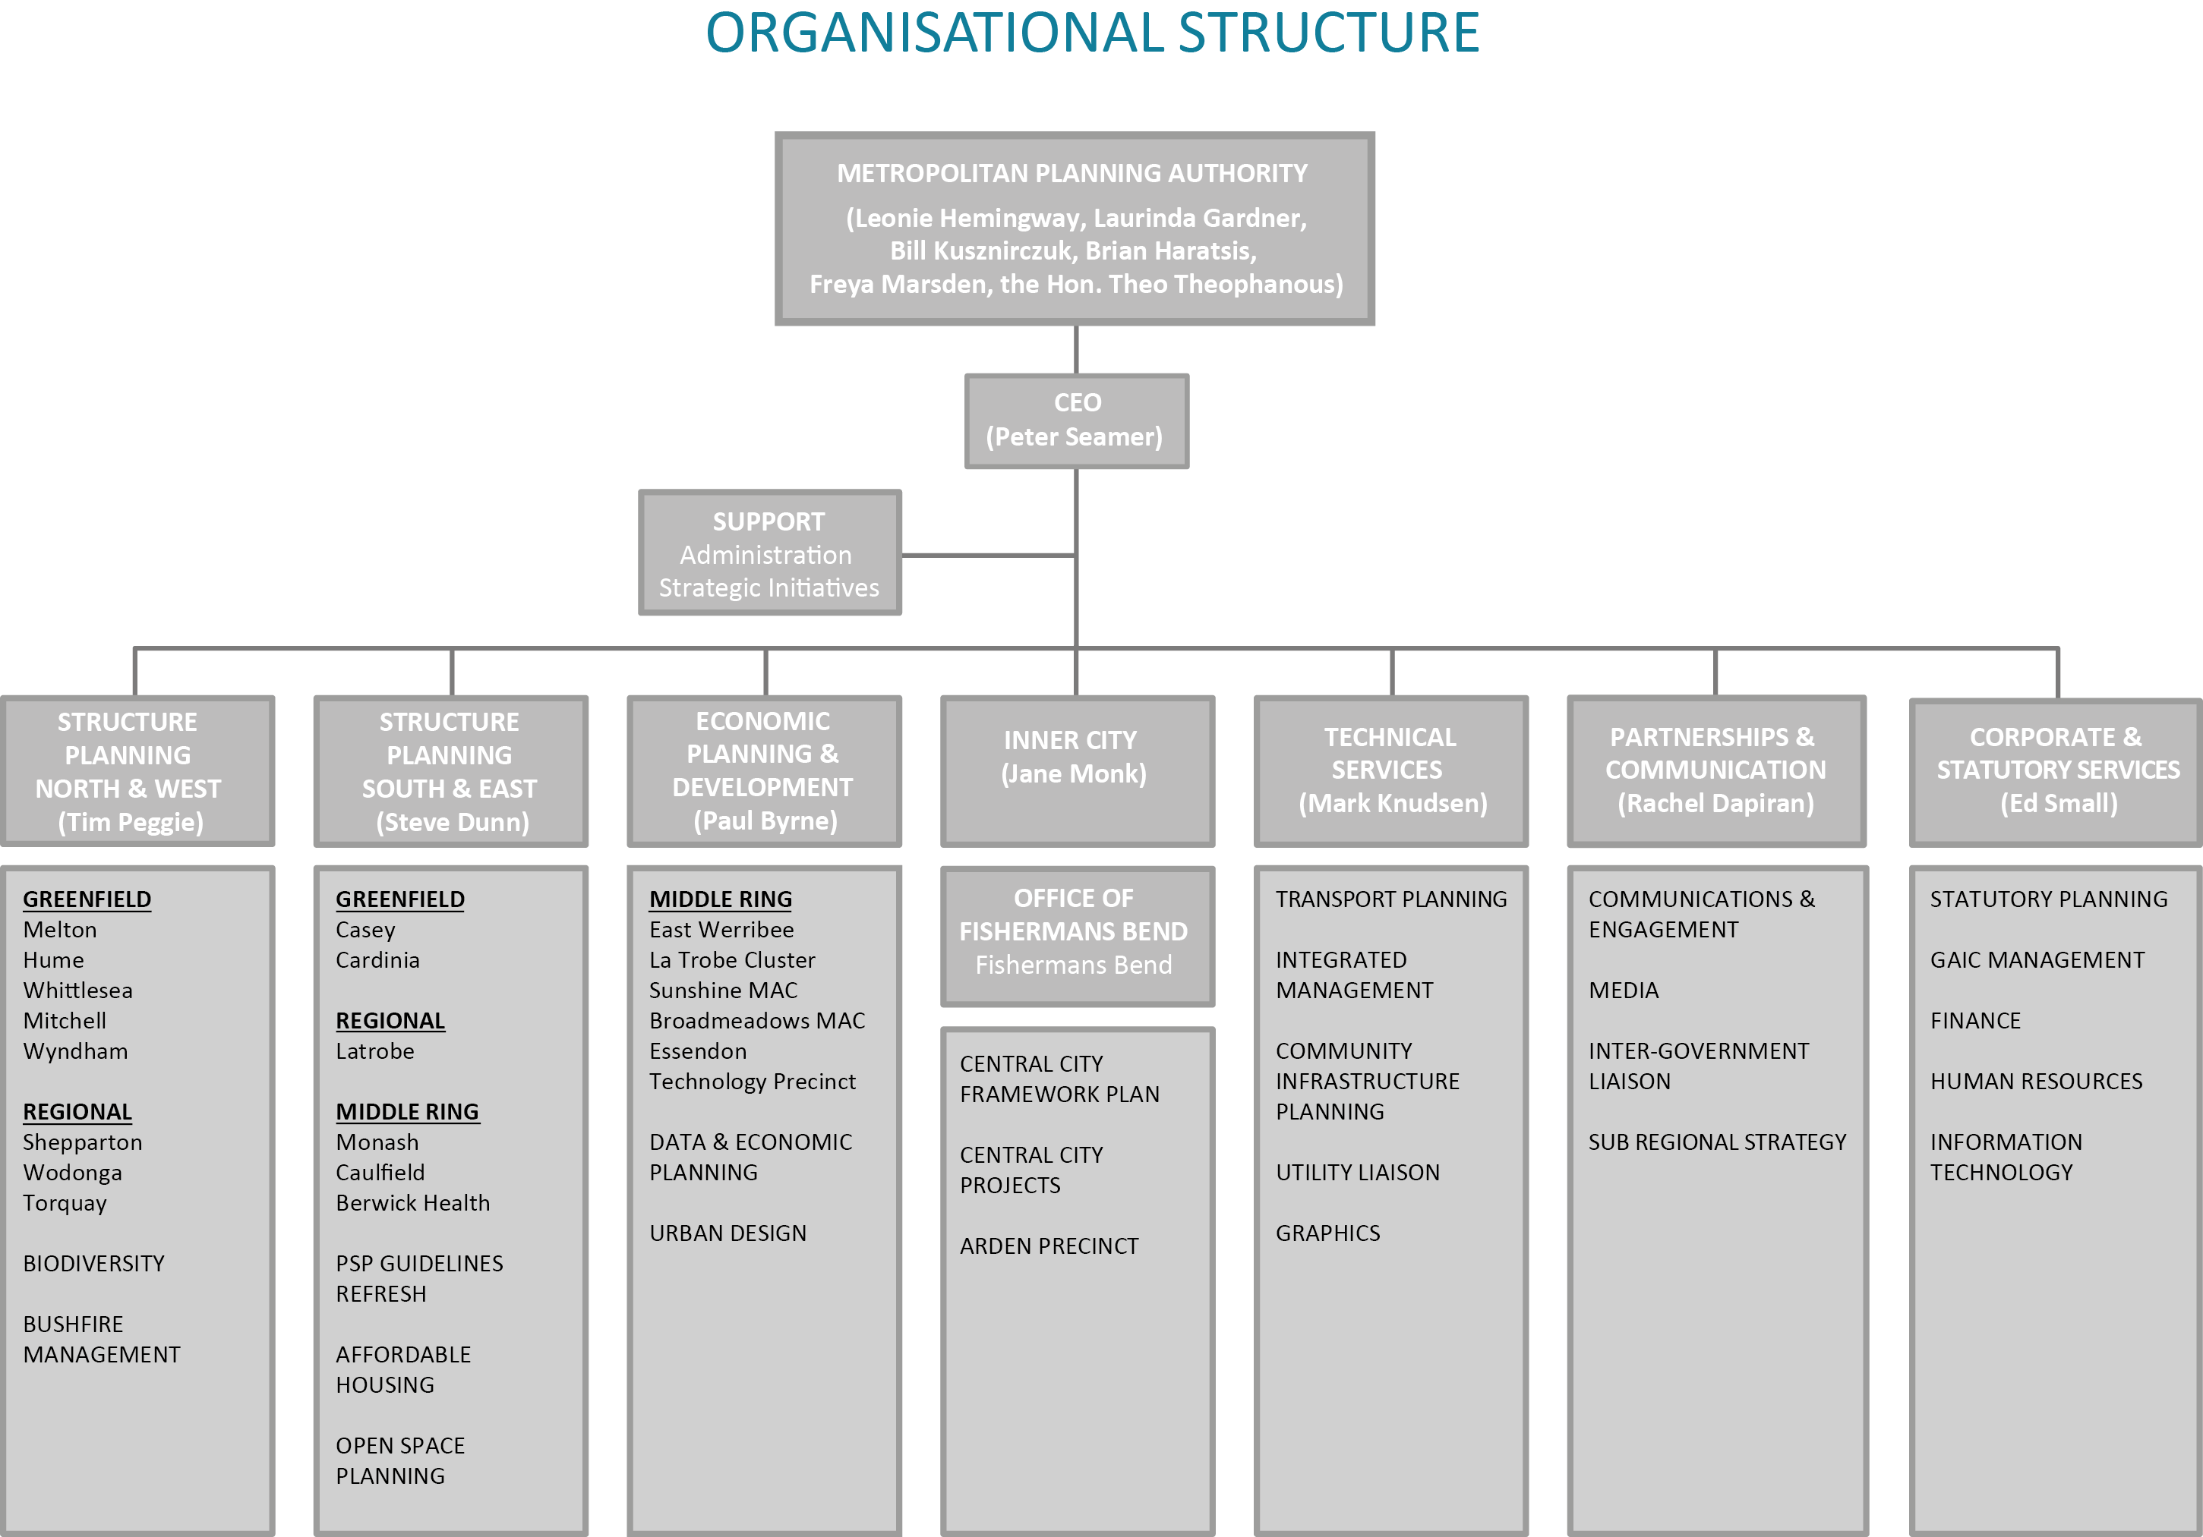
METROPOLITAN PLANNING AUTHORITY BUSINESS PLAN 2015-2016
13

Our resources

In its 2014-2015 Victorian budget, the Government announced that it was to provide further funding to the MPA. The Government has provided a significant increase to the MPA’s forward financial allocations and the MPA’s new allocations are:
• $13.9 million in 2015-2016
• $12.9 million in 2016-2017
• $12.9 million in 2017-2018
These funding allocations will enable the MPA to undertake its role in planning for growth in
Melbourne and Victoria. Also, the MPA currently has available at 30 June 2015, a brought forward surplus of $11.7 million. This amount represents funds that the MPA has received previously, in advance of the matching expenditure occurring. These funds are to be used to finance the completion of a number of the greenfield and other planning activities currently underway.

Budget

The MPA has approved the following budget and projections for 2015-2016 and has endorsed in-principle the financial projections for the subsequent three years. The MPA anticipates making operating deficits over each of the coming financial years as it expends the funds on hand which had been raised in an earlier year for specific projects. The expected revenue from third parties and related structure planning expenditure for future years has also been included in the table below.

Income

 | 2015-2016  $m | 2016-2017  $m | 2017-2018  $m | 2018-2019  $m
Appropriation | 13.9 | 12.9 | 12.9 | 12.9*
Other Contributions | 0.8 | 0.2 | 0.1 | 0.1
Interest | 0.3 | 0.2 | 0.1 | 0.0
Total Income | 15.0 | 13.3 | 13.1 | 13.0

Expenditure

 | 2015-2016  $m | 2016-2017  $m | 2017-2018  $m | 2018-19  $m
Executive & Reform | 1.0 | 1.2 | 1.0 | 1.0
Corporate and Statutory Services | 4.0 | 4.2 | 3.7 | 3.7
Government Partnerships | 0.7 | 0.6 | 0.5 | 0.5
Planning and Economic Development | 1.3 | 1.4 | 1.1 | 1.2
Structure Planning | 3.5 | 3.8 | 3.1 | 3.3
Inner Melbourne | 1.0 | 1.3 | 1.0 | 1.0
Technical Services | 2.1 | 1.9 | 1.6 | 1.7
Projects – external costs | 4.5 | 3.7 | 3.4 | 1.9
Total Expenditure | 18.1 | 18.1 | 15.4 | 14.3

Net Operating Shortfall 3.1 4.8 2.3 1.3

Brought forward | 11.7 | 8.6 | 3.8 | 1.5
End of Year | 8.6 | 3.8 | 1.5 | 0.2

Equity

2015-2016 |  | 2016-2017 | 2017-2018 | 2018-19
$m |  | $m | $m | $m
Net Equity | 8.6 | 3.8 | 1.5 | 0.2

*Assumed

Our prioritised annual work program

Project | Project Name | LGA | Major Activity | Projected Completion Date*
Inner Melbourne - Under Preparation
3050 | Arden | Melbourne | Structure plan & preliminary project planning | December 2017
3330 | Cremorne / Swan Street | Melbourne, Yarra | Support to council | Dependent on  council
3350 | Central Melbourne Framework | Maribyrnong, Melbourne, Port Phillip, Stonnington, Yarra | Framework for renewal | June 2016
3400 | Fishermans Bend  (Project responsibility to be transferred) | Melbourne, Port Phillip | Structure &  infrastructure plans | June 2016
Significant Development Sites and Precincts - Under Preparation
39.2 | East Werribee Employment Precinct | Wyndham | Land realisation  strategy | June 2017
4500 | Sunshine Cluster | Brimbank | Framework plan | June 2018
5100 | Broadmeadows Major Activity Centre | Hume | Framework plan | December 2017
5400 | Essendon Technology Precinct | Brimbank, Moonee Valley | Management plan | December 2017
5600 | La Trobe Cluster | Banyule, Darebin | Framework plan | June 2018
6550 | Monash Cluster | Greater Dandenong,  Kingston, Monash | Framework plan | June 2018
6570 | Clayton Central | Kingston, Monash | Structure plan | June 2018
7050 | Caulfield Station | Glen Eira, Stonnington | Structure plan with  council | June 2018
7500 | Berwick Health and Education | Casey | Structure plan  prepared by council | December 2016
Greenfield - Under Preparation
3.5 | Cardinia Road Employment (Review) | Cardinia | Structure plan | December 2017
11 | Minta Farm | Casey | Structure plan | June 2017
12 | Casey Central Town Centre | Casey | Structure plan | December 2017
25.1 | Craigieburn Employment Area North | Hume | Structure plan | June 2016
25.2 | English Street | Whittlesea | Structure plan | December 2015
31.2 | Paynes Road (Toolern - Part C) | Melton | Structure plan | June 2016
42.1 | Black Forest Road North | Wyndham | Structure plan | December 2015
1051 | Croskell (Casey Central) | Casey | Structure plan | June 2018
1055 | McPherson (Clyde East) | Casey | Structure plan | December 2016
1059 | Beveridge North West | Mitchell | Structure plan | June 2017
1062 | Beveridge Central | Mitchell | Structure plan | June 2017
1067 | Donnybrook | Mitchell, Whittlesea | Structure plan | December 2016
1070 | Wollert | Whittlesea | Structure plan | June 2016
1074 | Sunbury South | Hume | Structure plan | June 2017
1075 | Lancefield Road (Sunbury East) | Hume | Structure plan | June 2017
1078 | Plumpton | Melton | Structure plan | December 2016
1080 | Kororoit | Melton | Structure plan | December 2016

METROPOLITAN PLANNING AUTHORITY BUSINESS PLAN 2015-2016 15

Project | Project Name | LGA | Major Activity | Projected Completion Date*
Greenfield - Under Preparation (continued)
1082 | Mt Atkinson | Melton | Structure plan | December 2016
1085 | Tarneit Plains | Melton | Structure plan | December 2016
1094 | Quarry Hills | Whittlesea | Structure plan | June 2016
1096 | Woodstock | Whittlesea | Structure plan | December 2016
1099 | Rockbank | Melton | Structure plan | December 2016
1202 | Lindum Vale (Mt Ridley West) | Hume | Structure plan | June 2017
1207.1 | Lincoln Heath South | Wyndham | Structure plan | December 2015
1209 | Brompton Lodge | Casey | Structure plan | December 2016
Regional - Under Preparation
1101 | Lake Narracan | Latrobe | Structure plan | December 2015
1102 | Shepparton North East | Greater Shepparton | Structure plan | December 2017
1102.1 | Shepparton South East | Greater Shepparton | Structure plan | December 2017
1105 | Wodonga Leneva | Wodonga | Structure plan | December 2017
1225 | Bacchus Marsh | Moorabool | Framework plan | June 2018
1240 | Torquay - Spring Creek | Surf Coast | Structure plan | December 2017
Plan Melbourne Projects - Under Preparation
8600 | Metropolitan Open Space Strategy |  | Develop finalisation plan with DELWP | TBA
8650 | Boulevard Strategy |  | Develop finalisation plan with DELWP | TBA

* These dates are variable, dependent upon circumstance, and are to be regarded as indicative.

Metropolitan Planning Authority
Level 25, 35 Collins Street
Melbourne Victoria 3000

Telephone: 03 9651 9600
Facsimile: 03 9651 9623

www.mpa.vic.gov.au

