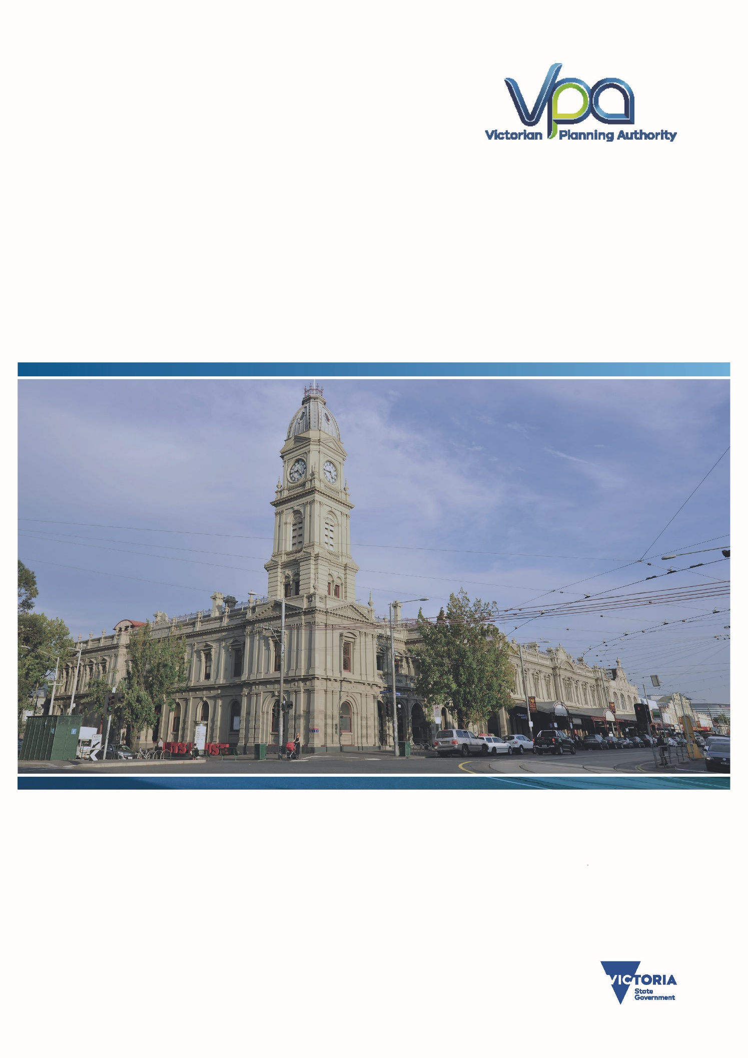
Prepared by the Victorian Planning Authority
September 2016
The VPA’s State of the State – 3rd Quarter 2016
A VPA report on Victoria’s Key Demographic & Economic Metrics

Contents
Contents 1
Executive Summary – KEY DEMOGRAPHIC AND ECONOMIC METRICS UPDATE 2
1. State Populations 3
2. Population Growth and Projections by Local Government Area 6
3. Births by Local Government Area 10
4. Deaths 12
5. Building Approvals 14
a) Residential Dwelling Approvals 15
b) Value of Approvals 18
i. Commercial Buildings 20
ii. Industrial buildings 22
iii. Other Non-Residential Buildings 24
6. Crane Counts 26
7. Construction Pipeline 27
8. Greenfield Developments in Melbourne’s Outer Growth Areas 28
a) Sales Rates 28
b) Supply and Stock 29
c) Price of Greenfield Lots 30
d) Supply of PSP land 31
9. Property Sales 32
10. Rents 38
11. Residential Rental Bonds 44
12. Unemployment 48
13. Employment Mix of Victoria 54
APPENDICES 56

Executive Summary – KEY DEMOGRAPHIC AND ECONOMIC METRICS UPDATE
- As at end of 2015, Victoria had a population of 5,996,285 and was growing at a rate of over 100,000 people per year. This is the strongest population growth of any Australian state or territory. It is likely Victoria crossed the 6 million person mark in early January.
- At present, approximately 75% of the State’s population live in metropolitan Melbourne and 25% in Regional Victoria.
- Victoria has had the highest interstate migration in living memory with more than 13,000 people moving from interstate in the past year.
- Within Melbourne, the outer growth area Local government areas and the City of Melbourne are the fastest growing areas.
- In 2014, Victoria recorded 74,222 births. Since 2012, Victoria has been experiencing a baby boom with 15,000 more births per year than were recorded in the early 2000s.
- Almost 38,000 people died in Victoria in 2014.
- There were almost $31 billion worth of building approvals approved in 2015/16 across Victoria. This compares to $28.7 billion for the full 2014/15 year. The large majority (72%) is for residential construction.
- The number of new dwellings approved in 2015/16 was 67,003 across Victoria. This was made up of 35,864 detached houses (53%), 10,571 semi-detached dwellings (16%) and 20,568 units or apartments (31%).
- Additionally, there were approvals for $2.71 billion worth of commercial buildings, $1.5 billion of industrial building and $4.45 billion worth of other non-residential buildings.
- The median sales price of a detached home in eight local government areas in Melbourne exceed a million dollars in 2016 so far. The data is, however, incomplete and may not fully reflect recent market changes.
- Prices were more affordable for semi-detached dwellings and units. Also, in many rural areas prices remain more affordable than metropolitan areas.
- Median rents for the whole metropolitan of Melbourne ranged from $320 for a one-bedroom flat to $440 for a four-bedroom house. There was large variation at the local government level based on the proximity to the city of the rental property.
- Housing lots in Melbourne’s greenfields have been selling in record numbers, with more than 22,000 sales in the past four quarters; averaging 60 sales per day. The Melbourne greenfields market is clearly the strongest in Australia.
- As a consequence of the strong sales, the supply of lots on the market has decreased with only slightly more than a month’s supply on the market.
- With the exception of Adelaide, lots in Melbourne’s greenfields remain much cheaper than all other markets in Australia. The median price of a lot was $221,730 in the June 2016 quarter.
- The latest ABS labour force data (June 2016) puts Victoria’s unemployment rate at 5.7%, having decreased from 6% in June 2015. The unemployment is not evenly spread, with some areas having much higher rates than the state average.
- There were 3,029,600 people employed in Victoria in February 2016. The largest industry was health care and social services, and this is growing markedly.

- State Populations
At the end of December 2015, the population of Victoria stood at 5,996,285 people. Victoria clearly remains the second largest state and will remain in that position for the foreseeable future. Within Victoria, the population split is currently approximately 75% in metropolitan Melbourne and 25% in regional Victoria.

Over the 12 months to 30 June 2015, Victoria’s population grew by 109,830 people, the highest increase of all the states.

In terms of percentage change, Victoria is also the fastest growing of all states and territories, growing at 1.87% for the year.

In terms of components of Victoria’s population growth, the natural increase was 36,249 people. There was a net inflow of 60,532 overseas migrants and a net inflow of 13,049 people migrating from interstate. Victoria and Queensland were the only two states or territories to see a positive net interstate migration.

Historically, Victoria has at times lost population to other states but this trend seems to have reversed, with net interstate migration at levels not seen since the Gold-rush era. Net overseas migration has been fairly stable for the past few years, after the high peak that occurred around 2009 and 2010, followed by a significant fall in 2011.

In recent years Victoria has seen an increase in the number of births. In 2012, the 40-year-old record for births was broken, with 77,405 births. 2013 and 2014 both recorded strong numbers of births.

- Population Growth and Projections by Local Government Area
All metropolitan local government areas except for Nillumbik experienced population growth in the year to 30 June 2015. In the year Victoria grew by 99,371, with 90,606 in Melbourne (91%) and 8,765 in regional Victoria (9%). The largest growth was found in Wyndham, with an additional 10,202 people. The other outer growth areas saw large increases, as did the cities of Melbourne and Moreland.
In regional Victoria, strong growth was seen in Greater Geelong, Ballarat and Bendigo. Other areas to experience large growth were peri-urban Local Government Areas (LGAs), such as Baw Baw and Macedon Ranges, and coastal LGAs, like Bass Coast.
Many of the more remote LGAs sustained a significant decrease in population.

The projected populations for each of Melbourne’s and Regional Victoria’s LGAs up until 2031 are outlined below. As at 2031, Victoria is projected to have 7.7 million people, with 5.9 million in metropolitan Melbourne (77%) and 1.8 million in regional Victoria (23%). This is a growth of 1.7 million people in metropolitan Melbourne (84% of the total state growth) and 270,000 in regional Victoria (16% of State growth), of which over 250,000 (or 94%) are in the 10 key regional centres and peri urban and coastal areas.

- Births by Local Government Area
Victoria had a total of 74,500 births in 2014, 57,500 of which were in metropolitan Melbourne (78%) and 16,550 in regional Victoria (22%).
By Local Government Area (LGA), the City of Casey had the most births, with 4,254 babies born, followed by other Greenfield LGAs, like Wyndham (3,975), Whittlesea (3,149) and Hume (3,070).
In regional Victoria, Greater Geelong had 2,709 births and Bendigo and Ballarat both had more than 1,000 newborns. Other interesting results were recorded in Baw Baw and Macedon Ranges, with more than 500 babies each.
Appendix 2 of this report contains maps of the 2014 Births.

- Deaths
In 2014, 37,958 people died in Victoria, a large increase compared to 2013, when only 35,916 people died. Of those who died, 25,497 were from metropolitan Melbourne (67%) and 12,461 were from regional Victoria (33%).
LGAs with younger populations tended to have fewer deaths than older, more established areas.

- Building Approvals
For the 2015/16 financial year, there was total of $30.95 billion worth of building approvals in Victoria. Of this, 72% was for residential buildings of all types.

The various categories of building approval numbers and values for both metropolitan Melbourne and regional LGAs are presented in the following charts, including for:
- Residential Dwellings Numbers
- Overall Value of all Building Approval Types
- Commercial Buildings
- Industrial Buildings
- Other Non-residential Buildings

  - Residential Dwelling Approvals
The latest building approvals (June 2016) show that in the past 12 months 35,910 detached houses and 32,028 other residential dwellings have been approved across the state. Historical detached houses have been the dominant type of residential construction in Victoria. However, in the past year, the number of other residential dwellings approved has been almost the same as detached houses. It is yet to be determined if this is a permanent trend or a short-term approbation.

Within the ‘other dwellings’ category, there were 10,571 semi-detached dwellings and 20,568 apartments and flats, of which 86% of those apartments were in buildings four storeys or more. The majority of these high-rise apartments were approved in the Melbourne central subregion, although a few local government areas in the Eastern and Northern subregions have had significant numbers. There were no high-rise apartments approved in regional Victoria.
Moreland had more than 1,000 semi-detached dwellings approved in 2015/16.

  - Value of Approvals
The City of Melbourne had the largest value of building approvals in the quarter, followed by Wyndham, Casey, Stonnington, Boroondara and Whitehorse.
In regional Victoria, the highest value of approvals were in Greater Geelong, Ballarat, Greater Bendigo and the Surf Coast.

                - Commercial Buildings
The City of Melbourne had the greatest value of commercial buildings approved, with the majority being offices. Monash and Greater Dandenong also had significant value of offices being approved. Most metropolitan Local Government Areas (LGAs) had some retail space approved.
Greater Geelong had the second highest value of commercial approvals in the state, with a mixture of offices and retail.

                - Industrial buildings
Over 77% of industrial buildings approved in 2015/16 were warehouses and most were located in the metropolitan area. The only Local Government Areas in Melbourne with approval of any major factories or other production buildings were Hume and Greater Dandenong.
In regional Victoria, there was $43 million worth of industrial buildings approved. Campaspe had some significant investment in the factories and production buildings category.

                - Other Non-Residential Buildings
Points of interests in the other non-residential building approvals were the short-term accommodation approved in Whitehorse and Mornington Peninsula, educational buildings in many councils, entertainment buildings in Wellington and Casey, and health buildings approved in Kingston, La Trobe and Wyndham.

- Crane Counts
Rider Levett Bucknall publishes a biannual Crane Index. The Crane Index tracks the number of cranes in the key mainland cities in Australia. This is a useful proxy for major construction work.

Across Melbourne, there were 148 cranes on sites at the start of the 2nd Quarter 2016. There had been 82 new cranes erected and 70 dismantled in the past six months. The vast majority of these were on residential projects.

Over a third of the cranes in Melbourne were located in the CBD, Docklands and Southbank but 30% were found in the eastern suburbs.

Melbourne had the second highest number of cranes in Australia. Sydney had the greatest number of cranes, possibly as a result of Sydney’s lack of greenfield growth, forcing multi-level residential development.

- Construction Pipeline
Cordell Connect collects information for their database on most construction projects across Australia, with the exception of single dwelling construction. This information is used across the construction industry.

In Victoria, the Cordell database currently has around 15,000 active projects. The majority of these projects are in the early or possible stages, with only about 20% currently underway.

In terms of value, even fewer of the works are currently underway or firm, with over $100 billion worth of projects only being in the early or possible stages.

Many of projects at the registration phase are large government projects, like Metro Tunnel.

Tables of number and value of Projects by LGA can be found in the appendices.
- Greenfields Developments in Melbourne’s Outer Growth Areas
  - Sales Rates
In the recent quarters, the Greenfields of Melbourne have been selling at a record pace, with 22,000 lots selling in the past four quarters to June 2016. Wyndham has been the busiest, selling over 6,300 lots in the past year. Sales in Melton have also been increasing rapidly. Only Whittlesea and Mitchell have not seen a sustained increase in sales.

The Melbourne Greenfield market is clearly the strongest in Australia in terms of demand and sales numbers.

  - Supply and Stock
As a consequence of the strong sales rates, stocks in the growth areas have generally declined over the past year. Areas that two years ago had several months of stock have seen the numbers fall rapidly. However, in the past two quarters developers have released enough lots to meet demand, which helped increase supply levels slightly.

Currently, there is only 1.3 months of supply on the market as result of the strong demand. The lowest amount of supply is in Wyndham, where only 0.7 months’ supply is available (A lot is averaging 3 weeks on the market). No Greenfield council has more than three months’ supply of lots.

  - Price of Greenfield Lots
The median price for a Greenfield lot was $221,7300 in Melbourne. It has remained in the $200,000 to $225,000 range for the past four years. The most expensive lots are in Wyndham, where the median price is $248,970. The cheapest are found in Mitchell, where a median lot can be found for $146,836.

Compared to most other capitals, Melbourne’s Greenfield lots are the second cheapest in Australia and significantly assist with housing affordability. Comparative prices in Sydney are over double Melbourne’s affordable prices, largely the result of the strong supply and competitive market in Melbourne.

  - Supply of PSP land
The Victorian Planning Authority (VPA) has conducted modelling to gauge the approximate amount of land in the Melbourne Greenfields that is available to be subdivided and developed. In most cases, this is land in Precinct Structure Plan (PSP) areas that has been approved, although some of the land pre-dates the implementation of the PSP program.
At the end of 2009, the Greenfields had approximately 4.4 years’ worth of land that was undergoing or could undergo development. Since then, with the completion of PSPs, the number of years’ supply has grown to above 10 years of supply.

The supply level varies greatly between corridors, with Wyndham having 19 years of supply and Whittlesea having just over two years’ supply. Supply of PSP land will increase in 2016 as there are a number large PSPs in the final stages of approval, in areas such as Whittlesea, where supply levels are low.

- Property Sales
In 2015, there were over 117,000 residential property sales across Victoria. Over three quarters of these sales were in Melbourne. As of December 2015, there was an estimated 2.457 million dwellings in Victoria, so the volume of sales represents an annual turnover of around 4.8%.
For 2016, the data is currently incomplete. All calculations contained in this report are based off of the Landata database, as of 1 August 2016, but is only truly accurate for the period to about May 2016. In all but four inner city LGAs, detached house sales were a majority of residential property sales.

Within 2016 so far, the median price of a detached house exceeded a million dollars in eight LGAs across Melbourne. The only LGAs where median prices were lower than $500,000 were the outer growth LGAs and Brimbank.
In regional Victoria, the coastal areas of Queenscliffe and Surf Coast had median prices above half a million dollars. The cheapest houses in the state were in the Wimmera areas; the lowest was Buloke where the median price was $82,750.

The median price for units in 2016 so far were generally much lower than house prices in most LGAs of Melbourne. However, in regional areas there was less price difference between the two; in some cases the median prices for a flat was higher than a detached dwelling. Some regional LGAs had no sales of strata title properties in the first six months.

- Rents
The Department of Housing and Human Services prepares a Quarterly Rental Report for Victoria. This provides information on the median rents. For example, the median rent for a two-bedroom flat in Melbourne was $400 a week compared to $240 in non-metropolitan areas.

The median rents have risen in the past 12 months in both Metro and Non-Metro in all categories. However, increases in rents have been fairly modest for several years and have yet to repeat the rapid rise that occurred from 2005 to 2010.

There is clearly a general trend in Melbourne that the Inner City Local government Areas (LGAs) have higher median rents compared to LGAs that are further out. This is true of both units and houses. The difference between rents for houses and units is also greater the closer to the centre. In some of the fringe LGAs there is little difference in rent for a two-bedroom house and two-bedroom flat.
In regional areas, there are generally fewer flats rented and therefore there is little difference between houses and units in most cases. In many LGAs there were no rentals of any flats of each type.

- Residential Rental Bonds
At the end of March 2016, there were 533,867 active residential rental bonds in Victoria. As there is generally one bond per residential rental property, this a good indicator of the number of rental properties in Victoria. The number of bonds has increased 3.2% in the past year and 31% in the past five years.
At the local government level, the City of Melbourne had the most active bonds in the state and West Wimmeria had the least.

- Unemployment
The latest ABS labour force data (June 2016) puts Victoria’s unemployment rate at 5.7%, having decreased from 6% in June 2015.
The Department of Employment produces labour market figures for smaller areas. The latest set released was for the March 2016 quarter. Greater Dandenong had the highest unemployment rate for a Local Government Area (LGAs) in the state (12.3%) and Moyne had the lowest (2%). Other areas with high rates were Brimbank and Central Goldfields.
In terms of raw numbers of unemployed persons, Casey and Brimbank both have over 10,000 unemployed people. Some of the regional areas with high unemployment rates have small populations, so the actual number of unemployed people is quite low.
The unemployment rates are not evenly spread within the LGAs. For example, Hume has an unemployment rate of 8.9% but some suburbs, such as Broadmeadows, have unemployment above 20%, whereas Sunbury has a rate less than 5%. See maps in Appendix 3 for more examples.

- Employment Mix of Victoria
The largest industry sector of the Victorian Labour Force is health care and social assistance, with almost 400,000 workers. Retail is the second largest sector in the state. Despite the difficulties facing this sector, manufacturing remains the fourth largest sector of the economy, with over a quarter of a million workers.
Victoria has very few people directly employed in the mining sector, unlike many other states.

APPENDICES
Appendix 1 – Building Approvals for 2014-15

Appendix 2 – LGA POPULATIONS June 30 2015

Appendix 3 – Cordell Connect Projects by LGA

Appendix 4 – Property Sales 2015

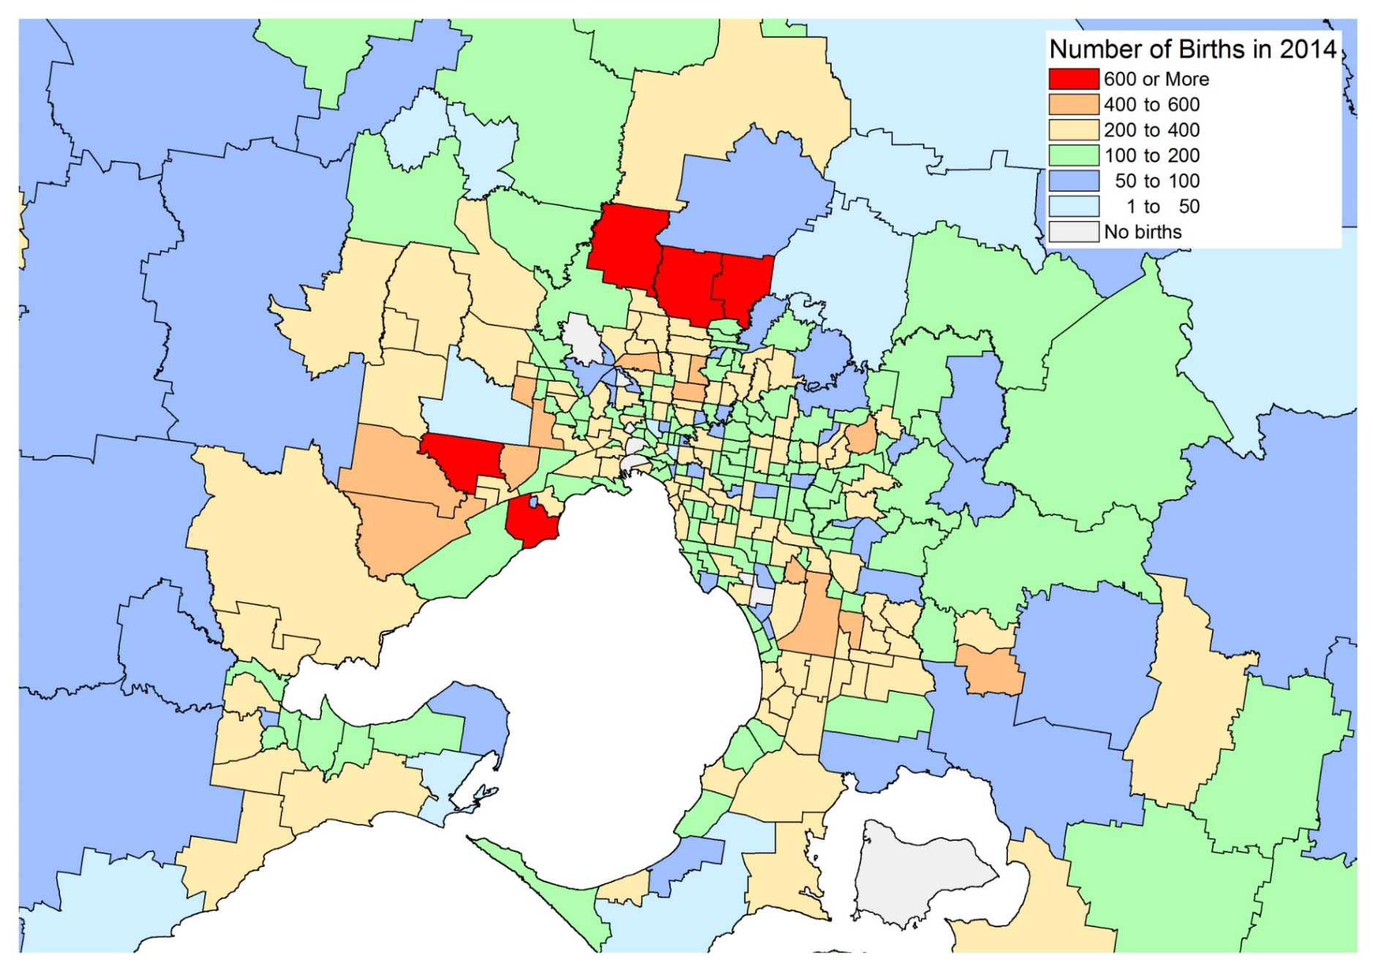
Appendix 5 – Maps of Births

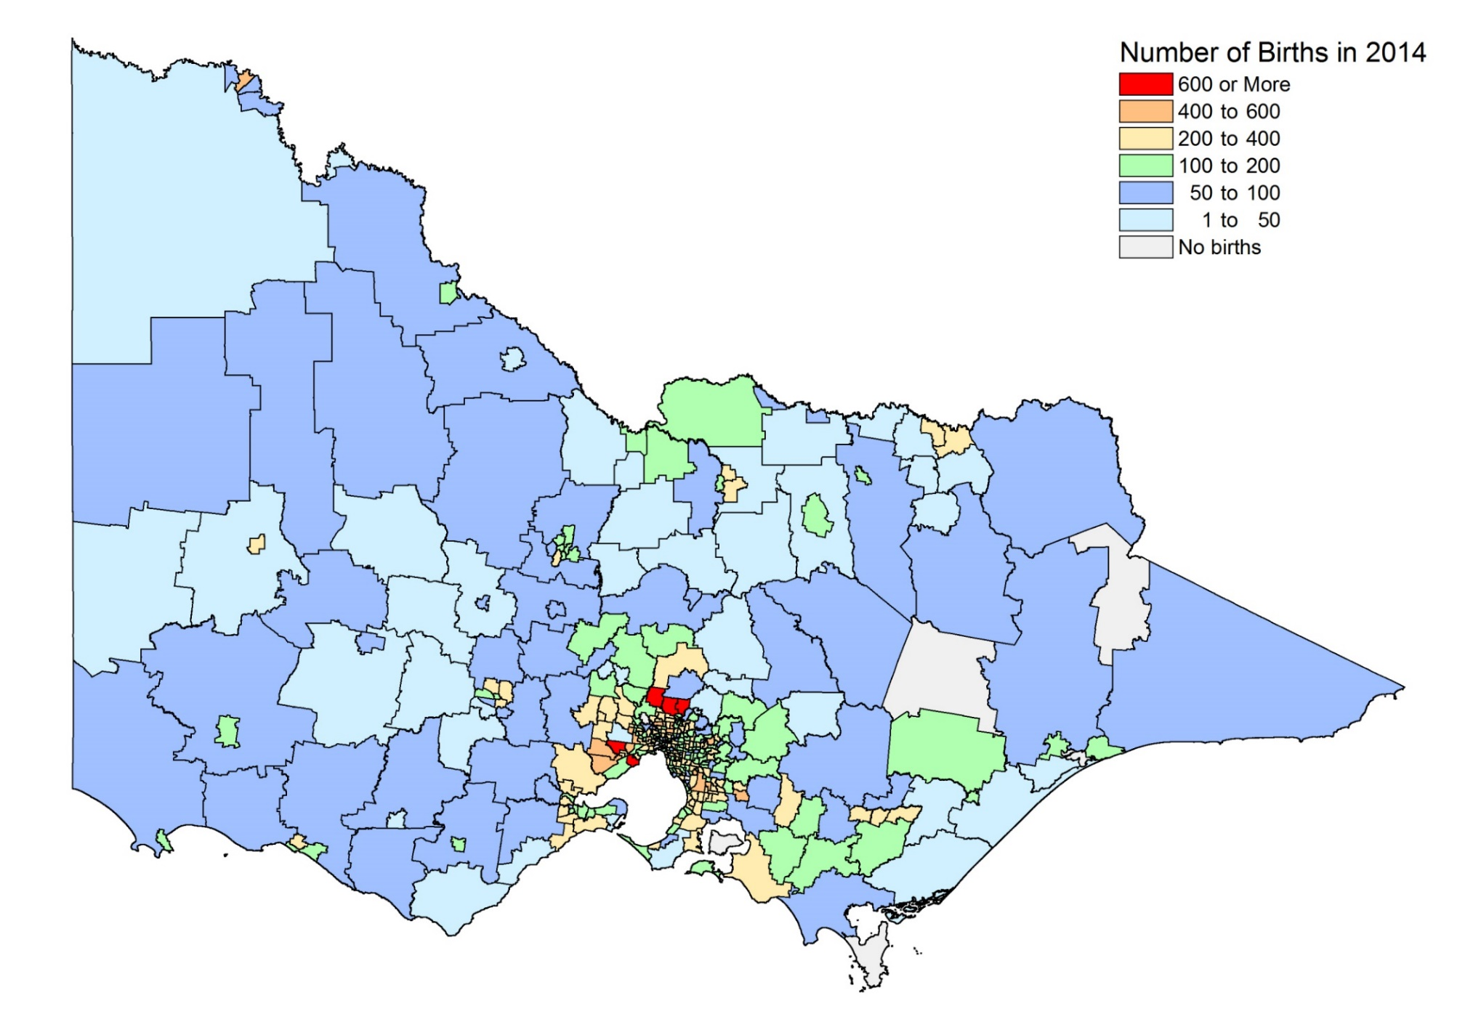

APPENDIX 6 – Maps of Unemployment
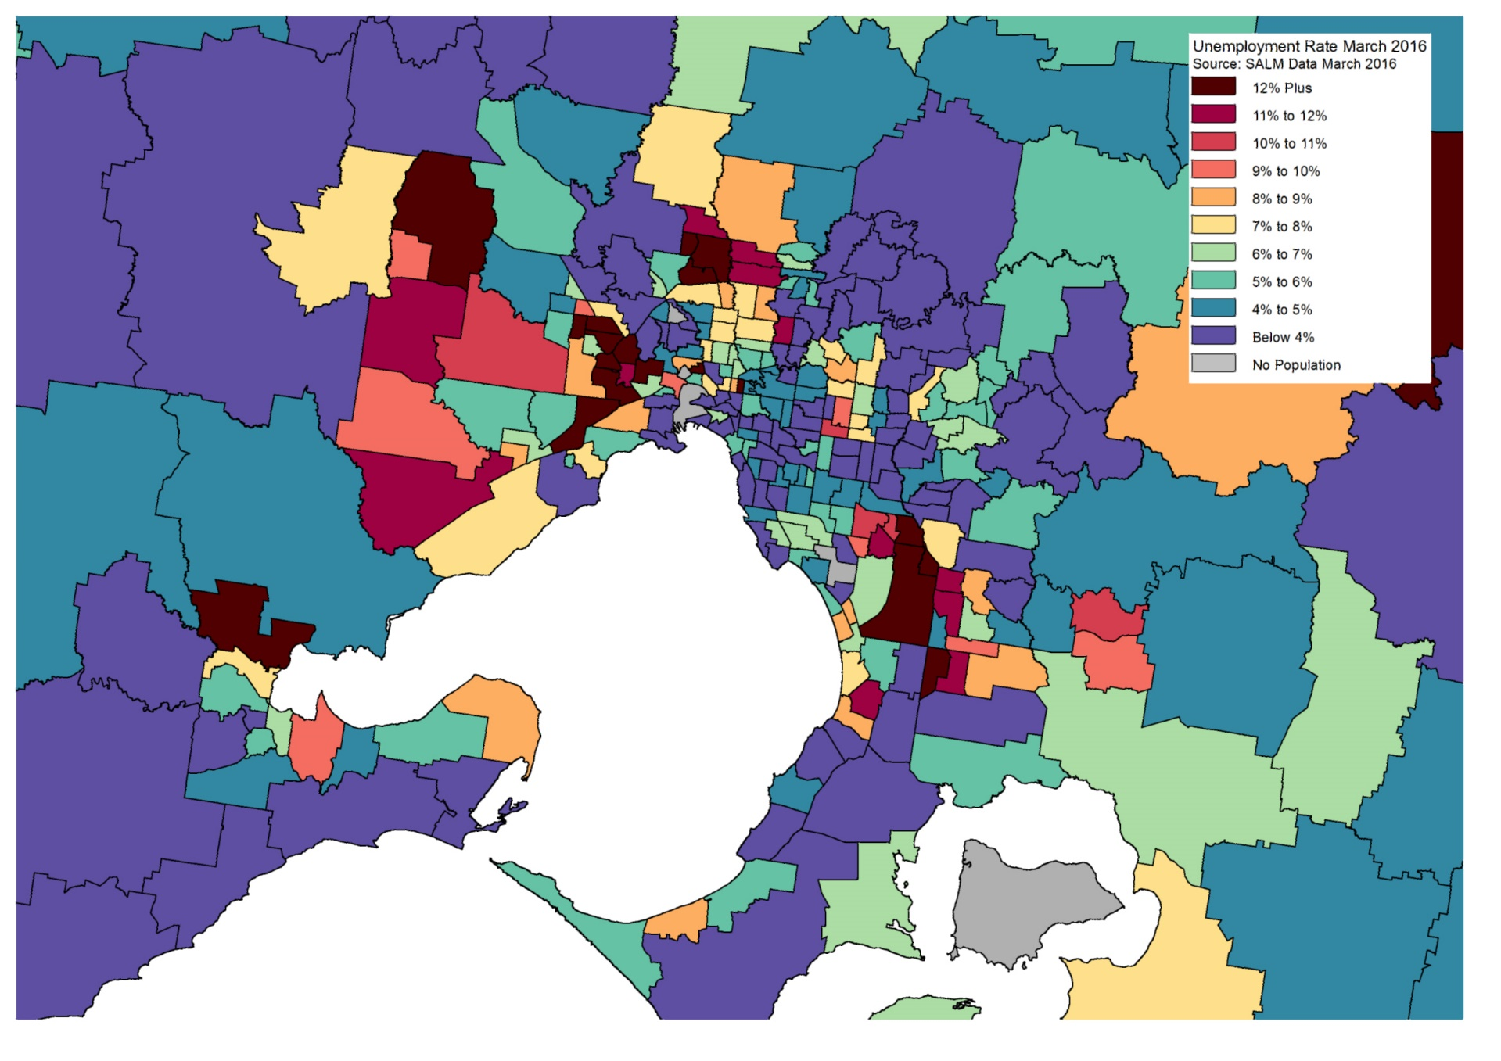
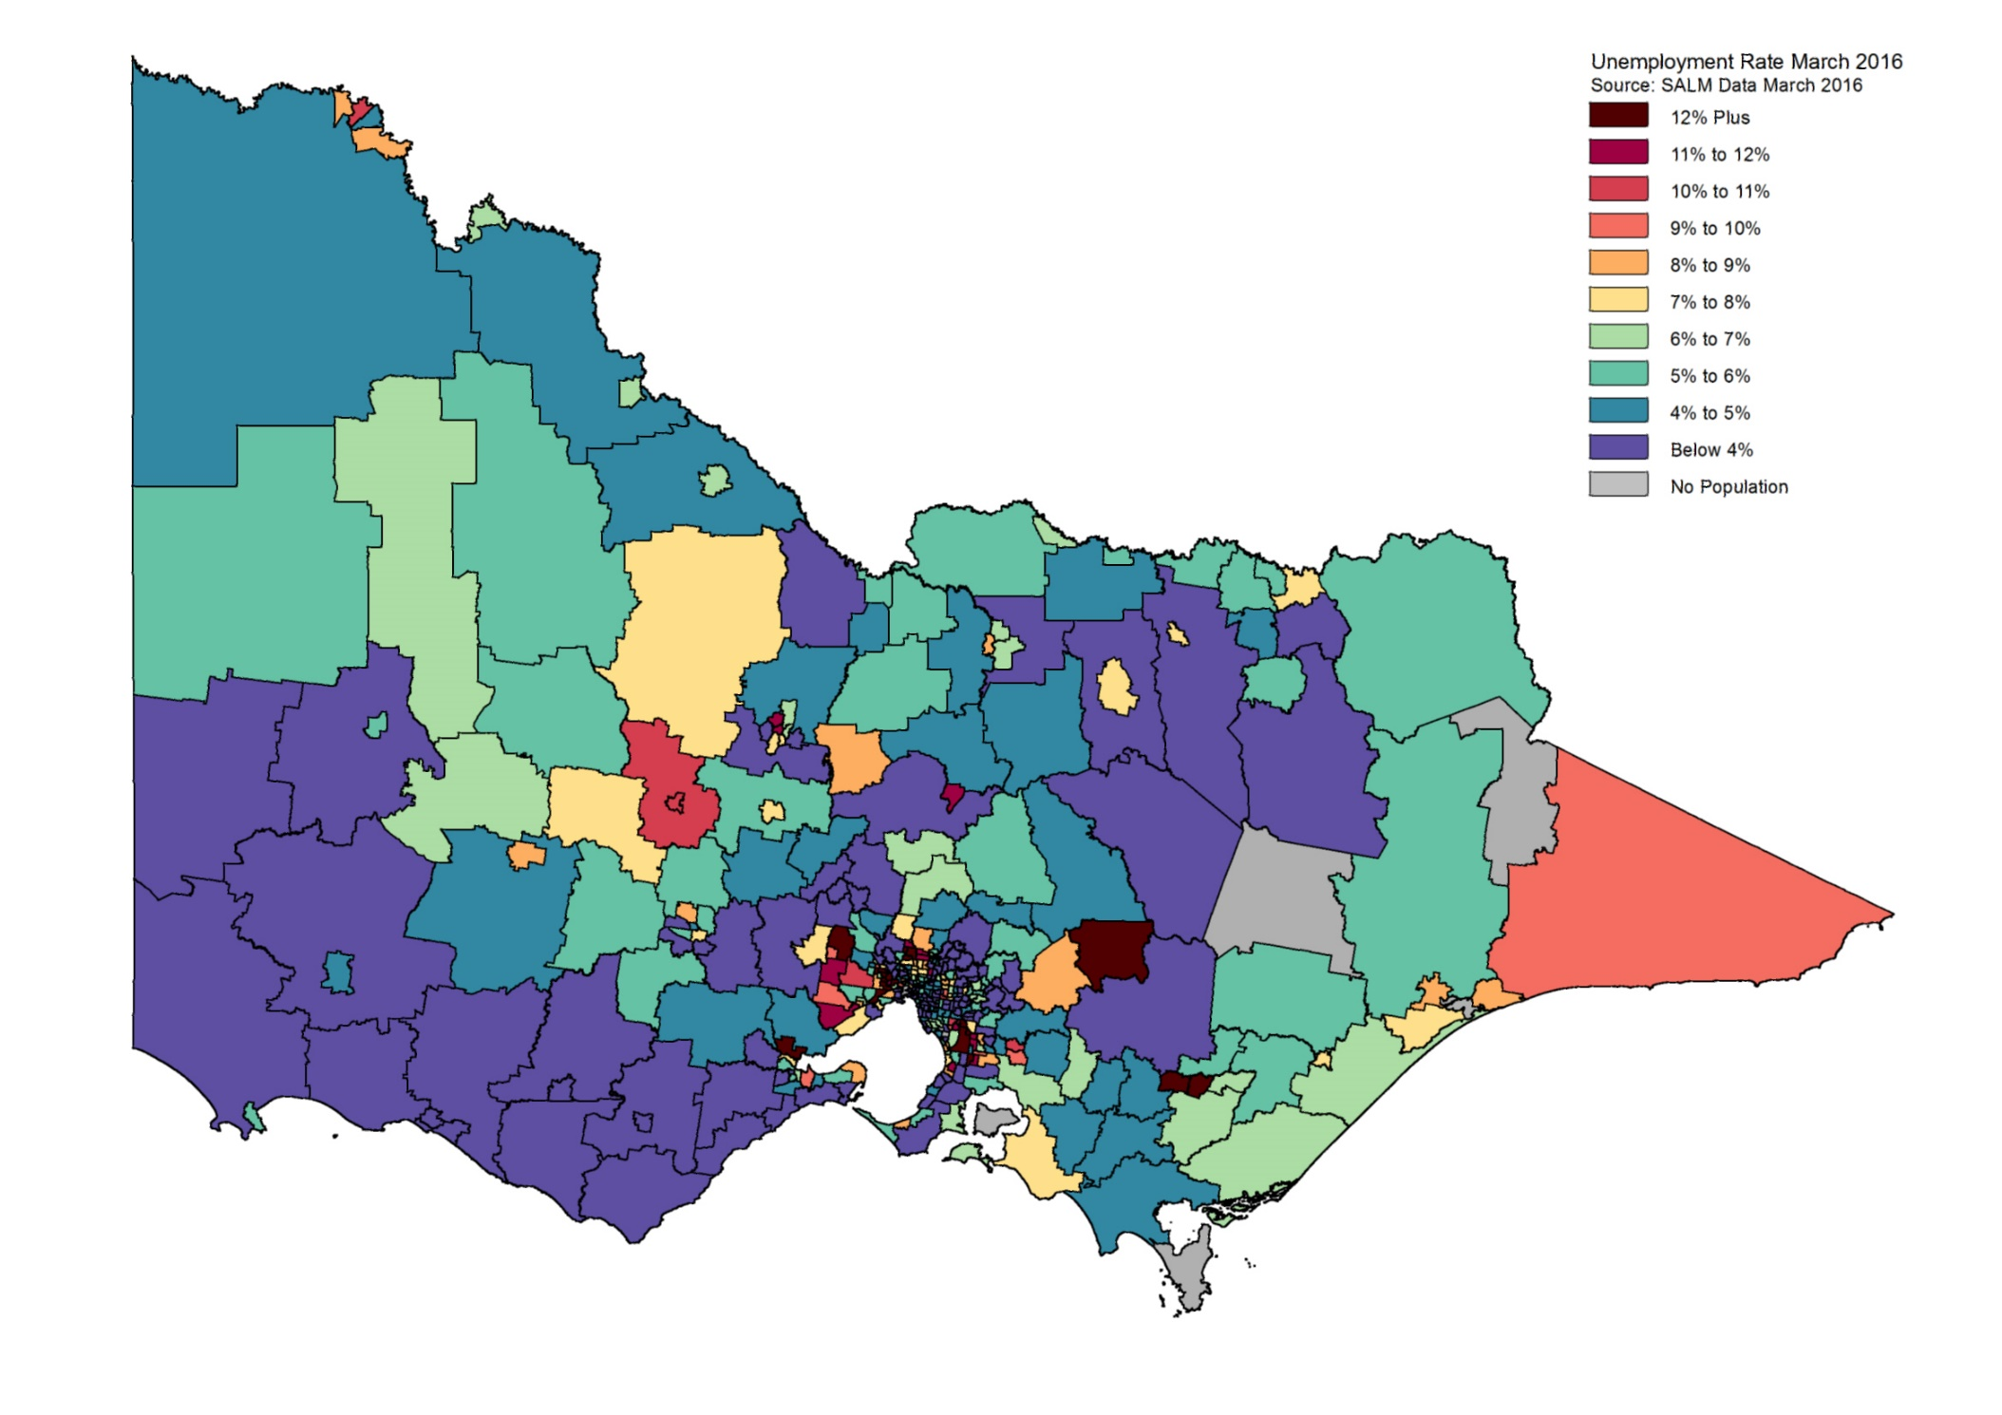
APPENDIX 8 – Active Greenfield Projects
