Amendment C146
Melton Planning Scheme
Plumpton PSP – Economic Evidence

Expert Witness Statement
of
John Henshall, B Com (Econ), Grad Dip TRP, M Soc Sci (Plg & Envrion), LFPIA

Contact details
For further details please contact Essential Economics Pty Ltd at one of our offices:
96 Pelham Street  Carlton  Victoria 3053  Australia  PH +61 3 9347 5255  FAX +61 3 9347 5355 | Level 26 / 44 Market Street  Sydney  New South Wales 2000  Australia  PH +61 2 9089 8654
EMAIL mail@essentialeconomics.com
WEB www.essentialeconomics.com
ABN 92 079 850 427
Project Number: 16213

Contents
1 Introduction 1
2 Outline of Plumpton PSP 4
3 Subject Land and Issues with Plumpton PSP 7
4 Industry and Employment 9
5 Proposed Aquatic Centre 18
6 Conclusions 20

Introduction

Professional Details
  - My name is John Charles Henshall and I am Founding Director and Senior Economist/Planner at Essential Economics Pty Ltd, located at 96 Pelham Street, Carlton, Victoria.
  - I hold the degree of Bachelor of Commerce (Economics) and the Post-Graduate Diploma of Town & Regional Planning, both from the University of Melbourne, and Master of Social Science (Planning & Environment) from RMIT University. I am a Life Fellow of the Planning Institute of Australia and a Fellow of the Victorian Planning and Environmental Law Association. A copy of my CV provided at Attachment A.

Area of Expertise
  - My areas of expertise are in urban and regional economics, and strategic land use planning and development. I have worked in this field since 1974. An area of particular professional activity is my involvement in preparing economic impact assessments for a wide range of projects, including industrial, commercial, residential and mixed use developments; activity centre planning and development; and net community benefit assessments. I also have a strong involvement in undertaking demand and supply assessments for key land use sectors, including industrial, commercial, retail, residential, and tourism. I work with both private and public sector clients, and I appear regularly as expert witness at Planning Panels and at VCAT.

Instructions
  - I have been instructed in this matter by Best Hooper, Lawyers, who are acting for the Mondous Group, owners of land at 206-288 Beattys Road, Plumpton (‘subject land’), in the City of Melton. The subject land involves a land holding of 124ha, a generally triangular-shaped piece of land located approximately central to the Plumpton Precinct Structure Plan (PSP).
  - The Plumpton PSP, which covers a total area of 1,016ha, is to be incorporated into the Melton Planning Scheme through Amendment C146. The Amendment implements the development of land in accordance with the PSP.
  - My instructions are to express my professional opinion in regard to Industry & Employment and the Aquatic Centre are as follows:
Industry & Employment
- The role of employment land in Plumpton ;
- The likely take-up rate of industrial land in Plumpton in future years;
- The job estimates assigned to industrial land in Plumpton in future years (as set out in Table 5 of the PSP);
- To review and advise on the proposed expanse of industrial and commercial zoning, including the town centre, in the PSP, particularly as it relates to the Mondous Group land holdings;
- To consider whether any of the land should to be zoned as mixed-use; and
- To consider the feasibility of the currently-proposed location of the aquatic facility and any other possible locations within the PSP area.
Aquatic Centre
- The optimal criteria for determining the preferred location of district-scale aquatic facilities;
- The proposed location of the Plumpton Aquatic Centre; and
- Potential alternative locations for the proposed Aquatic Centre in the eastern part of the Melton municipality, having regard to the district-scale role of the facility.

Preparation
  - I have reviewed the PSP prepared by the (then) Metropolitan Planning Authority (MPA) and I have examined supporting documents, where available. Where necessary I have drawn on reports prepared by Essential Economics in regard to the economics-related aspects of planning for PSPs.
  - I have identified and assessed a listing of relevant issues associated with the Plumpton PSP, including the location and extent of industrial and business land, the town centre, location of the aquatic facility, residential land and densities, and timing for development.
  - I have reviewed and assessed underlying assumptions regarding land allocation for various land uses, job densities and residential densities.
  - I have had regard for the Guide for Evidence and my Statement complies with this Guide.
  - I have been assisted by my colleague, Harriet Noall, Research Analyst at Essential Economics, in assisting in regard to data for aquatic centres.

Documents Relied on in Preparing Statement

- Capire, Plumpton and Kororoit – Open Space and Community Infrastructure Needs Assessment, April 2015
- DELWP, Urban Development Program, (various to 2014/15)
- DELWP, Victoria in Future 2016, 2016
- Essential Economics Pty Ltd, Growth Corridor Plans – Activity Centre and Employment Planning, November 2011
- Frankston Regional Aquatic Centre Pty Ltd, PARC Annual Report 2015
- Growth Areas Authority, Planning for Employment and Industry in Melbourne’s Growth Areas, October 2011
- HillPDA Consulting, Plumpton and Kororoit – Retail and Employment Land Assessment, for MPA, March 2015
- Metropolitan Planning Authority, Melton Planning Scheme, Amendment C146 Explanatory Report
- Metropolitan Planning Authority, Plumpton Precinct Structure Plan, June 2016
- Mitchell Shire Council, Mitchell Aquatic Strategy 2014-2024, August 2014

This Statement
1.12 This Statement comprises the following sections:
- Section 2: Outline of the Plumpton PSP
- Section 3: Subject Land and Issues with the Plumpton PSP
- Section 4: Industry and Employment
- Section 5: Proposed Aquatic Centre
- Section 6: Conclusions.

Outline of Plumpton PSP
This Section provides background to the Plumpton Precinct Structure Plan (PSP) that is relevant to my assessment of employment land and the aquatic centre, as proposed in the PSP.
  - The Plumpton PSP has been prepared by the Metropolitan Planning Authority (MPA) in consultation with Melton City Council and with the assistance of government agencies, service authorities and major stakeholders. The PSP was published by the MPA in June 2016.
  - In summary, the Plumpton PSP (p5) sets out plans to guide the delivery of quality urban environments in accordance with relevant Victorian Government Guidelines, and is designed to enable the transition of non-urban land to urban land. The PSP sets the vision for how land should be developed and the outcomes to be achieved.
  - Importantly, the PSP “outlines the projects required to ensure that future residents, visitors and workers within the PSP area can be provided with timely access to services and transport necessary to support a quality, affordable lifestyle” (p5).
  - The PSP guides land use and development where a planning permit is required under the Urban Growth Zone or another zone where that zone references the PSP.
  - The PSP covers an area of 1,016ha and is located approximately 30km to the west of the Melbourne CBD. As described in the PSP, the precinct aims to provide over 12,000 jobs (Table 5) close to where people live, with synergies between the Major Town Centre and adjacent commercial and industrial areas, thus encouraging a diversity of employment. The PSP indicates that the Main Town Centre activities are to be complemented by “the library, council facilities and nearby aquatic centre” (p9). A diversity of dwelling types and densities will be provided, and the Major Town Centre and the Local Town Centre will offer shopping, community facilities and services immediately adjacent to residential areas.
  - In addition to the 12,000-plus jobs, the PSP will accommodate at least 10,680 dwellings and 29,900 residents (p13).
  - Twenty-seven key objectives are set-out for the precinct, covering a number of specific planning objectives such as Transport & Movement, and Infrastructure Delivery & Development Staging (p10,11). The Implementation plan specifies Requirements in relation to planning considerations (eg, relating to image and character) and provides Guidelines to achieve these requirements (Section 3.1).
  - The Major Town Centre (MTC) identified in the PSP is designed to “form the heart of a regional catchment and will provide retail, commercial, cultural, community, sporting and social facilities. Adjacency to the Business and Industrial Precinct to the west will further strengthen the diverse employment potential and offer of the centre” (p27).

  - The Business & Industrial Precinct identified in the PSP will service the emerging residential communities in Plumpton and areas to the south and west. It is expected that this precinct will support a diversity of businesses, with higher density job figures encouraged in areas closer to the MTC and public transport services. Medium-density live-work options will be encouraged along the western side of Hopkins Road to facilitate a diversity of employment and development options, and provide an active interface to the MTC. Housing will be on upper floors, with employment uses on the ground floor (p36).
  - The PSP proposes the construction of an aquatic centre on the northern alignment of Beattys Road, as shown in Plan 5 of the PSP. This site is situated opposite a “community facility (ICP land)” and a government school. Mainly residential use surrounds the proposed aquatic centre site.
  - The Plumpton PSP provides a comprehensive plan for the locality, with directions provided for appropriate land use and development that will contribute to liveability for the new and emerging community. However, the Mondous Group have a number of issues that require consideration in regard to the location and extent of particular uses. These aspects are highlighted in the following Section. The PSP is shown in Figure 2.1.

Figure 2.1: Plumpton PSP
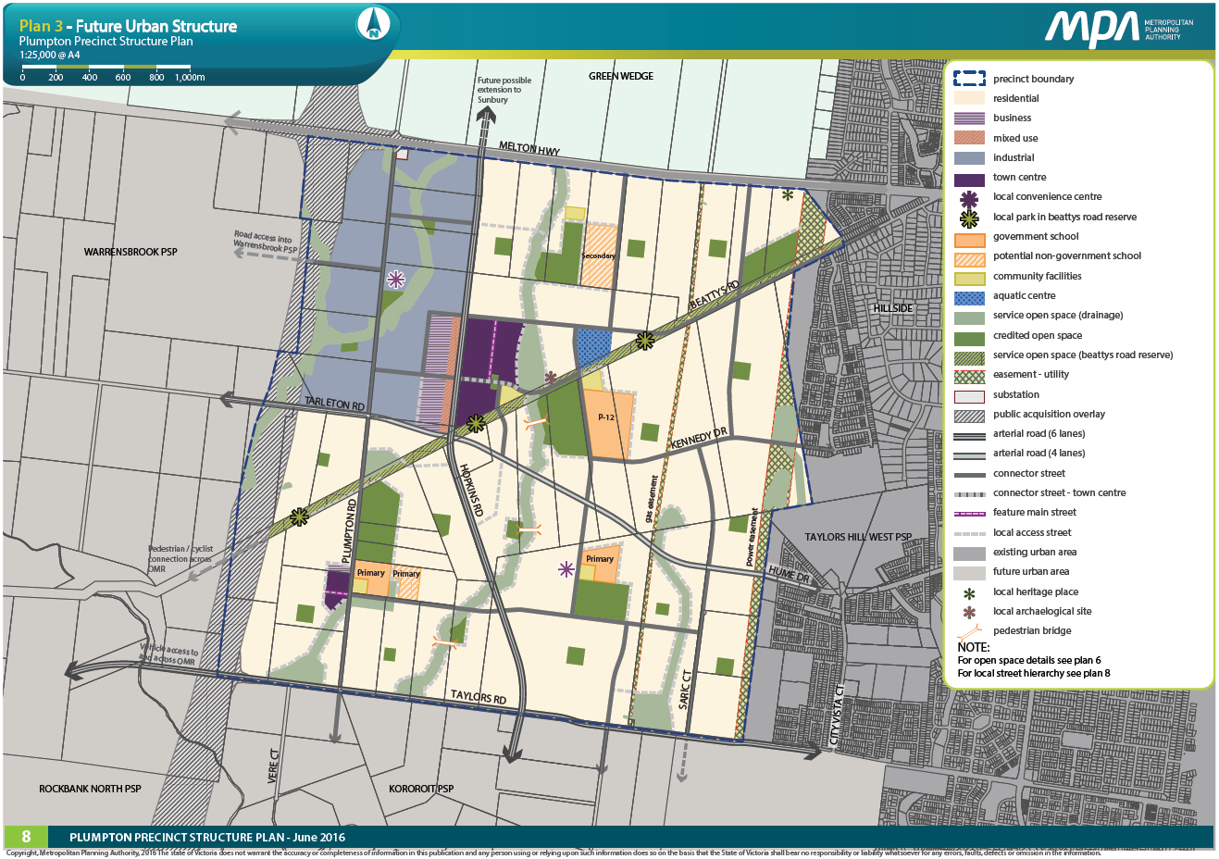

Subject Land and Issues with Plumpton PSP
This Section describes the subject land and identifies the issues associated with the Plumpton PSP as it affects the subject land. The need to reconfigure land uses in part of the subject land is also highlighted. Detail is provided in the subsequent Section 4 in regard to Industry and Employment and in Section 5 in regard to the proposed Aquatic Centre.
  - The location of the Mondous Group’s land holding in Plumpton is shown in Figure 3.1. The subject land involves a land holding of 124ha and comprises a generally triangular-shaped piece of land located approximately central to the Plumpton PSP. The PSP proposes that this land be developed for the Major Town Centre and also for an employment precinct, a number of community facilities, medium/high-density housing, and a large retarding basin.
  - The Mondous Group have identified a number of areas where clarity is required in respect to the location and extent of certain land uses identified in the Plumpton PSP and that impact on landholdings of the Mondous Group. The Group’s land holdings – which I refer to as the ‘subject land’ – are described below. In particular, issues with the PSP are as follows:
- the amount of industrial land in the Employment precinct;
- the potential for Mixed Use to be provided in part of the Industrial & Business land; and
- the location of the proposed Aquatic Centre.
  - Upon reviewing the land use type and distribution proposed in the PSP (Plan 5) as it relates to the subject land, it is my view that development of the majority of the land would be likely to occur in the longer-term period. Very little land exists on the subject land that could be developed in the short-term. Examples include the MTC, the industrial and commercial land, the aquatic centre, and higher-density residential land. However, a review of several aspects of the PSP should assist in ensuring that the land uses proposed for the MTC and environs – including the Business, Mixed Use, and Industrial areas – are optimised in terms of land area, employment and accessibility. This review is designed to assist development of these land use components in a timely manner.

Figure 3.1: Location of the Subject Land in Plumpton PSP
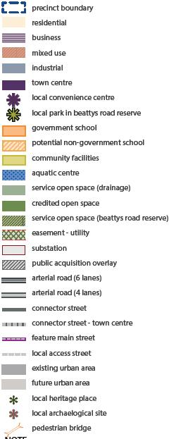
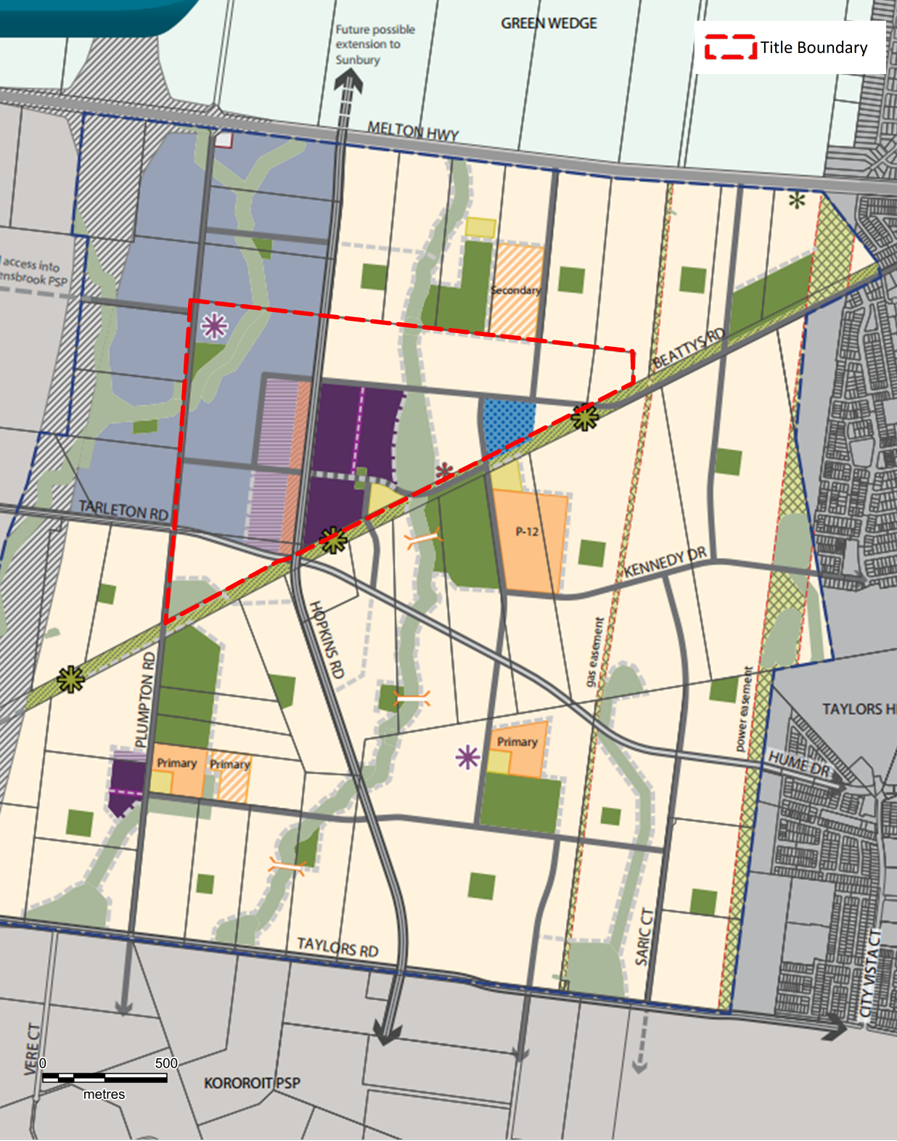
Source: VPA (Edit: Essential Economics)
Note: Refer Figure 2.1 for Legend showing proposed land use categories

Industry and Employment
This Section highlights the issues associated with industry and employment in the Plumpton PSP.
  - The PSP provides 105.7ha of land (Gross Developable Area) for the Plumpton Business & Industrial Precinct (PSP, p13), including an estimated 36ha located on the subject land. Thus, the subject land accounts for a substantial one-third (34%) of all industrial and business land in the Plumpton PSP.
  - Figure 3.1, shown earlier, indicates the location of industry and employment land in the revised Plumpton PSP as it relates to the subject land.
  - This provision of industrial and business land is intended to generate significant new employment opportunities by accommodating a range of new businesses in this precinct. However, in my view these outcomes in terms of industrial and business land consumption and industrial and business employment highlighted in the PSP are unlikely to be realised. Industrial and Employment Land Consumption
  - As background to the land consumption figures in the PSP, I refer to a report prepared by HillPDA titled “Plumpton and Kororoit – Retail and Employment Land Assessment”, for MPA, March 2015). HillPDA assume that 5.2ha per year (or 65%) of Melton’s demand for industrial and business land (8ha/ year) will be absorbed in Plumpton (p29, 33). This is a very large amount of industrial land consumption for the municipality (8ha/year) and a high share of the municipality’s estimated annual consumption of total industrial and business land (5.2ha/year) is to be provided in the Plumpton PSP. In my view, this is an optimistic total amount of industrial and business land for Melton, and also an optimistic share for Plumpton PSP to absorb. My Figure 4.1 referenced later in paragraph 4.9 shows the locational context of large areas of industrial land supply in the City of Melton.
  - The high level of industrial land consumption estimated by HillPDA can be traced back to their Table 4 (p28) which shows industrial construction activity in the municipality (9/2006 to 2/2015) and includes several categories, namely “Construction” undertaken in that period, as well as “Likely Construction”, “Possible Construction”, “Deferred“, and “No further information”. These latter four categories account for 69% of all industrial construction value over the period, as shown in their Table 4. HillPDA state that “this data suggests land take up trends have been up to 3.7ha per annum in Melton”, and that “The pipeline data shown above (ie, the four categories I mention above) suggests this rate could possibly double in the near future, say up to 8ha per annum”, and that the rate could even accelerate in years to come (p29).
  - This approach overstates the potential for industrial and business land in Melton and, by extension, in Plumpton. In my view, it is not correct to include the four categories that include “Likely Construction”, “Possible Construction”, “Deferred“, and “No further information”. If the industrial land has not been developed already over the period, the development either does not occur at all (ie, investment/construction plan falls over) or simply moves into the next year’s tally of land for actual or possible construction, or the subsequent years, and so on. In my view, these land consumption estimates are not an accurate assessment of land demand and their inclusion by HillPDA only serves to inflate overall demand estimates for industrial and business land in both Melton and the Plumpton PSP.
  - When HillPDA adopt only the “Construction” category, they estimate that industrial land consumption in Melton could be in the order of 2.2ha per year to 3.7ha per year (HillPDA, Table 5). Averaging these two estimates, the industrial land consumption in Melton would average 3ha per year. If I assume Plumpton accounts for 50% of this land supply (and this is a conservatively high share – see below at paragraph 4.8), the PSP area would experience 1.5ha per year in industrial land take-up. Taking the PSP’s provision of 105.7ha of industrial and business land, and adopting an average consumption rate of 1.5ha per year, the PSP would have sufficient land supply to last 70.5 years. This outcome demonstrates that the PSP is providing an over-abundance of industrial and business land in Plumpton.
  - The Urban Development Program (DELWP) indicates that an average of 6ha of industrial land has been taken-up in the period 2011/12 to 2014/15. If the Plumpton PSP area accounts for (say) 50% of this consumption, the PSP’s industrial land supply of 105.7ha would have a lifespan of some 35 years.
  - In my view it is unlikely that Plumpton would account for 50% of Melton’s industrial land demand, considering the significant areas of industrial land provision in the Western Employment Node, Western Highway and Mt Atkinson, all of which are in the municipality and have relatively better locational attributes. Figure 4.1 on the following page shows the main employment precincts in Melton, including existing and proposed employment areas and the proposed employment area in the Plumpton PSP. Vacant employment land in these areas totals 984ha; even if I adopt the HillPDA estimate of average consumption of 8ha of land per year in Melton (p29), this vacant land supply would last for 123 years. This information on vacant land is sourced from the Urban Development Program 2015 prepared by the Department of Environment, Land, Water and Planning.
  - I also note that the Plumpton employment land does not form part of a larger industrial node co-located with freight terminals or with access to existing freeways. The employment land is relatively small (approximately 10% of the municipality’s total supply of vacant employment land – see above) and has fragmented land ownership. It is is bisected by a creek. For all of these reasons it is not a strategic industrial precinct and it will only serve a local function. Hill PDSA also arrive at the same conclusion (p31).

Employment
  - In regard to employment, in my view the level of job creation assumed for the industrial/employment commercial area is over-estimated. The PSP (Table 5, p32) shows that 1 job per 60m² is assumed for this area, giving a total of 6,367 jobs (corrected to 6,494 jobs).
(Note: Table 5 in the PSP contains an error – it shows 1 job per 60m² (or 0.17 job/1m²), but this ratio should be corrected to 0.017 job/m² (ie, 1 job per 60m²). Also, the Table shows an incorrect floorspace figure of 38,200m²; in the HillPDA report (Table 10, p36 – and from which the PSP figure is sourced) this figure is correctly shown as 382,200m². These errors appear to be a typographical error; the actual results of the assessment correctly reflect the original HillPDA calculations of jobs and associated measurements).
  - In my view, 1 job per 60m² is a very low level of floorspace per job in an industrial/employment development context, and therefore results in a relatively high density for employment in industrial/employment areas. This is especially the case when I consider the types of jobs that the PSP (p36) anticipates will be located in this precinct, namely storage, printing, automotive & equipment repairs and supplies, distribution and postal services, dance studios and gyms, “and other uses which need larger floor plates than typically available in town centres” (emphasis added).
  - Taking account of my involvement in growth area planning and in assessing employment in a range of activities in inner and outer suburban areas, it would be more realistic to adopt an average of around 1 job/85m² located in an industrial/business context. Examples of typical floorspace per job from projects undertaken by Essential Economics include the following: warehouse 275m²; factory 200m²; workshop 125m²; business incubator 50m²; showroom/trade supplies 80m²; small office 15-20m²; research/training 70m²; childcare 50m²; and aged care 50m² (refer, for example, to “1850-180 Thompsons Road, Clyde North – Employment Analysis”, Essential Economics, November 2013).
  - My figure of 85m²/job assumes both industrial jobs and business jobs are evenly split (ie, 50:50) in a land use context between industry activities (eg, workshops) and business activities (eg, office-based). If more than 50% of available land is taken up by industry, then the average amount of floorspace per job would exceed the 85m²/job indicated above; if less land is taken up by industry, the average floorspace per job would be lower than 85m²/job. As it is likely that industrial land exceeds business land in the PSP, the floorspace per job will be considerably higher than the 85m²/job I have adopted in Table 4.1.
  - My estimates in Table 4.1 show that the gross land area of 109.5ha would support 4,495 jobs (or 41 jobs/ha); this contrasts with the 42% higher estimate by HillPDA that 6,370 jobs (or 58 jobs/ha) would be supported. These estimates allow for 70% net development area and 50% site coverage for workspaces, as adopted by HillPDA and shown in my Table 4.1. (Note: I have adopted the figure of 109.5ha in this Table to match this figure adopted by HillPDA in their report – this enables a direct comparison of the two approaches. The PSP shows the gross industrial land figure at 105.7ha, as noted in my paragraph 4.1).

Figure 4.1: Existing and Proposed Employment Areas in City of Melton
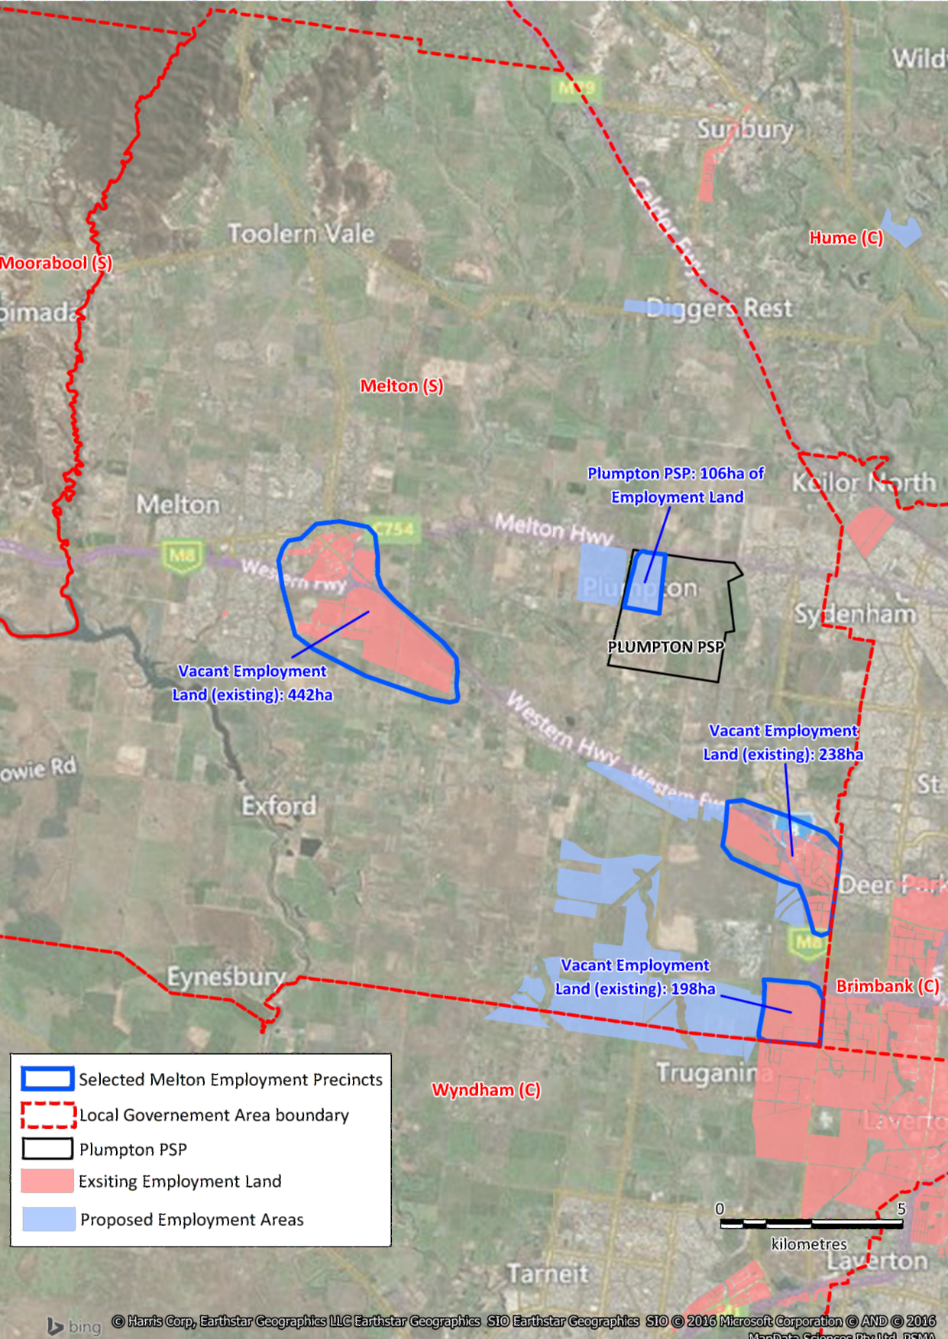Produced by Essential Economics using MapInfo, BingMaps and information from the Urban Development Program 2015 (DELWP)

Table 4.1: Calculations for Job Density in Plumpton PSP: HillPDA and Henshall
 |  | HillPDA ⁽¹⁾ | Henshall ⁽²⁾ ⁽³⁾
Site area (Gross) |  | 109.2ha | 109.2ha
Net developable area (70%) |  | 76.4ha | 76.4ha
Site coverage for buildings (50%) |  | 38.2ha or 382,000m2 | 38.2ha or 382,000m²
Job Density |  | 60m²/job | 85m²/job
Estimated Total No. Jobs (rounded) |  | 6,370 jobs ⁽²⁾ | 4,495 jobs
Jobs/ha | 58 jobs/ha |  | 41 jobs/ha
Source: ⁽¹⁾ HillPDA ⁽²⁾ Plumpton PSP Table 5 ⁽³⁾ Henshall
Note: ⁽³⁾ I have retained the original HillPDA data for land area (109.2ha) in order to provide a comparison of data using both the HillPDA estimate of job density and my estimate of job density.
  - I note that the HillPDA calculations for job density (refer HillPDA, Table 9) are sourced from the City of Melbourne Census of Land Use and Employment (CLUE, 2002 to 2012). The CLUE data is reflective of inner metropolitan area economic activities, and therefore in my view it is not appropriate to apply these indicators for growth areas on Melbourne’s metropolitan fringe. In growth areas the type and extent of business and industrial activities contrasts with those of inner Melbourne where property values are more expensive and where the very nature of economic activity is different from the fringe areas.
  - Research undertaken by Essential Economics shows that “overall employment intensity declines sharply across all types of employment location when comparing inner Melbourne with other regions” (Growth Corridor Plans – Activity Centre and Employment Planning, p95). This is shown in Table 4.2 below. The figures for Outer Melbourne are actually lower than what I have adopted in the text above.
Table 4.2: Jobs per Hectare of Zoned Land by Location Category
Employment Zone Type | Inner Melbourne | Middle Melbourne | Outer Melbourne
Activity centre – retail/office/other | 191 | 96 | 54
Employment/industrial areas | 35 | 18 | 3
Community – health/education/other | 272 | 91 | 41
Source: Essential Economics, Growth Corridor Plans: Activity Centre and Employment Planning, November 2011, Table 11.7
  - I also note that the HillPDA report (Table 10, p36) assumes that demand for business and industrial land will commence from Year 1 with estimated demand for 5.4ha of land, increasing each year as household growth continues. Adopting the HillPDA average shown in Table 1 above, in Year 1 the PSP area would have generated demand for 313 jobs; with an average of (say) 3 jobs per business, this means the industrial/business area would have attracted some 100 or so new businesses in Year 1. Even with an average of (say) 10 jobs per business, the area would be attracting 30-plus businesses in Year 1. These are very significantly high rates of new business and investment attraction for a growth area where, as HillPDA data shows (Table 8), the PSP area would only have attracted 948 households or about 2,600 residents in Year 1.
  - In summary, in my view the HillPDA and MPA estimates of industrial and business land requirements and job creation for Plumpton PSP are very optimistic.

Potential Alternative Urban Structure for Achieving Employment Aspirations in PSP
  - Having regard for my assessment of industrial and business land provision in the Plumpton PSP, it would be appropriate for a reconsideration of this provision. I consider two scenarios:

- Scenario 1 retains the existing plan as adopted for the revised Plumpton PSP, with land for Employment/Industrial, for Business, and for Mixed Use, as shown above in Figure 3.1. The estimated employment outcomes are shown in Table 4.3.

- Scenario 2 reflects the opportunity to re-zone 50% of the Industrial/Employment land as part Mixed Use and to retain the 50% balance of the land in the Industrial zone, as shown in Figure 4.2. The estimated employment outcomes are shown in Table 4.4.
  - Scenario 2 has the benefit of using the Mixed Use area as a buffer between the industry/employment uses and the non-industry/employment uses. The Hopkins Road uses to the east comprise town centre and residential uses, while the Tarleton Road uses to the south are residential. In this scenario, the industrial/employment area is located to the west of the Hopkins Road Mixed Use area.
  - For these scenarios I adopt up-to-date information on the land area (in hectares) for the subject land located to the west of Hopkins Road. These figures differ only marginally from the data presented in the PSP and the HillPDA report. The updated land area measurements have been provided by the client.
  - Scenario 1 shows that under the revised Plumpton PSP the subject land located to the west of Hopkins Road would support an estimated 1,225 jobs, based on the land uses and employment densities shown in Table 4.3.
Scenario 2 shows that under the preferred concept plan for the subject land to the west of Hopkins Road, this locality would support an estimated 1,520 jobs, as summarised in Table 4.4. This scenario has the land split 50:50 between Mixed Use along the Hopkins Road and Tarleton Road frontages and with the employment/ industrial land located further west to the western boundary of the site.
  - Comparing the two scenarios, I note that Scenario 1 which relates to the existing PSP arrangement of uses for the subject land located west of Hopkins Road would support an estimated 1,225 jobs, or 33 jobs/ha. In contrast, Scenario 2 where the subject land is divided equally between Industrial/Employment and Mixed Use, a total of 1,520 jobs would be supported, or an average of 41 jobs/ha.

  - Thus, if the land use mix is adopted as preferred by Mondous Group for the subject land west of Hopkins Road, a higher level of jobs would be supported and this would involve an additional +295 jobs or 24% greater than under the existing PSP proposal for this land.

Figure 4.2: Alternative Provision of Industry and Mixed-Use Land for Subject Land in Plumpton PSP
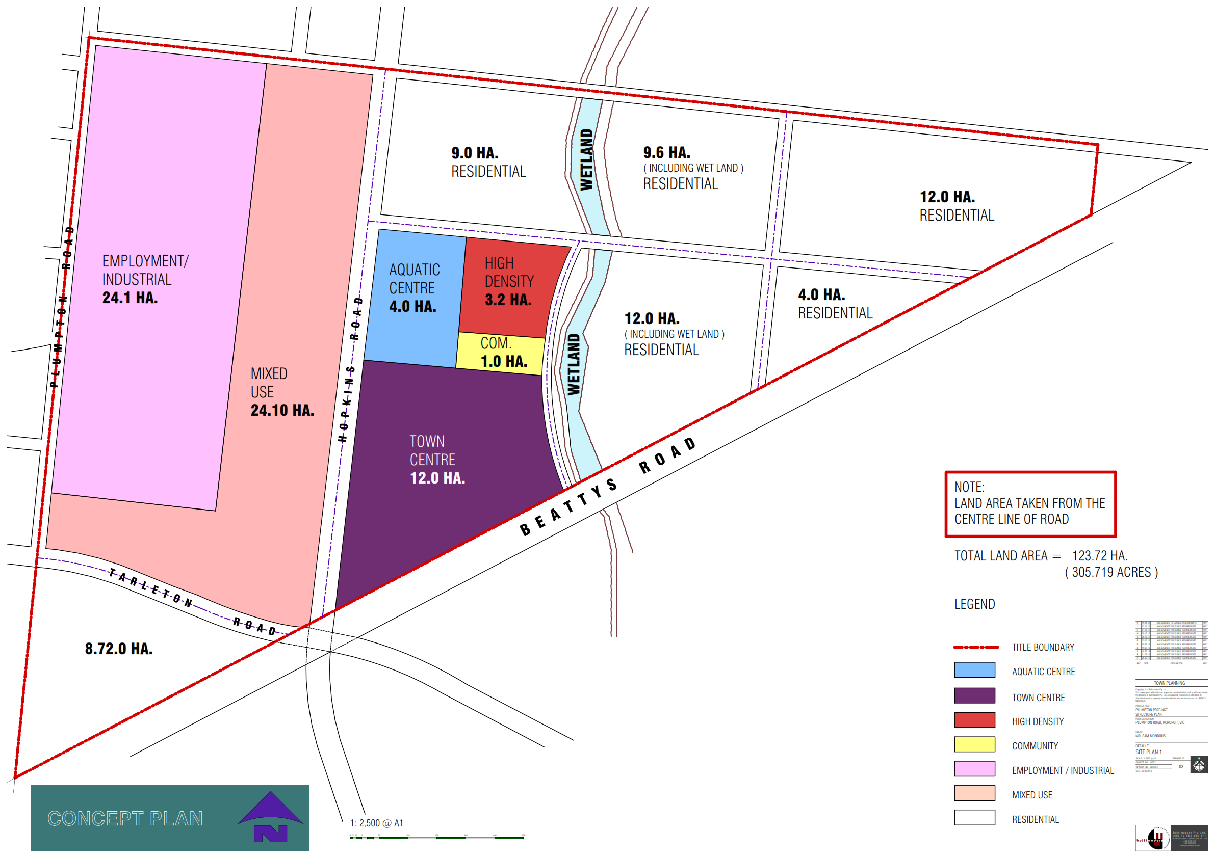
Source: Mondous Group

  - The two Tables showing the scenarios are presented below.

Table 4.3: Scenario 1 – Land Use Mix for Subject Land West of Hopkins Road as per PSP Revised Plan
Variables ⁽¹⁾ | Industrial Use | Business Use | Mixed Use | Total
Gross Developable Area in Ha | 25.0ha ⁽²⁾ | 9.0ha ⁽²⁾ | 3.0ha ⁽²⁾ | 37.0ha
70% Net Developable Area in Ha | 17.5ha | 6.3ha | 2.1ha | 25.9ha
50% Site Coverage in Ha | 8.8ha | 3.1ha | 1.0ha | 12.9ha
Square Metres | 88,000m² | 31,000m² | 10,000m² | 129,000m²
Square Metres per Job ⁽³⁾ | 150m²/job | 60m²/job | 60m²/job | 105m²/job ^{(d)}
Estimated No. Jobs (rounded)  Estimated Jobs per Ha (rounded) | 585 jobs  23 jobs/ha | 515 jobs  57 jobs/ha | 125 jobs  42 jobs/ha | 1,225 jobs  33 jobs/ha
Source: ⁽¹⁾ HillPDA March 2015 as input to Plumpton PSP
⁽²⁾ Echelon Planning
⁽³⁾ Essential Economics
Table 4.4: Scenario 2 – Mondous Group’s Preferred Use Mix for Subject Land West of Hopkins Road
Variables ⁽¹⁾ | Industrial Use ⁽²⁾ | Mixed Use ⁽²⁾ | Total
Gross Developable Area in Ha | 18.5ha | 18.5ha | 37.0ha
70% Net Developable Area in Ha | 13.0ha | 13.0ha | 26.0ha
50% Site Coverage in Ha | 6.5ha | 6.5ha | 13.0ha
Square Metres | 65,000m² | 65,000m² | 130,000m²
Square Metres per Job ⁽³⁾ | 150m²/job | 60m²/job | 86m²/job ^{(d)}
Estimated No. Jobs (rounded)  Estimated Jobs per Ha (rounded) | 435 jobs  23 jobs/ha | 1,085 jobs  59 jobs/ha | 1,520 jobs  41 jobs/ha
Source: ⁽¹⁾ HillPDA March 2015 as input to Plumpton PSP
⁽²⁾ Mondous Group
⁽³⁾ Brown Property Group and Essential Economics
  - In these two tables I estimate that Industrial use would generate an average of 23 jobs/ha. This figure compares favourably with the Growth Corridor Plans that assume a density of 15-20 jobs/ha in industrial areas. If the average figure shown in the Growth Corridor Plans is adopted (approximately 17 jobs/ha), the employment numbers would be even lower than shown in the tables.
  - In addition to the greater level of jobs supported under Scenario 2 (50:50 split in land use), a number of advantages over Scenario 1 (existing revised PSP) are evident from a planning perspective. These advantages include the introduction of Mixed Use zoning along the western alignment of Hopkins Road and along the southern alignment of Tarleton Road. This zoning provides a buffer between industrial uses to the west of the subject and the residential uses along Hopkins Road and Tarleton Road. Mixed Use also provides a buffer between the industrial area and those town centre uses that are located on the eastern alignment of Hopkins Road. A further advantage of the Mixed Use zone is that it provides a level of flexibility in the plan for this locality, and this may be important in terms of encouraging development in the short to medium-term, rather than development occurring in the longer-term.
  - As residential uses can exist in the Mixed Use zone, a schedule to the planning scheme would need to be prepared ensure that appropriate controls are in place in the western part of the Mixed Use zone to ensure such residential uses are buffered from the industrial activities located further to the west.

  - The extension of the Mixed Use zone would have a number of positive outcomes. It would provide a desirable location for smaller-format commercial and office/warehouse uses that typically seek a higher level of amenity than typically found in industrial areas; these smaller business operations generally do not seek locations in busy and congested town centres. The Mixed Use zone would also enable a larger number of residents to live and work in this locality, and would add significantly to the level of household spending that would be directed to the planned Plumpton Town Centre located to the east of Hopkins Road, opposite the Mixed Use zone.
  - In summary, I believe the underlying employment projections for the Plumpton PSP are optimistic, and this stems from the use of an inappropriate benchmark for job provision. The re-design of the land west of Hopkins Road to include a 50:50 mix of industry/employment land and mixed use would see a higher number of jobs in this locality compared with the job support under the employment/industry designation in the PSP.

Proposed Aquatic Centre
This Section provides an assessment of the proposed location of the Aquatic Centre in the Plumpton PSP, and provides commentary in respect to the optimal criteria for determining the preferred location of district-scale aquatic facilities; the proposed location of the Aquatic Centre in the Plumpton PSP; and consideration of potential alternative locations for the proposed Aquatic Centre.

Optimal Criteria for Location of District-scale Aquatic Facilities
  - The Melton City Council Aquatic Plan 2014-2034 identifies provision of three aquatic centres across the municipality and one of these is a district-level facility (Capire, Plumpton and Kororoit Open Space and Community Infrastructure Needs Assessment, April 2015, p26). The Aquatic Plan recommends that a district-level facility has a “high quality or distinct function, to support activities that draw people from across a large part of the Local Government Area” (Aquatic Plan, p50).
  - The City of Melton has a substantial existing population and this is forecast to further expand over coming years. In 2016 the resident population is estimated at 112,640 persons, and by 2031 this population is expected to reach 266,010 persons. Thus, over the next 15 years the municipality will more than double and is expected to experience growth of +153,370 persons at an average annual growth rate of +5.9%. By comparison, metropolitan Melbourne’s growth rate is forecast to average +1.8% pa over this period. (DELWP, Victoria in Future 2016). It is therefore important for the Plumpton Aquatic Centre to be suitably located to service a component of this existing and future population. The Plumpton locality will have an ultimate population of some 29,900 residents. Thus, the planned Plumpton Aquatic Centre will need to be suitably located to service a catchment that extends beyond Plumpton. Location of the centre is therefore of significant importance.
  - With Melton’s population forecast at 266,010 residents by 2031, and with three district-level aquatic centres proposed for the municipality, a district-level centre will need to service an average of some 90,000 persons, approximately. The centre may also serve people living beyond Melton’s municipal boundary, depending on the provision (or lack of) in neighbouring areas.
5.4 In my opinion, the optimal criteria for the location of an Aquatic Centre include the following:
- A catchment population of a size that can suitably support the facility and ensure its viability as an operation. A 10km catchment is likely for the Plumpton facility.
- Convenient access to the surrounding catchment, including access for pedestrians, bicycle riders, public transport (bus and train), and private car.
- Location on an arterial or main road to facilitate access and to provide public exposure to the facility.
- Adequate car parking is important as many users of the aquatic centre will be families travelling to the centre by car.
- A location in proximity to other community facilities and services, including retail, commercial and civic facilities, where possible, thus enabling multi-purpose visits to the general locality in which the aquatic centre is situated.
- Co-location with other sports/recreation facilities would also be a positive feature for an aquatic centre.
- The location needs to be accessible to a range of users in a socio-demographic context, including children and aged persons, families and other community and social groupings.

Comments on Proposed Location of Aquatic Centre in Plumpton PSP
  - The Plumpton Aquatic Centre is proposed for a location with frontage to Beattys Road. This road is planned as an open space reserve in the PSP (Plan 4, p12). As such, the site will not have direct access to an arterial road.
  - The site is not easily accessible by public transport. The site is not located on an arterial road and therefore it is distant from regional bus routes.
  - The site is not located near the Town Centre and therefore does not benefit from the co-location advantages note above. The benefits from making multi-purpose trips associated with the aquatic centre are also lost when this site is considered.
  - Although the proposed site in the PSP is situated in the vicinity of a proposed government school site and a potential non-government school site, this is not considered to be a positive feature as school children are not the dominant users of aquatic centres. Only a small minority of attendees at aquatic centres are of school age. For example, research conducted for the Peninsula Aquatic Recreation Centre (PARC) in Frankston shows that only 12,230 of the 571,300 attendees (or 2%) were from schools (PARC Annual Report 2014/15).
  - Overall, the proposed site in Beattys Road (or Beattys Reserve as it will become in the PSP implementation) does not meet the optimal locational criteria listed above.

Consideration of Potential Alternative Locations for Proposed Aquatic Centre
  - In my view, the most appropriate location for the aquatic centre is in the MTC where a 4ha site can be provided. This site is shown in Figure 4.2 in the previous Section. The aquatic centre would be located at the northern edge of the MTC, with frontage to Hopkins Road. This site has arterial road access, forms part of the MTC, facilitates multi-purpose trips (such as a visit to the aquatic centre, combined with shopping), and is serviced by public transport; the PPTN is nearby at Tarleton Road. Adequate parking can also be provided in conjunction with the Town Centre activities.

Conclusions
My conclusions from these assessments are as follows:

Issues with Plumpton PSP
- While the Plumpton PSP provides a comprehensive plan for the locality, the Mondous Group have a number of issues that require consideration in regard to the location and extent of particular uses.
- In particular, issues with the PSP are as follows:

- the amount of industrial land in the Employment precinct;

- the potential for Mixed Use to be provided in parts of the Industrial and Business precinct; and

- the location of the proposed Aquatic Centre.
- Development of the subject land (covering 124ha) would be likely to occur in the longer-term period, having regard for the mix of uses proposed for the land and the relatively small area for conventional residential development (20ha or 16% of the total subject land).
- A review of several aspects of the PSP should assist in ensuring that the land uses proposed for subject land – including the Major Town Centre and environs and the Business, Mixed Use, and Industrial areas – are optimised in terms of land area, employment and accessibility.

Employment
- Employment will be an important component in the PSP. However, in my view the PSP overstates the number of jobs that can be supported in industrial zoned land in this type of location. This issue arises because the PSP adopts a low level of floorspace per job (1 job/60m² or 58 jobs/ha) for these types of Industrial uses; I adopt the averages of 85m²/job or 41 jobs/ha (and this is still on the relatively high side in my view), as explained in my Statement.
- Using the same underlying assumptions in regard to gross land area and developable area, the PSP estimates for the total Industry precinct the provision of 6,370 jobs; my estimate is for 4,495 jobs for the precinct.
- A reconfiguration of the Industrial and Employment precinct as it relates to the subject land would assist in supporting more jobs than would be supported in the existing precinct. I show this in two scenarios for the land west of Hopkins Road:
- Scenario 1 retains the existing plan as adopted for the revised Plumpton PSP, with land for Employment/Industrial, for Business, and for Mixed Use.
- Scenario 2 reflects the opportunity to re-zone 50% of the subject site industrial/employment land as part Mixed Use and to retain the 50% balance of the land in the Employment/ Industrial zone.
- Comparing the two scenarios, Scenario 1 (existing arrangements for the subject land west of Hopkins Road) would support an estimated 1,225 jobs, or 33 jobs/ha. In contrast, Scenario 2 (this area is divided equally between Industrial/Employment and Mixed Use), a total of 1,520 jobs would be supported, or an average of 41 jobs/ha. Thus, if the land use mix is adopted as preferred by Mondous Group for the subject land west of Hopkins Road, a higher level of jobs would be supported and this would involve an additional +295 jobs or 24% greater than under the existing PSP proposal for this land.

Advantages of Introducing Mixed Use to West of Hopkins Road
9 Advantages of the re-configuration of this component of the subject land include the introduction of Mixed Use zoning along the western alignment of Hopkins Road and along the southern alignment of Tarleton Road, thus providing a buffer between industrial uses to the west of the subject land and the residential uses along Hopkins Road and Tarleton Road. Mixed-Use activities also provide a buffer between the industry uses and those town centre uses located on the eastern alignment of Hopkins Road.
- As residential uses can exist in the Mixed Use zone, a schedule to the planning scheme would ensure that appropriate controls are in place in the western part of the Mixed Use zone to ensure such residential uses are buffered from the industrial activities located further to the west.
- The extension of the Mixed Use zone would enable a larger number of residents to live and work in this locality, and would add significantly to the level of household spending that would be directed to the planned Plumpton Town Centre located to the east of Hopkins Road, opposite the Mixed Use zone.

Location of the Aquatic Centre
- In regard to the planned Aquatic Centre in the PSP, in my view the proposed location with frontage to Beattys Road (Reserve) is not optimal for a district-level facility of this type. The Aquatic Centre should be located on the northern edge of the Plumpton MTC where land can be made available, public transport access is available, multi-purpose trips can be made (associated with a visit to the Aquatic Centre), and the benefits of co-location with other services – retail, professional, civic and community – can be maximised.
- At this preferred location in the MTC, all of the significant site attributes for an aquatic centre that I list in my Statement can be met.

Declaration
I have made all the inquiries that I believe are desirable and appropriate and no matters of significance that I regard as relevant have to my knowledge been withheld.
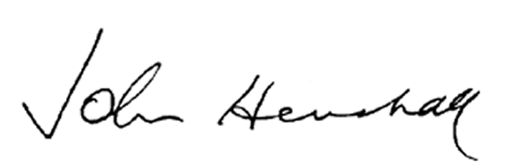

John Henshall
Founding Partner
Essential Economics Pty Ltd
18 November 2016
ATTACHMENT:
John Henshall CV

