Broadmeadows PUblic engagement outcomes report summary

context

The Greater Broadmeadows Framework Plan is being led by the Victorian Planning Authority (VPA), in collaboration with Hume City Council and other key State Government departments and agencies, and stakeholders. The Framework Plan will implement the objectives set out within Plan Melbourne, Melbourne’s metropolitan planning strategy.
By 2051 Melbourne’s population is set to increase by 3.5 million, to be a city of around 8.0 million people. To accommodate this growth, an additional 1.7 million dwellings and 1.7 million new jobs will need to be created. Growth of this scale requires long-term planning and management to maintain Melbourne's status, as one of the most liveable cities in the world.

The VPA's role is facilitating the required land supply, and identifying opportunities to increase housing, employment and investment across Melbourne and the regions within Victoria.

Purpose
Phase 1 of public engagement for the Greater Broadmeadows Framework Plan has been completed. This phase was used to test preliminary ideas and help formulate future land use, development and infrastructure planning. This report summarises the activities undertaken, the feedback received and how the feedback will be used in shaping the Framework Plan.

The vision for Greater Broadmeadows, and the sub-precincts, was the focus for the conversation about the future of the area. The VPA and Hume City Council presented four key ideas. Feedback was gained via surveys, drop-in sessions and stakeholder conversations.

The feedback provided was generally positive, with a majority of responses supporting the need for renewal in the Greater Broadmeadows area. This has provided the VPA and Hume City Council with a strong basis from which to proceed with the drafting of the Framework Plan. It generally builds on the community consensus about the approach set out in the Broadmeadows Structure Plan, completed and adopted by the Council in 2012.

Engagement Program and Activities

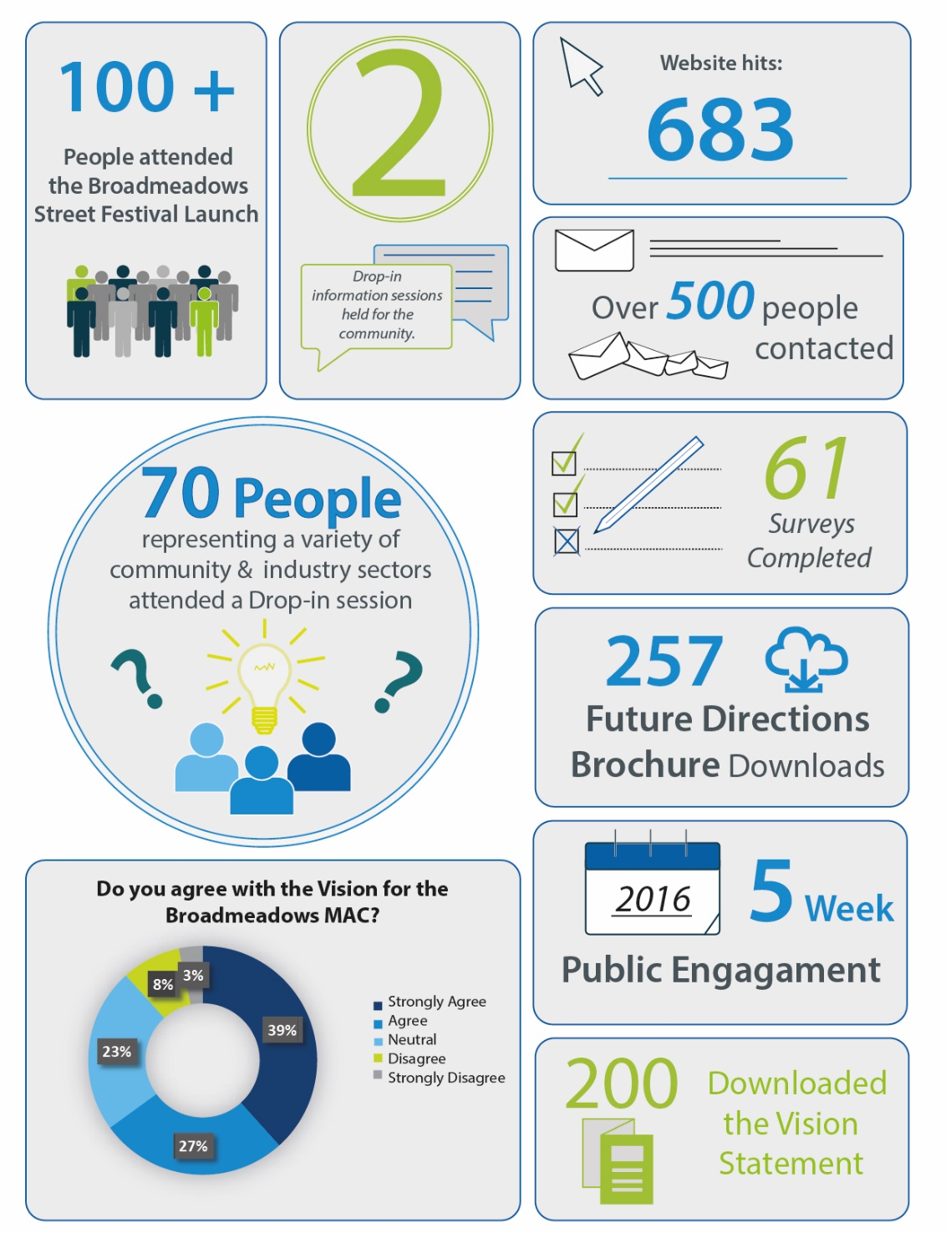

summary of feedback
Vision
Overwhelmingly, those surveyed identified ‘Making Broadmeadows a good place to work and do business’ as one of the most important principles for Broadmeadows’ future. There was a view expressed by survey participants that Broadmeadows has a lot of unrecognised or underutilised potential in this area, and that more should be done in order to invest in Broadmeadows’ commercial future.
Comments included:
- “The vision is taking too long to realise.”
- “I believe it is a great idea, although I hope the process of the project is quicker. And make the area cleaner, and a better place to be surrounded in.”
- “Melburnians have a biased opinion about Broadmeadows as the home for the poor, the unemployed and the trouble makers, which I don't think is correct, and hope that this will be changed one day.”
- “Every one of the four key moves are vital for the success of Broadmeadows as the capital of the north and should be strategically prioritised to gain the most out of the project.”
- “Fantastic to see the potential of Broadmeadows could be reached.”

jobs
A majority of survey participants stated that they were encouraged by Hume City Council’s redevelopment plans for the Broadmeadows Town Hall, which will create space for new professional offices and start-ups. Many suggested, however, that further investment was needed still in order to attract businesses and employers. Such investment could take the form of “simple maintenance and upkeep of key buildings”, which would act as a further incentive for businesses to trade in the local area.
Comments included:
- “The Federal, State and Local governments need to support and encourage local based employment initiatives and business start-ups to engage our local people rather than our local people being marginalized and having to travel for hours outside the municipality to obtain work.”
- “I am not sure a few dozen offices will solve unemployment problem, we need some unskilled jobs desperately.”
- “Hume needs to focus on attracting business interests to set up camp particularly around good public transport facilities.”
- “Where are the jobs going to come from, what are we transitioning to?”
- “Access to transport which is frequent and regular and runs east west and North South has to be introduced otherwise the use of private vehicles to get around will deter people being attracted to a central point.”

Housing
Survey respondents were generally very receptive to housing diversity and renewal opportunities in the Broadmeadows area. Constructive feedback was also provided on this topic, with many respondents commenting that while diverse housing options were important for the future of Broadmeadows, there also needed to be a focus on ensuring such housing options were of a high-quality design standard. This would seek to further enhance Broadmeadows’ amenity and overall appeal.
Comments included:
- “Diverse housing options just another excuse for poor quality housing.”
- “My concerns are for many residents here who will still have housing and employment problems due to their lack of education and financial situations.”
- “The housing trend is disturbing, the view of housing and streets is not pleasing to the eye and radicalisation needs to addressed.
- “More high density residential.”
- “I would be wary of too much public housing given Broadmeadows ‘poverty’ status. We need to lift our prospects and image.”

amenity
Numerous comments were made about the lack of activity and suggested a range of new facilities, such as an arts precinct, and a livelier night life in the heart of Broadmeadows. The redevelopment of the Town Hall within Hume Central was supported and seen as a way to expand business opportunities and activities with the town centre.
Comments included:
- “At this current moment people only go to Broadmeadows for things such as work, shops or basketball but these future plans will make it a safer place and a place people would like to visit.”
- “More youth sporting centres and recreational activities needed to prevent youth mindlessness & unsocial activities.”
- “More night life would greatly enhance business and employment opportunities.”
- “More youth sporting centres and recreational activities needed to prevent youth mindlessness & unsocial activities.”
- “We require an Arts precinct, a venue similar to the Clock tower.”
- “Broadmeadows needs some sort of night life... As it seems the moment the sun goes down... Broadmeadows shuts off.”
- “Culture and entertainment sadly lacking.”
- “More trees and stuff for us to walk around and have fun.”
- “I agree that Broadmeadows needs to be a more inclusive environment, which is greener and less industrialised.”

next steps
Figure 5 – Process and Next Steps

