Public Engagement Outcomes Report

Greater Broadmeadows
December 2016

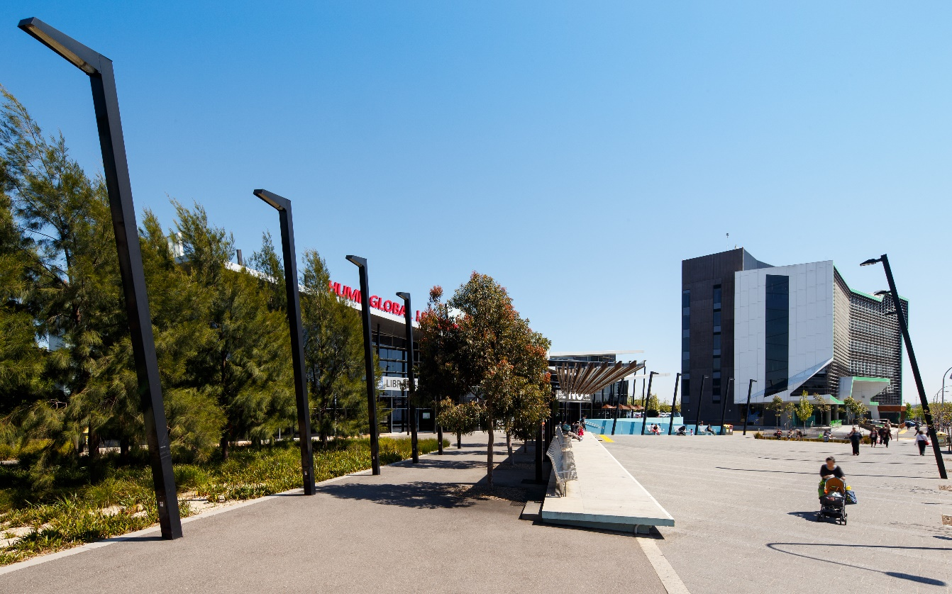
CONTENTS
1 Executive Summary 3
2 Introduction 4
2.1 Purpose 4
2.2 Report Structure 4
3 Project overview: Planning for Greater Broadmeadows 5
3.1 Context 5
3.2 Plan Melbourne Refresh 5
3.3 Greater Broadmeadows Framework Plan 6
4 Engagement Approach 9
4.1 Phase 1 Engagement: Vision, Principles & Key Ideas 9
4.2 Phase 2 Engagement: draft Framework plan 9
4.3 Summary of Results 9
5 Engagement Program and Activities 11
5.1 Shape Victoria 11
5.2 Notification and Advertising 12
5.3 Broadmeadows Street Festival 12
5.5 Surveys 12
5.6 Roxburgh College Secondary School Visit 12
5.7 Ongoing stakeholder engagement 13
5.8 Culturally & Linguistically Diverse Communities 14
6 Feedback & Outcomes 15
6.1 What we Learnt 15
6.2 Vision 15
6.3 The Four Key Moves 17
6.4 How the feedback will be used in the Framework Plan 25
7 Process and Next Steps 26

Figures
Figure 1 - Summary of Public Engagement Activities 3
Figure 2 – Metropolitan Context Plan 5
Figure 3 – Survey Participants Relationship to the Cluster 13
Figure 4 – Vision Survey Results 16
Figure 5 – Process and Next Steps 26

Tables

Table 1 – Public Engagement Participation Table 3
Table 2 – Public Engagement Participation Table 11

Executive Summary
Phase 1 of public engagement for the Greater Broadmeadows Framework Plan has been completed. This phase was used to test preliminary ideas and help formulate future land use, development and infrastructure planning for Greater Broadmeadows. This report summarises the activities undertaken, the feedback received and how the feedback will be used in shaping the Framework Plan.
The vision for Greater Broadmeadows, and the sub-precincts identified in the Framework Plan, was the focus of the conversation for the future of the area.
The VPA and Hume City Council presented four key ideas to be explored in the preparation of a Framework Plan for Greater Broadmeadows. Feedback was gained via surveys, drop-in sessions and stakeholder conversations.
The feedback was generally positive, with a majority of responses supporting the need for renewal in the Greater Broadmeadows area.
This has provided the VPA and Hume City Council with a strong basis from which to proceed with the drafting of the Framework Plan. It generally builds on the community consensus about the approach set out in the Broadmeadows Structure Plan, completed and adopted by the Council in 2012.

Of the 59 people who responded to the survey, there were several recurring themes:
- Overwhelmingly, those surveyed identified making Broadmeadows a good place to work and do business as one of the most important principles for Broadmeadows’ future.

- A majority of survey participants stated that they were encouraged by Hume City Council’s redevelopment plans for the Broadmeadows Town Hall, which will create space for new professional offices and start-ups.

- Survey respondents were generally very receptive to housing diversity and renewal opportunities in the Broadmeadows area. Constructive feedback was also provided on this topic, with many respondents commenting that while diverse housing options were important for the future of Broadmeadows, there also needed to be a focus on ensuring such housing options were of a high-quality design standard.

- There was, however, concern about the affordability of housing – both in how to retain its affordability, and how to ensure that affordability does not equate to poor design.

- Numerous comments were made about the lack of activity and suggested a range of new facilities, such as an arts precinct, and a livelier night life in the heart of Broadmeadows.
A number of submissions commented on the existing poor transport connections (in terms of both cars and buses), and sought improvements to bus reliability and the upgrading of the Broadmeadows Railway Station.

Table 1 – Public Engagement Participation Table

Date | Public Engagement Activity | No. of Participants
2 April 2016 | Shape Victoria online portal launched | 683 visits
2 April 2016 | Launch of Consultation at Broadmeadows Street Festival | 100+ attendees
2 April - 31 May 2016 | 'Have your say' survey | 61 responses
2 April - 31 May 2016 | Downloads of Vision statement | 200
2 April - 31 May 2016 | Downloads of Future Directions Brochure | 257
20 April 2016 | Drop-in session at Hume Global Learning Centre | 20 attendees
2 May 2016 | Visit to Roxburgh Park Secondary School for presentation to senior Geography students | 30 attendees
4 May 2016 | Drop-in session at Hume Global Learning Centre | 50 attendees

Figure 1 - Summary of Public Engagement Activities

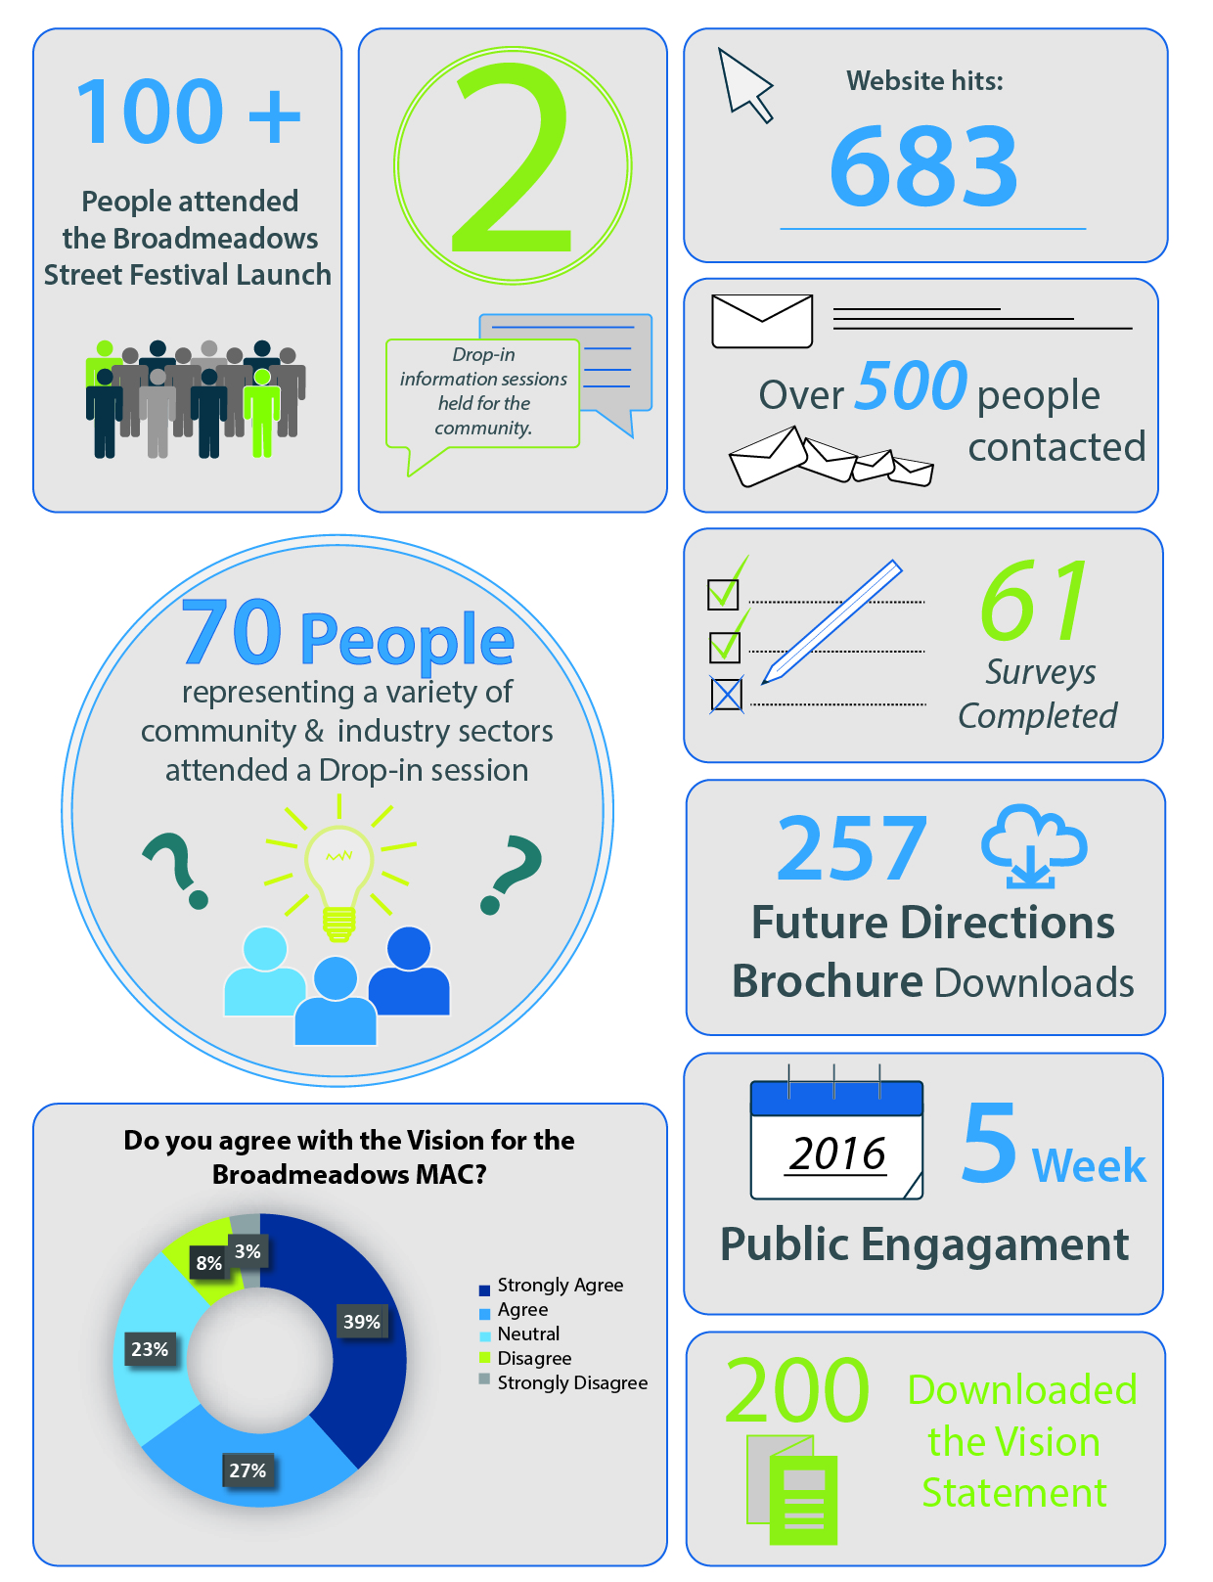

Introduction

Purpose
This Public Engagement Outcomes Report summarises the feedback received from public engagement on the draft Vision, Principles & Key Ideas for the Greater Broadmeadows Framework Plan.
Finally, you may notice our organisation is now known as the Victorian Planning Authority (VPA). The VPA has succeeded the Metropolitan Planning Authority (MPA) and continues to progress projects in key precincts such as Greater Broadmeadows. For further information see: http://www.premier.vic.gov.au/planning-for-smart-growth-across-victoria/

Report Structure
This report is arranged in four sections, as follows:
Section 3: Project Overview, providing an overview of the context in which the public engagement has taken place, including the main policy drivers and why a plan is required.
Section 4: Engagement Activities, providing an overview of the engagement program and activities for the project.
Section 5: Feedback & Outcomes, summarising stakeholder feedback received on the draft Vision, Principles and Key Ideas being out forward for the Greater Broadmeadows Framework Plan.
Section 6: Next Steps, addressing how the feedback and input will be carried forward.

Project overview: Planning for greater broadmeadows

Context
The Greater Broadmeadows Framework Plan is being led by the Victorian Planning Authority (VPA), in collaboration with Hume City Council and other key State Government departments, and stakeholders. The Framework Plan will implement the objectives set out within Plan Melbourne, Melbourne’s metropolitan planning strategy.
By 2051, Melbourne’s population is set to increase by 3.5 million, to be a city of around 8 million people. To accommodate this growth, an additional 1.7 million dwellings and 1.7 million new jobs will need to be created. Growth of this scale requires long-term planning and management to maintain Melbourne's status as one of the most liveable cities in the world. The VPA's role is facilitating the required land supply, and identifying opportunities to increase housing, employment and investment across Melbourne and Victoria’s regional towns and cities.
Figure 2 – Metropolitan Context Plan
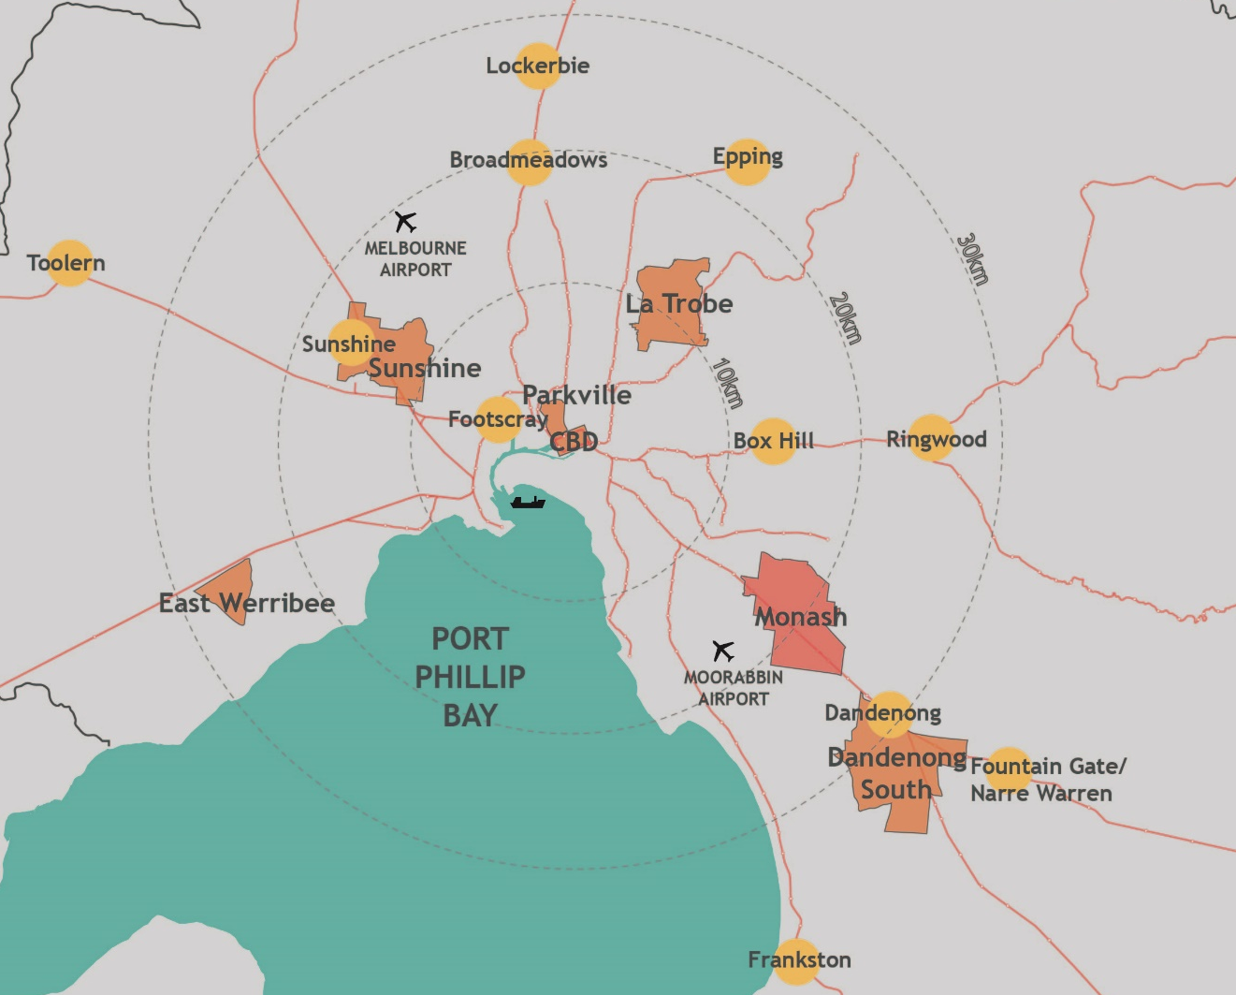

Plan Melbourne Refresh
Plan Melbourne Refresh is a 35-year plan for integrated land use, infrastructure and transport investment in metropolitan Melbourne. It focuses on delivering the required housing, jobs and services needed to support Melbourne’s projected growth while maintaining our quality of life for the future.

Plan Melbourne encourages new jobs closer to where people live, especially in Metropolitan Activity Centre’s (MAC’s) and employment clusters. Broadmeadows Town Centre is a Metropolitan Activity Centre – the highest order centre outside the Melbourne CBD.
Broadmeadows’ location, 15 kilometres to the northwest of Melbourne’s CBD and on the doorstep of the Hume growth corridor, positions it for a great future in the polycentric city. Together with the La Trobe National Employment Cluster in the north-east and Epping Metropolitan Activity Centre in the north, it completes a triangle of centres of influence in the northern suburbs of Melbourne.
In terms of transport links, Broadmeadows is adjacent to the M80 Freeway and located on the metropolitan and regional rail network. It is 5km from both Melbourne International Airport Essendon Airport.
Another key idea in Plan Melbourne is the 20-minute city. For people living in Broadmeadows, this means the ability to meet every day (non-work) needs locally, primarily within a 20-minute walk.

greater broadmeadows Framework Plan
Greater Broadmeadows has the building blocks to truly become Melbourne’s capital of the North-west – a powerhouse for new housing, jobs and businesses. The renewal of Broadmeadows is a priority for the Victorian Government.
It boasts a range of important government services, private sector businesses and is nestled in between highly valued recreational space and creek corridors that are under-utilised.
Many key public and private projects have recently been completed. And some welcome investment is coming to Broadmeadows.
The Victorian Government has provided funding for many projects in Broadmeadows in recent years including the Global Learning Centre, Hume School Regeneration project and funds towards the state of the art basketball stadium and aquatic centre.
In recognition of the ongoing need for renewal and future opportunities the Victorian Government in the 2015/2016 Budget has provided $14.3 million to:
- Redevelop Broadmeadows Town Hall
- Works to Broadmeadows Train Station
- Transforming Pascoe Vale Road into an urban boulevard
- Works to Meadowlink
Substantial landholdings – including industrial areas in Eastmeadows and Northmeadows and redevelopment sites in the Broadmeadows Town Centre – will provide the opportunity for a major transformation to bolster the local economy, generate jobs and activate Hume Central.
To realise its full potential, Broadmeadows now needs a plan for urban renewal that:
- generates jobs and attracts investment
- creates greater housing choice and regenerates public areas
- maintains housing affordability
- provides better transport connections for a growing population
- revitalises the heart of Broadmeadows
- improves and greens local places for residents and businesses
- delivers new mixed-use precincts revitalising industrial and former government land
- creates a better connected 20-minute city to improve the liveability of Broadmeadows
- builds resilience and develops environmental sustainability in the Broadmeadows community.
The Greater Broadmeadows Framework Plan is being prepared to help guide future land use, development and infrastructure planning to support job growth in the cluster. The Framework Plan will be a high-level planning tool that sets directions for preparation of more detailed localised plans.
The Framework Plan will:
- identify a future Vision and Principles for Greater Broadmeadows
- guide sustainable future growth and development over the next 30 years
- define key projects, areas for change and infrastructure requirements to support growth
- provide greater certainty for public and private investment in Greater Broadmeadows.

Engagement Approach
The VPA has devised a two-phase approach to public engagement for the Greater Broadmeadows Framework Plan.

Phase 1 Engagement: Vision, Principles & Key Ideas
The objectives of Phase 1 were to:
- seek feedback on the Vision for the Framework Plan
- test the key moves for delivery of the Vision and Principles including opportunities for new ideas and suggestions
- build understanding of the opportunities for urban renewal.
- offer an opportunity to contribute and influence the direction of the draft Greater Broadmeadows Framework Plan.
The feedback gathered from Phase 1 will help develop the Framework Plan further and highlight elements requiring more investigation.

Phase 2 Engagement: draft Framework plan
The objectives of Phase 2 public engagement will be to:
- Seek comments and submissions from stakeholders, agencies and the public on the draft Greater Broadmeadows Framework Plan.
- Exhibit planning scheme amendments to support the implementation of some of the short-term actions in the Greater Broadmeadows Framework Plan.

Summary of Results
The feedback provided through the online survey was generally positive, with a majority of responses supporting the need for renewal in the Greater Broadmeadows area.
One of the key findings was the support that was expressed for the proposed vision for the Greater Broadmeadows Framework Plan. Sixty-six percent of respondents either strongly agreed or agreed with the vision. Eleven percent either disagreed or strongly disagreed, with the remainder being neutral.
“I think it would be fantastic to see the potential of Broadmeadows reached and hopefully exceeded given its proximity to the Melbourne CBD and the future growth of the North.”
Another key finding was the strong support (82%) for the development of Hume Central into a lively destination with a mix of uses – to be the heart of the Broadmeadows Town Centre.
“Broadmeadows needs some sort of night life... As it seems the moment the sun goes down... Broadmeadows shuts off... this implies to lack of business operations after night... for example a decent place where you could eat out …”

Engagement Program and Activities
Table 2 – Public Engagement Participation Table
Date | Public Engagement Activity | No. of Participants
2 April 2016 | Shape Victoria online portal launched | 683 visits
2 April 2016 | Launch of Consultation at Broadmeadows Street Festival | 100+ attendees
2 April - 31 May 2016 | 'Have your say' Survey | 61 responses
2 April - 31 May 2016 | Downloads of Vision statement | 200
2 April - 31 May 2016 | Downloads of Future Directions Brochure | 257
20 April 2016 | Drop-in session at Hume Global Learning Centre | 20 attendees
2 May 2016 | Visit to Roxburgh Park Secondary School for presentation to senior Geography students | 30 attendees
4 May 2016 | Drop-in session at Hume Global Learning Centre | 50 attendees

Shape Victoria
Shape Victoria is the online communication and engagement platform used by the VPA for engagement on the Greater Broadmeadows Framework Plan. It also provides information and resources regarding the Greater Broadmeadows Framework Plan maps, descriptions, event information, project updates and background reports.
The webpage went live on the 2 April, 2016, signalling the beginning of the 8-week public engagement process (2 April – 31 May 2016). During the public engagement process the project page within Shape Victoria received 683 hits, with 45% of users frequenting the webpage more than once. The webpage allows users to engage with a range of material that will inform and provide details of what is proposed for Greater Broadmeadows.
Shape Victoria offered users access to:
- information brochure, maps and presentations on the Greater Broadmeadows Framework Plan
- upcoming event information
- background documents and reports
- ‘Have your say!’ survey
- project timeline
- an extensive list of FAQ’s
- useful links to external resources such as other State and Local Government websites
- key contact information
- updates about activities completed
Over the 8-week public engagement period:
- 200 stakeholders downloaded the Vision Statement
- 257 downloaded the Future Directions Brochure

Notification and Advertising
Notification of the consultation was advertised in the local press and stakeholders who had been involved with the Broadmeadows Structure Plan preparation by Council were emailed.

Broadmeadows Street Fesitval
On 2 April 2016 the VPA, in conjunction with Hume City Council, launched the Greater Broadmeadows Framework Plan consultation at the Broadmeadows Street Festival.
Over 100 people dropped in to the display tent to discuss the proposed Framework Plan.
At the event VPA and Council staff were on hand to discuss the Key Moves, with attendees supported by displays and information brochures. ‘Have your say!’ surveys were provided to all those who attended.

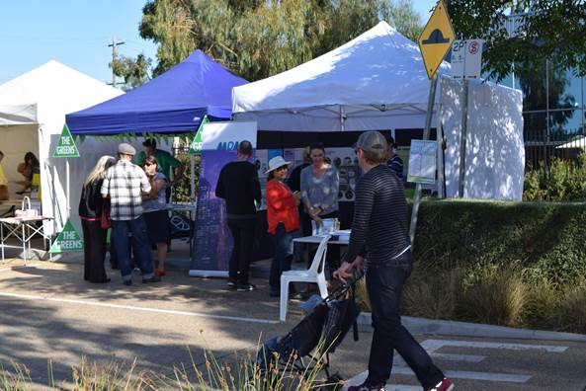

Greater Broadmeadows Framework Plan Launch – 2 April 2016 at the Broadmeadows Street Festival Seminar

DROP-IN SESSIONS
The VPA, in partnership with Hume City Council, ran two drop-in sessions for local residents, landowners and business (owners and employees) after hours on 20 April and 4 May 2016. Approximately 70 people attended the two sessions, and engaged the VPA and council staff in discussions about the ideas put forward in the four key moves, and the process to finalise the preparation of the framework plan.

Survey
The ‘Have your say!’ survey was the primary form for giving feedback adopted by stakeholders during the process and was available online and in hard copy. The survey was designed to give stakeholders the opportunity to provide feedback in a quick, simple, but meaningful fashion to aid the development of the draft Framework Plan.
There were a total of 61 survey respondents from industry, workers, students, residents and visitors within the Greater Broadmeadows area. The majority of responses were from people who live, work or own a business in Greater Broadmeadows as noted in Figure 3 below.

Roxburgh College Secondary School

The VPA presented the draft Greater Broadmeadows Framework Plan material to senior geography students at Roxburgh College.

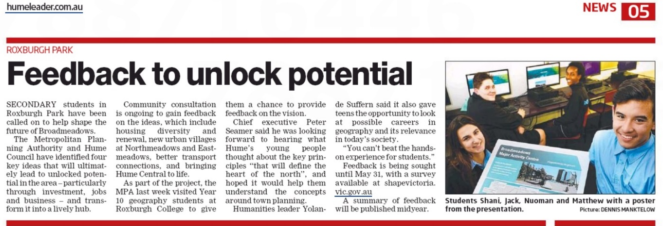

Figure 3 – Survey Participants Relationship to the Cluster

Ongoing stakeholder engagement
The VPA will continue to work collaboratively with stakeholders on developing the ideas for the Framework plan, and a range of key strategic sites and projects within Greater Broadmeadows.
It is anticipated that a further round of consultation on the Greater Broadmeadows Framework Plan and a number of amendments to the Hume Planning scheme supported by the Framework Plan will be undertaken in early 2017.

Culturally & Linguistically Diverse Communities
Translation services were made available in the 10 identified primary languages of the area. All information provided to the public for the Greater Broadmeadows draft Framework Plan were made digitally and graphically accessible for screen readers and the colour blind, and in downloadable in various formats (both PDF & Word DOC).
There were no requests for translation services made during the public engagement period.

Feedback & Outcomes

What we Learnt
Participation in the eight-week engagement period in the ‘Have your say!’ surveys and general discussions with stakeholders at drop in sessions has helped the VPA to develop a better understanding of issues with many participants offering up ideas for what should be done to achieve the Greater Broadmeadows Vision.

Vision
The Vision proposed for Greater Broadmeadows is:

“Broadmeadows will fulfil its destiny as the capital of Melbourne’s northwest – a centre for services, business, culture and entertainment.”
Figure 4 – Vision Survey Results

The survey results show that the majority of respondents either agreed or strongly agreed with the vision statement. However, a number strongly disagreed.
A range of feedback comments were received including the following:
- “The vision is taking too long to realise.”
- “Broadmeadows should be cleaner and safer.”
- “Quality services and community facilities go a long way to building the community.”
- “Culture and entertainment sadly lacking.”
- “Diverse housing options just another excuse for poor quality housing.”
- “Fantastic to see the potential of Broadmeadows could be reached.”
- “I think to be a "centre" of anything, a place has to offer new answers or solutions, so that it attracts people not just because it's the only place I could buy a house, or find a job but it's the place where I can function to live and grow, raise a family, participate in a community and feel recognised within it.”
- “My concerns are for many residents here who will still have housing and employment problems due to their lack of education and financial situations.”
- “Services yes business not sure and culture and entertainment surely not. Yogurt has more culture than Broadmeadows.”
- “Make a better basketball stadium and build up the shopping centre.”
- “I believe it is a great idea, although I hope the process of the project is quicker. And make the area cleaner, and a better place to be surrounded in.”
- “At this current moment people only go to Broadmeadows for things such as work, shops or basketball but these future plans will make it a safer place and a place people would like to visit.”
- “There should be more cameras at night because of the criminals.”
- “Hume needs to focus on attracting business interests to set up camp particularly around good public transport facilities.”

Overwhelmingly, those surveyed identified “Making Broadmeadows a good place to work and do business” as one of the most important principles for Broadmeadows’ future. There was a view expressed by survey participants that Broadmeadows has a lot of unrecognised or underutilised potential in this area, and that more should be done in order to invest in Broadmeadows’ commercial future.

The four key moves
The four key moves that were the focus of the consultation drew a range of comments and ideas form survey respondents. There were a range of responses on what ideas were the most important to the respondent.

A range of feedback comments were received including the following:
- “To me the question is really not which options are most important, but which options do the people in this project really have influence over.”
- “We require an Arts precinct, a venue similar to the Clock tower.”
- “Broadmeadows needs some sort of night life... As it seems the moment the sun goes down... Broadmeadows shuts off.”
- “Diverse housing is a killer! What you actually mean is cheap stock for a cheap and poor area!”
- “Every one of the above aspects are vital for the success of Broadmeadows as the capital of the north and should be strategically prioritised to gain the most out of the project.”
New Urban Villages at Northmeadows/Eastmeadows

In line with the policy directions contained in Plan Melbourne Refresh, it is anticipated that diversifying housing options will be a key strategy in the future renewal of residential areas within the catchment of the Broadmeadows Metropolitan Activity Centre. Some of these areas (such as in Northmeadows and Eastmeadows) will undergo major urban regeneration; other areas will see incremental and low key changes over time.

Respondents also had ideas for what could be done with under-utilised or vacant land. With the suburb moving on from its industrial roots, there was recognition that creating “greener” spaces would help improve the overall “look and feel” of the suburb. In particular, this would involve transforming vacant lots – such as the former Goulburn Street Swim Centre – into community gardens or open green spaces for residents to enjoy. Another potential use, participants suggested, would be to create a community environment park, modelled on CERES in East Brunswick. This would serve as a place for school children to learn about sustainability and different cultures.

Better Connecting People to Places in Broadmeadows

A number of submissions commented on the existing poor transport connections (in terms of both cars and buses), and sought improvements to bus reliability and the upgrading of the Broadmeadows Railway Station.

Bringing Hume Central to life

Numerous comments were made about the lack of activity and suggested a range of new facilities, such as an arts precinct, and a livelier night life in the heart of Broadmeadows. The redevelopment of the Town Hall within Hume Central was supported and seen as a way to expand business opportunities and activities with the town centre.

A majority of survey participants stated that they were encouraged by Hume City Council’s redevelopment plans for the Broadmeadows Town Hall, which will create space for new professional offices and start-ups. Many suggested, however, that further investment was needed still in order to attract businesses and employers. Such investment could take the form of “simple maintenance and upkeep of key buildings” which would act as a further incentive for businesses to trade in the local area.

Housing Diversity and Renewal
Survey respondents were generally very receptive to housing diversity and renewal opportunities in the Broadmeadows area. Constructive feedback was also provided on this topic with many respondents commenting that while diverse housing options were important for the future of Broadmeadows, there also needed to be a focus on ensuring such housing options were of a high-quality design standard. This would seek to further enhance Broadmeadows’ amenity and overall appeal.

There was however concern about the affordability of housing – both in how to retain its affordability, and how to ensure that affordability does not equate to poor design.

Is there anything else you would like to add about what is needed for more jobs and growth in Broadmeadows?

A range of feedback and comments were offered, including the following:

- “The housing trend is disturbing, the view of housing and streets is not pleasing to the eye and radicalisation needs to addressed.”
- “Melburnians have a biased opinion about Broadmeadows as the home for the poor, the unemployed and the trouble makers, which I don't think is correct, and hope that this will be changed one day.”
- “More youth sporting centres and recreational activities needed to prevent youth mindlessness & unsocial activities.”
- “More night life would greatly enhance business and employment opportunities.”
- “I am not sure a few dozen offices will solve unemployment problem, we need some unskilled jobs desperately.”
- “The Federal, State and Local government need to support and encourage local based employment initiatives and business start-ups to engage our local people rather than our local people being marginalized and having to travel for hours outside the municipality to obtain work.”
- “More places for kids to play and feel safe.”
- “More high density residential.”
- “More trees and stuff for us to walk around and have fun.”
- “I agree that Broadmeadows needs to be a more including environment, which is greener and less industrialised.”
- “I would be weary of too much public housing given Broadmeadows "poverty" status we need to lift our prospects and image.”
- “Access to transport which is frequent and regular and runs east west and North South has to be introduced otherwise the use of private vehicles to get around will deter people being attracted to a central point.”
- “Where are the jobs going to come from, what are we transitioning to?”

How the feedback will be used in the Framework Plan
Feedback received from the Phase 1 Public Engagement process will be used to inform and test the proposed Vision, Principles and Key Ideas for the draft Greater Broadmeadows Framework Plan. Feedback received during the 8 week public engagement process will form a basis to further develop the future directions and actions within the Framework Plan.
We have heard that the following issues are important to respondents:
- Better and upgraded public transport connections and facilities are needed.
- Diverse housing and urban renewal needs to be carefully managed, however the potential of Broadmeadows can be realised by encouraging housing diversity.
- The broadening of the city’s cultural and community facilities should be a key factor in the growth of Broadmeadows.
- Local jobs are important to creating a well-rounded community.

Process and Next Steps
The preparation of the Greater Broadmeadows Framework Plan is proposed to progress from the current stage ‘Public Engagement Phase 1’ to formulating the draft plan for further engagement in 2017 as outlined in the process to date. The key steps in the process are outlined below in Figure 5.

Figure 5 – Process and Next Steps

Appendices

Appendix 1
Greater Broadmeadows ‘Have Your Say’ Survey

What is your relationship with Broadmeadows (select more than one if applicable)
- Student
- Worker
- Resident
- Visitor
- Ratepayer
- Business
- Please tell us what you think of the following vision for Greater Broadmeadows:
Broadmeadows will fulfil its destiny as the capital of Melbourne’s north – a centre for services, business, culture and entertainment.
________________________________________________________________________________________________________________________________________________________________________________________________________________________
- Is there anything else you would like to add about this vision for Greater Broadmeadow?

- In order for Greater Broadmeadows to live up to this vision which of the following is most important? (Please tick a box)
- Making Broadmeadows a good place to work and do business
- Creating diverse new housing options
- Making Hume Central a regional destination for shopping, dining, and civic and cultural events
- Improving public transport and the ability to move in and around Broadmeadows
- Is there anything else you like to say anything more about any of these four key ideas?
_____________________________________________________________________________________________________________________________________________________________________________________________________________________
What is your view on the following statements?
- Opening up new areas for jobs and housing on underutilised land will help grow Broadmeadows.
- Strongly agree
- Agree
- Neutral
- Disagree
- Strongly disagree
- Broadmeadows needs more diverse social and private housing options.
- Strongly agree
- Agree
- Neutral
- Disagree
- Strongly disagree

- Hume Central should have a mix of great public spaces, new offices and entertainment options
- Strongly agree
- Agree
- Neutral
- Disagree
- Strongly disagree

- It is difficult to move from the east to the west of Broadmeadows by road, cycle or as a pedestrian.
- Strongly agree
- Agree
- Neutral
- Disagree
- Strongly disagree

Thanks you taking the time to fill out this survey. Is there anything you would like to add about what is needed for more jobs and growth in Broadmeadows?
_____________________________________________________________________________________________________________________________________________________________________________________________________________________

