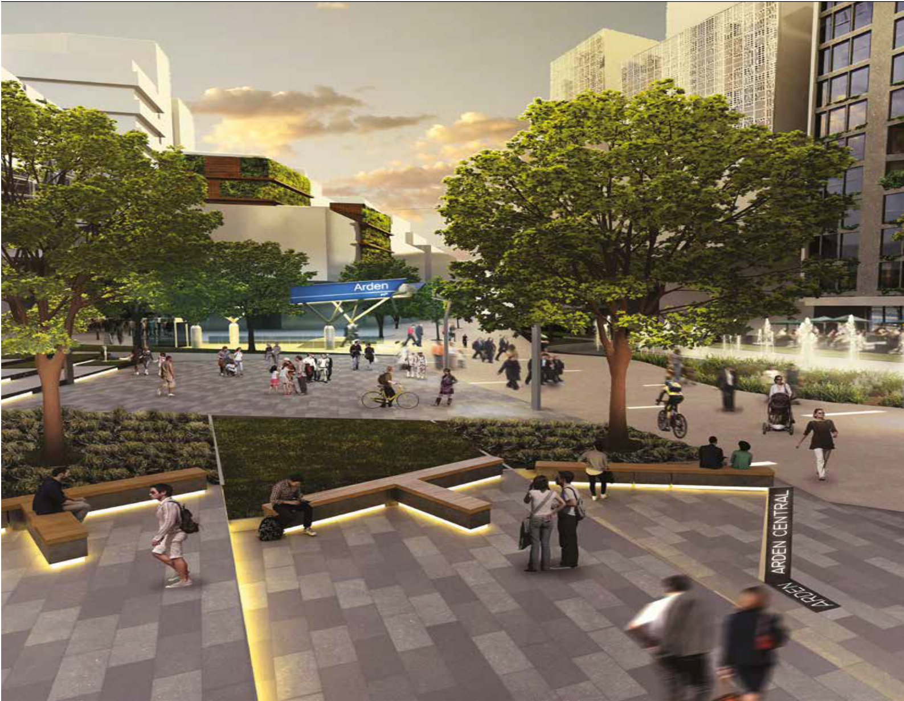












Business Plan
2016/17

partners in planning and infrastructure coordination

Contents
ii

Mission and values | 1
Introduction | 2
Members of the Authority | 4
Chief Executive Officer: Summary of primary priorities | 5
Overview of VPA’s work program | 8
Delivering on our objectives | 10
Key performance measures for 2016/17 | 12
Our organisation | 14
Our resources | 16
Our prioritised annual work program | 17

Cover image: Artist’s impression of new civic heart of Arden Central.

© State of Victoria, Victorian Planning Authority 2016. This publication is copyright. No part may be reproduced by any process except in accordance with the provisions of the Copyright Act 1968.

Disclaimer

This publication may be of assistance to you but the State of Victoria and its employees do not guarantee that the publication is without flaw of any kind or is wholly appropriate for your particular purposes and therefore disclaims all liability for any error, loss or other consequence which may arise from you relying on any information in this publication.

Mission and values

Mission of the Victorian Planning Authority
To set the vision and to undertake integrated land use and infrastructure planning in priority places and to be an active partner in ensuring Victoria’s affordable, sustainable and liveable new communities are of the highest international standard.

Values and behaviours of the Victorian Planning Authority
In all its work, the Victorian Planning Authority demonstrates the following values and behaviours:

Value | Behaviours
Leadership | We provide clarity and certainty, develop new and innovative solutions to problems, provide authoritative advice and lead by example to get things done and make a positive difference.
Partnership | We work in collaboration with our stakeholders through genuine consultation, sharing of information, and harnessing their expertise and resources.
Professionalism | We act with honesty and openness, are accountable for our actions and are respected for our expertise and high quality and balanced advice.
Responsiveness | We are aware of the needs of our stakeholders and strive to provide a high level of service and advice at all times.

Introduction

Minister for Planning

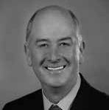
During the last election, the Victorian Government pledged to
boost jobs and development
in Victoria’s many wonderful regional cities and towns. The newly established Victorian Planning Authority (VPA) will be charged with doing just that. The VPA has an important role to play in planning
for future growth, setting Victoria’s foundations for the next 40 years, in conjunction with the vital ongoing commitment of local government.
The VPA will have a major role in providing expert advice to me on matters that are relevant to the implementation of Plan Melbourne, Regional Growth Plans and maintaining Victoria’s well-earned reputation for liveability. The VPA will continue its past work as the Metropolitan Planning Authority and Growth Areas Authority by expanding its strategic planning activities into Victoria’s regions.
As a statutory authority reporting to me, the VPA works in partnership with the Department of Environment, Land, Water and Planning, other Government agencies and local councils. It plans for the future in accordance with the objectives at section 46AR of the Planning and Environment Act 1987.
One of the Government’s main areas of focus for planning in the coming years will be housing affordability, economic growth, and job creation across Victoria. To help the Government achieve these outcomes, the VPA will undertake integrated land use and infrastructure planning in priority areas across the state. One of the ways the VPA will do this is by ensuring the State’s key infrastructure needs are planned for effectively.

The Victorian economy continues to grow, and the Government wants to ensure that regional Victoria benefits from this growth. To assist with planning for growth across the
State, the Government has launched the major Smart Planning reform program. This new program will unlock investment and create jobs through
an integrated and comprehensive package of reforms to modernise Victoria’s planning system.
It will make planning rules simpler and more accessible for industry, businesses and the community; improve confidence and trust in
planning processes and create a more efficient system. The changes will introduce new technology to facilitate clear, interactive communication between regulators, decision
makers and the community.

The VPA is delivering our Streamlining for Growth Program (2016/17), this program will provide support and capacity-building for Victorian councils. With a program budget of $4.1 million, the VPA will provide targeted funding and staff resources to selected projects which meet program criteria.
The program’s targeted funding and assistance will help build capacity in councils to unblock strategic
planning system delays and speed up projects that will result in employment growth and/or increased housing choice and affordability. In regional Victoria this will include providing planning support for strategic growth projects, by working closely with councils to implement the eight Regional Growth Plans. To deliver this, the VPA has been allocated an additional $2.15 million in funding.
In Melbourne, funding of $2 million will be directed to support the planning
of strategic sites in the metropolitan area, and help growth corridor councils overcome planning backlogs.

The VPA will continue to advise me about key infrastructure funds that cater to Melbourne’s booming growth areas. This includes the VPA’s ongoing roles in relation the two Growth Areas Infrastructure
Contribution funds, the Building New Communities Fund and the Growth Areas Public Transport Fund.
The VPA continues to have housing affordability and design quality at the heart of its planning and infrastructure coordination activities. Identifying strategically important places for growth across Melbourne will have a positive impact on housing affordability.
In growth areas planning has also had a significant effect on housing affordability, maintaining median lot prices below levels seen in 2011.
In the past 12 months, the VPA enhanced its community engagement activities, sparking two-way conversations with stakeholders, government agencies and communities. Its new engagement portal, Shape Victoria, and the launch of the VPA website, provide a more transparent way for the community to access information and to have a say.
Finally, I have requested that the Board of the VPA focus on the organisational transition to the new VPA the Government is committed to creating in 2017.
The program, as outlined in the VPA’s 2016/17 Business Plan, is broad and very exciting, and I am confident the Authority will liaise closely with all stakeholders to make Melbourne and greater Victoria an even better place to live and work.

The Hon. Richard Wynne MP Minister for Planning

Acting Chair’s Message


The creation of the new Victorian Planning Authority (VPA) is one of the most substantial reforms in
Victorian Planning history.

It establishes a new Statutory Authority charged with the role of undertaking integrated land use and infrastructure planning across our State as directed by the Minister for Planning from time to time. A clear focus of the VPA’s
role will be to deliver on housing affordability, economic growth and job creation. One of the most significant challenges for the new authority is
to transition itself to prepare for the proposed new entity expected on the 1st July 2017.
The Board along with the Executive are now clearly focused on preparing a transition plan which will incorporate a due diligence plan, a people management plan, a change management plan, a risk management plan and a stakeholder engagement and collaboration plan. This work
will provide a clear direction on how the Authority needs to engage, consult and establish systems of cooperation, and maintain strong and effective relationships with all stakeholders. This Business Plan articulates the Authority’s priorities for the year ahead, and articulates
new priorities as directed by the Hon. Richard Wynne MP, as well as those already underway. These priorities include but are not limited to:
- Supporting the implementation of
Plan Melbourne;
- Developing strategic land use plans;
- Use plans for key areas including
the Arden-Macaulay precinct and the National Employment and Innovation Clusters;
- Facilitating the implementation
plans for the Regional Growth Plans;
- Developing precincts structure plans
for the growth areas of Melbourne and Regional cities and towns.

The VPA will also work closely with the Minister and with government on the Streamlining for Growth Program 2016/17. The VPA has already prepared a detailed process for the allocation, control and measurement of the $4.1 million provided for this program to assist Local Councils to do significant planning work in their municipality.
This work is important as it will seek to unblock strategic planning system delays and speed up significant land use and development projects.
The Board has carefully reviewed the opportunities that has been placed before it and is now working on six clear governance directions, they are as follows:
- Determine the VPA strategic direction of the VPA;
- Provide oversight on the VPA corporate performance through
regularly monitoring the progress of work program all against adopted performance measures and criteria;
- Respond to directions or
statements of expectations from the Minister. The Hon. Richard Wynne MP has provided a very clear statement of expectations that he has for the VPA in this transition phase.
- The prepararation of a monitoring
reporting system against its own transition plan and importantly, it also needs to understand its role in the integrated land use process in particular the relationship with government’s new land entities so that it establishes its appropriate operating procedures and remains an accountable and transparent organisation.
- Provide leadership and direction
regarding change management and organisational transition and to guide due diligence and the transition process to ensure the organisation is ready to become the Victorian Planning Authority on the expected transition date of 1 July 2017.

In so doing the organisation
must develop and foster strategic relationships with the relevant government departments and agencies, provide oversight and monitoring of its own performance to ensure that the organisation is operating efficiently and effectively by providing clear direction on the annual performance expectations as set out in this business plan.
This plan responds to our objectives in the Planning and Environment Act 1987 and the Minister for Planning’s directions and expectations via a direction pursuant to 46AU(1) of
the Planning and Environment Act 1987, providing a comprehensive list of all the projects that the VPA will undertake in 2016/17.
The Victorian Planning Authority now has a very clear business plan. The key actions, milestones activities within it, the risk management process and the reporting framework that underpins it are all important features to deliver on the Government’s policy agenda
for planning in the state of Victoria.

I look forward to working with my colleagues and seeing the VPA continue to develop as a new strategic planning authority working with relevant Government Departments and Agencies, Regional Partnerships,
Local Government, community groups and the development industry to support delivery of this important policy agenda. In all its work the Victorian Planning Authority will need to deliver leadership, partnership, professionalism,
acting with accountability for our actions and responsiveness to our stakeholders as a service agency.

W. R. (Bill) Kuzsnirczuk Acting Chair

Members of the Authority
The VPA is overseen by a highly experienced board currently chaired by Bill Kusznirczuk, which brings together a broad range of experience in different disciplines, including planning, development, economics, board governance, organisational change, financial management, education and housing. The Authority reports to the Minister for Planning, The Hon. Richard Wynne MP. The six Authority Members were appointed by the Minister for Planning, effective from 16 August 2016 as the transitional Board under the State Owned Enterprises Act 1992.
A profile of each of the current Authority Members is set out below.

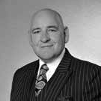
Bill Kusznirczuk (Acting Chair and Deputy Chair)
Bill Kusznirczuk is
a leading Urban and Regional Planner
in Australia.
He has extensive experience and knowledge in all aspects of planning, building, property development and how cities, rural and regional areas should look in the future. He is the founder
and Managing Director of Clement- Stone Town Planners which has a long and respected tradition of providing professional advice in these fields. Bill is sought as a regular commentator
on radio, TV and in print media.
He is the former Chair of the Building Advisory Council. Mr Kusznirczuk was appointed as the inaugural Chairman and Chief Commissioner of the Victorian Building Authority in 2013.
He is a Certified Practicing Planner and Associate Fellow of the Australia Institute of Management. Bill also brings his expertise in strategic and
business planning, project management,
stakeholder engagement, finance, risk and corporate governance. His valuable industry experience puts him at the forefront of advisors across
Australia. He also provides his valuable knowledge to the community, charities and on not-for-profit Boards.
Bill is an Australia Day Ambassador to Victoria.

Trevor Budge

Trevor Budge is the Manager of Strategy at the City of Greater Bendigo. He is an Adjunct Associate
Professor at the Bendigo campus of La Trobe University. He is a former State President of the Planning Institute of Australia and became a Member (AM) in the General Division of the Order of Australia in June 2011 for service to town planning. He was a Ministerial appointee for six years of the Victorian Catchment Management Council and is founding Board member of Victoria Walks. He has worked extensively for state, regional and local government, conducted his own consulting business for 16 years and for 12 years taught
at RMIT and La Trobe universities in planning and community development.


Jennifer Cunich
Jennifer Cunich has over 30 years experience in the business and property sectors, and is
currently the Chief Executive of the Australian Institute of Architects. She previously worked at the Property Council of Australia, first as the ACT Executive Director and since 2002 as the Executive Director at the Victorian Division. Jennifer is one of Australia’s most experienced property lobbyists and is a champion of promoting women in the property industry. She sits on the Property Council Executive Committee, the Women’s Property Initiatives Board, the Building Advisory Council and the Building Industry Consultative Council.

Brian Haratsis
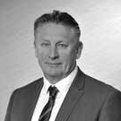
Brian Haratsis is MacroPlan
Dimasi’s founder and Executive Chairman. Brian is an economist and
future strategist with over 30 years of experience as an advisor to governments and major corporate clients throughout Australia. Brian commands an unparalleled, on-the-ground knowledge of residential markets across Australia,
having worked extensively and regularly in all capital cities and key regional markets.


Freya Marsden
Freya Marsden is Managing Director of the Acuity Group, which provides governance, strategy, policy
and economic advice, and is a former Director of the Business Council of Australia. Freya is a Non-Executive Director on several government and not-for-profit boards, and provides the VPA with increased governance and strategy skills. Freya brings policy and economic experience gained across
industry and the Victorian and Australian governments, including the Victorian Premier’s Department, the (former) Victorian Department of Infrastructure and the Commonwealth Treasury.

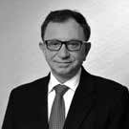
Theo Theophanous
Theo Theophanous is a former Victorian Government Minister. He held a number of senior portfolios, including
Industry, Energy, State Development and ICT. As Major Projects Minister, he steered the development of projects including the Recital Centre, AAMI Stadium and the Conference Centre and oversaw the Docklands development.
He now works as a Specialist Industry Advisor and Consultant and is on the Audit and Finance Committee of NICTA.

Chief Executive Officer: Summary of primary priorities

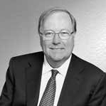
This first annual business plan for the new Victorian Planning
Authority (VPA) is a key component of government’s approach to the creation of jobs across the whole of Victoria. In order for our community to thrive we need to promote continued economic growth. The VPA will
contribute to this through strategic planning to facilitate development activity, employment opportunities and the creation of modern, connected communities. Our canvas has expanded to include land use and infrastructure planning
for strategically important precincts and sites in urban renewal areas, greenfield growth areas and regional areas.
The VPA is planning for increases in Melbourne’s population to almost 8 million people by 2051, and Victoria to 10 million. This level of population will require an additional:
- 1.7 million new jobs
- 1.6 million new dwellings in Melbourne alone
- Substantial development of our regional cities and towns. The VPA has a significant role in our capacity as
Victoria’s strategic planning authority, working closely with councils, government agencies and the planning and development community to integrate land use and infrastructure coordination for strategically important
development sites and precincts. Our major tasks include:
- Unlocking the supply of land and speeding up delivery of new residential lots to the market
- Facilitating housing diversity and affordability, job creation and better development of new communities
- Focusing activity for job creation through National Employment Clusters and central city expansion
- Working closely with councils and Government agencies to consider and determine infrastructure
and service needs
- Working with Metropolitan and Regional Partnerships to address challenges and opportunities and make our
suburbs, towns and cities healthier, more resilient and thriving places to live and work.
The VPA’s 2016/17 business plan is based around our four key areas of activity:
- Regional Victoria
- Key precincts in Melbourne’s inner
and middle ring suburbs
- Strategic redevelopment sites
- Melbourne Greenfield Growth Areas.
The VPA is expected to continue to have an important role in planning for Melbourne’s growth, and in contributing to housing affordability across the State.

Regional Victoria
The VPA will assist and advise Councils on how to unlock the growth potential of our regional cities and towns so they can accommodate a greater share of the state’s future growth and bolster regional economies. In turn, this will provide people with greater choices about where to live, work or start a business. The VPA has already undertaken strategic planning in regional areas such as
Drouin, Wodonga, Shepparton and Torquay. From the VPA’s strategic assessment of where our efforts should be directed in regional Victoria, three categories have emerged:
- Major regional cities (e.g. Bendigo, Ballarat, Geelong, La Trobe Valley, Wodonga, Shepparton)
- Growing regional cities (e.g. Wangaratta, Mildura, Warrnambool)
- Peri-Urban areas (e.g. Bacchus Marsh, Drouin/Warragul, Surf Coast).
The VPA’s purpose is to provide planning (in many cases, site-based master planning) assistance that leads to residential and/or job growth. It is expected that this work would commence at the invitation of the local council. A future VPA work program could consist of a range of projects:
- Structure Plans for new development precincts
- Local Infrastructure Plans for major towns experiencing
growth
- Site development strategies needing cross-government facilitation
- Strategic Planning for Melbourne’s peri-urban areas. The VPA will assist in the implementation of the Regional Growth Plans in conjunction with Regional Development Victoria (RDV) and the new Regional Partnerships program to marry economic development strategies with land use reforms to stimulate growth. To assist the VPA in delivering planning support for strategic growth projects in regional Victoria, the Government has provided the VPA with $2.1 million for the 2016/17 year to help build capacity in regional councils for strategic planning and unblocking strategic planning system delays.

Key Precincts in Melbourne’s inner and middle ring suburbs
Plan Melbourne identifies the opportunity for the Central City to expand and become Australia’s largest business centre. The VPA has been working to develop a whole-of- government spatial framework which sets out the vision for the network of urban renewal precincts and their proposed timing, staging and enabling investment. This will inform future investment and renewal priorities to meet the needs of Central Melbourne’s rapidly growing population and
to ensure the city’s ongoing competitive advantage.

The VPA is also undertaking planning for the Arden precinct on behalf of the Victorian Government. We are collaborating closely on this project with the City of Melbourne and government departments and agencies. The VPA is leading the preparation of the vision and planning framework to guide the precinct’s future growth. The new Melbourne Metro railway station at Arden combined with significant government land ownership will be the major catalyst for the precinct becoming a new central city destination.
The Arden precinct is part of the larger Arden-Macaulay urban renewal area. The VPA is working with the City of Melbourne and other government departments and
agencies to ensure that the Council’s planning and delivery of its Macaulay urban renewal area is appropriately supported by and integrated with the Arden precinct particularly in relation to issues such as drainage,
open space and community infrastructure planning.

The VPA is also continuing in its Responsible Authority role for section 173 agreements in the Fishermans Bend precinct.
In Melbourne’s inner ring suburbs, the VPA is continuing its strategic planning for the key areas of potential increased economic activity identified in Plan Melbourne, with a focus on the National Employment Clusters and the Metropolitan Activity Centres. The VPA will be continuing its work in Broadmeadows, East Werribee, La Trobe, Monash and Sunshine precincts, where it is working closely with the local councils and, where appropriate, universities and other local institutions. These are areas where there is,
or will be, significant employment and parallel residential growth. The VPA is also performing an advice and support- based role in other activity centres and clusters, such
as Footscray, Chadstone, Ringwood and Dandenong.

Significant Development Sites and Precincts
In addition, the $2 million provided to the VPA in the 2016/17 year for assistance to metropolitan councils, will also support the master planning for strategic sites within metropolitan Melbourne. These sites are generally expected to be brownfield sites that are close to facilities and transport
and are suitable for the development of new housing.

Melbourne’s Greenfield Growth Areas
The VPA is continuing with the program of Precinct Structure Plans (PSPs) for Melbourne’s greenfield locations. To date, 59 PSPs have been completed. Over the coming two years the VPA is to complete an additional 23 PSPs resulting in 100,000 extra residential lots being added to Melbourne’s future land supply.
Overall, development in PSP completed areas is proceeding well in terms of affordability, quality of life and the supply
of zoned land. However councils have experienced some problems with approvals processes following the completion of PSPs. The VPA will now be exploring ways of reducing post PSP planning obstacles, which may be slowing
zoned land being brought onto the market. In 2016/17, the Government has provided the VPA with $2 million additional funding, which includes money to assist metropolitan councils through a Post PSP Approvals Streamlining Project. The intention of the project is to increase the efficiency of the approvals system and maintain Melbourne’s competitive advantage in housing affordability by ensuring a steady stream of land supply in our growth areas. Funding of up
to $70,000 is available to individual growth area councils for specific initiatives that result in sustainable approvals
process improvements as well as resourcing support to help clear existing approvals backlogs.

Victorian Planning Authority

Building on the skills, knowledge and experience of the Growth Areas Authority and the Metropolitan Planning Authority, the VPA has a good record of introducing innovative planning practices and reducing red tape in the planning arena. The VPA will continue to work with stakeholders to recommend and implement process improvements. This business plan sets out the staffing, financial and other matters for the 2016/17 financial year.
The VPA has concentrated its activities on four key primary priorities. The detail of the prioritised annual work program is reflected on page 17 and these projects are to be progressed during this financial year. Further information on our work program will be periodically updated on the VPA’s website.
One of the reasons that the Authority is well-regarded is that we have developed a track record of working well with our stakeholders. The VPA collaborates with councils, a range of government departments and authorities, landowners, developers, and local communities. In particular, the VPA’s
role complements the role of the Department of Environment, Land, Water, and Planning (DELWP) to provide effective planning for the future growth and transformation of cities and regions through provision of clear policy direction, such as Plan Melbourne, and ensuring the effective performance of the regulatory framework.

The VPA is preparing a revision of the existing PSP Guidelines in order to deliver improved planning outcomes in new growth and urban renewal areas across Victoria. We are also working with DELWP to develop
a work program for the finalisation of the Boulevard Strategy and the review of open space in Melbourne.
In conjunction with DELWP, the VPA will be trialing the new Infrastructure Contribution Plans in selected locations of growth. The Authority will also work closely with DELWP and the Minister in our intended legislative transition to the new VPA on 1 July 2017.
I look forward to working with our stakeholders over the coming year.

Peter Seamer
Chief Executive Officer

Overview of VPA’s work program

Metropolitan Melbourne current work program
The map below sets out the key areas in metropolitan Melbourne where the VPA will be focusing its effort over the coming years.

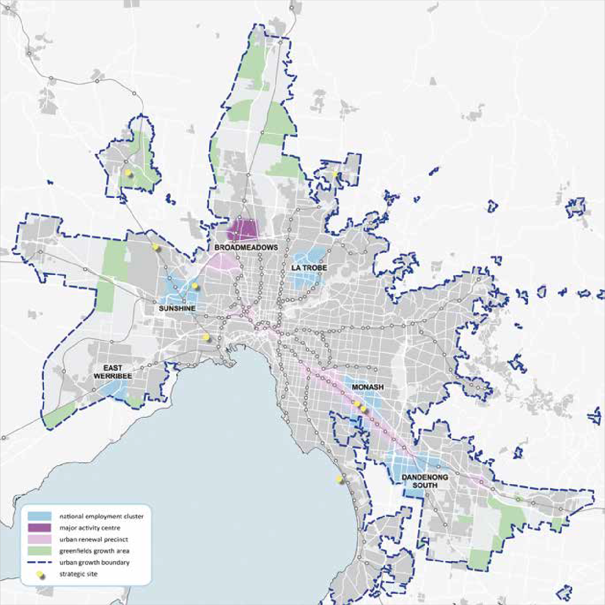

The detailed list of approved VPA projects is reflected in the section of this Business Plan entitled Our Prioritised Annual Work Program. That list sets out the nature of each activity, and includes the estimated completion date for each project.

Regional Victoria current work program
The map below reflects the key areas of Victoria (outside of metropolitan Melbourne) where the VPA will be focusing its effort over the coming year.

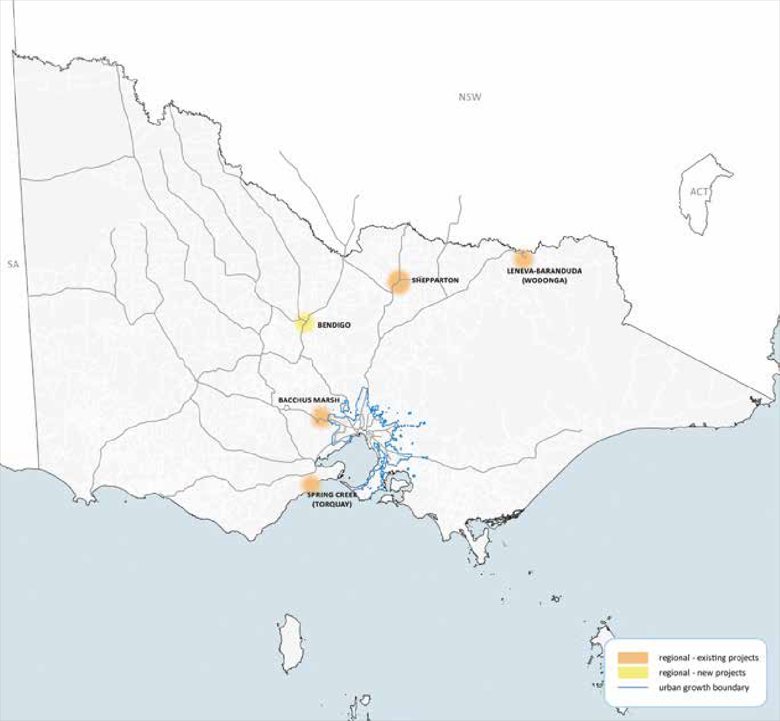

Over the coming years the VPA’s work program is expected to expand into many other areas in Regional Victoria. In addition the VPA will be providing planning support to a range of regional councils in 2016/17 through the Government’s Streamlining for Growth Program.

Delivering on our objectives

The objectives of the Authority are listed in Section 46AR of the Planning and Environment Act 1987. For each of the objectives, the Authority’s activities the priorities and plans for achieving these over the next three years, are outlined below. In addition, the subsequent table (page 12) reflects the performance measures for these objectives
for the next twelve months. The major activities that the VPA will be undertaking during the 2016/17 financial year are listed at the end of this document (page 17).
The Minister for Planning launched the VPA effective from 16 August 2016. Initially the Growth Areas Authority (known as the Metropolitan Planning Authority up until 16 August 2016) will be trading as the VPA, and is a reorganizing body under the State Owned Enterprises Act 1992. The expectation is that legislative change will follow, formally creating the new VPA from 1 July 2017.
The additional objectives for the VPA in 2016/17 include a particular focus on:
- Ensuring that the organisation develops and fosters strategic relationships with relevant government
departments and agencies, Metropolitan and Regional Partnerships, local government and local government locational groups;
- Planning for the transition to the new VPA.
These new objectives allow us to focus the Authority’s work program on core priorities as we transition to the new VPA.
Furthermore, the Government is well progressed with its refresh of Plan Melbourne. The revised Plan Melbourne is expected to be released later in 2016. The VPA Business Plan for 2016/17, whilst taking into account known changes announced by the Government, is largely based on directions in place at the time of its preparation. We will incorporate any revised actions from Plan Melbourne into our work program.
The VPA’s KPIs for delivering its objectives over the next 12 months are set out in the Key Performance Measures table (page 12). The VPA’s objectives beyond the life of this plan are set out below.

Development occurs in a coordinated and timely manner
The VPA’s role is to ensure that development in all identified areas occurs in a coordinated and timely manner.

The priorities for this objective over the next three years include:
The VPA will continue to progress the planning projects on its approved prioritized annual work program including the master planning activity for the National Employment
Clusters of Monash, La Trobe, East Werribee and Sunshine. In addition, the completion of the additional structure plans contained in the current VPA work program is expected to provide for more than a further 100,000 residential sites
and 1,400 employment hectares by the end of 2017.

Infrastructure, services and facilities are provided in a coordinated and timely manner
The provision of appropriate infrastructure and services in a timely manner is a critical objective of the VPA to ensure the continued development of areas identified for growth. The VPA works with Government agencies and local councils to prepare infrastructure plans for growth areas. In addition the VPA carries out a number of administrative roles relating to the collection and allocation of Growth Areas Infrastructure Contribution (GAIC).

The priorities for this objective over the next three years include:
Working closely with the relevant councils and Government agencies on infrastructure plans for growth areas. This includes developing Infrastructure Contribution Plans (ICPs) as part of the structure planning process for the renewal areas of Metropolitan Melbourne. The VPA is also expecting to be able to finalise some GAIC Works-in-Kind (WIK) arrangements for the early delivery of land for State infrastructure.

Promote sustainable development of land
The VPA’s role in pursuing this objective is very broad and this objective aligns closely with a number of the other statutory objectives.

The priorities for this objective over the next three years include:
Ensuring that the review of the PSP Guidelines explore the usage, treatment and storage of waste and water and as well as energy sustainability.

Environment
Document, publish and implement the VPA’s role in responding to climate change through planning initiatives to be applied in Victoria.
The VPA will work in Metropolitan Melbourne and with Victoria’s regional cities and towns to secure our valuable environmental assets, ensure efficient use of land, safeguard agricultural operations, strengthen local employment,
plan connected and well-serviced communities, and build resilience to the effects of climate change.

Infrastructure
Seek innovative planning solutions to reduce energy use and resource consumption, for example water.

Social
Ensure structure plans facilitate the provision of affordable and community housing, and green areas for social and recreation purposes whilst also providing the environmental benefit of limiting areas of urban heat concentration, through the revised PSP Guidelines.

Promote housing diversity and affordability
The VPA focuses on the two elements of this objective through its master planning process.

The priorities for this objective over the next three years include:
Continuing to focus on the provision of a range of housing types within the application of PSP Guidelines, and ensuring that there is an adequate supply of zoned land to assist Victoria’s continuing growth and to contribute to housing affordability in metropolitan Melbourne and Victoria.

Promote employment opportunities
Creating jobs is one of the most important economic challenges facing Victoria. The VPA considers that business and employment growth in new and revitalised communities is fundamental to the health of our city and State and is influenced by a range of factors, particularly drawing on the economic advantages of Melbourne
and Victoria. Whilst this is only one part of a complex equation, the VPA will be able to significantly add to Victoria’s economic development by influencing how land in the nominated areas is planned to be used.

The priorities for this objective over the next three years include:
Preparing structure plans for key areas within metropolitan Melbourne and regional Victoria as considered a priority by the Minister for Planning.

Land is provided for commercial and industrial purposes in a co-ordinated and timely manner
The VPA works closely with the Department of Economic Development, Jobs, Transport and Resources (DEDJTR) to achieve this objective though the VPA’s master planning activities.

The priorities for this objective over the next three years include:
Working closely with DEDJTR and other agencies to ensure the supply of sufficient industrial and employment zoned land is maintained and that employment areas are of the right type to encourage business growth.

Foster the development of communities
Much of the work and activity of the VPA is focused on achieving this objective across all of our areas of growth, including regional Victoria.

The priorities for this objective over the next three years include:
Ensuring that the appropriate community engagement occurs during the VPA’s master planning activities in order to contribute to the development of thriving communities which have a sense of place, livability, amenity, community infrastructure, walkability and thriving local activity centres, including through close liaison with local government.

Integrate land use and transport to enable the coordinated provision of a sustainable transport system for the benefit of the community
The VPA works closely with VicRoads, Public Transport Victoria (PTV), DEDJTR and DELWP to implement this objective.

The priorities for this objective over the next three years include:
Working closely with DEDJTR and other agencies to ensure appropriate transport infrastructure and services are included in infrastructure plans and that land use plans and transport plans are aligned.

Discharge governance activities
In addition to its statutory objectives, the VPA has an obligation to the Victorian community to ensure that it conducts its affairs and operations in accordance with Government’s standards and expectations.

The priorities for this objective over the next three years include:
Developing and implementing sustainable funding and governance arrangements for the transition to, and ongoing operations of, the VPA. In addition, the VPA is to ensure appropriate transition arrangements are in place to enable a smooth transition to the new Authority as of 1 July 2017.

Key performance measures for 2016/17
In order to achieve the VPA’s objectives over the coming three years, the VPA is expecting to achieve the following during the 2016/17 financial year:

Outcomes | Reference to the VPA Legislative Objective under section 46AR of the Planning and Environment Act 1987* | KPI | Target
Unlock the supply of land, while creating well serviced and sustainable communities | - Development occurs in a coordinated and timely manner  - Infrastructure, services and facilities are provided in  a coordinated and timely manner  aa. Integrate land use and transport to enable the coordinated provision of a sustainable transport system for the benefit of the community | Complete the exhibition process of draft Planning Scheme Amendments for Precinct Structure Plans and advertise the Planning Panel Hearings.  (Timeliness) | 10 draft PSPs exhibited and advertised before 30 June 2017.**
 |  | Complete the exhibition and advertising for draft PSPs by 31 December 2017 which  make provision for the zoning of in excess of 100,000 residential lots.  (Quantity) | Draft PSPs providing for the zoning of in excess of 100,000 residential lots well progressed by 30 June 2017.**
 |  | VPA Planning and Design Review program to provide a collaborative, multi-disciplinary analysis of PSPs early in their development.  (Quality) | 1 PSP reviewed per annum
 |  | VPA continues to implement approved work program. (Timeliness) | 10 planning projects outside of greenfield areas and 20 greenfield PSPs underway by 30 June 2017.**
Provide opportunities for employment growth in sustainable communities. | - Promote employment opportunities  - Ensure that land is provided for commercial and industrial purposes in a coordinated and timely manner | Hectares of employment land included in draft PSPs prepared for exhibition by 30 June 2017. (Quantity) | 400 hectares of employment land included in draft structure plans prepared by 30 June 2017.
Future population growth balanced across growth areas, inner Melbourne, significant development sites and regional Victoria, in accordance with Plan Melbourne | - Promote sustainable development of land  - Promote housing diversity and affordability  f. Ensure that land is provided for commercial and industrial purposes in a coordinated and timely manner | VPA work program reflects the initial strategic planning projects that the VPA will be involved with in inner city, significant development sites and regional Victoria. (Timeliness) | VPA work program published on the VPA website by  30 November 2016.
Implement aspects of Plan Melbourne relevant to the role of the Authority | All | VPA’s website reflects its new obligations arising from the refreshed Plan Melbourne. (Quantity) | If required a revised VPA work program is to be published on the VPA website within three months of release of Plan Melbourne 2016.

Outcomes | Reference to the VPA Legislative Objective under section 46AR of the Planning and Environment Act 1987* | KPI | Target
Provide the opportunity for sustainable communities | c. Promote sustainable development of land | Revised PSP Guidelines incorporate the promotion of energy sustainability. (Quantity) | A draft Discussion Paper for the revision of the Precinct Structure Plan Guidelines to include promotion of energy sustainability prepared by 31 December 2016.
VPA and its stakeholders work in partnership for optimum planning outcomes. | b. Infrastructure, services and facilities are provided in  a coordinated and timely manner  e. Promote employment opportunities  g. Foster the development of communities  aa. Integrate land use and transport to enable the coordinated provision of a sustainable transport system for the benefit of the community | Key Stakeholders to confirm that VPA has satisfactorily consulted with them during planning processes. (Quantity) | The VPA conducts a stakeholder satisfaction survey by 30 June 2017 which indicates whether the VPA’s key stakeholders are satisfied with the quality and extent of consultation undertaken by the VPA during the 2016/17 financial year.
VPA produces a Business Plan annually. | NA | Approved Business Plan published on VPA website. (Timeliness) | Approved Business Plan published on VPA website by 30 November 2016.
VPA remains financially sustainable. | NA | Operating shortfall within agreed tolerance.  (Cost) | Operating shortfall for the year is no greater than 10% more than the budgeted deficit of  $2.9 million for the year ended 30 June 2017, except in relation to any additional unbudgeted expenditure directed by the Minister for Planning.
Employees reflect public sector values in the work of the VPA | NA | Number of material breaches by VPA staff members of the Code of Conduct for Victorian Public Sector Employees 2015. (Quality) | No breaches by VPA staff members of Code of Conduct reported in VPA annual report for 30 June 2017.

- The alphabetic references in this column relate to the subsection numbers of section 46AR of the Planning and Environment Act 1987.
** These measures are similar, but are all slightly different, as they are measuring different timeframes of the VPA’s program, commencement of PSPs, consultation on draft PSPs, and rezoning of land on completion of PSPs.

Our organisation

The Authority meets regularly throughout the year, and has two specialist sub-committees, dealing with Risk and Audit and Executive Remuneration matters.
The Authority had a staff complement of 89 employees as at 30 June 2016, periodically supported by contract or seconded employees to help meet work targets and to
provide expert assistance in key areas. With the change in the role and focus of the Authority, the MPA had increased its staff levels over the past two years in order to carry out its expanded work program. The complement in future years will be dependent upon the VPA’s allocated workload and financing, and may vary from the 2016/17 level.
The VPA is structured around four groups that reflect the key activity streams of the VPA. The groups are now organised into 11 teams, in a manner that optimises the capacity of VPA to conduct its activities.
The Urban Renewal Group is responsible for preparing employment PSPs and also for developing planning and design approaches for town and city centres. It comprises of three teams. The Group manages PSP preparation for industrial and town centres in metropolitan Melbourne. This
group is active in the key National Employment Clusters and Major Activity Centres of Broadmeadows, Monash, La Trobe and Sunshine, and also the renewal of the Arden Precinct.
The Growth Areas Group is responsible for strategic planning in Melbourne’s greenfield Growth Areas. This Group comprises three teams. These teams work in partnership with the local council to complete PSPs for land within the existing urban growth boundary in accordance with the program approved by the Minister. The responsibility for the rollout of the development of the East Werribee Employment Precinct also falls within this group, but is expected to transfer outside of the VPA during 2016/17.
The Regional Group comprises two teams and is responsible for working closely with the local councils, Regional Partnerships and the Regional Development Victoria for preparing master plans to assist in optimising economic, employment and housing opportunities for identified regional projects. These teams also have responsibility for providing planning assistance, when requested by the Minister, to regional Victoria.
The Technical Services Group incorporates, the Technical Services Team, the Corporate and Statutory Services Team and the Research Team.
  - The Technical Services Team is responsible for supporting the planning and other operations of the VPA
through the provision of technical advice, infrastructure coordination planning and graphics, GIS and drafting support. This Team also focuses on Local Infrastructure Planning.

The Corporate and Statutory Services Team is
responsible for the governance activities at the VPA (including finance, human resources, administrative and information technology functions). These activities incorporate the VPA’s administration of the GAIC and providing support for the GAIC Hardship Relief Board. This team also has responsibility for corporate wide activities, such as insurance, risk management and the ongoing operations of the VPA offices. This team also
conducts the organisation’s statutory planning activities, and also has the important responsibility for ensuring that the VPA is appropriately prepared for Planning Panels.
  - This Group also includes a small Research Team which
coordinates the VPA’s economic research and design activities.
Two other smaller teams complete the VPA organisational structure.
The Partnerships and Communication Team has the key role of managing and coordinating the interaction with all government authorities, and also has the responsibility for the organisation’s media, engagement and communication activities.
The Innovation and Reform Team is charged with the responsibility of identifying and implementing streamlining opportunities for post-PSP planning.
The following table summarises the VPA’s expected staffing for the coming year:
Staff | 2015-2016 | 2016-2017
Executives | 8 | 8
Non-executive | 81 | 83
Total | 89 | 91

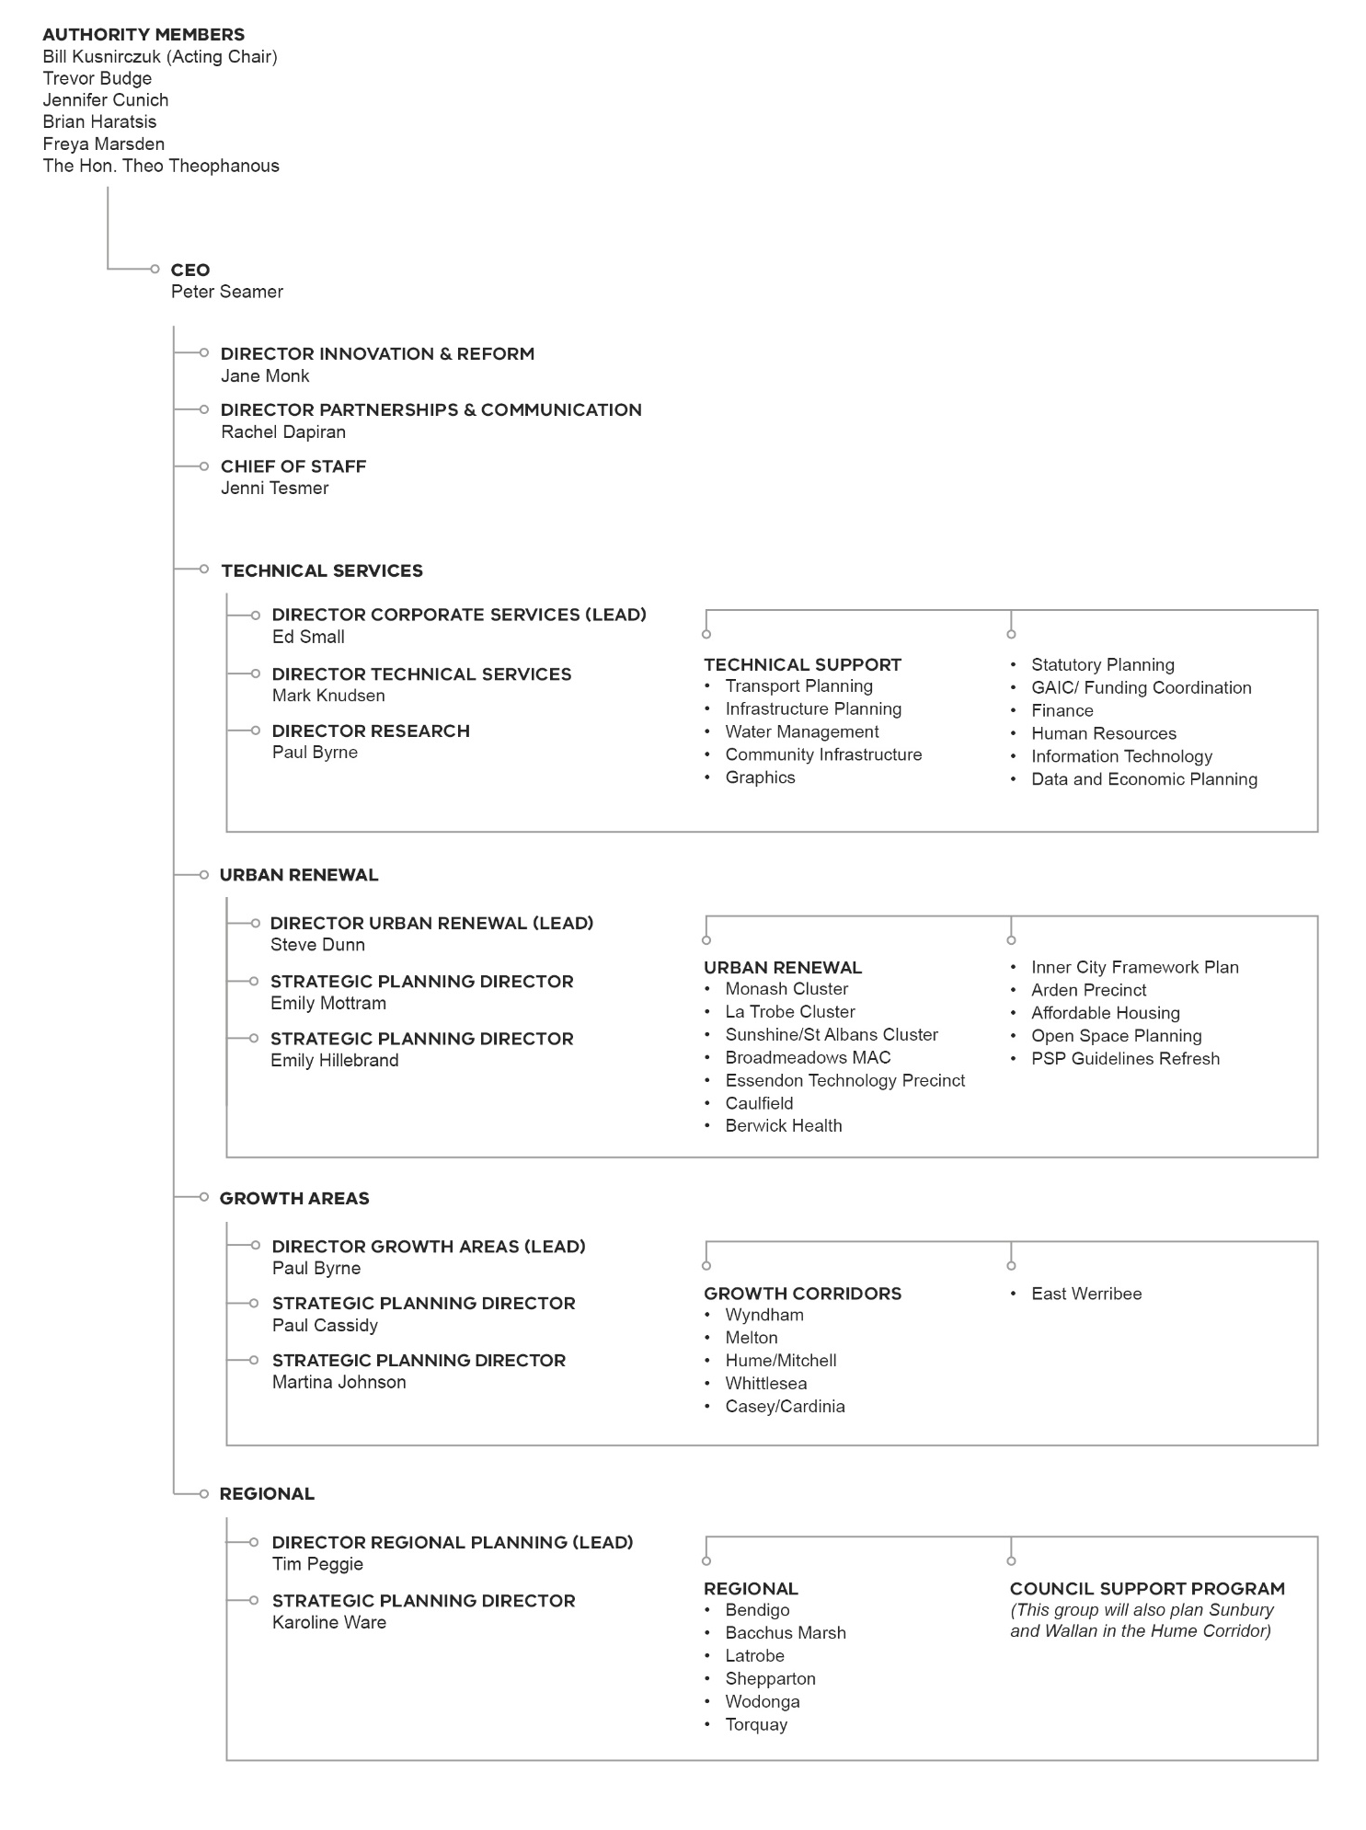

Our resources

It is anticipated that the nature and extent of the work of the VPA will vary from year to year, and that the revenue and expenditure of the Authority will correspondingly change. The VPA’s forward State Government appropriations for the next four years are currently anticipated to be:
• $17.9 million in 2016/17
• $13.7 million in 2017/18
• $13.5 million 2018/19
• $13.5 million 2019/20.
The allocations are shown before any contribution to be made by the Authority to the Department of Environment Land Water and Planning of $800,000 per annum for the
funding to support the Fishermans Bend Hub. The future funding of the new VPA is expected to be confirmed during this financial year.
In addition the VPA has been allocated an additional
$4.2 million in the Government’s 2016/17 Budget, and this budget assumes that this funding does not continue into the future years. These funding allocations will enable the VPA to extend its role in planning for growth in Melbourne and Victoria.
The VPA has a brought forward surplus at 1 July 2016 of
$8.1 million. This represents funds that the VPA has received previously, in advance of the matching expenditure occurring. These funds are to be used to finance the completion of a number of the greenfield and other planning activities currently underway.

Budget 2016/17 to 2019/20
The VPA has approved the following budget for 2016/17 and has endorsed, in-principle the financial projections, for the subsequent three years. The VPA anticipates making operating deficits over each of the coming financial years as it expends the funds on hand which had been raised in earlier years for specific identified projects.

Income

 | 2016-2017  $m | 2017-2018  $m | 2018-2019  $m | 2019-2020  $m
Base Appropriation | 13.7 | 13.7* | 13.5* | 13.5*
Less: Fishermans Bend Hub Support | (0.8) | (0.8)* | (0.8)* | (0.8)*
Additional Appropriation – Regional | 2.2 | 0.0 | 0.0 | 0.0
Additional Appropriation – Metropolitan | 2.0 | 0.0 | 0.0 | 0.0
Third Party Contributions | 0.7 | 1.5 | 1.4 | 0.0
Interest | 0.2 | 0.1 | 0.1 | 0.1
Fishermans Bend Reimbursement | 1.8 | 0.0 | 0.0 | 0.0
Total Income | 19.8 | 14.5 | 14.2 | 12.8

Expenditure

 | 2016-2017  $m | 2017-2018  $m | 2018-2019  $m | 2019-2020  $m
Executive | 0.9 | 0.9 | 0.9 | 0.9
Technical Services | 6.6 | 6.5 | 5.7 | 5.6
Partnerships | 0.7 | 0.5 | 0.4 | 0.4
Urban Renewal – Staff Costs | 2.3 | 2.4 | 2.0 | 2.0
Growth Areas – Staff Costs | 1.8 | 1.7 | 1.5 | 1.4
Regional – Staff Costs | 1.6 | 1.5 | 1.2 | 1.2
External Project Costs | 4.2 | 2.9 | 2.8 | 2.5
Grants to Council | 1.6 | 0.0 | 0.0 | 0.0
Streamlining Activities | 0.5 | 0.0 | 0.0 | 0.0
EWEP Planning | 0.6 | 0.1 | 0.1 | 0.0
EWEP Transfer | 1.9 | 0.0 | 0.0 | 0.0
Total Expenditure | 22.7 | 16.5 | 14.6 | 14.0

Net Shortfall (Surplus) | 2.9 | 2.0 | 0.4 | 1.2
Surplus Brought Forward | 8.1 | 5.2 | 3.2 | 2.8
End of Year Surplus | 5.2 | 3.2 | 2.8 | 1.6
* To be finalised

Our prioritised annual work program

Project | Project Name | LGA/Agency | Major Activity | Funding Source* | Status - October 2016 | Estimated start date | Estimated Completion Date | Forecast status - June 2017
URBAN RENEWAL
Projects carried forward from 2015/16
Central Melbourne
3051 | Arden | Melbourne, MMRA*** & DEDJTR | Structure Plan | VPA & Third Party | Under Preparation | Jan-15 | Dec-17 | Final consultation
3350 | Inner City Framework Plan | Melbourne | Framework Plan | VPA | Consultation | Nov-14 | Dec-16 | Complete
Dandenong/Eastern Corridor
6550 | Monash | Greater Dandenong, Kingston, Monash | Framework Plan | VPA | Under Preparation | Mar-14 | Dec-17 | Post consultation
6570 | Clayton Structure Plan | Kingston, Monash | Structure Plan | VPA | Under Preparation | Jun-16 | Dec-17 | Consultation
7050 | Caulfield Precinct | Glen Eira | Structure Plan | VPA | Under Preparation | Nov-14 | Jun-18 | Consultation
7500 | Berwick Health & Education | Casey | Structure Plan | VPA | Under Preparation | Jul-14 | Dec-17 | Final consultation
Northern Corridor
5600 | La Trobe Cluster | Banyule, Darebin | Framework Plan | VPA | Under Preparation | Mar-14 | Dec-17 | Final consultation
5100 | Broadmeadows MAC | Hume | Framework Plan | VPA | Under Preparation | Feb-16 | Dec-17 | Final consultation
5400 | Essendon Technology Precinct | Moonee Valley | Framework Plan – with Council | VPA | Under Preparation | Jan-15 | Dec-17 | Consultation
Western Corridor
4500 | Sunshine Framework Plan (including Health Precinct) | Brimbank | Framework & Infrastructure Plan | VPA | Under Preparation | Mar-14 | Dec-17 | Post consultation
*** MMRA = Melbourne Metropolitan Rail Authority

Project | Project Name | LGA/Agency | Major Activity | Funding Source* | Status - October 2016 | Estimated start date | Estimated Completion Date | Forecast status - June 2017
URBAN RENEWAL
New Projects for 2016/17
Central Melbourne
3052 | Macaulay ICP | Melbourne | Infrastructure Contribution Plan | VPA | Under Preparation | Jan-16 | Jun-17 | Complete
3053 | Josephs Road ICP | Maribyrnong | Infrastructure Contribution Plan | VPA | Under Preparation | Jun-16 | Sep-17 | Post Consultation
3470 | Flinders to Richmond | Melbourne, Yarra, PTV, MPV, DEDJTR | Framework Plan | VPA | Not commenced | Oct-16 | Dec-17 | Consultation
Dandenong/Eastern Corridor
7850 | CD9 Corridor | Various | Strategy document | VPA | Not Commenced | Nov-15 | Jun-17 | Complete
7010 | Chadstone/ Oakleigh | Monash/ Stonnington | Investigation | VPA | Not Commenced | Jan-17 | Jun-17 | Complete
6575 | Clayton Business Park | Kingston | Strategic site | VPA | Under Preparation | Sep-14 | Jun-17 | Complete
6565 | PMP Site - Clayton | Monash | Strategic site | VPA & Third Party | Under Preparation | May-16 | Jun-18 | Consultation
7100 | Dandenong South NEC | Monash | Framework Plan | VPA | Not commenced | Jan-17 | Jun-18 | Under Preparation
7900 | Frankston Corridor & MAC | Frankston | Planning support | VPA | Not commenced | Jan-17 | Dec-17 | Under Preparation

Project | Project Name | LGA/Agency | Major Activity | Funding* | Status - October 2016 | Estimated start date | Estimated Completion Date | Forecast status - June 2017
URBAN RENEWAL
New Projects for 2016/17 (continued)
Western Corridor
4052 | Solomon Heights (Sunshine) | Brimbank | Strategic site | VPA | Under Preparation | Jul-15 | TBA | Consultation
4510 | Watergardens | Brimbank | Strategic site planning support | VPA & Third Party | Not commenced | Jan-17 | Dec 17 | Consultation
4520 | Altona North | Hobsons Bay | P15 Strategic site | VPA &  Streamlining for Growth** | Under Preparation | Jul-16 | Sep-17 | Post consultation
Strategic Development Sites/Innovation
8610 | Other specific sites | Various | To be defined | Streamlining for Growth** | NA | NA | NA | Ongoing
Various | Metro Partnerships | Various | Support for program | VPA | NA | NA | NA | Ongoing

Miscellaneous Projects

Project | Project Name | LGA/Agency | Major Activity | Funding* | Status - October 2016 | Estimated start date | Estimated Completion Date | Forecast status - June 2017
Various | Plan Melbourne Implementation | Various | Various projects  - TBA | TBA | Ongoing | Ongoing | Ongoing | Ongoing

Project | Project Name | LGA/Agency | Major Activity | Funding Source* | Status - October 2016 | Estimated start date | Estimated Completion Date | Forecast status - June 2017
REGIONAL
Projects carried forward from 2015/16
Bacchus Marsh
1225 | Bacchus Marsh | Moorabool | Framework Plan | VPA &  Streamlining for Growth** | Under Preparation | Feb-16 | Feb-18 | Consultation
Other Regional
1240 | Torquay - Spring Creek | Surf Coast | Structure plan with council as planning authority | VPA | Under Preparation | Nov-16 | Jun-17 | Complete
1105 | Wodonga/Leneva | Wodonga | Structure plan with council as planning authority | VPA &  Council | Under Preparation | Jan-16 | Dec-17 | Consultation
1102.1 | Shepparton South East | Greater Shepparton | Structure plan | VPA &  Council | Under Preparation | Mar-15 | Dec-17 | Consultation
1102 | Shepparton North East | Greater Shepparton | Structure plan | VPA &  Council | Under Preparation | Jun-14 | Dec-17 | Consultation
REGIONAL
New projects for 2016/17
Other Regional
1248 | Plan Bendigo | Greater Bendigo | Strategic sites - TBA | VPA &  Streamlining for Growth** | Under Preparation | Aug-16 | TBC | Under preparation
1103 | Shepparton Framework Plan | Greater Shepparton | Framework Plan | VPA &  Streamlining for Growth** | Preparatory work | Nov-16 | TBC | Under preparation
8200 | Regional Growth Plans | Various | Work with DELWP/RDV | VPA &  Streamlining for Growth** | Preparatory work | Ongoing | Ongoing | Complete
Various | Support program for local government planning | Various | Assistance to be provided by VPA | VPA &  Streamlining for Growth** | Preparatory work | Jan-17 | Jun-17 | Complete

Project | Project Name | LGA/Agency | Major Activity | Funding Source* | Status - October 2016 | Estimated start date | Estimated Completion Date | Forecast status - June 2017
GREENFIELD
Projects carried forward from 2015/16
Sunbury Growth Corridor
1074 | Sunbury South | Hume | Precinct Structure Plan | VPA & Third Party | Under Preparation | Nov-12 | Dec-17 | Final consultation
1075 | Lancefield Road | Hume | Precinct Structure Plan | VPA & Third Party | Under Preparation | Mar-13 | Dec-17 | Final consultation
North Growth Corridor
1067 | Donnybrook | Mitchell, Whittlesea | Precinct Structure Plan | VPA & Third Party | Under Preparation | Jun-12 | Mar-17 | Complete
1096 | Woodstock | Whittlesea | Precinct Structure Plan | VPA & Third Party | Under Preparation | Jun-12 | Mar-17 | Complete
1094 | Quarry Hills | Whittlesea | Precinct Structure Plan | VPA & Third Party | Under Preparation | Aug-11 | Nov-16 | Complete
1070 | Wollert | Whittlesea | Precinct Structure Plan | VPA & Third Party | Under Preparation | Aug-11 | Mar-17 | Complete
25.1 | Craigieburn Employment | Hume | Precinct Structure Plan | VPA | Complete | Jul-12 | Aug-16 | Complete
1202 | Lindum Vale | Hume | Precinct Structure Plan | VPA & Third Party | Under Preparation | Jun-12 | Dec-17 | Consultation
1062 | Beveridge Central | Mitchell | Precinct Structure Plan | VPA | Under Preparation | May-12 | Sep-17 | Approval process
1059 | Beveridge North West | Mitchell | Precinct Structure Plan | VPA & Third Party | Under Preparation | Jun-13 | Mar-18 | Panel
West Growth Corridor
39.2 | EWEP - Divestment | Wyndham | Major development parcel divestment | EWEP  Grant | Under Preparation | Jan-14 | Jan-17 | VPA role complete
39.4 | EWEP - Ongoing Planning | Wyndham | Ongoing planning activities | EWEP  Grant | Under Preparation | Ongoing | Ongoing | Ongoing
1099 | Rockbank | Melton | Precinct Structure Plan | VPA & Third Party | Under Preparation | Oct-12 | Dec-16 | Complete
1082 | Mt Atkinson | Melton | Precinct Structure Plan | VPA & Third Party | Under Preparation | Mar-14 | Jun-17 | Complete
1085 | Tarneit Plains | Melton | Precinct Structure Plan | VPA & Third Party | Under Preparation | Mar-14 | Jun-17 | Complete
1078 | Plumpton | Melton | Precinct Structure Plan | VPA & Third Party | Under Preparation | May-13 | Jun-17 | Complete
1080 | Kororoit | Melton | Precinct Structure Plan | VPA & Third Party | Under Preparation | May-13 | Jun -17 | Complete
1080.2 | Kororoit Part 2 | Melton | Precinct Structure Plan | VPA & Third Party | Under Preparation | May-13 | Dec-17 | Consultation
1600 | Melton Infrastructure Plan | Melton | Preparation of pilot | VPA | Under preparation | Jun-16 | Jun 17 | Draft complete
South East Growth Corridor
12 | Casey Central Town Centre | Casey | Precinct Structure Plan | VPA | Under Preparation | Dec-10 | Oct-16 | Complete
1209 | Brompton Lodge | Casey | Precinct Structure Plan | VPA & Third Party | Under Preparation | Oct-14 | Oct-16 | Complete
1055 | McPherson | Casey | Precinct Structure Plan | VPA & Third Party | Under Preparation | May-14 | Dec-17 | Panel
11 | Minta Farm | Casey | Precinct Structure Plan | VPA | Under Preparation | Mar-10 | Dec-17 | Panel
1051 | Croskell | Casey | Precinct Structure Plan | VPA & Third Party | Not Commenced | Oct-16 | Dec-19 | Pre-planning

Project | Project Name | LGA/Agency | Major Activity | Funding Source* | Status - October 2016 | Estimated start date | Estimated Completion Date | Forecast status - June 2017
GREENFIELD
New projects for 2016/17
Sunbury Growth Corridor
1500 | Caloola Sunbury | Hume | Strategic site | VPA &  Streamlining for Growth** | Under Preparation | Aug-16 | Dec-17 | Consultation
North Growth Corridor
1201.1 | Wallan South | Mitchell | Precinct Structure Plan | VPA & Third Party | Under Preparation | Nov-16 | Aug-19 | Under Preparation
5460 | Mernda Town Centre | Whittlesea | Master planning arising from station | VPA &  Streamlining for Growth** | Under Preparation | Jun-16 | Dec 17 | Consultation
1069.1 | Shenstone Park | Whittlesea | Precinct Structure Plan | VPA & Third Party | Under Preparation by Council | Jan-16 | Dec 18 | Under preparation
1065.1 | Merrifield North | Mitchell/Hume | Master plan | VPA &  Streamlining for Growth** | Under Preparation | Jun 16 | Dec 17 | Consultation
South East Growth Corridor
4.5 | Officer Town Centre | Cardinia | Review of structure plan | VPA & Third Party | Under Preparation | Sep-16 | Jun-18 | Consultation
5 | Officer Employment | Cardinia | Precinct Structure Plan | VPA & Third Party | Not Commenced | Jul-17 | Jun-20 | Pre-planning
6 | Pakenham South Employment | Cardinia | Precinct Structure Plan | VPA &  Council | Under Preparation by Council | Dec-14 | Jun-18 | Consultation
Other
8690 | Streamlining (Post PSP) – Phase 1 | Various | Assistance to councils | Streamlining for Growth** | Under Preparation | Jun-16 | Jun 17 | Phase 1 completed
GREENFIELD
New projects for 2017/18
1056 | Clyde South | Casey | Precinct Structure Plan | VPA & Third Party | Not Commenced | Jul-17 | Jun-20 | Pre-planning
1068 | Craigieburn West (inc Greenvale R1) | Hume | Precinct Structure Plan | VPA & Third Party | Not Commenced | Jul-17 | Jun-20 | Pre-planning
1065 | Merrifield North | Hume | Precinct Structure Plan | VPA & Third Party | Not Commenced | Jul-17 | Jun-20 | Pre-planning
1207 | Aviators Field | Wyndham | Precinct Structure Plan | VPA & Third Party | Not Commenced | Jul-17 | Jun-20 | Pre-planning
1208 | Werribee Junction | Wyndham | Precinct Structure Plan | VPA & Third Party | Not Commenced | Jul-17 | Jun-20 | Pre-planning

* Funding Source: VPA – from budget allocations to VPA
Third Party – contribution from other party towards planning activity
Streamlining for Growth – targeted funding for selected projects which meet program criteria

** Potential that this project may be able to be selected for funding (or part funding) through the Streamlining for Growth program

Project | Project Name
GREENFIELD
PSPs not on current VPA program
North Growth Corridor
1060 | Beveridge North East
1061 | Beveridge South West
1201 | Wallan East
1063 | Northern Freight
1071 | Cooper Street West
Western Growth Corridor
1076 | Melton East
1077 | Warrensbrook
1081.2 | Rockbank South
1083 | Warrawee
1084 | Ravenhall (Quarry Site)
1086 | Chartwell East
1087 | Derrimut Fields
1088 | Oakbank
1092.1 | Quandong (Council undertaking)
1093 | Mambourin East
1093.1 | Bayview
1072 | Sunbury North
1095 | Sunbury West
1204 | Minns Road
1205 | Bulmans Road
1206 | Melton West
South Eastern Growth Corridor
1057 | Casey Fields South
1058 | Devon Meadows
1210 | Pakenham East (Council undertaking)
7 | Pakenham West
10.4 | Botanic Ridge (Stage 4)













Victorian Planning Authority
Level 25, 35 Collins Street
Melbourne Victoria 3000
Telephone: 03 9651 9600
Facsimile: 03 9651 9623
www.vpa.vic.gov.au

