Sunshine National Employment and Innovation Cluster

Draft Framework Plan

March 2017
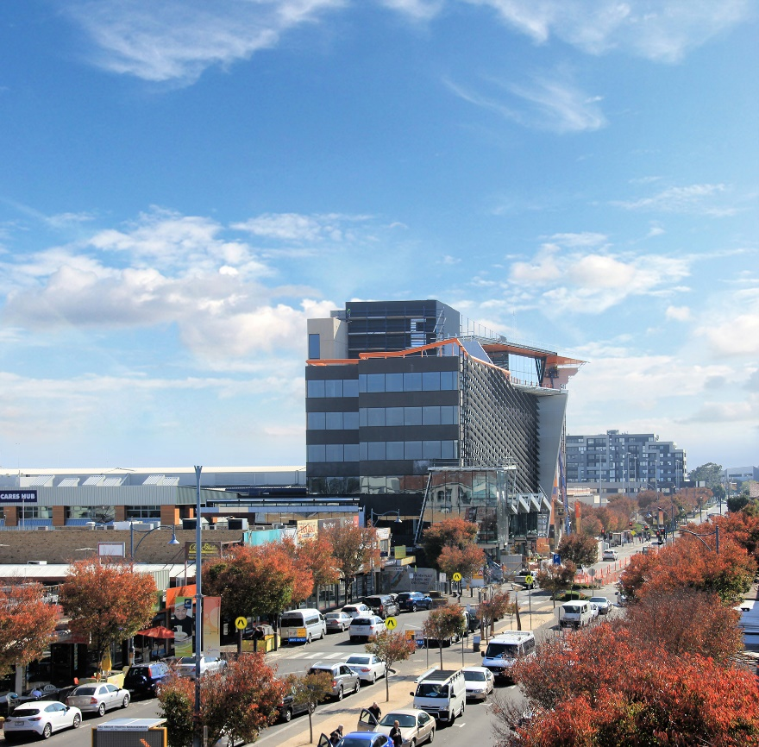

Contents
EXECUTIVE SUMMARY 3
CONTEXT 4
VISION 6
PRINCIPLES 8
STRATEGIC OUTCOMES 10
Strategic outcome 1: Utilise place-based management bodies to drive progressive improvements to job centres 11
Strategic outcome 2: Deliver an integrated transport network linking pools of workers with the key job centres in the Sunshine Cluster 12
Strategic outcome 3: Build key missing links in the shared trail and cycle path network 13
Strategic outcome 4: Facilitate amenity improvements through targeted works in the public realm 14
Strategic outcome 5: Unlock land for jobs through land use plans for key employment centres 15
5.1 Sunshine Metropolitan Activity Centre 17
5.2 Sunshine Health, Wellbeing and Education Precinct (SHWEP). 19
5.3 St Albans Major Activity Centre 21
5.4 Solomon Heights Investigation Area 23
IMPLEMENTATION 25
APPENDIX 29

Figures
Figure 1 – Metropolitan Context Map 5
Figure 2 - Framework Plan 7
Figure 3 – Open Space and Trail Network Plan 9
Figure 4 – Key Employment Centres 16
Figure 5-Sunshine Metropolitan Activity Centre 18
Figure 6- Sunshine Health and Wellbeing Education Precinct Figure 20
Figure 7- St Albans Major Activity Centre 22
Figure 8- Solomon Heights Investigation Area 24

EXECUTIVE SUMMARY
The Sunshine National Employment and Innovation Cluster (Sunshine Cluster) is a premier location for the growth of suburban employment and business.
Occupying a central location in Melbourne’s west and located close to key arterial roads, bus networks, suburban train lines and the regional rail line, the Sunshine Cluster is perfectly placed to influence the specialised activities and major investments to service the growth in Melbourne’s western subregion.
Investment and planning for the long term will see a significant increase in the number of jobs in the Sunshine Cluster, leveraging the strong foundations of the Sunshine Cluster: its existing industries, vibrant activity centres, Sunshine Hospital and the two campuses of Victoria University.
This Sunshine National Employment and Innovation Cluster Framework Plan (the Sunshine Framework Plan) sets out a shared vision for the next 30 years to build on the Sunshine Cluster’s key public and private assets and to sustainably grow local jobs.
The framework plan is an important step forward in the implementation of Plan Melbourne 2017-2050. It is a coordinated action plan aimed at increasing employment by driving economic growth in the suburbs through harmonised public and private investment The plan shows that Melbourne’s west is “open for business”, that there is a clear investment pipeline and a vision for how this city-shaping project will be delivered.
This document defines actions to build on investment in healthcare and education, to improve the amenity of the Sunshine Cluster, to encourage the establishment of new businesses and services, to improve transport links and public transport and to coordinate business attraction and investment.
It also gives the Victorian Government, councils, developers, business and residential communities greater certainty and confidence about future development within the Sunshine Cluster.
A range of strategic outcomes with actions are outlined in the framework plan to achieve this vision, including:
- A future employment and investment attraction strategy for the Sunshine Cluster to promote investment and renewal opportunities that target jobs.
- Priority infrastructure projects and potential funding streams to deliver infrastructure to support the implementation of the Sunshine Framework Plan.
- Development of a register of key strategic sites informed by a strategic assessment process.
- Development of a grid of high-frequency bus routes that run through and link to key destinations and job centres in the Sunshine Cluster and surrounding areas.
- Encouragement of widespread tree planting of publicly owned land throughout the Sunshine Cluster.
- Implementation of a network of boulevard style arterial roads throughout the Sunshine Cluster including: Ballarat Road/Western Highway, St Albans Road, McIntyre Road, Sunshine Road and Furlong Road.
- Development of an Integrated Water Management Plan for the cluster.
- Increased open space, connections and other uses along Melbourne Water and transmission easements and through strategic site redevelopment.
- Development of a Comprehensive Development Plan for the Sunshine Health, Wellbeing and Education Precinct.
- Creation of a structure plan for the Solomon Heights Investigation Area to guide its future use and development.

CONTEXT
Metropolitan Melbourne is forecast to grow towards 7.9 million people by 2051 so it is imperative that we plan for a much bigger city with a larger number of suburban jobs closer to peoples’ homes.
Plan Melbourne 2017-2050 describes Melbourne as a city of centres linked to regional Victoria. Its main focus is to achieve a productive city that attracts investment, fosters innovation and creates jobs. Investing in areas with the potential to foster innovation and growth in the education, health and ancillary industries will help create jobs for Melbourne’s growing population.
Sunshine is one of seven National Employment and Innovation Clusters identified in Plan Melbourne. The clusters are distributed across suburban Melbourne in key strategic areas that have the right attributes and specialised activities to foster innovation and to grow knowledge based employment to complement the array of existing industries in support of a sustainable economy.
Plan Melbourne describes the Sunshine Cluster as a place that ‘has the potential to build a critical mass of tertiary education, health-related training, health care, and retail and professional services, as well as facilitate private investment’.
The Sunshine Cluster is located within Brimbank City Council, about 12-14 km west of Melbourne’s CBD. The cluster is developing as an economic hub that provides a central service function for Melbourne’s west. It is a significant contributor to the national economy, supporting approximately 14,600 jobs across a diverse range of industries stretching between the established centres of Sunshine and St Albans.
In recent decades, Sunshine’s fortunes have declined with the loss of manufacturing enterprises. The area is ripe for renewal, the next phase of investment and re-emergence as a major job centre.
There is tremendous opportunity for the Sunshine cluster to develop as a focal point for health and education services, building upon its well established facilities and services, including:
- A full range of government and Catholic schools.
- Victoria University’s two campuses at Sunshine and St Albans.
- The Sunshine Hospital, Western Centre for Health Research and Education, incorporating medical training for students of Victoria University and Melbourne University, and two campuses of IPC Health Care.
- The $200 million Joan Kirner Women’s and Children’s Hospital will also be built adjacent to the Sunshine Hospital.
- The proposed Sunshine Private Hospital.
Sunshine’s locational advantages are set to be enhanced with the completion of a number of large-scale infrastructure projects including:
- The Regional Rail Link (completed 2014)
- Level crossing removals at St Albans Road and Furlong Road, St Albans (completed 2016)
- The M80 Western Ring Road widening between Sunshine Avenue and Keilor Park Drive (under construction), and
- The Metro Tunnel which will provide a 15-20 minute train commute to the CBD and provide a direct link from the Sunshine Cluster to the south-eastern suburbs (to be completed in 2026).
Planning of the Sunshine Cluster has been underway since 2014. The key outcomes and principles presented in this document have been developed in conjunction with Brimbank City Council, state agencies and authorities and key local stakeholders.
The plan has evolved from the earlier consultation on the key ideas in July and August 2016, which received strong support. Key findings of this engagement and subsequent stakeholder consultation have been incorporated in the framework plan.

Figure 1 – Metropolitan Context Map

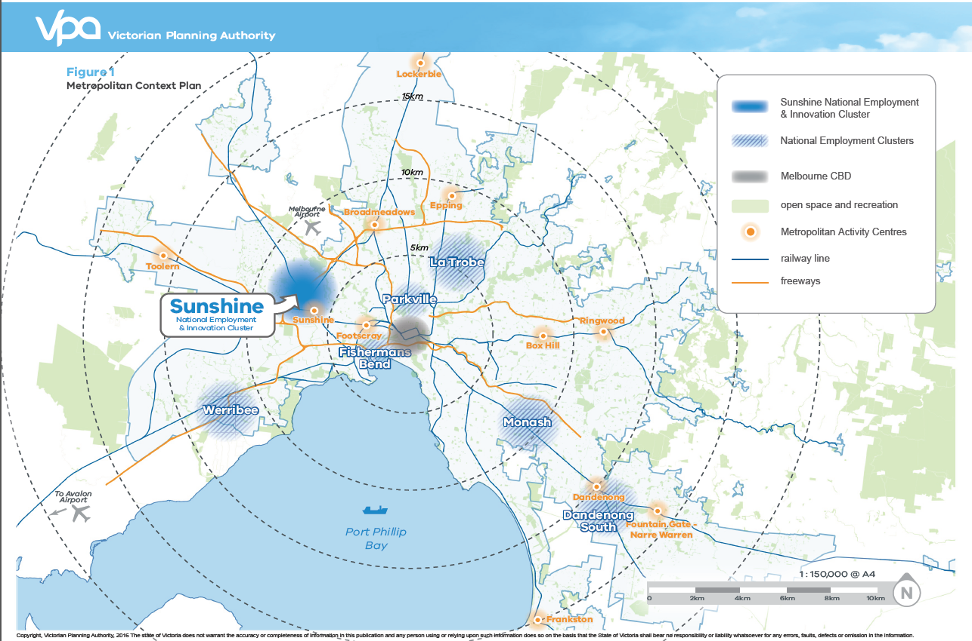

VISION
The Sunshine Cluster will build on its legacy of established public institutions, business services and transport connections to become the preferred location for healthcare services, medical research, education and training, transport, businesses and retail services in Melbourne’s west.
Sitting at the junction of key rail and road networks, the Sunshine Cluster is highly accessible and is perfectly placed to provide major public service facilities for the growth areas of Melton, Sunbury, Wyndham and beyond to the western region of Victoria.
New development will build on existing education and health facilities to generate new business opportunities and jobs in healthcare and education.
The Sunshine Cluster presents opportunities for residential growth and for new dwellings to be built for workers closer to jobs.
In addition to developing a broader range of services, the cluster will transform to provide a greater emphasis on innovation, liveability, attractiveness and environmental sustainability.

Man Lifting Cow, Sunshine
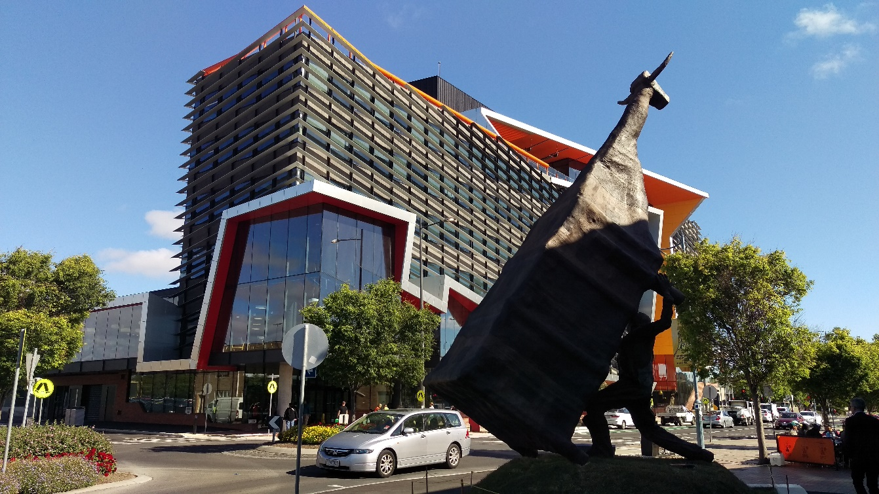

Figure 2 - Framework Plan
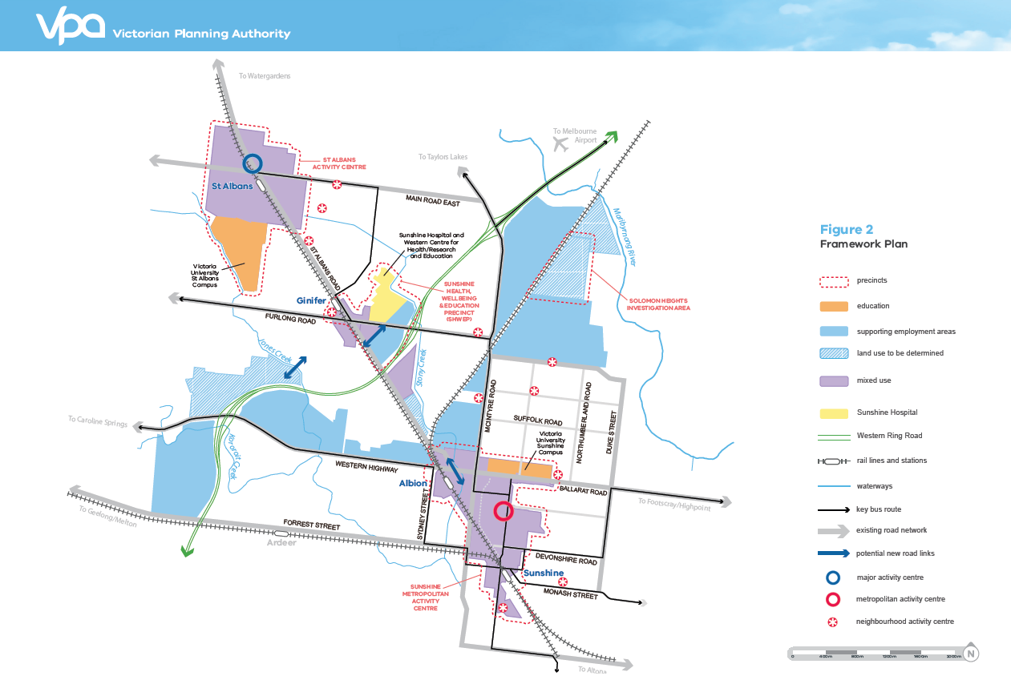

PRINCIPLES
The following principles provide government, investors, stakeholders and communities with a common understanding of the directions for implementing the vision. They serve as a guide for decision-making to help stakeholders to better understand the focus for changes in the Sunshine Cluster.
Facilitate increased employment and development, through amendments to the planning scheme and infrastructure investment in the Sunshine Cluster.
Use strategic redevelopment sites to expand the range of businesses and business services available to workers and residents.
Build stronger transport connections within the cluster and link it to the wider region to provide efficient access to employment, industry and regional infrastructure.
Improve the physical appearance and environmental sustainability of the Sunshine Cluster.
Provide a greater range of new housing stock and accommodation in locations that are well-served by transport and services.

Hampshire Road, Sunshine
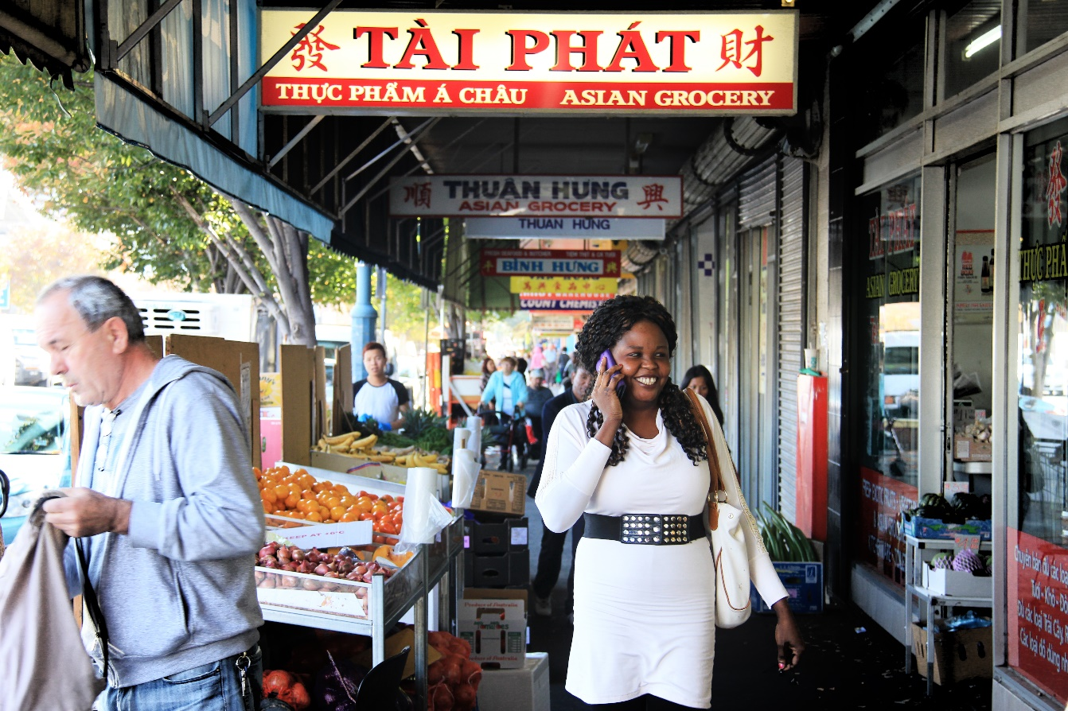

Figure 3 – Open Space and Trail Network Plan

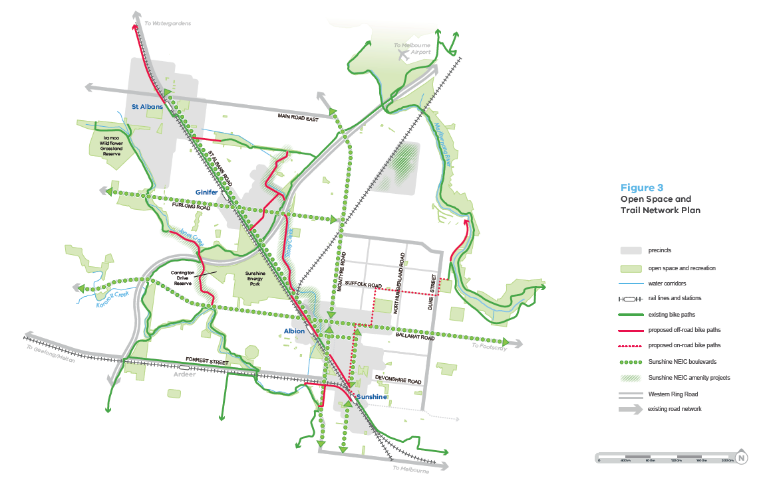

STRATEGIC OUTCOMES
Focused actions are necessary to realise the vision for Sunshine Cluster. The strategic outcomes below summarise the key actions that will assist in successfully bringing about the vision. These are further detailed overleaf.
Table 1- Strategic Outcomes

Strategic outcomes
SO1 | Utilise place-based management bodies to drive progressive improvements to job centres.
SO2 | Deliver an integrated transport network linking pools of workers with the key job centres in the Sunshine Cluster.
SO3 | Build key missing links in the shared trail and cycle path network.
SO4 | Facilitate amenity improvements through targeted works in the public realm.
SO5 | Unlock land for jobs through land use plans for key employment centres in the:  - Sunshine Metropolitan Activity Centre  - Sunshine Health, Wellbeing and Education Precinct (SHWEP)  - St Albans Major Activity Centre  - Solomon Heights Investigation Area

Sunshine Hospital, St Albans
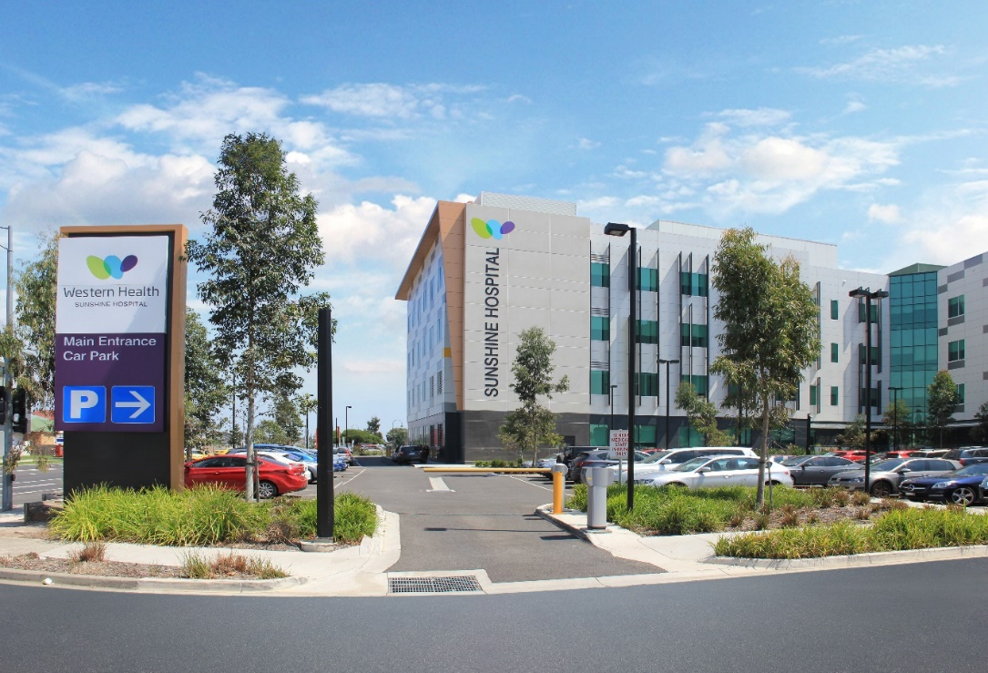

Strategic outcome 1: Utilise place-based management bodies to drive progressive improvements to job centres
Existing jobs are concentrated in the Sunshine Cluster around the key activity centres of Sunshine and St Albans, the Sunshine Hospital and in the traditional industrial areas of Sunshine North and along the Western Highway.
Jobs growth is forecast to increase significantly around Sunshine, St Albans and around the Sunshine Hospital.
There is a need to establish a strategy to coordinate development of the Sunshine Cluster as a whole, through identification of potential funding sources and key strategic redevelopment sites.
To better attract and coordinate development of the key job centres over time, the Department of Economic Development, Jobs, Transport and Resources (DEDJTR) will prepare a future employment and investment attraction strategy for the cluster.
Key employment precincts will utilise the successful partnership model established by Brimbank City Council for Sunshine and St Albans. New and existing management groups, comprising members from local businesses, institutions and local and state authorities, will oversee the implementation of land use and economic development plans for each of the centres, as well as promotion and investment attraction.
Actions
 |  | Time Frame | Lead agencies
1.1 | Prepare a future employment and investment attraction strategy to promote investment and renewal opportunities that target jobs. | Short | DEDJTR
1.2 | Identify priority infrastructure projects and potential funding streams to deliver infrastructure. | Short | BCC / VPA / DEDJTR
1.3 | Support the ongoing activities of the management boards in the precincts. | Short | BCC
1.4 | Develop a register of key strategic sites informed by a strategic assessment process. | Short | VPA / BCC
1.5 | Promote and facilitate investment in education, health and research within the Sunshine Cluster. | Medium | BCC/ DEDJTR
1.6 | Advocate for the accelerated delivery of NBN to support connectivity and innovation in the cluster. | Short | BCC

- VPA = Victorian Planning Authority
- BCC = Brimbank City Council
- DEDJTR = Department of Economic Development, Jobs, Transport and Resources

Strategic outcome 2: Deliver an integrated transport network linking pools of workers with the key job centres in the Sunshine Cluster
The Sunshine Cluster’s great strengths are its established transport links. The cluster is strongly connected to central Melbourne, the Port of Melbourne, Melbourne Airport and to the greater western Melbourne area by a well-developed network of major roads, including the M80 Western Ring Road, Ballarat Road and McIntyre Road.
The Melton and Sunbury train lines travel through the middle of the Sunshine Cluster, linking it directly to central Melbourne, Melbourne’s western growth areas and further afield, to regional Victoria’s largest cities.
High-frequency bus services can be enhanced to link the key job centres of the Sunshine Cluster with larger pools of potential workers in areas not on train lines, such as in Maidstone and Taylors Lakes. Together, these links provide considerable potential to move large numbers of workers directly and rapidly to jobs in the Sunshine Cluster.

Actions
 |  | Time Frame | Lead agencies
2.1 | Develop a grid of high-frequency bus routes that run through and link to key destinations and job centres in the Sunshine Cluster and surrounding areas. | Short | VPA / TfV
2.2 | Identify targeted infrastructure projects that improve the functioning of public transport. | Medium | VPA / TfV / BCC
2.3 | Consider funding options to build a new road and trail link between Foundry Road, Sunshine and St Albans Road, Sunshine North. | Medium | VPA / TfV / BCC
2.4 | Explore the potential for a new link across Kororoit Creek between the job centres of the Sunshine Health, Wellbeing and Education Precinct (SHWEP) and St Albans Major Activity Centre and the pool of workers living in the Caroline Springs and Burnside area. | Long | VPA / TfV / BCC
2.5 | Explore the potential for a new link across Jones Creek between Cairnlea and St Albans to link workers in Cairnlea and Deer Park to the SHWEP. | Long | VPA / TfV / BCC

- VPA = Victorian Planning Authority
- BCC = Brimbank City Council
- TfV = Transport for Victoria

Strategic outcome 3: Build key missing links in the shared trail and cycle path network

A number of important metropolitan trails run through the Sunshine Cluster, including the M80 Ring Road trail, the Maribyrnong River trail, Kororoit Creek trail and the Sunshine rail trail between Sunshine and Watergardens. These are supported by a developing network of dedicated, on-road bike lanes and local paths.
With cycling becoming an increasingly desirable way of commuting to work, and given the relatively flat topography of the Sunshine Cluster, there is real potential to improve the mode share of cycling trips as a proportion of journeys made to work.
Improvements to the path network will also provide better recreation opportunities for workers and other users of the Sunshine Cluster, particularly to access the parks and natural areas associated with the cluster’s waterways.
Several key missing links in this network reduce its present effectiveness, thereby reducing access to the job centres of the Sunshine Cluster. The Sunshine Framework Plan will focus on identifying the key missing links in the path and trail network with the view to funding new connections.

Actions
 |  | Time Frame | Lead agencies
3.1 | Investigate ways to provide a shared path link between the Sunshine Rail Trail in Albion and St Albans Road, Sunshine North. | Medium | VPA / BCC / TFV
3.2 | Investigate ways to provide a new shared path link along Stony Creek to join the M80 Ring Road shared path and transmission powerline linear reserve to the north in St Albans. | Short | BCC / VPA/ MW
3.3 | Investigate ways to extend the Maribyrnong River Trail (south side) from Braybrook to Sunshine via a new network of on-road cycle paths and off-road shared paths. | Medium | BCC / TFV / MW

- VPA = Victorian Planning Authority
- BCC = Brimbank City Council
- TFV = Transport for Victoria
- MW = Melbourne Water

Strategic outcome 4: Facilitate amenity improvements through targeted works in the public realm
Brimbank City Council and other agencies have identified the need for improvements in the visual presentation of the Sunshine Cluster as a high priority, with specific focus on increasing overall canopy tree cover.
Initiatives that can further reinforce the council’s tree planting program include promoting boulevard-style planting of major roads and improved planting of powerline easements and creek lines.
Public realm improvements are at the centre of council’s plans for the major centres of Sunshine and St Albans. In Sunshine, Council’s Hampshire Road Master Plan is progressively transforming the look and feel of the main street of Sunshine. The plan comprises a number of interrelated projects, including road works, the building of new footpaths, tree planting and the installation of public art.
Improvements to the Sunshine Cluster’s highly modified waterways are underway with the Upper Stony Creek naturalisation project. This project will restore a green corridor through the centre of the Sunshine Cluster. There is potential to extend this work to other reaches of the creek as well as to other creek lines in the Sunshine Cluster.
Relevant key water agencies in the cluster are investigating the potential for better use of water, including recycling and reuse of stormwater in public reserves.

Actions
 |  | Time Frame | Lead agencies
4.1 | Encourage widespread tree planting of publicly owned land throughout the Sunshine Cluster. | Short | BCC
4.2 | Plan and implement a network of boulevard style arterial roads throughout the cluster including: Ballarat Road/Western Highway, St Albans Road, McIntyre Road, Sunshine Road and Furlong Road. | Medium | VPA / TFV
4.3 | Work with responsible water authorities to develop an Integrated Water Management Plan for the cluster. | Medium | VPA / BCC / MW / CWW / DELWP
4.4 | Work with responsible water authorities to investigate the potential for naturalisation of highly modified reaches of Stony Creek and Jones Creek. | Long | BCC / MW / CWW
4.5 | Explore potential to increase open space, connections and other uses along Melbourne Water and transmission easements and through strategic site redevelopment. | Medium | BCC / MW / Powercor
- VPA = Victorian Planning Authority
- BCC = Brimbank City Council
- MW = Melbourne Water
- CWW = City West Water
- DELWP = Department of Environment, Land, Water and Planning
- TfV = Transport For Victoria
- Powercor = Powercor Australia

Strategic outcome 5: UNlock land for jobs through land use plans for key employment centres
Master planning for key jobs centres is central to the framework plan’s ambitions to drive jobs growth in the Sunshine Cluster. It is within the key centres of the Sunshine Cluster that the largest jobs growth is forecast. These areas tend to have the strongest transport connections, well-established business services, retail shops and large institutions.
Master plans such as structure plans provide the local community, government and the development industry great confidence about the vision, required infrastructure, desired future form and uses of land to shape future growth.
Structure plans have been completed for the established centres of Sunshine and St Albans. These two centres are strongly developed with key central city institutions and existing business services to build on and these land use plans will facilitate and guide future development approvals.
The Sunshine Health, Wellbeing and Education Precinct (SHWEP) is in the early stages of planning and envisages tremendous growth in jobs and businesses leveraging off the Sunshine Hospital.
Solomon Heights is an industrially zoned and subdivided area in Sunshine North that is yet to develop. Planning for this area will need to resolve a number of challenges to enable future development to proceed.

Actions
 | Action | Time Frame | Lead agencies
5.1 | Continue to implement the Sunshine Town Centre Structure Plan and Development Contributions Plan. | Short | VPA / BCC
5.2 | Prepare and implement a Comprehensive Development Plan for the Sunshine Health, Wellbeing and Education Precinct (SHWEP). | Medium | BCC / VPA
5.3 | Continue to implement the St Albans Major Activity Centre Structure Plan 2014. | Short | BCC
5.4 | Prepare and implement a structure plan for the Solomon Heights Investigation Area to guide its future use and development. | Long | BCC / VPA

- VPA = Victorian Planning Authority
- BCC = Brimbank City Council

Figure 4 – Key Employment Centres
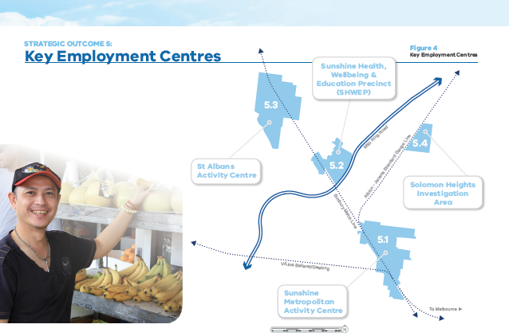

5.1 Sunshine Metropolitan Activity Centre
Key Information
- Size: 144 Ha

Key Elements

- Government service centre including Brimbank City Council offices, the Sunshine Leisure Centre, VISY Cares Hub, the Duke Street Community House, Sunshine Police Station and Courthouse, Centrelink and VicRoads;
- Victoria University’s Sunshine Campus;
- Two major shopping centres and an extensive traditional shopping strip along Hampshire Road;
- Existing schools, including Sunshine College (Senior) and Sunshine Primary School.

Long Term Vision
The Sunshine Metropolitan Activity Centre is a major commercial and retail centre that will cater for employment and residential growth by offering development opportunities in close proximity to existing transport links.
Development will be guided by the Sunshine Town Centre Structure Plan 2014 which customises land uses and sets preferred building heights to ensure Sunshine becomes one of Melbourne’s great centres to visit, shop, work, study and live in.
Current Status
The Sunshine Town Centre Structure Plan 2014 and Sunshine Town Centre Development Contributions Plan are completed.
Sunshine Rising (a town centre management and revitalisation program) will continue to coordinate council departments, the VPA and external agencies to realise the vision for the centre.

Actions
A | Implement the Sunshine Town Centre Structure Plan 2014 through planning approvals. | Short | BCC
B | Support the ongoing activities of the Sunshine Rising Partnership Group. | Short | BCC
C | Implement works on the public realm to provide for increased worker amenity, including streetscape improvements and ongoing works to implement the Hampshire Road Masterplan. | Medium | BCC

Figure 5-Sunshine Metropolitan Activity Centre
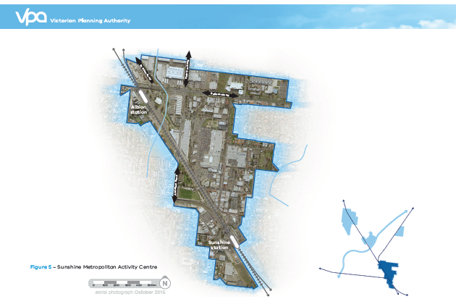

5.2 Sunshine Health, Wellbeing and Education Precinct (SHWEP).

Key Information
- Size: 50 Ha
Key Elements

- Sunshine Public Hospital;
- The Western Centre for Health, Research and Education (completed 2011) incorporating the University of Melbourne and Victoria University;
- The Joan Kirner Women’s and Children’s Hospital (to be completed 2018);
- Furlong Road level crossing removal and Ginifer Train Station redevelopment (completed 2017);
- Sunshine Private Hospital (approved).
Long Term Vision
The Sunshine Health, Wellbeing and Education Precinct (SHWEP) is envisioned as an integrated health and education precinct based around the Sunshine Hospital. The precinct aims to be recognised as a centre for excellence in medical treatment, health research, wellbeing, training and education. The precinct will provide for the needs of all workers, users and visitors to the precinct.
Future planning will identify new road and transport infrastructure to unlock investment and jobs. Planning will also promote the broadening of business services on offer to encompass increased training facilities, medical businesses, student and visitor accommodation, recreational trails and parklands, additional shops, cafes and restaurants.

Current Status
Preliminary investigations for a master plan for the precinct are being undertaken by the VPA in close collaboration with Brimbank City Council, Department of Health and Human Services, Western Health and Transport for Victoria.
The SHWEP Management Board was established in 2013 to advise Council and coordinate key institutions and the State Government.

Actions
A | Preparation of a Comprehensive Development Plan. | Medium | VPA
B | Preparation of an Infrastructure Contributions Plan or other equivalent funding mechanism. | Medium | VPA
C | Support the ongoing activities of the Sunshine Health, Wellbeing and Education Precinct Management Board. | Medium | BCC

Figure 6- Sunshine Health and Wellbeing Education Precinct Figure

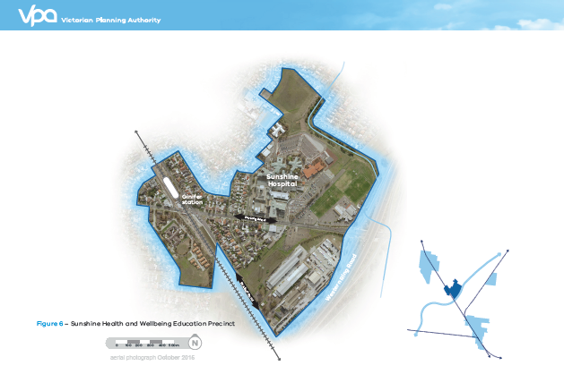

5.3 St Albans Major Activity Centre
Key Information
- Size: 144 Ha
Key Elements
- A traditional shopping strip centred on Alfreida Street;
- The St Albans campus of Victoria University;
- Council facilities including the St Albans Library, Errington Reserve and Alice’s play space, St Albans Community Youth Club Inc. (“The Tin Shed”) and Good Shepherd House;
- Public and private schools, including St Albans Secondary College, St Albans
- Primary School, Catholic Regional College, St Albans (Junior secondary campus) and Sacred Heart Primary School; and,
- Main Road level crossing removal and St Albans Train Station redevelopment (completed 2017).

Long Term Vision
Brimbank City Council’s vision is for St Albans to become a high-quality, people-focussed activity area with a defined sense of place while maintaining the feel of a local centre.
Council has recently revised and updated the St Albans Activity Centre Structure Plan 2025 (from 2011) to include changes to planning zones, design and development controls and includes references to the completed level crossing removal for Main Road.

Current Status
The St Albans Activity Centre Structure Plan 2025 is completed and provides a strategic and integrated plan for the future development of the St Albans Activity Area.
Council has established the St Albans Connect Partnership Group as an advisory group to Council, comprising membership from local residents, community organisations, traders, government agencies and service providers.

Actions
A | Implement the St Albans Activity Centre Structure Plan 2025 through planning approvals. | Short | BCC
B | Implement the Collins Street Master Plan to facilitate the development of a mixed use precinct within the structure plan area.  area. | Short | BCC
C | Support the ongoing activities of the St Albans Connect Partnership Group. | Short | BCC
D | Implement works on the public realm to provide for increased worker amenity. | Medium | BCC

Figure 7- St Albans Major Activity Centre
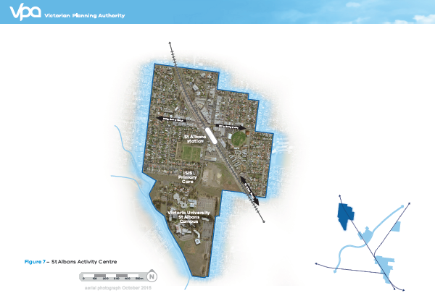

5.4 Solomon Heights Investigation Area

Key Information
Size: 32 Ha
Key Elements
- Vacant land that was subdivided in the 1920s
- No utility servicing
- Several significant native grassland patches containing several Matters of National Environmental Significance (MNES) including the Spiny Rice Flower and Striped Legless Lizard.
Long Term Vision
The plan will provide for the sustainable protection of nationally significant flora and fauna, whilst simultaneously enabling development.
Following resolution of a strategy to protect the MNES, a land use plan will be needed to enable integration between existing industrial areas to the south with the developing River Valley residential estate in the east.
Current Status
The Brimbank City Council is leading planning of the Solomon Heights area with assistance from the VPA to produce a Strategic Impact Assessment (to protect MNES is in perpetuity) for federal government approval under the Environment Protection and Biodiversity Conservation (EPBC) Act.

Actions
A | Secure Federal Government approval for a Strategic Impact Assessment to protect MNES in perpetuity. | Medium | BCC
B | Prepare a structure plan for the precinct, in partnership with key stakeholders and local authorities. | Long | BCC
C | Support the ongoing activities of the Solomon Heights Land Ownership Group. | Short | BCC

Figure 8- Solomon Heights Investigation Area

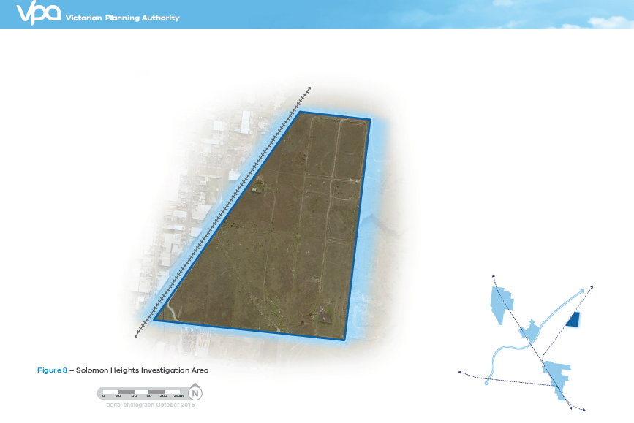

IMPLEMENTATION
 |  |  | Action |  |  | Timing |  |  |  | Lead Agencies
 |  | STRATEGIC OUTCOME 1: UTILISE PLACE-BASED MANAGEMENT BODIES TO DRIVE PROGRESSIVE IMPROVEMENTS TO JOB CENTRES
1.1 |  | Develop a future employment and investment attraction strategy for the Sunshine Cluster to promote investment and renewal opportunities that target jobs. |  |  |  |  | Short |  |  | DEDJTR
1.2 |  | Identify priority infrastructure projects and potential funding streams to deliver infrastructure to support implementation of the Sunshine Framework Plan. |  |  |  |  | Short |  |  | BCC / VPA / DEDJTR
1.3 |  | Support the ongoing activities of the management boards in the precincts. |  |  |  |  | Short |  |  | BCC
1.4 |  | Develop a register of key strategic sites informed by a strategic assessment process. |  |  |  |  | Short |  |  | VPA / BCC
1.5 |  | Promote and facilitate investment into education, health and research within the Sunshine Cluster. |  |  |  |  | Medium |  |  | BCC/ DEDJTR
1.6 |  | Advocate for the accelerated delivery of NBN to support connectivity and innovation in the Sunshine Cluster. |  |  |  |  | Short |  |  | BCC
 |  | STRATEGIC OUTCOME 2: DELIVER AN INTEGRATED TRANSPORT NETWORK LINKING POOLS OF WORKERS WITH THE KEY JOB CENTRES IN THE SUNSHINE CLUSTER
2.1 |  | Develop a grid of high-frequency bus routes that run through and link to key destinations and job centres in the Sunshine Cluster and surrounding areas. |  |  |  |  | Short |  |  | VPA / TfV
2.2 |  | Identify targeted infrastructure projects that improve the functioning of public transport. |  |  |  |  | Medium |  |  | VPA / TfV / BCC
2.3 |  | Consider funding options to build a new road and trail link between Foundry Road, Sunshine and St Albans Road, Sunshine North. |  |  |  |  | Medium |  |  | VPA / TfV / BCC
2.4 |  | Explore the potential for a new link across Kororoit Creek between the job centres of the SHWEP and St Albans Major Activity Centre and the pool of workers living in the Caroline Springs and Burnside area. |  |  |  |  | Long |  |  | VPA / TfV / BCC
2.5 |  | Explore the potential for a new link across Jones Creek between Cairnlea and St Albans to link workers in Cairnlea and Deer Park to the SHWEP. |  |  |  |  | Long |  |  | VPA / TfV / BCC
 |  | STRATEGIC OUTCOME 3: BUILD KEY MISSING LINKS IN THE SHARED TRAIL AND CYCLE PATH NETWORK
3.1 |  | Investigate ways to provide a shared path link between the Sunshine Rail Trail in Albion and St Albans Road, Sunshine North. |  |  |  |  | Medium |  |  | VPA / BCC / TfV
3.2 |  | Investigate ways to provide a new shared path link along Stony Creek to join the M80 Ring Road shared path and transmission powerline linear reserve to the north in St Albans. |  |  |  |  | Short |  |  | BCC / VPA/ MW
3.3 |  | Investigate ways to extend the Maribyrnong River Trail (south side) from Braybrook to Sunshine via a new network of on-road cycle paths and off-road shared paths. |  |  |  |  | Medium |  |  | BCC / TfV / MW
 |  | STRATEGIC OUTCOME 4: FACILITATE AMENITY IMPROVEMENTS THROUGH TARGETED WORKS IN THE PUBLIC REALM
4.1 |  | Encourage widespread tree planting of publicly owned land throughout the Sunshine Cluster. |  |  |  |  | Short |  |  | BCC
4.2 |  | Plan and implement a network of boulevard style arterial roads throughout the Sunshine Cluster including: Ballarat Road/Western Highway, St Albans Road, McIntyre Road, Sunshine Road and Furlong Road. |  |  |  |  | Medium |  |  | VPA / TfV
4.3 |  | Work with responsible water authorities to develop an Integrated Water Management Plan for the Sunshine Cluster. |  |  |  |  | Medium |  |  | VPA / BCC / MW / CWW / DELWP
4.4 |  | Work with responsible water authorities to investigate the potential for naturalisation for highly modified reaches of Stony Creek and Jones Creek. |  |  |  |  | Long |  |  | BCC / MW / CWW
4.5 |  | Explore potential to increase open space, connections and other uses along waterways and transmission easements and through strategic site redevelopment. |  |  |  |  | Medium |  |  | BCC / MW / Powercor
 |  | STRATEGIC OUTCOME 5: UNLOCK LAND FOR JOBS THROUGH LAND USE PLANS FOR KEY EMPLOYMENT CENTRES.
5.1 |  | Continue to implement the Sunshine Town Centre Structure Plan and Development Contributions Plan.
 | A |  |  | Implement the Sunshine Town Centre Structure Plan 2014 through planning approvals. |  |  |  | Short |  |  | BCC
 | B |  |  | Support the ongoing activities of the Sunshine Rising Partnership Group. |  |  |  | Short |  |  | BCC
 | C |  |  | Implement works on the public realm to provide for increased worker amenity. |  |  |  | Medium |  |  | BCC
5.2 |  | Prepare and implement a Comprehensive Development Plan for the SHWEP.
 | A |  |  | Preparation of a Comprehensive Development Plan. |  |  |  | Medium |  |  | VPA
 | B |  |  | Preparation of an Infrastructure Contributions Plan. |  |  |  | Medium |  |  | VPA
 | C |  |  | Support the ongoing activities of the Sunshine Health, Wellbeing and Education Precinct Management Board. |  |  |  | Medium |  |  | BCC
5.3 |  | Continue to implement the St Albans Major Activity Centre Structure Plan 2014.
 | A |  |  | Implement the St Albans Activity Centre Structure Plan 2025 through planning approvals. |  |  |  | Short |  |  | BCC
 | B |  |  | Implement the Collins Street Master Plan to facilitate the development of a mixed use precinct within the structure plan area. |  |  |  | Short |  |  | BCC
 | C |  |  | Support the ongoing activities of the St Albans Connect Partnership Group. |  |  |  | Short |  |  | BCC
 | D |  |  | Implement works on the public realm to provide for increased worker amenity. |  |  |  | Medium |  |  | BCC
5.4 |  | Prepare and implement a structure plan for the Solomon Heights Investigation Area to guide its future use and development.
 | A |  |  |  | Secure Federal Government approval for a Strategic Impact Assessment to protect MNES in perpetuity. |  |  |  | Medium |  | BCC
 | B |  |  |  | Prepare a Structure Plan for the precinct, in partnership with key stakeholders and local authorities. |  |  |  | Long |  | BCC
 | C |  |  |  | Support the ongoing activities of the Solomon Heights Land Ownership Group. |  |  |  | Short |  | BCC

Short Term: 1-5 years, Medium Term 6-10 years, Long Term 10+ years

- VPA = Victorian Planning Authority
- BCC = Brimbank City Council
- DHHS = Department of Health and Human Services
- TFV = Transport for Victoria
- DELWP = Department of Environment, Land, Water and Planning
- CWW = City West Water
- MW = Melbourne Water
- DEDJTR = Department of Economic Development, Jobs, Transport and Resources
- Powercor = Powercor Australia

APPENDIX

Plan Melbourne 2017-2020, Victorian State Government (March 2017).
Sunshine National Employment Cluster: Background Report, April 2015, prepared by Brimbank City Council.
Sunshine National Employment Cluster Public Engagement Outcomes Report, VPA (November 2016).

