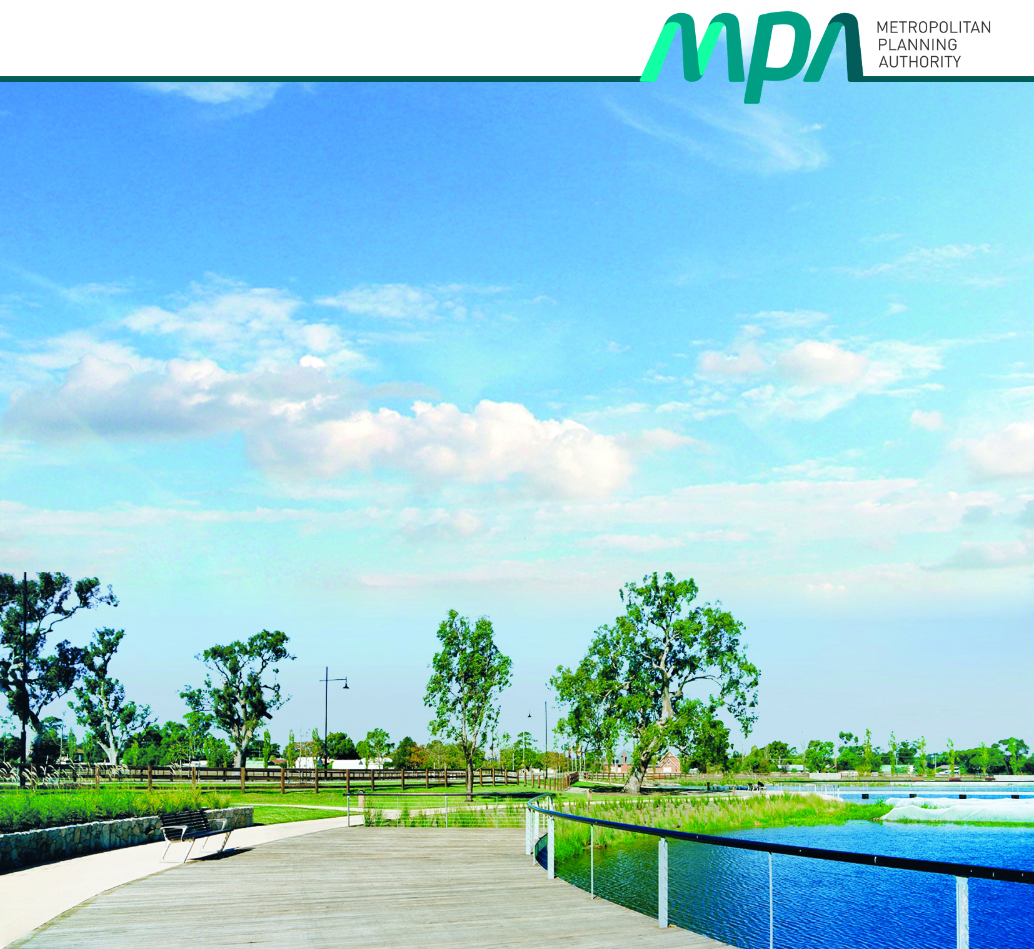
Disability Action Plan
2015 - 2018
Disability Action Plan
2015 – 2017

Contents
Foreword 3
About the Metropolitan Planning Authority 4
Background to MPA Disability Action Plan 4
MPA Approach 5
Outcome Area 1 6
Outcome Area 2 9
Outcome Area 3 11
Outcome Area 4 13
Monitoring & Evaluation 14
Staff Awareness Training – including actions under the DAP 15

Foreword
The Metropolitan Planning Authority (MPA) is committed to ensuring all people have access to our premises and are able to participate in community engagement and consultation activities. It is also important that people of all abilities can access information about our key planning projects as we work to plan for Victoria’s future.
As a progressive government agency, we pride ourselves on service excellence, innovation and continuous improvement. This includes ensuring that we have a comprehensive plan setting out how we can reduce barriers for those with a disability who wish to participate or engage with our key activities.
This Disability Action Plan has been developed in line with the MPA’s core values of:
- Leadership
- Professionalism
- Partnership (Collaboration and Influence)
- Responsiveness and Commitment
- Innovation, Drive and Enthusiasm
At the MPA, we believe it is good business practice to make reasonable adjustments for persons with disabilities. Actions set out in this plan apply to all aspects of our organisation, including employment, community consultation and planning for new communities as well as urban renewal and the evolution of regional centres.
The MPA looks forward to working with all members of the community over the next three years as we plan for new residential and commercial centres and the delivery of important infrastructure and services across Victoria.

Peter Seamer
CEO, Metropolitan Planning Authority

About the Metropolitan Planning Authority
The Metropolitan Planning Authority was founded in 2006 to plan for Melbourne’s growth, maintain a steady supply of quality housing and identify opportunities to create jobs and encourage investment to make sure Melbourne continues to be a great place to work and live. We work closely with Councils and local communities, other government agencies, landowners and developers to plan for strategically important precincts in inner and middle ring Melbourne, the growth areas and regional cities.
Our planning activities focus on ensuring key services are delivered and coordinating infrastructure delivery to support new communities and growing communities. Strategic long term land use planning covers business areas, residential areas, transport links and open space for parks and sports facilities, while protecting our built form and biodiversity sites.

Background to MPA Disability Action Plan
A disability action plan (DAP) is developed by organisations to identify and implement actions that ensure their facilities, services and programs do not treat people with a disability less favourably or exclude them.
Section 38 of the Disability Act 2006 requires all public sector bodies to develop, implement and monitor a DAP while reporting on its success in their annual report.
The act identifies four outcome areas that every DAP needs to address. These are;
- reducing barriers to persons with a disability accessing goods, services and facilities;
- reducing barriers to persons with a disability obtaining and maintaining employment;
- promoting inclusion and participation in the community of persons with a disability; and
- achieving tangible changes in attitudes and practices which discriminate against persons with a disability.
The Disability Act 2006 describes disability in relation to a person as;
(a) a sensory, physical or neurological impairment or acquired brain injury or any combination thereof, which—
- is, or is likely to be, permanent; and
- causes a substantially reduced capacity in at least one of the areas of self-care, self-management, mobility or communication; and
- requires significant ongoing or long term episodic support; and
- is not related to ageing; or
- an intellectual disability; or
- a developmental delay;

MPA Approach
An advisory group was formed from a diverse range of members across the Authority to ensure a broad spectrum of support and input. The advisory group was made up of eight members and included Directors, Structure Planners, Policy Planners, Community Planners, Graphic and Design Specialists, Communications and Corporate Services. The group split into smaller teams to focus on specific areas of expertise. Each team reviewed the current practices and policies in place at the MPA. The advisory group met monthly during the development of the DAP to report on the progress of its development and discuss ideas.
Once the plan was near completion, consultation with the Office for Disability was undertaken in order to ensure our DAP would be successful in addressing the issues set out in the Disability Act 2006.
Our DAP includes an organisational communication schedule to ensure we communicate expectations and outcomes with all staff. An initial survey of current staff attitudes and beliefs was conducted to identify areas to focus on. Another survey will be completed in 12 months’ time to evaluate the outcomes of the DAP.
Action items from this plan will be included as an item in future budgets as appropriate to ensure adequate support for the implementation of the plan.
The DAP was formally endorsed by the Executives at their meeting on 7 September 2015.

Outcome Area 1: Reducing barriers to persons with a disability accessing goods, services and facilities S 38 (1) (a)
Area of work | Current Status | Action | Implementation | Resources Required | Timeline | Responsible Person
1.1 Accessing our offices | Accessibility is managed by building management. | Audit our office accessibility and review options for;  - transport  - Public Transport – route options  - Car – accessible parking options  - Walking  - Taxis  - building access  - wheelchair access  - concierge assistance  - office entrance/reception  - public facilities  - meeting rooms  - acoustics, audio-visual facilities toilets | Collate information for the general public accessing our offices, but with a specific focus on relevant advice to provide extra assistance to those with a disability on:  - transport options  - building access  - facilities  A draft has been prepared, with approvals to modify the website to be finalised. | NA | Nov 2014  COMPLETED | Administration Assistant
1.1 Accessing our offices | Specific Issue
1.1 Accessing our offices | Evaluate accessibility in our building and office on:  - transport options  - building access  - facilities
1.2 Information to access our offices | No specific information to assist those with a disability to access the office. | Make information about accessibility to our office widely accessible to all our potential stakeholders through the provision of relevant information.  - transport options  - Public Transport – route options  - Car – accessible parking options  - Walking  - Taxis  - building access  - wheelchair access  - concierge assistance  - office entrance/reception  - public facilities  - meeting rooms  - acoustics, audio-visual facilities toilets | Get approval and post detailed information for the general public accessing our offices, with a specific focus on relevant advice to provide extra assistance to those with a disability on:  - transport options  - building access  - facilities  Information has been posted to our website. | NA | Nov 2014  COMPLETED | Administration Assistant
1.2 Information to access our offices | Specific Issue
1.2 Information to access our offices | Information needs to be made available on the website regarding:  - transport options  - building access  - facilities
1.3 Accessing Our Consultation Processes | Current Status | Ensure that when we go out into the community to consult, where practicable we do so in a way that allows everyone to participate in a way that meets their needs.  - location/accessibility  - consultation sessions in accessible locations  - online access to engagement  - facilities  - buildings with disabled access  - buildings with accessible facilities  - if catered, make allowance for special dietary needs  - materials  - appropriate audio-visual material  - appropriate hard-copy material  - trained & aware staff | Develop a package to assist those engaged in consultation to plan for maximising access to the MPA’s consultation programs through:  - Development of brief guidance material to assist practitioners  - Information/awareness sessions to include Advice on the issues and available material (see Organisational Implementation Plan)  - Development of a checklist to assist with planning and to monitor performance | N/A | April 2016 | Structure Planning Manager/ Community Engagement Advisor
1.3 Accessing Our Consultation Processes | While the MPA undertakes some targeted consultation in preparing precinct plans and is required to deliver statutory consultation as part of formal planning scheme amendment/permit processes, no specific attention or training has been made to improving universal access to our consultation processes.
1.3 Accessing Our Consultation Processes | Specific Issue
1.3 Accessing Our Consultation Processes | - materials  - location/accessibility  - facilities
1.4 Accessing Our Website | Current Status | Ensure our website is accessible to as many users as is practical through utilising appropriate design standards.  - accessible layout  - simple  - intuitive  - good search function  - accessible design  - appropriate colour schemes  - scalable fonts/images  - reader compatible  - downloads  - suitable document sizes  - readable formats  - access to alternatives  - link to access address | Updating the website itself will be undertaken progressively to ensure appropriate accessibility. This will involve four main areas:  - Look & feel of the website itself;  - Inclusion of tailoring (e.g. font resizing) capabilities within the site;  - Ensure compatibility with screen reader technology  - Updated advice regarding accessing MPA material via the web, including retaining link to accessibility@mpa.vic.gov.au;  - Ensuring material made available for downloading is accessible (see 1.4) through management of file sizes, types and formats |  | June 2016  June 2016  June 2016  June 2016  June 2016 | Community Engagement Advisor  Community Engagement Advisor  Community Engagement Advisor  Community Engagement Advisor  Community Engagement Advisor
1.4 Accessing Our Website | Website is only partially compliant with visual accessibility standards.  Website does include a link to accessibility information, including a link to the accessibility@mpa.vic.gov.au email account that allows those with accessibility issues to seek information in suitable formats.
1.4 Accessing Our Website | Specific Issue
1.4 Accessing Our Website | - accessible layout & design
1.5 Accessing Our Documents | Current Status | Ensure all documents prepared by or for the MPA are accessible through ensuring appropriate design standards are utilised.  - Electronic Documents  - accessible language suitable to the audience/subject  - accessible design according to standards  - file sizes  - alternative formats in readable format  - 100% of consultant reports in accessible format  - Hard Copy Documents  - accessible language suitable to the audience/subject  - accessible design according to standards  - 100% of consultant reports in accessible format | As part of a more general action to improve the look & feel of MPA documents, as well as improving consistency and quality control, greater attention will be paid to ensuring consistent application of accessibility guidance. This will include:  - Development and confirmation of standard accessible formats, colours, layouts, etc. for statutory documents in Adobe pdf format (including urban structure and supporting maps)  - Development and confirmation of standard accessible look & feel, formats, colours, layouts, etc. for non-statutory MPA documents in Adobe pdf format  - Development and confirmation of standard text-to-speech reader compatible Microsoft Word templates for use as alternatives to Adobe pdf format downloads  - Managing Adobe pdf file sizes through splitting documents to generally meet guidance along with the provision of text-to-speech readable documents  - Inclusion of alternative text for diagrams, maps and tables in all publicly available documents  - Provide awareness and use training as required to ensure uptake of the revised approaches  - Develop and arrange a training program for staff who author publicly accessible documents in writing in plain English (see Organisational Implementation Plan)  - Ensure standard RFQ templates specifically include appropriate requirements of contractors that will be providing reports that are to be publicly available to ensure they are appropriately accessible | May require some external advice or review to ensure full compliance.  May require some external advice or review to ensure full compliance.  May require some external advice or review to ensure full compliance.  NA  NA  Organisational communication schedule  Included in staff development  NA | June 2015  COMPLETE  June 2016  June 2016  Ongoing  June 2015  COMPLETE  Ongoing  Ongoing  June 2015  COMPLETE | Graphic & Design Specialist  Graphic & Design Specialist  Graphic & Design Specialist  Graphic & Design Specialist  Graphic & Design Specialist  Human Resources Coordinator  Human Resources Coordinator  Director Technical Services
1.5 Accessing Our Documents | Most material is at least somewhat accessible, however full compliance with accessibility guidance, including provisions of alternative formats, is not yet universal.
1.5 Accessing Our Documents | Specific issue
1.5 Accessing Our Documents | - accessible design  - file size  - printed versions  - alternatives

Outcome Area 2: Reducing barriers to persons with a disability obtaining and maintaining employment S 38 (1) (b)
Area of work | Current Status | Action | Implementation | Resources Required | Timeline | Responsible Person
2.1 Emergency Policies around disability | Fire wardens are verbally trained in what to do when staff are physically unable to evacuate the premises. | Document and train relevant personal in the event of an emergency evacuation for individuals with a disability. | Create procedure. | Organisational communication schedule | February 2015  COMPLETED | Human Resources Coordinator
2.1 Emergency Policies around disability | Specific Issue
2.1 Emergency Policies around disability | Currently no documented procedure for evacuating individuals with a disability in an emergency.
2.2 Staff Wellness initiatives (targeted towards persons with a disability) | Current Status | Source Information on fitness programs for staff in order to increase their physical activity and stay healthy.  Explore option for adjustable desks to decrease sedentary activity and to cater for employees with specific requirements. | Continuously investigate and communicate to staff ideas and opportunities available to encourage them to be healthy and active, including disability friendly options. | NA | Ongoing | Human Resources Coordinator / Accounts Officer
The MPA currently provides the following services to all staff;
Annual Flu shots
Employee Assistance Program
Work health checks
Ergonomic Assessments
Access to discounted private health

 | Specific Issue
 | Ensure the continuous improvement of wellness initiatives within the organisation.
2.3 Recruitment procedures | Current Status | Collating information regarding organisations which support people with a disability gaining and maintaining employment.  Explore opportunities for people with disabilities to enter the workforce through traineeship programs  Amend Recruitment Policy to ensure external advertisements are placed on www.careers.vic.gov.au which provides accessibility options | Report to the CEO and executives on the findings of the research.  Report to the CEO and executives on the findings of the research.  Update in Records Management System | NA  NA  NA | December 2015  December 2015  January 2015  COMPLETE | Human Resources Coordinator
2.3 Recruitment procedures | Current recruitment policy does not include practices which excludes recruitment of people with a disability.
2.3 Recruitment procedures | Specific Issue
2.3 Recruitment procedures | Ensure our recruitment policies and procedures do not unfairly treat people with a disability who are both current, potential and future staff.
2.4 Reasonable adjustment on disclosed disabilities | Current Status | Revise the current policy to be approved by the CEO. The Policy outlines the MPA’s procedures surrounding disclosure of a disability and reasonable adjustments. | Approval by CEO and Executives required. | NA | October 2015  COMPLETE | Human Resources Coordinator
2.4 Reasonable adjustment on disclosed disabilities | The Equity, Anti-discrimination and Diversity Policy addresses reasonable adjustment at a high level.
2.4 Reasonable adjustment on disclosed disabilities | Specific Issue
2.4 Reasonable adjustment on disclosed disabilities | No detailed policy regarding reasonable adjustments and disclosure of a disability
2.5 Training for recruitment selection panels | Current Status | HR to provide selection panels with best practice information on interviewing and recruiting people with a disability and best practise for working with employees with a disability. | HR involvement in the interview process to ensure that best practice is followed. More information can be provided to panels where applicable. Consultation with disability peak bodies will be undertaken where required. | NA | Ongoing | Human Resources Coordinator
2.5 Training for recruitment selection panels | No information collated on best practice when recruiting and working with staff with a disability
2.5 Training for recruitment selection panels | Specific Issue
2.5 Training for recruitment selection panels | HR and Managers should be aware of best practise when recruiting and working with staff with a disability.

Outcome Area 3: Promoting inclusion and participation in the community of persons with a disability S 38 (1) (c)
Area of work | Current Status | Action | Implementation | Resources Required | Timeline | Responsible Person
3.1 PSP guidelines | PSP Guidelines under review. | Deliver a review of the PSP Guidelines for Growth Areas and include new Guidelines for regional cities and towns and urban renewal areas  Workshop  Transport Planning Manager to Engage Heart Foundation and tap into their research into what influences walkability/ accessibility, to advocate to VicRoads or (Councils for local streets) around better outcomes for street designs, and specifically roundabouts as a first stage. | Universal Design Facilitator at DHHS (Sport and Recreation Victoria) to review as part of PSP Guidelines engagement phase.  Improve designs of roundabouts to improve walkability and cycling safety and include in PSP Guidelines | NA  NA | Mid 2016  Seek reforms to current approaches by November 2015. | Policy Manager  Transport Planning Manager
3.1 PSP guidelines | Specific Issue
3.1 PSP guidelines | In reviewing the PSP Guidelines, consider whether they sufficiently deliver places for people with varying abilities.  Review of use of, and/or design of roundabouts for universal access. Roundabouts typically prioritise car movement and are often less safe for pedestrians (including people with walking frames, wheelchairs and electric scooters).
3.2 Infrastructure Contribution Plans | Current Status | The proposed list of community infrastructure for the ICP can allow for public toilets within community infrastructure. We need to ensure that this can include either stand alone public toilets or public toilets within community facilities that are accessible to all members of the general public. | Work with DELWP to ensure that the provision of public toilets is recognised in an ICP.  Ensure that PSPs include the provision of either accessible public toilets in community facilities or accessible standalone public toilets. | NA  - | On Hold until implementation of ICP is identified as priority project for government | Structure Planning Manager  Work with internal specialist to provide guidance in ICP Practice Note or similar.
3.2 Infrastructure Contribution Plans | ICP legislation yet to pass through Parliament.
3.2 Infrastructure Contribution Plans | Specific Issue
3.2 Infrastructure Contribution Plans | Adequate provision of public toilets removes a barrier for people with disabilities to visit and use public places such as parks.
3.3 Housing for people with disabilities | Current Status | MPA could proactively engage with social housing providers, and facilitate connecting them with developers at relevant times in the planning process (especially where MPA is the Responsible Authority).  For example: MPA has facilitated a potential partnership with developers and the Summer Foundation (a foundation that provides housing for young people with disabilities). | Develop a transparent EOI process that would enable Housing associations and Housing providers to express interest in forming partnerships with developers in areas where MPA is planning for growth. | NA | Subject to Board direction and clarification from the Minister for Housing and Minister for Planning about Government role to facilitate additional affordable housing in MPA precincts. Potentially – develop a process by January 2016 | Senior Community Infrastructure Planner
3.3 Housing for people with disabilities | Pending Ministerial direction about MPA role to address this issue
3.3 Housing for people with disabilities | Specific Issue
3.3 Housing for people with disabilities | Housing for people with disabilities is becoming harder to provide in good locations (accessible to public transport, shops, family/ friends).
3.4 Consideration of Disability inclusion at project inception stage to assist with whole of MPA cross- organisational buy in and awareness | Current Status | There is an opportunity during project scoping to think about how disability inclusion could be considered within projects.  Awareness raising - have guest speakers raise awareness about living/working with disabilities. Ask staff for their interest in learning about disability types eg what would staff like to hear from people with different disabilities. | Endorse one Director to workshop with all Directors a process to ensure that Disability inclusion is included at project scoping stage. This could be included in MPA’s project management framework.  Develop a program of speakers over the coming years to talk with staff about living and working with disabilities. | NA  NA | Ongoing  Ongoing | Director Technical Services  Human Resources Coordinator
Currently the DAP is being over seen by a committed working group. This does not mean there is whole of organisation buy-in.
No formal process currently exists at Director level to ensure consideration of disability inclusion is considered at project inception stage
 | Specific Issue
 | Nominate Director Technical Services to work with MPA executive to ensure that staff think through disability inclusion at project inception stage

Outcome Area 4: Achieving tangible changes in attitudes and practices which discriminate against persons with a disability S 38 (1) (d)
Area of work | Current Status | Action | Implementation | Resources Required | Timeline | Responsible Person
4.1 Current Staff Attitudes | The MPA currently has the following policies - Equity, Anti Discrimination and Diversity Policy  Anti Bullying Policy  Charter of Human Rights training | Consult with the Office for Disability to provide a survey to current employees to gauge current standard of understanding and attitudes towards persons with a disability in order to identify formal training needs | Engage external organisation to provide advice and guidance on the content of the survey and how the results will be meaningful to the MPA  Conduct another survey 12 months later to measure the effectiveness of the DAP actions | $TBC | January 2016  January 2017 | Accounts Officer
4.1 Current Staff Attitudes | Specific Issue
4.1 Current Staff Attitudes | Need to gauge level of awareness and understanding of current staff when it comes to disability
4.2 Training Needs | Current Status | Using the results from the above survey identify which specific areas require training (refer also 3.4 above). Investigate and run a small interactive training sessions and also provide routine updates regarding the DAP at staff meetings. | Organise and schedule training sessions where required for staff | Training Consultant ($TBC) | February 2016 | Accounts Officer/ Human Resources Coordinator
4.2 Training Needs | No formal training program for staff about disability
4.2 Training Needs | Specific Issue
4.2 Training Needs | All staff need to be aware of the MPA’s policies and their responsibilities when dealing with persons both internally and externally with a disability
4.3 Inclusivity Initiatives | Current Status | Set up a Staff Social Group which will be responsible for continuing with organising staff activities to continue to encourage participation of all staff ensuring a culture of inclusion. | Ask staff to volunteer to participate in the Staff Social Group. Devise Terms of Reference for the committee with CEO approval. | NA | January 2016 | Accounts Officer/ Human Resources Coordinator
4.3 Inclusivity Initiatives | Social activities are run and arranged through HR
4.3 Inclusivity Initiatives | Specific Issue
4.3 Inclusivity Initiatives | Increasing the number of individuals involved will help improve the quantity and diversity of the activities to be attainable to persons with a disability
4.4 Staff Interaction and participation | Current Status | At any identified training sessions feedback will be elucidated from attendees and recommendations to management will be prepared were appropriate. | Develop feedback forms to distribute to staff at conclusion of training. Create template for report feedback to management. | NA | February 2016 | Accounts Officer/ Human Resources Coordinator
4.4 Staff Interaction and participation | Staff may have great ideas about initiatives for disability but we are not facilitating the capture of these organisationally
4.4 Staff Interaction and participation | Specific Issue
4.4 Staff Interaction and participation | No formal/informal processes in place which encourages and allows employees express their ideas and initiatives for disability.

Monitoring & Evaluation
A key step in ensuring implementation of the DPA is regular review. This will involve:
- 6 month review - Report progress to Executive and the Authority
- Annual review - Report progress to Executive , the Authority and in the annual report
The plan has a life of three years and at the end of this period will be replaced by a new three year plan. During the life of the current plan, it is intended that entire DAP committee will be replaced gradually with new members to ensure wider organisational participation. As a result of the phased election program, we will have a new committee of six staff to carry on the work of the DAP in the future.
Timeline for new DAP committee.
When | What | Where | Who
March 2016 | Recruit one new DAP members – 2 current members to retire | MPA | DAP Committee
September 2016 | Recruit two new DAP members – 3 current members to retire | MPA | DAP Committee
March 2017 | Recruit two new DAP members – 3 current members to retire | MPA | DAP Committee
September 2017 | Recruit one new DAP members – 2 current members to retire | MPA | DAP Committee

As the MPA’s precinct planning is a key organisational output, a review of the outcomes of precinct plans will be undertaken before the expiry of the plan to assess the success of actions under Outcome Area 3 and guide any future updates of Precinct Structure Planning Guidelines.
One year after the first survey of staff awareness and attitudes, another survey will be conducted to measure changes in perceptions resulting from the actions within the DAP.
Accessibility guidelines will be reviewed every six months to ensure we are keeping up to date with the latest standards.

Staff Awareness Training – including actions under the DAP
When | What | Where | Who
February 2015 | Ensure fire wardens and admin staff are aware of the procedure when evacuating people with a disability | MPA | Fire Wardens/Admin Staff
January 2016 | Disability awareness training - Conduct small training sessions and commence invited speaker program based on the results of the organisation Disability Awareness survey | MPA | All Staff
January 2016 | Communicate revised approaches to document accessibility | MPA | All Staff
March 2016 | 6 Month Review – Report progress to staff  Communicate updated consultation processes to staff | Staff Meeting | All Staff
June 2016 | Report in Annual Report | MPA | NA
January 2017 | Annual Disability awareness training | Staff Meeting | All Staff
January 2018 | Annual Disability awareness training | Staff Meeting | All Staff

