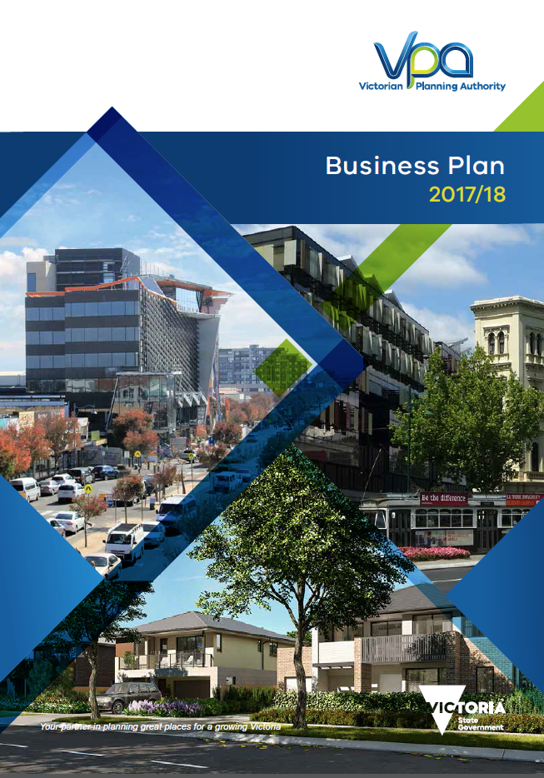

Minister for Planning
Victoria is experiencing a period of unprecedented growth, and to meet this growth Victoria needs integrated land use planning. This government is committed to delivering improved land use and infrastructure planning to support Victoria’s growth.

With the assent of the new Victorian Planning Authority Act 2017, the government has been successful in implementing its election commitment of establishing a new Victorian Planning Authority (VPA). The VPA will lead the strategic land-use planning in designated areas to ensure effective planning for Victoria’s growth and liveability. The new VPA is to ensure that strategic land-use planning in Victoria is holistic and aligned.
The new legislation provides a clear operating framework for the Authority, increases the experience and skill level required for Board Members and puts in place important protections for the Victorian community, by strengthening the conflict of interest provisions.

The new VPA will play a key role in working with the Department of Environment, Land, Water, and Planning (DELWP) in implementing the government’s refreshed Plan Melbourne 2017-2050.

Recognising the challenges and opportunities presented to Victoria in the current population boom, our metropolitan planning strategy Plan Melbourne 2017-2050 is designed to give Victoria the certainty it needs to grow stronger and fairer. In the associated Implementation Plan, the new VPA has been given the responsibility as the lead or joint lead agency for 11 significant actions, and named as an implementation partner for 41 other actions.

During 2016/17 the VPA commenced the government’s $4m Streamlining for Growth program. This proved to be very popular and successful, and as a result of that outcome the government has extended this program. The VPA will now be co-ordinating the allocation and expenditure of a further $5 million per annum for each of the coming three years, through our Homes for Victorians strategy. The projects that will be funded will be across Victoria, in the regional cities, Melbourne’s greenfield growth areas, and in areas of urban renewal.

I have charged the VPA Board with ensuring the smooth transition from the former Growth Areas Authority.

In relation to personnel, the government appointed the very well regarded and extensively experienced Ms Jude Munro AO in December 2016 to lead the new Authority. One of the Board’s major roles has been to seek a new Chief Executive Officer to replace the Peter Seamer. I wish to recognise the significant contribution that Mr Seamer has made to both the Authority and to the people of Victoria for his many years of valuable public service.

In June 2017, experienced planning expert and public servant Stuart Moseley commenced as the new Chief Executive Officer of the Victorian Planning Authority.

Stuart Moseley’s long list of achievements, experience and commitment to innovative solutions, will be a great asset for the VPA as it sets out to plan for a strong and sustainable Victoria for many decades to come.

The VPA’s program, as outlined in this Business Plan for 2017-18, is broad and very exciting, and I am confident the Authority will liaise closely with all stakeholders to make Melbourne and greater Victoria an even better place to live and work.

The Hon. Richard Wynne MP
Minister for Planning

Contents

Foreword – Chair and Chief Executive Officer 2
Our role 2
Our future focus 4
Our organisation 5
Our strategic framework 6
VPA Objectives 6
VPA Vision 6
VPA Mission 6
VPA Values 6
Our Strategy on a Page 7
Delivering on our strategic outcomes 8
Our key performance measures for 2017/18 10
Our work program 13
Metropolitan Melbourne current work program 13
Regional Victoria current work program 14
Our prioritised annual work program 15
(This program is subject to review) 15
Our resources 21
Attachment A: Minister’s Direction to the VPA 23

Foreword – Chair and Chief Executive Officer
Welcome to the Victorian Planning Authority’s (VPA’s) Business Plan for 2017-18. Our legislation, the Victorian Planning Authority Act 2017 (the Act), commenced on 1 July 2017, giving the VPA a primary object to provide advice and assistance to the Minister for Planning, Councils and other government agencies in accordance with the objectives of land use planning in Victoria.
The creation of the VPA is one of the most substantial reforms in Victorian planning history. It represents a clear opportunity to assist in addressing the long term challenges and opportunities of population growth, climate change and global economic trends. The Board and the Executive are very pleased to be able to implement the transition to the VPA.
We are transitioning from the Growth Areas Authority to the VPA. Through our Strategic Plan 2017-2020, we are focusing on delivering our strategic outcomes. Our stakeholder engagement and collaboration plan provides a clear direction on how the Authority will engage, consult and establish systems of cooperation, and maintain strong and effective relationships with all stakeholders.
The VPA undertakes integrated land use and infrastructure planning, and coordinates state government action in relation to planning the use, development and protection of land in areas designated by the Minister for Planning, including:
- Urban renewal sites and areas, such as the Arden precinct, site of a new Melbourne Metro Station
- National Employment and Innovation Clusters (NEICs), strategic redevelopment sites in Melbourne’s inner and middle ring suburbs
- Melbourne’s greenfield growth areas; Wyndham, Melton, Sunbury, Hume, Mitchell, Whittlesea, Casey and Cardinia
- Areas in regional cities and towns, such as Bendigo, Wodonga and Shepparton.
Our role
Our Business Plan for 2017-18 articulates how we will deliver the first 12 months of the VPA Strategic Plan 2017-2021, incorporating our strategic framework. This Business Plan includes the new priorities set out by the Minister for Planning, the Hon. Richard Wynne MP, in his VPA - Statement of Expectations and Directions for the 2017/18 Financial Year, as well as those actions and projects already authorised and underway.
Key priorities set for the VPA by government for 2017-18 are:
- Implementing Plan Melbourne and Homes for Victorians
- Planning for the zoning of 100,000 new residential lots in Melbourne’s growth areas by December 2018
- Stronger and more effective engagement and capacity building
- Completing the organisational transition from the MPA to the VPA.
Our prioritised work program (refer page 15) incorporates these priorities and identifies the specific projects that are to be progressed during this financial year. Further information on our work program, including changes that may be required through the year, will be periodically updated on the VPA’s website.
Implementing Plan Melbourne 2017-2050
The VPA has a lead role in planning for the delivery of Plan Melbourne 2017- 2050. Of the 112 actions listed in the plan, the VPA is nominated as lead / joint lead agency for 11 actions and these are separately identified in the Prioritised Annual Work Program.
The VPA’s role is part of a whole of government approach to ensure that Melbourne continues to be a global city of opportunity and choice. The focus for our planning through Plan Melbourne 2017- 2050 is to:
- Protect Melbourne’s environment, biodiversity, and natural assets, and plan for climate change
- Provide for new housing in the right places with the right services and infrastructure
- Grow and link job clusters in the suburbs to better transport infrastructure and services
- Provide for a wide range of affordable and accessible housing
- Provide for a more integrated and efficient road and public transport network
- Develop a city of 20-minute neighbourhoods that are accessible by walking, cycling and by short public transport trip.
In summary, the VPA has the lead role in preparing planning frameworks that will ensure that identified growth areas are made development-ready. We will deploy meaningful engagement methods, efficient and effective processes and nation-leading professional skills to ensure that growth delivers the best possible outcomes for Victorian communities.
The VPA is an implementation partner for a number of other Plan Melbourne actions. We will play an active role in these projects. The full extent of the VPA’s role in each of these specific activities will be defined in association with our partners and the Minister for Planning. Generally, our role will be to advise on, and support, the planning and delivery frameworks required to ensure that these actions are delivered.
Over the coming year, the VPA will work with the Department of Environment, Land, Water and Planning (DELWP) and the Minister for Planning to define the extent of these and other actions, and to develop an action plan for their implementation.
Implementing Homes for Victorians
The VPA has a key role in implementing the state government’s affordable housing strategy, Homes for Victorians, by completing 17 residential precinct structure plans by the end of 2018 to add an additional 100,000 residential lots and maintain a 15 year land supply in Melbourne’s growth corridors.
In addition, the VPA will deliver the government’s streamlining for growth program (see below) to help improve the supply of lots to the market and hence assist in reducing upward pressure on land and housing prices.
The VPA will assist the government to develop new planning tools to increase the supply of affordable housing and will work with the development industry and housing providers to apply these tools in urban renewal settings in particular.
Streamlining for Growth
The VPA has a key role in building the capacity and efficiency of planning practice and frameworks with the goal of increasing the supply of housing and employment land through faster planning approvals.
In late 2015, the government allocated the VPA an initial amount of $4 million to provide support to Councils in Metropolitan Melbourne and regional Victoria to assist them in delivering better and more timely planning outcomes. This program has proved very popular with councils and the government has extended the program by an additional $16.4 million, allocated over a four year period.
For 2017/18 and for each of the subsequent two years the VPA has been allocated $5.1 million to progress this significant initiative by targeting:
- Established areas of Metropolitan Melbourne
- Metropolitan Melbourne’s Greenfield Growth Areas
- Metropolitan Strategic sites for redevelopment
- Regional Victoria
- Streamlining of post-PSP planning approvals
The results of the Streamlining for Growth program for each year will be published in the VPA’s annual report.
Whole-of-government priorities
As a key element of our role, the VPA works across government to identify synergies and opportunities to link priorities. This includes collaborating with organisations while maintaining accountability to the Minister for Planning, delivering programs in a coordinated way, improving engagement with individuals and communities, and enabling effective responses to emerging issues.
We focus on the economic, social and environmental priorities of government that influence our work. We recognise that our infrastructure needs in Melbourne and Victoria are changing with strong population and jobs growth and a changing workforce. Our prosperity, liveability and productivity outcomes all rely on a Victoria that is well-connected within Melbourne, between our cities across the state, and to national and international gateways.
Victoria's Climate Change Framework articulates the government's long-term vision and approach to climate change, whilst Water for Victoria is a plan for a future with less water as Victoria responds to the impact of climate change and a growing population. Protecting Victoria’s Environment – Biodiversity 2037 is Victoria’s plan to stop the decline of our native plants and animals and improve our natural environment so it is healthy, valued and actively cared for.
Victoria’s Regional Statement outlines the government’s commitments and investments for regional Victoria. It’s about supporting a brighter future for regional Victoria by growing jobs and boosting infrastructure. Victoria’s Regional Network Development Plan sets out regional public transport priorities to suit different needs of each region.
These and other government strategies all influence the outcomes that VPA is seeking through our planning.

Our future focus
In delivering this Business Plan, we will continue to influence and inform best practice by partnering with government agencies at State and local level, including building capacity, improving systems and reducing red-tape, to deliver an integrated approach to place-based planning. We will consider wider economic, social and environmental objectives – including objectives of other agencies as they may relate to the precinct or project under consideration. We will also consider future needs and requirements, intergenerational equity and environmental justice.
Our aim is to work in collaboration with our stakeholders and the community through public participation and engagement, sharing of information, and harnessing expertise and resources. The Board and Executive will continue to ensure that there is a common understanding across government and stakeholders of the different and complementary roles of the VPA, DELWP and related government agencies.
The VPA is proud of our people and we are investing in their development, capability and continued visible presence in the community.
The Board will continue to seek to reinforce the separation of the governance from the operation of the organisation and to streamline the operations of the Board and of the Board Members. Over the coming year, the Board and Executive will focus on improved evidence based reporting and trend analysis.
With an enviable track record of delivering quality growth outcomes, a new legislative platform, a strong reform agenda and clear mandate from government, 2017-18 will be a year of evolution and continued delivery. We will leverage our outstanding track record of achievement to deliver the broader and stronger planning outcomes that we have been tasked to deliver.
To do this, we will need not only to deliver on our business plan, but to ensure we are looking to the future. Through early identification of new trends and technology, and by assessing and enhancing the potential future outcomes of innovative new forms of development, we will build our capacity to inform – as well as deliver on – Victoria’s future growth.
The VPA looks forward to working closely with our partners and stakeholders over the course of the 2017/18 year to deliver against the outcomes set out in this plan.

Jude Munro AO  Chair | Stuart Moseley  Chief Executive Officer

Our organisation

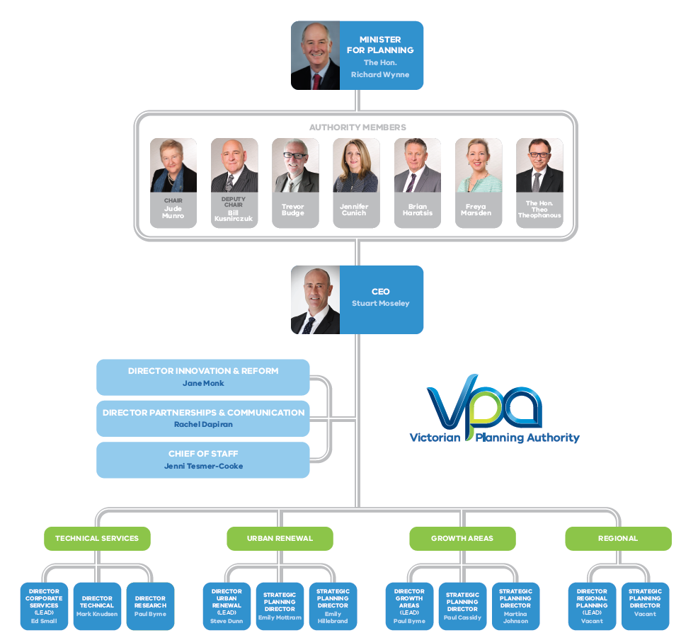

Our strategic framework
The VPA Strategic Plan 2017-2020 outlines our purpose, vision, mission and objectives. It includes seven strategic outcomes to guide delivery:
- Community Life
- Economic development
- Natural environment
- Innovation, technology and changing environment
- Community engagement
- Urban design and build environment
- Governance and organisation

VPA Objectives
The objects and functions of the VPA set out in the Victorian Planning Authority Act 2017 can be summarised to be:

- Provide strategic planning advice and assistance to the Minister for Planning, and with the Minister’s approval to give advice or assistance to Councils and other public sector bodies.
- In areas designated by the Minister for Planning:
- Lead strategic planning
- Undertake integrated infrastructure and land use planning
- Work in collaboration with agencies and councils.

VPA Vision
Great urban places supporting sustainable, vibrant and growing communities for Victoria

VPA Mission
To undertake integrated land use and infrastructure planning in priority places and to be an active partner in ensuring Victoria’s affordable, sustainable and liveable growing communities are of the highest international standard

VPA Values
The following values are based on the Victorian Public Sector Values and are the foundations that guide our work and outline what Victorians can expect from the VPA:

Value | Behaviours
Leadership: | We provide clarity and certainty, develop new and innovative solutions to problems, provide authoritative advice and lead by example to get things done and make a positive difference.
Partnership: | We work in collaboration with our stakeholders through genuine consultation, sharing of information, and harnessing their expertise and resources.
Professionalism: | We act with honesty and openness, are accountable for our actions and are respected for our expertise and high quality and balanced advice.
Responsiveness: | We are aware of the needs of our stakeholders and strive to provide a high level of service and advice at all times.

What does success look like?
The VPA has an opportunity to influence integrated land use and infrastructure planning in Victoria. We want to make the most of this opportunity by being an influential, collaborative and evidence-based organisation that is identified as the leading expert body in urban planning across Australia.

Strategy on a Page
The Board of the VPA has adopted a Strategy on a Page which summarises how the VPA’s strategic themes align with the legislative objectives of the VPA (see the next page).

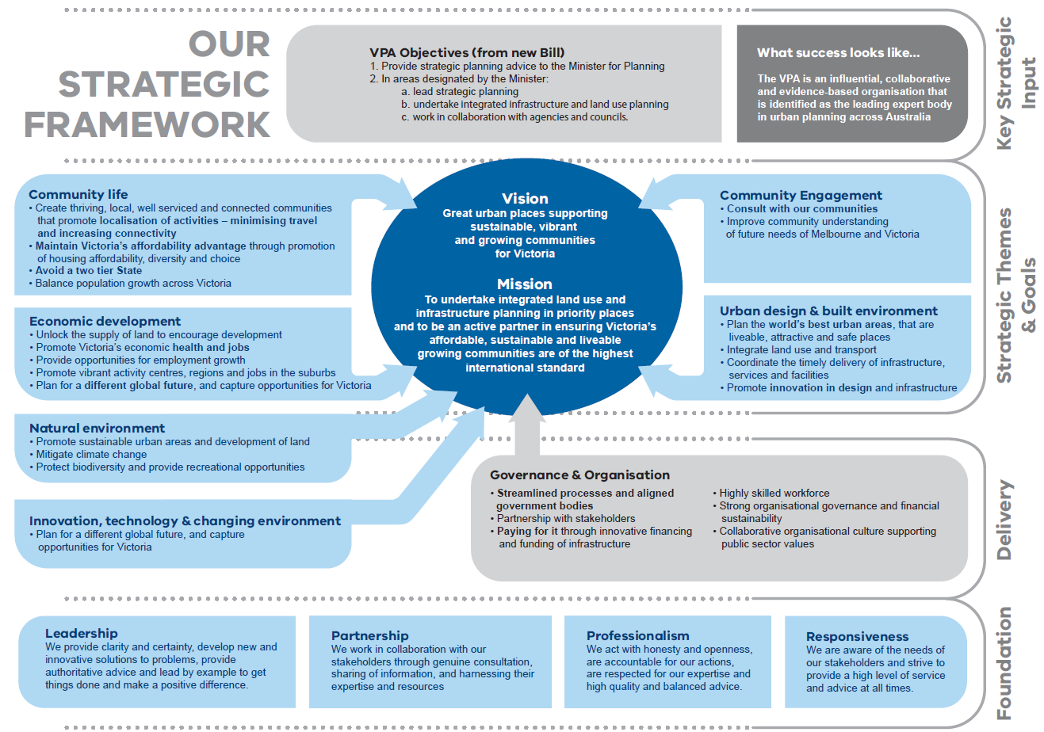
Our Strategy on a Page

Delivering on our strategic outcomes

Introduction
In late 2016 the VPA Board, in preparation for the transition to the new VPA, undertook an extensive process to develop the strategic framework for the new organisation. This resulted in the VPA identifying the key strategic outcomes that it will be focusing on over the life of this business plan (the coming four years). The three key elements of the VPA business plan are planning for housing, employment and infrastructure in Victorian growth areas, all of which are vital to Victoria’s future. The new VPA has an important role in land use planning in each of these aspects.

Over the coming twelve months, the VPA Board and CEO will work together to develop enhanced performance measures focusing more on outcomes and outputs, rather than on inputs and processes.

Community life
The VPA aims to create thriving, local, well serviced and well connected communities. We do this through planning for 20-minute neighbourhoods that enable and promote local activities, and deliver complete local communities that offer a full range of services and employment opportunities. This helps to minimise travel and increase connectivity.

We aim to maintain Victoria’s affordability advantage by ensuring an ongoing supply of a diverse range of housing that meets market demands. Residential and employment land supply needs to respond to the challenges of population growth and structural changes to the Victorian economy, while providing housing choice to Victorians.

Through good urban planning, we will contribute to Victoria’s liveability, which is already recognised as among the best in the world, is preserved and enhanced as our population continues to grow. We will do this by balancing population growth across Melbourne’s greenfield growth areas, key strategic urban renewal sites, and regional Victoria in accordance with Plan Melbourne and the Regional Growth Plans. In accommodating population growth we will work to provide a community with equitable access to employment and services in all areas where we work - urban renewal areas, Victoria’s regions, and the growth area precincts.

Economic development
VPA planning will seek to support more economic activity by planning for investment, employment and economic growth. We will unlock the supply of land to encourage development, and plan for vibrant employment clusters and activity centres that provide jobs in the right places – in our suburbs and regions, as well as the central city. We will respond to ongoing changes and emerging opportunities in employment patterns in the Victorian economy.

Attracting investment to Victoria and the creation of jobs underpins the wellbeing of the Victorian community. The VPA will continue to work closely with the Department of Economic Development, Jobs, Transport and Resources (DEDJTR) in planning for economic prosperity. Now that the VPA has had its regional focus expanded, it will seek to extend these planning outcomes to Regional Victoria.

The VPA will seek to support Melbourne retaining its competitive advantage as the world’s most liveable city through the planning and evolution of central city precincts and suburban employment and innovation clusters. We will seek to enhance the central city’s role as a hub for tourism, the arts, sports and high level retail, the centre of government and corporate headquarters.

Natural environment
We will promote sustainable urban areas and the sustainable development of land, ensuring that we are protecting Victoria’s biodiversity, natural assets and liveability as the population grows. We will seek to minimise the environmental impact of urban development through innovative environmental design and localisation of employment and services. We will provide recreational opportunities through attractive local parks and public spaces and help to ensure that development emphasises the importance of keeping our metropolitan areas green.

We will actively plan to reduce greenhouse gas emissions from urban development, and mitigate the effects of climate change. We will build resilience to natural hazards and extreme weather events into our urban planning. We will provide a leading role in fostering and demonstrating innovation in this area.

Urban design and built environment
We aim to create the world’s best urban areas, which are attractive, safe and socially sustainable. We will develop a sense of place based on natural and cultural features, and promote a high quality and sustainable built environment. We will recognise and build on the existing character and heritage of Victoria’s urban places.

We will improve design innovation and the public domain, developing solutions that respond to emerging trends and applying new thinking to our urban areas.

We will work with other government agencies to create and capture value through our plans. We will deliver integrated land use and transport planning, and ensure the timely provision of infrastructure and services for growing communities, eg through infrastructure contribution plans and growth area infrastructure contributions.

Governance and organisation
The government has recognised the importance of governance for the new VPA, and the Victorian Planning Authority Act 2017 has a particular focus on ensuring that conflict of interest situations are avoided by setting out clear processes and expectations for all parties involved with the VPA. The Act recognises that parties who might have a potential conflict include VPA staff and Board members (and their relatives and friends), and also contractors to the VPA, and developers or landowners.

This commitment to governance is illustrated by the Minister of Planning’s Directions to the VPA, which are included at the end of this document.

The VPA Board is also very committed to ensuring the governance within the organisation is maintained at a very high standard with transparent and accessible policies and procedures.

We seek to implement streamlined planning processes and aligned government bodies, cutting red tape and advocating more efficient and responsive planning processes across government. We will work in partnership with councils and other government agencies to ensure a whole of government approach to key urban planning challenges.

We promote innovative and sustainable ways of paying for timely infrastructure through financing and funding arrangements that support equity. We work with our stakeholders in industry and government to inform, coordinate and leverage infrastructure investment, promote funding certainty and ensure that infrastructure is provided in a timely manner.

We provide a highly collaborative organisational culture that reflects the public sector values and our commitment to deliver value for money outcomes. We provide a healthy, safe and inclusive workplace that focuses on continuous improvement. We aim to be the leading expert body in urban planning in Australia, and support the ongoing development of a highly skilled workforce. Our success is underpinned by strong organisational governance and financial sustainability.

The Minister for Planning has advised, through his Statement of Expectations for the Authority 2017/18 that, to underpin our work, the VPA Board should ensure that the organisation develops and fosters strategic relationships with relevant government departments and agencies, Metropolitan and Regional Partnerships, local government and local government locational groups.

Our existing strategic stakeholder engagement and collaboration plan will actively inform, promote and guide strategic engagement as a means to achieving the vision, mission and strategic goals of the organisation. The plan will be reviewed in 2017/18 to ensure that it continues to capture our strategic intent going forward.

Community engagement
We will consult with our communities to ensure the public are actively engaged in planning our urban areas across Melbourne and the regions, using a range of traditional and innovative methods. We will adopt the Victorian Auditor General Office standards for engagement. We will promote improved community understanding of the future needs of Melbourne and Victoria. We will publish consultation reports and provide transparency in the demonstration of how community views shape our plans.

Innovation, technology and changing environment
The VPA will plan for a different future, where Victoria holds a different place in the global economy, and new technologies such as driverless cars, passive building design, and smart transport networks, reshape the way in which our cities function. We will maintain a focus on innovation and understanding future trends so that we can capture the opportunities for Victoria in our urban planning.

The VPA’s KPIs for delivering these outcomes over the next 12 months are set out in the Key Performance Measures table (page 10).

Our key performance measures for 2017/18
In order to achieve the VPA’s outcomes over the coming four years, the VPA is expecting to achieve the following during the 2017/18 financial year:

Task | Strategic Outcome | Reference to the Victorian Planning Authority Act 2017 | KPI | Target
Unlock the supply of land, while creating well serviced and sustainable communities | Community Life  Economic Development  Natural Environment  Urban Design and Built Environment  Governance and organisation  Community Engagement  Innovation, technology and changing environment | Section 7(1) and 7(2)(a), (b), (c), (d), (e) & (f) | Complete the exhibition process of draft Planning Scheme Amendments for Precinct Structure Plans and advertise the Planning Panel Hearings.  (Timeliness)* | 17 draft PSPs complete and recommended for Ministerial approval by 31 December 2018.
 |  | Section 7(1) and 7(2)(a), (b), (c), (d), (e) & (f) | Complete the exhibition and advertising for 17 draft PSPs for Ministerial approval by 31 December 2018 (as per Homes for Victorians 100,000 residential lots action).  (Quantity)* | 17 draft PSPs complete and recommended for Ministerial approval by 31 December 2018.
 |  | Section 7(1) and 7(2)(a), (b), (c), (d), (e) & (f) | VPA Planning and Design Review program to provide a collaborative, multi-disciplinary analysis of PSPs early in their development.  (Quality)* | The revised PSP Guidelines are to include a process for the periodic review of PSPs that have been in place for 5 years, including the potential for an increased role for local authorities by 30 June 2018.
 |  | Section 7(1) and 7(2)(a), (b), (c), (d), (e) & (f) | VPA continues to implement approved work program.  (Timeliness)* | 21 planning projects outside of Melbourne's greenfield growth areas and 19 greenfield PSPs underway by 30 June 2018.
Provide opportunities for employment growth in sustainable communities. | Economic development | Section 7(1) and 7(2)(a), (b), (c), (d), & (f) | Hectares of employment land included in draft PSPs prepared for exhibition by 30 June 2018.  (Quantity)* | 400 hectares of employment land included in draft structure plans prepared by 30 June 2018.
Future population growth balanced across Melbourne’s greenfield growth areas, inner Melbourne, significant development sites and regional Victoria, in accordance with Plan Melbourne2017-2050 | Innovation, technology and changing environment | Section 7(1) and 7(2)(a), (b), (c), (d), (e) & (f) | VPA work program reflects the initial strategic planning projects that the VPA will be involved with in inner city, strategic development sites and regional Victoria.  (Timeliness)* | New VPA work program published on the VPA website by 30 August 2017.
Implement aspects of Plan Melbourne 2017-2050 relevant to the role of the Authority | Governance and organisation | Section 7(1) and 7(2)(a), (b), (c), (d), (e) & (f) | VPA’s website reflects its new obligations arising from the refreshed Plan Melbourne.  (Quantity)* | VPA website updated to reflect VPA role in Plan Melbourne 2017 – 2050 by 30 August 2017.
Provide the opportunity for sustainable communities | Community life  Economic development  Natural environment  Urban design and built environment  Innovation, technology and changing environment | Section 7(1) and 7(2)(a), (b), (c), (d), (e) & (f) | Revised PSP Guidelines incorporate the promotion of energy sustainability.  (Quantity) | A draft revision of the Precinct Structure Plan Guidelines to include promotion of energy sustainability prepared by 30 June 2018.
VPA and its stakeholders work in partnership for optimum planning outcomes. | Governance and organisation  Community engagement | Section 7(1) and 7(2)(a), (b), (c), (d), (e) & (f) | Key Stakeholders to confirm that VPA has satisfactorily consulted with them during planning processes.  (Quantity)* | The VPA conducts a stakeholder satisfaction assessment by 30 June 2018 which indicates whether the VPA’s key stakeholders are satisfied with the quality and extent of consultation undertaken by the VPA during the 2017/18 financial year.
VPA produces a Business Plan annually. | Governance and Organisation | Section 44 | Approved Business Plan published on VPA website.  (Timeliness)* | Approved Business Plan published on VPA website by  30 August 2017.
VPA remains financially sustainable. | Governance and Organisation | Section 45 | Operating shortfall within agreed tolerance.  (Cost)* | Operating shortfall for the year is no greater than 10% more than the budgeted deficit for the year ended 30 June 2018, except in relation to any additional unbudgeted expenditure directed by the Minister for Planning.
Employees reflect public sector values in the work of the VPA | Governance and Organisation | Section 10 | Number of material breaches by VPA staff members of the Code of Conduct for Victorian Public Sector Employees 2015.  (Quality)* | No breaches by VPA staff members of Code of Conduct reported in VPA annual report  for 30 June 2018.
* Explanation of main focus on individual performance measure
Performance measures generally include a range of assessment, even though an individual measure is often selected to primarily one aspect. The VPA is interested in measuring a number of different elements in its performance. These include:
- Timeliness – was the action performed in a timely way.
- Quality - was the action performed to a suitable standard.
- Quantity – was the action performed at a satisfactory quality.
- Cost – was the action completed at a suitable cost.

Our work program
Metropolitan Melbourne current work program
The map below sets out the key areas in metropolitan Melbourne where the VPA will be focusing its effort over the coming years.

The detailed list of approved VPA projects is reflected in the section of this Business Plan entitled Our Prioritised Annual Work Program. That list sets out the nature of each activity, and includes the estimated completion date for each project.

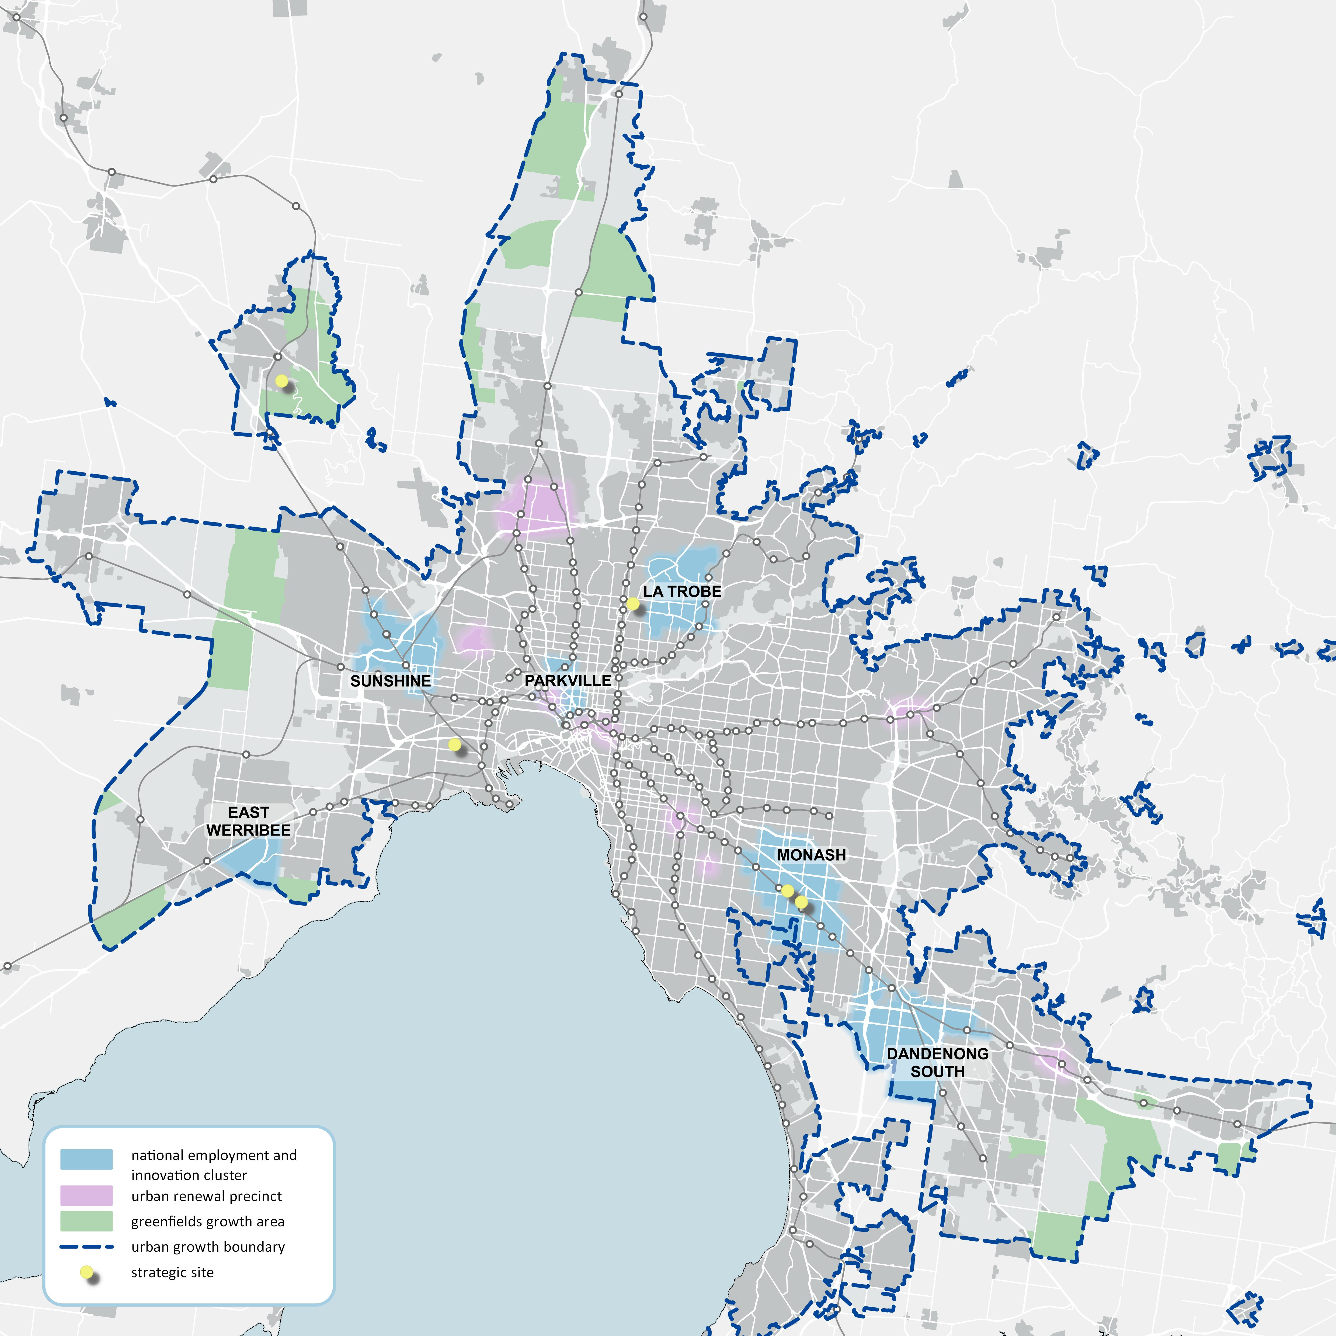

Regional Victoria current work program
The map below reflects the key areas of Victoria (outside of metropolitan Melbourne) where the VPA will be focusing its effort over the coming year.

Over the coming years the VPA’s work program is expected to expand into many other areas in Regional Victoria. In addition the VPA will be providing planning support to a range of regional councils in 2017/18 through the government’s Streamlining for Growth Program.

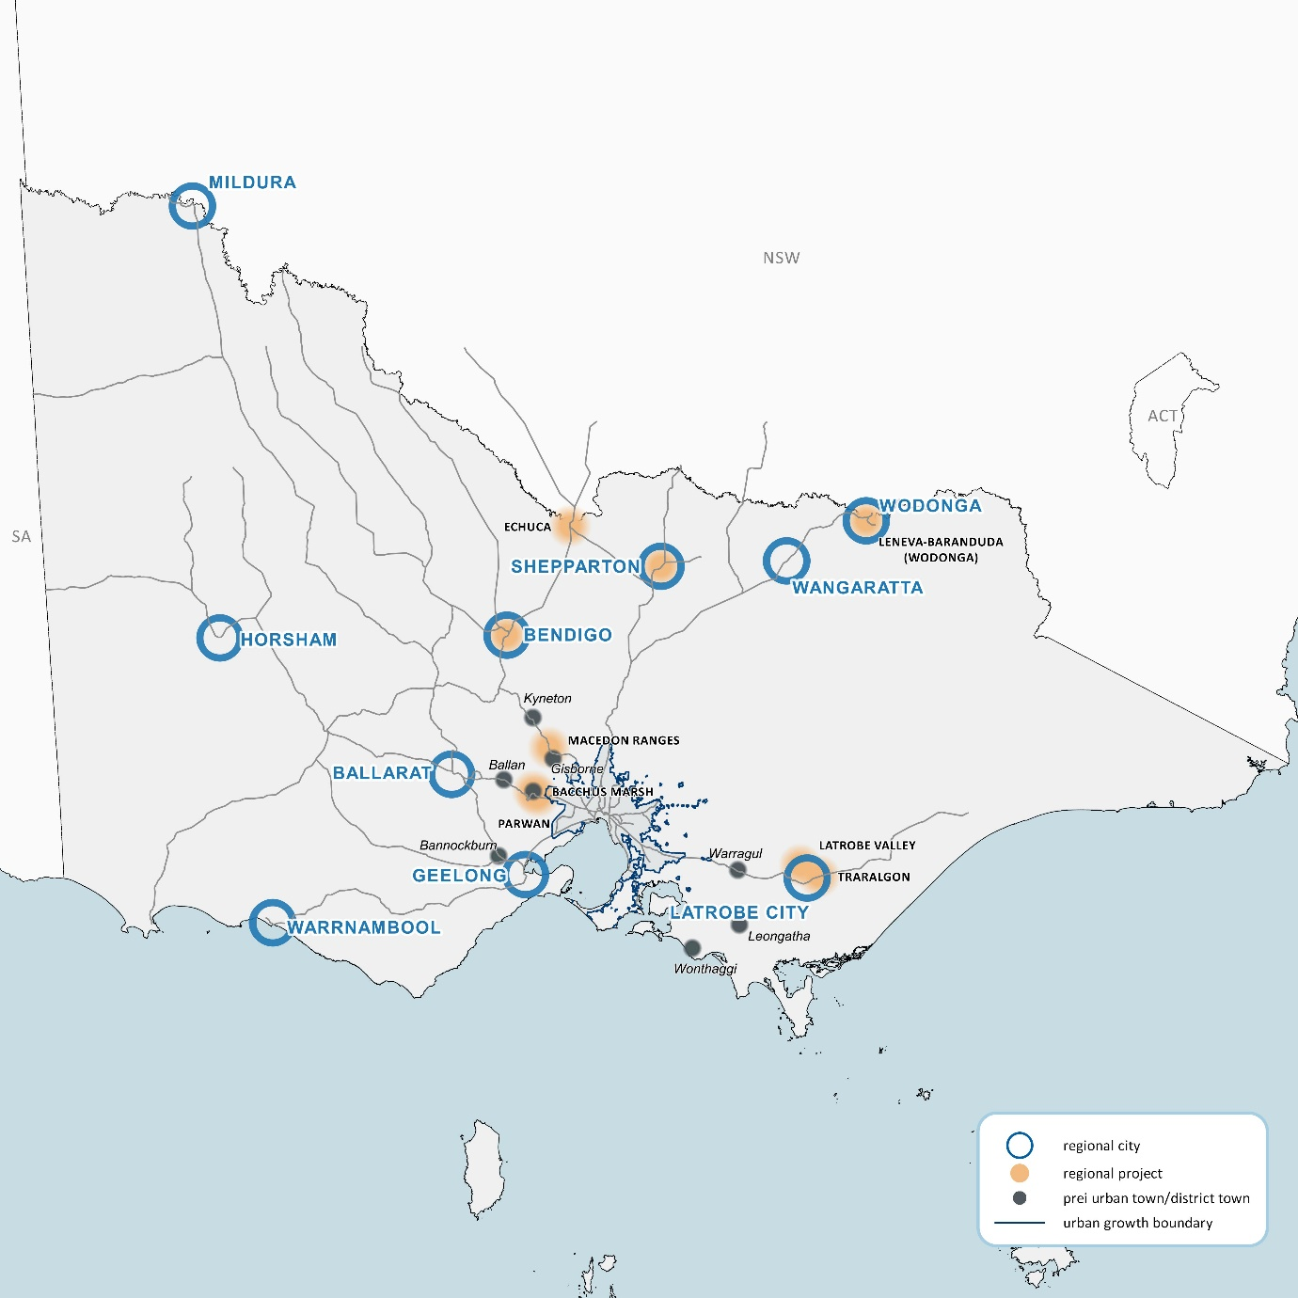

Our prioritised annual work program
(This program is subject to review)
Project | Project Name |  | LGA/Agency |  |  | Major Activity |  |  | Funding Source* |  |  | Status – June 2017 |  |  | Estimated start date | Estimated Completion Date |  |  |  |  |  | Forecast status - June 2018
PLAN MELBOURNE
3 | Central City Urban renewal precincts |  | DEDJTR & DELWP |  |  | Scope and develop program |  |  | VPA |  |  | Under preparation |  |  | May 17 | June 18 |  |  |  |  |  | Completed
4 | Land use & Infrastructure plans - NEIC |  | DEDJTR & DELWP |  |  | Scope and develop program |  |  | VPA |  |  | Under preparation |  |  | May 17 | June 18 |  |  |  |  |  | Completed
6 | Health & education precincts |  | DHHS, DET, DELWP & DEDJTR |  |  | Scope and develop program |  |  | VPA |  |  | Under preparation |  |  | May 17 | June 18 |  |  |  |  |  | Completed
7500 | Berwick Health & Education |  | Casey |  |  | Support to Council |  |  | VPA |  |  | Under Preparation |  |  | Jul-14 | Dec 18 |  |  |  |  |  | Complete
4501 | Sunshine Health, Wellbeing & Education Precinct |  | Brimbank |  |  | Structure Plan |  |  | VPA |  |  | Under preparation |  |  | Jan-15 | Dec-18 |  |  |  |  |  | Under preparation
13 | Employment opportunities in Melbourne’s greenfield growth areas |  | DELWP & DEDJTR |  |  | Scope and develop program |  |  | VPA |  |  | Under preparation |  |  | May 17 | June 18 |  |  |  |  |  | Completed
16 | Urban renewal pipeline of projects across Melbourne |  | DEDJTR & DELWP |  |  | Scope and develop program |  |  | VPA |  |  | Under preparation |  |  | May 17 | June 18 |  |  |  |  |  | Completed
20 | Precinct Structure Plan Guidelines |  | DELWP, DEDJTR, DHHS, DET |  |  | Scope and develop program |  |  | VPA |  |  | Under preparation |  |  | May 17 | June 18 |  |  |  |  |  | Completed
21 | A clear sequence for growth area development |  | DELWP |  |  | Scope and develop program |  |  | VPA |  |  | Under preparation |  |  | May 17 | June 18 |  |  |  |  |  | Completed
78 | Not-for-profit community service providers |  | DHHS & DELWP |  |  | Scope and develop program |  |  | VPA |  |  | Under preparation |  |  | May 17 | June 18 |  |  |  |  |  | Completed
102 | Growth frameworks for regional cities |  | DEDJTR & DELWP |  |  | Scope and develop program |  |  | VPA |  |  | Under preparation |  |  | May 17 | June 18 |  |  |  |  |  | Completed
103 | Peri-urban town strategies |  | DELWP |  |  | Scope and develop program |  |  | VPA |  |  | Under preparation |  |  | May 17 | June 18 |  |  |  |  |  | Completed
109 | Infrastructure contributions for strategic development areas |  | DELWP |  |  | Scope and develop program |  |  | VPA |  |  | Under preparation |  |  | May 17 | June 18 |  |  |  |  |  | Completed
PMA | VPA as Plan Melbourne Implementation Partner |  | DELWP |  |  | Assist in delivery |  |  | VPA |  |  | Under preparation |  |  | May 17 | June 18 |  |  |  |  |  | Completed
PMB | VPA as Plan Melbourne support |  | DELWP |  |  | Provide support on request |  |  | VPA |  |  | Ongoing |  |  | Ongoing | Ongoing |  |  |  |  |  | Ongoing
HOMES FOR VICTORIANS
1067 | Donnybrook |  | Mitchell, Whittlesea |  |  | Precinct Structure Plan |  |  | VPA & Third Party |  |  | Under Preparation |  |  | Jun-12 | Sep-17 |  |  |  |  |  | Complete
1096 | Woodstock |  | Whittlesea |  |  | Precinct Structure Plan |  |  | VPA & Third Party |  |  | Under Preparation |  |  | Jun-12 | Sep-17 |  |  |  |  |  | Complete
1202 | Lindum Vale |  | Hume |  |  | Precinct Structure Plan |  |  | VPA & Third Party |  |  | Under Preparation |  |  | Jun-12 | Dec-18 |  |  |  |  |  | Under preparation
1062 | Beveridge Central |  | Mitchell |  |  | Precinct Structure Plan |  |  | VPA |  |  | Under Preparation |  |  | May-12 | Dec-17 |  |  |  |  |  | Complete
1059 | Beveridge North West |  | Mitchell |  |  | Precinct Structure Plan |  |  | VPA & Third Party |  |  | Under Preparation |  |  | Jun-13 | Dec-18 |  |  |  |  |  | Under preparation
1069.1 | Shenstone Park |  | Whittlesea |  |  | Precinct Structure Plan |  |  | VPA & Third Party |  |  | Under Preparation by Council |  |  | Jan-16 | Dec 18 |  |  |  |  |  | Under preparation
1074 | Sunbury South |  | Hume |  |  | Precinct Structure Plan |  |  | VPA & Third Party |  |  | Under Preparation |  |  | Nov-12 | Dec-18 |  |  |  |  |  | Ongoing
1075 | Lancefield Road |  | Hume |  |  | Precinct Structure Plan |  |  | VPA & Third Party |  |  | Under Preparation |  |  | Mar-13 | Dec-18 |  |  |  |  |  | Ongoing
1082 | Mt Atkinson |  | Melton |  |  | Precinct Structure Plan |  |  | VPA & Third Party |  |  | Under Preparation |  |  | Mar-14 | Dec-17 |  |  |  |  |  | Complete
1085 | Tarneit Plains |  | Melton |  |  | Precinct Structure Plan |  |  | VPA & Third Party |  |  | Under Preparation |  |  | Mar-14 | Dec-17 |  |  |  |  |  | Complete
1078 | Plumpton |  | Melton |  |  | Precinct Structure Plan |  |  | VPA & Third Party |  |  | Under Preparation |  |  | May-13 | Dec-17 |  |  |  |  |  | Complete
1080 | Kororoit |  | Melton |  |  | Precinct Structure Plan |  |  | VPA & Third Party |  |  | Under Preparation |  |  | May-13 | Dec -17 |  |  |  |  |  | Complete
1080.2 | Kororoit Part 2 |  | Melton |  |  | Precinct Structure Plan |  |  | VPA & Third Party |  |  | Under Preparation |  |  | May-13 | Dec-18 |  |  |  |  |  | Under preparation
1092.1 | Quandong |  | Wyndham |  |  | Precinct Structure Plan |  |  | Council & VPA & Streamlining for Growth |  |  | Under Preparation by council |  |  | Jun-14 | Dec-18 |  |  |  |  |  | Under preparation
1055 | McPherson |  | Casey |  |  | Precinct Structure Plan |  |  | VPA & Third Party |  |  | Under Preparation |  |  | May-14 | Jun 18 |  |  |  |  |  | Complete
11 | Minta Farm |  | Casey |  |  | Precinct Structure Plan |  |  | VPA |  |  | Under Preparation |  |  | Mar-10 | Dec-18 |  |  |  |  |  | Under preparation
1210 | Pakenham East |  | Cardinia |  |  | Precinct Structure Plan |  |  | Council & VPA |  |  | Under Preparation by Council |  |  | Jul-17 | Dec-18 |  |  |  |  |  | Under preparation
STREAMLINING FOR GROWTH
2012 | Streamlining Greenfields |  | Various |  |  | To be defined |  |  | SFG |  |  | Not Commenced |  |  | Jul 17 | Jun 18 |  |  |  |  |  | Complete
8690 | Streamlining (Post PSP) – Phase 2 |  | Various |  |  | Assistance to councils |  |  | Streamlining for Growth* |  |  | Under Preparation |  |  | Jul-17 | Jun 18 |  |  |  |  |  | Phase 2 completed
2012 | Streamlining Urban Renewal |  | Various |  |  | To be defined |  |  | SFG |  |  | Not Commenced |  |  | Jul 17 | Jun 18 |  |  |  |  |  | Complete
2111 | Kingston DFO |  | Kingston |  |  | To be defined |  |  | SFG |  |  | Not Commenced |  |  | Jul 17 | Jun 18 |  |  |  |  |  | Complete
2112 | Box Hill ICP |  | Whitehorse |  |  | To be defined |  |  | SFG |  |  | Not Commenced |  |  | Jul 17 | Jun 18 |  |  |  |  |  | Complete
2113 | Monash Health & Ed |  | Monash |  |  | To be defined |  |  | SFG |  |  | Not Commenced |  |  | Jul 17 | Jun 18 |  |  |  |  |  | Complete
2011 | Streamlining Regional |  | Various |  |  | To be defined |  |  | SFG |  |  | Not Commenced |  |  | Jul 17 | Jun 18 |  |  |  |  |  | Complete
1239 | Latrobe Valley |  | Latrobe, Baw Baw, & Wellington |  |  | Support DELWP and Councils as required |  |  | VPA |  |  | TBD |  |  | TBD | TBD |  |  |  |  |  | TBD
1240 | Torquay - Spring Creek |  | Surf Coast |  |  | Structure plan with council as planning authority |  |  | VPA |  |  | Under Preparation |  |  | Nov-16 | Mar-18 |  |  |  |  |  | Complete
1245 | Macedon Ranges – Phase 1 |  | Macedon Ranges |  |  | Support DELWP |  |  | VPA & Streamlining for Growth* |  |  | Under Preparation |  |  | Feb-17 | Jun-18 |  |  |  |  |  | Complete
1105 | Wodonga/Leneva |  | Wodonga |  |  | Structure plan with council as planning authority |  |  | VPA & Council |  |  | Under Preparation |  |  | Jan-16 | Dec-18 |  |  |  |  |  | Under preparation
1102.1 | Shepparton South East |  | Greater Shepparton |  |  | Structure plan |  |  | VPA & Council |  |  | Under Preparation |  |  | Mar-15 | Jun-19 |  |  |  |  |  | Under preparation
1102 | Shepparton North East |  | Greater Shepparton |  |  | Structure plan |  |  | VPA & Council |  |  | Under Preparation |  |  | Jun-14 | Dec-18 |  |  |  |  |  | Under preparation
1103 | Shepparton Framework Plan |  | Greater Shepparton |  |  | Framework Plan |  |  | VPA & Streamlining for Growth* |  |  | Preparatory work |  |  | Nov-16 | Dec 18 |  |  |  |  |  | Under preparation
1225 | Bacchus Marsh Urban Growth Framework |  | Moorabool |  |  | Framework Plan |  |  | VPA & Streamlining for Growth* |  |  | Under Preparation |  |  | Feb-16 | Dec-18 |  |  |  |  |  | Ongoing
1226 | Parwan Employment |  | Moorabool |  |  | Structure Plan |  |  | VPA & Third Party |  |  | Not commenced |  |  | Jan-18 | Dec-19 |  |  |  |  |  | Under preparation
1248 | Plan Bendigo |  | Greater Bendigo |  |  | Strategic sites - TBA |  |  | VPA & Streamlining for Growth* |  |  | Under Preparation |  |  | Aug-16 | Jun 18 |  |  |  |  |  | Complete
NATIONAL EMPLOYMENT AND INNOVATION CLUSTERS
6550 | Monash National Employment and Innovation Cluster |  | Greater Dandenong, Kingston, Monash |  |  | Framework Plan |  |  | VPA |  |  | Under Preparation |  |  | Mar-14 | Dec-17 |  |  |  |  |  | Complete
4500 | Sunshine National Employment and Innovation Cluster |  | Brimbank |  |  | Framework & Infrastructure Plan |  |  | VPA |  |  | Under Preparation |  |  | Mar-14 | Dec-17 |  |  |  |  |  | Complete
5600 | La Trobe National Employment and Innovation Cluster |  | Banyule, Darebin |  |  | Framework Plan |  |  | VPA |  |  | Under Preparation |  |  | Mar-14 | Dec-17 |  |  |  |  |  | Complete
3700 | Parkville National Employment and Innovation Cluster |  | Melbourne/DPC |  |  | Framework Plan |  |  | VPA |  |  | Not commenced |  |  | Jul-17 | Jun-18 |  |  |  |  |  | Completed
7100 | Dandenong National Employment and Innovation Cluster |  | Greater Dandenong |  |  | Framework Plan |  |  | VPA |  |  | Not commenced |  |  | Jan-18 | Dec-19 |  |  |  |  |  | Under preparation
39.4 | Werribee National Employment and Innovation Cluster (EWEP) |  | Wyndham |  |  | Ongoing planning activities |  |  | EWEP Grant |  |  | Under Preparation |  |  | Ongoing | Ongoing |  |  |  |  |  | Ongoing
EMPLOYMENT PSPS
1208 | Werribee Junction |  | Wyndham |  |  | Precinct Structure Plan |  |  | VPA & Third Party |  |  | Not Commenced |  |  | Jul-17 | Jun-20 |  |  |  |  |  | Pre-planning
4.5 | Officer Town Centre |  | Cardinia |  |  | Review of structure plan |  |  | VPA & Third Party |  |  | Under Preparation |  |  | Sep-16 | Dec-18 |  |  |  |  |  | Under preparation
1068 | Craigieburn West (inc Greenvale R1) |  | Hume |  |  | Precinct Structure Plan |  |  | VPA & Third Party |  |  | Not Commenced |  |  | Jul-17 | Jun-20 |  |  |  |  |  | Pre-planning
STRATEGIC DEVELOPMENT SITES
4520 | Altona North |  | Hobsons Bay | Strategic Site |  |  | VPA & Streamlining for Growth |  |  | Under Preparation |  |  | Jul-16 |  |  |  | Jun-18 |  |  | Complete
V6009 | East Bentleigh Village |  | Glen Eira | Structure Plan |  |  | VPA |  |  | Not commenced |  |  | Jan 18 |  |  |  | Dec 20 |  |  | Under preparation
5460 | Heidelberg Station & Austin Precinct |  | Banyule | Structure Plan |  |  | VPA |  |  | Not commenced |  |  | Sep-17 |  |  |  | Jun-19 |  |  | Under preparation
4504 | NURP –La Trobe Cluster |  | Darebin | Structure Plan |  |  | VPA |  |  | Not commenced |  |  | Sep-17 |  |  |  | Dec 20 |  |  | Under preparation
3501 | Inner West Employment and Logistics Framework Plan |  | Melbourne, Maribyrnong | Framework Plan |  |  | VPA |  |  | Not commenced |  |  | Sep-17 |  |  |  | Dec 20 |  |  | Under preparation
3350 | Central City Framework Plan |  | Maribyrnong, Melbourne, Port Phillip, Stonnington, Yarra, DEDJTR & DELWP | Framework Plan |  |  | VPA |  |  | Under Preparation |  |  | Nov-14 |  |  |  | Dec-17 |  |  | Complete
1500 | Caloola Sunbury |  | Hume | Strategic site |  |  | VPA & Streamlining for Growth* |  |  | Under Preparation |  |  | Aug-16 |  |  |  | Dec-17 |  |  | Complete
V5006 | Preston Market |  | Darebin | Strategic site |  |  | VPA & Streamlining for Growth* |  |  | Not commenced |  |  | Aug-17 |  |  |  | Dec-19 |  |  | Under preparation
3051 | Arden |  | Melbourne, Melbourne Metropolitan Rail Authority & DEDJTR | Structure Plan & Infrastructure Contributions Plan |  |  | VPA & Third Party |  |  | Under Preparation |  |  | Jan-15 |  |  |  | Dec-18 |  |  | Under preparation
3052 | Macaulay DCP |  | Melbourne | Development Contributions Plan |  |  | VPA |  |  | Under Preparation |  |  | Jan-16 |  |  |  | Sep-17 |  |  | Complete
3470 | Flinders to Richmond |  | Melbourne, Yarra, PTV, DV, DEDJTR | Framework Plan |  |  | VPA |  |  | Under Preparation |  |  | Oct-16 |  |  |  | Dec-17 |  |  | Complete
5100 | Greater Broadmeadows |  | Hume | Framework Plan |  |  | VPA |  |  | Under Preparation |  |  | Feb-16 |  |  |  | Dec-17 |  |  | Complete
5460 | Mernda Town Centre |  | Whittlesea | Master planning arising from station |  |  | VPA & Streamlining for Growth* |  |  | Under Preparation |  |  | Jun-16 |  |  |  | Dec 17 |  |  | Complete
3053 | Josephs Road DCP |  | Maribyrnong | Development Contributions Plan |  |  | VPA |  |  | Under Preparation |  |  | Jun-16 |  |  |  | Dec-17 |  |  | Complete
V4004 | Maribyrnong Defence Site |  | Maribyrnong | Structure Plan |  |  | VPA |  |  | Not commenced |  |  | Jul-17 |  |  |  | Dec-18 |  |  | Under Preparation
7050 | Caulfield Framework Plan |  | Glen Eira | Framework Plan |  |  | VPA |  |  | Not commenced |  |  | Jul-17 |  |  |  | Dec-18 |  |  | Under preparation
6570 | Clayton Structure Plan |  | Kingston, Monash | Structure Plan |  |  | VPA |  |  | Under Preparation |  |  | Jun-16 |  |  |  | Dec-18 |  |  | Under preparation
6575 | Clayton Business Park |  | Kingston | Strategic site |  |  | VPA |  |  | Under Preparation |  |  | Sep-14 |  |  |  | Dec-17 |  |  | Complete
6565 | PMP Site - Clayton |  | Monash | Strategic site |  |  | VPA & Third Party |  |  | Under Preparation |  |  | May-16 |  |  |  | Jun-18 |  |  | Complete
V6010 | Lilydale Quarry |  | Yarra Ranges | Structure Plan |  |  | VPA & Council |  |  | Not commenced |  |  | Jan 18 |  |  |  | Dec 20 |  |  | Under preparation
VPA BOARD PRIORITIES
8881 | VPA Regional Centres Strategy |  | Various | Delivery plan |  |  | VPA |  |  |  | Not commenced |  |  | Jul 17 |  |  |  | Dec 18 |  |  | Under preparation
8884 | Seminars and Workshops |  | Various | DELWP |  |  | VPA |  |  |  | Not commenced |  |  | Jul 17 |  |  |  | Dec 18 |  |  | Under preparation
OTHER PROJECTS
39.2 | EWEP - Divestment | Wyndham |  |  | Major development parcel divestment |  |  | EWEP Grant |  |  | Under Preparation |  |  | Jan-14 |  |  |  | Dec-17 | VPA role complete
Other | Support to for Level Crossing Removal program | LXRA |  |  | Various projects - TBA |  |  | TBA |  |  | Ongoing |  |  | Ongoing |  |  |  | Ongoing | Ongoing
Other | Provide support to the Yarra River Action Plan | DELWP |  |  | Various projects - TBA |  |  | TBA |  |  | Ongoing |  |  | Ongoing |  |  |  | Ongoing | Ongoing
* Funding Source: VPA – from budget allocations to VPA
Third Party – contribution from other party towards planning activity
Streamlining for Growth – targeted funding for selected projects which meet program criteria

Projects identified to begin in 2018/19
Project | Project Name
Greenfield
PSPs not on current VPA program
North Growth Corridor
1065 | Merrifield North (Lake Kalkallo)
1201.1 | Wallan South
1071 | Cooper Street West
Western Growth Corridor
1207 | Aviators Field
South Eastern Growth Corridor
1057 | Casey Fields South
1058 | Devon Meadows
1051 | Croskell
6 | Pakenham Employment South
5 | Officer South Employment

Projects not scheduled
Project | Project Name
Greenfield
PSPs not on current VPA program
North Growth Corridor
1060 | Beveridge North East
1061 | Beveridge South West
1072 | Sunbury North
1201 | Wallan East
1095 | Sunbury West
1063 | Northern Freight
Western Growth Corridor
1086 | Chartwell East
1087 | Derrimut Fields
1077 | Warrensbrook
1081.2 | Rockbank South
1083 | Warrawee
1084 | Ravenhall (Quarry Site)
1093 | Mambourin East
1088 | Oakbank
1093.1 | Bayview
1076 | Melton East
1204 | Minns Road
1205 | Bulmans Road
1206 | Melton West
South Eastern Growth Corridor
7 | Pakenham West
1056 | Clyde South

Our resources
It is anticipated that the nature and extent of the work of the VPA will vary from year to year, and that the revenue and expenditure of the Authority will correspondingly change. The VPA’s forward allocations from the Department of Environment, Land, Water and Planning (DELWP) for the next four years are currently anticipated to be:

- $12.7 million in 2017/18
- $12.7 million in 2018/19
- $12.7 million in 2019/20
- $12.7 million in 2020/21.

The VPA has achieved a brought forward surplus at 1 July 2017 of $8.8 million. This represents funds that the VPA has received previously, in advance of the matching expenditure occurring. These funds are to be used to finance the completion of a number of the greenfield growth area and other planning activities currently underway. The following table summarises the VPA’s expected staffing over the coming years, based on the expected funding for the period:

Staff | 2017-18 | 2018-19 | 2019-20 | 2020-21
Executives | 8 | 8 | 8 | 7
Non-executive | 91 | 85 | 85 | 68
Total | 99 | 93 | 93 | 75*
*This complement has been adjusted to reflect the relative reduction of revenue in 2020-21.

Budget 2017/18 to 2020/21
The VPA has approved the following budget for 2017/18 and has endorsed, in-principle the financial projections, for the subsequent three years. The VPA anticipates making operating deficits over the coming financial years as it expends the funds on hand which had been raised in earlier years for specific identified projects. The final year of this budget reflects a reduction in both income and expenditure when compared with prior years, but the VPA is anticipating that it will be able to be identify additional sources of revenue by then, and not need to reduce the overall budget. Potential additional sources of income include an increased base appropriation and also increased third party contributions.

Income
 | 2017-2018  $m | 2018-2019  $m | 2019-2020  $m | 2020-2021  $m
Base Appropriation | 12.7 | 12.7 | 12.7 | 12.7
Streamlining for Growth | 4.1 | 4.1 | 4.1 | 0.0
Strategic Sites – Housing Affordability | 1.0 | 1.0 | 1.0 | 0.0
Plan Melbourne Appropriation | 0.5 | 0.5 | 0.0 | 0.0
Third Party & Other Contributions | 0.8 | 3.0 | 3.8 | 4.5
Interest | 0.2 | 0.1 | 0.1 | 0.0
Reimbursement Revenue | 0.5 | 0.5 | 0.5 | 0.1
Total Income | 19.8 | 21.9 | 22.2 | 17.3

Expenditure
 | 2017-2018  $m | 2018-2019  $m | 2019-2020  $m | 2020-2021  $m
Executive | 0.9 | 0.8 | 0.8 | 0.7
Corporate Services | 4.9 | 4.8 | 4.9 | 4.0
Technical Services | 1.9 | 1.8 | 1.9 | 1.6
Partnerships & Innovation | 1.7 | 1.5 | 1.6 | 1.3
Urban Renewal – Staff Costs | 3.1 | 3.3 | 3.4 | 2.8
Melbourne’s Greenfield Growth Areas – Staff Costs | 2.3 | 2.1 | 2.1 | 1.7
Regional – Staff Costs | 1.5 | 1.5 | 1.5 | 1.3
External Project Costs | 3.0 | 5.2 | 5.2 | 3.7
Grants to Council | 2.9 | 2.9 | 2.9 | 0.0
Transfer to Government Agency | 0.0 | 0.0 | 0.0 | 1.9
Total Expenditure | 22.2 | 23.9 | 24.3 | 19.0

Net Surplus (Shortfall) for the year | (2.4) | (2.0) | (2.1) | (1.7)
Movement in third party contributions | 1.1 | 0.2 | (0.2) | 1.9
Adjusted Surplus (Shortfall) for the year | (1.3) | (1.8) | (2.3) | 0.2

Movement in Equity (excluding third party funding)
Accumulated Surplus brought forward (not committed) | 5.7 | 4.4 | 2.7 | 0.4
Adjusted Surplus (Shortfall) for the year | (1.3) | (1.8) | (2.3) | 0.2
Accumulated Surplus at the end of the year (not committed) | 4.4 | 2.6 | 0.4 | 0.6

Reconciliation of movements in Equity (including third party funding)
Total Accumulated Surplus brought forward | 8.8 | 6.4 | 4.4 | 2.3
Net Surplus (Shortfall) for the year | (2.4) | (2.0) | (2.1) | (1.7)
Total Accumulated Surplus at the end of the year | 6.4 | 4.4 | 2.3 | 0.6
Attachment A: Minister’s Direction to the VPA
