Bannockburn Growth Plan
Background Report

October 2020

CONTENTS
1 Executive Summary 1
2 Introduction 2
2.1 About Bannockburn 2
3 Strategic Context 4
3.1 State Policy 4
3.2 Local policy 4
4 Study Area 5
5 Biodiversity 6
6 Land Capability 8
7 Transport 10
7.1 Traffic network assessment 10
7.2 Public and active transport 12
8 Community Infrastructure 14
9 Economy 16
10 Stormwater Drainage 18
11 Bushfire 19
Tables
Table 1 Existing public transport 12
Table 2 Comparison of bus services 12
Figures
Figure 1 Regional context 3
Figure 2 G21 Regional Growth Plan planned growth 4
Figure 3 Growth Plan Investigation Area 5
Figure 4 Modelled Ecological Vegetation Classes 7
Figure 5 Potential for contamination 9
Figure 6 Five corridor options 11
Figure 7 Evaluation of route option 11
Figure 8 Concept drainage assets 18
Figure 9 BAL 12.5 separation distances 20

Executive Summary
The Victorian Planning Authority (VPA) in partnership with Golden Plains Shire Council (Council) has prepared the Bannockburn Growth Plan (Growth Plan) to guide the sustainable growth of the town to the year 2050. A draft planning scheme amendment has been prepared to implement the Growth Plan as a Background Document and support a number of changes to the Planning Policy Framework (PPF) of the Golden Plains Planning Scheme.
This Background Report outlines information that supports the Growth Plan and draft amendment. The report summarises technical information and recommendations provided by technical consultants and outlines how this has informed the Growth Plan and draft amendment.

Introduction
The VPA in partnership with Council has prepared the Growth Plan, a high-level and broad strategy that:
- Set out the future vision for sustainable growth and land use planning in Bannockburn
- Identifies future residential and employment areas to ensure adequate land supply for the next 30 years.
- Identifies the key considerations for further detailed planning and development of growth areas.
- Defines key projects and infrastructure to deliver to support growth.
- Provides a more certain environment for both public and private investment decisions.
The Growth Plan will be used to coordinate, guide and inform the preparation and consideration of future, more detailed local plans and planning permit applications.
The current strategic plan for Bannockburn is the Bannockburn Urban Design Framework (Parsons Brinckerhoff, 2011). Since 2011, Bannockburn has exceeded its forecasted growth, with proportional growth rates above the averages for both regional Victoria and the G21 Region Alliance (G21). Golden Plains Shire is expected to continue to grow at high rates in the future, with most of this Growth focused in Bannockburn. The Growth Plan will serve as an update to the 2011 Urban Design Framework.

About Bannockburn
Bannockburn is a rapidly growing town approximately 22km from Geelong, providing residents with opportunities to enjoy a rural lifestyle while still having convenient access to service and employment opportunities.
The Wadawurrung peoples are the Traditional Owners of the land on which Bannockburn is situated, represented by the Wadawurrung Traditional Owners Aboriginal Corporation.
Bannockburn is the largest town in Golden Plains Shire and provides services and amenities for a network of southern settlements including Teesdale, Inverleigh, Lethbridge, Batesford and Gheringhap.
The Bannockburn regional context is outlined in Figure 1.
Figure 1 Regional context
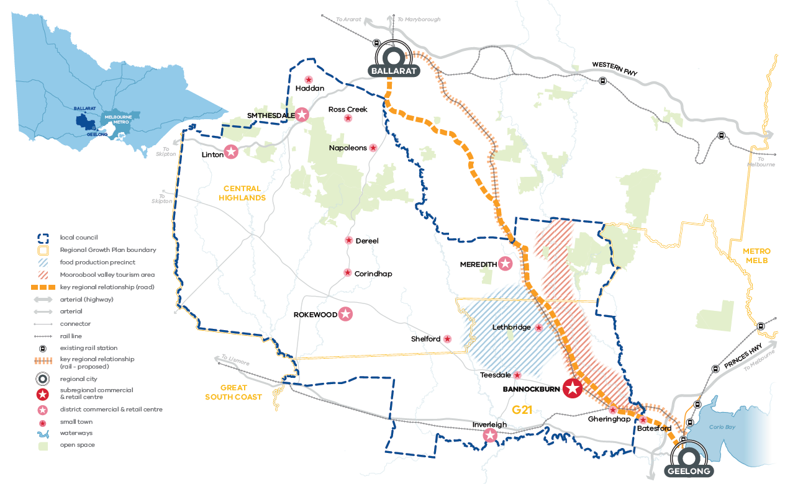

Strategic Context

State Policy

G21 Regional Growth Plan
Bannockburn is identified as a Regional Centre in the North West Gateway of the G21 region. The G21 Regional Growth Plan (2013) acknowledges Bannockburn’s provision of larger lifestyle lots and relatively affordable housing options. Settlements such as Bannockburn play an important role in supporting surrounding rural communities and productive farming activity.
See Figure 2 for a map of the G21 region and planned growth.
Figure 2 G21 Regional Growth Plan planned growth
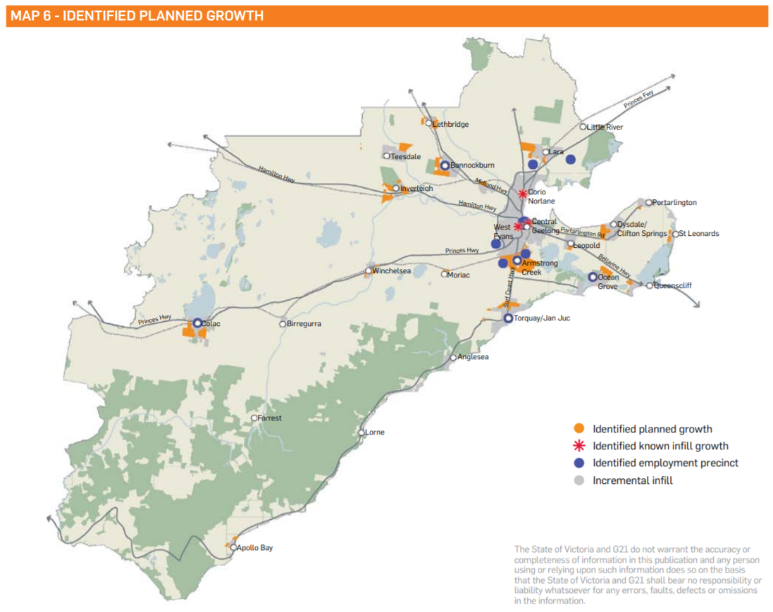

Local policy
The Golden Plains Shire Planning Scheme emphasises the central role that Geelong and Ballarat play in the region. Ballarat is to be a main centre for regional growth, services and employment. Geelong, being Victoria’s second city’ also should be revitalised and strengthened as a major regional city. Bannockburn is one of the district towns which have been identified for growth as well, however, for these smaller townships, maintaining the agricultural component is important.

Study Area

The Growth Plan Investigation Area (Figure 3) was derived from the identification of development constraints. These constraints are identified on and described below:
- Connectivity constraints imposed by Bruce’s Creek.
- Midland Highway and the railway line.
- Barwon Water infrastructure.
- Bannockburn Flora and Fauna Reserve.
- Rural Activity Zone identifying quality farmland.
- Non-urban break between Gheringhap and Bannockburn.
- Buffer from proposed employment uses at Gheringhap.

Each growth direction was also assessed in the Strategic Desktop Bushfire Risk Assessment (2020) to understand the bushfire risk associated with potential growth directions. The assessment concluded that development in the north and west would have a similar bushfire risk to the south. The east was identified as having a lower risk

The Growth Plan Investigation Area provided a boundary for the completion of technical work and targeted engagement with key agencies to determine the allocation of growth areas.

The Growth Plan Investigation Area formed the study area for the majority of the technical studies discussed in this Background Report.
Figure 3 Growth Plan Investigation Area
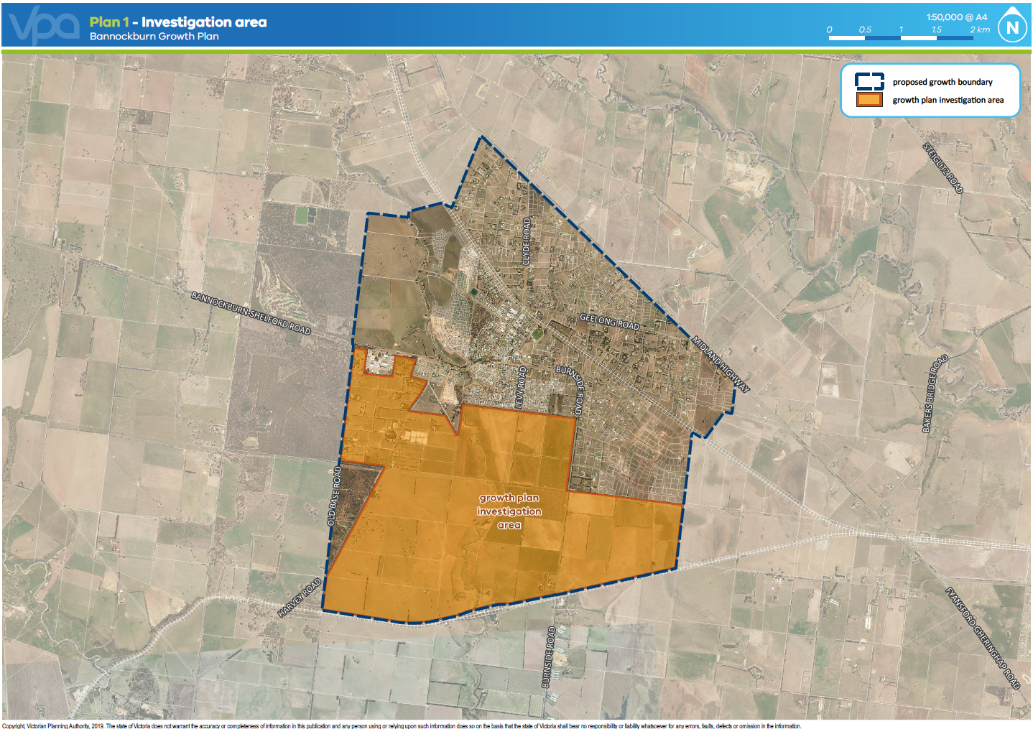

Biodiversity
Ecology and Heritage Partners Pty Ltd prepared the Bannockburn Growth Area Biodiversity Assessment (March 2020). This involved a desktop assessment of biodiversity values in the study area and ground truthing (from publicly accessible land) to verify findings from the desktop assessment. Figure 4 identifies the Modelled Ecological Vegetation Classes (EVC) that apply in the study area.
Key findings included:
Significant flora
- Identified in other technical work (Trengrove, 2017):
  - Melbourne Yellow-gum Eucalyptus leucoxylon subsp. connata (threatened under the FFG Act). Moderate to high likelihood of presence elsewhere in the study area.
- Identified during ground truthing:
  - Black Wattle (protected under the FFG Act)
  - Golden Wattle (protected under the FFG Act)
- Potential to occur within the study area:
  - Nationally significant:
    - Spiny Rice Flower
    - Button Wrinklewort
    - Large-headed Fireweed
    - Matted Flax-lily
    - Adamson’s Blown-grass
  - State significant:
    - Cut-leaf Burr Daisy
    - Small Scurf-pea
    - Hairy Tails
Significant fauna
- Potential to occur within the study area:
  - Nationally significant:
    - Golden Sun Moth
    - Striped Legless Lizard
    - Growling Grass Frog
Communities
- Potential to occur within the study area:
  - Nationally significant:
    - Grassy Eucalypt Woodland of the Victorian Volcanic Plain
    - Natural Temperate Grassland of the Victorian Volcanic Plain (low quality)
    - Seasonal Herbaceous Wetlands (modelled wetland in south-west section of the study area)
  - State significant:
    - Western (Basalt) Plains Grassland
    - Western Basalt Plains (River Red Gum) Grassy Woodland
In summary:
- There is both state and nationally significant biodiversity present in the study area.
- Further assessments by a suitably qualified ecologist are required to understand the quality of native vegetation within the study area as well as determine the presence or absence of significant flora and fauna species.
- This matter will be further addressed as part of the detailed planning for the proposed growth areas.
Figure 4 Modelled Ecological Vegetation Classes
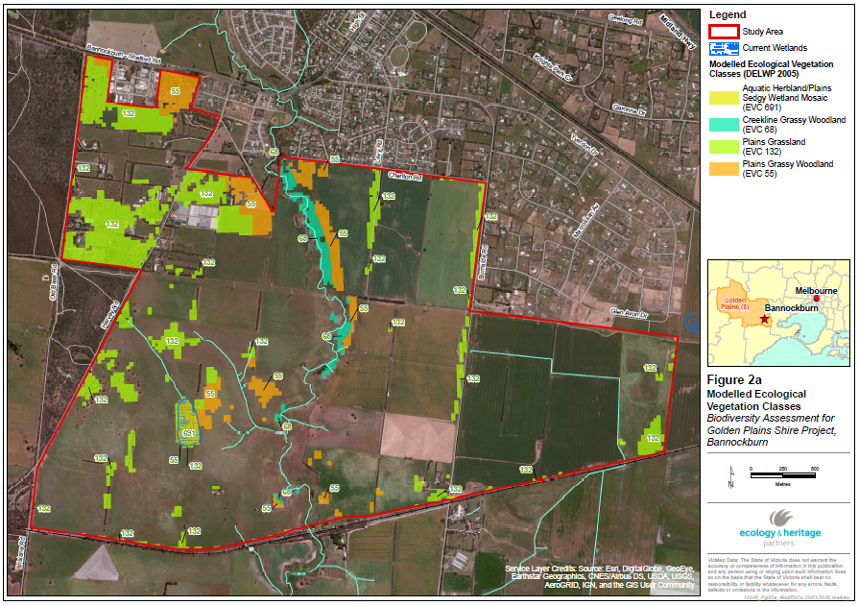

Land Capability
Meinhardt Infrastructure & Environment Pty Ltd prepared the Bannockburn Land Capability Assessment (June 2020). This assessment included the completion of a desktop assessment to determine the capability of residential, commercial and industrial land uses in the study area based upon potential environmental contamination, hydrological and geological features.
Key findings included:
Geology:
- Topography suggests development should be set back from Bruce’s Creek.
- Geotechnical restraints, slope stability, bearing capacity, and erosion should all be considered prior to development.
Contamination:
- Potentially contaminating activities in the area included:
  - Earthworks / stockpiling / importation and use of possibly uncontrolled fill material;
  - Structures / buildings with unknown use;
  - Storage and maintenance of heavy machinery associated with farming / agricultural practices;
  - Use of agricultural sprays and irrigations of crops;
  - Storage of chemicals / fuel / oil, chemical mixing;
  - Potential asbestos containing materials (ACM) in structures or buildings, especially those built before 1980.
  - Livestock grazing
- 28 out of 30 properties were rated as having ‘Low’ potential for contamination, with the remaining 2 rated as having a ‘Medium’ potential (see Figure 5).
- Properties rated as having ‘Medium’ potential for contamination are likely to require a detailed, property specific desktop assessment, and where appropriate, limited investigation and sampling of surface soils.
Potential Contamination of Sites:
- Further investigation of potential contamination must be undertaken for ‘Medium’ rated properties.
- Targeted site investigations should be undertaken where potentially contaminating land uses are known to have occurred.
- Further review and inspection may be required for ‘Low’ rated properties, including discussions with landowners to enhance understanding of potential contamination.
- During development, any contaminated soil must be treated as Prescribed Industrial Waste and removed from the site.
Broiler Farms:
- Size, location and distance of broiler sheds from site should be considered in developments within the growth area to ensure appropriate setback/separation distances are maintained.
Hydrology & Hydrogeology:
- Identified surface water features in area will require surveys to provide details of drainage patterns. Drainage paths need to be maintained, diverted or an alternative provided to ensure all areas remain appropriately drained during and after development.
Hazardous Materials:
- Hazardous materials surveys should be carried out for structures within area identified for future demolition or relocation. Inspection by qualified asbestos specialist should be considered at properties contained pre-1980 structures.
Ecological Restraints:
- Many properties noted as containing native vegetation and / or potential to contain Groundwater Dependent and Ecosystems Inflow Dependent Ecosystems. Ecological surveys should be conducted prior to development of these areas.
- Water Sensitive Urban Design (WSUD) initiatives should be considered to minimise disruption to Bruce’s Creek ecology.
Cultural Heritage Restraints:
- Nine properties were noted as containing Cultural Heritage Sensitivity Areas.
- Further investigation recommended to determine if development of these areas will trigger requirement for a Cultural Heritage Management Plan.
Geotechnical Assessments:
- Detailed geotechnical assessments should be completed prior to detailed design stage for any development in area. It is understood that this would be triggered at subdivision stage.
Figure 5 Potential for contamination
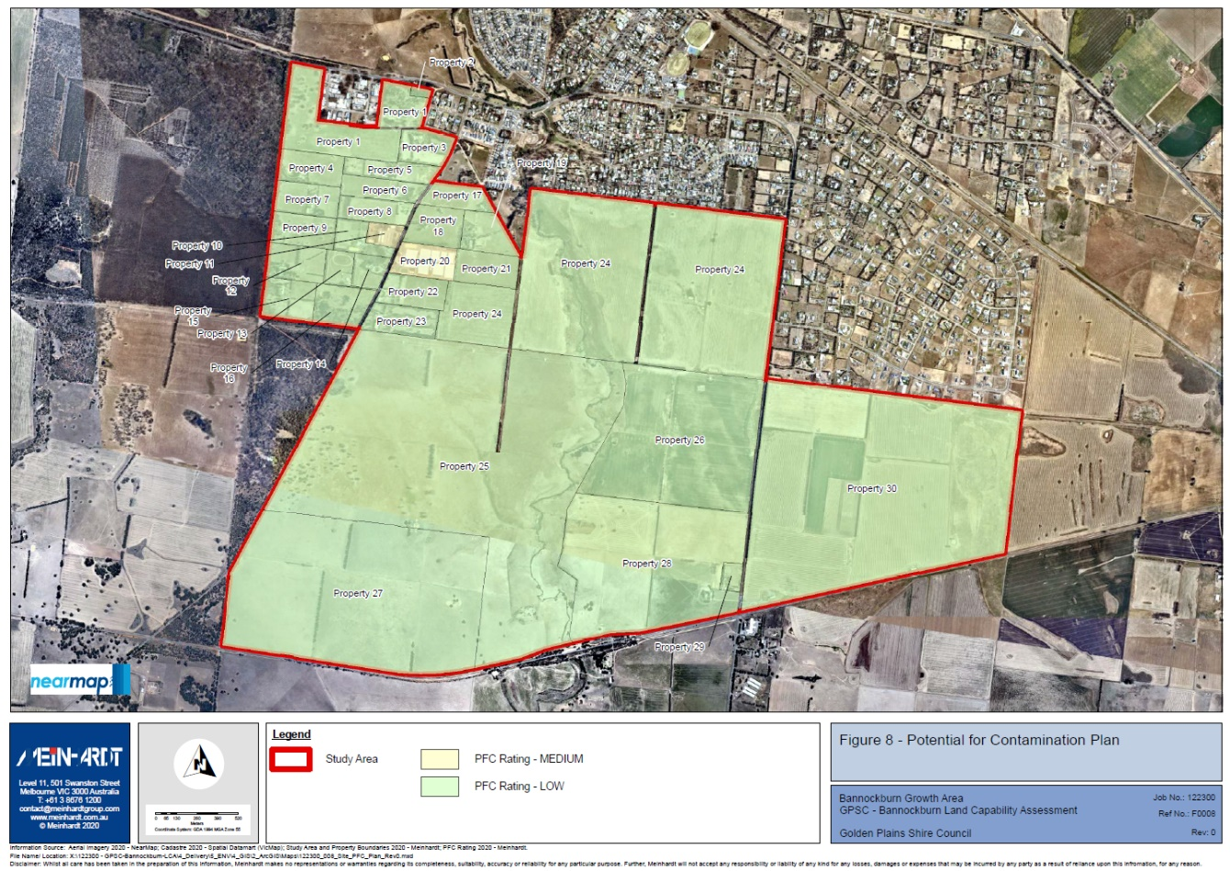
In summary:
- The majority of land parcels have a ‘low’ rating for potential contamination.
- Two parcels have a ‘medium’ rating for potential contamination. These parcels will likely require a detailed property specific assessment.
- This matter will be further addressed at the planning permit stage.

Transport

Traffic network assessment
The VPA prepared the Bannockburn Growth Plan Traffic Network Assessment (August 2020) (the assessment). The assessment identifies a possible future road network and arterial road option for Bannockburn. It provides an assessment of existing network conditions and investigates the need to expand the arterial road network to accommodate projected growth.
Key findings of the assessment are identified under the headings below.

Existing conditions
The assessment includes a summary of existing conditions, the key findings are:
- High Street in central Bannockburn is carrying approximately 10,365 vehicles per day (veh/day), of which 8% are heavy vehicles.
- Geelong Road is carrying approximately 9,659 veh/day, of which 12% are heavy vehicles.
- West of the central town, Bannockburn-Shelford Road is carrying approximately 5,441 veh/day, of which 13% are heavy vehicles.
- A significant proportion of heavy vehicles through Bannockburn are semi-trailers and B-doubles.
- Truck volumes through Bannockburn fluctuate significantly over the year, which could be explained by forestry and agriculture harvest times. Small and medium trucks showed the most variance, with large trucks having the most steady volumes across the year.
- The 2013 bypass study indicated a positive overall response to the idea of an alternative heavy vehicle route around Bannockburn.

Arterial Road
The assessment concludes that an additional arterial road is required to meet the needs of the Growth Plan. The process of testing the need for this road included:
- Reviewing the recommendations of previous Bannockburn bypass investigations were reviewed in the context of the Growth Plan.
- GIS was used to plot potential constraints mapping.
- Five options for an additional arterial road alignment were identified.
- Supporting local network was overlayed.
- Traffic Impact Assessment was undertaken to understand traffic implications.
The five corridor options for the arterial road are identified in Figure 6.
Figure 6 Five corridor options
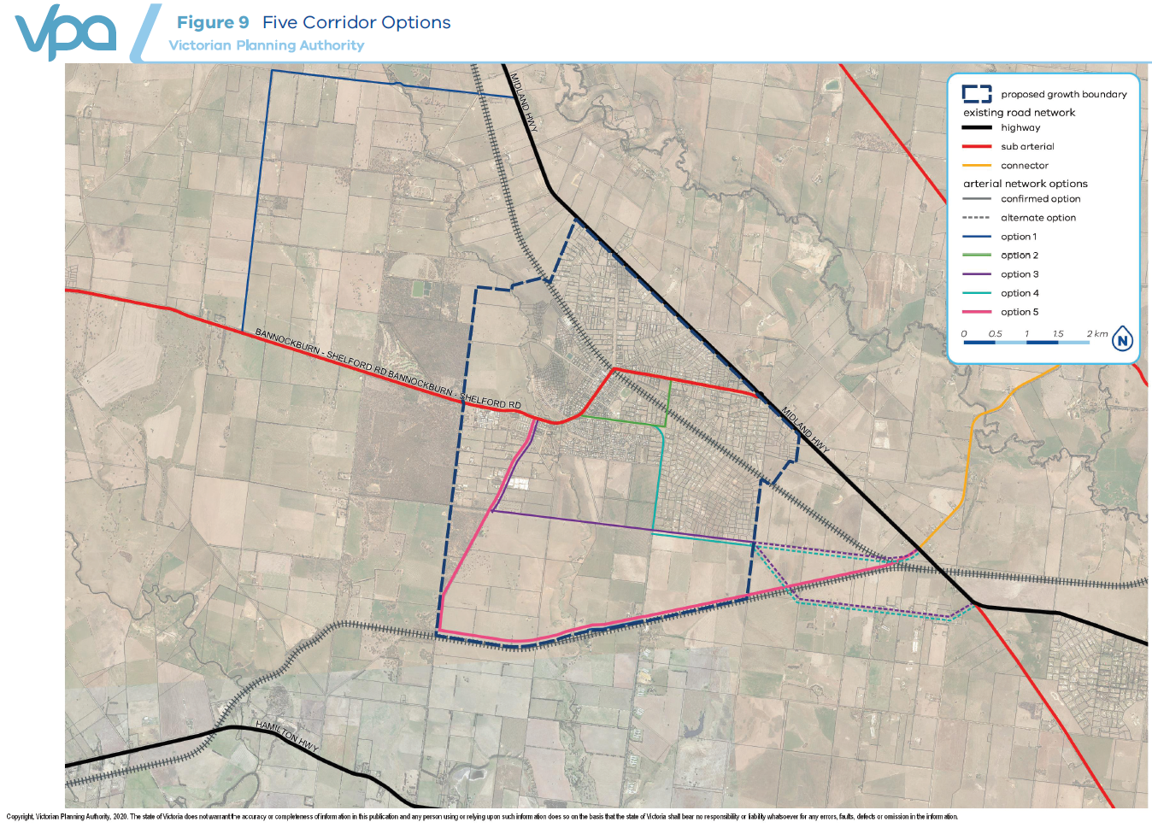
An assessment of the traffic impacts of each of the five route options was conducted and each route was evaluated against a range of transport, economic, environmental and social criteria (see Figure 7).

Additionally, a base line minimal change option was evaluated to understand the impacts of not providing an additional arterial road.
Figure 7 Evaluation of route option
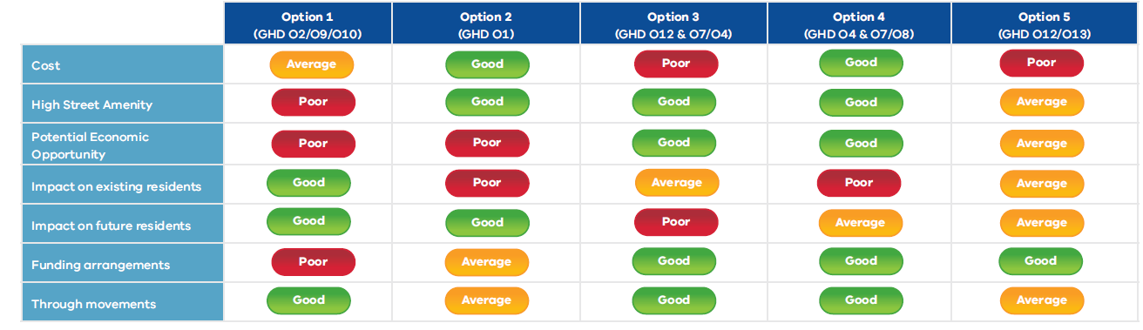
In summary:
- An additional arterial road is required through Bannockburn to meet the forecast traffic demands generated by the Growth Plan over 30 years.
- An additional arterial road through Bannockburn would:
  - provide an alternative arterial route for heavy vehicles and provide scope to improve general traffic operations and safety in the township;
  - present an important opportunity to improve safety and amenity of the central township;
  - redress the imbalance in the existing movement and place priorities through the High Street;
  - facilitate placemaking improvements in the central township;
  - support the needs of future public transport services;
  - provide a grade separated crossing of the Geelong to Ballarat railway line.
- Based on a high-level evaluation, Route Options 3 and 4 are found to be the most viable corridor options for an arterial road and are recommended for inclusion in the draft Growth Plan.
- This matter will be further addressed as part of the detailed planning for the proposed growth areas.
- This matter will be further addressed as part of the detailed planning for the proposed growth areas.

Public and active transport
There are currently limited public transport connections to and from Bannockburn as identified in Table 1. There is currently no public transport services that operate within the town.
A high-level overview of bus services in regional towns similar in size to Bannockburn’s current and long-term projected population reveals the town is currently underserviced. There is scope to expand both regional, inter-centre services as well as introduce local services as the town grows (see Table 2).
Table 1 Existing public transport
Source: G21 Public Transport Strategy
Line/network | Description | Weekday services | Weekend services
Geelong – Ballarat via Bannockbrun | V/Line coach on Midland highway route | Three trips each way | Three trips on Saturdays; two on Sundays
Geelong – Bannockburn | Intertown bus service | One trip only, to Bannockburn in mid-afternoon | None
Table 2 Comparison of bus services
Town | Population | Local Services | Regional Services
Armstrong Creek | 4,700 | 0 | 1
Gisborne | 13,000 | 2 | 0
Sunbury | 36,000 | 7 | 0
Lara | 16,000 | 3 | 0
Wonthaggi | 7,500 | 3 | 5
Warrnambool | 34,000 | 7 | 0
Bannockburn | 7,000 | 0 | 2*
* Existing service timetables do not allow for commuter service to Geelong.

Active Transport
The Victorian Principle Bike Network in the town consists of a shared path extending from Midland Highway, along Geelong Road to the intersection of High Street with Geelong, Kelly and Clyde Roads. There is scope and desire for an expansion of pedestrian and cycling links within the town for both leisure and commuter uses. In Cardno’s Existing Conditions and Issues and Opportunities Report (2019), commissioned by the council, a number of issues and opportunities for were outlined for active transport in the town. Issues included a lack of safe crossing points in the town centre, a lack of key links and on or off road shared or bicycle paths, and a lack of safe crossing points along key arterials and connectors in the town.
The report highlighted the strengthening of pedestrian and cycling links across the town, including across the creek and along key local roads, as significant opportunities.
In summary:
- Bannockburn is currently underserviced in terms of public transport connections.
- There is an opportunity to improve opportunities for active travel within and to and from Bannockburn.
- This matter will be further addressed as part of the detailed planning for the proposed growth areas.

Community Infrastructure
The VPA prepared a high-level report that outlines Community Infrastructure needs. This identified the potential population of the town and the likely community infrastructure facilities needed to service this growth.
Key findings included:
Kindergarten
- Short term: 1 additional program for 4 year old. The additional facility will likely service the North West or South East growth area.
- Medium term: 1 additional kindergarten, servicing the South West growth area.
- Consideration should be given to collocate future kindergartens with other community facilities.
Day Care
- Short term: 1 additional Day Care facility.
- Medium term: 1 additional Day Care facility, servicing the South West growth area. This is subject to further investigation.
Maternal and Child Health
- Provision ratios indicate that the existing MCH facility is enough to cater for short term growth, however council has raised the need to investigate either an expansion of the existing MCH facility or provision of an additional facility in the medium term.
Primary school
- Short term: 1 additional Government Primary School, 1 additional Catholic Primary School and 1 additional non-Government Primary School may be required. The split between Government and non-Government school provision is subject to further discussion with DET and other providers.
Secondary school
- Provision ratios indicate that the existing secondary school is enough to cater for long term needs, however noting that Bannockburn College may service surrounding townships, there may be a need to investigate an additional and/or non-Government Secondary School in the long term.
Community Centre
- Short term: 1 additional Level 1 or 2 community centre should be investigated to service either the North West or South East growth areas.
- Medium term: No clear evidence for an additional Level 1 or 2 community centre the medium term, however this may be investigated depending on demand.
- There is scope to consider relocating the existing playgroup building and expanding the Cultural Centre to increase its capacity.
Youth services
- Demand for youth spaces aligns with demand for a Level 1 or 2 community centre, therefore investigations into additional youth space and community centre provision may is investigated at the same time.
- Long term: A dedicated higher order youth facility may be considered, particularly if Bannockburn continues to attract young families.
Seniors group facility
- Long term: A lower order seniors facility can be investigated, co-located with a Level 1 or 2 community centre.

Indoor recreation centre
- Council has raised the need to provide additional indoor recreation facilities, subject to further investigation. In particular, council has indicated that it intends to consider an indoor recreation centre (short term), aquatic facility (medium term), netball courts (short to medium term) and tennis courts (medium term).
In summary:
- The high level recommendations have given an indication of what community infrastructure may be needed in future growth areas.
- This matter will be further addressed as part of the detailed planning for the proposed growth areas.

Economy

Industrial land
The VPA prepared a high-level analysis of industrial land requirements, this analysis found that Bannockburn’s occupied industrial land has grown at the rate of 0.5 hectares of annum. Assuming industrial land expands at the same rate, this would mean an additional 5-10 hectares of industrial land would be needed in Bannockburn by 2036. However, it is unclear whether this truly reflects demand in the area or if this slow growth rate is constrained by a lack of zoned industrial land.
Bannockburn currently has approximately 12 hectares of industrial land, well below the average 31 hectares in towns of similar size. The existing Bannockburn business park has been taken up at a significant rate, indicating that this type of land is desirable in Bannockburn. A potential expansion of this business park was identified in the Bannockburn Urban Design Framework (2011), it’s considered this remains the most logical location for additional industrial land supply for the town.
The Gheringhap Structure Plan (2012) indicates that there may be an opportunity for Gheringhap to address capacity issues in relation to employment land, where such uses cannot be provided in towns such as Bannockburn and Batesford. This may include industrial land supply.
In summary:
- Bannockburn currently has approximately 12 hectares of industrial land, well below the average 31 hectares in towns of similar size.
- The most local location for additional industrial land is as an expansion of the existing Bannockburn business park and at Gheringhap.
- This matter will be further addressed as part of the detailed planning for the proposed growth areas.

Retail
MacroPlan prepared the Bannockburn Retail Study (February 2020), providing an overview of existing spending patterns and projected retail needs.
Key findings included:
- The catchment served by Bannockburn is defined to include three primary sectors (central, south and north), two growth area sectors (growth area west and growth area south) and two outer sectors (outer north and outer west).
- Compared to regional Victoria, the Bannockburn trade area has a higher proportion of traditional family units in early life stages. As a result, the level of retail expenditure is 20% above the non-metropolitan Victorian average.
- Total retail expenditure is forecast to grow strongly, at an average annual growth rate of 6.1%.
- Retail facilities in the main trade area are concentrated within the Bannockburn Town Centre on High Street. The closest higher order retail and business hub is Geelong, located 23km south-east of Bannockburn.
- By 2023, the population within the main area is estimated at 6,900 residents, which can sustain around 7,000m² retail floorspace. This means that the planned redevelopment of Bannockburn Plaza and Woolworths expansion is supportable at that time.
- Analysis shows that as the growth areas in Bannockburn develops, there will be a need for another retail precinct in the town. At around 2038-2040, when the growth area south sector reaches a population of 3,000, it is considered that a small 1,500m2 centre anchored by a 500m2 foodstore would be supportable at a secondary location within the southern growth area. At 8,000 residents or by around 2058-2060, a centre anchored by a full-scale supermarket would be considered supportable.
- It is expected that the Bannockburn Town Centre will also increase its provision of retail floorspace to 2060, likely supporting a second full scale supermarket and Aldi supermarket in the long term. A location on Burnside Road would be a possible site due to its convenient access for residents.
In summary:
- As the growth areas in Bannockburn develop, there will need to be a second retail precinct in the town.
- When the growth area south sector reaches a population of 3,000, it is considered that a small 1,500 sqm centre anchored by a 500 sqm food store would be supportable at a secondary location within the southern growth area.
- An additional 1,000 sqm of floorspace, for a total of 2,500 sqm, would be supportable by the time the population in the southern growth area reaches 5,000 residents. At 8,000 residents or by a centre anchored by a full-scale supermarket would be considered supportable.
- This matter will be further addressed as part of the detailed planning for the proposed growth areas.

Stormwater Drainage
Alluvium Consulting Pty Ltd prepared the Bannockburn Catchment Assessment (May 2020) which highlights the existing conditions, flow directions, sub catchments and outfall locations we well as providing high-level modelling of treatment and drainage assets needed to serve the study area.
Based on this high-level analysis a high-level drainage and treatment model has been devised and concept assets recommended (see Figure 8).
The study area generally consists of flat plains, with much of the area draining into Bruce’s Creek, located at the bottom of a steep escarpment of around 20-30m. Wetlands and retarding basins will used further up in catchments, and a number of constructed waterways could be developed. These drainage assets have the potential to provide recreational, amenity, environmental and urban cooling opportunities. An existing wetland in the south west precinct was also identified and an investigation into its value and potential drainage uses was recommended.
This analysis built off a previous detailed drainage assessment by Alluvium for the Bannockburn South West Precinct, which determined concept drainage options and costings. Some concept assets from this assessment were further recommended in the May 2020 analysis, though some previously recommended assets were left out as the expanded growth area allowed treatment further down the catchment. The next phase of planning will need build off this work to undertake further hydrologic modelling to estimate peak flows and ensure adequate asset provision.
In summary:
- Much of the area drains into Bruce’s Creek.
- Wetlands, retarding basins and constructed waterways could be developed to manage stormwater.
- Constructed waterways have the potential to provide recreational, amenity, environmental and urban cooling opportunities.
- This matter will be further addressed as part of the detailed planning for the proposed growth areas.
Figure 8 Concept drainage assets
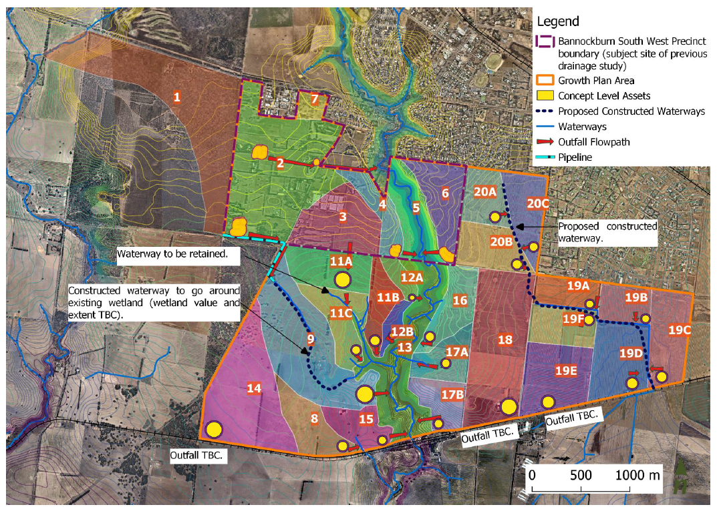

Bushfire
Ecology and Heritage Partners Pty Ltd prepared the Strategic Bushfire Risk Assessment (August 2020) to inform the identification of precincts and directing development area from identified bushfire hazards. The report includes an assessment of the study against relevant bushfire legislation, namely Clause 13.02-1S Bushfire, Clause 44.06 Bushfire Management Overlay, Clause 53.02 Planning for Bushfire and the BPA.
Key findings included:
- When considering potential growth directions, the assessment concluded that development in the north and west would have a similar bushfire risk to the south. The east was identified as having a lower risk compared to the south.
- Through the implementation of the findings of the assessment, the study area will meet the objectives and strategies of Clause 13.02-1A via the incorporation of the recommended BAL construction standards and commensurate separation distances (see Figure 9).
- Other fire mitigation measures would include maintaining the open space, parkland, waterways and sporting facilities in a low threat state, providing a hydrant network, providing adequate access for emergency vehicles throughout the precinct and providing a 22-metre-wide rolling front buffer around any new buildings during construction phase.
- As part of future subdivision, classified vegetation will potentially be required to be ground-truthed and further investigation may be required to determine the relevant bushfire mitigation measures and appropriate BAL construction standards in response to classified vegetation
- If dwellings are constructed in within the Bushfire Management Overlay, a Bushfire Management Statement must be produced to effectively respond to Clause 44.06 Bushfire Planning and mitigate the higher level of bushfire threat.
- Future developments within the BPA and BMO may also be required to submit a Bushfire Management Plan which addresses the mitigation measures to effectively respond to classified vegetation within the study area during construction.
In summary:
- Through the implementation of the findings of the assessment, the study area will meet the objectives and strategies of Clause 13.02-1A via the incorporation of the recommended BAL construction standards and commensurate separation distances (see Figure 9).
- Detailed bushfire risk mitigation measures will be applied as part of the planning for the proposed growth areas.
- This matter will be further addressed as part of the detailed planning for the proposed growth areas.

Figure 9 BAL 12.5 separation distances
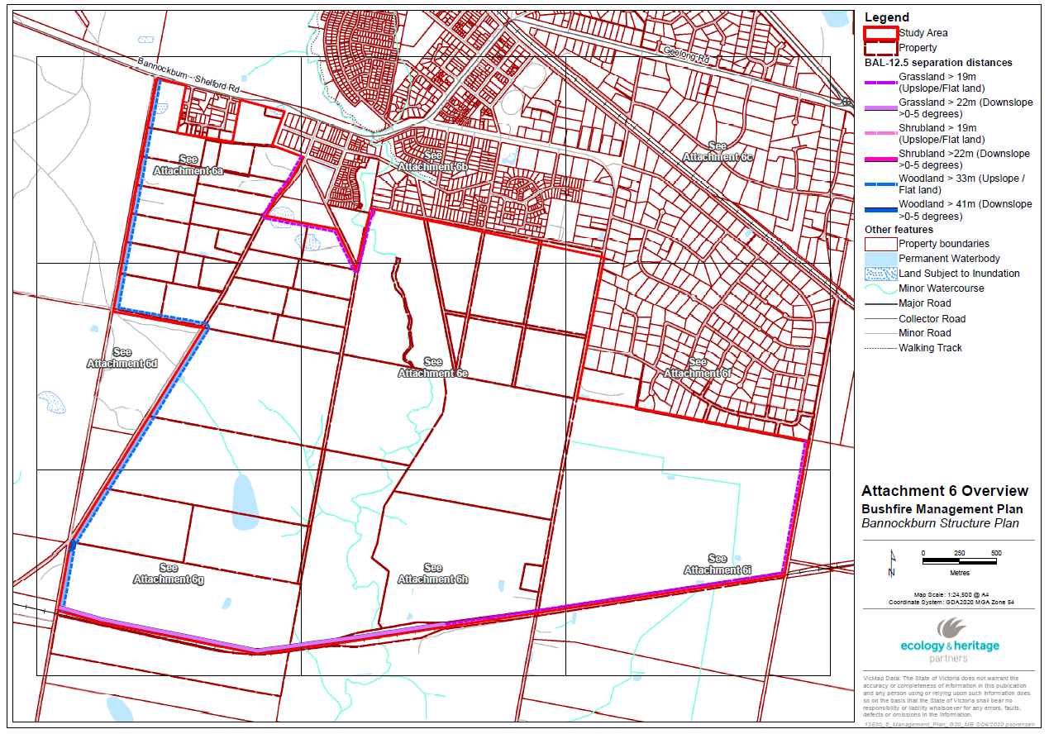

G21 is the formal alliance of government, business and community organisations working together to improve the lives of people within the Geelong region across five municipalities – Colac Otway, Golden Plains, Greater Geelong, Queenscliffe and Surf Coast.
Golden Plains Shire Region Profile 2019 (prepared by Civic Collective on behalf of G21 Region Alliance).
Gheringhap Structure Plan (Parsons Brinckerhoff, 2012). Page 17.

