



TOWARDS A BRAYBROOK URBAN DESIGN FRAMEWORK
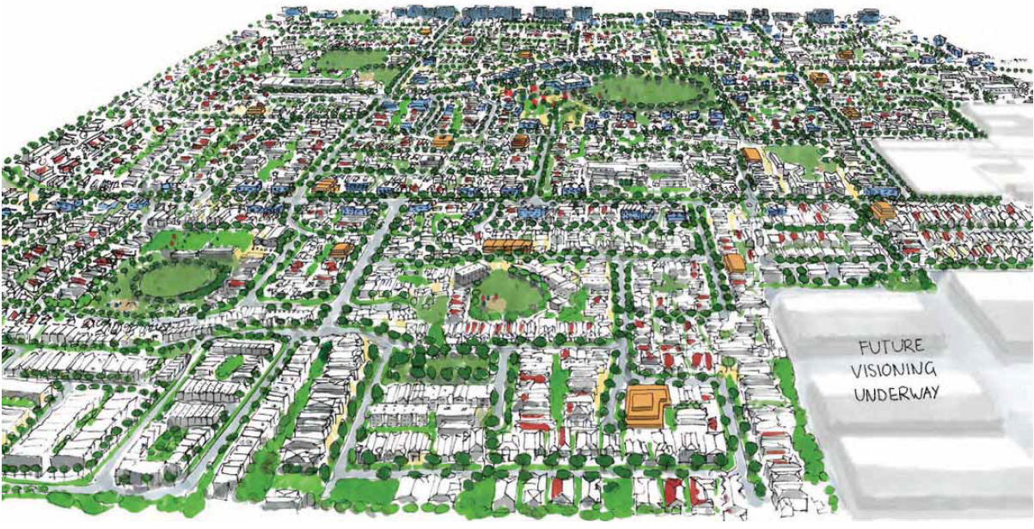

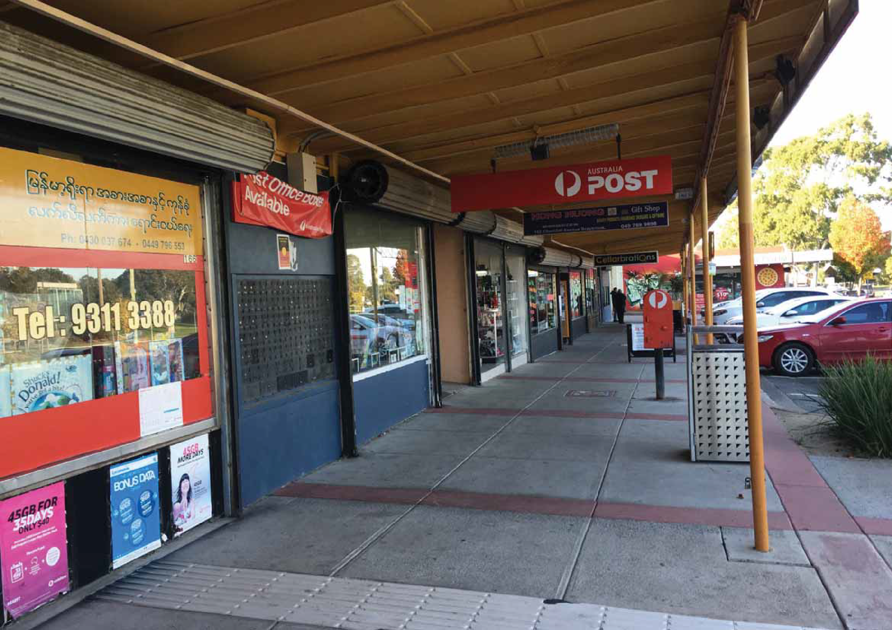

Contents

Aboriginal acknowledgement
The Victorian Government proudly acknowledges Victoria’s Aboriginal communities and their rich culture and pays its respects to their Elders past and present. The government also recognises the intrinsic connection of Traditional Owners to Country and acknowledges their contribution in the management of land, water and resources.
We acknowledge Aboriginal people as Australia’s ﬁrst peoples and as the Traditional Owners and custodians of the land and water on which we rely.
We recognise and value the ongoing contribution of Aboriginal people and communities to Victorian life and how this enriches us. We embrace the spirit of Reconciliation, working towards the equality of outcomes and ensuring an equal voice.

VPA disclaimer

© VICTORIAN PLANNING AUTHORITY 2021
This draft Towards a Braybrook Urban Design Framework was developed by the VPA on behalf of the Victorian Government in collaboration with Maribyrnong City Council and other State and local government partners. Any projections are based on reasonable assumptions at the time of publication but should
not be relied upon without ﬁrst seeking appropriate expert advice. Although every effort has been made to ensure that the information in this document is factually correct at the time of publication, the VPA does not warrant the accuracy, completeness or relevance of the information. Any person using or
relying upon this document does so on the basis that the State of Victoria shall bear no responsibility or liability whatsoever for any errors, faults, defects or omissions in the information.
Site Context 4
Engagement Summary 6
Foundations of the Plan 7
The Draft Plan 8
Principles 9
Connectivity & Legibility 10
Design Framework 11
Design Ideas 12
Vibrant & Diverse Community 18
Design Framework 19
Design Ideas 20
Sustainability & Open Space 22
Design Framework 23
Design Ideas 24
Amenity & Character 26
Design Framework 27
Future Character Areas 28

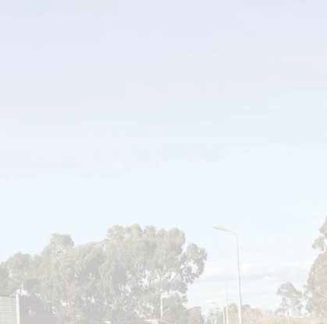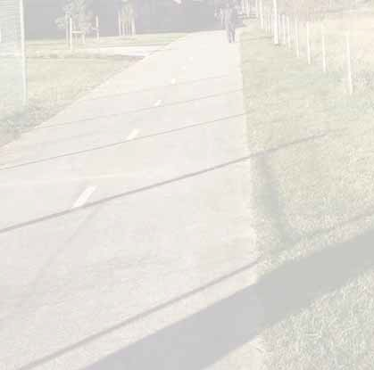This document has been prepared solely for the beneﬁt of VPA and is issued in conﬁdence for the purposes only for which it is supplied. Unauthorized use of this document in any form whatsoever is prohibited. No liability is accepted by Lat37, any employee, contractor, or sub-consultant of this company with respect to its use by any other person. This disclaimer shall apply notwithstanding that the document may be made available to other persons.

Strategic Context

Braybrook is changing
Braybrook is growing and evolving as new jobs are brought to the inner west and new residents are drawn to the neighbourhood’s affordability and proximity to Sunshine and the city.
Braybrook is well located to support Melbourne’s population growth, nestled within the Sunshine Transport Precinct, to the west of the Footscray Business Precinct, adjacent to Central West Major Activity Centre, within 4 kilometres of Highpoint Major Activity Centre, and situated 9 kilometres west of Melbourne.
As part of the Victorian Government’s response to the Covid-19 crisis, the Braybrook Regeneration Project presents a unique opportunity for neighbourhood scale revitalisation.
Change is already happening, as older homes are replaced and new infrastructure is delivered under Council’s Revitilising Braybrook action plan. With signiﬁcant investment in the revitalisation of older, no longer ﬁt for purpose social and market housing, local open space, community facilities and transport could see Braybrook grow from 3,750 dwellings and accommodate up to 10,000 dwellings by the year 2051.

Towards a Braybrook Urban Design Framework
To support the implementation of the Braybrook Revitalisation Project, The Victorian Planning Authority are working with Maribyrnong City Council to create a plan for the new services, parks and infrastructure, and housing needed for a growing Braybrook. It’s called the Braybrook Urban Design Framework or Braybrook UDF. This vision document, Towards a Braybrook Urban Design Framework has been prepared to seek input into the planning and design principles that will form the basis of the Braybrook
UDF. When approved, the UDF will go into the Maribyrnong Planning Scheme and guide future development in Braybrook.

We are planning for diverse, accessible and affordable homes in Melbourne’s West
The provision of diverse and affordable housing is essential to Victoria’s productivity, liveability and social equality.
The revitalisation of Braybrook can have a signiﬁcant inﬂuence on the future liveability of Maribyrnong and the west. Braybrook presents an opportunity to renew older social and market housing stock and create high-quality affordable housing close to jobs, local centres, services and transport.

Regional investment
Melbourne’s inner west continues to attract unprecedented population and employment growth. Health, education and professional services are emerging as key drivers of the economy.
Signiﬁcant infrastructure investment by the State is reshaping the west, including the $13 billion Melbourne Airport Rail Link, $11 billion Metro Tunnel and $7
billion West Gate Tunnel. Capturing the value creation opportunities from these major investments will be critical to ensuring the State’s continued economic success and to capturing increased beneﬁts for the community.
Investment in fast and frequent public transport to Sunshine Transport Precinct will improve accessibility for the community, as well as providing a catalyst for improved amenity and urban regeneration.
Sunshine is emerging as an economic and transport super hub. Its economic output from health, manufacturing, retail and education makes it a strong contributor to the
economy, supporting several thousand jobs. The Braybrook Regeneration Project’s proposed planning land use interventions will support the Sunshine Transport Precinct’s growth as a health, commercial and education service centre supporting thousands of new high-value jobs.

Melbourne’s housing dilemma We need to grow with greenery
Braybrook is changing. This change is bringing challenges because there isn’t an overarching plan to guide housing design and streetscape quality.
Typical redevelopment of suburban residential areas involves landowners demolishing a house and subdividing their existing block into smaller lots.
This typically results in existing trees being removed, and garden space being fragmented and broken up into insigniﬁcant areas, providing little to no new space for signiﬁcant vegetation or green space.
This pattern is repeated until a street or neighbourhood has excessive driveway pavement and no garden big enough to provide space for medium and large canopy trees.
This effect over time means streets and neighbourhoods lose tree canopy cover, reduce an areas capacity to mitigate local ﬂooding after heavy rains and holds onto more heat.
Though this is a poor outcome for many suburbs, we want to avoid this outcome for Braybrook through careful, considered and strategic planning interventions.

4 Towards a Braybrook Urban Design Framework

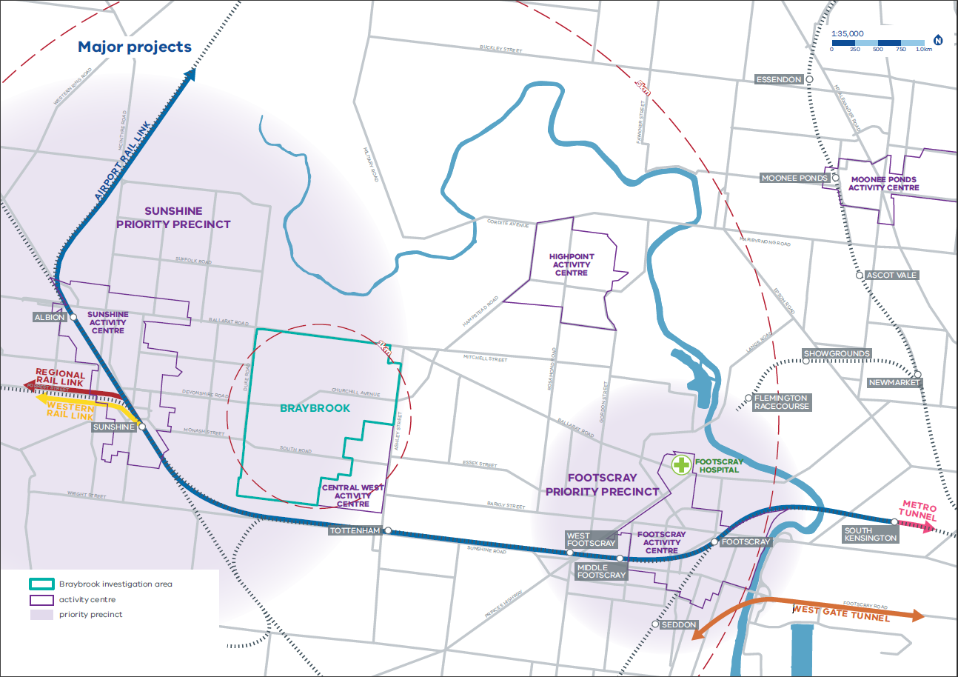

Context
The plan for Braybrook will cover the area between Ballarat Road and the Sunshine rail line, from the western edge of the Central West business centre over to Duke Street.
This work is complemented by a broader suite of coordinated strategic planning underway within Melbourne’s inner west, which includes State Government planning for the Sunshine Transport Precinct, Brimbank City Council planning for Sunshine’s Town Centre, including the under construction Hampshire Road Upgrade project and Maribyrnong City Council preparing a Central West Structure Plan and Braybrook North Employment Precinct Framework Plan.

Engagement Summary

Phase 1 Stakeholder Soundings
Phase 1 stakeholder soundings for the Braybrook Regeneration Project were undertaken between Monday 16 November to Friday 11 December 2020. Stakeholders were invited to provide feedback on the draft planning principles and objectives.
The draft planning principles and objectives were generally supported, and participants provided additional feedback to the project team for consideration. The list below is
a summary of key ﬁndings, categorised by discussion themes.
Access and connection:
- Improve disability access to public transport and community facilities
- Improve diversity of bus routes and frequency
- Use durable materials to avoid vandalism at bus stops and shelters
- Ensure signage is accessible for culturally and logistically diverse community members
- Increase the amount of safe pedestrian crossings on Ballarat Road, South Road and around Central West Shopping Centre
- Designating drop-off zones for each school

Vibrant and diverse community:
- Consider places for residents to meet in the evening
- Provide community facilities for young people, for example youth centres, sports facilities and gathering places
- Additional multicultural events and art activities to celebrate cultural diversity
- Spaces to support local start-ups and social enterprises
- Greater recognition of Traditional Owners
- Revitalise existing neighbourhood houses
- Concern about the access to gambling facilities for young people

Perception of safety:
- Mixed views on the perception of safety in Braybrook
- Primary school students felt that Braybrook is unsafe at night
- Concerns about a needle exchange proximity to children’s playground and kindergarten
- Suggestion CCTV cameras and good lighting would improve safety perception

Streetscape and open space:
- Suggest using native, drought and climate resilient plants
- Choose tree species that do not obstruct footpaths or create trip hazards
- Ensure gardens are provided in private properties
- More community gardens
- Activate street fronts by putting shops on ground ﬂoors
- Provide dog-friendly areas
- Improve waste management

Neighbourhood character:
- Improve condition of older houses and social housing
- Support for providing affordable housing
- Upgrade old Department of Health and Human Services properties
- Concern that housing upgrades will increase housing prices
- Interest in the form of character areas and the inﬂuence it will have on the experience of the place
Other suggestions:

- The Urban Design Framework (UDF) needs to consider future changes to demographics in Braybrook not just the current residents
- Consider climate responses in all aspects
- Consider the impact on community of drug use and gambling issues

Ideas for broader community engagement:
- Clearly communicate to avoid disappointment or ‘false hope’; there’s a community sentiment that many government promises have not been delivered in the past
- Community organisations can assist targeting different cohorts, for example Cohealth with Aboriginal and Torres Strait Islander community and Western Bulldogs Foundation with young people
- Engage with community leaders from culturally and linguistically diverse (CALD) backgrounds to promote and assist engagement
- Provide translated materials
- Consider targeted engagement for the Burmese community
- Use existing women’s groups
- Targeted engagement for young people

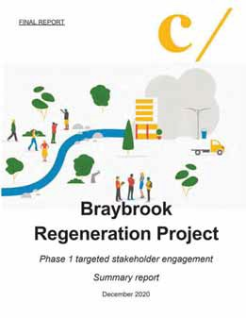Braybrook Regeneration Project, Summary Report, December 2020

6 Towards a Braybrook Urban Design Framework

Key Policy Foundations of the Plan

Plan Melbourne: Realising the 20-minute neighbourhood in Braybrook
Plan Melbourne 2017–2050 (Plan Melbourne) is the primary metropolitan strategy for supporting jobs, housing and transport. It builds on Melbourne’s legacy of distinctiveness, liveability and sustainability. Plan Melbourne sets out clear directions to support the
development of 20-minute neighbourhoods where people can easily access local employment, education, community and recreational facilities and services within 10-minute walk or 20-minute return journey. The regeneration of Braybrook’s housing, local centres and streets will provide signiﬁcant improvements to local amenities and better realise this aspiration for a 20-minute neighbourhood.

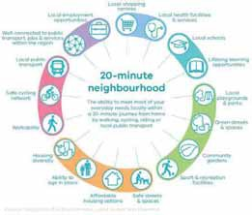

Growing Corridors & Nodes along Melbourne’s Principal Public Transport Network
The plan intends to focus higher intensity development and land use along key corridors of the Principal Public Transport Network (such as Ballarat Road, South Road,
Churchill Avenue and Ashley Street) and nodes (areas surrounding local activity/services such as Churchill Avenue Shops). This will make sure the highest density of housing is located closest to transport and local amenities.

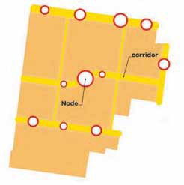

‘Cooling & Greening’ Maribyrnong
Climate change has increased the City of Maribyrnong’s ecological vulnerability. The municipality features a highly urbanised environment including signiﬁcant areas of industrial land and a lack of adequate canopy cover, which was measured at only 8.3 per cent under council’s 2018 draft Urban Forest Strategy. Strategies such as Living Melbourne: our metropolitan urban forest and Maribyrnong City Council’s Urban Forest Strategy provide direction
to reduce the use of potable water, increase ecological resilience, minimise costs and maximise community value. This reﬂects a broader trend and growing evidence base supporting the restoration and maintenance of urban forests within metropolitan Melbourne. Better protecting existing urban trees, providing more certainty for trees and cooling outcomes in new development and providing space and conditions for healthy trees in medium density developments will ensure every future project contributes to ‘cooling and greening’ Braybrook.

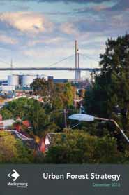

Revitalising Braybrook
Maribyrnong Council’s ‘Revitilising Braybrook Action Plan 2013-2015’ sought to leverage the strengths and attributes of the Braybrook community. The Revitilising Braybrook Action Plan set tangible action’s in key priority areas
(e.g. urban growth, liveability, economic prosperity and environmental sustainability) and delivered signiﬁcant investment like the Braybrook Community Hub. Revitilising Braybrook advocates for improved social housing quality, maintaining housing diversity and affordability. The Plan will help realise this aspiration.

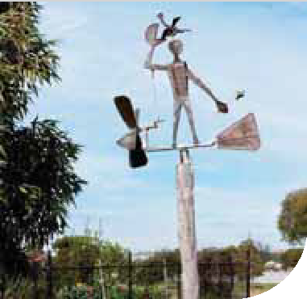

MARIBYRNONG CITY COUNCIL

Revitalising Braybrook Action Plan
2013-2015

Towards a Braybrook Urban Design Framework 7

Principles
The regeneration of Braybrook will follow four principles which will guide the actions proposed within this document and within the forthcoming Braybrook UDF. These principles complement the aspirations of Council, Government and the local community.



Connectivity & Legibility
A community that has strong connections between facilities and residential areas and has easy access to public transport and the wider region



Vibrant & Diverse Community
A connected community that celebrates its diversity and has easy access to a wide range of activities, services and retail.



Sustainability & Open Space
A community that is well integrated with its natural ecosystem, is environmentally sustainable and well- prepared for the impacts of climate change



Amenity & Character
A community with a strong sense of place that celebrates the areas natural assets with high quality public realm and built form design.

8 Towards a Braybrook Urban Design Framework

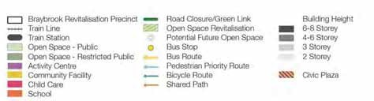
The Draft Plan

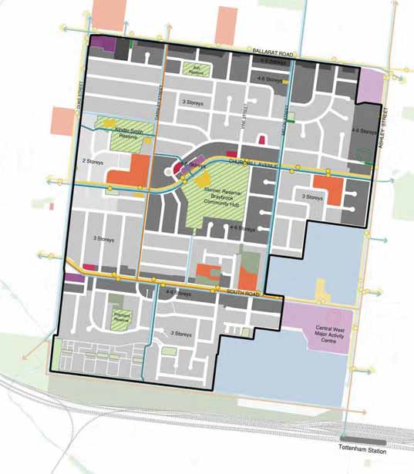The Draft Plan is based on solid technical evidence and solutions for movement and parking, urban design, utility services, open space, environmental sustainability and infrastructure coordination.
Towards a Braybrook Urban Design Framework
9
The Plan responds to the four planning and design principles that underpin the ‘6 key ideas’ of the Plan:
  - Create a new public plaza for gathering and events
  - Provide different types of housing for a growing population
  - Make it safer and easier to travel to and around Braybrook
  - Make streets, parks and homes greener
  - More and better local services
  - Set higher standards for new buildings and allow some taller buildings so more people can live near Braybrook’s Community Hub, shops and public transport

The Framework Plan

Connectivity & Legibility

Braybrook has lots of great local places and most of the shops, schools and parks are close to where people live. We want to make it easier and nicer to move between those places by walking, cycling and public transport, and to make life less reliant on owning a car.
Transforming key routes into inviting and comfortable places for all people and abilities is important to changing in how we move. We want Braybrook to become a healthier, more active community and recognising streets are an important part of this.
The street network could become one of Braybrook’s key assets. It is envisaged to include continuous stretches of medium and large canopy trees, providing shade on hot days and reducing overall heat. Water sensitive urban design interventions will make streets more visually appealing whilst also dealing with local drainage issues. New pockets of activity will provide interest for pedestrians and encourage people to discover their community on foot.
Making sure people feel safe walking around the streets both day and night is also important. Slowing traffic and improving lighting will make streets physically safer, while greater amount of new homes will enable more “eyes on the street” and contribute to a greater feeling of safety.

Walking
Most of the streets in Braybrook connect in a grid, which makes it easier to move around. The main ideas for improving walking are to prioritise pedestrians over cars, make walking easier by providing seats and shady trees along key walking routes and addressing any gaps in public street lighting.
“Pedestrian priority streets” will encourage more walking, through better road crossings and more traffic calming measures, so cars know to slow down so that more people can walk uninterrupted through these main streets
Tottenham Station offers the nearest access to the passenger rail network from the regeneration area. The distance from the station, lack of direct walking paths through the Central West business park, poor quality approaches to the Station and difficulty crossing Ashley Street all restrict access to the Station. The Council’s Central West Structure Plan, now being prepared, will propose improvements to walking and cycling access to the Station from Central West and the Braybrook Regeneration area. State Government and Council will
work together on the changes, as major roads and railway stations are State Government assets.

Cycling
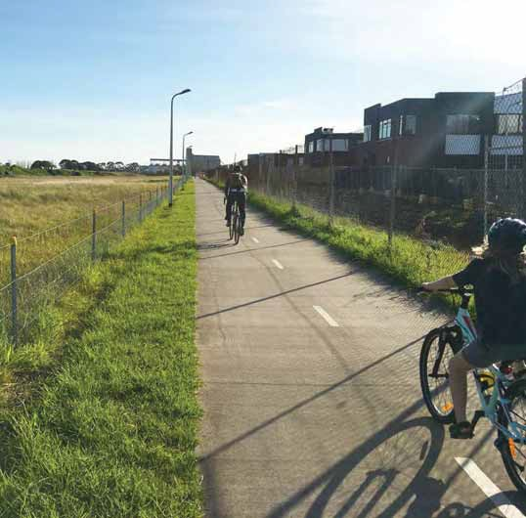
We want people to be able to safely ride bikes for fun, exercise and as a quick way to get to local places.
Sometimes this will be through shared space on the road and sometimes through dedicated bike only pathways.
The upgraded bike network has been designed to better connect with Sunshine and Footscray. The dedicated bike lane along the railway line will remain the best way to do this, with better connections to this path along main roads and more priority for cyclists along Churchill Avenue.

Public Transport
The current bus network is extensive with frequent services connecting to Sunshine, Footscray, Highpoint and the
CBD. The future plan will advocate for an increase in both bus and train services as the population increases, with the need for bus network extensions to be reviewed in the future.
Major transport investments are coming to Sunshine through the Melbourne Airport Rail Link and the Western Rail Plan. The State government continues to look at how these projects will change and beneﬁt public transport access in Braybrook. A signiﬁcant part of this is looking at Ballarat Road to see how safety, amenity and capacity of this road can be improved to create a boulevard linking Sunshine, Footscray and Highpoint.

10 Towards a Braybrook Urban Design Framework

Connectivity & Legibility Design Framework

A community that has strong connections between facilities and residential areas and has easy access to public transport and the wider region.

Objectives:
  - Make Braybrook highly walkable with safe, attractive streets, day and night, for pedestrians and cyclists
  - Improve pedestrian and bicycle access to activity centres
  - Locate tram and bus stops where they are easily accessible to enable Braybrook to be well serviced by public transport options
  - Provide a variety of footpath, landscape, car parking and bicycle options within a network or larger and smaller streets
  - Prioritise growth and improve transit along Principal Public Transport Network (PPTN)
  - Provide parking based on local road network capacity
  - Design and manage parking to optimise movement and place outcomes

Actions:
- Provide a network of pedestrian priority routes on Darnley Street, Melon Street, Lily Street (partial), Churchill Avenue, Kingsford Street, South Road and Beachley Street
- Complete the cycling network identiﬁed in Council’s Bicycle Strategy 2020-2030 with dedicated bike and shared paths to connect key points of interest within Braybrook
- Create better active transport links to Maribyrnong River, Sunshine and Footscray Activity Centres and other regional destinations
- New footpaths are to be a minimum of 1.5m wide and at least 2.0m wide on pedestrian priority streets (excluding Melon Street)
- Create better pedestrian amenity and increase open space close underutilised streets sections to vehicles
- Improve timetable signage, wait time information, passenger experience of transit routes and priority for existing public transport
- Balance the roles of streets consistent with the Department of Transport’s Movement and Place assessment framework
- Promote sustainable transport modes through explicit allocation of space along corridors and improved quality between stops
- Develop a car parking strategy to manage the impact of parking on the neighbourhood amenity
- Encourage active and public transport usage

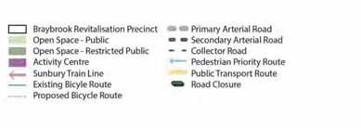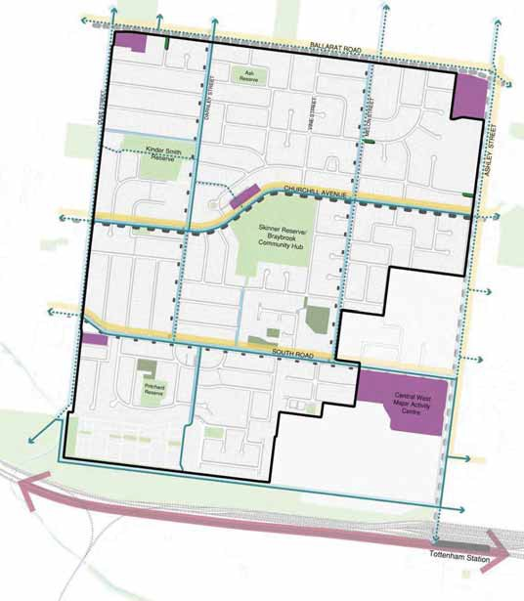

Towards a Braybrook Urban Design Framework 11
Connectivity & Legibility Principle Plan


Connectivity & Legibility
Design Ideas Darnley Street Existing Darnley Street Proposed
Key interventions for Darnley Street include:
  - 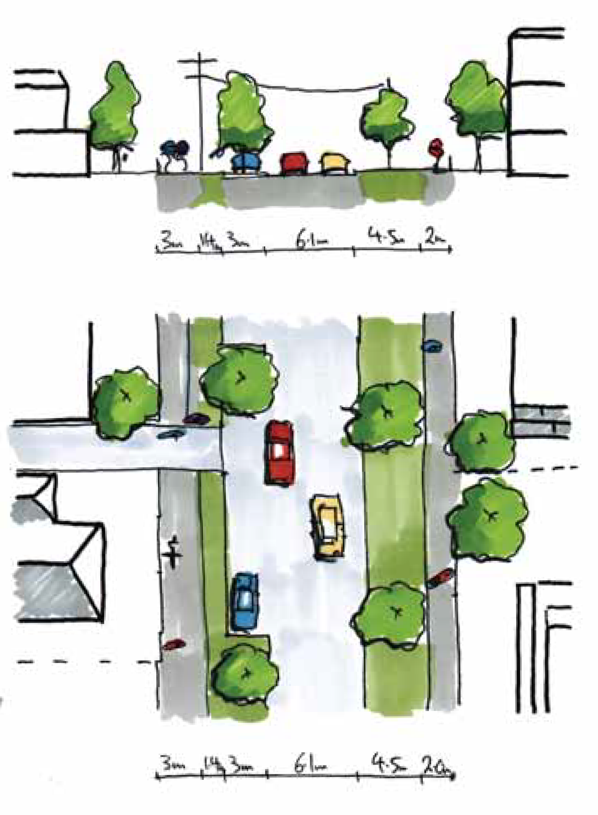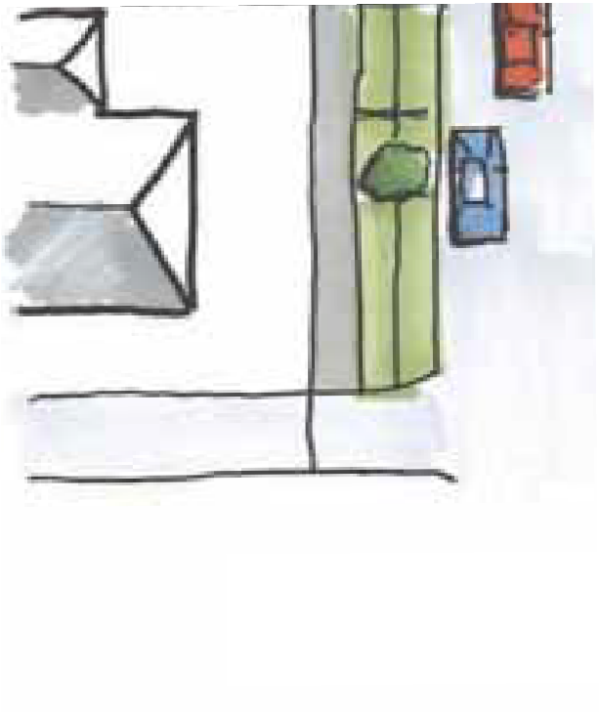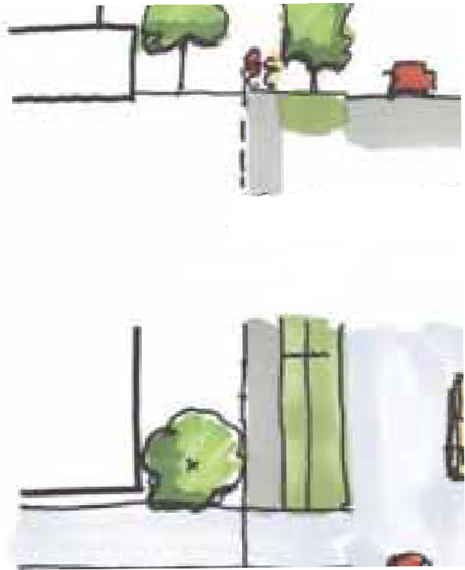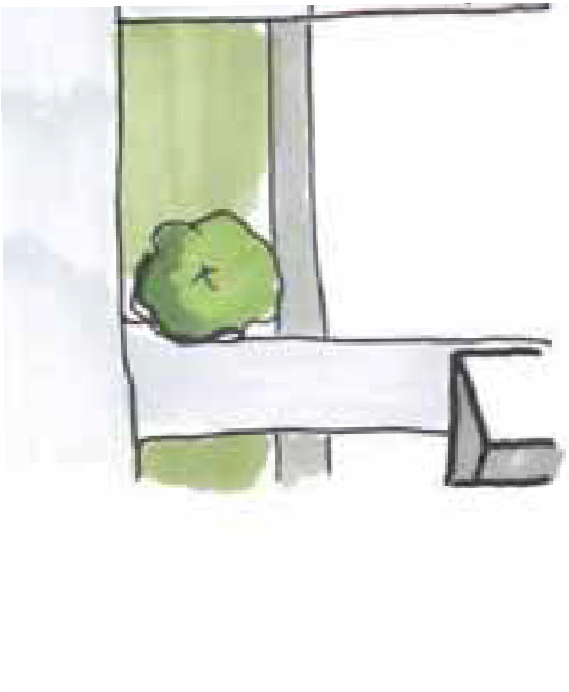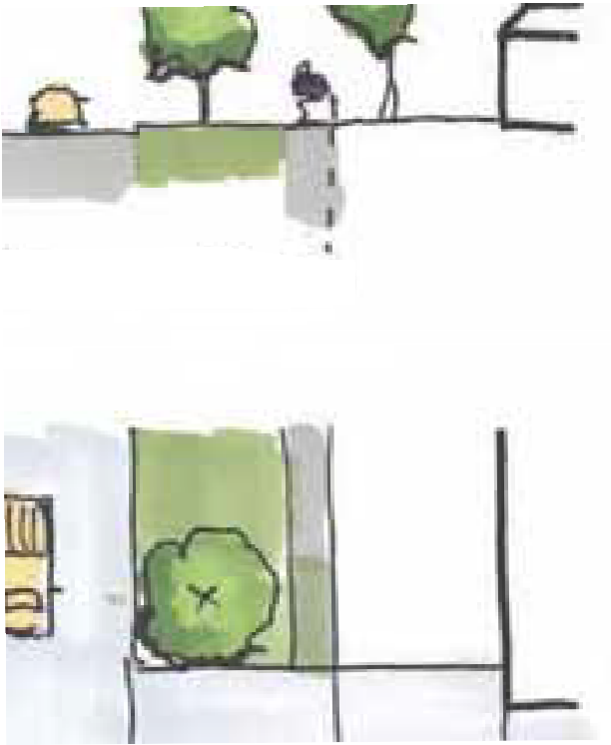A narrower carriageway with less street parking
3.0m 1.4m 3.0m
6.1m 4.5m 2.0m
Shared Nature In street Carriageway Nature Footpath
path strip tree pits
strip

3.0m 1.4m 3.0m
6.1m 4.5m 2.0m
Shared Nature In street Carriageway Nature Footpath
path
strip tree pits
strip
1.5m 2.9m
9.1m
5.0m 1.5m
1.5m 2.9m
9.1m
5.0m 1.5m
Footpath Nature
strip
Carriageway
Nature Footpath
strip
  - The introduction of a shared path on the western edge
  - A wider footpath on the eastern edge
  - The introduction of WSUD on the western edge
  - The introduction of large canopy street trees in kerb outstands on the western edge
  - The introduction of medium canopy street trees on the eastern edge

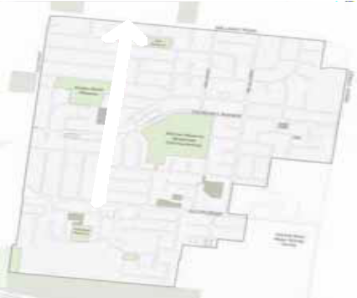

12 Towards a Braybrook Urban Design Framework

Connectivity & Legibility
Design Ideas Melon Street Existing Melon Street Proposed
Key interventions for Melon Street include:
  - 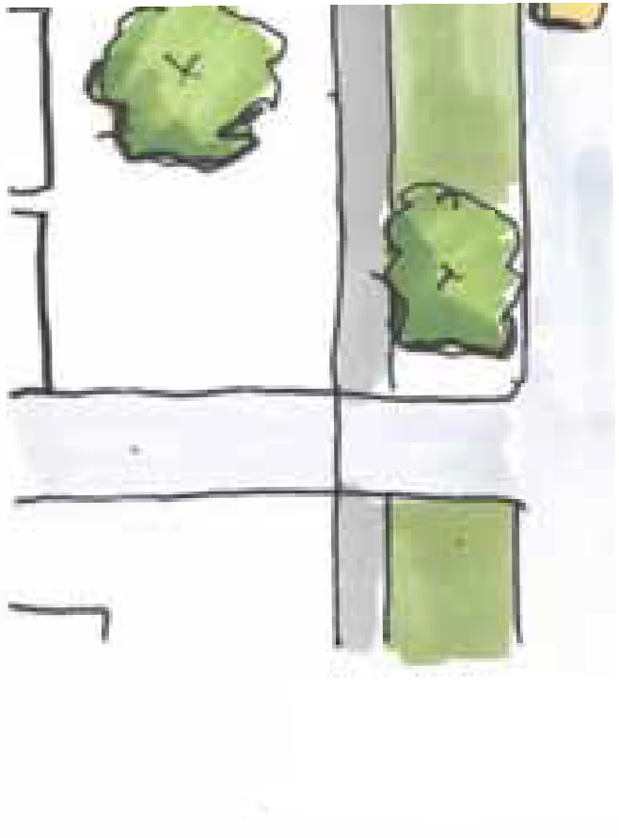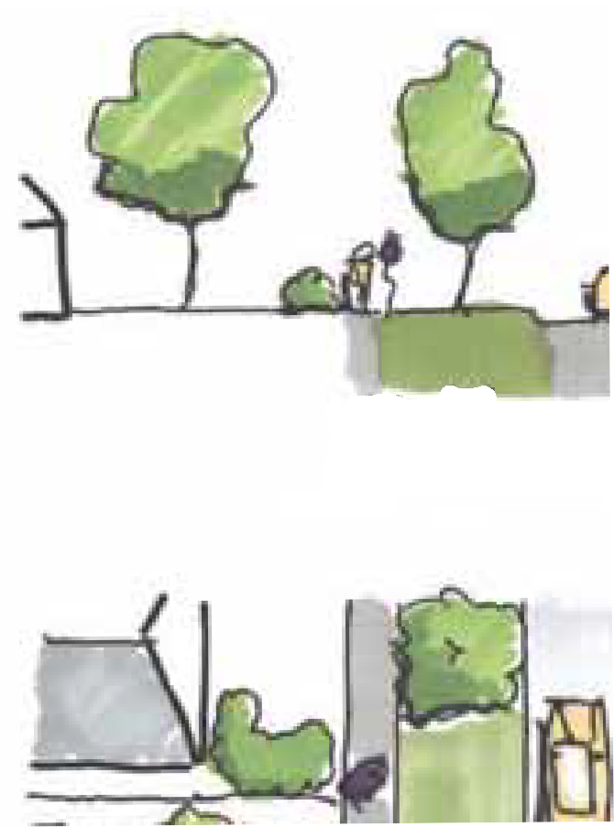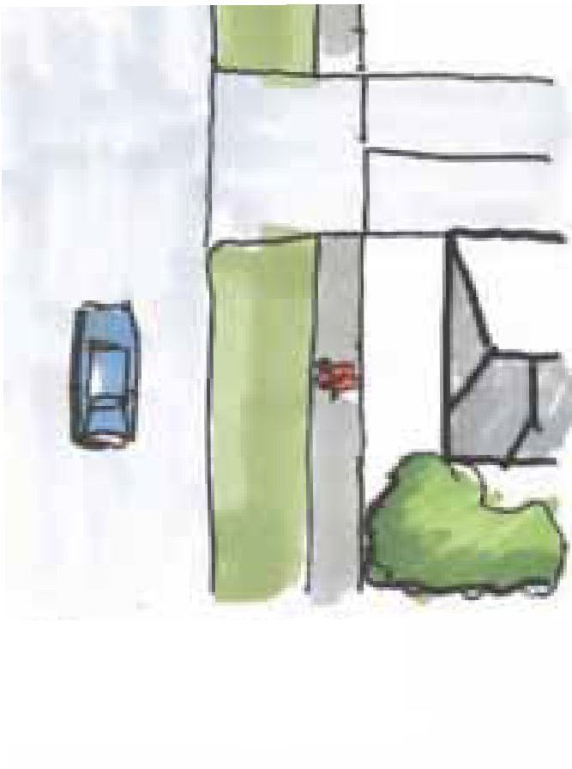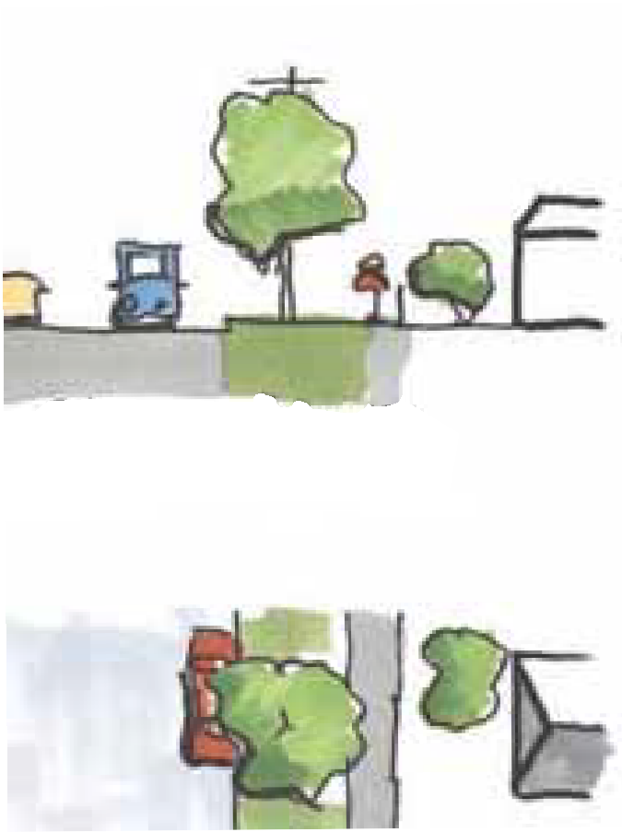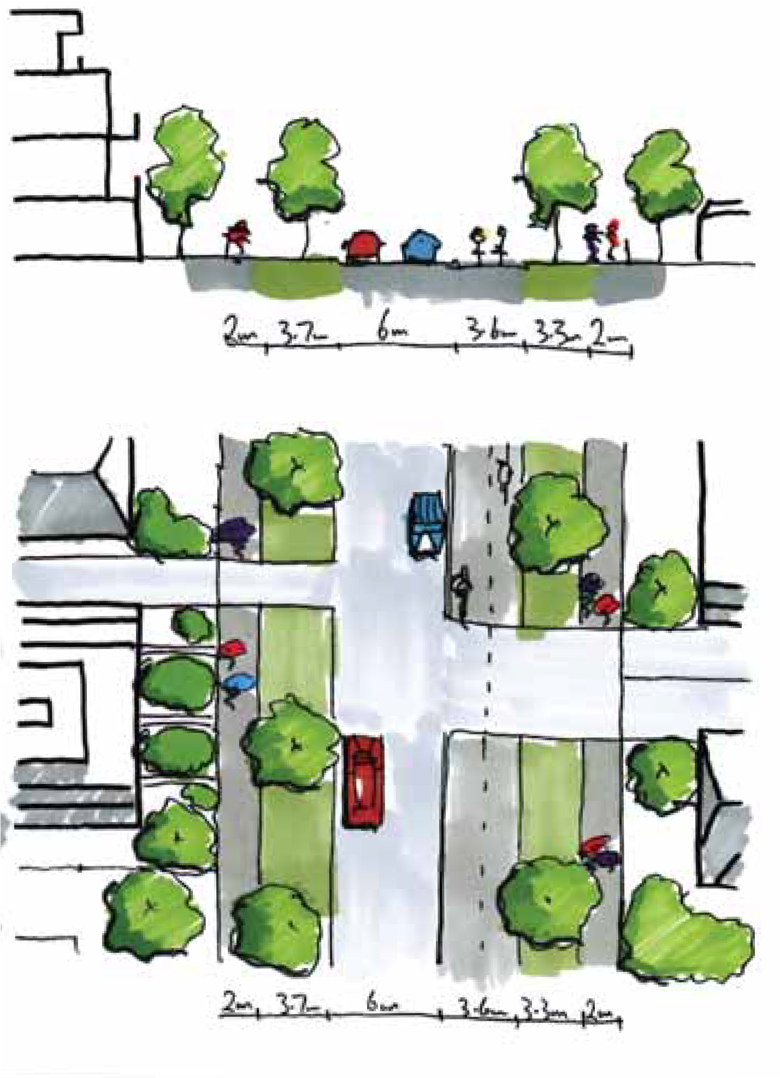The introduction of a protected on-road, two-way cycle path on the eastern edge
1.5m 4.2m
Nature
9.6m
3.8m 1.5m

Nature
1.5m 4.2m
otpath Nature
9.6m
3.8m 1.5m
Carriageway
Nature Footpa
tri
1.5m 4.2m
7.1m
2.5m 3.8m 1.5m
Footpath Nature
strip
Carriageway On road Nature Footpath
two way strip cycle
1.5m 4.2m
7.1m
2.5m 3.8m 1.5m
Footpath Nature
strip
Carriageway On road Nature Footpath
two way strip cycle
  - The introduction of large canopy street trees on the western edge
  - The introduction of large canopy street trees on the eastern edge

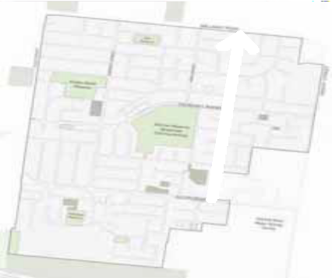

Towards a Braybrook Urban Design Framework 13

Connectivity & Legibility
Design Ideas South Road Existing South Road Proposed
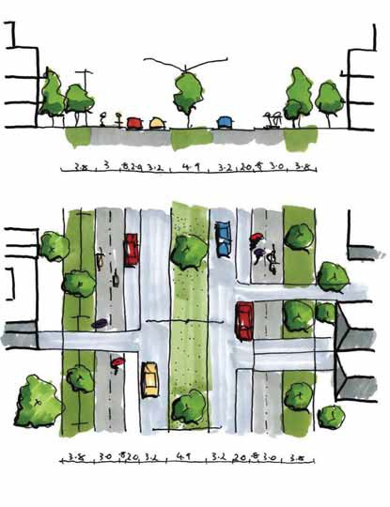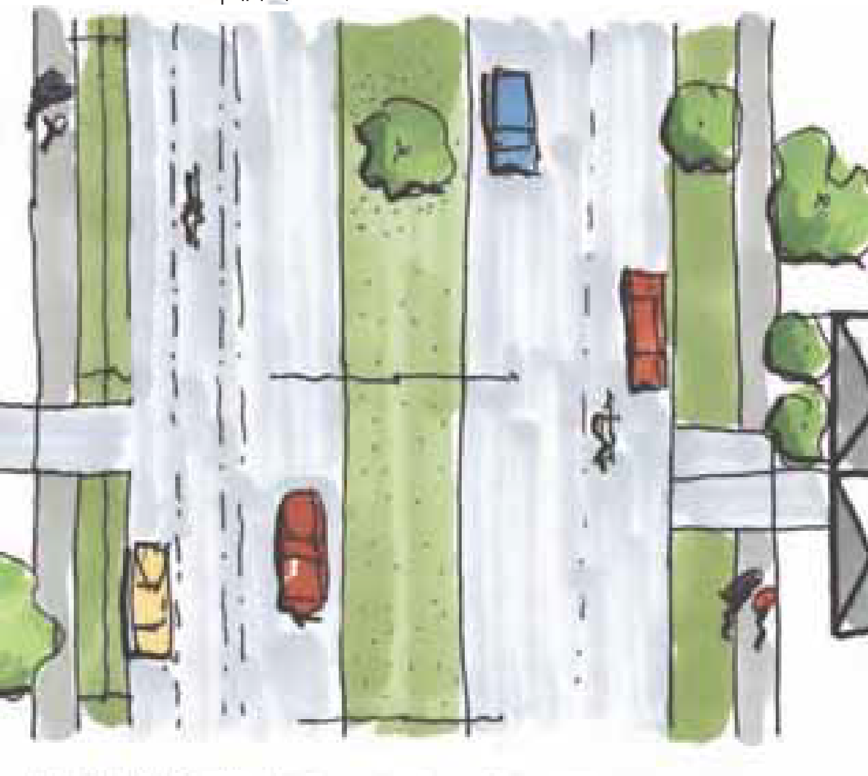Key interventions for South Road include:
0.8m
3.8m 3.0m 2.0m 3.2m
4.9m
0.8m
3.2m 2.0m 3.0m 3.8m
Nature Shared
Carriageway
Carriageway
Shared Nature
strip path Parking
Cycle separator
Central median
Parking path strip Cycle
separator
0.8m
3.8m 3.0m 2.0m 3.2m
4.9m
0.8m
3.2m 2.0m 3.0m 3.8m
Nature Shared
Carriageway
Carriageway
Shared Nature
strip path Parking Central
Cycle separator
median
Parking path strip Cycle
separator
.
1.5m 2.2m 2.0m 1.7m 4.5m
4.9m
.
4.2m 1.7m 2.0m 2.8m 1.5m
Footpath Nature On road Carriageway
strip cycle
Carriageway On road Nature Footpath
cycle strip
Parking
Cycle
eparato
Central media
Cycle
eparato
Parking
.
1.5m 2.2m 2.0m 1.7m 4.5m
4.9m
.
4.2m 1.7m 2.0m 2.8m 1.5m
Footpath Nature On road Carriageway
strip cycle
Carriageway On road Nature Footpath
cycle strip
Parking
Cycle
eparato
Central media
Cycle
eparato
Parking
  - A narrower carriageway in both directions without on- road bicycle lanes
  - The introduction of a shared path on the northern edge
  - The introduction of a shared path on the southern edge
  - Increased nature strip provision on the northern edge
  - Increased nature strip provision on the southern edge
  - The introduction of medium canopy street trees on the northern edge
  - The introduction of medium canopy street trees on the southern edge

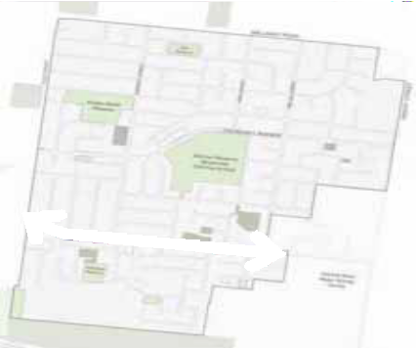

14 Towards a Braybrook Urban Design Framework

Connectivity & Legibility

Design Ideas Churchill Avenue (Outside Activity Centre) Existing Churchill Avenue (Outside Activity Centre) Proposed
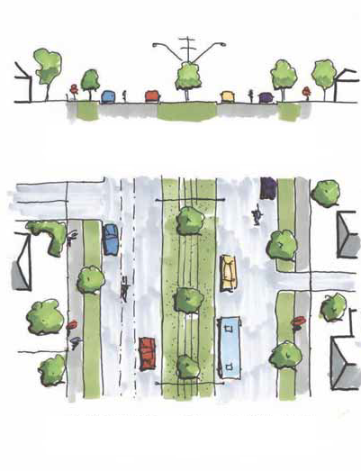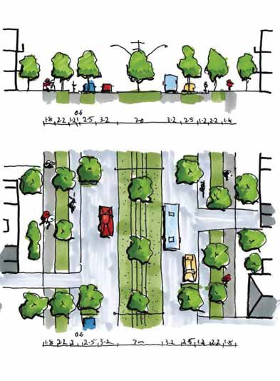Key interventions for Churchill Avenue (outside activity centre) include:
1.8m 2.2m 2.4m 1.6m 3.5m
7.0m 3.5m 1.6m 2.4m 2.2m 1.8m
ootpath Nature Parking Carriageway
strip
Carriageway Parking Nature Foo
On road
entral
On road
strip
1.8m 2.2m 2.4m 1.6m 3.5m
7.0m 3.5m 1.6m 2.4m 2.2m 1.8m
ootpath Nature Parking Carriageway
strip
On road
entral
Carriageway Parking Nature Foo
On road
strip
0.6m
1.8m 2.2m 1.2m 2.5m 3.2m 7.0m
0.6m
3.2m 2.5m 1.2m2.2m 1.8m
Footpath Nature
strip
Parking
Central median
Bus/
Bus/
Parking Nature Footpath
On road
Carriageway
Carriageway
cycle path
strip On road cycle path
0.6m
1.8m 2.2m 1.2m 2.5m 3.2m
0.6m
3.2m 2.5m 1.2m2.2m 1.8m
Footpath Nature
strip
Parking
7.0m
Central median
Bus/
Bus/
Parking Nature Footpath
On road
Carriageway
Carriageway
cycle path
strip On road cycle path
  - A narrower carriageway with less parking
  - The introduction of a protected on-road cycle path on the northern edge
  - The introduction of a protected on-road cycle path on the southern edge
  - The introduction of medium canopy street trees in kerb outstands on the northern edge
  - The introduction of large canopy street trees in kerb outstands on the southern edge

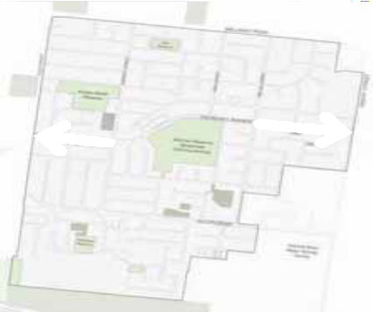

Towards a Braybrook Urban Design Framework 15

Connectivity & Legibility Design Ideas

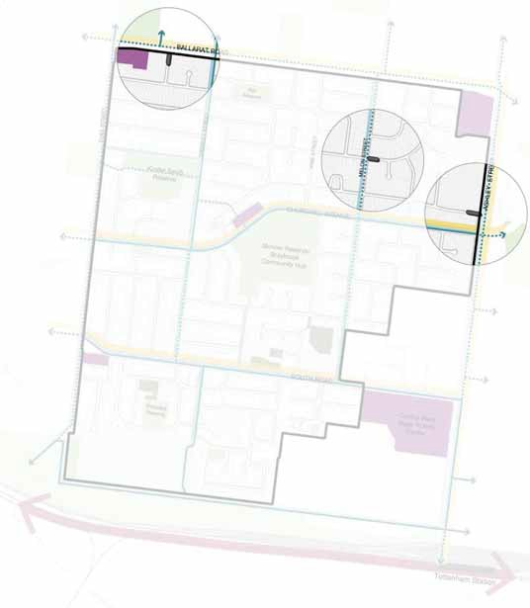Road Closures
Close 1
Close 2
Close 3
Braybrook will be a suburb that encourages walking and cycling for local trips over the use of vehicles. Closing some of the road network to vehicular traffic, while allowing pedestrian and cyclist connections will limit private vehicle ‘rat runs’. This will make local streets safer and quieter, while also increasing opportunities for the creation of new pocket parks and planting.
These links can be utilised as safe passages to key destinations, rest stops and an extension of open spaces and areas for activities such as on-street dining located off busy roads. Three closures are being considered at Castley Crescent where it meets Melon Street, at Hargreaves Crescent where it meets Ashley Street and at Commerce Street where it meets Ballarat Road. These suggested road closures will not happen without strong community support. Future consultation with affected residents would ensure these changes would not stop residents accessing their homes. These closures would reduce traffic movement turning in and out of major roads and make it
safer for both pedestrians and vehicle drivers at dangerous intersections. The street network will not be hindered by these closures as other vehicular access to properties will not be impacted.

16 Towards a Braybrook Urban Design Framework

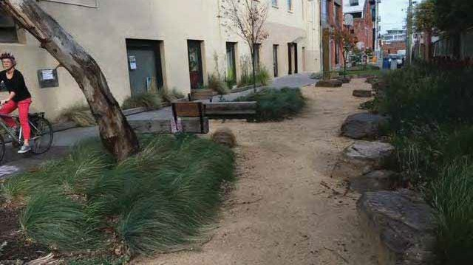
Saxon Street Parklet, Photo: Ella McDonald
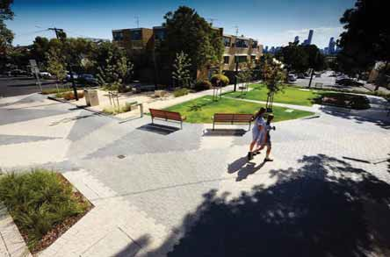
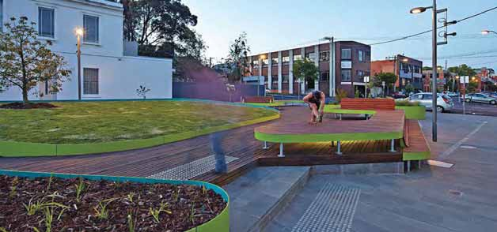
Richmond Terrace, Photo: Andrew Lloyd Oxford Street Park, Photo: Leanne O’Shea

Towards a Braybrook Urban Design Framework 17

Vibrant & Diverse Community

The Braybrook community has many strengths – strong social bonds, multicultural diversity and amazing local facilities like the Community Hub, Skinner Reserve and RecWest. A big part of managing change as more people move to Braybrook is determining what parts of Braybrook are important hold onto and improve, and what parts to change over time.
Braybrook is already well served by local shops and larger business centres. The plan will look to support these businesses so they can grow and adapt to “Covid normal” life rather than planning for any major new centres. Similarly, there are several government and non- government schools already in the area, so there is no immediate plan for any new schools to be built.
Community facilities and open space will need to grow and be upgraded as the population increases. This will include better use of public places, more community meeting spaces at existing facilities and new places for maternal child health and early years care. The space around the Community Hub can be transformed to further strengthen the civic heart of Braybrook.
The main change to Braybrook will be providing new and different types of housing to meet the needs of both the existing and future community, and to make sure new buildings are built to a high design and environmental standard. These are some of the housing changes we are considering;

Homes for larger families
Braybrook has lots of existing larger homes that can accommodate larger families.
Braybrook has many separate houses that can ﬁt larger families but lacks homes for single people and small households. The plan is to add more townhouses, terrace houses and apartments. They would be a mix of different sizes that would suit small and larger households.

Homes for smaller families
Braybrook has fewer 1 and 2 bedroom homes for singles and smaller families.
The future planning changes will encourage more 1 and 2 bedroom apartments in taller buildings along main roads such as Ballarat Road and Ashley Street, and around community facilities and parks

Rental properties
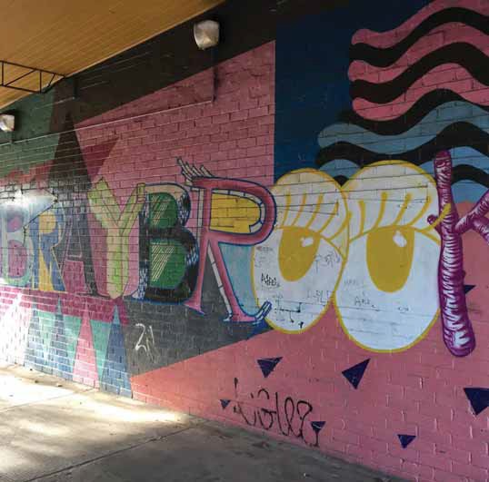
Braybrook has a higher amount of rental properties than the Melbourne average.
The additional housing growth to Braybrook will see some existing rental properties redeveloped, but growth will increase the overall amount of rental housing available. The introduction of apartments will also provide different types of rental properties rather than just single houses.

Social housing
Braybrook has a lot of social housing that provides secure, stable, and affordable housing for many local residents.
The revitalisation of Braybrook will include the renewal of the older public housing stock, replacing this housing with modern, well designed, and sustainable dwellings in line with the proposed form in each of the character areas. New social housing will also be provided to support growth, although this will occur at levels lower than that planned for private housing across Braybrook.

Home offices
Home offices and home-based businesses will be encouraged in Braybrook.

Jobs and Business opportunities
Population growth will support improved business performance and new retail and commercial floorspace development. Some new floorspace development is possible, however demand is likely to be absorbed by larger centres (Central West Shopping Centre & Braybrook Shopping Centre) and local centres (Churchill Ave Shops & Duke / South Road shops).

18 Towards a Braybrook Urban Design Framework

Vibrant & Diverse Community Design Framework

A connected community that celebrates its diversity and has easy access to a wide range of activities, services and retail.

Objectives:
  - Provide a range of facilities and services supporting a diversity of needs and people within Braybrook
  - Support a higher population density through an increase of activity and services available to everyone and upgrade to facilities
  - Plan and advocate for new housing that provides a range of typologies to suit people of varying family units, ages, demographics and life stages
  - Create a vibrant central heart for Braybrook to provide space for everyone with a range of community and commercial facilities as well as activities to foster social resilience
  - Facilitate an urban form that creates local economic activity
  - Improve safety and increase transport choices for all

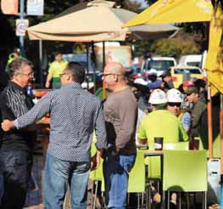

Actions:
- Consolidate and expand range of services and amenities available at local centres
- Improve walking and cycling access to existing centres
- Transform Ballarat Road into a mixed use boulevard with new retail, commercial and residential uses
- Activate street frontages along pedestrian priority routes where appropriate
- Create new civic open space associated with the Churchill Avenue local centre
- Provide additional spaces for community support services above the Churchill Avenue local centre shops when developed
- Provide for one new early years hub within Braybrook
- Provide new community meeting/ﬂexible at the Braybrook Hub and Braybrook Maidstone Neighbourhood House
- Expand the offering and provide additional multipurpose courts co-located within Skinner Reserve

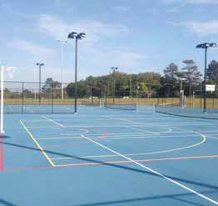

Towards a Braybrook Urban Design Framework 19

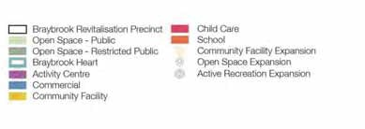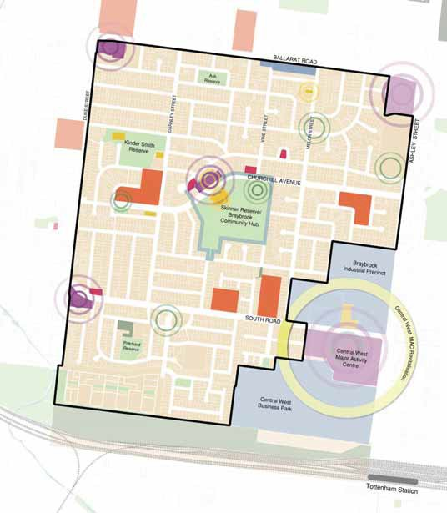Vibrant & Diverse Principle Plan


Vibrant & Diverse Community Design Ideas

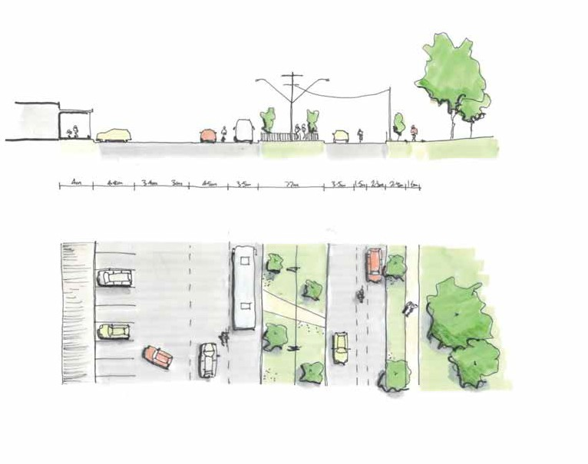Existing Condition
The Community Hub, Skinner Reserve and the Churchill Road shops form the key public amenities in the heart of Braybrook. However, they are currently separated by four lanes of traffic as well as the hard-stand area required
to accommodate 90 degree car parking in front of the shops. This means that to get from one side of the road to the other it is around 37.7 metres with approximately 30 metres of bitumen and a 7.7 metre grassed median strip
in the middle. The crossing point over this median strip is fenced, forcing pedestrians to zigzag. This results in an
environment that feels like it is designed primarily for the convenience of motor vehicles, instead of pedestrians.

4.0m
4.8m 3.4m
3.0m
4.5m 3.5m
7.7m
3.5m
1.5m 2.3m 2.4m 1.6m

Footpath Parking
Parking circulation

Carriageway
Central median

Carriageway
Parallel parking

Footpath

area
On road cycle
Nature strip

20 Towards a Braybrook Urban Design Framework

Vibrant & Diverse Community Design Ideas

Shared Space - (Long Term Proposition)
To create a heart that is enjoyable for people, the idea is to create a new civic place for the community by transforming the area in between to a new plaza where people of all ages can come together to socialise and relax in a safe
and supported environment. The new plaza will be a great place to people watch and meet new and old friends and family, there will be plenty of action both day and night with a range of activities to choose from such as eating at one of the restaurants, before taking a class at the local library, watching a community soccer match or reading
a book in the sun. While visitors will not need to spend money to participate in the action, the lively environment will encourage people to stay for longer periods, driving economic activity within the Centre.
The Churchill Avenue shops will be connected to the Braybrook Hub through signiﬁcant public realm upgrades. This space will be prioritised for people. Vehicles moving along Churchill Avenue will slow down due to the increase in pedestrian activity and reduction in road space.
Other traffic calming methods will be used including the introduction of large planter boxes housing signiﬁcant canopy trees and water sensitive urban design in the form of bioswales that feature boulders.

5.8m 5.8m

The pull-up car park will be transformed into a plaza space that acts as an extension of the public realm. While having more of a hardscaped space than the other green spaces of Braybrook, this area will be heavily landscaped with mature trees to provide shade for users. Permeable surfaces will be utilised so rainwater is absorbed in place for nearby plants. Fixed and moveable seating will be
provided. By making more space for people to sit and meet up, the centre would attract more shopping and outdoor dining.
Plaza
Shared use zone
Shared use zone
Pedestrian path and landscape verge

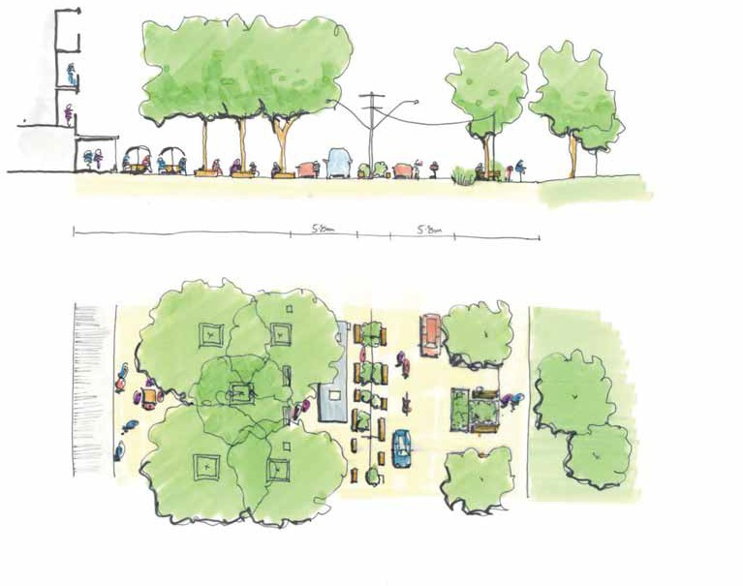

Towards a Braybrook Urban Design Framework 21

Sustainability & Open Space

Braybrook already has a well-connected network of small and large open spaces. Braybrook’s open space is valued by the community for its trees and greenery, as places offering recreation, relaxation and play, as places
offering escape from traffic and urban busyness, for social gatherings, organised sports and as animal habitat.
Over the last 12 months of the Covid-19 pandemic, Braybrook’s parks and streets have made an unprecedented contribution to general community wellbeing.
Anticipated and planned population growth will require Braybrook’s open spaces, public realm and local streets to work more efficiently, with spaces offering increased
ﬂexibility and supporting a greater, more intensive range of community activity and usage.

Public Open Space
Public realm improvements will be focused around local Activity Centres and along pedestrian priority routes.
Improvements works will build from the communities existing sense of pride and instill a renewed conﬁdence in the quality and provision of public space – with a new focus supporting on-street dining and greater programming and activation of civic spaces.
Population growth across Braybrook will require the creation of new green spaces. Small pocket parks will support the suburbs larger open spaces, providing a more immediate and local level of access to green space for Braybrooks current and future residents.

Active Open Space
Skinner and Kindersmith Reserves, as Braybrook’s largest active open spaces, play a signiﬁcant role in community life, and will be upgraded with Skinner Reserves’ tennis courts expanded to provide new multi-use courts with improved lighting.

The role of local streets
Local streets connect the community of Braybrook to its open spaces, community facilities, centres and transport services.
Upgrades to key pedestrian priority routes, supported by the delivery of a pocket park, greater street planting provisions, expanded footpaths and safer, more direct
cycling paths all provide priority to those on foot and bike. This supports healthier lifestyles and improves access throughout Braybrook and beyond to the Maribyrnong River and Stony Creek.

Limited road closures/pocket parks
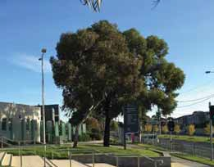
Encouraging walking and cycling for local trips over the use of cars is critical to managing Melbourne’s growing car congestion issues.
The closure of some local streets to car traffic, will signal a new prioritisation of pedestrian and cyclist access. This will allow a greater number of pocket parks to be introduced in Braybrook. Future pocket parks will act as improved pedestrian and cycling links offering rest stop amenities, and safer passage to key destinations in Braybrook.

Temporary transformations
Braybrook’s public realm poses many opportunities for the testing of ideas. Temporary measures can be used to stage projects over time, encourage a change in behavior, and understand how well initiatives are received by the community.
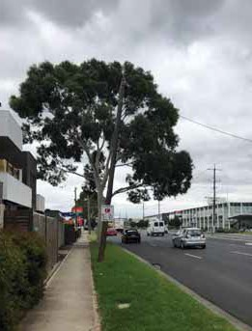
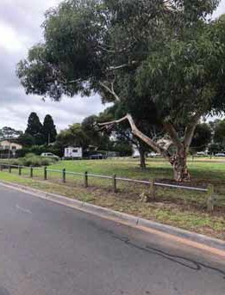
The conversion of the Churchill Central Heart to public space could be introduced through temporary measures, with progressive increases to public space made through the gradual take-over of surplus on-street car parking for open space, tree planting, seating or on-street dining.

Environmental Sustainable Design (ESD)
Neighbourhood scale change, coupled with enormous investment in newer and better social housing, offers signiﬁcant opportunities to also deliver improved sustainability outcomes and to deliver adaptation responses which will increase the resilience of Braybrook’s future community.
The aspiration of this work is to deliver new and renewed social and market housing that draws on current best practice standards. Future requirements will raise the bar on the ESD credentials of all new housing in Braybrook.

22 Towards a Braybrook Urban Design Framework


Sustainability & Open Space Design Framework

A community that is well integrated with its natural ecosys- tem, is environmentally sustainable and well- prepared for the impacts of climate change.

Objectives:
- Increase street trees and landscape to provide continuous canopy coverage and more comfortable walking environment
- Connect Braybrook with surrounding natural ecosystems such as the Maribyrnong River, Stony Creek and signiﬁcant remnant grasslands
- Integrate passive irrigation and water sensitive urban design into the street network to manage water runoff, improve air quality and help reduce the urban heat island effect
- Set a high standard of environmental sustainability through all developments, including public and private housing and community infrastructure
- Ensure landscape guidelines including canopy tree provision, are integral to any development approval process

Actions:
- Provide a new Neighbourhood Park at Ashley Gardens caravan park site
- Provide a new small Local park at the intersection of Castley Crescent and Melon Street
- Improve connectivity between open spaces within the precinct and on the periphery
- Ensure local centres provide spaces for dining on the street
- Program civic spaces to perform a variety of uses at different times of the day
- Pedestrian priority streets are to have medium or large canopy trees at a minimum of one per frontage (approximately 16m maximum) in the public realm
- Provide seats, bins and water fountains along pedestrian priority routes to support walkability
- Water Sensitive Urban Design (WSUD) is to be located along pedestrian priority routes where appropriate
- Minimise vehicle crossovers along major pedestrian corridors and areas of higher activity
- Plant street trees that are climate appropriate, provide shade cover and are passively irrigated
- Increase the amount of permeable surfaces within the public realm including converting underutilised road surfaces to green space
- Provide a new public plaza along Churchill Avenue for gathering and events
- Provide upgraded sport and recreation facilities in Skinner Reserve and Kinder Smith Reserve
- Provide a new small local park at Ravenhall Street Reserve along Churchill Avenue
- Provide new playground equipment and increased canopy tree planting in Pritchard Reserve

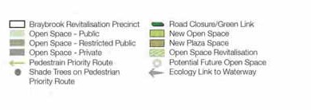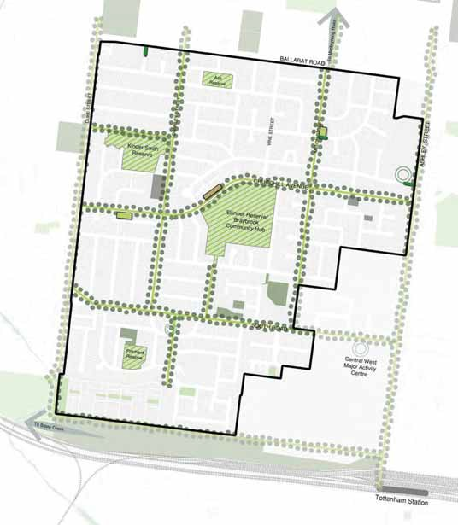

Towards a Braybrook Urban Design Framework 23
The Public Domain & Sustainability Principle Plan

Sustainability & Open Space Design Ideas

Environmentally Sustainable Design
Precinct scale change and renewal offers signiﬁcant opportunities to also deliver improved sustainability outcomes, to support whole of government aspirations around carbon mitigation and to deliver adaptation responses which will increase the resilience of any future community.
These recommendations are focussed on the standards which could be implemented at a lot scale within the Braybrook precinct, drawing on current best practice and aligning with complementary standards, such as those identiﬁed by DHHS for new housing stock. It is recognised that current work is ongoing within DELWP in the area of ESD reform, and the opportunities identiﬁed below may align or diverge from recommendations arising from that reform.
The requirements identiﬁed in this summary have been proposed as they provide simple opportunities and benchmarks for raising the bar on the ESD credentials of the precinct, but should be read alongside the
complementary standards contained in Clause 55 and 58.
In general, an approach which seeks to identify a relevant benchmark (i.e. a rating or % requirement) which must be met by a development, but which recognises the myriad of ways a development might reach that benchmark is preferred. This is considered important as the context, aspirations and inﬂuences for each development will differ and retaining ﬂexibility will increase the practicality of implementation.

Overall sustainability rating
BESS is a tool developed by CASBE / MAV to assess the overall environmental sustainability of a development.
The tool assesses a development’s response to a range of sustainability matters. The use of the BESS tool (or suitable equivalent like the Green Star rating system) allows for
an overarching understanding of a project’s sustainability. Similar tools consider the sites overall response to stormwater management.
The following requirements could be set for development within Braybrook:
– Minimum BESS requirement of 70%, which represents ‘excellence’
– Seek a 100% STORM rating

Passive energy efficiency
While transitioning energy sources to renewables is fundamental, incorporating passive energy efficiency is crucially important for both reducing pressure on the grid in a time of transition and in also reducing the costs associated with maintaining a comfortable living environment for residents. Regard should be had to existing planning scheme requirements around cooling loads, sunlight and daylight access which also support passive design outcomes.
Minimum passive energy standards for development within Braybrook could seek:
– To apply a minimum average 7.5 star NatHERS rating, with a minimum of 6.5 star for individual dwellings
– To increase the current requirement for 40% cross ventilated apartments to 100%
– To support the integration of external circulation spaces designed to reduce mechanical ventilation
– Require carparks to be either naturally ventilated, or if this is not practical to be provided with energy efficient mechanical alternatives

Active energy efficiency
Active energy efficiency standards would seek to lower the precinct’s reliance on fossil fuels in a move towards net zero.
Such standards would seek to:
Require all new development within the precinct to be fossil fuel free
- Require nominated spaces for batteries and other renewable energy technologies
- Set a minimum requirement for GPO locations close to bicycle parking
- Set a minimum requirement for the provision of EV ready car parking spaces
- Require consideration of future capacity of electrical systems to support an increased delivery of EV ready car spaces

Urban heat responsiveness
The urban heat island effect relates to the increase in temperatures due to urban areas that have high levels of hard surfaces. New development has a key role to play in reducing the impacts of the urban heat island effect through responsive design.
- Requirements within Braybrook could seek to:
- Require the equivalent of at least 70% of the development’s total site area as building or landscape elements that reduce the impact of the urban heat island effect. These elements include:
  - Green infrastructure
  - Roof or facade materials with a high solar reﬂectivity
  - Solar panels or shading structures
  - Hardscaping materials with a high solar reﬂectivity
- Set minimum requirements for green cover and canopy tree planting commensurate with the scale of development proposed

Sustainable transport usage
Requirements for car parking are more difficult to manage at a lot scale but in seeking to deliver sustainable transport options within the Braybrook precinct regard could be had to recent research into post-occupancy usage of supplied car parking spaces and to recognise the more diverse range of transport options available to residents.
The Braybrook renewal precinct could seek to:
- Reduce the car parking requirement for new dwellings, for example to a 1:1 ratio
- Set a minimum the bicycle parking requirement, such as 1:1, and ensure that there is clear direction on the location and design of bicycle parking spaces
- Set requirements for the incorporation of motorbike and scooter parking

24 Towards a Braybrook Urban Design Framework

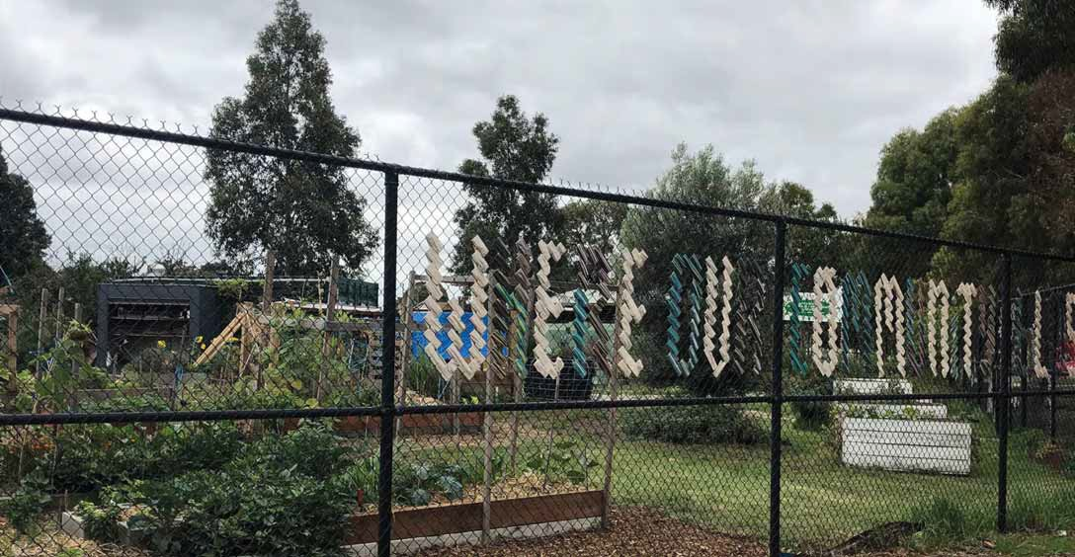

Towards a Braybrook Urban Design Framework 25

Amenity & Character

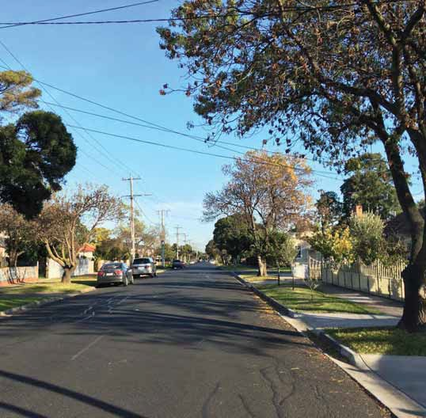
All areas of Braybrook will see more trees planted and improvements to the walking and cycling networks. Council will continue its capital works program and other initiatives to make Braybrook great. All new housing will have to meet greater design and environmental sustainability standards.
If sufficient infrastructure and services are provided and major projects like Airport Rail Link are delivered,
Braybrook may grow by between 4,000 and 7,000 new households by 2050. This will cause some residential areas to change more than others.
The existing workers cottage heritage area and many of the properties on typical residential streets will stay the same or have limited change similar to the redevelopment already occurring. Other areas along public transport corridors or close to community facilities and open space will see a greater amount of change, with apartments replacing a lot of the existing houses and buildings.
As change will occur over 30+ years it can be hard to conceptualise what this looks like. To help understand the change over time we have separated Braybrook into 7 change areas and described how they may evolve over time. These include:
Heritage Precinct Hinterland Braybrook Central Central Heart South Road Ashley Street Ballarat - Balmoral
1
2
3
4
5
6
7

26 Towards a Braybrook Urban Design Framework


Amenity & Character Design Framework

A community with a strong sense of place that celebrates the areas natural assets with high quality public realm and built form design

Objectives:
  - Establish distinct neighbourhoods within Braybrook that address different characters, built form expectations and strengthen a sense of community
  - Ensure new developments respond to their context and achieve high quality outcomes through a strong built form that contribute to safe streets
  - Enhance the sense of place in Braybrook

Actions:
  - Create distinct character areas each with their own typology offering through the application of the built form controls
  - Focus high intensity development along key transit corridors and around the local activity centre
  - Create places to encourage work from home and employment containment
  - Promote active frontages to the street, particularly along transit corridors to promote local activity and enhance ‘sense of place’
  - Consider CEPTED in the design of both the public and private realm
    - Facilitate passive surveillance of streets and community spaces:
    - Locate key entrances, exits, openings and balconies on the primary façade, with corner sites to address both primary and secondary streets
    - Front fencing is to be permeable and no higher than 1.5m to ensure a visual connection with the street
    - Residential balconies at the ground ﬂoor are to be no higher than 1.2m above NGL
    - Orientate development towards the street with setbacks as speciﬁed in the built form controls

– Encourage new development to achieve a high architectural standard
– Incorporate bicycle storage into all new developments consistent with SDAPP spatial requirements
– Encourage dedicated car share spaces on street and in new developments in and around Activity Centres
– On site car parking must be integrated into the built form architecture and maintain an active and safe interface
– Locate parking to minimise negative impacts on streetscape and public spaces
– Encourage all new housing to comply with Liveable Housing Design Guidelines – Gold Level
– New apartment developments must comply with Better Apartment Design Standards
– The design of new development must meet the desired character statements
– Materials for built form are to be of a high quality, high environmental standard and reﬂect the desired character for the area
– Demonstrate high quality architectural outcomes in social housing renewal projects
– Limit vehicle crossovers for new residential development to one per lot

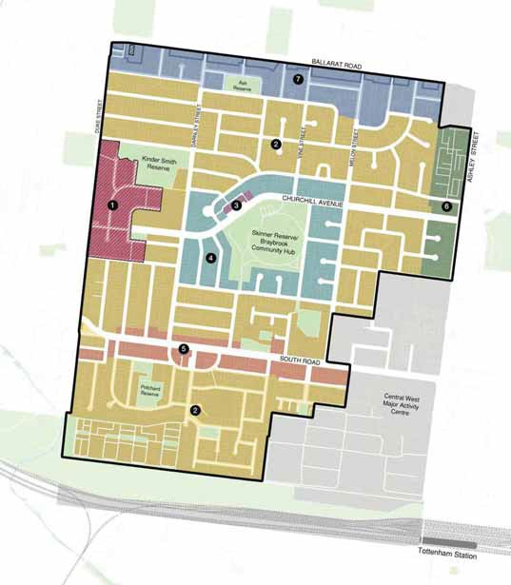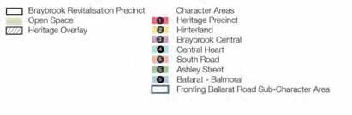

Towards a Braybrook Urban Design Framework 27
Amenity & Character Principle Plan

Future Character Areas

Heritage Precinct

Existing Proposed

This character area consists of the Heritage Overlay 05 which is in regards to the munition housing estate dated from 1942 with a key focus on the mainly intact ‘curving street forms’ and the ‘provision of integrated parkland’.
– The Heritage Precinct is characterised by the retention of existing low-set detached and semi-detached brick munitions housing set within spacious landscaped environs
– New buildings are located to the rear of properties largely in the form of additions to existing dwelling where height and setbacks limit visibility from the public realm
– Rear setbacks provide opportunities for canopy planting and continuous green corridors throughout the precinct whereas upper levels are further set back to maintain amenity to adjoining residential properties
- Side setbacks provide for space around buildings and a streetscape rhythm that responds to the exiting subdivision pattern
- A high quality of architectural composition is achieved through articulated building mass with well- proportioned windows and balconies in addition to
robust material palettes that are visually interesting and durable
- Low and visually permeable front fences retain views to gardens from the public realm. Minimised crossovers
and visually recessive garages allow the retention of on- street car parking and street trees

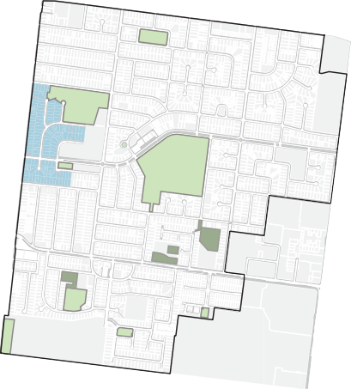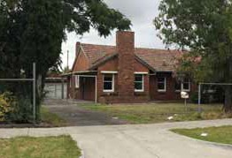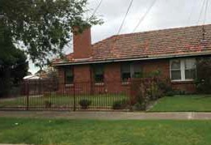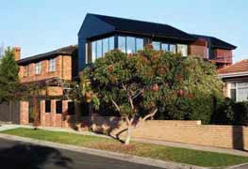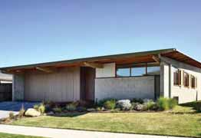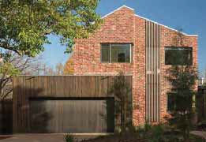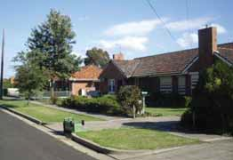

28 Towards a Braybrook Urban Design Framework

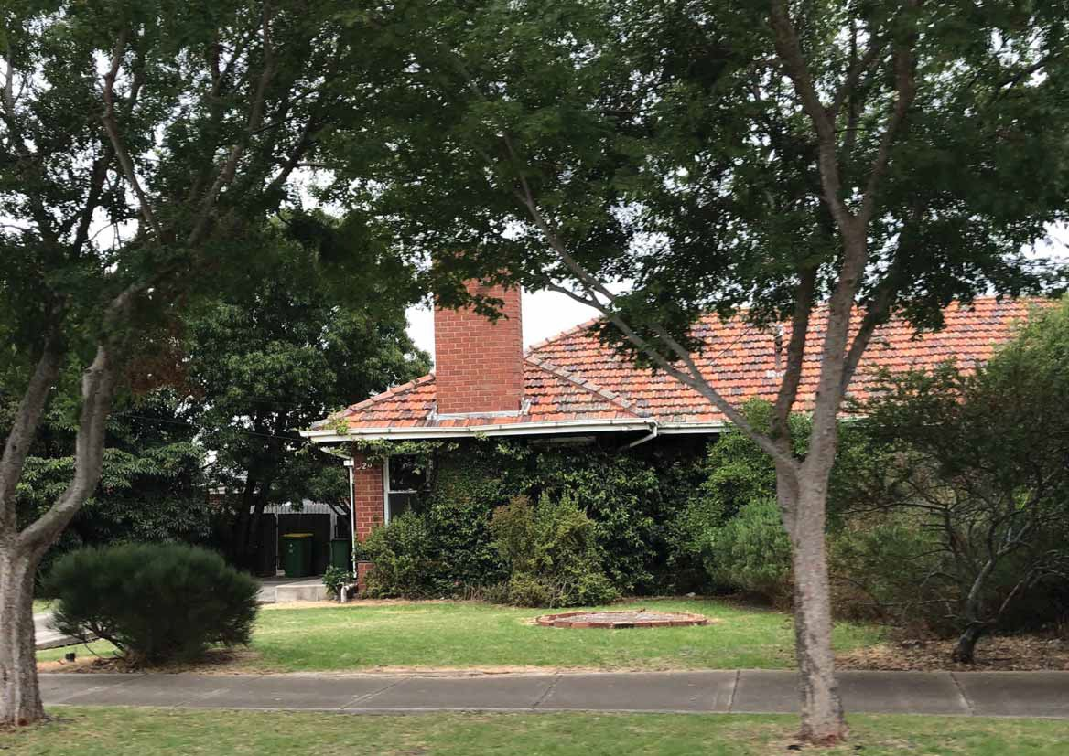

Future Character Areas

Hinterland

Existing Proposed

This character area currently has the preferred character statement of ‘Garden Court’ (primarily affecting properties north of South road), described in the Local Planning Policy as:
  - Spacious informal streetscapes strengthened through the continued maintenance of existing dwellings and gardens, as well as replacement buildings that enhance these characteristics
  - The visual prominence of car parking structures and crossovers will be minimal, with single-lane driveways and garages that are set behind the line of the front façade
  - Dwellings will be surrounded by spacious gardens that comprise canopy trees, shrubs and lawn, and views to these landscaped areas will be retained through the provision of low, permeable or no front fencing
As well as the preferred character statement of ‘Urban Contemporary’ to the south, described in the Local Planning Policy as:
- The garden settings of dwellings throughout the precinct will be strengthened through the provision of trees that contribute to an overall canopy
- A variation in materials across facades will improve the contribution of buildings to streetscapes and create interest in the built form
- The interaction between buildings and the streetscape will continue, with the provision of glazing at lower and upper levels, and low, permeable or no front fences that allow views to gardens and dwellings
- The Hinterland character area is a low rise neighbourhood, characterised by a mixture of single dwellings and multi-dwelling developments set within generous gardens and an established landscape context
- The height and setbacks of new buildings are well- proportioned to provide increased built form intensity whilst integrating with existing character and providing space for canopy planting
- Rear setbacks provide opportunities for canopy planting and continuous green corridors throughout the precinct whereas upper levels are further set back to maintain amenity to adjoining residential properties
- Side setbacks provide for space around buildings and a streetscape rhythm that responds to the exiting subdivision pattern
- A high quality of architectural composition is achieved through articulated building mass with well- proportioned windows and balconies in addition to
robust material palettes that are visually interesting and durable
- Low and visually permeable front fences retain views to gardens and from the public realm and minimised crossovers and visually recessive garages allow the retention of on-street car parking and street trees

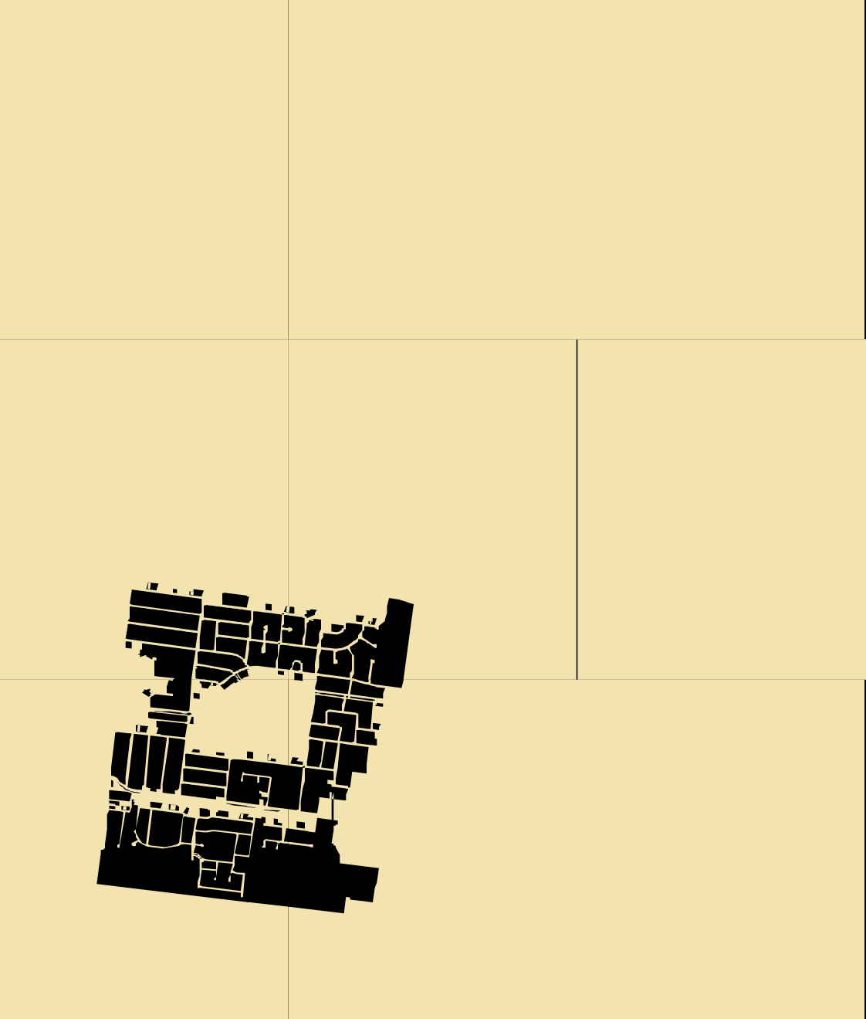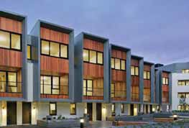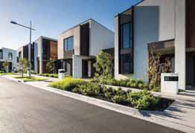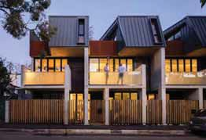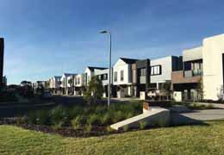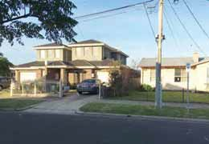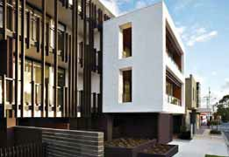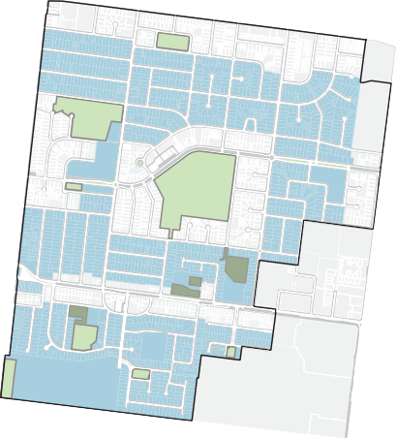

30 Towards a Braybrook Urban Design Framework

Future Character Areas

Hinterland

2051

New landscaping requirements address number and size of canopy trees and suggest suitable species for site frontages and within rear setbacks
2041

Generous rear setbacks will enable new developments to have rear gardens that will mostly be landscaped to meet permeability requirements
2031

Now
Lot co
less cross overs and more shade trees in front gardens, leading to a more friendly pedestrian and cyclist experience
nsolidation will lead to

A two dir
ectional bike path on
the western side of Darnley Street will minimise interaction with vehicles due to the presence of less cross overs

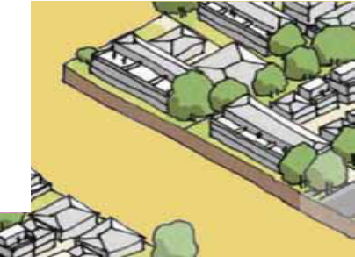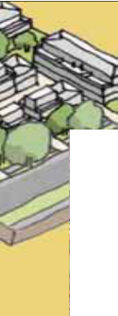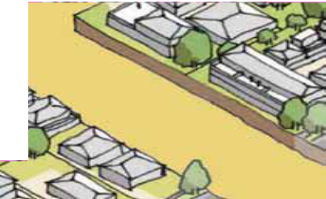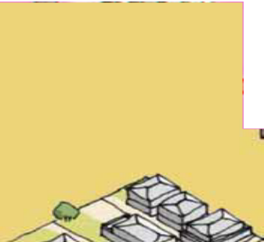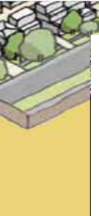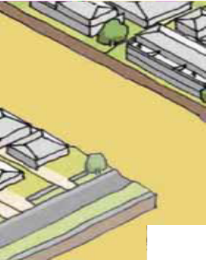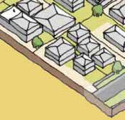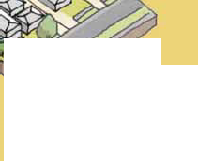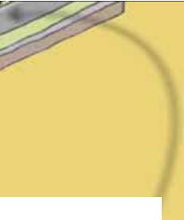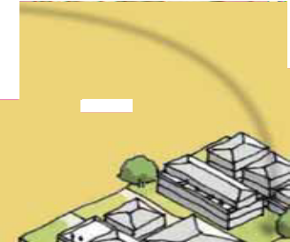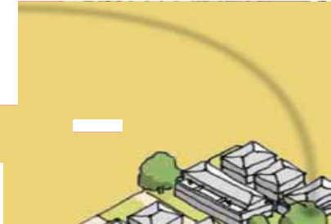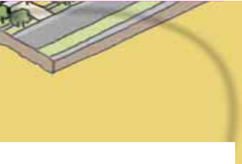New c
ontrols will prescribe the
number and size of canopy trees required, as well as minimum deep soil planting area dimensions and area requirements
Towards a Braybrook Urban Design Framework 31

Future Character Areas

Braybrook Central

Existing Proposed

This character area currently has the preferred character statement of ‘Garden Court’ described in the Local Planning Policy as:
- Spacious informal streetscapes strengthened through the continued maintenance of existing dwellings and gardens, as well as replacement buildings that enhance these characteristics
- The visual prominence of car parking structures and crossovers will be minimal, with single-lane driveways and garages that are set behind the line of the front façade
- Dwellings will be surrounded by spacious gardens that comprise canopy trees, shrubs and lawn, and views to these landscaped areas will be retained through the provision of low, permeable or no front fencing
  - Braybrook Central is the vibrant and engaging core with commercial uses set beneath shop-top housing and within a distinctly urban context and principle heart of Braybrook
  - Built form comprises a zero-lot line at lower levels providing a robust urban condition whilst upper levels are set back to reduce visual prominence and maintain a human scale. Consolidated lots can accommodate larger buildings height given they can accommodate larger setbacks to reduce the impacts of taller built form
  - Lower levels of building comprise boundary construction to provide a continuous and well-deﬁne
street wall whilst the upper levels and interfaces with residential properties are set back to maintain existing and future amenity
- A high quality of architectural composition is achieved through articulated building mass with well- proportioned windows and balconies in addition to
robust material palettes that are visually interesting and durable
- The Ground Level interface comprises well- proportioned windows with clear glazing to provide activation and vehicle access is generally provided to the rear to maximise activation and minimise conﬂict with pedestrians

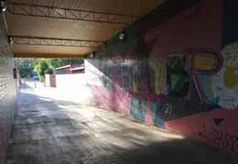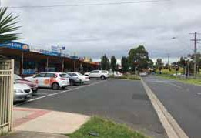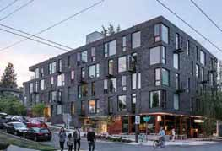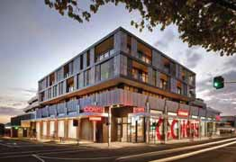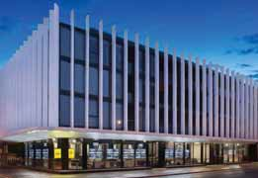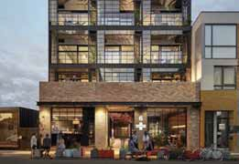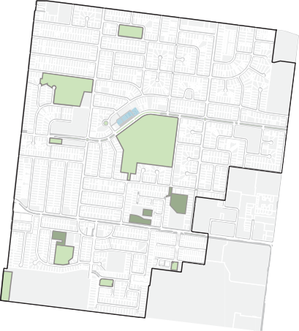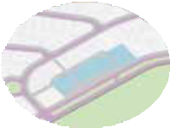

32 Towards a Braybrook Urban Design Framework

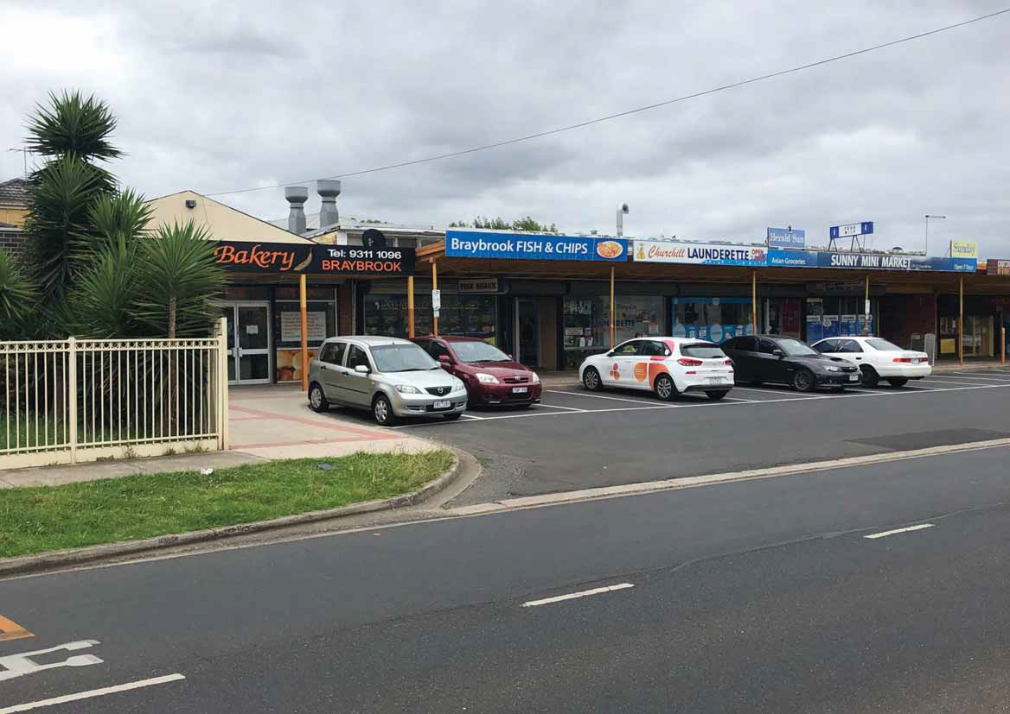

Future Character Areas

Central Heart

Existing Proposed

This character area currently has the preferred character statement of ‘Garden Court’ described in the Local Planning Policy as:
- Spacious informal streetscapes strengthened through the continued maintenance of existing dwellings and gardens, as well as replacement buildings that enhance these characteristics
- The visual prominence of car parking structures and crossovers will be minimal, with single-lane driveways and garages that are set behind the line of the front façade
- Dwellings will be surrounded by spacious gardens that comprise canopy trees, shrubs and lawn, and views to these landscaped areas will be retained through the provision of low, permeable, or no front fencing
  - The Central Heart is a mid-rise neighbourhood with multi-dwelling developments (including apartments) surrounding the core civic facilities and central activity centre of Braybrook, set within generous front and rear gardens with established canopy landscaping
  - The height and setbacks of new buildings are well- proportioned to provide increased built form intensity whilst integrating with existing character and providing space for canopy planting. Consolidated lots can accommodate larger buildings height given they can accommodate larger setbacks to reduce the impacts of taller built form
  - Setbacks to the side and rear are generous and allow for space around built form and the provision of canopy
vegetation with deep soil planting area. The extent of basement site coverage is managed to ensure deep soil planting for proposed canopy trees and the retention of existing canopy trees
- A high quality of architectural composition is achieved through articulated building mass with well- proportioned windows and balconies in addition to
robust material palettes that are visually interesting and durable
- Low and visually permeable front fences retain views to gardens and from the public realm and minimised crossovers and visually recessive garages allow the retention of on-street car parking and street trees

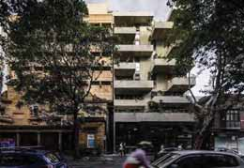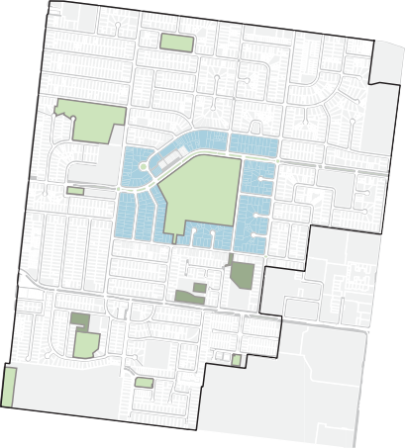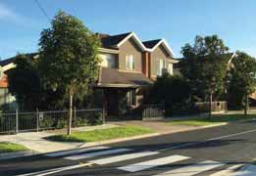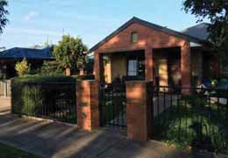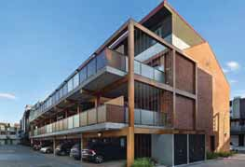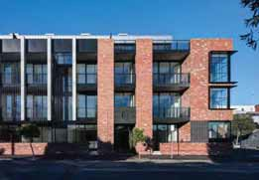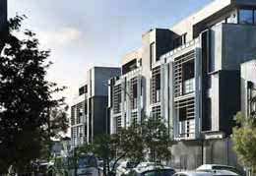

34 Towards a Braybrook Urban Design Framework

Future Character Areas

Central Heart

2051

2041

Side setbacks will provide gaps between existing houses and new developments and could be landscaped to meet permeability requirements
2031

Now
Street s
tree planting zones will allow larger trees to grow in front gardens
etbacks combined with

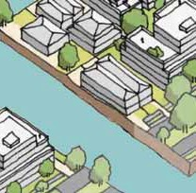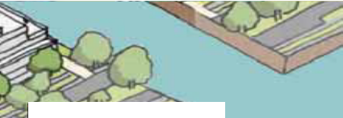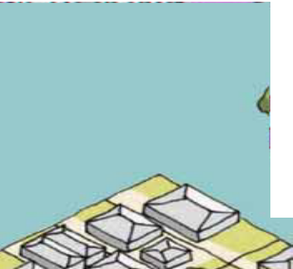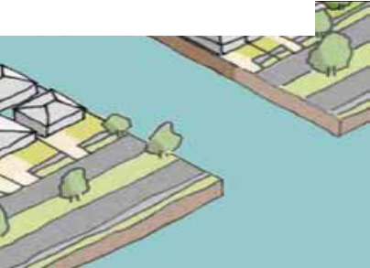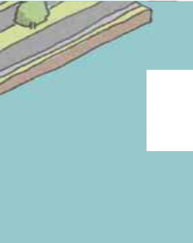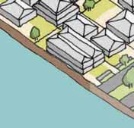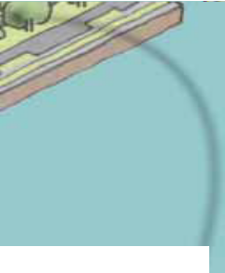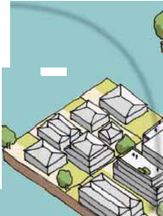

In street tree p
its will add more
trees to the streetscape whilst also harvesting rain water
and slowing traffic speeds on Churchill Avenue

Towards a Braybrook Urban Design Framework 35

Future Character Areas

South Road

Existing Proposed

This character area currently has the preferred character statement of ‘Garden Court’ to the north, described in the Local Planning Policy as:
  - Spacious informal streetscapes strengthened through the continued maintenance of existing dwellings and gardens, as well as replacement buildings that enhance these characteristics
  - The visual prominence of car parking structures and crossovers will be minimal, with single-lane driveways and garages that are set behind the line of the front façade
  - Dwellings will be surrounded by spacious gardens that comprise canopy trees, shrubs and lawn, and views to these landscaped areas will be retained through the provision of low, permeable, or no front fencing
As well as the preferred character statement of ‘Urban Contemporary’ to the south, described in the Local Planning Policy as:
- The garden settings of dwellings throughout the precinct will be strengthened through the provision of trees that contribute to an overall canopy
- A variation in materials across facades will improve the contribution of buildings to streetscapes and create interest in the built form
- The interaction between buildings and the streetscape will continue, with the provision of glazing at lower and upper levels, and low, permeable, or no front fences that allow views to gardens and dwellings
- The South Road character area is a mid-rise neighbourhood with multi-dwelling developments (including apartments) surrounding a major transport corridor connecting both schools and activity
centres and set within a compact garden setting with established canopy landscaping
- The height and setbacks of new buildings are well- proportioned to integrate with the existing character and provide space for canopy planting and visually recessive upper levels through increasing setbacks. Consolidated lots can accommodate larger buildings height given they can accommodate larger setbacks to reduce the impacts of taller built form
  - Setbacks to the side and rear are generous and allow for space around built form and the provision of canopy vegetation with deep soil planting area. The extent of basement site coverage is managed to ensure deep soil planting for proposed canopy trees and the retention of existing canopy trees
  - A high quality of architectural composition is achieved through articulated building mass with well- proportioned windows and balconies in addition to
robust material palettes that are visually interesting and durable
  - Low and visually permeable front fences retain views to gardens and from the public realm and minimised crossovers and visually recessive garages allow the retention of on-street car parking and street trees

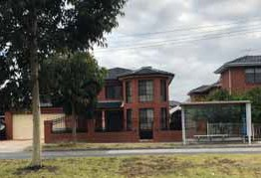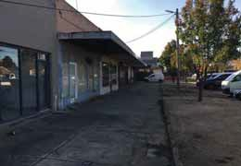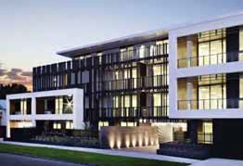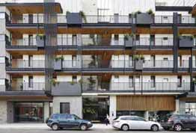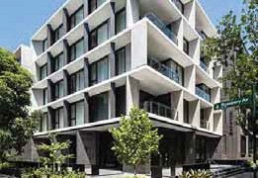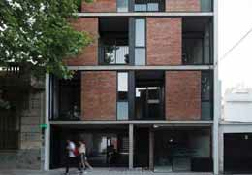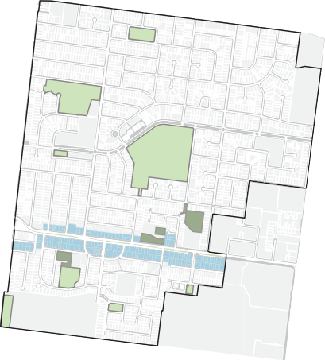

36 Towards a Braybrook Urban Design Framework

Future Character Areas

South Road

2051

2041

Higher permeability requriements mean that new developments will have less concrete and more landscaping
2031

Now
Dev

storeys will be set back from the street so that no impact is made on the walking environment
elopment above three

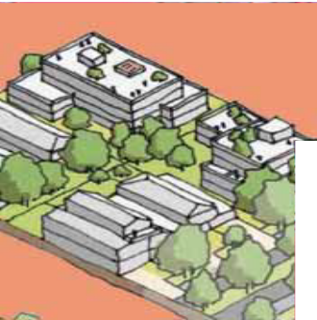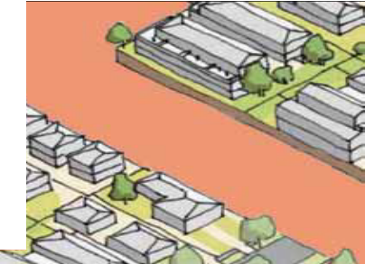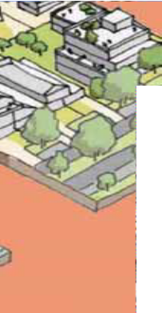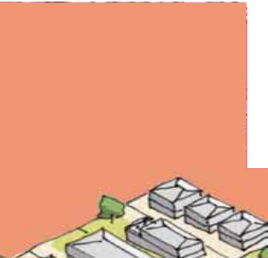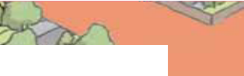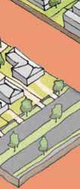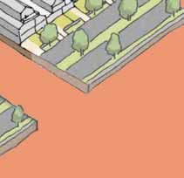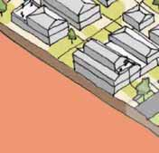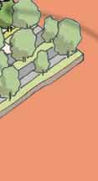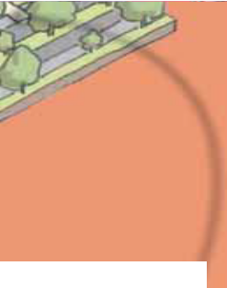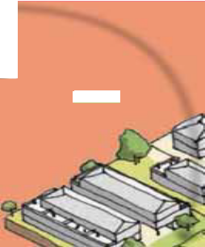

Wider nature s
trips will allow
more and larger trees to be planted on the street, softening the higher development along this corridor

Towards a Braybrook Urban Design Framework 37

Future Character Areas

Ashley Street

Existing Proposed

This character area currently has the preferred character statement of ‘Garden Court’ described in the Local Planning Policy as:
- Spacious informal streetscapes strengthened through the continued maintenance of existing dwellings and gardens, as well as replacement buildings that enhance these characteristics
- The visual prominence of car parking structures and crossovers will be minimal, with single-lane driveways and garages that are set behind the line of the front façade
- Dwellings will be surrounded by spacious gardens that comprise canopy trees, shrubs and lawn, and views to these landscaped areas will be retained through the provision of low, permeable, or no front fencing
  - The Ashley Street character area is a mid-rise neighbourhood with multi-dwelling developments (including apartment typologies) surrounding a major transport corridor connecting activity centres and
set within a compact garden setting with established canopy landscaping
  - The height and setbacks of new buildings are well- proportioned to integrate with the existing character and provide space for canopy planting and visually recessive upper levels through increasing setbacks. Consolidated lots can accommodate larger buildings height given they can accommodate larger setbacks to reduce the impacts of taller built form
  - Setbacks to the side and rear are generous and allow for space around built form and the provision of canopy
vegetation with deep soil planting area. The extent of basement site coverage is managed and opportunities existing for side boundary construction in instances where an existing boundary wall is present of in a stage development scenario
- A high quality of architectural composition is achieved through articulated building mass with well- proportioned windows and balconies in addition to
robust material palettes that are visually interesting and durable
- Low and visually permeable front fences retain views to gardens and from the public realm and minimised crossovers and visually recessive garages allow the retention of on-street car parking and street trees

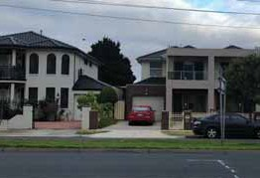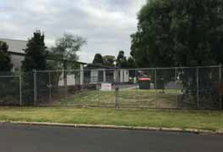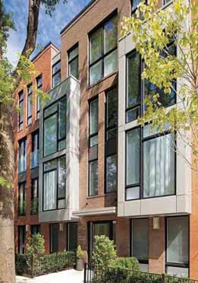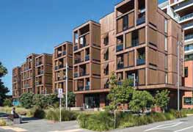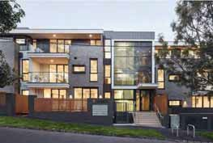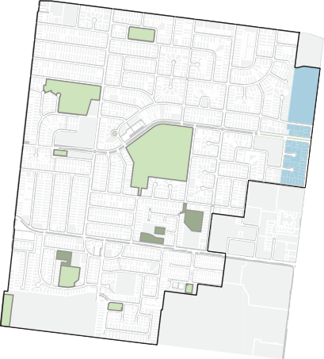

38 Towards a Braybrook Urban Design Framework

Future Character Areas

Ashley Street

2051

2041

Shared path along Ashley Street to be continued between Braybrook Central and Tottenham Train Station
2031

Now
Mid rise development will be set

back above 3 storeys to allow for passive surveillance of the street

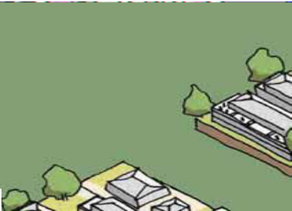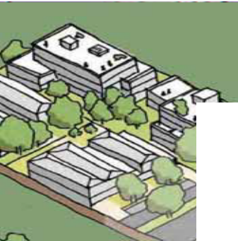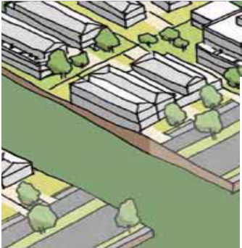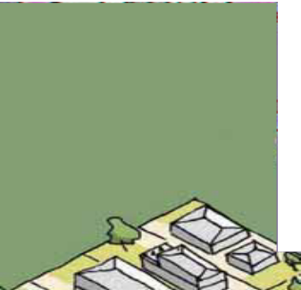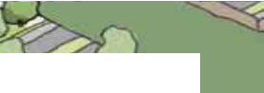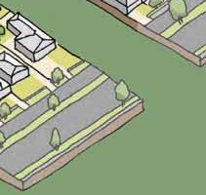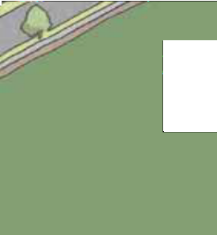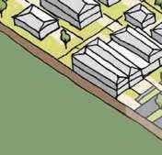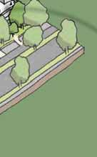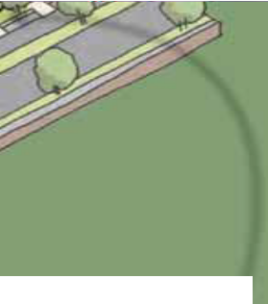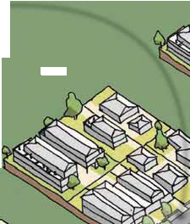

Lots with f
ontages over 20m
require two canopy trees both in the front and rear of new developments, raising the canopy coverage of Braybrook

Towards a Braybrook Urban Design Framework 39

Future Character Areas

Ballarat - Balmoral

Existing Proposed

This residential zone of this character area currently has the preferred character statement of ‘Garden Court’ described in the Local Planning Policy as:
- Spacious informal streetscapes strengthened through the continued maintenance of existing dwellings and gardens, as well as replacement buildings that enhance these characteristics
- The visual prominence of car parking structures and crossovers will be minimal, with single-lane driveways and garages that are set behind the line of the front façade
- Dwellings will be surrounded by spacious gardens that comprise canopy trees, shrubs and lawn, and views to these landscaped areas will be retained through the provision of low, permeable, or no front fencing
- Ballarat-Balmoral comprises the highest level of built form change within Braybrook and is deﬁned by mid to high-rise, vibrant mixed-use development
along the major transit corridor of Ballarat Road with opportunities for commercial uses at ground level
- The height and setbacks of new buildings create a high degree of built form deﬁnition to Ballarat Road and contribute to future character distinct from the existing context. Consolidated lots can accommodate larger height buildings given they can accommodate larger setbacks to reduce the impacts of taller built form
- Lower levels of building comprise boundary construction to provide a continuous and well-deﬁne street wall whilst the interfaces with residential properties are set back to maintain existing and future amenity
  - A high quality of architectural composition is achieved through articulated building mass with well- proportioned windows and balconies in addition to robust material palettes that are visually interesting
  - The Ground Level interface comprises well-proportioned windows with clear glazing to commercial uses, street- oriented balconies to residential uses and minimal vehicle access points to maximise activation
  - Other streets are characterised by mid-rise apartment developments set within spacious landscape surrounds that provide increased built form intensity whilst integrating with existing character and providing space for canopy planting

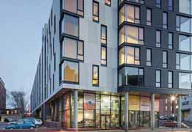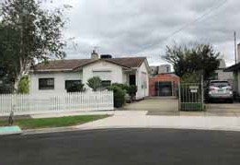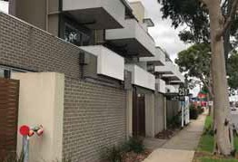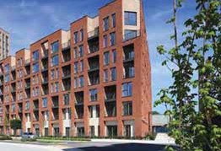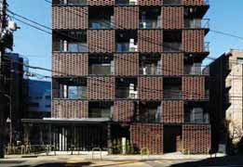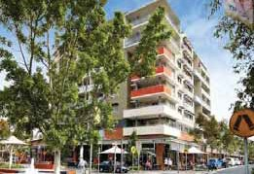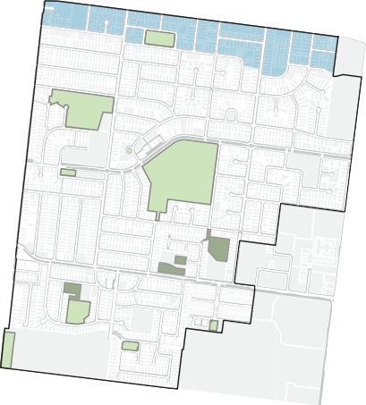

40 Towards a Braybrook Urban Design Framework

Future Character Areas

Ballarat - Balmoral

2051

2041

New developments are to have canopy trees in both the front and rear setbacks, greatly increasing the number of trees within Braybrook
2031

Now
Larger rear setbacks will lead to
combined strips of green space allowing larger trees to grow to help screen larger developments on Ballarat Road

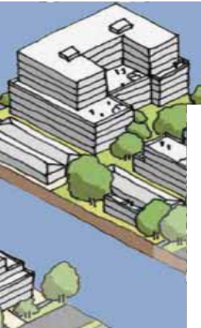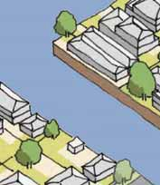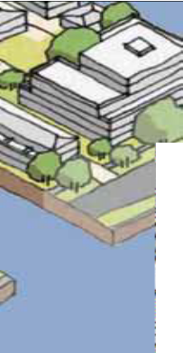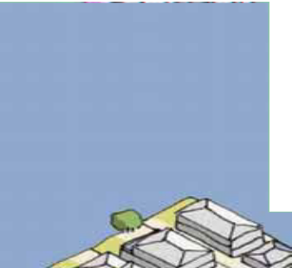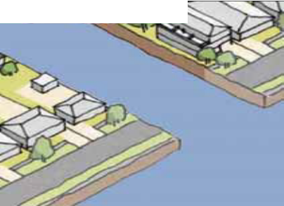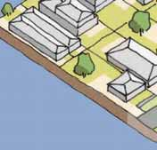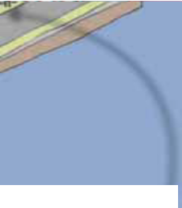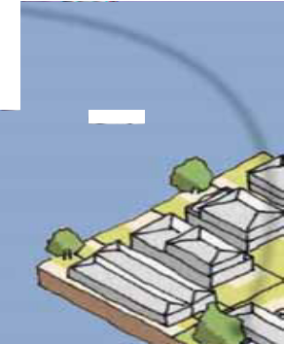

Lot consolidat
ion in this precinct
leads to reduced cross overs which results in more green space for street tree planting

Towards a Braybrook Urban Design Framework 41

