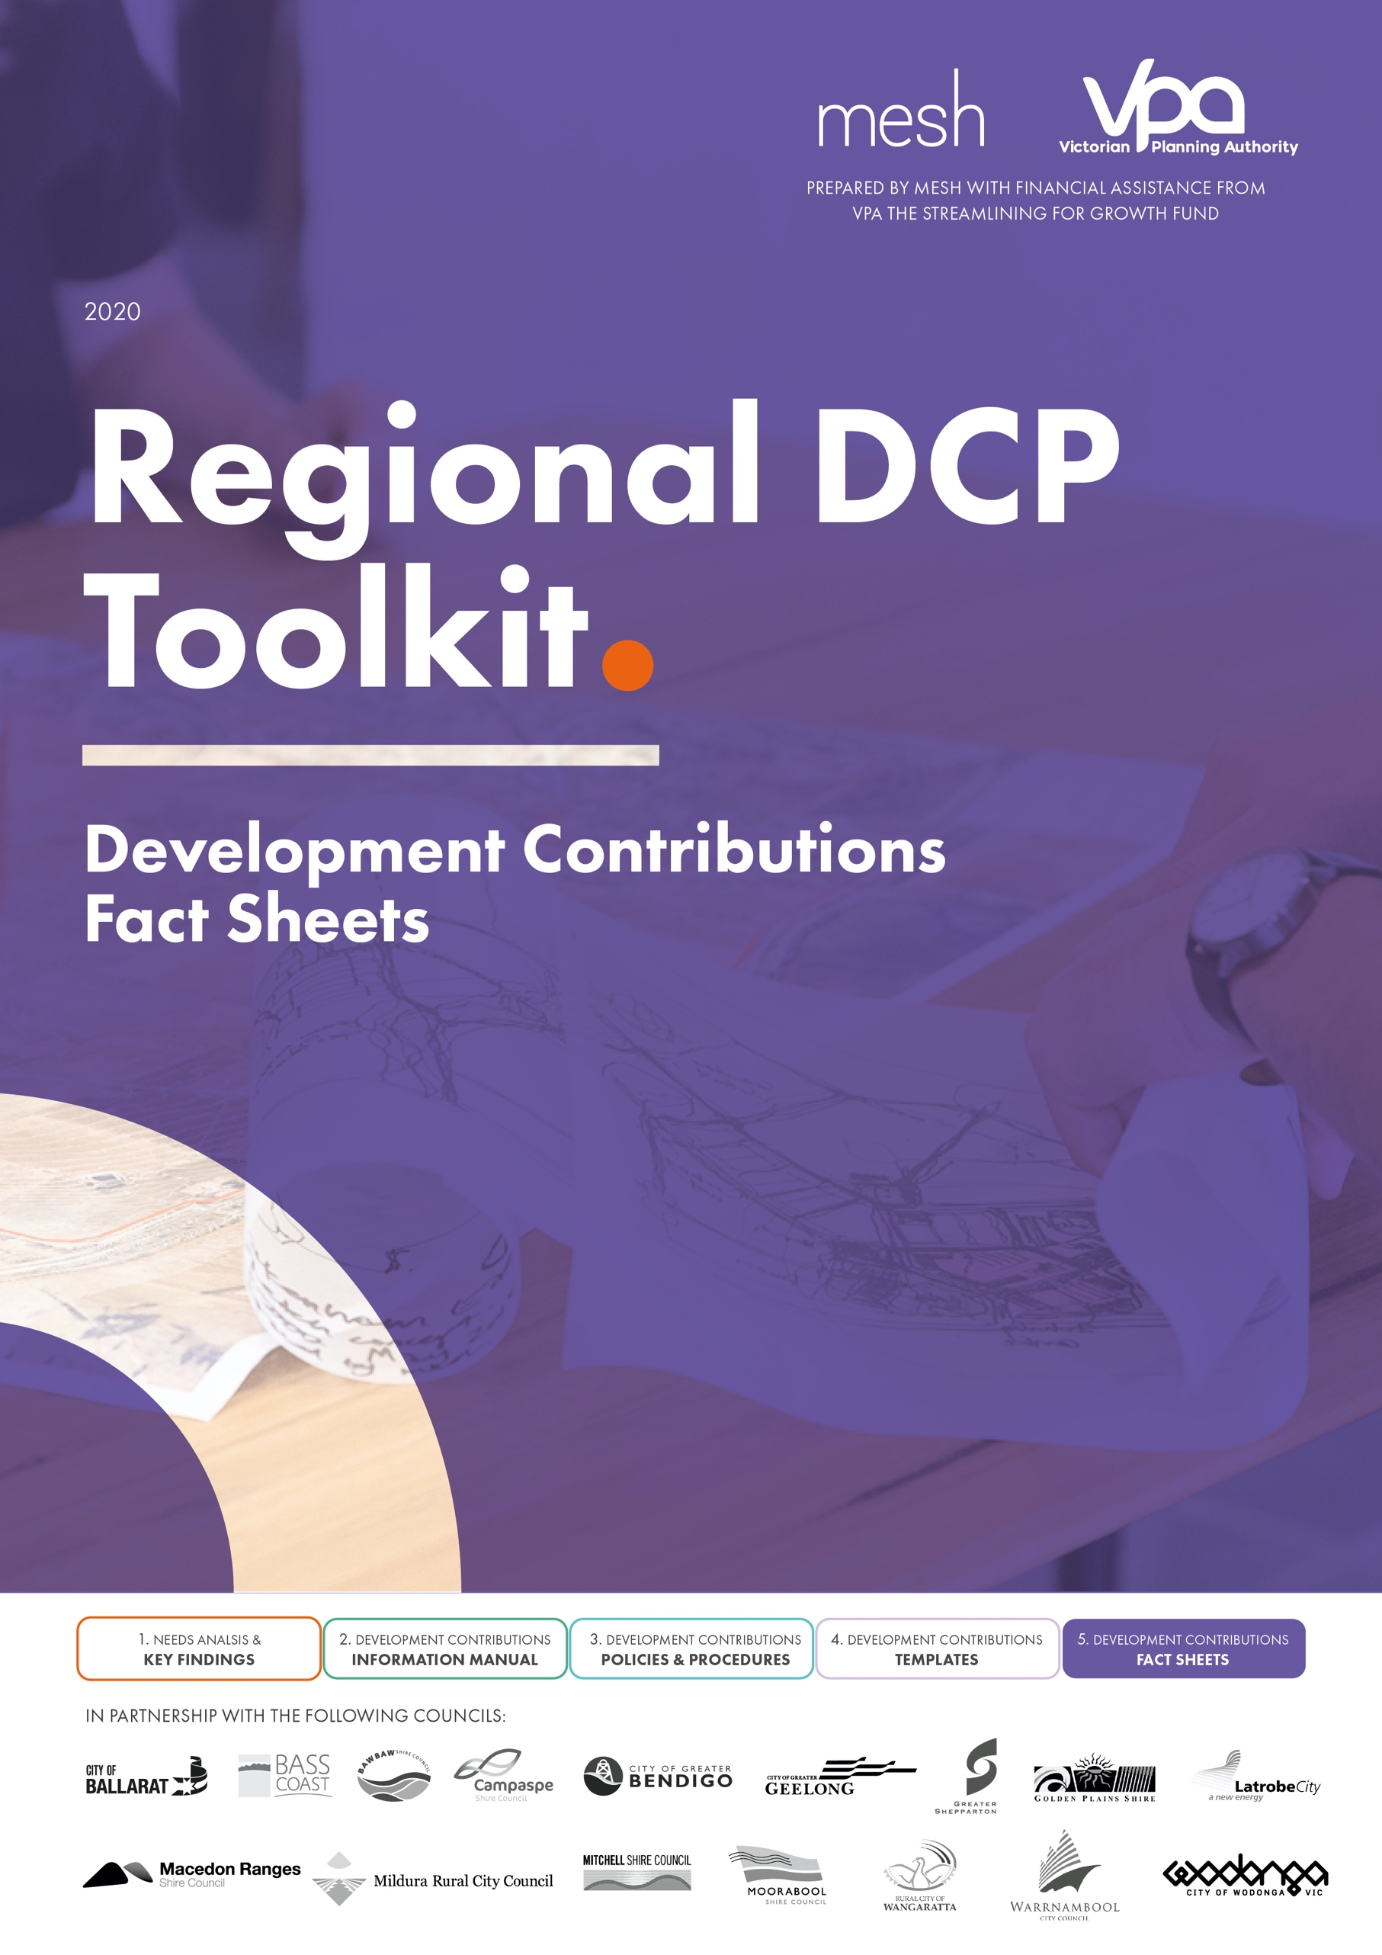

Contents
Development Contributions 3
1. What is a Development Contribution Plan? 3
2. Why do we need a Development Contribution Plan? 3
3. What is Amendment [insert details]? 3
4. What levies are proposed? 3
5. What projects are funded? 4
6. What proportion of the projects are funded via the DCP? 4
7. What types of development are required to pay the Development Infrastructure Levy? 4
8. What types of development are required to pay the Community Infrastructure Levy? 5
9. When do the DCP levies need to paid? 5
10. How are the levies calculated? 5
11. How do I know what levy I must pay? 5
12. Are there exemptions? 5
13. Are there any transitional arrangements? 5
14. How long does the DCP apply/operate for? 6
15. What happens if I’ve been issued a planning permit or building permit? 6
16. How can I have my say/ articulate my views? 6
17. What happens to my submission? 6
18. What happens next? 6
a) Council must take all submissions into consideration. 6
b) If we cannot resolve your concerns, we will refer the amendment to an independent planning panel (appointed by the Minister for Planning). 6
c) The Panel will review all submissions and provide a report with recommendations about the amendment back to Council. 6
d) After the planning panel has released the report, the Amendment and report will again be presented to the Councillors for their consideration. 6
e) If the Councillors adopt the amendment at this stage, the Minister for Planning will then consider the Panel's report and whether or not to approve Amendment [insert details] to the [insert details] Planning Scheme. 6
19. Where can I find out more information? 7
Provision of Works in Kind 8
1. Introduction 8
2. What are works in kind (WIK)? 8
3. Delivery of Works in Kind 8
4. Process to discuss a potential works in kind arrangement with council 9

Development Contributions
Example of information that should accompany a new DCP (Q and A)

What is a Development Contribution Plan?
A Development Contributions Plan (DCP is a planning implementation tool to enable equitable funding and delivery of higher order infrastructure. Development contributions are the ‘payments or works in kind and land, provided by developers towards the supply of infrastructure that will be required to meet the needs of new or expanding communities’.
A DCP identifies the area of land it applies to, the infrastructure projects that the financial contributions would fund, and how these contributions would be calculated and shared across property owners. The DCP only includes infrastructure required to meet the needs of the future residents of the [insert name] growth area.
A DCP is introduced via planning overlay called a Development Contribution Plan Overlay which is placed on land where a DCP applies so that land owners know what their future obligations are if they subdivide and/or develop their land.

Why do we need a Development Contribution Plan?
Development contributions help fund the higher order, basic and essential works and services required by new communities including roads, intersections, shared paths, parks, local sporting and community facilities.
Council has a limited infrastructure budget that is required to cover the entire municipality. New growth areas require substantial new or upgraded infrastructure and the DCP equitably shares these costs between all land owners. If a DCP is not introduced the broader community could need to pay for the required infrastructure through Council rates.

What is Amendment [insert details]?
Insert description of the Amendment i.e. it proposed to introduce a Development Contribution Overlay into the [insert name] Planning Scheme. This will allow Council to collect levies from new residential and employment [note this will need to reflect the specific DCP] development within the [insert name] growth area.
Insert plan showing area the DCP applies to

What levies are proposed?
The Development Contribution Plan introduces two levies: -
- Development Infrastructure Levy (DIL). The DIL is set by the DCP and is payable by [insert demand unit].

- Community Infrastructure Levy (CIL). The CIL is capped at [insert amount] as per the Planning and Environment Act 1987 and is payable per dwelling.

What projects are funded?
The DCP includes [insert number] of projects which are funded via either the development infrastructure levy or community infrastructure levy. The number and type of projects funded via each levy is specified below.
- Development Infrastructure Levy (DIL), this levy funds the following types of infrastructure (land and construction): -
- Roads,
- Intersections;
- Bridges;
- Shared paths;
- Community activity centres that include kindergarten, maternal and child health centres etc
- Library, indoor recreation centres (land only)
- Playing fields i.e. football pitches, cricket ovals, tennis courts
- Sporting Pavilions (land only)
- Playgrounds
- Open space embellishments/ public realm improvements
- Drainage – trunk drainage including wetlands and retarding basins
- Modify list so that it is specific to DCP being introduced– i.e. number of projects by type and total cost

- Community Infrastructure Levy (CIL) this levy funds the following types of infrastructure (construction only): -
- Sporting pavilions
- Libraries
- etc
- Modify list so that it is specific to DCP being introduced – i.e. number of projects by type and total cost

Insert an overall DCP project plan showing all DCP projects on the land budget table so people can understand the relationship between the DCP projects and their property.

What proportion of the projects are funded via the DCP?
The DCP includes [insert number] of projects, the total value of these projects is [insert $]. The DCP will collect [insert %] of the total cost of these projects, the balance will be funded via [insert details].

What types of development are required to pay the Development Infrastructure Levy?
New development [insert development types applicable] are required to pay the DCP levies,

What types of development are required to pay the Community Infrastructure Levy?
New dwellings are required to pay the DCP levies, include definition of dwelling if the DCP includes one.

When do the DCP levies need to paid?
Payment of the Development Infrastructure Levy must be made at one of the following stages:
- Before a Statement of Compliance is issued
- Prior to commencement of works
- Before a building permit is issued.

Payment of the Community Infrastructure Levy must be made before the date of issue of a Building Permit.
Both levies are paid to Council, which is the Collecting Agency under the Act.

How are the levies calculated?
The DCP has been divided into [insert number] charge areas. The cost of the DCP projects has been attributed to the type of development that creates the demand for the infrastructure and a charge per [insert demand unit] has been calculated for each individual project. These charges are combined/summed to determine a total Development Infrastructure Levy charge per land use type and a total Community Infrastructure Levy payable per dwelling.
The total charges are set out in Schedule [insert number] to the Development Contribution Plan Overlay.
Potentially include a copy of the table from the DCPO schedule here.
Maybe include a calculation example

How do I know what levy I must pay?
Insert details of councils development contribution calculator [if there is one available] or alternatively refer to councils planning team and that when the applicant lodges a planning or building application, Council will provide you with an indication of the amount that you will need to pay. Note that confirmation of the final amount to be paid will be confirmed via invoice from council.

Are there exemptions?
Outline exemptions [ensure they match the DCPO schedule and DCP].

Are there any transitional arrangements?
[insert details of transitional arrangements if there are any, if not state that} There are no transitional provisions for Amendment [insert details]. If Amendment [insert details] is approved, levies will need to be paid from this time.

How long does the DCP apply/operate for?
The DCP has a lifespan of [insert years] years, each DCP project has indicative provision triggers and the levies collected must be spent on delivering these projects.

What happens if I’ve been issued a planning permit or building permit?
Use if applicable

How can I have my say/ articulate my views?
Amendment [insert details] is now available for comment.
- Submissions must be made in writing and must:
- Include your name and contact details*
- Clearly state the grounds on which you support or oppose the amendment
- Indicate the changes (if any) you want to make Closing date for submissions is [insert day, date and time submissions close].
* Name and contact details of submitters are required for Council to consider submissions and to notify such persons of the opportunity to attend Council meetings and any public hearing held to consider submissions.

What happens to my submission?
Under the Planning and Environment Act 1987, Council must make a copy of every submission available at its office during office hours free of charge until two months after the amendment comes into operation or lapses.

What happens next?

Council must take all submissions into consideration.

If we cannot resolve your concerns, we will refer the amendment to an independent planning panel (appointed by the Minister for Planning).

The Panel will review all submissions and provide a report with recommendations about the amendment back to Council.

After the planning panel has released the report, the Amendment and report will again be presented to the Councillors for their consideration.

If the Councillors adopt the amendment at this stage, the Minister for Planning will then consider the Panel's report and whether or not to approve Amendment [insert details] to the [insert details] Planning Scheme.

Where can I find out more information?
Refer to Councils website and include link.
Email relevant council department/ phone number

Provision of Works in Kind

Introduction
The majority of infrastructure (both land and construction) are located within the development contribution plan (DCP) area and many properties will be affected. For example, land for a future community centre may be required from one property, or alternatively land and construction of a new council arterial road may be located across multiple properties.
The DCP clearly shows the infrastructure projects it funds, the projects are identified in plan form, the land required for the project is quantified per property, and the scope and project cost (both land cost and construction cost separately) is clearly set out.
[potentially include the land budget plan showing all projects across each property]

What are works in kind (WIK)?
A collecting agency (insert name of Council) may accept land or infrastructure (or a combination of the two) in lieu of receiving the DCP infrastructure levy as a monetary (cash) payment. This is known as works in kind (WIK).
Any DCP WIK may be required to be secured through a Section 173 Agreement. There are many benefits of allowing developers to undertake works in kind.
These include:
- Works can be integrated with subdivision development i.e. the developer can provide the infrastructure item when they need it which will often result in early delivery of specific infrastructure items;
- Developers can often deliver infrastructure items more cost effectively than Council; and
- The developer can offset the credits they are entitled to for the DCP projects delivered as works in kind against their DCP development infrastructure levy charge liability i.e. the developer can deliver DCP projects in kind in lieu of making cash payments.

Delivery of Works in Kind
Outline council’s policy position regarding works in kind i.e. council encourage the provision of works in kind in lieu of cash payments to satisfy DCP levy charges.
- Accepting a WIK proposal is at the discretion of the collecting agency (council).
- There is no right to review if a collecting agency refuses to accept WIK.
The collecting agency and development agency ‘decide the timing for when a WIK credit is given, which is usually, but may not always necessarily be at the time the works are carried out. The timing should be linked to the infrastructure delivery priorities set out in the IPL.

Process to discuss a potential works in kind arrangement with council
The following process outlines the key steps involved to prepare a works in kind proposal is prepared, considered by Council, and if successful approved and implemented.
Task | Detail | Who at council will your main point of contact?
Meeting with Council officers | - The applicant will meet with PM and statutory planner to explain council’s policy position in relation to works in kind and potential works in kind projects, likely timing, potential credits etc. | insert specific staff (ideally the same main point of contact throughout this process i.e. planner dealing with the application).
Works in kind proposal | - Applicant to inform Council PM via written confirmation the potential works in kind proposal including potential staging of the development, NDA areas, potential works in kind, credits etc.  Note: Council will provide a DC schedule for the applicant to fill in to ensure all necessary information is provided. | insert specific staff
Council will assess the merits of the works in kind proposal | - Council will assess the potential works in kind proposal against the following criteria.  - Financial  - Reduce Council’s financial risk?  - Assist Council to close a ‘funding gap’?  - Save council money in the long term?  - Significantly minimise resource requirements for Council?  - Quality  - Accord with the relevant strategic documents (i.e. PSP, DP, DCP)?  - Commit to provide infrastructure in accordance with Council’s standards? Or improve on the scope originally intended?  - Timing  - Significantly reduce the timeframes for delivery of the infrastructure?  - Align with Councils IPL? Is the project a priority project?  - Demand  - Does it assist to meet community demand for new infrastructure?  - Significance  - Is it a catalyst project that will open up development of the area?  - Does it result in no financial impact or risk to council? | insert specific staff
Internal review of works in kind proposal | - Insert council officer will present the works in kind proposal to the PCG for review and comment.  - PCG to make recommendation to PS to accept/reject proposal. | insert specific staff PCG
Council to provide written confirmation to applicant | - Following decision from PS the PM will write to the applicant and advise of the PS decision and next steps.  - If PS accept the proposal, Council will provide applicant with preferred section 173 template. | insert specific staff PS
Drafting of Section 173 Agreement | - A section 173 agreement is drafted in line with the proposal accepted by council.  - Section 173 is reviewed by lawyer on behalf of council, details are finalised. | insert specific staff
Execution of 173 | - PCG/PS review final 173 agreement, and if all is in order the PS will recommend to the CEO that the 173 is signed and sealed. | insert specific staff PCG  PS

