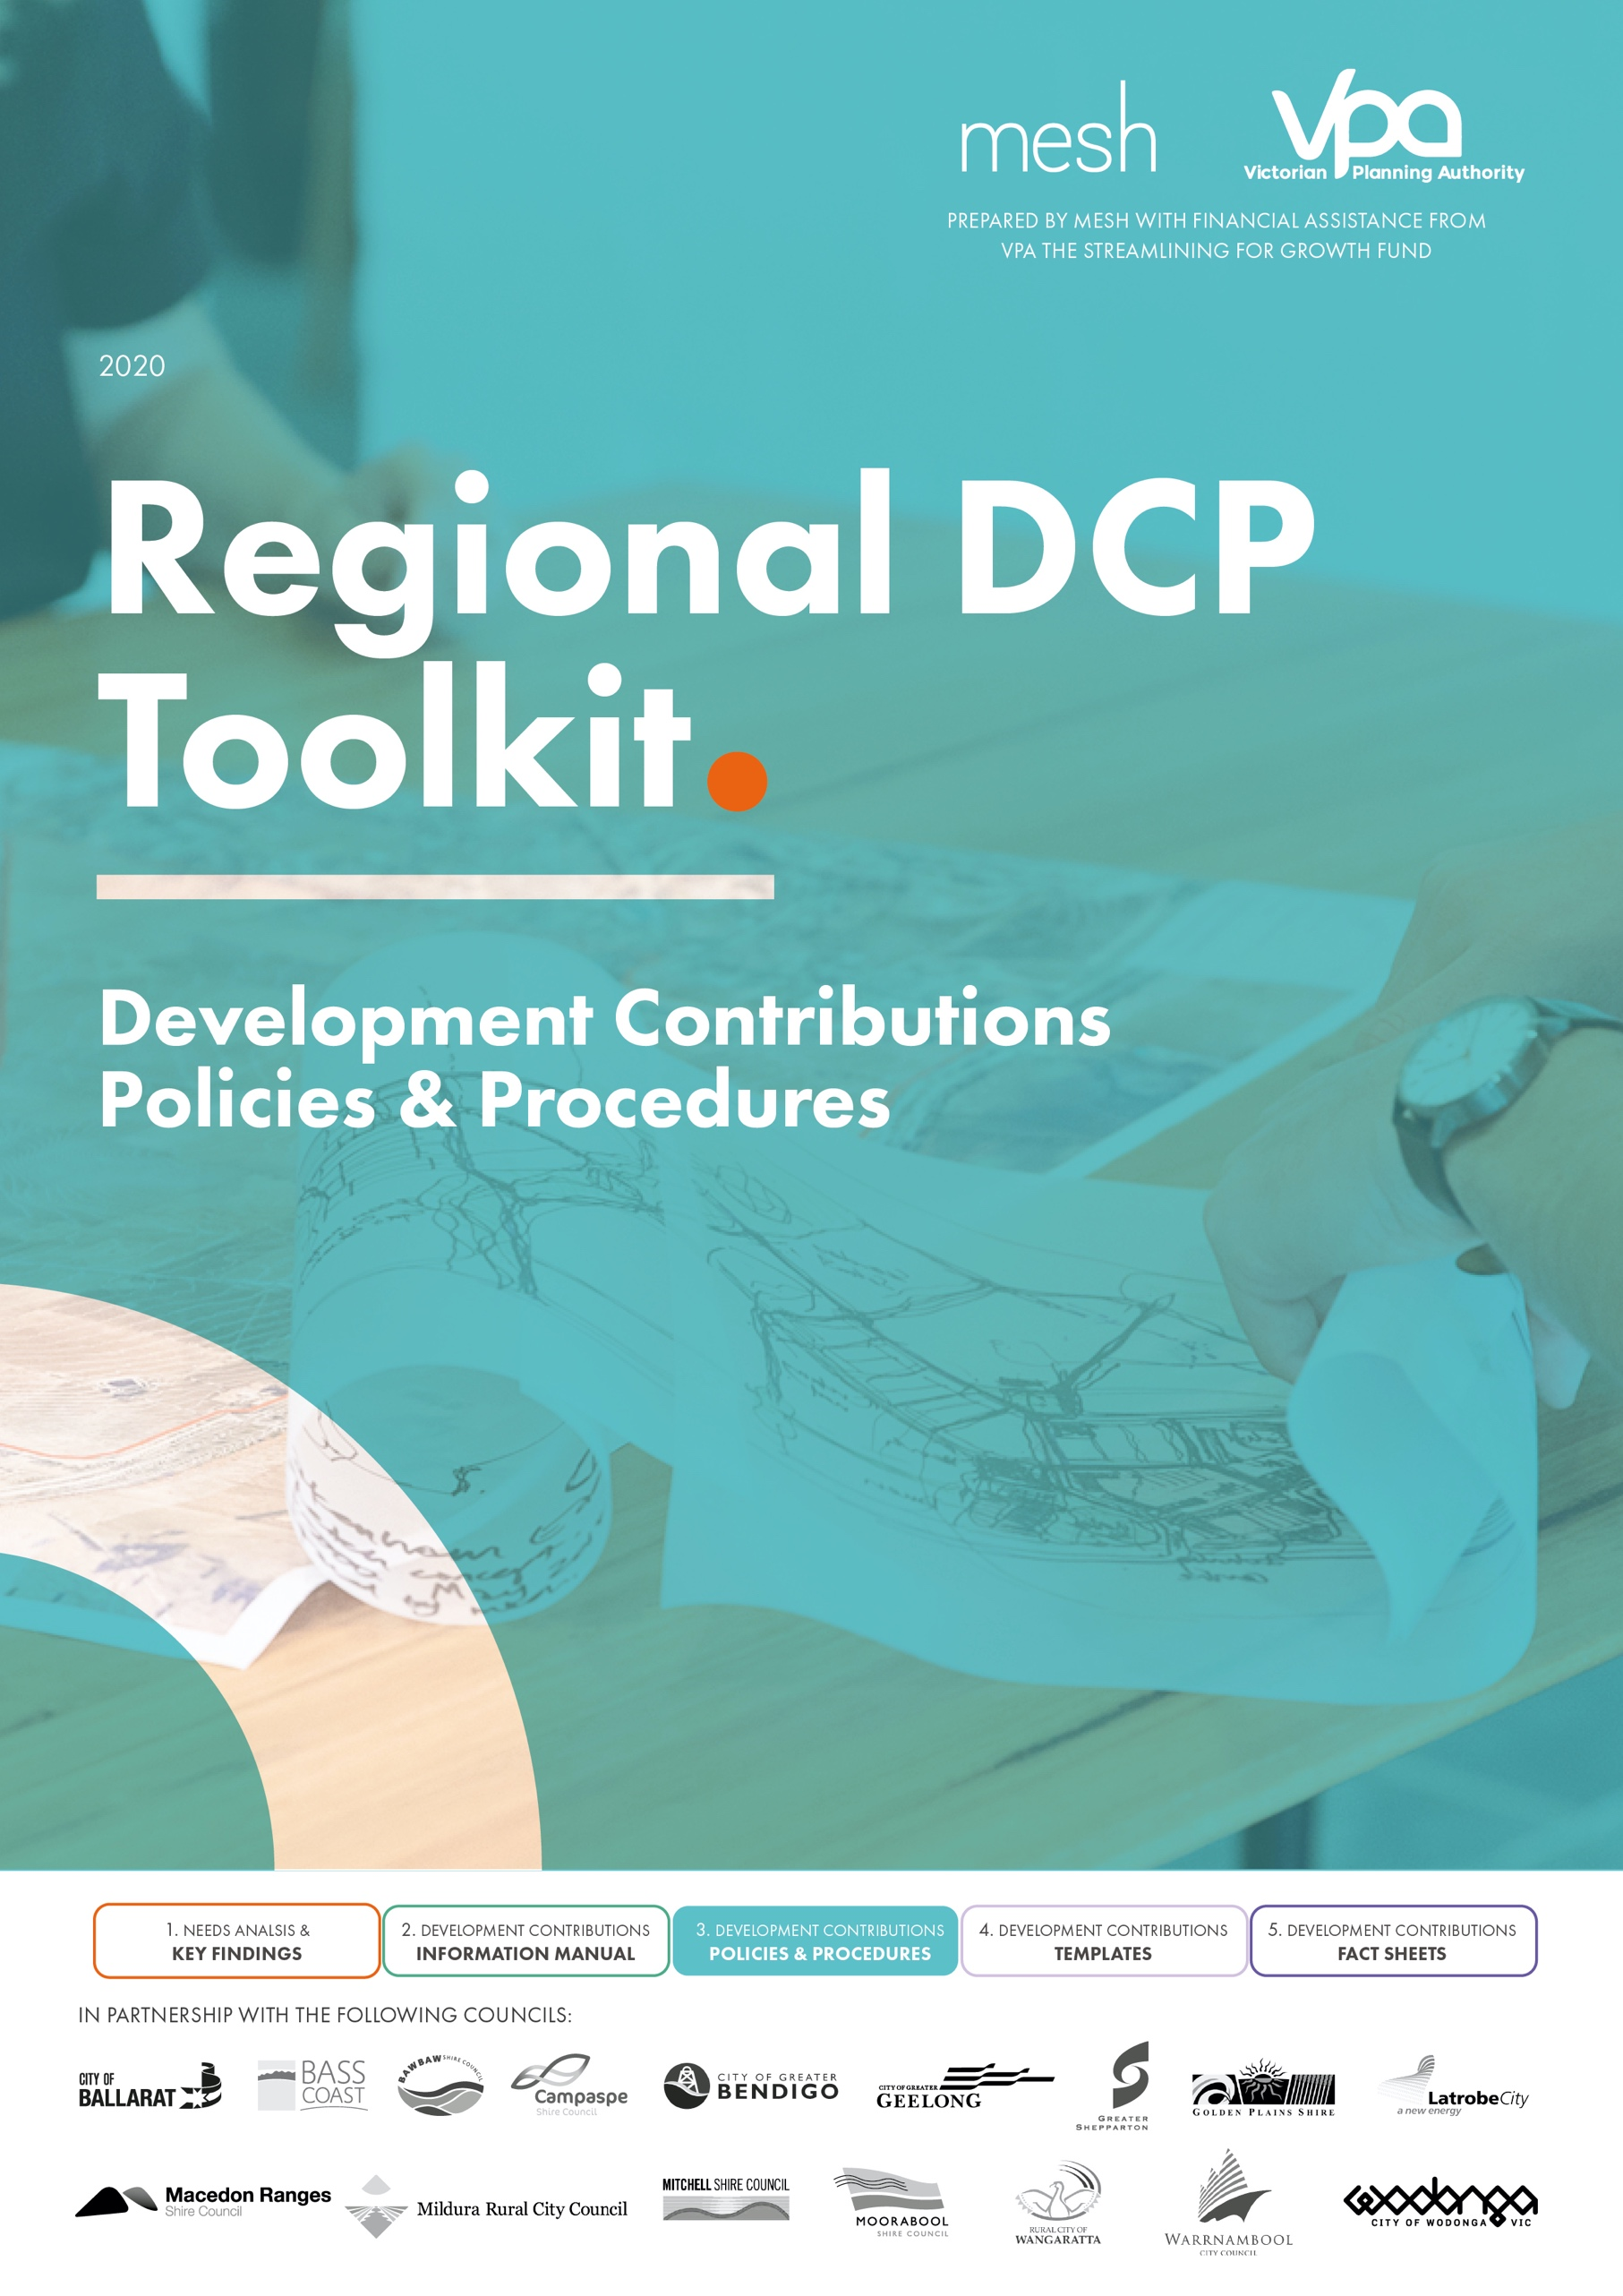
Contents
Introduction 4
1. Purpose of this document 4
2. Background to development contributions in [insert council name] 4
3. Structure of the document 4
Overview of the Development Contributions Framework 6
Governance Framework 7
1. Overview 7
2. Policy Objective/ Position 7
3. Roles and Responsibilities 7
Application 10
1. Overview 10
Development Context 10
2. Policy Objective/ Position 11
3. Roles and Responsibilities 11
4. Procedures and Processes 11
Preparation 14
1. Overview 14
2. Policy Objective/ Position 14
3. Roles and Responsibilities 14
4. Procedures and Processes 16
Development Contribution Plans 16
Informal Shared Funding Arrangement 24
Section 173 Agreement 24
Implementation 27
1. Overview 27
2. Policy Objective/ Position 27
3. Roles and Responsibilities 28
4. Procedures and Processes 30
Infrastructure Review and Infrastructure Priority Lists (IPL) 30
Cash Flow Modelling 33
Calculating / Invoicing of both the development infrastructure levy and community infrastructure levy 35
Changes to Land Use Budget 37
Works in Kind 38
Development Contributions Schedule 41
Developer Rolling Credits 42
Handover of Infrastructure Projects 43
Maintenance 45
1. Overview 45
2. Policy Objective/ Position 45
3. Roles and Responsibilities 45
4. Procedures and Processes 46
Recording and Reporting 48
1. Overview 48
Recording and Expenditure/Delivery Requirements 48
Annual Financial Reports 48
2. Policy Objective/ Position 49
3. Roles and Responsibilities 49
4. Procedures and Processes 50
Review 53
1. Overview 53
DCP Review 53
Informal shared funding arrangement Review 53
Section 173 Agreement Review 53
2. Policy Objective/ Position 53
3. Roles and Responsibilities 54
4. Procedures and Processes 55
Figure 1: Development Contribution Funding Mechanisms 8
Figure 2: Governance Framework 10
Figure 3: Understanding the Development Context 12
Figure 4: Summary of Funding Application roles and responsibilities 13
Figure 5: Summary of Preparation roles and responsibilities 16
Figure 6: Summary of Implementation Roles and Responsibilities 31
Figure 7: IPL Preparation Process 35
Figure 8: Process for approving the development contribution schedule 44
Figure 9: Process for managing development contribution rolling credits for works in kind 45
Figure 10: Process for Handover of Infrastructure Projects 47
Figure 11: Summary of maintenance roles and responsibilities 48
Figure 12: Summary of recording and reporting responsibilities 52
Figure 13: Summary of review roles and responsibilities 57

Table 1: Governance Roles and Responsibilities 10
Table 2: Procedure to determine potential application of development contribution method 13
Table 3: Preparation – Roles and Responsibilities 17
Table 4: Process to Prepare a DCP 18
Table 5: Process for reviewing a DCP prepared by another agency 25
Table 6: Process to prepare a Section 173 Agreement – where the Section 173 agreement is primary funding mechanism (i.e. it is not implementing a DCP or informal shared funding arrangement) 27
Table 7: Implementation – Roles and Responsibilities 31
Table 8: Procedure to prepare an Infrastructure Priority List 33
Table 9: Procedure to prepare a Cash Flow Model 36
Table 10: Process for calculating DIL infrastructure levies payable 38
Table 11: Procedure for assessing changes to the land use budget 40
Table 12: Procedure for negotiating works in kind agreements 42
Table 13: Maintenance – roles and responsibilities 49
Table 14: Procedure for indexing development contribution infrastructure costs 49
Table 15: Recording and Reporting – Roles and Responsibilities 53
Table 16: Procedure for recording and reporting 53
Table 17: Review Roles and Responsibilities 57
Table 18: Process to complete a review of a DCP 58

Introduction

Purpose of this document
The purpose of this document is to provide an implementation framework for [insert name] council in regard to the internal processes and procedures to prepare, implement, and administer development contributions.
This is simply a template of types of processes and procedures and it is intended that Councils can use this as a base to tailor to suit their own organisations, governance frameworks and delegation of responsibilities.

Where specific information is required to be entered by a council this has been highlighted in orange for ease of use and to guide the reader.

Background to development contributions in [insert council name]
Describe the current development contribution mechanisms currently in place within the municipality, illustrate them in map form and include a summary of the types of projects and costs they include.

Councils may also wish to include a vision and/or statement of intent up front.

If council has recently completed an audit of its development contribution processes this template could be adjusted to clarify how the new procedures and processes respond to those recommendations.

Structure of the document
This document has been structured having regard to the seven aspect of development contribution preparation, implementation and administration as illustrated in the following figure.

Overview of the Development Contributions Framework
Development contributions are the ‘payments or works in kind and land, provided by developers towards the supply of infrastructure that will be required to meet the needs of new or expanding communities.’

Development contributions help fund the higher order, basic and essential works and services required by new communities including roads, intersections, shared paths, parks, local sporting and community facilities. The various infrastructure requirements are identified and justified through a strategic plan/document such as the Precinct Structure Plan process. This infrastructure (land and construction) is in addition to general ‘developer provided’ infrastructure which includes local estate infrastructure i.e. local roads, local drainage, services and improvements to local parks.

Development contributions are a very important and significant source of funding, at the time of writing this template the Victorian Regional Councils combined DCPs include approximately $2 billion worth of development contribution projects to be delivered and managed.

This template provides an overview, governance framework, roles and responsibilities, and key procedures and processes relating to the three key development contribution funding mechanisms currently available including: -
- Development Contribution Plans (DCP)
- Informal Shared Funding Arrangements
- Section 173 Agreements / Planning Permits

Figure 1 provides a summary of the three mechanisms currently available in regional Victoria however it is recommended that staff read the Development Contribution Manual for a detailed description of each mechanism.
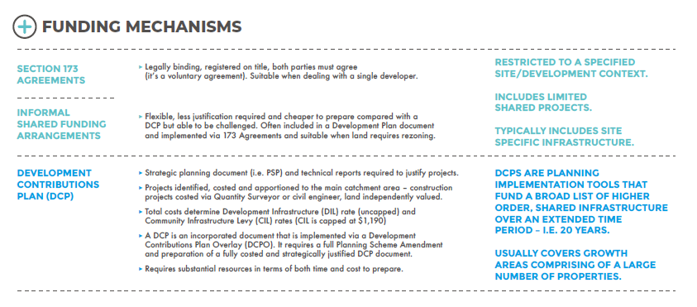
Figure 1: Development Contribution Funding Mechanisms

Governance Framework

Overview
To successfully manage growth area planning within the [insert council] certain conditions must exist within Council to enable successful DCP, Informal Shared Funding Arrangement and Section 173 Agreement implementation and administration.

These conditions include:
- Acknowledgement that DCPs, Informal Shared Funding Arrangements and Section 173 Agreements are a shared responsibility across various Council departments;
- Understanding of DCP processes and implications at the Senior Leadership Level and support for officers engaged in DCP administration;
- Ability to take a strategic view of likely development staging and infrastructure sequencing;
- An appreciation of the benefits to Council of delivery of works in kind by developers; and
- Adoption of an open, transparent and cooperative approach with developers to achieve the best outcomes.

In order to achieve the above, a governance framework is required that clearly identifies the roles and responsibilities across a range of Council departments. The following structure sets out the framework that Council has agreed to operate under. Further sections of this document identify the roles and responsibilities for each key aspect of the DCP, informal shared funding arrangement and 173 Agreement process.

Policy Objective/ Position
[to be inserted]

Roles and Responsibilities

This section sets out the governance framework for Council. Figure 2 identifies the hierarchy of the framework with the following sections identifying the roles and responsibilities.
Figure 2: Governance Framework
*This will depend on size of council and number of DCPs, 173s etc. There may also be a technical working group instead of a single PM – again depending on the workload

Table 1: Governance Roles and Responsibilities
Position | Responsibility/ Role | Designated Officer
Project Sponsor/ Project Board | The Project Sponsor has the following role:  - Overall accountability for growth area planning within [insert Council].  - Responsible for reporting and informing the Executive team.  - Responsible to ensure all areas of Council are operating within this framework and there is a whole of Council approach to growth area planning.  - Responsible for providing direction to the Project Owner or Project Control Group when matters are escalated. | - The [insert Director] is the Project Sponsor.
Project Control Group | The PCG has the following role:  - To enable Senior Management Coordination on growth area planning;  - To support the Project Sponsor and identify when any matters should be escalated to the Project Sponsor;  - To review recommendations of the PM taking into account the implications more broadly for Council; and  - Responsible for tasks as set out for the PCG throughout this document. | The PCG comprises of the following members:  - [list the various managers and identify who is the PCG Chair]
PCG Chair | The PCG Chair has the following role:  - Responsible on reporting and informing the Project Sponsor.  - Responsible for chairing the Project Control Group (PCG).  - Responsible for escalating matters to Project Sponsor as per recommendation from PCG, or escalating any specific matters on an as needs basis.  - Responsible to provide any feedback from the Project Sponsor to PCG.  - Responsible to provide any feedback from the PCG to Project Manager. | - The [insert position] is the Chair of the PCG.
Project Manager  As noted earlier depending on the amount and type of DCPs, 173s a council may have a technical working group rather than a single project manager – as the PM or TWG is directly responsible for undertaking the majority of work. | The Project Manager has the following role:  - Responsible for overseeing each step of the DCP and Section 173 Agreement process.  - Responsible for reporting and informing the PCG and providing recommendations to the PCG for their consideration.  - To provide expertise and planning advice on complex planning matters.  - Responsible for escalating matters to PCG on an as needs basis.  - Responsible for tasks as set out for the Project Manager throughout this document.  - The PM will coordinate internal working groups when required to undertake the specific tasks set out in this document. | - The [insert role] is the Project Manager.

Application

Overview
When deciding which funding mechanism to apply it is important to understand DCPs and Section 173 Agreements including their primary functions, when it is best to apply them, and the advantages and disadvantages associated with their use and implementation.

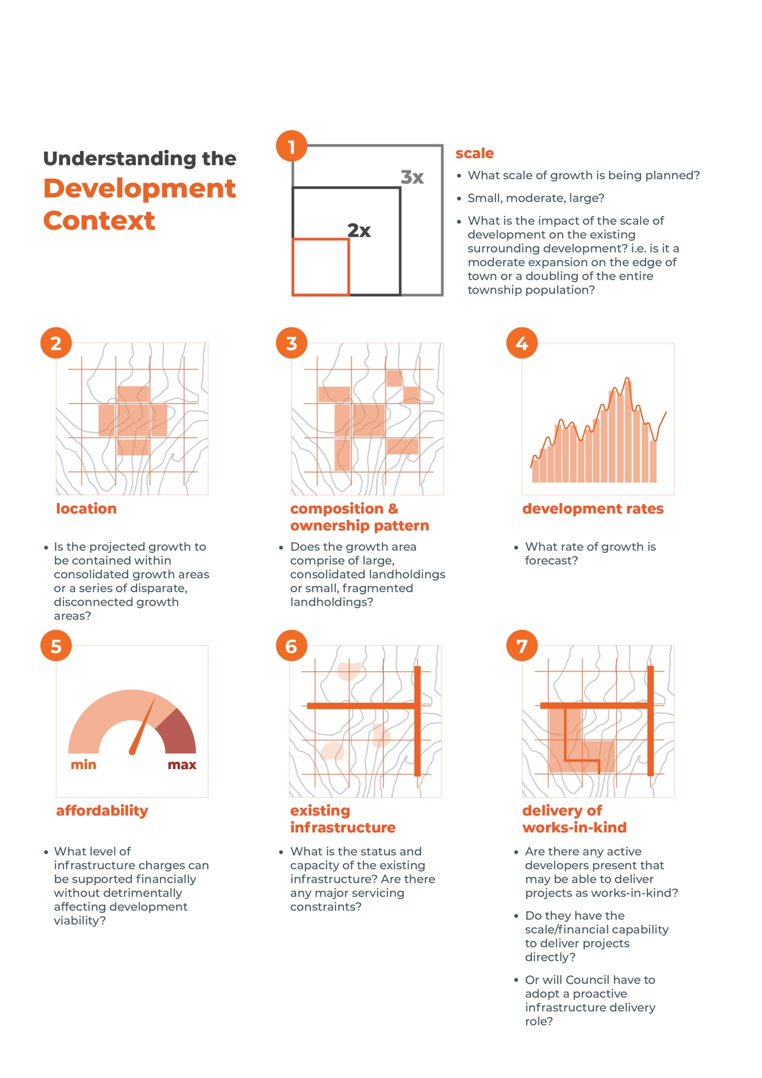
Development Context
The successful implementation of any funding mechanism requires a detailed knowledge of the local development context. Particular regard should be had to the following matters illustrated in Figure 3.

Figure 3: Understanding the Development Context

Policy Objective/ Position
[to be inserted]

Roles and Responsibilities
Figure 4 illustrates the key roles and responsibilities in regard to ‘Application’ and Councils governance framework.
Figure 4: Summary of Funding Application roles and responsibilities

Procedures and Processes
Table 2 sets out the procedure to determine which development contribution method to apply to a growth area or key development site.
Table 2: Procedure to determine potential application of development contribution method
Method | Application/Issues | Responsibility
Development Contribution Plan | Application  The growth area will: -  - experience high levels of urban growth such as greenfield sites and large redevelopment sites;  - contain a large number of properties;  - contain fragmented ownership patterns;  - require a broad range of infrastructure to support the new community; and  - is covered by a detailed strategic planning document such as a structure plan which sets out a sound strategic basis and design rationale for the area.  Key Issue  - Substantial work required to satisfy the statutory requirements against potential benefits | [Insert PM]  [PCG to consider PM recommendation]  [PS to approve PCG recommendation]
Informal Shared Infrastructure Agreement | Application  The growth area to be developed is: -  - is controlled by a small number of land holders;  - Where the supporting strategic document, i.e. PSP, Development Plan (or equivalent), has been prepared but is not supported by the necessary level of strategic justification required to prepare a formal DCP;  - Where the supporting strategic document has identified key essential infrastructure that is required to support the growth area;  - The growth area will require rezoning for urban development to progress; and  - There is a general awareness among the landowners of the benefit of adopting a coordinated approach to the delivery of key infrastructure.  Key Issue  - Requires agreement of affected landowners but provides greater flexibility as to the type of projects funded and limited financial exposure to council | [Insert PM]  [PCG to consider PM recommendation]  [PS to approve PCG recommendation]
Section 173 Agreements | Application  The growth area to be developed is: -  - a small or discrete area;  - The area may develop in an ad hoc manner over a long period of time;  - There are a small number of properties and land owners involved;  - There is a lack of strategic justification to support the preparation of a formal DCP; and  - The section 173 agreement will specify the provision of works in kind, staging of payments or reimbursements.  Key Issue  - Requires agreement of affected landowners and lacks transparency but provides greater flexibility as to the type of projects funded and limited financial exposure to council  A section 173 Agreement is also the preferred mechanism to implement works in kind arrangements to implement DCPs and informal shared funding arrangements, | [Insert PM]  [PCG to consider PM recommendation]  [PS to approve PCG recommendation]

Preparation

Overview
Once Council determines which funding mechanism to use, preparation of a DCP or Section 173 Agreement can commence.
Preparation of a DCP requires a significant amount of time and resources. It is an iterative process that often involves exploring inclusion and exclusion of various items and Council making an informed decision regarding which items to include and being aware of the financial obligations this will place on Council as it is both the Collecting Agency and Development Agency.
As indicated in Section 3, preparation of a Section 173 Agreement is not as complexed process as a DCP, however a Section 173 Agreement is a legal document and Council needs to ensure that the obligations in the Agreement meet the requirements and obligations of Council.

Policy Objective/ Position
[to be inserted]

Roles and Responsibilities
Figure 5 summaries the key roles and responsibilities when preparing the development contribution funding mechanism.

Figure 5: Summary of Preparation roles and responsibilities

Table 3 sets out the detailed roles and responsibilities in regard to ‘Preparation’ and Councils governance framework.
Table 3: Preparation – Roles and Responsibilities
Project Manager (PM) | Project Control Group (PCG) | Project Sponsor (PS)
DCP’s prepared by Council
PM to lead any DCP preparation.  Responsible for ensuring there is sufficient strategic justification to support the DCP projects identified in the corresponding structure plan or other relevant strategic document. | Review and provide recommendation to PS of infrastructure to be funded by a new DCP prior to the infrastructure being costed.  Review and provide recommendation to PS of final infrastructure costings to be funded by a new DCP.  Review DCP to ensure the DCP includes mandatory information and specifications.  Review final draft DCP and provide recommendation to PS prior to it going out on public exhibition and prior to it being forwarded to the Minister for Planning for approval and gazettal. | Review and approve proposed list of infrastructure projects for a new DCP prior to the infrastructure being costed.  Review and approve recommendation of PCG in regard to final infrastructure costings to be funded by a new DCP and any liability that will remain with Council.  Review final draft DCP and provide recommendation to executive team prior to it going out on public exhibition and prior to it being forwarded to the Minister for Planning for approval and gazettal.
Implementation of DCP -Section 173 Agreement
PM to prepare recommendation to enter into a Section 173 Agreement to implement infrastructure within a DCP (i.e. Works in Kind). PM to present to PCG. | PCG to provide a recommendation to the PS on whether to enter into a Section 173 Agreement in regard to implementing infrastructure within a DCP. | Review and approve recommendation of PCG in regard to entering into a Section 173 Agreement to implement infrastructure within a DCP.
New 173 Agreement (where no DCP applies)
PM to manage overall Section 173 Agreement process and provide overview of draft Agreement to PCG for consideration.  PM to prepare proposed draft infrastructure list (prior to the infrastructure being costed) to be funded through a new 173 Agreement. PM to present recommendation to PCG.  Developer to prepare initial costings. PM to manage process, including a peer review, and liaise with internal departments as required. Once peer review complete, PM to provide draft recommendation to PCG.  Note: a peer review may be carried out internally or externally depending on expertise, initial costing to be provided by developer. | PCG to review proposal and provide recommendation to PS in regard to the list of infrastructure projects to be funded via a new Section 173 Agreement prior to the infrastructure being costed. Note: The PCG would have already approved the use of a Section 173 Agreement through Section 3.4 of this document.  PCG to review final infrastructure costings and provide recommendation to PS  Be satisfied that the Section 173 Agreement contains mandatory requirements and specifications as set out in Section 3.3.1 and Annexure 2 of this document. Provide a recommendation to the PS. | Review and approve the recommendation from the PCG in regard to the proposed list of infrastructure projects to be funded via a new Section 173 Agreement prior to the infrastructure being costed.  Review and approve recommendation of PCG regarding final infrastructure costings (including reviewing any liability that may remain with Council) to be included in Section 173 Agreement.  Review and approve the recommendation of the PCG in regard to the content of the Section 173 Agreement. The PCG must approve all Section 173 Agreements, prior to the Agreement being signed.
Strategic growth area documents (i.e. PSP)
Any strategic documents prepared by PM related to growth area planning must be presented to the PCG for review and comment. | Review and provide comments on any strategic documents related to growth area planning. Provide a recommendation to PS. | Review and approve recommendation of PCG in regard to any documents that relate to growth area planning.

Procedures and Processes
Table 4 sets out the process to prepare a DCP, for further detailed explanation regarding the determination of analysis areas, main catchment areas and the use of equivalence ratios officers should refer to the DCP Guidelines prepared by the State Government, updated in 2007.

Development Contribution Plans
Table 4: Process to Prepare a DCP
Task | Detail | Responsibility
Determine area to be subject to DCP | - Determine the area to be subject of a DCP.  Q. Does the DCP area match the strategic growth planning area (PSP or equivalent), if not, why not? Does the boundary have deliberate regard to the strategic context, service catchments and physical context areas?  - Justify the DCP boundary.  - Report to the PCG. | Insert officers – these can be direct positions such as senior strategic planner and coordinator of engineering etc or Council could nominate the PM who can them delegate (depends on councils’ approach).
Ensure sufficient strategic justification to support a DCP | - PM to review the Strategic document that the DCP is to implement, including supporting background technical reports to ensure the sufficient level of justification is provided.  - PM is to prepare brief summary Report to PCG outlining status of information inputs and level of strategic justification and whether additional technical advice is required.  - PCG to approve commissioning (and budget) for additional technical reports.  - PM to commission any further work to fill any information gaps identified.
Identification of projects to be included in the DCP | - PM in consultation with the project engineer, open space and active recreation planner and social planner [and any other relevant officers] to identify projects suitable for inclusion in the DCP and determine likely timing triggers.  Note: preparing a DCP is an iterative process and the initial list will usually be extensive and it will be refined through a series of revisions (think of it as your full shopping list or wish list). It is recommended that broad estimates (based on similar recently completed projects, or costing details such as the VPA benchmark costs) are applied to start to get a feel for the order of costs and likely charge rates. Review the initial list to identify priority projects, projects that could be directly delivered by developers or funded via alternative means etc and ensure the projects are able to be funded via the DIL and CIL definitions as per the 2016 Ministerial Direction to prepare a refined the project list.  - PM to report to PCG with recommended projects to be included in DCP.  - PCG to report to PS for approval of projects to be included in the DCP prior to costing items.  Note: it is important that you take the council executive team and councillors on this journey, so they understand the process and rigor that has been applied to determine the refined project list. | Identify staff involved i.e.  Strategy planner  Project engineer  Open space and recreation planners, social/community planners as well as PM.  PCG  PS
Determine costs of DCP Projects | - Following approval from PS of the list of projects to be included in the DCP. PM to coordinate the preparation of detailed construction costs and commission land valuations for the various proposed DCP projects.  - PM to consult with the various departments when finalising the specific scope and timing of each infrastructure project.  Note: specific, detailed instructions must be provided to the consultant (if the costs are being prepared externally) i.e. for road projects, ideally functional layout plans should be prepared, or at least cross-sections, determine the exact length of the roads, shared paths etc and provide instructions around particular allowances such as contingency amounts, design costs and particular short term maintenance costs that are associated with the infrastructure establishment period.  Land valuations. Council must make a deliberate decision regarding which approach they will the apply in the DCP and whether the one approach will apply to all land projects. For example, in the Melbourne Water Development Services Schemes (DSS) which operate separately to a DCP. All flood prone land is attributed a zero value, however all land required for wetlands/ retarding basins that service the broader catchment are based on a broad hectare assessment.  - precinct based broad hectare values. This approach has typically been adopted in older DCPs and where all land owners agreed to the value i.e. Epping North East DCP, Strathfieldsaye Township East DP;  - property specific broad hectare values. This approach has been adopted across several DCPs, the use of property specific broad hectare valuations results in a value that has regard to each properties characteristics and the amount of land required under the DCP however the broad hectare assessment results in a lower overall value per hectare compared with option © being a site-specific valuation ;  - property site-specific valuations. This approach ultimately results in the highest land value for all DCP land projects. Prior to the creation of PLEM this approach was used widely in metropolitan Melbourne DCPs; and  - Public Land Equalisation Method (PLEM). This approach uses a combination of broad hectare and site specific valuations and has been used in DCP prepared by the VPA such as Leneva Baranduda DCP.  - Peer review of infrastructure costings to be undertaken. I.e. if costs prepared in house, then external consultant to review costs. If external consultants have prepared the construction costs, then Council officers to undertake a peer review.
Prepare detailed property/ parcel specific land budget | - PM to coordinate the preparation of a detailed property specific land budget. Council (or external consultant) are to digitise the strategic plan (PSP or equivalent) in GIS (this requires cutting up the plan into all the different land uses) and export out the values so that the land budget in excel can be populated.  A detailed property specific land budget is required to determine the net developable area that will be charged a levy, or alternatively the dwelling and floorspace projections if the DIL is to be charged on that basis. | PM and GIS team
Draft Calculation of Charges including initial risk assessment | - PM to prepare the calculation of charges table.  The calculation of charges table can be prepared once the construction costs, land valuations and detailed property land budget have been finalised.  - Complete an initial risk assessment. This requires a critical review of the draft DCP to identify projects that may pose a significant financial risk to council and determining how these risks can be mitigated or minimised. This should include identifying: -  - Development projections – are there any uncertainties in terms of information inputs? What are the risks associated with these?  - Large expensive projects – determining how these can be delivered? Are they required early in the life of development and will council be required to deliver them?  - Large areas of land – how do these DCP land projects impact upon the affected land holdings? i.e. do they require the majority of a property to be set aside for public purposes? Will the land holder likely trigger Land Acquisition and Compensation Act.  - Linked projects – identify these and determine council position regarding how out of sequence development will be addressed and what works if any will be credited.  - External apportionment – identify and quantity the amount of external apportionment proposed. Critically review the justification and calculations. The aim is to limit the amount of external apportionment included in the DCP.  - Implementation complexity – ensuring projects are not located where they will require undue complexity such as a collector road straddling two properties, drainage basins located across multiple properties or located external to the DCP area etc. Are there projects that cross municipal boundaries or are funded via multiple DCPs – how will these be addressed?  - Delivery method – identify how projects will most likely be delivered i.e. either via works in kind (developers) or directly by Council and whether any finance costs are required to directly deliver key infrastructure early in the life of the DCP.  - PM to report to the PCG outlining the DCP preparation process and the refinement of the project list and the final changes proposed. | PM and insert office/ potentially finance officer
Finalisation of Calculation of Charges | - Final charge rates are to be reviewed in terms of affordability and its recommended Council review them relative to recent DCP rates within similar sized other regional councils.  - Changes to any DCP projects should be documented via inclusion of a notes column in the calculation of contributions table which should explain changes to project scope, costs, removal of project etc – as this information will assist when the DCP gets to a Panel Hearing and Council must justify the preparation process.  - PM to brief PCG on the final project list and charge rates. | [PM and insert office/ potentially finance officer]
Implementation Strategy | - Preparation of an implementation strategy.  - This can either consist of either a brief section outlining the projects considered suitable to be delivered as works in kind and the criteria that council will assess works in kind applications against.  - Alternatively, the DCP can include a detailed implementation section (an example is provided is the DC Manual and Huntly DCP). This involves having regard to the development context to: -  - Identify implementation precincts;  - Determine the DIL liability for each property within each implementation precinct; and  - Identify and tag projects to be directly delivered by each implementation precinct and those that will most likely need to be provided directly by Council.  - PM to brief PCG. | PM  PCG
Peer Review | - PM to seek an independent peer review prior to seeking authorisation for exhibition of the DCP.  - PM/PCG to consider peer review findings and agree on changes to DCP document. | PM  PCG
Finalisation of DCP document | - PM to update the DCP document accordingly.  - PS to brief council executive on the final DCP. | PM  PCG  PS
Council resolution to seek authorisation for exhibition | - PM to prepare council report which clearly explains the DCP, the financial risk it poses, how this is to be addressed etc.
DCP placed on exhibition | - DCP is placed on public exhibition

It is assumed that Council officers have been actively involved throughout the preparation of the strategic document, such as precinct structure plan, that identifies and justifies the potential DCP projects. Table 5 sets out the process to review a DCP that has been prepared by an external agency.

Table 5: Process for reviewing a DCP prepared by another agency
Task | Detail | Responsibility
Review the draft DCP document | - PM to coordinate the respective council departments to review the DCP document and projects included. This review includes reviewing the: -  - scope, cost and justification of each project;  - identifying any potential financial implications for council associated with particular infrastructure projects i.e. large amount of external apportionment, projects required early in development that may require finance costs, large land projects located over multiple properties etc;  Note: this task includes similar components as Item 16 in the previous process table.  - Mitigating financial risk where possible i.e. Council officers talking to land holders required to provide large amounts of land for future public purposes and whether they would be willing to enter into a 173 Agreement to fix the value of the land and timing of transfer and credits payments/ reimbursements (if applicable);  - ensuring Council executive understand the financial implications associated with the DCP | PM and relevant council departments including transport, engineering, active recreation, social infrastructure, strategic and statutory planning, finance etc
Consolidate review findings | - PM to consolidate each departments feedback into a single document and make recommendations to the PCG | PM
Present review findings and recommendations to the PCG | - PM to present the review findings and recommendations to the PCG for their consideration and comment. | PM
Finalise review findings and recommendations & provide to agency who prepared the draft DCP | - PM to update the review findings and recommendations following receipt of comments from the PCG. PS to approve Council officers review to be provided to the agency who prepared the DCP.  - PS to present the findings to councillors prior to the comments being provided to the government agency. | PM  PCG  PS

Informal Shared Funding Arrangement
If council seek to prepare an informal shared infrastructure funding arrangement it is recommended that a similar process to that outlined in Table 4 is followed in terms of identifying, scoping and costing the projects and calculating charges. However, given an informal shared funding arrangement is usually included as a section of the respective Development Plan or similar planning document. The funding arrangement does not need to go through a formal planning scheme amendment process, it is a council approved document.

Section 173 Agreement
During the application phase, if the PCG and PS have agreed to prepare a section 173 agreement then the process set out in Table 6 must be followed. It is anticipated that Council will have a section 173 template prepared by a lawyer.

Table 6: Process to prepare a Section 173 Agreement – where the Section 173 agreement is primary funding mechanism (i.e. it is not implementing a DCP or informal shared funding arrangement)
Task | Detail | Responsibility
Identify infrastructure requirements to be included in the 173 agreement | - Following initial discussions with the development proponent regarding the terms of the agreement the PM is to review the development proposal of the subject land and determine the scope and timing of projects to be included in the Section 173 Agreement.  - PM to report to PCG with recommended projects to be included in 173 Agreement.  - PCG to report to PS for approval of projects to be included in Section 173 Agreement prior to costing items. | PM
Determine costs of infrastructure projects | - Following approval from PS of the list of projects to be included in the Section 173 Agreement. Project Manager to coordinate the preparation of detailed construction costs and commission land valuations for the various proposed infrastructure projects. The cost of this work is to be recovered via the Section 173 Agreement.  - Project Manager to consult with the various departments when finalising the specific scope and timing of each infrastructure project.  - Peer review of infrastructure costings to be undertaken. I.e. if costs prepared in house, then external consultant to review costs. If external consultants have prepared the construction costs, then Council officers to undertake a peer review. | [Insert officers]  PM  Strategy Planner  Project Engineer  Open Space and Active Recreation Planner.  Social/community planner.  etc
Calculation of Charges | - Once the construction costs, land valuations and detailed property land budget have been finalised the contribution charges can be calculated. | PM and [insert position], finance officer
Implementation Strategy/ Delivery of Infrastructure | - PM to coordinate agreement of the timing triggers to be included in the Section 173 Agreement.  - Section 173 Agreement is to include a review period whereby these triggers can be updated, subject to Council approval.  - It is important to identify if the Section 173 Agreement will obligate Council to providing specific infrastructure or reimbursements. | PM  [Insert officers]
Finalisation of the Section 173 Agreement | - Once the scope, timing and cost of infrastructure items to be included in the Section 173 Agreement have been included then the 173 Agreement should be prepared.  Council 173 Agreement template should be used. Developer should pay costs to prepare the agreement and have it lodged with titles office. | PM to coordinate
Review | - PCG to review final document and recommend any changes.  - Depending on the amount of infrastructure projects included in the Section 173 Agreement, PCG to consider an external legal review of the proposed draft 173 Agreement.  - PCG to report to PS with final Section 173 Agreement and outline any specific financial implications it will have on Council and how it proposes to actively address these.  - PS to approve the Section 173 Agreement and recommend CEO sign it. | PM  PCG  Independent legal peer review, if required.  PS
Execution of Agreement | - Once developer/ land holder has signed the agreement the CEO signs and seals the agreement and it is lodged on title. | PM to coordinate  CEO to sign and seal

Implementation

Overview
Implementation of a DCP, informal shared funding arrangement or Section 173 Agreement is complex, and it requires a number or procedures and processes.

The following are addressed in this section: -
- Infrastructure Review and Infrastructure Priority Lists (IPL)
- Cash Flow Modelling
- Invoicing of both the development infrastructure levy and community infrastructure levy
- Changes to land use budget
- Works in Kind, including preparing Section 173 Agreements
- Development Contributions Schedule
- Developer Rolling Credits
- Handover of Infrastructure Projects

Policy Objective/ Position
To ensure there is consistency in the implementation of a DCP and that infrastructure is delivered to the community in a timely and cost-efficient manner.
This policy applies to landowners which develop land within our growth areas, where a DCP applies and it is intended to provide assistance for Council officers in negotiating with developers: -

Works in Kind
- Council will support the delivery of DCP projects as works in kind by developers that are consistent with the Priority List and have a nexus to the development.
- If Council agrees to the early delivery of an infrastructure project, no credit will be given prior to the timing trigger identified in the Priority List unless there are extraordinary circumstances which give reason to an early credit being given. This excludes any external funding portion.
- The timing of the credit/offset for the external funding portion is to be in accordance with the Priority List for the DCP applicable. This should not to be deviated from even when the DCP funded portion of the works-in-kind and/or land credit is brought forward to an earlier stage for the purposes of a rolling credit scenario.
- In the case of two or more developers completing different portion of an infrastructure project, the external funding portion will be allocated to the two or more developers based on the percentage of works each has provided.
- Project costs / credits will be given based on the DCP project amount.
- Credit for works in kind will only be accepted once the works have been completed.
- All works in kind projects must be secured through a Section 173 Agreement.
- In the case of a rolling credit agreement with a developer, the credit for works-in-kind/land in excess of the DIL obligation to be offset against DIL in future stages can be released on confirmation of Practical Completion of the works provided.
- In the case of an agreement with a developer to pay out the credit for works-in-kind/land in excess of the DIL obligation at that stage of subdivision, the amount can only be paid when the works are off maintenance and the titles have been issued for land acquired.

Roles and Responsibilities
Figure 6 summaries the key roles and responsibilities of the project manager, project control group and project sponsor across the multiple implementation components.

Figure 6: Summary of Implementation Roles and Responsibilities

Table 7 provides a detailed description of the roles and responsibilities across each component.

Table 7: Implementation – Roles and Responsibilities
Project Manager (PM) | Project Control Group (PCG) | Project Sponsor (PS)
Pre Application Meeting
Responsible planner/ PM to lead and include relevant departments in the pre application process. PM to present proposal to PCG. | PCG to review proposal and provide input when required. PM to prepare a written response to applicant including any comments from the PCG.
Infrastructure Priority List (IPL) & Cash Flow Modelling
PM to prepare draft IPL (including cash flow for each IPL). PM to present to PCG for initial discussions and review. The PM will convene a technical working group to assist in the preparation and review process of an IPL. | Review draft IPL for each growth corridor and provide a recommendation for approval to the PS annually. | Review and approve IPL’s and associated cash flows annually.  PS to present and seek endorsement of IPL’s and associated cash flows from Executive. PS to present IPL to Council and seek formal resolution.
Works in Kind, Development Contributions Schedule, Developer Rolling Credits, Section 173 Agreement
PM to prepare a paper relating to a specific proposal to deliver works in kind. This paper will outline the total NDA for the estate, DIL liability and potential works in kind projects, total value of credits and overall estate balance. The PM will make recommendations regarding whether Council should consider applying Developer Rolling Credits, and preparation of a Section 173 Agreement. | Review the works in kind proposal and provide recommendations to the PM. PM to update report accordingly (this may require further correspondence with the development proponent).  The final report to the PCG must clearly outline any financial implication the works in kind proposal may place on Council.  PCG to provide recommendation to PS. | Review the works in kind proposal, including the Development Contribution Schedule, possible use of Developer Rolling Credits, and requirement for a Section 173 Agreement.  PS to approve/decline the works in kind proposal including the Development Contribution Schedule, possible use of Developer Rolling Credits, and requirement for a Section 173 Agreement. PS to notify Executive of decision.
Handover of Infrastructure Projects
PM is to coordinate the inspection and relevant sign off of the works in kind project from the relevant departments. PM is to calculate the total development contributions credit based on the relevant indexed DCP values. PM is to present the works in kind project that has been delivered, including its scope, PC date, total credit value, and status of the development proponents obligations under the respective Section 173 Agreement to the PCG. | Review the completed works in kind project and provide a recommendation for approval to the PS.  Note: this recommendation may include payment of DC funds to the development proponent. | Review the works in kind project.  The PS will decide whether to accept the works in kind project.

Procedures and Processes

Infrastructure Review and Infrastructure Priority Lists (IPL)
The preparation of a Priority List for each DCP will assist Council in the management of DCPs and financial liabilities/cashflows. Once a DCP is gazetted/approved, the Project Manager will initiate the preparation of a Priority List.
Each Priority List will identify short, medium and long term infrastructure projects and include an indicative timeframe for delivery.

In the preparation of a Priority List consideration should be had to the following:
- Current knowledge of landownership and developer interest;
- Staging of DCP infrastructure items having regard to the above;
- Likely timing and sources of funding for externally funded projects;
- Implication for the DCP fund’s cash flow as a result of DCP payments (from development) and credits (from works in kind); and
- Any 173 Agreements that Council has entered into.

It is recommended that Councils IPL is updated annually or alternatively when a substantial works in kind agreement is being proposed. Table 8 sets out the procedure to prepare a cash flow model.

Table 8: Procedure to prepare an Infrastructure Priority List
Task | Detail | Responsibility
Prepare Infrastructure Priority List (IPL) for each DCP/ growth area. | - Prepare an Infrastructure Priority List (IPL) for each DCP or growth area nominating: -  - Each project – separate out the land and construction components into separate project items. Populate the IPL template. | PM & in consultation with staff from:  Strategy  Statutory Planning  Tech services  Asset Planning  Accounting  Projects and Recreation
Determine delivery/ funding sources and timing | - Once the IPL template has been populated with the DCP projects, the next step is to nominate how each project within the IPL is to be delivered i.e. as works/land in kind by the developer or by Council.  - Identify how each project will be delivered i.e. in how many components i.e. property 12 will deliver 0.5ha of open space OS03 and property 13 will deliver 0.3ha of open space OS03.  - Nominate the total credit value of the projects (both in terms of amount of land required and units of construction i.e. linear metres of road to be constructed), and if known, any cost overruns.  - Identify the likely timing of delivery for each project. Initially nominate the projects as either short (to be delivered within 0-5 years) /medium (5-10 years) / long term (10+ years) or as Council defines.  - Refine the timing to exact financial years.  - Identify any financial implications i.e. external apportionment.  This involves examining the various growth fronts, any obligations via Section 173 Agreements and holding discussions with the developers regarding their staging. During this phase it may become evident that 2 or 3 development scenarios should be examined.  In addition, most councils have a project ranking criteria that they use when determining their capital works program. These criteria could be applied or adjusted to determine criteria to prioritise the IPL projects. | Project Manager
Alternative scenarios | It is likely that council will prepare several development scenarios which will result in the requirement for several IPL lists to feed into the cash flow models | Project Manager and [insert position], - Finance Department

The process to prepare an IPL is illustrated in Figure 7.

Figure 7: IPL Preparation Process
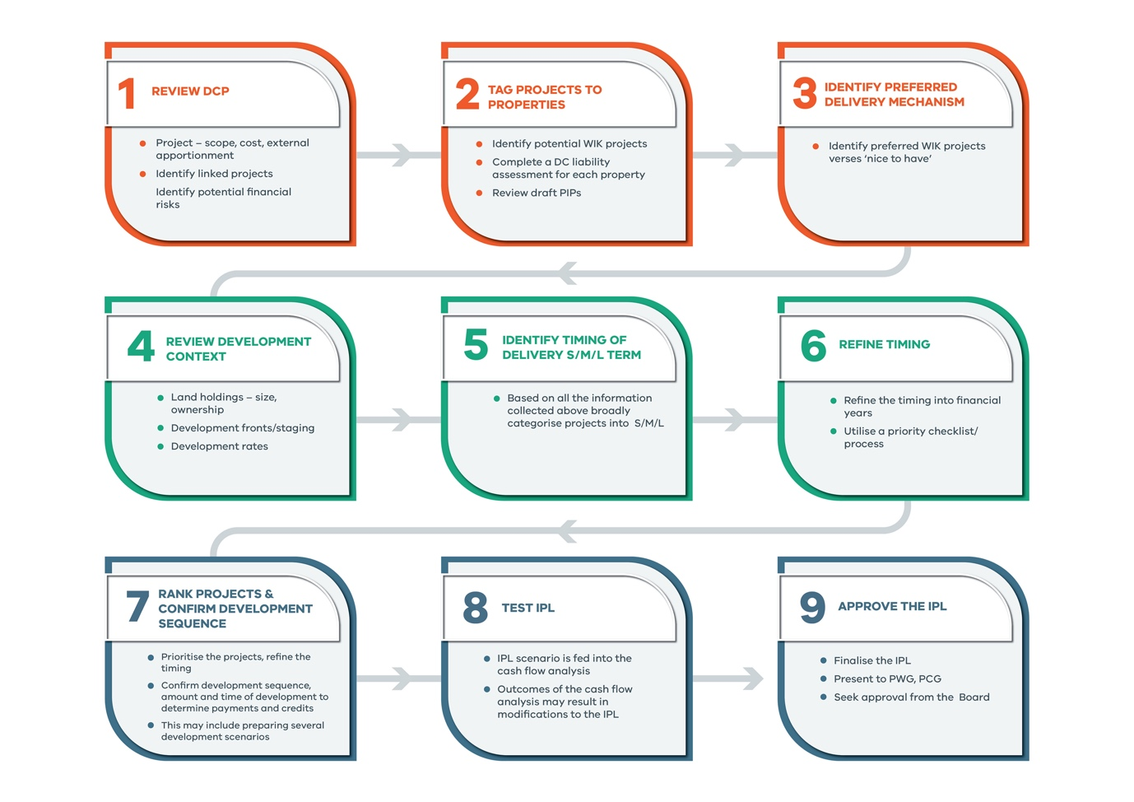

Cash Flow Modelling
It is recommended that Councils cash flow model is updated annually or more frequently if a substantial works in kind agreement is being proposed. Table 9 sets out the procedure to prepare a cash flow model.
Table 9: Procedure to prepare a Cash Flow Model
Task | Detail | Responsibility
Finalise the Infrastructure Priority Lists (IPL) for each DCP/ growth area. | - The IPL is a primary input into the cash flow model.  The IPL would have been completed following the process set out in the preceding process. | PM & in consultation with staff from:  [insert departments]
Determine potential development infrastructure levy (DIL) income | - Review the DCP/growth area and determine the likely development timing and staging of all parcels within the DCP/growth area and how this impacts the timing of DCP DIL payments. It is likely that 2 or 3 growth scenarios will be prepared.  - This requires completing the following steps: -  - Calculating the total DIL payable for each property based on the total yield (as the point in time);  - Determining the likely staging of each property i.e. allocating a specific yield to each financial year – the table will then calculate the total DIL payable per financial year for each individual property. | PM & in consultation with staff from:  [insert departments]
Determine the total value of works in kind credits | - Determine the total value of works in kind credits each property is entitled to when they directly deliver a DCP project/s.  - Using the yearly DIL projections determine how long the works in kind credits will be applied (that is when a property is to provide DCP projects as works in kind but the total value of the works in kind does not exceed the total DIL payment). This step will determine the total value of ‘credits’ that are being attributed to each financial year. | PM & in consultation with staff from:  [insert departments]
Determine value and timing of reimbursement payments | - Identify the properties that are required to provide DCP projects which total value exceeds the properties total DIL liability to determine the reimbursement amount owing to the developer.  - Determine how and when this amount is to be reimbursed – i.e. as a single lump sum, staged payments etc. | PM & in consultation with staff from:  [insert departments]
Determine projects to be directly delivered by Council | - Identify the exact project or part of project and amount/ value of works to be provided by financial year.  - Discuss with the finance staff who prepare the capital works plan regarding timing and amount of funds that will be available to either deliver projects before funds have been received or cover external demand shortfalls. | PM & in consultation with staff from:  [insert departments]
Prepare Cash Flow Scenarios | - Once the steps above have been completed and the inputs for the cash flow are finalised the cash flow can be prepared. It is common to prepare 2 to 3 cash flow scenarios which look at different growth rates so Council officers can compare the financial implications associated with each scenario. | Finance Department
Review Cash Flow Scenarios | - Once the cash flow scenarios have been prepared, the PM will report back to the PCG on each scenario including an outline of the assumptions/inputs and the associated financial implications i.e. impact on the capital works program. | PM & Finance Department  PCG
Finalise the cash flow model | - Finalise the preferred cash flow.  - PCG and PS (potentially council executive) to sign off on the final cash flow (&IPL). | PCG  PS  Council Executive

Calculating / Invoicing of both the development infrastructure levy and community infrastructure levy
Table 10 sets out the process for calculating the DIL levies payable for a particular stage of development.

Table 10: Process for calculating DIL infrastructure levies payable
Task | Detail | Responsibility
Confirm the applicant and development details | - Obtain the property address, applicant, relevant planning permit number, determine the ‘property number’ in the applicable DCP. | [insert position]
Determine the total demand units (NDHa) | - Determine the total demand units for the property which is usually net developable hectares. Note any DCP land projects that are required from the property and any exempt land such as schools etc. | [insert position]
Determine the land use type and DIL levy payable | - Determine the land use type i.e. is it residential, commercial, retail or employment – identify how many demand units is attributed to each land use.  - Obtain the indeed DIL charges that are applicable from councils website. | [insert position]
Calculate the total levy payable | - For each land use type multiply the demand units (usually net developable hectares) by the respective DIL charge to determine the total levy payable. | [insert position]
Identify any land or works provided in lieu of a cash contribution | - Identify any DCP land projects being vested in council as part of the respective stage of subdivision/development i.e. flaring for intersection IT03 or 0.8 hectares for community centre CO01. Note the DCP project, amount of land being provided and entitled land credit value from the indexed DCP rates.  - Identify any DCP projects to be provided as works in kind (construction), note the DCP project, units to be constructed i.e. linear metres of road, credit amount per unit and total credit amount. | [insert position]
Prepare the invoice | - Prepare the invoice using all the inputs above. The invoice will show whether a cash payment is required, the applicant is credit (they may wish to proceed on a rolling credit basis) or the applicant is entitled to a cash reimbursement payment from Council.  - Ensure it matches up with the original DC schedule prepared and endorsed with the planning permit. | [insert position]
Invoice to be checked/ signed off | - [insert position] to sign off on invoice | [insert position]
Invoice to be provided to applicant | - [insert position] to send invoice to applicant. | [insert position]

Changes to Land Use Budget
It is inevitable that there will be some modifications to the property specific land budget during the life of the DCP. Whilst most DCPs note that the DCP land budget will not be modified to respond to minor changes, therefore there is the ability for minor changes to be agreed to between the applicant and collecting agency which do not require a change to the DCP document.
Table 11: Procedure for assessing changes to the land use budget
Task | Detail | Responsibility
Identify potential change to a DCP land project or general land use type | - Review applicants plan of subdivision, urban design framework etc and identify and quantify the land uses against the detailed DCP property specific land budget.  - Identify any discrepancies, quantify these and explain why these changes are being sought.  - Quantify impact on the DCP. | [insert]
Determine if it is a minor change which will not require formal amendment to the land budget | When assessing potential minor land use changes that do not require a formal change to the DCP property specific land use budget the following principles must be considered: -  - There is no negative financial impact on the DCP;  - The impact of the potential changes can be managed between the landowner/ or landowners affected i.e. they all affected landowners agree to the change;  - The DCP project can still be delivered and function as intended;  - The potential land budget changes assist in the delivery of a works in kind project; and  - There is a transparent way to document the minor changes agreed to. | [insert]
PCG to approve minor change | - PM to present change to PCG and seek approval. | [insert]
PS to approve minor change | - PCG to present change to PS | [insert]
If accepted, note internally the minor change accepted | - [insert] to record minor change accepted | [insert]

There will occasionally be instances where substantial changes are proposed which will significantly impact the detailed land use budget. In the situation where the proposed changes cannot be managed within the affected landholdings and where there is an overall financial impact on the DCP a full review of the DCP is required following by a planning scheme amendment to give effect to the changes.

Works in Kind
DCPs and Informal Shared Funding Arrangements provide an opportunity for developers to deliver infrastructure projects, and potentially offset these costs against their Development Contributions Liability (‘DIL’). This is known as ‘works in kind’. Any DCP WIK may be required to be secured through a Section 173 Agreement. There are many benefits of allowing developers to undertake works in kind.

These include:
- Developers can often deliver infrastructure items more cost effectively than Council.
- Works can be integrated with subdivision development.
- There is less risk to Council in terms of funding and cash flow.
- Developers may provide for early delivery and funding of infrastructure.

However, there may be instances where it may not be worthwhile for Council to accept a WIK, this may be due to the fact that Council wish to directly delivery the infrastructure item or the infrastructure item is not required for a long period of time (this may be due to a property being developed ‘out of sequence’).

If Council do wish to proceed with a works in kind proposal it is recommended that this is formalised through a section 173 agreement. It is anticipated that Council will have a section 173 template prepared by a lawyer.

Section 173 Agreement
The Agreement should set out, as a minimum, the following standard requirements: -
- Reference to the Planning Permit and the approved DC Schedule or Public Infrastructure Plan.
- A schedule of works.
- Timing of reimbursements/credits.
- Maintenance requirements.
- The requirements to be met prior to any land being vested in Council (i.e. de-rocked, fenced, free of contamination etc).
- DIL and CIL obligations, timing of payments, offsets etc.
- Project delivery – i.e. scope of works, refer to approved plans etc.
- Indexation and payouts.
- Approval of works.
- Any Council obligations.
- Any developer/landowner obligations.
Note: It is recommended specialised legal advice be sort by Council in regard to standard section 173 Agreements and the scope of the Agreement.

[insert example of Section 173 template from Ballarat as a case study]

When negotiating works in kind agreements it is important that Council officers are guided by the following principles set out in Table 12.

Table 12: Procedure for negotiating works in kind agreements
Task | Detail | Responsibility
Meeting with applicant | - PM and statutory planner to meet with applicant to explain council’s policy position in relation to works in kind. | PM and staff
Works in kind proposal | - PM to seek written confirmation from applicant outlining the potential works in kind agreement. | PM and staff
Assess the merits of the works in kind proposal | - Assess the potential works in kind agreement against the following criteria.  - Financial  - Reduce Council’s financial risk?  - Assist Council to close a ‘funding gap’?  - Save council money in the long term?  - Significantly minimise resource requirements for Council?  - Quality  - Accord with the relevant strategic documents (i.e. PSP, DP, DCP)?  - Commit to provide infrastructure in accordance with Council’s standards? Or improve on the scope originally intended?  - Timing  - Significantly reduce the timeframes for delivery of the infrastructure?  - Align with Councils IPL? Is the project a priority project?  - Demand  - Does it assist to meet community demand for new infrastructure?  - Significance  - Is it a catalyst project that will open up development of the area?  - Does it result in no financial impact or risk to council? | PM and staff
Internal review of works in kind proposal | - Present the works in kind proposal to the PCG for review and comment.  - PCG to make recommendation to PS to accept/reject proposal. | PM and staff  PCG
Written confirmation to applicant | - Following decision from PS the PM will write to the applicant and advise of the PS decision and next steps.  - If PS accept the proposal, Council will provide applicant with preferred section 173 template. | PM and staff  PS
Drafting of Section 173 Agreement | - A section 173 agreement is drafted in line with the proposal accepted by council.  - Section 173 is reviewed by lawyer on behalf of council, details are finalised. | PM and staff
Execution of 173 | - PCG/PS review final 173 agreement, and if all is in order the PS will recommend to the CEO that the 173 is signed and sealed. | PM and staff  PCG  PS

Development Contributions Schedule
Figure 8 sets out the process for approving the development contribution schedule.

Figure 8: Process for approving the development contribution schedule

Developer Rolling Credits
Figure 9 sets out the process for managing development contributions for rolling credits for works in kind.

Figure 9: Process for managing development contribution rolling credits for works in kind
Finance to recognise works-in-kind/land capital expenditure and process a transfer from in-kind reserve journal

If Council agrees to developer works-in-kind/land acquisition offsets as part of a rolling credit agreement the following DC In-Kind Debtor process is required.
Finance person to forward DC In-Kind debtor invoice request to Council's Accounts Receivable Officer to record DIL income at the applicable stage as per indexation confirmation 21 days prior to Statement of Compliance.
Accounts Receivable Officer will forward the printed Debtors invoice to Financial Accounting Coordinator for filing. This is for internal recording purposes and is not to be sent to developer
Finance to recognise income and process a transfer to in-kind reserve journal
Financial Accounting Coordinator to forward a DC In-Kind credit note request and provide a copy of developer letter (practical completion process) confirming works-in-kind approval and/or land transfers to Financial Accountant.
Financial Accountant to forward the printed credit note to the Management Accounting Coordinator for filing. This is for internal recording purposes and is not to be sent to developer.
Accounts payable will provide a copy of the DC In-kind Debtors Statement to the developer at the end of each financial year. This will provide the current financial status of the rolling DC Schedule
Accounts payable will request Finance pay the developer if a credit balance remains or follow up payment if a debit balance remains. The payment is to be in accordance with Section 173 Agreement

1
2
2

Handover of Infrastructure Projects
When a developer advises that a DCP WIK project is complete, the following is required to be completed within Council:
- Relevant internal departments inspect the project and sign-off.
- The development contributions credit for the project is calculated based on the DCP project value indexed to the year of completion.
- Preparation of a Statement of Practical Completion which includes the value of credit given for the item provided in-kind.
- For buildings and works - the project is added to the Council Asset Register, including a schedule of rates (building components, costs, etc) for valuation and depreciation purposes;
- For land acquired – titles are issued to Council.
- Council obtains insurance for the asset.
- Where a Section 173 Agreement with a developer provides for a payment of the credit for works-in-kind/land in excess of the DIL obligation at that stage of subdivision, the amount can only be paid when the works are off maintenance and/or the titles have been issued for land acquired.

Figure 10: Process for Handover of Infrastructure Projects

Maintenance

Overview
One of Council’s key responsibilities when administering DCPs, informal shared funding arrangements and Section 173 Agreements is to ensure that the rates are adjusted regularly to keep pace with escalation in costs of construction and land.

Each DCP, informal shared funding arrangements and Section 173 Agreement requires adjustment to occur. Most DCPs, informal shared funding arrangements and Section 173 Agreements are indexed annually, and this is usually undertaken on 1 July each year, although this can vary. DCPs and Section 173 Agreements can include projects containing construction and/or land components which will need to be indexed.
- Construction costs: indexed in accordance with a publically available index as stipulated in the DCP, informal shared funding arrangements or Section 173 Agreement.
- Land values: Escalated in accordance with the provisions included in the DCP, informal shared funding arrangements or Section 173 Agreement.

As Council has a number of DCPs, informal shared funding arrangements and Section 173 Agreements and this is expected to continually increase, it is recommended that a register is created of all DCPs, informal shared funding arrangements and Section 173 Agreements which includes the requirement for indexation, the timing of the indexation and the index, or escalation rate, required.

Policy Objective/ Position
To be inserted

Roles and Responsibilities
Figure 11 sets out a summary of the key roles and Table 13 provides additional detail.

Figure 11: Summary of maintenance roles and responsibilities

Table 13: Maintenance – roles and responsibilities
Project Manager (PM) | Project Control Group (PCG) | Project Sponsor (PS)
PM to manage indexation process including providing a recommendation to the PCG to commission a consultant to index construction costs and undertake land valuations, if this cannot be undertaken by Council officers.  PM to present updated costings for construction and land valuations to PCG. PM to provide an update to PCG at the completion of indexation period, as require. | Review and approve the recommendation of PM in regards to indexing construction costs and undertaking land valuations.  PCG to review and approve the indexed DCP and Section 173 Agreement costs including the publication of indexed DCP costs. | PS to inform executive of publication of indexed levies including any significant changes in land valuations.

Procedures and Processes
Council is responsible to ensure that the development contribution charge rates and project costs are adjusted annually (or otherwise stated in the respective document) to ensure the costs keep pace with the market. Table 14 sets out the procedure for indexing the infrastructure costs and calculating the revised charge rates.

Table 14: Procedure for indexing development contribution infrastructure costs
Task | Detail | Responsibility | Timing
Create a central register of all DCP, informal funding arrangements and Section 173 Agreements that require indexing. Note the type of projects to be indexed, index method to be applied and when the indexation is to occur.
Land cost index | - Apply the specified land cost index – this will usually be annual re-valuations completed by an independent certified land valuer.  - Update all land costs with the revised figures, the most recent DCPs will usually include a land values ‘worksheet’ and by updating the values in this sheet the values in the calculation table will automatically update.  Ensure that council keeps an individual record of each DCP indexed year so when reconciliations are required, or rates and credits queried it is very easy to find the respective values. | [insert position], | As specified in DCP/ 173
Construction cost index | - Obtain the specified Index as required by the DCP.  - Apply the index to the construction costs i.e. apply the change index rate for the review period (usually a year). | [insert position], Finance | As specified in DCP/ 173
Update excel Tables | - Utilising the specified Index and average land value from the above steps, update the excel tables. | [insert position], Finance | As specified in DCP/ 173
Publish escalated DCP rate and land value | - Insert a notice in local paper setting out the updated DCP rate/ha, as well as the underlying land value used to determine the DCP rate. | [insert position], Finance | Upon completion of indexation
Notify parties affected by signed Section 173 Agreements | - Notify in writing parties who have signed section 173 Agreements which include indexation of projects which are not subject to a formal DCP. | [insert position], | Upon completion of indexation

Recording and Reporting

Overview
Council is required by the Planning and Environment Act 1987 and the Local Government Act 1989 to keep proper accounts of any levies paid to it. As such, it is at this phase of DCP administration (note there are no formal reporting requirements for section 173 agreements and informal shared funding arrangements) that the focus shifts from the Planning Department to the Finance Department.

Recording and Expenditure/Delivery Requirements

Tracking of payments and expenditure
The collecting agency and development agency is required to keep accurate records which track the levies collected and expenditure. This includes recording the property, stage, demand units (usually NDA), land use type, DIL levy payable, plan of subdivision, planning/building permit, amount of levies received as cash payments and any provision of works or land in lieu of cash payments.

Pooling of Funds
The Planning and Environment Act 1987 and the DCP Guidelines, 2003 updated 2007, do not specifically mention the pooling of funds. However, it has long been ana accepted practice adopted by Councils implementing DCPs, as otherwise no infrastructure would be able to be built till well into the life of development (long after delivery triggers have been met). Therefore, to ensure the timely delivery of infrastructure when it is required, DCP funds will be pooled within the specific DCP fund (i.e. funds cannot be pooled across different DCP funds).

Interest bearing accounts
The collecting agency must pay an amount of a levy received into a Consolidated Fund (as per Section 46QA of the Act). It is common practice that this is a separate interest bearing account and one account is set up for each DCP.

Annual Financial Reports
Section 46QD of the Planning and Environment Act 1987 requires the collecting agency or development agency to prepare a report for each financial year and given the to the Minister for Planning within 3 months after the end of the financial year reported on.
If the collecting or development agency is a municipal council the report must be included in the report of operations contained in the council’s annual reported prepared under the Local Government Act 1989.
The October 2019 Ministerial Direction on the Reporting requirements for Development Contributions Plans requires the following to be completed by collecting agencies and development agencies.
Collecting agencies
5. A collecting agency must report on:
a) any infrastructure levy paid to it under Part 3B of the Act in a financial year in accordance with Table 1 in the Annexure;
b) any land, works, services or facilities accepted by it in a financial year in accordance with Table 2 in the Annexure.
6. If a development contributions plan is approved on or after 1 June 2016, a collecting agency must report on the total amount of infrastructure levies paid to it, the total amount of land, works, services or facilities accepted by it, and the total amount of infrastructure levies expended by it under Part 3B of the Act in accordance with Table 3 in the Annexure.

Development agencies
7. A development agency must report on:
a) its use of any land, works, services or facilities accepted as works-in-kind under section 46P of the Act; and
b) the expenditure of any infrastructure levy paid to it under Part 3B of the Act; in accordance with Table 4 in the Annexure.

Policy Objective/ Position
- Development Contribution Invoices are issued to all stages of subdivision (or development is not SOC is required) and must be paid/satisfied prior to issue of statement of compliance or as stated in the gazetted DCP.
- To ensure the timely delivery of infrastructure when it is required, DCP funds will be pooled within the specific DCP fund.
- Council will establish separate interest bearing accounts for each DCP. All interest earned is to be spent on delivering the infrastructure projects in the gazetted DCP.

Roles and Responsibilities
Figure 12 summaries the key responsibilities of the PM, PCG and PS whilst Table 15 explains the roles in further detail.

Figure 12: Summary of recording and reporting responsibilities

Table 15: Recording and Reporting – Roles and Responsibilities
Project Manager (PM) | Project Control Group (PCG) | Project Sponsor (PS)
Quarterly Reports
[insert position] to prepare quarterly draft report and present to PCG on income including cash contributions, works and land provided in kind (assets), credits owing and expenditure (direct delivery of projects, payment of reimbursements to developers). | Review quarterly accounts including contributions received as either cash, land or infrastructure assets and expenditure and provide update to PCG. [insert position] to present to PCG. | To review the report presented by the [insert position].  PS informs Executive of reports.
Annual Reports
[insert position] to prepare and review the annual report and present this to the PCG. Prepare a report and present to PCG. | Review annual financial report and report to PS. | Review annual report.  PS informs Executive of reports.
Annual Report to Minister for Planning
[insert position] to prepare the annual financial data in the template tables included in the Ministerial Direction | Review the annual report, report to PS. | Review annual report.  PS informs Executive and seeks approval to include in the ‘report of operations’.

Procedures and Processes
Table 16 set out the procedure for recording and reporting on development contribution income and expenditure.
Table 16: Procedure for recording and reporting
Task | Detail | Responsibility | Timing
Record DCP, informal shared funding arrangement, Section 173 Agreement cash payments, land and works in kind, DIL credits | Prior to Statement of Compliance of each stage of subdivision, developers must meet DCP, informal shared funding arrangement, Section 173 Agreement obligations.  An invoice will be raised for each stage of subdivision.  - Payments made, either as cash, land or works in kind, must be recorded in Council’s finance system and ‘tracked’ against the overall DCP liability of the developer. This must also include tracking of DIL credits.  - Likewise, expenditure from the DCP fund, in the form of credits or cash reimbursement for ‘works in kind’ must be recorded in the account. | [insert position], Finance Department | When payments are made (prior to issue of Statement of Compliance)
Record transfer and registration of assets | - Payments made as either provision of land or works in kind must be recorded on the asset register and the asset maintenance schedule | [insert position], Property/ Asset Management | At time of issue of Statement of Compliance
Regular reporting of DCP funds account balances | - Regular reports about DCP balances must be circulated to relevant departments including Strategy, Finance, Infrastructure and Community and Recreation Departments.  - Each completed financial years data can be added to the cash flow model to ensure it is up to date.  Aside from Council legal reporting requirements, accurate reports are critical to:  enable Council to have regard to the cash flow position of the DCP fund when negotiating timing of credits for works in kind; and  enable Council to program any capital works (if Council intends to undertake any DCP projects) and for cash contributions to cover funding gaps and shortfalls. | [insert position], Finance Department | Quarterly or as required.
Annual report to the Minister for Planning | - In accordance with the Ministerial Direction, October 2016, within 3 months of the end of the financial year Council must prepare a report (using the templates included in the annexures to the Ministerial Direction) and submit this to the Minister for Planning. The report must also be included in the report of operations contained in the council’s annual report prepared under the Local Government Act 1989.  Note. The reporting template required to be submitted to the Minister for Planning will not be as detailed as the internal annual report i.e. councils internal annual report will keep track of all rolling credits, timing of capital works budget funds etc. | [insert position], Finance Department | Within 3 months of the end of financial year.

Review

Overview
As development occurs, Council will gain a greater and more accurate understanding of the infrastructure triggers, requirements and costs within a DCP, informal shared funding arrangement or Section 173 Agreement. As such, regular review of a DCP and Section 173 Agreements (if the Agreement allows) is critical to ensure that the document, including project scope and the estimated costs remain relevant and accurate.
DCP documents usually specify a recommended review period, this is typically every 5 years. Section 173 Agreements on the other hand can include a range of review periods or triggers, which can vary greatly and should be set out in the Agreement.

DCP Review
When reviewing a DCP, changes to the DCP can only be applied to future developers (i.e. it is not possible to retrospectively apply changes, unless it is to refund unspent funds).
Furthermore, changes to DCP costs can only be applied to future developers proportionate to their usage of each project. This means that if the cost of a project increases significantly, the DCP can only charge future developers the cost increase of their share of the infrastructure. Council will be required to fund the increase in cost of the share of the infrastructure used by land that has already developed.

Informal shared funding arrangement Review
Informal shared funding arrangements usually sit as part of the respective Development Plan document, which is a council approved document. It is intended that a review of an informal shared funding arrangement will follow a similar procedure and process as that outlined for DCPs. However, the revised document will need to be approved by Council and will not be subject to a formal planning scheme amendment process.

Section 173 Agreement Review
Each Section 173 Agreement (that is the primary development contribution mechanism i.e. it is not implementing a DCP) will include different review times and triggers and it is important that Council have a register of all Section 173 Agreements that records specific review periods or triggers. Depending on the wording of a Section 173 Agreement, there may be no ability to review the project scope, costs and timing of delivery included in a 173 Agreement.
A Section 173 Agreement that is implementing a DCP or informal shared funding arrangement should include Clauses that ensure that the charge rates are indexed as per the method outlined in original approved document, or otherwise if specified in the 173 agreement.

Policy Objective/ Position
To be inserted

Roles and Responsibilities
Figure 13 sets out a summary of the key roles and responsibilities and Table 17 sets these out in further detail.

Figure 13: Summary of review roles and responsibilities

Table 17: Review Roles and Responsibilities
Project Manager (PM) | Project Control Group (PCG) | Project Sponsor (PS)
Annual Audit
PM to undertake an annual audit of obligations stipulated in all Section 173 Agreements and whether they have been met/enforced and provide an update to PCG including any recommendations. | To review the findings/recommendation from the PM and provide a recommendation to the PS. | To review and approve the recommendation of the PCG. Determine if any matters need escalating to the Executive.
Statutory Reviews
PM to determine if a statutory review of a DCP is required and provide a recommendation to the PCG. PM to present to PCG.  PM to undertake a review of DCP’s if required and provide a recommendation to the PCG in regard to the contents of the review.  Planning Scheme Amendment process to be managed by Strategic Planning. | PCG to review the recommendation of the PM and provide a recommendation as to whether to support a review or not to the PS.  The PCG to review recommendation in regard to content of review and provide recommendation to PS.  PCG to review the revised documents to be placed on public exhibition. | To review the recommendation of the PCG and determine if a formal review should proceed.  PS to review and approve recommendation of PCG including approval of the commencement of the planning scheme amendment process. (Any planning scheme amendment to be carried out in accordance with the current process/delegations).

Procedures and Processes
Table 18 sets out the process to complete a formal review of a DCP.

Table 18: Process to complete a review of a DCP
Task | Detail | Responsibility
Advising senior leadership that a review is required | - PM to prepare report to PCG outlining why a review is required. Report to be presented to PS for endorsement.  - Prepare a report to Council explaining why the review is being completed and the process of the review.  - Inform development community that a review is about to begin. Potentially hold a workshop explaining what the review will entail i.e. process, timeframes, impacts etc | [insert position], department
Prepare Council report | - Prepare a council report that sets out: -  - Basis of the DCP review;  - Identify potential impacts on existing and future permits.  - Set out Councils position regarding how they will deal with planning permits whilst the review is underway which will ideally include a resolution from Council that: -  - The review will not hold up the issue of planning permits and statement of compliance;  - Council officers will consult with affected developers and explain the extent of the changes and impact on the DCP projects and DIL charges; and  - Outline any transitional arrangements that will be implemented i.e. conditions on permit/ or 173 agreement that require a ‘reconciliation’ once the updated DCP has been gazetted.  - Outline next steps; and  - Recommendations. | [insert position], department
Complete a full review of the DCP projects | - A spot check of several projects within each infrastructure category to ensure the unit rates applied are consistent with the market (i.e. that the indexation mechanisms have kept pace with the market).  - Review of projects delivered as works in kind to identify if the costs have been in line with the DCP (another check to determine if indexation mechanism is current); whether there are any issues associated with the initial project scope and design – identify , quantify the issues and other projects that may be affected.  - Change in delivery strategy – has council or state government (i.e. access to 3-year-old kindergarten) made any changes to the scope and delivery of projects that may affect the DCP projects.  - External apportionment – review to determine if any changes are required.  - Projects funded via CIL – review and determine if some projects may be best removed from the DCP (if they well exceed the cap and therefore are not technically receiving any funding from the DCP).  - Review delivery timings – have these changed, are there key priority projects? If so, are finance costs required and should these be reviewed/included?  - Summarise the changes identified through the steps above and determine whether technical reports are required – this may involve updating existing reports or commissioning new reports. | [insert position], department
Review of the Urban Structure | - Review the urban structure for any changes to the DCP project location and that result in land budget changes? Including any change to the land use type i.e. residential and employment uses. . If so, identify these and update the land budget.  It is intended that this task will be completed in conjunction with the task above. | [insert position], department
Review of yield projections | - Review the yield projections of approved development to determine whether they align with the proposed projections included in the respective PSP and DCP.  For DCPs that charge DIL based on a dwelling or m2 of floorspace, ensure the yields in approved developments are meeting the proposed property yields. If not, understand why this is the case and whether the overall yield for the DCP area needs to be revised to avoid a shortfall in contributions recovered under the DCP. | [insert position], department
Audit of implementation to date | - Review the implementation section of the DCP to identify any updates required so that the document matches councils’ current best practice. | [insert position], department
Update the DCP document including plans and tables. | - Following the completion of the above tasks update the DCP document, plans and tables.  - Quantify the impact of the changes i.e. if the costs have been substantially increased Council can only seek contributions from future development (it cannot be applied retrospectively) so council will need to cover any shortfall. | [insert position], department
Prepare council report summarising the key findings and recommendations of the review | - Prepare a council report that addresses the following: -  - Basis of the DCP review i.e. requirement/recommendation included in the gazetted DCP;  - Justification/ reason for any changes to the DC projects scope, cost, charge rates and implementation approach;  - Quantify the changes and implications i.e. additional funding shortfalls that council will have to fund due to the revised charges only being able to be sought from future development;  - Identify all permits issued and key characteristics in terms of amount of net developable area (NDA) already granted statement of compliance, balance of NDA and likely timing (i.e. will statement of compliance be sought in the next three years) and likely works in kind projects associated with the current permits;  - Set out Councils position regarding how they will deal with planning permits whilst the review is underway which will ideally include a resolution from Council that: -  - The review will not hold up the issue of planning permits and statement of compliance;  - Council officers will consult with affected developers and explain the extent of the changes and impact on the DCP projects and DIL charges; and  - Outline any transitional arrangements that will be implemented i.e. conditions on permit/ or 173 agreement that require a ‘reconciliation’ once the updated DCP has been gazetted.  The report should clearly identify the current permits that are affected and quantify the NDA and potential WIK and outline the changes/implications the revised DCP will have on these.  - Seek council resolution to adopt the revised DCP. | [insert position], department
Seek authorisation to prepare the amendment | - Seek authorisation from the Minister of Planning to prepare the amendment to the planning scheme. | [insert position], department
Exhibition and notification of Amendment | - Place the revised DCP on public exhibition. And direct notification of affected landowners. A minimum of 4 weeks exhibition is recommended.  - Arrange a stakeholder workshop to explain and discuss the revised DCP (if required).  - Following completion of the exhibition period a council report will need to be prepared identifying the submissions received, initial council officer response and whether the amendment should be referred to heard by an independent planning panel. | [insert position], department
Planning Panel Hearing | - Depending on the nature of submissions a planning panel hearing may be required.  - Following receipt of the panel report, Council can accept, accept in part or reject the recommendations | [insert position], department
Adoption of Final amended DCP | - Following receipt of the panel report the DCP is updated.  - Council report is prepared setting out: -  - Purpose of the amendment,  - Summary of submissions;  - Panel recommendations  - Final changes and why. | [insert position], department
Public notification of changes | - Publicly notify affected landholders and place a public notice in newspapers, council website specifying the amended levy charges. | [insert position], department

