Croskell (Employment)
Infrastructure Contributions Plan
Draft for Public Consultation
September 2024


CONTENTS
Summary 3
1.1 Monetary Component 3
1.2 Land component 3
2 Introduction 6
2.1 Document Structure 6
2.2 Planning and Environment Act 1987 7
2.3 Strategic planning and justification 7
2.4 Timeframe and plan review period 7
2.5 Area to which this infrastructure contributions plan applies (ICP plan area) 7
3 Monetary component project identification 10
3.1 Cost apportionment and related infrastructure agreements 10
3.2 Transport construction projects 12
3.3 Community and recreation construction projects 19
3.4 Project staging 19
4 Public purpose land provision 22
4.1 Inner and outer public purpose land 22
4.2 Land component 24
5 Contributions & administration 30
5.1 Collecting agency 30
5.2 Development agency 30
5.3 Net developable area 30
5.4 Contribution land 30
5.5 Levy rates and classes of development 30
5.6 Estimated value of public purpose land 31
5.7 Payment of contributions 32
5.8 Payment of land credit amounts 32
5.9 Development exempt from contributions 33
5.10 Works in kind 33
5.11 Works in kind reimbursement 34
5.12 Funds administration 34
5.13 Annual indexation of standard levy rates 34
5.14 Adjustment of land credit amounts 34
5.15 Adjustment of land equalisation amounts 35
6 Appendix 1 Definitions 36
7 Appendix 2 Land use budget 37
8 Appendix 3 Designs (Placeholder) 42
PLANS
Plan 1: ICP Plan Area and Classes of Development 9
Plan 2: Standard and Supplementary Levy Transport Construction Projects 11
Plan 3: Standard Levy Community & Recreation Construction Projects 18
Plan 4: Public Land Provision 21
Plan 5: Land Use Budget 37
Tables
Table 1: Monetary component ICP levy summary 3
Table 2: ICP Land Contribution Percentage 4
Table 3: Land credit and equalisation amounts [To be updated prior to gazettal] 4
Table 4: Development classes & areas 8
Table 5: Standard levy transport construction projects 12
Table 6 Supplementary levy transport construction projects 17
Table 7: Standard levy community & recreation construction projects 19
Table 8: Inner and outer public purpose land 22
Table 9: Public purposes land summary 24
Table 10: ICP land equalisation rate 26
Table 11: Public purpose land credit & equalisation amounts 27
Table 12: Classes of development & standard levy rates 31
Table 15: Indices 34
Table 16: Summary land use budget 38
Table 17: Parcel specific land use budget 39

Summary

Monetary Component
The following table summarises the monetary component of the infrastructure contribution imposed under this infrastructure contributions plan (ICP) for each class of development.
The monetary component consists of a standard and supplementary levy that is calculated by multiplying the net developable area (NDA) by the total levy rate.
Details of the infrastructure construction projects and plan preparation costs that will be funded by the monetary component and their apportionment are provided in Section 3 of this ICP.
Details of the standard levy rates are provided in Section 5 of this ICP.
Table 1: Monetary component ICP levy summary
Class of development | Net developable area (hectares) | Levy rate | Levy to be paid
STANDARD LEVY
Residential development | 35.14 | $256,650 | $9,017,518
Commercial and industrial | 141.66 | $147,562 | $20,903,686
Subtotal | 176.8 |  | $29,921,204
SUPPLEMENTARY LEVY
Residential | 35.14 | $43,012 | $1,511,255
Commercial and industrial | 141.66 | $43,012 | $6,093,130
Subtotal | 176.8 |  | $7,604,386
TOTAL LEVY
Residential | 35.14 | $299,662 | $10,528,774
Commercial and industrial | 141.66 | $190,574 | $26,996,816
Total | 176.8 |  | $37,525,590
Note: Minor discrepancies in numbers due to rounding.

Land component
The following table specifies the ICP land contribution percentage for each class of development.
The ICP land contribution percentage for a class of development is calculated by dividing the total area of public purpose land specified in this ICP that is attributable to that class of development by the total area of the contribution land in the ICP plan area of this ICP in that class of development (refer Table 9 Public Purposes Land Summary for more detail).
Details of the public purposes that this land will be used and developed for, is specified in Section 4 of this ICP.
Table 2: ICP Land Contribution Percentage
CLASS OF DEVELOPMENT | ICP LAND CONTRIBUTION PERCENTAGE
Residential | 16.06%
Commercial and industrial | 4.10%
The land component of the infrastructure contribution in relation to a parcel of land in the ICP plan area is:
- any inner public purpose land that forms part of the parcel of land, and
- any land equalisation amount in relation to the parcel of land.
Table 3 specifies for each parcel of land in the ICP plan area:
- the area of inner public purpose land to be provided by the parcel
- land credit amount or the land equalisation amount in relation to the parcel
Table 3: Land credit and equalisation amounts [To be updated prior to gazettal]
Parcel ID | inner Public Purpose Land (Ha) | Land Credit Amount (Total $) | Land Equalisation Amount (Total $) | Land Equalisation Amount ($ per NDHa)
CK-01E | 0.95 | - | - | -
CK-01R | 0.22 | - | - | -
CK-02 | - | - | - | -
CK-03 | - | - | - | -
CK-04 | 0.01 | - | - | -
CK-05 | 0.25 | - | - | -
CK-06 | 0.63 | - | - | -
CK-07 | - | - | - | -
CK-08 | 0.71 | - | - | -
CK-09 | - | - | - | -
CK-10 | 1.00 | - | - | -
CK-11 | 0.10 | - | - | -
CK-12 | 0.03 | - | - | -
CK-13E | 0.64 | - | - | -
CK-13R | 0.73 | - | - | -
CK-14 | 1.73 | - | - | -
CK-15E | - | - | - | -
CK-15R | - | - | - | -
CK-16 | - | - | - | -
CK-17 | - | - | - | -
CK-18 | - | - | - | -
CK-19 | 0.44 | - | - | -
CK-20 | 1.54 | - | - | -
CK-21 | 0.47 | - | - | -
CK-22 | - | - | - | -
CK-23 | - | - | - | -
CK-24 | 1.32 | - | - | -
CK-25 | - | - | - | -
CK-26 | - | - | - | -
CK-R01 | - | - | - | -
CK-R02 | - | - | - | -
CK-R03 | - | - | - | -
CK-R04 | - | - | - | -
CK-R05 | - | - | - | -
CK-R06 | - | - | - | -
CK-R07 | - | - | - | -
CK-R08 | - | - | - | -
CK-R09 | - | - | - | -
CK-R10 | - | - | - | -
CK-R11 | - | - | - | -
CK-R12 | - | - | - | -
CK-R13 | - | - | - | -
CK-R14 | - | - | - | -
CK-R15 | - | - | - | -
CK-R16 | - | - | - | -
CK-R17 | - | - | - | -
CK-R18 | - | - | - | -
SUBTOTAL | 10.77
OUTER LAND
PROJECT ID | OUTER PUBLIC  PURPOSE LAND (HA) | LAND CREDIT AMOUNT  (TOTAL $) | LAND EQUALISATION AMOUNT  (TOTAL $) | LAND EQUALISATION AMOUNT ($ PER NDHA)
CK-OPPL-RD-01 | 0.99 | - | - | -
CK-OPPL-IN-06 | 0.69 | - | - | -
SUBTOTAL | 1.68 | - | - | -
 | INNER/OUTER PUBLIC PURPOSE LAND (HA)
TOTAL | 12.45

Introduction
The Croskell (Employment) Infrastructure Contributions Plan (the ‘ICP’) has been prepared by the Victorian Planning Authority (VPA) with the assistance of Casey Council, service authorities and other stakeholders.
This ICP has been incorporated in the Casey Planning Scheme for the purposes of imposing infrastructure contributions on development proponents to contribute to the provision of works, services or facilities and the provision of land for public purposes.
The infrastructure contribution imposed under this ICP in relation to the development of land in the ICP plan area consists of a monetary component and a land component.
The ICP:
- Establishes the statutory mechanism for development proponents to make a monetary contribution towards the cost of infrastructure projects identified in Croskell (Employment) Precinct Structure Plan (PSP)
- Establishes the statutory mechanism for development proponents to provide land to be used and developed for the public purposes identified in the Croskell (Employment) PSP
- Lists the individual infrastructure projects identified in the Croskell (Employment) PSP, and
- Has been prepared in accordance with Part 3AB of the Planning and Environment Act 1987 (‘the Act’), the Ministerial Direction on the Preparation and Content of Infrastructure Contributions Plans (February 2021) and the Infrastructure Contributions Plan Guidelines.

Document Structure
This document comprises the sections described below.

Planning and Environment Act 1987
This ICP has been prepared in accordance with Part 3AB of the Act, it is consistent with the Minister for Planning’s Ministerial Direction on the Preparation and Content of Infrastructure Contributions Plans (February 2021) made under section 46GJ of the Act.
In accordance with section 46GG of the Act, this ICP has been incorporated in the Casey Planning Scheme for the purposes of imposing infrastructure contributions to fund the provision of works, services or facilities and the provision of land for public purposes. This ICP is implemented in the Casey Planning Scheme through Schedule 04 of Clause 45.11 to the Infrastructure Contributions Overlay and is an incorporated document under Clause 04.

Strategic planning and justification
This ICP has been prepared in conjunction with the Croskell (Employment) PSP.
The Croskell (Employment) PSP sets out the vision for how land should be developed, illustrates the Place-based Plan and describes the outcomes to be achieved by the future development. The PSP also identifies the infrastructure projects required as well as providing the rationale and justification for the infrastructure items. The background reports for the PSP provide an overview of the planning process for the Croskell (Employment) ICP area.
The PSP has confirmed:
- All road, intersection, shared user path, pedestrian signals and culvert projects required to service the new community
- The sporting reserves and local parks required to service the new community
- The public purpose land required for the above, and
- The parcel specific land budget detailing the encumbrances, the net developable area (NDA) and the contribution land.

Timeframe and plan review period
This ICP adopts a long-term outlook for development. It considers planned future development in the area. This ICP commences on the date of incorporation into the Casey Planning Scheme. This ICP will end when development within the ICP area is complete, which is projected to be 25 years after gazettal, or when this ICP is removed from the Casey Planning Scheme.
This ICP is expected to be reviewed and updated every five years by the Collection Agency (or more frequently if required). This review may result in minor changes or have no changes at all. Alternatively, this may require an amendment to the Casey Planning Scheme to replace this document with an alternative, revised document.

Area to which this infrastructure contributions plan applies (ICP plan area)
This ICP plan area applies to 317.24 total hectares of land as shown in Plan 1.
The classes of development of land in relation to which an infrastructure contribution is to be imposed under this plan are ‘residential’ and ‘commercial and industrial’.
The classes of development are identified in Plan 1. The NDA and contribution land for each class of development are summarised in Table 4.
Table 4: Development classes & areas
Class of Development | Net Developable Area (Hectares) | Contribution Land (Hectares)
Residential | 35.14 | 39.86
Commercial and Industrial | 141.66 | 147.70
Total for ICP plan area | 176.8 | 187.56
Note: Discrepancy in numbers due to rounding of decimal point. Table 17 takes precedence.
The monetary component of the infrastructure contribution is payable on the NDA.
The land component of the infrastructure contribution is calculated based on the contribution land.

Plan 1: ICP Plan Area and Classes of Development
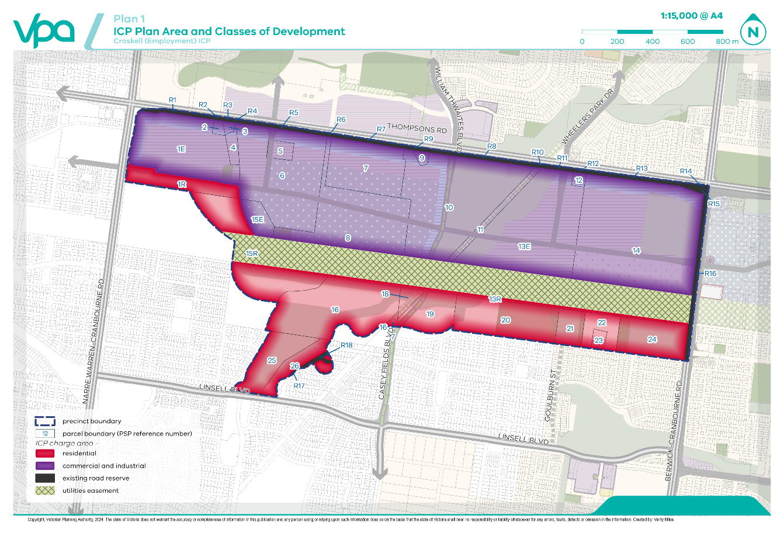

Monetary component project identification
The strategic need for infrastructure included in this ICP has been determined, and been subject to consultation, as part of the preparation of the Croskell (Employment) PSP.
Items can only be included in an ICP if they are consistent with the Allowable Items listed in the Ministerial Direction on the Preparation and Content of Infrastructure Contributions Plans (February 2021). Only items listed in this ICP can be contributed to by the monetary component (standard levy) of the infrastructure contribution imposed under this ICP. Infrastructure not listed must be funded via other funding mechanisms.
The monetary component will contribute towards two types of infrastructure projects (refer to Plan 2, Plan 3 and Plan 4 and Table 5, Table 6 and Table 7):
- Transport construction
- Community and recreation construction
Table 5, Table 6 and Table 7 also include staging for when the projects are expected to be delivered. The infrastructure projects have been identified as short (S), medium (M) and long (L) term stages:
Short (S): 0–5 years approx.
Medium (M): 5–10 years approx.
Long (L): 10 years and beyond

Cost apportionment and related infrastructure agreements
Some projects within this ICP will require some apportionment external to the ICP area. Projects that have external apportionment as well as the source of the balance of funding external to this ICP are identified in Table 5, Table 6 and Table 7.

Plan 2: Standard and Supplementary Levy Transport Construction Projects
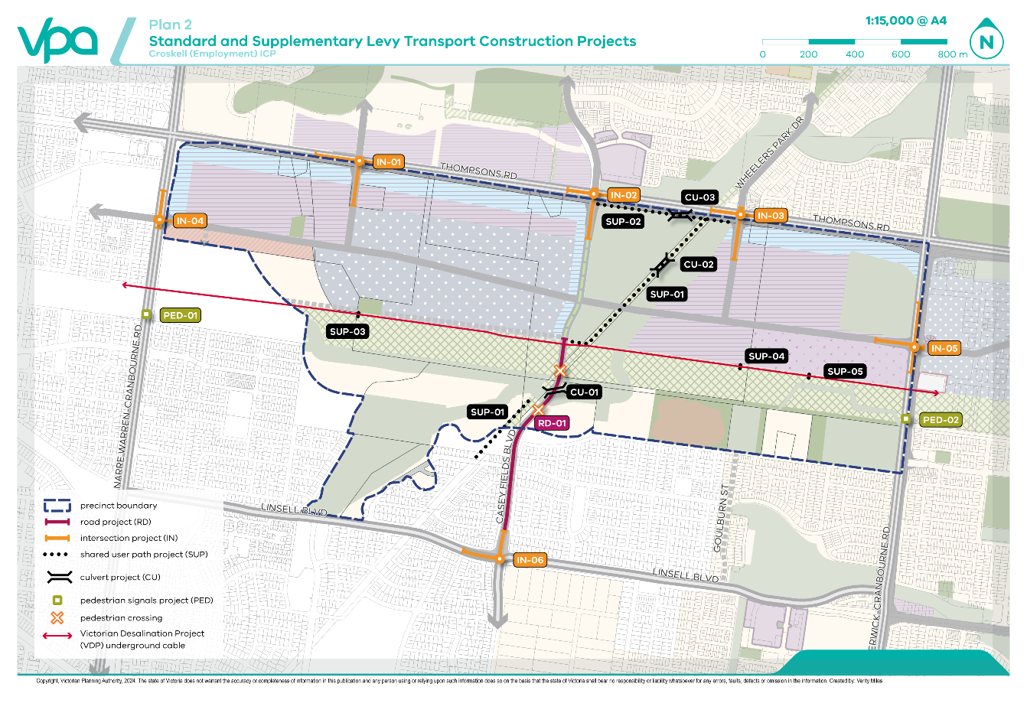

Transport construction projects
The transport construction projects included in this ICP are based on the transport network depicted in Plan 2, as identified by the Croskell (Employment) PSP.
The transport construction projects contributed to by the monetary component of this ICP are listed in the following tables.
Table 5 describes the transport construction projects contributed to by the standard levy, the expected staging, the apportionment to this ICP, any external funding source(s) for items not fully apportioned to this ICP, the total estimated cost and the estimated cost per net developable hectare.
Table 5: Standard levy transport construction projects
 | Project ID | Project Title & Description | Staging | Apportion-ment To This ICP | Apportionment Funding Source | Total ESTIMATED Cost | Cost apportioned to ICP | Cost per Ha
 | Road projects
CK-RD-01 |  | Casey Fields Boulevard  Construction of a connector boulevard with one traffic lane in each direction within a 31m road reserve from northern leg of IN06 to southern boundary of central utilities easement.  Construction of a connector boulevard with one traffic lane in each direction within a 23.75m road from southern boundary of central utilities easement to northern boundary of central utilities easement. | S | 18.7% | Remaining balance covered by Croskell (Employment) supplementary levy | $9,358,541 | $1,754,156 | $9,922
Shared user path projects
 | CK-SUP-01 | Shared user path: Melbourne Water pipe track  Construction of a shared user path | S | 100% | Croskell (Employment) ICP | $3,069,827 | $3,069,827 | $17,364
 | CK-SUP-02 | Shared user path: Thompsons Road  Construction of a shared user path | S | 100% | Croskell (Employment) ICP | $559,627 | $559,627 | $3,165
 | CK-SUP-03 | Shared user path: Victorian Desalination Project assets western crossing  Construction of a shared user path crossing over the VDP assets | S | 100% | Croskell (Employment) ICP | $343,383 | $343,383 | $1,942
 | CK-SUP-04 | Shared user path: Victorian Desalination Project assets eastern central crossing  Construction of a shared user path crossing over the VDP assets | S | 100% | Croskell (Employment) ICP | $343,383 | $343,383 | $1,942
 | CK-SUP-05 | Shared user path: Victorian Desalination Project assets eastern crossing  Construction of a shared user path crossing over the VDP assets | S | 100% | Croskell (Employment) ICP | $343,383 | $343,383 | $1,942
Pedestrian signal projects
 | CK-PED-01 | Pedestrian Signals: Narre Waren Cranbourne Road  Construction of a signalised pedestrian crossing | S | 100% | Croskell (Employment) ICP | $392,048 | $392,048 | $2,218
 | CK-PED-02 | Pedestrian Signals: Berwick Cranbourne Road  Construction of a signalised pedestrian crossing | S | 100% | Croskell (Employment) ICP | $394,999 | $394,999 | $2,234
 | Intersection Projects
 | CK-IN-01 | Thompsons Road and Industrial Connector Road (southern leg)  Construction of the southern leg of a primary arterial to industrial connector road signalised four-way intersection | S | 100% | Croskell (Employment) ICP | $2,774,591 | $2,774,591 | $15,694
 | CK-IN-02 | Thompsons Road and Casey Fields Boulevard (southern leg)  Construction of the southern leg of a primary arterial to connector boulevard signalised four-way intersection | S | 100% | Croskell (Employment) ICP | $2,986,223 | $2,986,223 | $16.891
 | CK-IN-03 | Thompsons Road and Wheelers Park Drive (southern leg)  Construction of the southern leg of a primary arterial to industrial connector road signalised four-way intersection | S | 100% | Croskell (Employment) ICP | $2,516,982 | $2,516,982 | $14,237
 | CK-IN-04 | Narre Warren Cranbourne Road and Industrial Connector Road (eastern leg)  Construction of the eastern leg of a primary arterial to industrial connector road signalised four-way intersection | S | 100% | Croskell (Employment) ICP | $2,700,643 | $2,700,643 | $15,275
 | CK-IN-05 | Berwick Cranbourne Road and Industrial Connector Road (western leg)  Construction of the western leg of a primary arterial to industrial connector road signalised four-way intersection | S | 100% | Croskell (Employment) ICP | $2,573,597 | $2,573,597 | $14,557
 | CK-IN-06 | Linsell Boulevard and Casey Fields Boulevard (northern leg)  Construction of the northern leg of a secondary arterial to connector boulevard signalised four-way intersection | S | 100% | Croskell (Employment) ICP | $1,846,909 | $1,846,909 | $10,447
 | Culvert & Bridge Projects
 | CK-CU-01 | Culvert: Casey Fields Boulevard  Construction of box culverts across ultimate road reserve width | S | 100% | Croskell (Employment) ICP | $2,614,083 | $2,614,083 | $14,786
 | CK-CU-02 | Culvert: shared user path  Construction of box culverts along shared user path over constructed waterway | S | 100% | Croskell (Employment) ICP | $849,296 | $849,296 | $4,804
 | CK-CU-03 | Culvert: shared user path  Construction of culvert on shared user path over constructed waterway | S | 100% | Croskell (Employment) ICP | $849,296 | $849,296 | $4,804
 | Total standard transport levies |  |  |  |  | $34,516,810 | $26,912,425 | $152,223
Note: Minor discrepancies in numbers due to rounding

Table 6 Supplementary levy transport construction projects
Project ID | Project Title & Description | Staging | Apportion-ment To This ICP | Apportion-ment Funding Source | Total ESTIMATED Cost | Cost apportioned to ICP | Cost per Ha
Road projects
CK-RD-01 | Casey Fields Boulevard  Construction of a connector boulevard with one traffic lane in each direction within a 31m road reserve from northern leg of IN06 to southern boundary of central utilities easement.  Construction of a connector boulevard with one traffic lane in each direction within a 23.75m road from southern boundary of central utilities easement to northern boundary of central utilities easement. | S | 81.3% | Remaining balance covered by Croskell (Employment) standard levy | $9,358,541 | $7,604,386 | $43,012
Total supplementary transport levies |  |  |  |  | $9,358,541 | $7,604,386 | $43,012
Note: Minor discrepancies in numbers due to rounding.

Plan 3: Standard Levy Community & Recreation Construction Projects
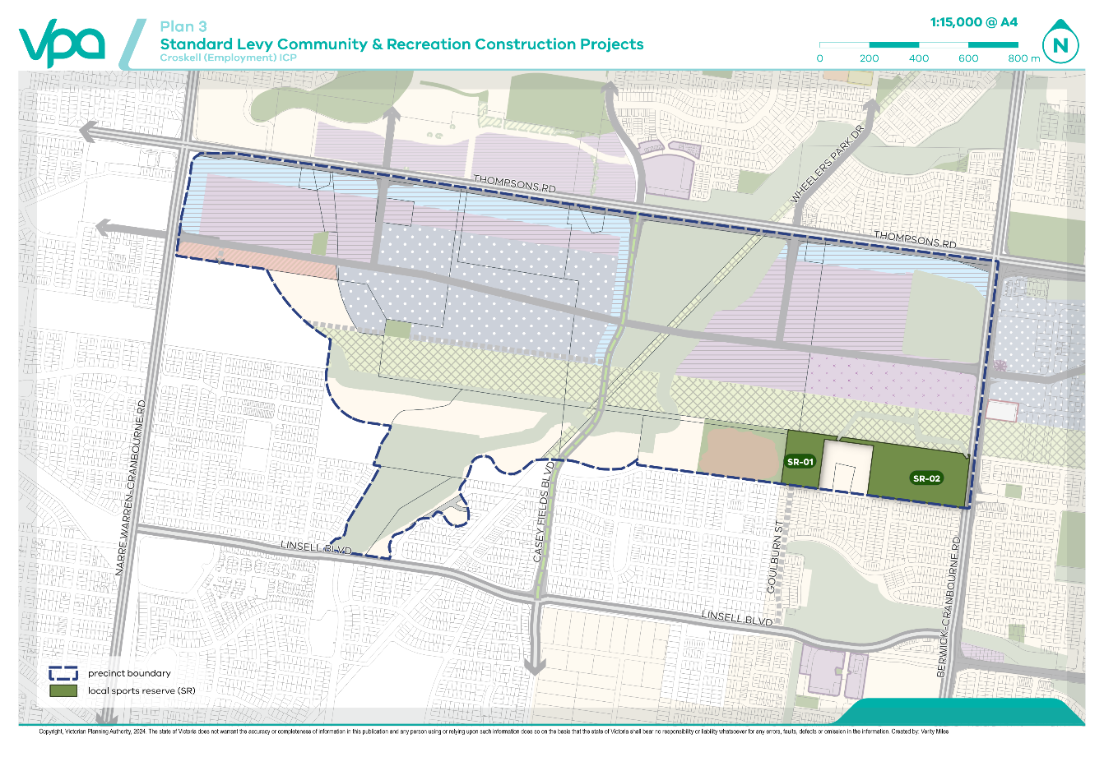

Community and recreation construction projects
The community and recreation construction projects included in this ICP are consistent with the range of facilities identified in the Croskell (Employment) PSP.
The community and recreation construction projects identified in this ICP are listed in the following table. As there are no allowable supplementary levy items for community and recreation construction, all listed projects will be contributed to from the standard levy. The expected staging, the apportionment to this ICP, any external funding source(s) for items not fully apportioned to this ICP, the total estimated cost and the estimated cost per hectare are shown in the following table.
Under Ministerial Direction on the Preparation and Content of Infrastructure Contributions Plans (February 2021), the amount of the total standard levy rate for residential development that may be used for community and recreation construction must not exceed $109,088 per net developable hectare in the 2024/2025 financial year or the indexed amount in subsequent financial years.
Table 7: Standard levy community & recreation construction projects
Project ID | Project Title & Description | Staging | Apportion-ment To This ICP | Apportion-ment Funding Source | Total Cost | Cost apportioned to ICP | Cost Per Ha
Open Space Projects

CK-SR-01 | Construction of lawn bowls | M | 16.5% | Balance to be covered by City of Casey | $10,100,667 | $1,666,610 | $47,428
CK-SR-02 | Construction of 2 football/cricket ovals, pavilion, cricket nets and 2 netball courts and a multi-purpose pavilion | M | 16.6% | Balance to be covered by City of Casey | $13,039,821 | $2,166,742 | $61,660
Total standard community & recreation levies |  |  |  |  | $23,140,487 | $3,833,352 | $109,088
Total capped community and recreation levy |  |  |  |  |  |  | $109,088

Project staging
The expected staging of each infrastructure construction item is set out in Table 5, Table 6 and Table 7 and is based on information available at the time that the ICP was prepared. The collecting and development agencies will monitor and assess the required timing for infrastructure projects and have regard to strategic resource plans, the development of the PSP and areas external to the ICP.
The collecting and development agencies may consider alternative staging where:
- Infrastructure is to be constructed/provided by development proponents as works in kind, as agreed by the collecting agency
- Transport network priorities require the delivery of works or provision of public purpose land to facilitate broader road network connections, and
- Community needs determine a change to the delivery of works or provision of public purpose land for community facilities or open space.
All items in this ICP will be provided as soon as is practicable and as soon as sufficient contributions are available, consistent with this ICP and acknowledging the development agency’s capacity to provide the balance of funds not collected by this ICP.
Plan 4: Public Land Provision
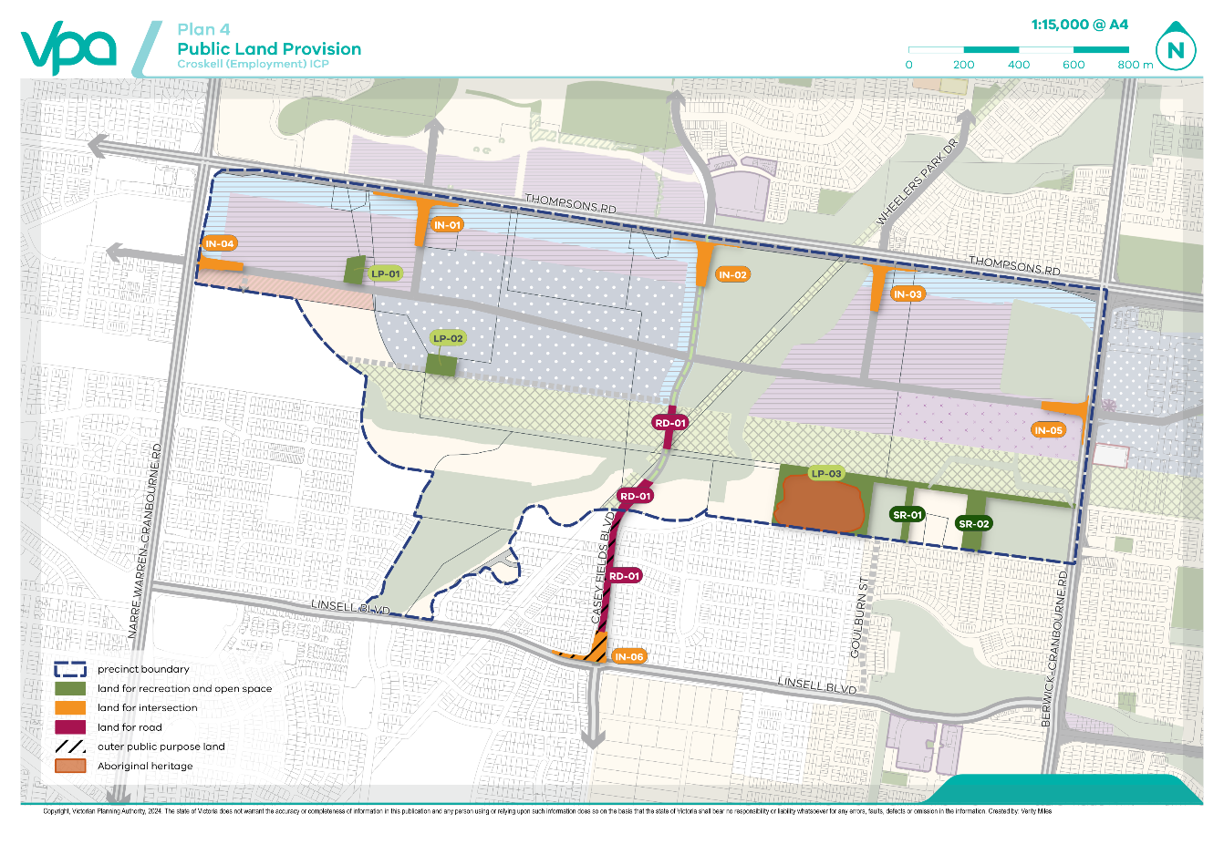

Public purpose land provision
The public purpose land included in this ICP has been determined, and been subject to consultation, as part of the preparation of the Croskell (Employment) PSP.
Public purpose land specified in an ICP may only be used or developed for an allowable public purpose specified in Annexure 1 to the Ministerial Direction on the Preparation and Content of Infrastructure Contributions Plans (February 2021). Public purpose land may be:
Inner public purpose land (IPPL): Land within the ICP plan area that is specified in the ICP as land to be set aside for public purposes; or
Outer public purpose land (OPPL): Land outside of the ICP plan area that is specified in the ICP as land to be acquired for public purposes.
Only items listed in this ICP can be provided for by the land component of this ICP. Public purpose land not listed must be funded via other funding mechanisms.

Inner and outer public purpose land
Plan 5 shows the location of public purpose land (both inner and outer) as well as the type of allowable public purposes for which it may be used and developed.
Table 8 specifies for each public purpose land (inner and outer) the type of allowable public purposes for which it may be used and developed, the area and the expected staging. The staging for public purpose land is the same as the monetary component specified in Section 3.
The IPPL forming part of each parcel of land is specified in Table 9.
Table 8: Inner and outer public purpose land
ICP Project ID |  | PROJECT TITLE & DESCRIPTION | PUBLIC PURPOSE LAND Area (Ha) | Staging
Transport (Inner) Public Purpose Land
CK-RD-01 |  | Casey Fields Boulevard  Provision of land to create a 31m road reserve from PSP boundary to southern boundary of central utilities easement.  Provision of land to create a 23.75m road reserve from southern boundary of central utilities easement to northern boundary of central utilities easement. | 0.82 | N/A
CK-IN-01 |  | Thompsons Road and Industrial Connector Street (southern leg)  Provision of land for the southern leg of a primary arterial to industrial connector road signalised four-way intersection | 0.87 | N/A
CK-IN-02 |  | Thompsons Road and Casey Fields Boulevard (southern leg)  Provision of land for the southern leg of a primary arterial to connector boulevard signalised four-way intersection | 0.73 | N/A
CK-IN-03 |  | Thompsons Road and Wheelers Park Drive (southern leg)  Provision of land for the southern leg of a primary arterial to industrial connector road signalised four-way intersection | 0.67 | N/A
CK-IN-04 |  | Narre Warren Cranbourne Road and Industrial Connector (eastern leg)  Provision of land for the eastern leg of a primary arterial to industrial connector road signalised four-way intersection | 0.58 | N/A
CK-IN-05 |  | Berwick Cranbourne Road and Industrial Connector (western leg)  Provision of land for the western leg of a primary arterial to industrial connector road signalised four-way intersection | 0.64 | N/A
Sub-Total |  |  | 4.31
Community & recreation (Inner) Public Purpose Land
CK-SR-01 |  | Sports reserve  Provision of land | 0.74 | N/A
CK-SR-02 |  | Sports reserve  Provision of land | 2.22 | N/A
CK-LP-01 |  | Local park  Provision of land | 0.60 | N/A
CK-LP-02 |  | Local park  Provision of land | 0.71 | N/A
CK-LP-03 |  | Local park  Provision of land | 2.19 | N/A
Sub-Total |  |  | 6.46
Transport (Outer) Public Purpose Land
CK-OPPL-RD-01 | Casey Fields Boulevard  Provision of land to create a road reserve for 22m of the total 31m road reserve from the northern boundary of IN-06 to the PSP boundary. |  | 0.99 |  | N/A
CK-OPPL-IN-06 | Linsell Boulevard and Casey Fields Boulevard (northern leg)  Provision of land for the northern leg of a secondary arterial to connector boulevard signalised four-way intersection |  | 0.69 |  | N/A
Sub-Total |  |  | 1.68
Total Inner and Outer Public Purpose Land |  |  | 12.45

Public open space contributions
The overall open space contribution for this ICP is identified in Table 16 Summary land use budget and Table 17 Parcel specific land use budget. This ICP provides for the provision of public purpose land for local sports reserves and local parks. The community and recreation levy of the monetary component contributes towards the construction of local sports reserves. The construction of local parks is considered developer works and separate from this ICP.

Land component
The following table summarises for each class of development specified in this ICP:
- The total area of contribution land
- The total area of transport inner public purpose land
- The total area of community and recreation inner public purpose land
- The total area of inner public purpose land
- The total area of outer public purpose land
- The ICP land contribution percentage
Table 9: Public purposes land summary
Class of Development | Total Contribution Land (HA) | class of development proportion of precinct | Transport inner Public Purpose Land (HA) | Residential Community & Recreation inner Public PurposeLand (HA) | Commercial & Industrial Community & Recreation inner Public Purpose Land (ha) | Total Inner Public Purpose Land (HA) | Total Outer Public Purpose Land (HA) | Total Public Purpose land (HA) | Total ICP Land Contribution Percentage
Residential (Ha) | 39.86 |  | 0.66 | 4.06 |  | 4.72 | 1.68 | 6.40 | 16.06%
Commercial & Industrial (Ha) | 147.7 |  | 3.65 |  | 2.40 | 6.05 | - | 6.05 | 4.10%
Total | 187.56 |  | 4.31 | 4.06 | 2.40 | 10.77 | 1.68 | 12.45
The ICP land contribution percentage for a class of development is calculated by dividing the total area of public purpose land specified in this ICP that is attributable to that class of development, by the total area of the contribution land in the ICP plan area in that class of development.
Where the need for a type of public purpose land is attributable to more than one class of development (for example, transport public purpose land), each development class’ share of the public purpose land is equal to its proportion of the total contribution land.
As public purpose land cannot be evenly distributed across all parcels, 10.77ha of inner public purpose land and 1.68ha of outer public purpose land identified in Table 9, will be equalised by parcels that are required to provide less than the ICP land contribution percentage identified in Table 9.
Table 10 summarises for each class of development specified in this ICP:
- total amount of IPPL (in hectares) that is provided over the ICP land contribution percentage
- the total value of the credits for the IPPL over the ICP land contribution percentage
- the total estimated value for any OPPL
- the total land equalisation to be paid (IPPL credits plus OPPL estimated value)
- the total amount of IPPL that is equal to or less than the ICP land contribution percentage (this is IPPL (Ha) to be directly provided by each parcel and this land is not entitled to a credit), and
- the land equalisation rate (total land equalisation value divided by the total IPPL under the ICP land contribution percentage).
The land equalisation rate ($ per Ha) is used to determine the land equalisation amount specified in Table 10. The land equalisation amount is required to be paid by parcels which have a land contribution percentage that is less than the ICP land contribution percentage.
Table 10: ICP land equalisation rate
Class of Development | Total IPPL (Ha) Equal to or less than ICP Land Contribution Percentage | Total IPPL (Ha) Over ICP Land Contribution Percentage | Total ippl land credit amount (for ‘over’ land) | Total outer land estimated value | Total land equalisation to be paid | Land Equalisation Rate ($ per Ha)
Residential (Ha) | 4.48 | 2.80 | - | - | - | -
Commercial and Industrial (Ha) | 1.28 | 1.28 | - | - | - | -
Total | 5.76 | 4.08 | - | - | - | -
Table 11 specifies for each parcel of land in the ICP plan area: the total contribution area of the parcel:
- The total ICP land contribution percentage
- The type of public purpose for which that IPPL may be used and developed
- The IPPL parcel contribution percentage
- The number of hectares that the parcel contribution percentage is above (land credit) or below (land equalisation) the ICP land contribution percentage
- A land credit amount (hectares and total ($))
- The land equalisation amount expressed as a rate per net developable hectares in the parcel.

Table 11: Public purpose land credit & equalisation amounts
PSP PARCEL ID | Total Contribution Area (Hectares) | Land Use | ICP Land Contribution Percentage (Hectares) | Public Purpose Land |  |  |  | Parcel Contribution Percentage (%) | Land Credit Amount |  | Land Equalisation Amount
 |  |  |  | Transport (Hectares) | Residential Community & Recreation (Hectares) | Commercial & Industrial Community & Recreation (Hectares) | Parcel Contribution Total (Hectares) | Parcel Contribution Percentage (%) | Hectares | Total $ | Hectares | Total $ | $ per NDHA
Inner public purpose land
CK-01E | 19.12 | Employment | 0.78 | 0.36 | - | 0.59 | 0.95 | 4.97% | 0.17 | - | - | - | -
CK-01R | 4.96 | Residential | 0.80 | 0.22 | - | - | 0.22 | 4.44% | - | - | 0.58 | - | -
CK-02 | 0.50 | Employment | 0.02 | - | - | - | - | - | - | - | 0.02 | - | -
CK-03 | 0.40 | Employment | 0.02 | - | - | - | - | - | - | - | 0.02 | - | -
CK-04 | 1.16 | Employment | 0.05 | - | - | 0.01 | 0.01 | 0.86% | - | - | 0.04 | - | -
CK-05 | 1.44 | Employment | 0.06 | 0.25 | - | - | 0.25 | 17.36% | 0.19 | - | - | - | -
CK-06 | 22.59 | Employment | 0.93 | 0.63 | - | - | 0.63 | 2.79% | - | - | 0.30 | - | -
CK-07 | 12.18 | Employment | 0.50 | - | - | - | - | - | - | - | 0.50 | - | -
CK-08 | 19.49 | Employment | 0.80 | - | - | 0.71 | 0.71 | 3.64% |  | - | 0.09 | - | -
CK-09 | 0.54 | Employment | 0.02 | - | - | - | - | - | - | - | 0.02 | - | -
CK-10 | 14.15 | Employment | 0.58 | 1.00 | - | - | 1.00 | 7.07% | 0.42 | - | - | - | -
CK-11 | 0.10 | Employment | 0.00 | 0.10 | - | - | 0.10 | 100.00% | 0.10 | - | - | - | -
CK-12 | 0.58 | Employment | 0.02 | 0.03 | - | - | 0.03 | 5.17% | 0.01 | - |  | - | -
CK-13E | 20.11 | Employment | 0.82 | 0.64 | - | - | 0.64 | 3.18% | - | - | 0.18 | - | -
CK-13R | 0.92 | Residential | 0.15 | - | 0.73 | - | 0.73 | 79.35% | 0.58 | - | - | - | -
CK-14 | 32.64 | Employment | 1.34 | 0.64 | - | 1.09 | 1.73 | 5.30% | 0.39 | - |  | - | -
CK-15E | 2.70 | Employment | 0.11 | - | - | - | - | - | - | - | 0.11 | - | -
CK-15R | 9.31 | Residential | 1.50 | - | - | - | - | - | - | - | 1.50 | - | -
CK-16 | 7.97 | Residential | 1.28 | - | - | - | - | - | - | - | 1.28 | - | -
CK-17 | 0.01 | Residential | 0.00 | - | - | - | - | - | - | - | - | - | -
CK-18 | 0.08 | Residential | 0.01 | - | - | - | - | - | - | - | 0.01 | - | -
CK-19 | 3.95 | Residential | 0.63 | 0.44 | - | - | 0.44 | 11.14% |  | - | 0.19 | - | -
CK-20 | 5.08 | Residential | 0.82 | - | 1.54 | - | 1.54 | 30.31% | 0.72 | - | - | - | -
CK-21 | 0.47 | Residential | 0.08 | - | 0.47 | - | 0.47 | 100.00% | 0.39 | - |  | - | -
CK-22 | 3.23 | Residential | 0.52 | - | - | - | - | - | - | - | 0.52 | - | -
CK-23 | 0.81 | Residential | 0.13 | - | - | - | - | - | - | - | 0.13 | - | -
CK-24 | 1.32 | Residential | 0.21 | - | 1.32 | - | 1.32 | 100.00% | 1.11 | - | - | - | -
CK-25 | 0.03 | Residential | 0.00 | - | - | - | - |  | - | - | - | - | -
CK-26 | 1.70 | Residential | 0.27 | - | - | - | - | - | - | - | 0.27 | - | -
CK-R01 | - | Residential | - | - | - | - | - | - | - | - | - | - | -
CK-R02 | - | Residential | - | - | - | - | - | - | - | - | - | - | -
CK-R03 | - | Residential | - | - | - | - | - | - | - | - | - | - | -
CK-R04 | - | Residential | - | - | - | - | - | - | - | - | - | - | -
CK-R05 | - | Residential | - | - | - | - | - | - | - | - | - | - | -
CK-R06 | - | Residential | - | - | - | - | - | - | - | - | - | - | -
CK-R07 | - | Residential | - | - | - | - | - | - | - | - | - | - | -
CK-R08 | - | Residential | - | - | - | - | - | - | - | - | - | - | -
CK-R09 | - | Residential | - | - | - | - | - | - | - | - | - | - | -
CK-R10 | - | Residential | - | - | - | - | - | - | - | - | - | - | -
CK-R11 | - | Residential | - | - | - | - | - | - | - | - | - | - | -
CK-R12 | - | Residential | - | - | - | - | - | - | - | - | - | - | -
CK-R13 | - | Residential | - | - | - | - | - | - | - | - | - | - | -
CK-R14 | - | Residential | - | - | - | - | - | - | - | - | - | - | -
CK-R15 | - | Residential | - | - | - | - | - | - | - | - | - | - | -
CK-R16 | - | Residential | - | - | - | - | - | - | - | - | - | - | -
CK-R17 | - | Residential | - | - | - | - | - | - | - | - | - | - | -
CK-R18 | - | Residential | - | - | - | - | - | - | - | - | - | - | -
SUB TOTAL | 187.56 |  |  | 4.31 | 4.06 | 2.40 | 10.77 |  | 4.08 |  | 5.76 | - | -
Residential Sub Total | 39.86 |  | - | 0.66 | 4.06 |  | 4.72 |  | 2.80 |  | 4.48
Commercial & Industrial Sub Total | 147.70 |  | - | 3.65 |  | 2.40 | 6.05 |  | 1.28 |  | 1.28
Outer Public Purpose Land
PROJECT ID | TOTAL CONTRIBUTION AREA (HECTARES) | LAND USE | ICP LAND CONTRIBUTION PERCENTAGE (HECTARES) | PUBLIC PURPOSE LAND |  |  |  | PARCEL CONTRIBUTION PERCENTAGE (HECTARES) | LAND CREDIT AMOUNT |  | LAND EQUALISATION AMOUNT
 |  |  |  | TRANSPORT (HECTARES) | RESIDENTIAL COMMUNITY & RECREATION (HECTARES) | COMMERCIAL & INDUSTRIAL COMMUNITY & RECREATION (HECTARES) | PARCEL CONTRIBUTION – TOTAL (HECTARES) |  | HECTARES | TOTAL $ | HECTARES | TOTAL $ | $ PER NDHA
CK-OPPL-RD-01 | - | Residential | - | 0.99 | - | - | 0.99
CK-OPPL-IN-06 | - | Residential | - | 0.69 | - | - | 0.69
SUB TOTAL |  |  |  | 1.68
TOTAL CROSKELL (EMPLOYMENT) | 187.56 |  |  | 5.99 | 4.06 | 2.40 | 12.45
Residential Total | 39.86 |  |  | 2.34 | 4.06 |  | 6.40 | 16.06%
Commercial & Industrial Total | 147.70 |  |  | 3.65 |  | 2.40 | 6.05 | 4.10%
Equalisation Rate

Contributions & administration

Collecting agency
Casey Council is the collecting agency for the purposes of Part 3AB of the Act and this ICP. The monetary component and any land equalisation amount of an infrastructure contribution imposed under this ICP must be paid to the collecting agency. As the collecting agency, Casey Council is responsible for the administration and enforcement of this ICP, including the payment of land credit amounts, in accordance with Part 3AB of the Act.

Development agency
Casey Council is the development agency for the purposes of Part 3AB of the Act and this ICP. The development agency is responsible for provision of the infrastructure projects and acquisition of outer public purpose land identified in this ICP. As the development agency, Casey Council is also responsible for the proper administration of this ICP in accordance with Part 3AB of the Act.

Net developable area
The monetary component of Metropolitan Greenfield Growth Area ICPs are payable on the net developable area (NDA) of land on any given development site (NDA is defined in Appendix 1 Definitions).
To align with the classes of development specified in this ICP, the NDA is divided into:
- Net developable area residential (NDA-R) – the NDA for the residential class of development
- Net developable area employment (NDA-E) – the NDA for the commercial and industrial class of development.
The NDA for this ICP has been calculated in Table 16 Summary Land Use Budget and Table 17. Table 16 is the summary land use budget which summarises the land requirements and net developable area for the ICP plan area as a whole. Table 17 is the parcel specific land use budget which specifies the net developable area and land requirements for each parcel of land in the ICP plan area.
For the purposes of this ICP, the number of net developable hectares will only change if the collecting agency agrees to a variation to the parcel specific land budget and associated tables in the PSP and ICP.

Contribution land
The land component of the infrastructure contribution is calculated based on the contribution land.
The contribution land specified in this ICP is the land in the ICP plan area in respect of which an infrastructure contribution is to be imposed under this plan if any of that land is developed. It excludes encumbered land, land already used or developed for a public purpose and land that is exempt from paying an infrastructure contribution under the Ministerial Direction on the Preparation and Content of Infrastructure Contributions Plans (February 2021). It includes the net developable area and inner public purpose land.
The contribution land in the ICP plan area is specified in Table 4 and Table 17.

Levy rates and classes of development
Annexure 1 to the Ministerial Direction on the Preparation and Content of Infrastructure Contributions Plans (February 2021) specifies standard levy rates for two classes development for Metropolitan Greenfield Growth Areas – ‘residential development’ and ‘commercial and industrial development’.
Table 12 specifies the standard levy rate for each class of development.
Table 12: Classes of development & standard levy rates
CLASS OF DEVELOPMENT | Community & Recreation construction | TRANSPORT CONSTRUCTION | Total standard levy rate
Residential | $109,088.00 | $147,562 | $256,650
Commercial and Industrial | - | $147,562 | $147,562
Table 3: Classes of development & supplementary levy rates
Class of Development | Community and Recreation Construction | Transport Construction | Total Supplementary Levy Rate
Residential |  | $43,012 | $43,012
Commercial and Industrial |  | $43,012 | $43,012
Table14: Classes of development & total monetary levy rates
Class of Development | Community and Recreation Construction | Transport Construction | Total Levy Rate
Residential | $109,088.00 | $190,574 | $299,662
Commercial and Industrial | - | $190,574 | $190,574

Estimated value of public purpose land
A land credit amount specified in this ICP is based on the estimated value of the inner public purpose land in that parcel of land determined in accordance with Part 3AB of the Act and the Ministerial Direction on the Preparation and Content of Infrastructure Contributions Plans (February 2021) and the Infrastructure Contributions Plan Guidelines (ICP Guidelines).
The component of a land equalisation amount specified in this ICP that relates to any outer public purpose land is based on the estimated value of the outer public purpose land determined in accordance with the method specified in the Ministerial Direction.
The component of a land equalisation amount specified in this ICP that relates to any inner public purpose land is based on the estimated value of land credit amounts for inner public purpose land.
The estimated value of inner public purpose land in a parcel of land is required to be calculated when the parcel contribution percentage of that land is more than the ICP land contribution percentage for the class of development.
The parcels of land with a land contribution percentage that is more than the ICP public land contribution percentage are identified in Table 10.

Payment of contributions

Timing of payment of monetary component & land equalisation amounts

Subdivision of land
If the development of the land involves a plan under the Subdivision Act 1988, the monetary component (standard levy) and any land equalisation amount of an infrastructure contribution must be paid to the collecting agency for the land after certification of the relevant plan of subdivision but cannot be required more than 21 days prior to the issue of a Statement of Compliance with respect to that plan.
If the subdivision is to be developed in stages, only the monetary component and any land equalisation amount for the stage to be developed is required paid to the collecting agency within 21 days prior to the issue of a Statement of Compliance for that stage, provided that a Schedule of Infrastructure Contributions is submitted with each stage of the plan of subdivision. The schedule must show the amount of the infrastructure contributions payable for each stage and the value of the contributions for prior stages to the satisfaction of the collecting agency.
If the collecting agency agrees to works in lieu of payment of the monetary component, the landowner must enter into an agreement under Section 173 of the Planning and Environment Act 1987 in respect of the proposed works in lieu.

Development of land where no subdivision is proposed
Provided an infrastructure contribution has not yet been collected for development of the subject land, the monetary component and any land equalisation amount of an infrastructure contribution must be paid to the collecting agency before the issue of a building permit for each net developable hectare proposed to be developed prior to the commencement of any development (development includes buildings, car park, access ways, landscaping and ancillary components). If the collecting agency agrees to works in lieu of payment of the monetary component, the landowner must enter into an agreement, or other suitable arrangement, under Section 173 of the Act in respect of the proposed works or provision of land in lieu.

Where no building permit is required
Where no building permit is required, the monetary component and any land equalisation amount of an infrastructure contribution must be paid to the collecting agency prior to the commencement of any development in accordance with a permit issued under the Act, unless otherwise agreed by the collecting agency in a Section 173 agreement.
If the collecting agency agrees to works in lieu of payment of the monetary component, the landowner must enter into an agreement under Section 173 of the Act in respect of the proposed works or provision of land in lieu.

Inner public purpose land
If any land component of an infrastructure contribution includes inner public purpose land, that inner public purpose land must be provided in accordance with section 46GV of the Act.

Payment of land credit amounts
A person is entitled to be paid the land credit amount specified in this ICP in relation to a parcel of land if:
- On development of that parcel the person must, in accordance with section 46GV(4) of the Act, provide inner public purpose land forming part of that parcel to the collecting agency or a development agency; and
- The parcel contribution percentage of the parcel of land to be developed is more than the ICP land contribution percentage for that class of development.
The land credit amount is to be paid by the collecting agency to the landowner at a time to be agreed, but not before lodgement of a subdivision plan. This may be formalised in a section 173 agreement if the collecting agency and landowner agree.

Development exempt from contributions
Some classes of development are exempt from infrastructure contributions. Where land is subdivided or developed for an exempt purpose, as listed below, and the land is subsequently used for a purpose other than as one of those exempt uses, the owner of that land must pay to the collecting agency infrastructure contributions in accordance with the provisions of this ICP. The levy must be paid within 28 days of the date of the commencement of the construction of any buildings or works for that alternative use.

Schools
The development of land for government and non-government schools are exempt from the requirement to pay an infrastructure contribution levy in accordance with the Ministerial Direction on the Preparation and Content of Infrastructure Contributions Plans (February 2021).

Housing
Any housing to be provided by or on behalf of the Department of Health & Human Services (DHHS) is exempt from the requirement to pay an infrastructure contributions levy in accordance with the Ministerial Direction on the Preparation and Content of Infrastructure Contributions Plans (February 2021).

Works in kind
Under section 46GX of the Act, the collecting agency may accept the provision of works, services or facilities by an applicant in part or full satisfaction of the monetary component of an infrastructure contribution payable by the applicant to the collecting agency (‘works in kind’).
Before accepting the provision of works in kind, the collecting agency must obtain the agreement of the development agency or agencies specified in this ICP.
The collecting agency should only accept the provision of works in kind if:
- The works in kind constitute part or all of the delivery of an infrastructure project(s) identified in this ICP, to the satisfaction of the collecting agency and development agency.
- The collecting agency and development agency have agreed that the timing of the works in kind is consistent with priorities in this ICP (alternatively a credit for works may be delayed to align with clearly identified and published development priorities).
- The works in kind are defined and agreed in a section 173 agreement.
- The detailed design of the works in kind is to the satisfaction of the development agency and any others identified in permit conditions.
If the collecting and development agencies accept the provision of works in kind:
- The value of the works in kind will be negotiated between the collecting agency and the applicant
- The monetary component the infrastructure contribution payable by the applicant will be offset by the agreed value of the works in kind.
The land component and any land equalisation amounts or land credit amounts cannot be accepted as works in kind.

Interim and temporary works
Interim and temporary works are not considered as eligible for works in kind credits against this ICP, unless agreed to by the collecting and development agencies.

Works in kind reimbursement
If the collecting agency agrees to accept works under section 46GX of the Act and the value of those works is greater than the monetary component of the infrastructure contribution payable by the applicant, the applicant is entitled to be reimbursed the difference between the two amounts.
The details of a reimbursement must be negotiated with and agreed to by the collecting agency and development agency.

Funds administration
The contributions made under this ICP will be held by the collecting agency until required for the provision of infrastructure projects. Details of contributions received and expenditures will be held by the collecting agency in accordance with the provisions of the Local Government Act 1989, the Act and the Ministerial Reporting Requirements for Infrastructure Contributions Plans (February 2021).
In accordance with the Planning and Environment Act, the collecting agency to which the monetary component of contributions are paid must forward to the VPA (as planning authority) any part of the monetary component of contributions that is imposed for plan preparation costs. Subject to the agreement between the collecting agency and the planning authority, reimbursement of plan preparation costs should occur as soon as practicable within the first five years of development.

Annual indexation of standard levy rates
The standard levy rates specified in this ICP will be indexed in accordance with the indexation method specified in Annexure 1 of the Ministerial Direction on the Preparation and Content of Infrastructure Contributions Plans (February 2021) on 1 July each year.
The indices used in the indexation method are set out in Table 13.
Table 15: Indices
CLASS OF INFRASTRUCTURE | INdex
Community and recreation construction | Australian Bureau of Statistics Producer Price Index for Non-Residential Building Construction – Victoria (Catalogue 6427.0, Table 17, Output of the Construction Industries, subdivision and class index numbers)
Transport construction (inclusive of plan preparation costs) | Australian Bureau of Statistics Producer Price Index for Road and Bridge Construction – Victoria (Catalogue 6427.0, Table 17, Output of the Construction Industries, subdivision and class index numbers)

Adjustment of land credit amounts
The land credit amounts specified in this ICP will be adjusted in accordance with the method of adjustment specified in Annexure 1 of the Ministerial Direction on the Preparation and Content of Infrastructure Contributions Plans (February 2021) on 1 July each year.

Adjustment of land equalisation amounts
The land equalisation amounts specified in this ICP will be adjusted in accordance with the method of adjustment specified in Annexure 1 of the Ministerial Direction on the Preparation and Content of Infrastructure Contributions Plans (February 2021) on 1 July each year.

Appendix 1 Definitions
collecting agency | The Minister, public authority or municipal council specified in an infrastructure contributions plan as the entity that an infrastructure levy is payable to in accordance with Part 3AB of the Planning and Environment Act 1987.
contribution land | The land in the ICP plan area of an infrastructure contribution plan in respect of which an infrastructure contribution is to be imposed under the plan if any of that land is developed.  This excludes encumbered land, existing public purposes land and land that is exempt from paying a contribution. It includes net developable area and inner public purpose land
development agency | The Minister, public authority or municipal council specified in an infrastructure contributions plan as the entity responsible for works, services or facilities and public purpose land specified in this ICP plan.
gross developable area | Total precinct area excluding encumbered land, arterial roads and other roads with four or more lanes.
inner public purpose land | Land within the ICP plan area that is specified in this ICP as land to be set aside for public purposes.
net developable area (NDA) | Land within a precinct available for development. This excludes encumbered land, arterial roads, railway corridors, schools and community facilities and credited public open space. It includes lots, local streets and connector streets. Net developable area may be expressed in terms of hectare units (for example NDHa).
summary land use budget table | A table setting out the total precinct area, a breakdown of constituent non developable land uses proposed within the precinct and the net developable area.
parcel specific land use budget | As per summary land use budget but broken down on a parcel by parcel basis. For the ICP, it also includes contribution land areas and a breakdown of transport and community and recreation land takes for each parcel.
Outer Public Purpose Land | Land outside of the ICP plan area that is specified in this ICP as land to be acquired for public purposes.
plan preparation costs | The reasonable costs and expenses incurred by the planning authority in preparing the infrastructure contributions plan and the related precinct structure plan or strategic plan.
works in kind | Any works, services or facilities accepted by the collecting agency in a part or full satisfaction of the monetary component of an infrastructure contribution.

Appendix 2 Land use budget
Plan 5: Land Use Budget
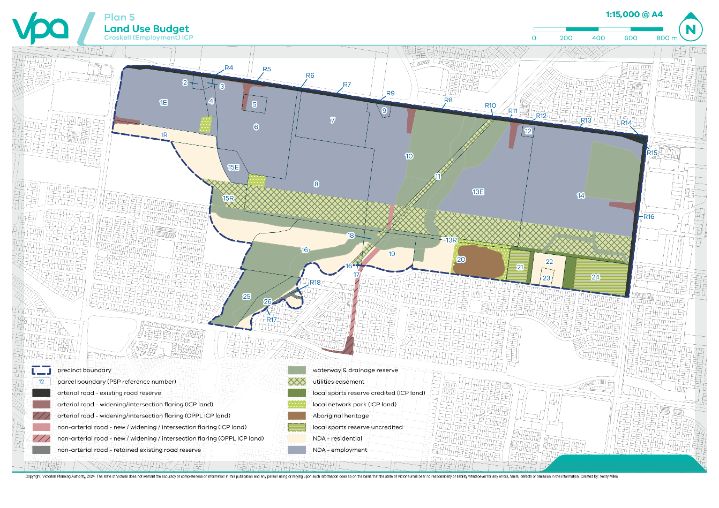
Table 16: Summary land use budget
DESCRIPTION | AREA (HA) | % OF TOTAL | % OF NDA
TOTAL PRECINCT AREA (ha) | 317.24
TRANSPORT
Arterial road - existing road reserve | 8.66 | 2.73% | 4.90%
Arterial road - new / widening / intersection flaring (ICP land) | 3.48 | 1.10% | 1.97%
Non-arterial road - new / widening / intersection flaring (ICP land) | 0.82 | 0.26% | 0.46%
Non-arterial road - retained existing road reserve | 0.47 | 0.15% | 0.27%
SUB-TOTAL TRANSPORT | 13.43 | 4.23% | 7.60%
OPEN SPACE
UNCREDITED OPEN SPACE & REGIONAL OPEN SPACE
Aboriginal heritage | 5.40 | 1.70% | 3.06%
Waterway and drainage reserve | 65.62 | 20.69% | 37.12%
Utilities easements | 40.38 | 12.73% | 22.84%
Local sports reserve uncredited | 9.14 | 2.88% | 5.17%
SUB-TOTAL UNCREDITED OPEN SPACE & REGIONAL OPEN SPACE | 120.54 | 38.00% | 68.18%
CREDITED OPEN SPACE
Local network park (ICP land) | 3.50 | 1.10% | 1.98%
Local sports reserve credited (ICP Land) | 2.96 | 0.93% | 1.68%
SUB-TOTAL CREDITED OPEN SPACE | 6.46 | 2.04% | 3.66%
TOTAL ALL OPEN SPACE | 127.01 | 40.03% | 71.84%
TOTAL NET DEVELOPABLE AREA – (NDA) Ha | 176.80 | 55.73%
NET DEVELOPABLE AREA – RESIDENTIAL (NDAR) Ha | 35.14 | 11.08%
NET DEVELOPABLE AREA – EMPLOYMENT (NDAE) Ha | 141.66 | 44.65%

Table 17: Parcel specific land use budget
PARCEL ID | TOTAL AREA (HA) | TRANSPORT |  |  |  | OPEN SPACE |  |  |  |  |  | TOTAL NET DEVELOPABLE AREA (HA) | TOTAL CONTRIBUTION LAND (HA) | TRANSPORT (HA) | RESIDENTIAL COMMUNITY & RECREATION (HA) | COMMERCIAL & INDUSTRIAL COMMUNITY & RECREATION (HA)
PARCEL ID | TOTAL AREA (HA) | Arterial Road - Existing Road Reserve | Arterial Road - New / Widening / Intersection Flaring (ICP land) | Non-Arterial Road - Retained Existing Road Reserve | Non-Arterial Road - New / Widening / Intersection Flaring (ICP land) | Waterway and Drainage Reserve | Utilities Easements | Local Network Park (ICP land) | Aboriginal Heritage | Local Sports Reserve Uncredited | Local Sports Reserve Credited (ICP Land)
CK-01E | 19.12 | - | 0.36 | - | - | - | - | 0.59 | - | - | - | 18.17 | 19.12 | 0.36 | - | 0.59
CK-01R | 4.96 | - | 0.22 | - | - | - | - | - | - | - | - | 4.74 | 4.96 | 0.22 | - | -
CK-02 | 0.50 | - | - | - | - | - | - | - | - | - | - | 0.50 | 0.50 | - | - | -
CK-03 | 0.40 | - | - | - | - | - | - | - | - | - | - | 0.40 | 0.40 | - | - | -
CK-04 | 1.16 | - | - | - | - | - | - | 0.01 | - | - | - | 1.15 | 1.16 | - | - | 0.01
CK-05 | 1.44 | - | 0.25 | - | - | - | - | - | - | - | - | 1.20 | 1.44 | 0.25 | - | -
CK-06 | 22.59 | - | 0.63 | - | - | - | - | - | - | - | - | 21.96 | 22.59 | 0.63 | - | -
CK-07 | 12.18 | - | - | - | - | - | - | - | - | - | - | 12.18 | 12.18 | - | - | -
CK-08 | 32.46 | - | - | - | - | 1.22 | 11.76 | 0.71 | - | - | - | 18.78 | 19.49 | - | - | 0.71
CK-09 | 0.54 | - | - | - | - | - | - | - | - | - | - | 0.54 | 0.54 | - | - | -
CK-10 | 32.01 | - | 0.73 | - | 0.27 | 15.33 | 2.53 | - | - | - | - | 13.15 | 14.15 | 1.00 | - | -
CK-11 | 2.90 | - | - | - | 0.10 | 0.29 | 2.51 | - | - | - | - | - | 0.10 | 0.10 | - | -
CK-12 | 0.58 | - | 0.03 | - | - | - | - | - | - | - | - | 0.55 | 0.58 | 0.03 | - | -
CK-13E | 39.48 | - | 0.64 | - | - | 8.79 | 10.59 | - | - | - | - | 19.46 | 20.11 | 0.64 | - | -
CK-13R | 1.58 | - | - | - | - | 0.66 | - | 0.65 | - | - | 0.08 | 0.19 | 0.92 | - | 0.73 | -
CK-14 | 53.58 | - | 0.64 | - | - | 11.56 | 9.37 | - | - | - | 1.09 | 30.91 | 32.64 | 0.64 | - | 1.09
CK-15E | 2.70 | - | - | - | - | - | - | - | - | - | - | 2.70 | 2.70 | - | - | -
CK-15R | 15.90 | - | - | - | - | 3.77 | 2.82 | - | - | - | - | 9.31 | 9.31 | - | - | -
CK-16 | 18.87 | - | - | - | - | 10.90 | - | - | - | - | - | 7.97 | 7.97 | - | - | -
CK-17 | 0.34 | - | - | - | - | - | 0.32 | - | - | - | - | 0.01 | 0.01 | - | - | -
CK-18 | 1.26 | - | - | - | - | 0.71 | 0.47 | - | - | - | - | 0.08 | 0.08 | - | - | -
CK-19 | 5.90 | - | - | - | 0.44 | 1.94 | - | - | - | - | - | 3.51 | 3.95 | 0.44 | - | -
CK-20 | 11.84 | - | - | - | - | 1.36 | - | 1.54 | 5.40 | - | - | 3.54 | 5.08 | - | 1.54 | -
CK-21 | 3.03 | - | - | - | - | - | - | - | - | 2.55 | 0.47 | - | 0.47 | - | 0.47 | -
CK-22 | 3.23 | - | - | - | - | - | - | - | - | - | - | 3.23 | 3.23 | - | - | -
CK-23 | 0.81 | - | - | - | - | - | - | - | - | - | - | 0.81 | 0.81 | - | - | -
CK-24 | 7.91 | - | - | - | - | - | - | - | - | 6.59 | 1.32 | - | 1.32 | - | 1.32 | -
CK-25 | 6.82 | - | - | - | - | 6.79 | - | - | - | - | - | 0.03 | 0.03 | - | - | -
CK-26 | 4.01 | - | - | - | - | 2.31 | - | - | - | - | - | 1.70 | 1.70 | - | - | -
SUB-TOTAL | 308.10 |  | 3.48 |  | 0.82 | 65.62 | 40.38 | 3.50 | 5.40 | 9.14 | 2.96 | 176.80 | 187.56 | 4.31 | 4.06 | 2.40
CK-R01 | 0.80 | 0.80 | - | - | - | - | - | - | - | - | - | - | - | - | - | -
CK-R02 | 0.09 | 0.09 | - | - | - | - | - | - | - | - | - | - | - | - | - | -
CK-R03 | 0.14 | 0.14 | - | - | - | - | - | - | - | - | - | - | - | - | - | -
CK-R04 | 0.02 | 0.02 | - | - | - | - | - | - | - | - | - | - | - | - | - | -
CK-R05 | 1.01 | 1.01 | - | - | - | - | - | - | - | - | - | - | - | - | - | -
CK-R06 | 0.05 | 0.05 | - | - | - | - | - | - | - | - | - | - | - | - | - | -
CK-R07 | 0.81 | 0.81 | - | - | - | - | - | - | - | - | - | - | - | - | - | -
CK-R08 | 1.31 | 1.31 | - | - | - | - | - | - | - | - | - | - | - | - | - | -
CK-R09 | 0.20 | 0.20 | - | - | - | - | - | - | - | - | - | - | - | - | - | -
CK-R10 | 0.07 | 0.07 | - | - | - | - | - | - | - | - | - | - | - | - | - | -
CK-R11 | 0.34 | 0.34 | - | - | - | - | - | - | - | - | - | - | - | - | - | -
CK-R12 | 0.15 | 0.15 | - | - | - | - | - | - | - | - | - | - | - | - | - | -
CK-R13 | 0.99 | 0.99 | - | - | - | - | - | - | - | - | - | - | - | - | - | -
CK-R14 | 0.41 | 0.41 | - | - | - | - | - | - | - | - | - | - | - | - | - | -
CK-R15 | 0.21 | 0.21 | - | - | - | - | - | - | - | - | - | - | - | - | - | -
CK-R16 | 2.07 | 2.07 | - | - | - | - | - | - | - | - | - | - | - | - | - | -
CK-R17 | 0.04 | - | - | 0.04 | - | - | - | - | - | - | - | - | - | - | - | -
CK-R18 | 0.44 | - | - | 0.44 | - | - | - | - | - | - | - | - | - | - | - | -
Sub-Total | 9.14 | 8.66 |  | 0.47

Appendix 3 Designs (Placeholder)


Croskell (Employment) Infrastructure Contributions Plan
September 2024

