


1051 Croskell (Employment)
Precinct Structure Plan
Bunurong Country

September 2024

Acknowledgment of country
The Victorian Planning Authority proudly acknowledges Victoria’s Aboriginal community and their rich culture and pays respect to their Elders past and present.
We acknowledge Aboriginal people as Australia’s first peoples and as the Traditional Owners and custodians of the land and water on which we rely.
We recognise and value the ongoing contribution of Aboriginal people and communities to Victorian life and how this enriches us.
We embrace the spirit of reconciliation, working towards the equality of outcomes and ensuring an equal voice.
We acknowledge the Bunurong People as the Traditional Custodians of the Croskell (Employment) Precinct Structure Plan area. We recognise their continuing connection to the lands and waters of Bunurong Country. We pay our respects to their Elders past and present and extend that respect to all First Nations People.

ACCESSIBILITY
The Victorian Planning Authority is committed to ensuring that all persons, including those with disabilities, can access information about our key planning projects, are able to participate in community engagement and consultation activities, and have access to our premises.
This document has been optimised to be compatible with screen readers. We welcome your feedback especially where you feel we are not compliant or could provide better accessibility. If you would like us to send you a printed or electronic copy of this or any VPA publication, please contact us at accessibility@vpa.vic.gov.au
© VICTORIAN PLANNING AUTHORITY 2024
This planning report was developed by the Victorian Planning Authority (VPA) on behalf of the Victorian Government.
Any projections are based on reasonable assumptions at the time of publication but should not be relied upon without first seeking appropriate expert advice. Although every effort has been made to ensure that the information in this document is factually correct at the time of publication, the VPA does not warrant the accuracy, completeness or relevance of the information. Any person using or relying upon this document does so on the basis that the State of Victoria shall bear no responsibility or liability whatsoever for any errors, faults, defects or omissions in the information.

General notes
Victorian Desalination Project assets
All north-south crossings shown over the Victorian Desalination Project (VDP) assets within the PSP are indicative and subject to a whole of government resolution process.
Regionally Significant Commercial Area, Development Services Scheme and drainage investigation areas
The Croskell (Employment) PSP includes land identified as forming a Regionally Significant Commercial Area under the Melbourne Industrial and Commercial Land Use Plan (2020), and a key objective of the PSP is to maximise the development of this important area. The draft PSP identifies five areas of drainage investigation on the Plan 2 Place based plan to highlight potential areas of opportunity to move, expand, or optimise Development Services Scheme (DSS) assets where feasible with the aim of maximising net developable employment land within the Regionally Significant Commercial Area. All DSS assets are indicative and subject to further refinement and investigation provided the alternatives satisfy the DSS objectives (including but not limited to these five investigation areas).

CONTENTS
Acknowledgment of country 1
ACCESSIBILITY 1
General notes 2
Plans 5
Tables 5
Figures 6
1 Context 7
1.1 How to read this document 7
1.2 Purpose of the PSP 8
1.3 Regional context 8
1.4 Precinct features 9
1.5 Cultural context 10
1.6 Strategic policy context 11
1.7 Infrastructure contributions plan (ICP) 11
1.8 Background information 11
2 PSP Outcomes 12
2.1 PSP vision 12
2.2 PSP purpose 12
3 Implementation 15
3.1 Viable densities 15
3.1.1 Objectives 15
3.1.2 Requirements and guidelines 15
3.2 Safe, accessible and well-connected 20
3.2.1 Objectives 20
3.2.2 Requirements and guidelines 20
3.3 Connect people to jobs and higher order services 24
3.3.1 Objectives 24
3.3.2 Requirements and guidelines 24
3.4 High quality public realm 30
3.4.1 Objectives 30
3.4.2 Requirements and guidelines 30
3.5 Bushfire Management 39
3.5.1 Objectives 39
3.5.2 Requirements and guidelines 39
3.6 Infrastructure coordination 41
3.6.1 Objectives 41
3.6.2 Requirements and guidelines 41
4 Appendices 45
Appendix 1 Precinct infrastructure plan 46
Appendix 2 Summary land use budget & parcel-specific land use budget 51
Appendix 3 Standard road cross sections & functional layout plans 56
Appendix 4 Place-based road cross sections & functional layout plans 59
Appendix 5 Glossary of terms 65

Plans
Plan 1 Precinct features 10
Plan 2 Place based plan 13
Plan 3 Housing 19
Plan 4 Movement network and public transport 23
Plan 5 Utility easement 23
Plan 6 Employment and activity centre 29
Plan 7 Public realm and water 36
Plan 8 Native vegetation retention and removal 38
Plan 9 Community infrastructure 38
Plan 10 Bushfire 40
Plan 11 Infrastructure and development staging 44
Plan 12 Precinct infrastructure plan 46
Plan 13 Land use budget 51

Tables
Table 1 Place-based objectives – viable densities 15
Table 2 Requirements and guidelines – viable densities 15
Table 3 Housing density and diversity 16
Table 4 Dwelling yields 18
Table 5 Place-based objectives – safe, accessible and well-connected 20
Table 6 Place-based requirements and guidelines – safe, accessible and well-connected 20
Table 7 Place-based objectives – Connect people to jobs and higher order services 24
Table 8 Place-based requirements and guidelines – Connect people to jobs and higher order services 24
Table 9 Employment Area Planned Character Outcomes 25
Table 10 Employment generation 28
Table 11 Place-based objectives – High quality public realm 30
Table 12 Place-based requirements and guidelines – High quality public realm 30
Table 13 Open space delivery 34
Table 14 Place-based objectives – Bushfire management 39
Table 15 Place-based requirements and guidelines – Bushfire management 39
Table 16 Bushfire hazard vegetation management and setback requirements 40
Table 17 Place-based objectives – Infrastructure coordination 41
Table 18 Place-based requirements and guidelines – Infrastructure coordination 41
Table 19 Infrastructure coordination requirements – Development Services Scheme DSS assets 41
Table 20 Infrastructure coordination requirements – parcels 42
Table 21 Precinct infrastructure 47
Table 22 Summary land use budget 52
Table 23 Parcel-specific land use budget 53
Table 24 Glossary of terms 65

Figures
Figure 1 PSP performance summary 14
Figure 2 Integrated Water Management Strategic Outcomes 37
Figure 3 Cross section – Connector street Boulevard (28-31m) 56
Figure 4 Cross section – Connector street industrial (26m) 56
Figure 5 Cross section – Local access street level 2 industrial (22m) 57
Figure 6 Cross section – Local access street level 2 (20m) 57
Figure 7 Cross section – Local access street level 1 (16m) 58
Figure 8 Cross section – Connector street boulevard (23.75m) 59
Figure 9 Local access street level 2 – industrial / diversion underground pipe (20m) 59
Figure 10 Functional layout plans – Proposed crossings over the Victorian Desalination Project (VDP) assets 60

Context

How to read this document
The precinct structure plan (PSP) guides land use and development where a planning permit is required under the Urban Growth Zone (Clause 37.07 of the Casey Planning Scheme), or any other provision of the Casey Planning Scheme that references this PSP.
Part 1: Context
The first part contains the contextual overview of the PSP document and the function of individual components as well as infrastructure contributions required to deliver the precinct.
Part 2: PSP outcomes
The second part contains the outcomes the PSP is seeking to achieve.
A planning application and subsequent planning permit must implement the outcomes of the PSP.
The outcomes are expressed as:
- The Vision, which is the overarching unique place-based outcome intended for this PSP.
- The Purpose, which sets out how the PSP will deliver on the vision for the precinct.
- The Objectives, place-based objectives to achieve the vision and purpose for the precinct.
Part 3: Implementation
The third part contains the strategic land use context and place-making elements to be implemented for the precinct and responds to each of the seven 20-minute neighbourhood hallmarks.
Each hallmark is implemented according to the following sub-structure:
- PSP objectives: The PSP identifies a set of place-based objectives to achieve the vision and purpose for the precinct. These provide the guidance required to achieve the specific outcomes sought for each of the seven hallmarks within the precinct. A responsible authority may consider alternative strategies to achieve the vision and objectives. Alternative strategies must demonstrate how they will achieve the vision and objectives of the PSP.
- PSP implementation and delivery: The PSP provides guidance in the form of requirements, plans, tables and diagrams to help with understanding of how to implement the strategies.
- Place-based requirements: PSP Requirements must be adhered to in developing the land. Where they are not demonstrated in a permit application, requirements will usually be included as a condition on a planning permit whether or not they take the same wording as in the structure plan. A requirement may reference a plan, table or figure in the structure plan.
- Place-based guidelines: The PSP Guidelines express how discretion will be exercised by the responsible authority in certain matters that require a planning permit. If the responsible authority may consider an alternative to a guideline if it is satisfied that an application for an alternative, implements the outcomes. A guideline may include or reference a plan, table or figure in the PSP.
Any objective, requirement or guideline applies to the whole PSP, and not just to the Hallmark under which it is nested. Meeting these requirements and guidelines will implement the vision, purpose and objectives of the PSP.

Part 4: Appendices
This section contains the technical and administrative information required to support the implementation of the strategic land use context and place-making elements of the PSP. It will generally comprise of a series of tables and plans. These include:
- Precinct infrastructure plan and table.
- Summary land use budget and parcel-specific land use budget.
- Cross-sections.
- Various concept plans (e.g., Victorian Desalination Project crossing concept plans, etc).
- Glossary of terms.
Not every aspect of land use, development or subdivision is addressed in this PSP. A responsible authority may manage development and issue permits as relevant under its general discretion. The Generally in Accordance Guidance Note is available on the VPA website to provide direction in the application of discretion where a PSP applies.
Development must comply with Acts and approvals where relevant e.g., the Environment and Biodiversity Conservation Act 1999, the Melbourne Strategic Assessment (Environmental Mitigation) Levy Act 2020 and the Aboriginal Heritage Act 2006, among others.

Purpose of the PSP
The purpose of the PSP is to activate the PSP outcomes by:
- Providing the planning conditions for private industry delivery
- Identifying and, where appropriate, providing the shared funding for a diverse range of open spaces and community infrastructure
- Ensuring planning permit applications will generate the necessary population to support investment in critical infrastructure.

Regional context
The Croskell (Employment) precinct is located in the City of Casey, within the established suburbs of Clyde North and Cranbourne East, approximately 40km from Melbourne’s CBD.
Growth Corridor Plans identify the approximate location for the future transport network and land uses for growth corridors, and provide the high-level spatial planning framework that the PSP needs to respond to. In the South East Growth Corridor Plan, Croskell (Employment) is identified for “business with residential.” Croskell (Employment) is bordered by developing employment precincts to the north and east, as well as existing residential precincts to the north, south and west.
The City of Casey has been growing quickly, and the population is expected to grow by an additional 40 per cent to 550,000 people within the next 20 years. Rapid population growth has meant that the number of new residents has been growing faster than the rate of new jobs, and currently two thirds of Casey’s workers need to commute out of the area for work. Delivery of a new employment precinct centrally located within a largely built out existing residential area provides an excellent opportunity to help reverse this trend.
Within the local area, the precinct has excellent access to several existing nearby activity centres, namely Avenue Village to the north, Selandra Rise and The Hunt Club to the south, and Springhill to the west. In addition, several additional activity centres are proposed in the nearby area, including an expansion of the Casey Central Major Activity Centre to the north and the development of the Hardys Road Major Activity Centre to the south east. Local residents and workers are also within cycling distance of a potential future Cranbourne East rail station to the south west.
In the wider region, the precinct is centrally located to several existing or planned State Significant Industrial Precincts (SSIP), including Dandenong South and the Officer Employment Corridor.

Precinct features
The Croskell (Employment) precinct is 317 hectares and while relatively small for a precinct structure plan, its location within a largely built out urban area represents a significant strategic development opportunity for the City of Casey.
Croskell (Employment) is bounded to the north by Thompsons Road, a major east-west arterial road and part of the Principal Freight Network linking the precinct to the state significant industrial land in Officer South. To the west, the precinct is bordered by Narre Warren Cranbourne Road and to the east, Berwick Cranbourne Road – both of which are planned to be future six lane primary arterial roads. To the south, Croskell (Employment) is bounded by Linsell Boulevard, a future four lane secondary arterial road.
The site generally falls from south to north and west to east with the northeast corner (at the intersection of Thompsons Rd and Berwick Cranbourne Rd) being the lowest point. The central northern section is elevated through man-made excavation and stockpiling of cut material with loose materials forming large berms, bunds and rises. On some of these landforms, trees have established to maturity. Large sections of the east and southern portions are relatively flat with modest fall to the south.
The precinct is currently predominately rural – comprising agricultural land, mainly for grazing and food production with small pockets of industrial land use, namely an abattoir, an old quarry and concrete batching plant. The land to the north of the precinct is currently commercial/residential. The land to the precinct’s east is developed industrial and residential. The land to the south and west of the precinct is developed residential.
There is a water body to the south west corner of the PSP that is an extension of wetlands from the development to the south. This connects to Ti Tree Creek through the site on a north-east alignment to connect with the development to the north. Some large dams also represent significant water bodies.
Significant easements impact the future development potential of the site and will inform the future character. Most notably there is an east-west easement in the southern portion of the site that contains both overhead electricity and a sub-surface high voltage power line to the Victorian Desalination Project. Development around the sub-surface high voltage power line is subject to restrictions under a proposed Specific Controls Overlay. There is also a Melbourne Water underground water supply pipeline reserve that runs diagonally through the middle of the site.
Croskell (Employment) was surveyed as part of the Melbourne Strategic Assessment program, and while there are no conservation areas located within the project area, the Registered Aboriginal Party for the area, the Bunurong Land Council Aboriginal Corporation, has identified a patch of vegetation in the south eastern portion of the precinct that has intangible cultural heritage values.

Plan 1 Precinct features
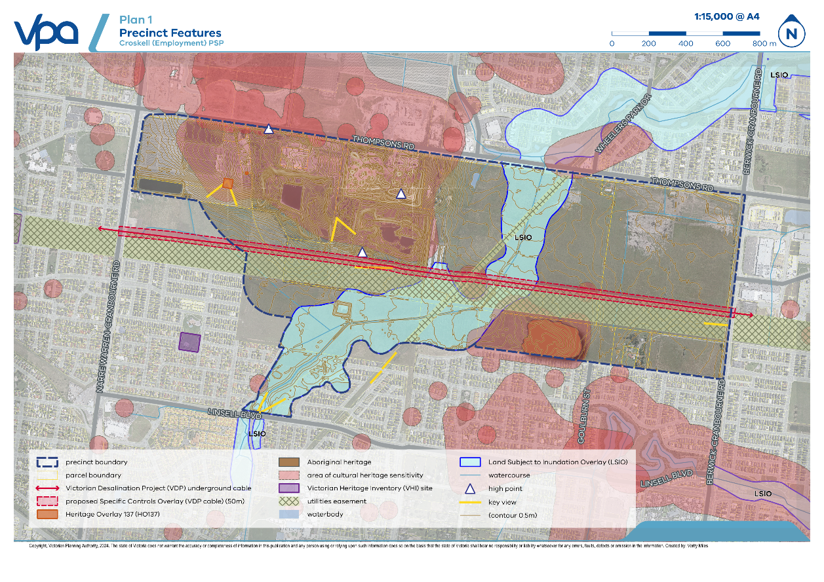

Cultural context
The Croskell (Employment) Precinct Structure Plan area is located on Bunurong Country.
The Bunurong Land Council Aboriginal Corporation (BLCAC) is the Registered Aboriginal Party (RAP) for Bunurong peoples. Bunurong peoples are recognised as the Traditional Owners of their lands and waters across metropolitan Melbourne, the Mornington Peninsula, the Bass Coast and West Gippsland. The BLCAC aims to preserve and protect the sacred lands and waterways of their ancestors, their places, traditional cultural practices, and stories.
Through the preparation of a Cultural Values Interpretation Strategy (CVIS), the BLCAC have identified three broad cultural values themes that are associated with the Croskell (Employment) PSP area:
- Place
- People
- Time.
These three broad cultural values themes incorporate various sub-themes that are identified as being relevant to Croskell (Employment) PSP area, including the values of places between places, moving through Country, and connection and connectivity (between people, time, nature, culture, Country, etc).
The BLCAC also acknowledge that the landscape of the Croskell (Employment) PSP area — both natural and cultural — is dynamic and has undergone many significant changes over millennia. The myriad natural and cultural processes that have and continue to inform the current configuration of the Croskell (Employment) PSP area also shape the many complex and layered place meanings that the Croskell (Employment) PSP area holds for Bunurong peoples and the broader community. Many of these place-making processes, as well as destructive processes such as climate change, erosion, urbanisation, private ownership, and land clearing and conversion, continue today.
The BLCAC identified a patch of 5.41ha of vegetation in the south eastern portion of the precinct along Donohue Street that is culturally significant to the Bunurong peoples. This vegetation should be retained in recognition of its significance. The vegetation sits within the largest of several Aboriginal Places in the precinct. These Aboriginal Places are registered under the Aboriginal Heritage Act 2006 and must be managed in line with the Act – Cultural Heritage Management Plans (CHMPs) must be prepared with the BLCAC as required.

Strategic policy context
This PSP is informed by:
- The Planning Policy Framework set out in the Casey Planning Scheme
- The South East Growth Corridor Plan (2012)
- Plan Melbourne 2017–2050
- The Melbourne Industrial and Commercial Land Use Plan (2020)
- The Precinct Structure Planning Guidelines: New Communities in Victoria (VPA, 2021).

Infrastructure contributions plan (ICP)
This PSP is supported by the Croskell (Employment) Infrastructure Contribution Plan (the ICP) which is incorporated into the Casey Planning Scheme.
The ICP sets out the essential infrastructure requirements and expected contributions arrangements delivered as part of the development permit process.

Background information
The Croskell (Employment) PSP Background Report provides detailed information relating to the precinct, including its local and metropolitan context, history, landform and topography, biodiversity, drainage, open space, transport infrastructure, employment, and community facilities. The report details the technical information and rationale that has informed the place-based decisions and planning outcomes expressed in this PSP.
The technical studies are available at https://vpa.vic.gov.au/project/croskell/

PSP Outcomes

PSP vision
The Croskell (Employment) Precinct Structure Plan is an “infill” precinct that builds on the existing character of the surrounding Cranbourne East and Clyde North community. Development will leverage the amenity from the central north-south green spine following the course of the future wetlands. The retention of high quality existing vegetation where feasible will help establish a strong sense of precinct character.
Croskell (Employment) will deliver a regionally significant commercial precinct with 6,532 jobs, along with a mix of housing typologies and densities. The commercial precinct will extend the Thompsons Road business corridor, attracting employers by leveraging the precinct’s strong connections to other employment areas in the south east, including the Dandenong National Employment and Innovation Cluster and the Officer South State Significant Industrial Precinct. Croskell (Employment) will play a key role in supporting local employment aspirations and the types of businesses that locate in the precinct are expected to commence with light industrial, retail and service uses that will gradually transition towards higher order office and commercial uses over time within designated areas along key frontage roads.
Croskell (Employment) will emphasise local and regional connections, delivering a road and pathway network that encourages walking and active modes of transport, enables connections across and through the high-voltage electricity utilities easement and support the use of emerging transport technologies. The precinct will connect workers and residents to internal destinations and surrounding activity centres, as well as the Cranbourne Railway Station and a potential future Cranbourne East Railway station. The precinct will be well serviced by public transport along the arterial roads and the internal connector road network.

PSP purpose
The PSP aims to deliver:
- A diverse, and regionally significant mix of business and industry that will provide a range of job opportunities for Casey residents – helping to reduce the need to commute long distances to work
- A network of diverse, walkable neighbourhoods connected by a comprehensive and attractive street and path network
- A precinct that protects, manages and celebrates its Aboriginal places and historic heritage sites
- A well integrated network of waterways and open spaces that tell the story of Country, effectively manage and drain stormwater and provide amenity to workers and residents
- A well connected precinct that integrates seamlessly with surrounding development and provides multi-modal linkages to nearby destinations such as activity centres, open space and rail stations
Plan 2 Place based plan
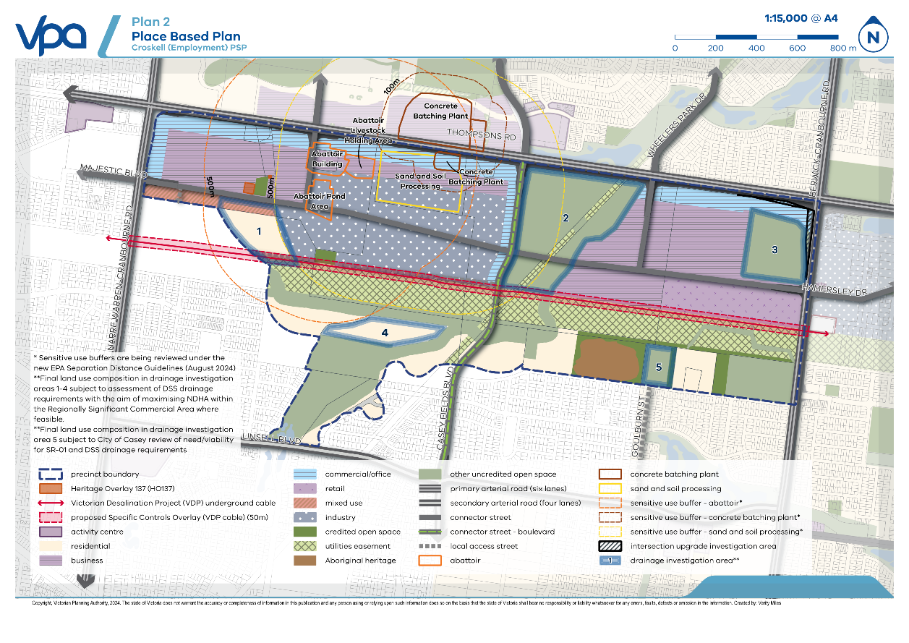

Figure 1 PSP performance summary
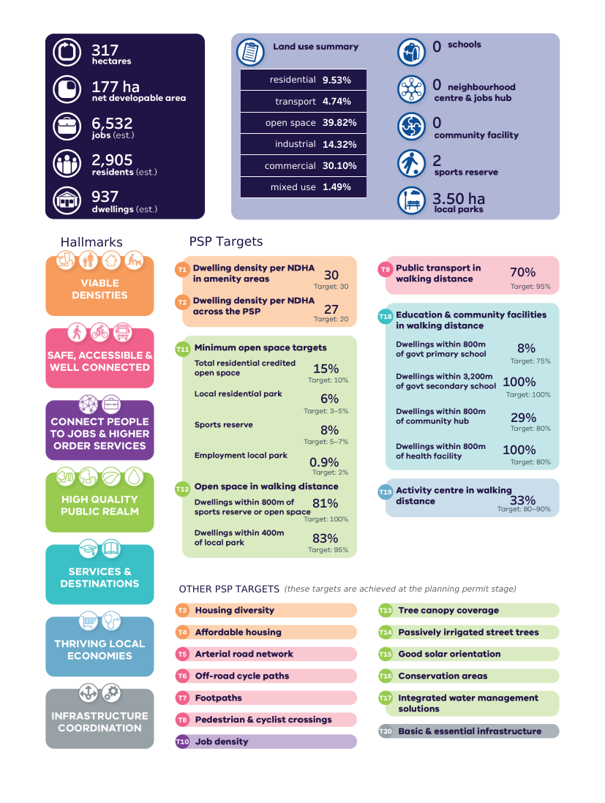
Note: See Croskell (Employment) Precinct Structure Plan – Amendment C296case Background Report – September 2024 for a discussion of the place-based response to PSP target metrics

Implementation

Viable densities

Objectives
Table 1 Place-based objectives – viable densities
OBJECTIVES |  | IMPLEMENTATION TOOLS
 | To ensure subdivision and development delivers a legible and contextually responsive urban structure that is well integrated with the surrounding environment | R1, R2 & G1
 | To provide a range of housing options that will support a diverse and inclusive community | G2 & G3
 | To facilitate affordable housing in accordance with the City of Casey Affordable Housing Strategy 2020 (or subsequent revisions) | G2 & G3

Requirements and guidelines
Table 2 Requirements and guidelines – viable densities
REQUIREMENTS
Subdivision for residential development must be in accordance with the Plan 3 Housing and Table 3 Housing density and diversity to the satisfaction of the responsible authority.
Subdivision proposals involving the delivery of residential lots as shown on Plan 3 must deliver the minimum number of housing typologies and target density for each catchment as described in the Table 3 Housing density and diversity unless it can be demonstrated to the satisfaction of the responsible authority that:
- sufficient housing diversity is achieved by other housing typologies within 800m, or
- the proposed subdivision is constrained in a way that makes compliance with this requirement impractical.
Subdivision and development fronting existing dwellings must ensure that an active frontage is delivered towards the existing development.
Subdivision must provide a diverse neighbourhood character by providing a range of lot sizes and dwelling types throughout the precinct.
GUIDELINES
Subdivision and development along Thompsons Road, Berwick Cranbourne Road and Narre Warren Cranbourne Road should:
- support a sense of arrival at a destination or point of interest along the route
- make a positive contribution to creating a distinct ‘gateway character’ when interfacing with connector roads into the precinct
Applications for residential subdivision and development should demonstrate how they will contribute to the target of delivering 12% minimum of all housing within the precinct as affordable housing in accordance with the City of Casey Affordable Housing Strategy 2020 (or subsequent revisions).
Social and affordable housing, special needs housing and retirement living housing should preferably be located in high amenity areas close to services and community facilities but should also be considered outside of these areas
Opportunities for co-working, small office and home office arrangements should be provided in locations where they will make a positive contribution to neighbourhood character
Specialised housing forms, such as retirement living, or aged care should:
- Respond to and integrate with adjoining development, avoiding inactive interfaces and blank facades to the public street network.
- Be located within amenity areas as shown on Plan 3 Housing
- Be accessible by public transport.
- Not present a barrier to movement through the surrounding road and pedestrian movement network
Table 3 Housing density and diversity
AMENITY AREA (GRZ)
Housing catchment area | Applies to residential land which is located within 400m walkable catchments of activity centres and train stations, and 50m walkable catchment of open space and the Principal Public Transport Network or similar as shown on Plan 3 Housing
Target density | Average of 30 dwellings or more per NDHa
Target typologies | Character statement  Development will have an urban neighbourhood character, characterised by buildings up to three storeys in height.  Housing will comprise a variety of typologies, including low-rise apartments buildings, terraced homes and townhouses (including rear-loaded lots), and detached dwellings.  Typologies  To support delivery of diverse housing outcomes in amenity areas, the PSP and applicable planning applications should enable opportunities to deliver at least four (4) different housing typologies. The mix of dwelling typologies should include, but is not limited to:  - Detached dwelling  - Terrace townhouse  - Multi-unit  - Apartment  - Duplex  - Dual occupancy
BALANCE AREA (GRZ)
Housing catchment area | Applies to residential land which is located outside of the nominated amenity areas as shown on Plan 3 Housing
Target density | Average of 20 dwellings or more per NDHa
Target typologies | Character statement  Development will have a conventional suburban neighbourhood character characterised by buildings up to three storeys in height.  Housing will generally comprise detached and semi-detached typologies, however more intensive forms of development such as terrace townhouses may be provided where it can be demonstrated that a positive contribution will be made to the planned neighbourhood character.  Typologies  To support delivery of diverse housing outcomes in balance areas, the PSP and applicable planning applications should enable opportunities to deliver at least two (2) different housing typologies. The mix of dwelling typologies should include, but is not limited to:  - Detached dwelling  - Terrace townhouse  - Multi-unit  - Duplex
MIXED USE (MUZ)
Housing catchment area | Applies to land which is located within the Mixed Use area on Plan 3 Housing
Target density | Average of 30 dwellings or more per NDHa
Target typologies | Character statement  Development will have an urban built character, providing a transition buffer between the residential land to the south and the business/commercial land to the north.  Housing will generally comprise more intensive typologies. Commercial activity will generally be smaller-scale, providing local services and supporting the potential delivery of public transport along the east-west industrial connector.  Typologies  To support delivery of diverse housing outcomes in mixed use areas, the PSP and applicable planning applications should enable opportunities to deliver at least three (3) different housing typologies. The mix of dwelling typologies should include, but is not limited to:  - Terrace townhouse  - Multi-unit  - Apartment  - Shop-top  - Duplex

Table 4 Dwelling yields
HOUSING CATCHMENT AREA | NDA (HA) | DWELLINGS/NDHA | NO. OF DWELLINGS
Amenity area | 18.7 | 30 | 561
Balance area | 11.7 | 20 | 234
Mixed use | 4.7 | 30 | 142
TOTAL | 35.1 | - | 937
Anticipated population at 3.1 persons per dwelling |  |  | 2,905

Plan 3 Housing
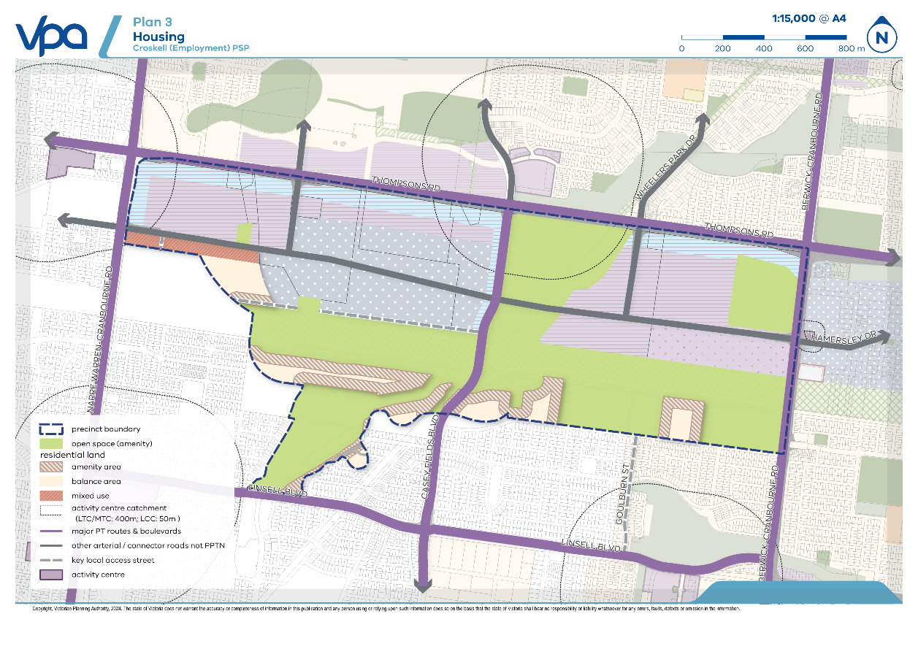

Safe, accessible and well-connected

Objectives
Table 5 Place-based objectives – safe, accessible and well-connected
OBJECTIVES |  | IMPLEMENTATION TOOLS
 | To provide a transport network that integrates planned land uses with adjoining established areas and supports active and public transport options within the precinct and to surrounding areas. | R9, G10
 | To establish an integrated and permeable transport network to encourage public transport, walking and cycling, reduce car dependency and maximise safety and connectivity for all road users. | R9, R10, R12, R13, G8
 | To create a comprehensive pedestrian and cycling network that allows residents and employees to be active and travel safely and directly through the precinct between key destinations and local parks. | R9, R12, R13, G6, G7, G8

Requirements and guidelines
Table 6 Place-based requirements and guidelines – safe, accessible and well-connected
REQUIREMENTS
Standard arterial roads and local streets must be designed and developed in accordance with the relevant standard cross sections in Appendix 3, unless otherwise agreed by the relevant Authority. Alternative cross sections can be considered in line with the criteria outlined in G6 and G7.
The design and delivery of all sections of Casey Fields Boulevard must be done in consultation with the responsible authority.
The proponent delivering Casey Fields Boulevard over the high voltage transmission utilities easement and Victorian Desalination Project (VDP) infrastructure must:
- Liaise with the responsible authority and the Department of Energy, Environment and Climate Action to ensure the road is delivered in the location specified on Plan 4 Movement network and public transport and Plan 5 Utility easement unless otherwise approved by the Secretary to the Department of Energy, Environment and Climate Action and the responsible authority.
- Design and develop the road in accordance with the relevant site-specific cross section in Appendix 4 for the extent of road shown in Plan 4 Movement network and public transport and Plan 5 Utility easement
- Enter into an Interface Works Agreement with the Department of Energy, Environment and Climate Action for the development of an appropriate engineering response for the road crossing over the VDP assets, based on the design in Appendix 4 unless otherwise approved by the Secretary to the Department of Energy, Environment and Climate Action.
The proponent delivering any shared user path crossing over Victorian Desalination Project (VDP) infrastructure must:
- Enter in an Interface Works Agreement with the Department of Energy, Environment and Climate Action for the development of an appropriate engineering response for the shared user path crossing over the VDP assets – based on the design in Appendix 4 unless otherwise approved by the Secretary to the Department of Energy, Environment and Climate Action.
The delivery of the Local Access Street Level 2 – Industrial / Diversion Underground Pipe must be in accordance with the cross section in Appendix 4 and include the delivery of Diversion Underground Pipe (E) as shown on Plan 11 Infrastructure and development staging unless otherwise approved by the responsible authority and Melbourne Water.
Pedestrian and active transport infrastructure must be provided in accordance with those items indicated in Plan 4 Movement network and public transport and Plan 5 Utility easement and the relevant cross sections in Appendix 3 and Appendix 4.
Vehicular access to commercial/industrial properties fronting Thompsons Road, Berwick–Cranbourne Road and Narre Warren–Cranbourne Road must be from connector streets, service roads, internal loop roads or rear laneways.
All parcels fronting Thompsons Road must provide a shared user path along the parcel boundary adjacent to the arterial road reserve capable of accommodating pedestrian and active transport movements that also connects to any existing bus stops to the satisfaction of the responsible authority.
Pedestrian and cyclist crossings must be provided every 400–800m, where appropriate, along arterial roads, rail lines, waterways, and any other accessibility barriers.
- crossings of the Victorian Desalination Project (VDP) infrastructure must be delivered where shown on Plan 4 Movement network and public transport and Plan 5 Utility easement) unless otherwise approved by the Secretary to the Department of Energy, Environment and Climate Action and the responsible authority.
- crossings of the water supply pipeline infrastructure must be delivered where shown on Plan 4 Movement network and public transport and Plan 5 Utility easement unless otherwise approved by Melbourne Water.
Design of all subdivisions, streets and arterial roads must provide:
- A permeable, direct and safe street network prioritising walking and cycling, particularly walking and cycling to schools.
- Safe and convenient crossing points of connector roads and local streets at all intersections and on key desire lines as well as crossing waterways.
- Safe pedestrian crossings of arterial roads at all intersections, at key desire lines, and on regular intervals appropriate to the function of the road and public transport provision.
- Safe and convenient transition between on and off-road bicycle networks
- Convenient access to regional and local points of interest and destinations for effective integration with neighbouring properties, parkland and sports reserves.
- Direct and convenient walking access to public transport services.
GUIDELINES
A variety of cross sections should be used in subdivision layouts for local streets, to create differentiation, sense of place and neighbourhood character.
Alternative cross sections should ensure that:
- Sufficient provision is made for street tree planting to achieve 30% canopy tree coverage in the public realm.
- Minimum required carriageway dimensions are maintained to ensure safe and efficient operation of emergency vehicles on all streets as well as buses on connector streets.
- The performance characteristics of standard cross sections as they relate to pedestrian and cycle use are maintained.
- Relevant minimum road reserve widths for the type of street are maintained.
Where alternative cross-sections have been implemented, they should provide for off-road bicycle paths on all connector streets and arterial roads.
Alternative footpath or shared path approaches may be used where they enhance walkability and permeability and respond to the purpose of the place and character of the urban form to the satisfaction of the responsible authority.
The frequency and impact of vehicular crossovers on verges of connector roads should be minimised to avoid undue impacts on public transport movements using a combination of:
- rear loaded lots with laneway access
- vehicular access from the side streets
- combined or grouped crossovers
- increased lot widths
Street layouts should provide multiple convenient routes via direct off-road active network paths to major destinations such as local parks, sporting reserves, train/bus interchanges and significant employment areas both within the precinct and in surrounding areas.

Plan 4 Movement network and public transport
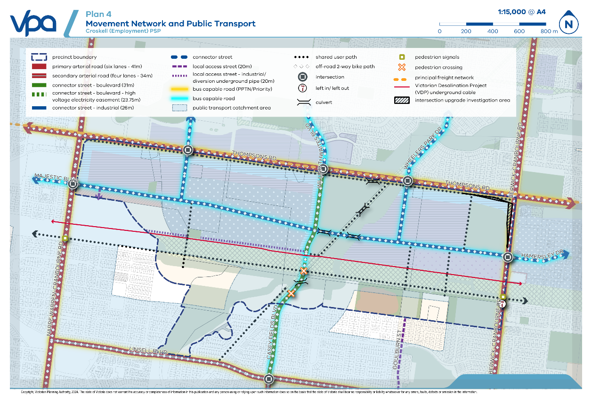
Plan 5 Utility easement
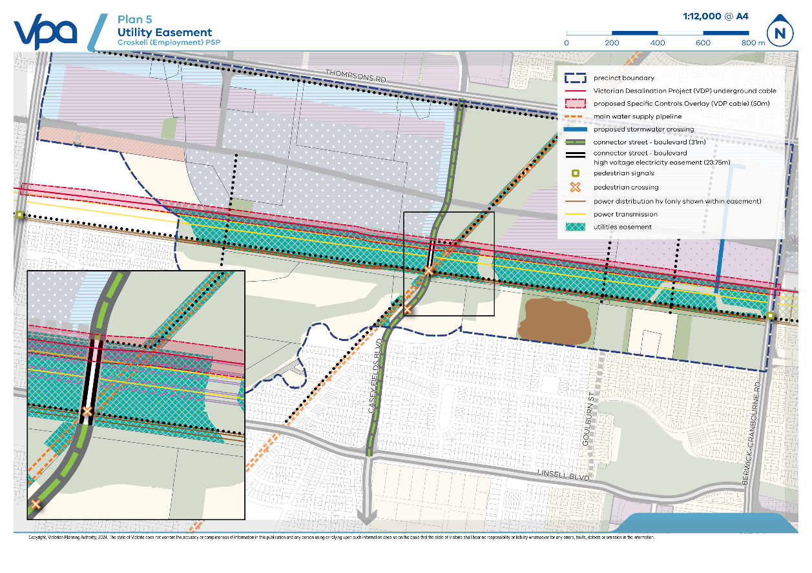

Connect people to jobs and higher order services

Objectives
Table 7 Place-based objectives – Connect people to jobs and higher order services
OBJECTIVES |  | IMPLEMENTATION TOOLS
 | To develop Croskell (Employment) into a regionally significant destination for business and industry to grow and innovate | R15, R16
 | To reduce the need for local workers to travel out of the region for employment. | G11
 | To ensure Croskell (Employment) has a flexible and adaptable urban structure that can attract ongoing investment and higher order employment uses over time. | R15, R17, G11
 | To ensure the structure of employment land is well-integrated with the surrounding environment, and that the location, scale and intensity of commercial and industrial activity is compatible with adjoining land uses. | G11
 | To increase access to jobs by walking, cycling and public transport. | R16, G11
 | To ensure that the location and design quality of retail and commercial focused facilities and spaces makes them inviting, attractive, and safe places to work and visit. | R17, G11
 | To support a night-time economy in appropriate locations | R14

Requirements and guidelines
Table 8 Place-based requirements and guidelines – Connect people to jobs and higher order services
REQUIREMENTS
Subdivision of employment land must be in accordance with Plan 6 Employment and activity centre and Table 9 Employment Area Planned Character Outcomes to the satisfaction of the responsible authority.
Subdivision and development involving the delivery of employment land must:
- provide for a form, scale and intensity of land use and activity that is compatible with adjacent land uses.
- be adaptable to changing use, regeneration, and intensification initiatives
- provide a diversity in lot sizes at subdivision to meet the needs of a range of commercial business and industries and ensure large lots are protected for large footprint economic and employment uses.
Subdivision and development involving the delivery of employment land must consider the design guidance within the City of Casey Employment Land Design Guide 2022 and, where relevant, the City of Casey Restricted Retail Design Guide 2023 (or subsequent revisions of either document).
Buildings fronting Thompsons Road, Berwick–Cranbourne Road and Narre Warren–Cranbourne Road must:
- Manage visual bulk and provide an appropriate interface to residential areas through design tools such as upper level setbacks
- Provide four metre minimum depth landscaping planting zone setbacks between the road and buildings to allow landscaping to soften building edges and provide a vegetation landscape character
- Locate car parking along the side or at the rear of the site. Convenience car parking can be provided closer to the main entrance of the building
- Break car parking up by tree islands at a rate of at least one island per six spaces, where feasible
- Ensure that trucks/heavy vehicles are able to safely egress the site and avoid conflicts with pedestrians or cyclists
to the satisfaction of the responsible authority
GUIDELINES
Subdivision and development involving the delivery of employment land should:
- Provide a transition in scale and intensity between employment-oriented areas and sensitive land use areas (e.g. residential).
- Deliver a high-quality, high amenity setting attractive to businesses and workers.
- Provide car parking efficiently through the use of shared and consolidated parking areas, including multi-level parking.
- Locate car parking and loading facilities to the side or rear of any buildings. Any visitor car parking and access areas in the front setback area should be set back a minimum of 3 metres from any local street frontage to enable provision of sufficient landscape strips at the street frontage.
- Ensure any large expanses of continuous wall visible to the street have appropriate articulation and other elements to provide relief and visual interest.

Table 9 Employment Area Planned Character Outcomes
EMPLOYMENT AREA | PLANNED CHARACTER OUTCOMES
Retail (C2Z)  Applies to areas indicated as ‘Retail’ area shown on Plan 6 Employment and activity centre | The Retail area is located along the precinct’s frontage with Berwick–Cranbourne Road north of the high voltage transmission line utilities easement.  The Retail area is envisaged as a walkable destination for workers and visitors to the precinct to access daily needs and services. It is anticipated that this area will include lots capable of supporting retail, restricted retail and other commercial services.  Subdivision and development within the Retail area should:  - Reflect the purpose and planned character outcomes described in Table 8  - Provide a common building setback for each street.  - Prioritise connectivity to key local or connector entry streets to support accessibility to active transport and potential future public transport and routes.  - Provide tree islands with car parks at a rate of at least one island per six spaces, where feasible.  - Locate any cafes, restaurants, convenience shops and convenience restaurants fronting open space, drainage waterways or a connector street or connector boulevard.
Business (C2Z)  Applies to land located within the ‘Business’ area shown on Plan 6 Employment and activity centre | The Business area is located along key local or connector entry streets and within the heart of the precinct set back from the arterial road frontages.  The Business area is envisioned as a walkable and multi-functional employment area with a variety of commercial, manufacturing, retailing and business uses. Uses located along key local or connector entry streets will be expected to address the street directly to support the higher-amenity character of these areas and provide a pedestrian-focused street environment.  Subdivision and development within the Business area should:  - Encourage small to medium scale tenancies and land uses to locate along key local or connector entry streets to allow a greater number of uses to present to the street.  - Minimise setbacks between adjacent buildings along frontages to key local or connector entry streets.  - Encourage multi-storey buildings to locate adjacent to key local or connector entry street frontages.  - Prioritise the needs of pedestrians through the design of buildings and the public realm.  - Prioritise connectivity to key local or connector entry streets to support accessibility to active transport and potential future public transport routes.  - Provide tree islands with car parks at a rate of at least one island per six spaces, where feasible.  - Locate cafes, restaurants, convenience shops and convenience restaurants fronting open space, drainage waterways or a connector street or connector boulevard.
Commercial/Office (C2Z)  Applies to land located within the ‘Commercial/Office’ area shown on Plan 6 Employment and activity centre | The Commercial/Office area is located along key arterial road frontages and Casey Fields Boulevard. The Commercial/Office area is envisaged as having a high-quality built form that will evoke a gateway character and provide a distinct sense of address for the precinct. It is anticipated that this area will include uses that facilitate evening activation.  Subdivision and development within the Commercial/Office area must:  - Provide lots to support medium to large scale commercial and office uses to establish over time along the arterial road frontages and Casey Fields Boulevard gateway into the precinct  Subdivision and development within the Commercial/Office area should:  - Be located to maximise walkable accessibility for the local workforce  - Provide an active frontage with key local or connector entry streets, open space/wetlands (where relevant) and surrounding buildings to support place identity and the legibility of the urban structure  - Incorporate tree islands into any open space parking unless sunshade is provided or a mixture of the two  - Locate any cafes, restaurants, convenience shops and convenience restaurants fronting open space, drainage waterways or a connector street or connector boulevard.
Industry (IN3Z)  Applies to land located within the ‘Industry’ area shown on Plan 6 Employment and activity centre | The Industry area is located in the core of the precinct with good access to the Principal Freight Network along Thompsons Road via Casey Fields Boulevard.  The Industry area is envisaged as supporting a range of small-scale industrial based services with limited sensitive use impacts. Uses with the industry area are expected to integrate well with the surrounding commercial, residential and mixed use precincts.  Subdivision and development within the Industry area should:  - provide a common building setback for each street.  - prioritise connectivity to key local or connector entry streets to support accessibility to active transport and potential future public transport and routes.  - incorporate tree islands into any open space parking unless they are providing sunshade or a mixture of the two.  - locate any cafes, restaurants, convenience shops and convenience restaurants fronting open space, drainage waterways or a connector street or connector boulevard.
Mixed Use (MUZ)  Applies to land located within the ‘mixed use’ area shown on Plan 6 Employment and activity centre | The Mixed Use area is located south of the industrial connector running east west from Majestic Boulevard with good access to Narre Warren Cranbourne Road.  The Mixed Used area is envisaged as a buffer zone between a busy industrial connector that will be carrying significant freight movements and the residential land to the south, located both within the Croskell (Employment) PSP and within the Cranbourne East Development Plan.  Employment uses within the Mixed Use area are expected to encompass a mix of local services and retail.  Subdivision and development involving employment uses within the Mixed Use area should:  - Integrate well with any residential uses within the Mixed use area and residential uses to the south  - Incorporate tree islands into any open space parking unless they are providing sunshade or a mixture of the two.

Table 10 Employment generation
LAND USE | NDA (ha) | ESTIMATED JOBS
Regional Significant Commercial Area (RSCA) | 118.9 | 5,271
Other employment land supporting the RSCA | 22.8 | 1,225
SUBTOTAL | 141.7 | 6,496
Residential (refer to Table 4) | 35.1 | 36
TOTAL | 176.8 | 6,532

Plan 6 Employment and activity centre
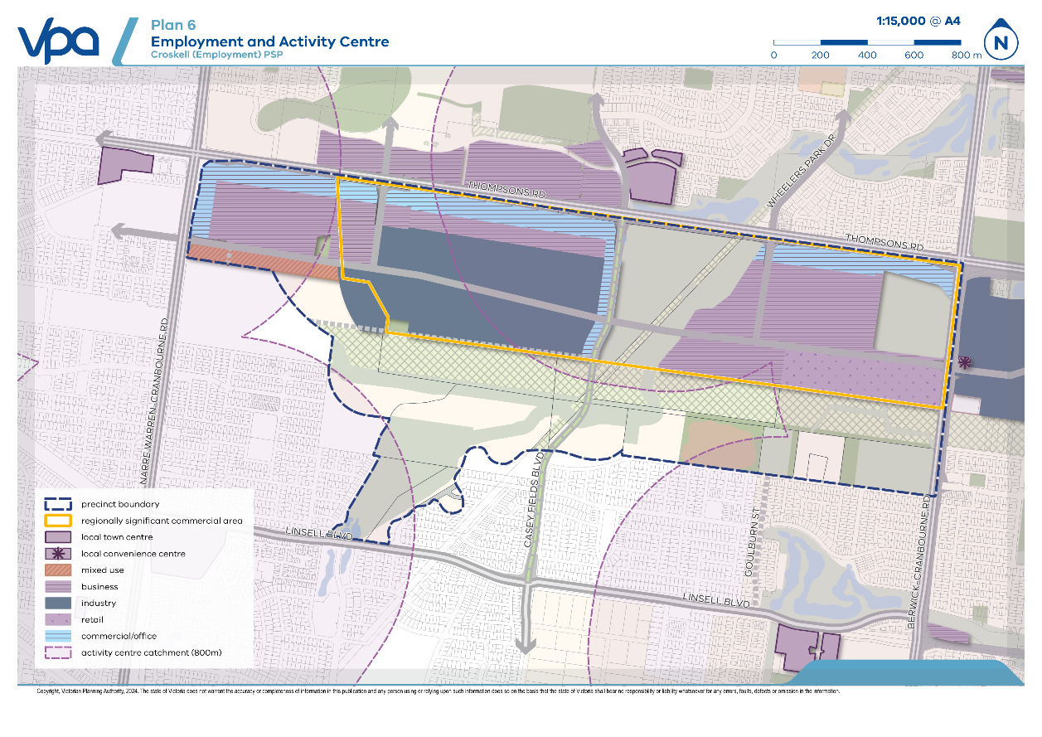

High quality public realm

Objectives
Table 11 Place-based objectives – High quality public realm
OBJECTIVES |  | IMPLEMENTATION TOOLS
 | To retain and protect features of the natural environment that make an important contribution to local character, amenity, culture and ecology. | R22
 | To ensure development incorporates the natural environment as a defining feature of neighbourhood structure and place-based character. | R22, G19
 | To ensure that development within the public realm provides sufficient canopy tree coverage to support cooler and greener neighbourhoods | R18, R19, R25, G12
 | To provide a range of local parks, open space and recreation opportunities that meet the needs of the community. | R24, G18
 | To support the conservation or management of cultural heritage and traditional owner values. | R22
 | To develop safe, resilient, water sensitive, environmentally sustainable urban environments that respond to climate change and other hazards | R20, R28
 | To develop sustainable water, drainage and wastewater systems that protect, conserve, and improve biodiversity, waterways and other natural resources and maintains or enhances the safety, health and wellbeing of people and property. | G18, R28
 | To ensure stormwater is managed for flood protection factoring in climate change and water quality treatment | R20, R27, R28, R29, G17
 | To ensure stormwater meets all requirements for crossing over critical utility infrastructure consistent with the Development Services Scheme (DSS) | R27
 | To encourage a strong sense of place through the identification, retention and celebration of places of post-contact and Aboriginal cultural heritage significance within the precinct. | R22, G21

Requirements and guidelines
Table 12 Place-based requirements and guidelines – High quality public realm
REQUIREMENTS
Canopy tree coverage within the public realm must achieve a minimum of 30% (excluding areas dedicated to biodiversity or native vegetation conservation).
A landscape plan must specify tree species which are suitable to the local climate and soil conditions, to the satisfaction of the responsible authority.
A landscape plan must implement integrated water management and water sensitive design outcomes to the satisfaction of the responsible authority.
Removal and retention of native vegetation must be in accordance with the Croskell (Employment) Native Vegetation Precinct Plan June 2024 or Plan 8 Native vegetation retention and removal
The retention, enhancement and integration of the existing natural environment, landscape features, registered Aboriginal Places or any areas of tangible or intangible Aboriginal cultural significance determined via a Cultural Heritage Management Plan must be considered through subdivision design, and, where applicable, building design.
Appropriate transition must be provided with landscape, building height, setbacks and materials to any buildings adjacent to the historic heritage site (HO137) on Plan 7 Public realm and water
All local parks must:
- Be located, designed and developed in accordance with the location identified in Plan 7 Public realm and water and the attributes described in Table 13 Open space delivery unless otherwise approved by the responsible authority.
- Adhere to any conditions outlined within an approved Cultural Heritage Management Plan if relevant
Local parks must contain planting of vegetation or large canopy trees that are suitable to the urban environment, local climate and soil conditions to the satisfaction of the responsible authority.
Residential lots directly abutting credited or uncredited open space must provide for a primary point of access from a footpath or shared user path proximate to the lot boundary
A Stormwater Management Plan must include Integrated Water Management solutions consistent with Plan 7 Public realm and water and the relevant Development Services Scheme (DSS) and achieve the objectives of the Best Practice Environment Management Guidelines (CSIRO, 1999) and the urban stormwater management guidance (EPA’s publication 1739).
Applications must demonstrate, through the preparation of Integrated Water Management plans, the extent to which development will contribute towards:
- Outcomes identified in the DEECA Western Port Strategic Directions Statement (September 2018) and Western Port IWM Catchment Scale Plan (September 2022)
- Outcomes identified in the Croskell Precinct Structure Plan Integrated Water Management Plan (ARUP, Nov 2023).
- Stormwater volume reduction and infiltration targets in Melbourne Water’s Healthy Waterway Strategy (2018), which are applicable to the PSP.
- Potable water reduction targets outlined in the draft Greater Melbourne Urban Water and System Strategy – Water for Life, which are applicable to the PSP.
- Waterways and integrated water management outcomes that enable land to be used for multiple recreation and environmental purposes.
to the satisfaction of South East Water, Melbourne Water and the responsible authority.
Stormwater runoff from development must meet the performance objectives of the Commonwealth Scientific and Industrial Research Organisation Best Practice Environmental Management Guidelines for Urban Stormwater (or as amended) prior to discharge to receiving waterways and as outlined in Plan 7 Public realm and water, unless otherwise approved by Melbourne Water and the responsible authority.
The final layout, boundaries and design of constructed wetlands, retarding basins, stormwater quality treatment infrastructure, and associated paths, boardwalks, bridges, and planting must
- Include appropriate treatments to provide protection for dispersive soils where these are present
- Must mitigate the risk of erosion from sodic and dispersive soils
to the satisfaction of Melbourne Water and the responsible authority
Stormwater conveyance and treatment must be designed in accordance with the relevant Development Services Scheme and Plan 7 Public realm and water, such that:
- Overland flow paths and piping within road reserves will be connected and integrated across parcel boundaries.
- Melbourne Water and the responsible authority freeboard requirements for overland flow paths will be adequately contained within the road reserves and waterways.
- The risk of erosion of sodic and/or dispersive soils is avoided or mitigated
to the satisfaction of Melbourne Water and the responsible authority.
Drainage waterways must be designed in accordance with the relevant Development Services Scheme and Plan 7 Public realm and water. Waterways must be delivered to:
- Provide safe drainage and flood protection.
- Incorporate environmental, cultural and amenity value.
- Provide an open drainage system
to the satisfaction of Melbourne Water and the responsible authority.
Prior to the construction of any drainage assets shown within the relevant Development Services Scheme, the proponent must obtain any relevant groundwater licenses and/or approvals from the relevant authority.
GUIDELINES
Canopy trees should have an average canopy of foliage of 6.4m in diameter at maturity in summer. Where this cannot be achieved because of local climate and soil conditions, a suitable species should be selected which closest achieves suitable canopy cover, to the satisfaction of the responsible authority. The requirement for a minimum 30% canopy tree coverage within the public realm must still be met.
Alternative irrigation may be considered where it can be demonstrated through a comprehensive alternative plan (such as an Integrated Water Management Plan) that passive irrigation is either unnecessary or inferior to the proposed alternative (for example, recycled water irrigation of street trees in mandated recycled water areas).
Subdivision and development should provide opportunities for the harvesting and/or re-use of stormwater where practical.
Applications should consider a range of IWM options as indicated in Plan 7 Public realm and water. Potential IWM options may include but are not limited to:
- Recycled water to residential and / or non-residential areas
- Stormwater or regional rainwater harvesting for open space irrigation
- Rainwater harvesting for commercial/industrial zones
- Passive irrigation of street trees from road runoff
- Roof irrigation to evaporate stormwater in industrial areas
- Dedicated spongy areas in the waterway corridor
- Green roofs for commercial buildings.
Drainage assets and public open space areas should be located adjacent to waterways to provide a buffer to development where appropriate to the satisfaction of the responsible authority.
Development should include integrated water management initiatives to reduce reliance on potable water and increase the utilisation of storm and recycled water contributing to a sustainable urban environment by having regard to relevant water management policies and strategies implemented by the responsible authority.
Integrated water management systems should be designed to:
- Maximise habitat values for local flora and fauna species.
- Enable future harvesting and/or treatment and re-use of stormwater.
- Recognise and respond to Aboriginal cultural heritage and values.
Subdivision and development should respond to significant landscape features and existing vegetation in a way that:
- Retains and protects landscape features and existing vegetation that make a significant positive contribution to place character, amenity, cultural and/or ecological values.
- Incorporates the sense and experience of the natural environment into the planned urban character.
- Provides for increased provision of tree canopy cover in the public realm over time.
The design and layout of roads, road reserves, and public open space should optimise water use efficiency and long-term viability of vegetation, tree canopy and public uses to contribute to a sustainable and green urban environment. This should be achieved using overland flow paths, passive watering, and Water Sensitive Urban Design initiatives such as street swales, rain gardens and/or locally treated storm water for irrigation.
Arborist assessed native trees and MSA timestamped native vegetation and scattered trees identified as “should be retained” on Plan 8 Native vegetation retention and removal should:
- Where safe and practical, be retained in publicly accessible spaces such as road reserves, local parks or drainage reserves
- Be retained within private lots
unless otherwise agreed to in writing by the responsible authority.
Subdivision design, and, where applicable, building design should demonstrate how it has responded to the principles outlined under Section 5 – Interpretation Strategy of the Cultural Values Interpretation Strategy Summary Report (February 2024)
Alternative locations and configurations for local parks shown on Plan 7 Public realm and water may be considered subject to:
- Open space being retained within the same landownership, unless otherwise agreed with the affected landowners.
- Not diminishing the quality or usability of the space
- Not adversely affecting walkable accessibility of the network
- Not adversely affecting the overall diversity of the precinct’s open space network
- Adhering to any conditions outlined within an approved Cultural Heritage Management Plan if relevant
to the satisfaction of the responsible authority.
Subdivision should provide for a local street separating development from development services scheme assets, sporting reserves, utility easements and local parks. Where subdivision does not propose a local street separating development, design and layout options should demonstrate:
- Lots directly fronting open space and landscape value areas should be set back at least 4.5 metres
- Lots directly fronting open space should allow for vehicular access via a rear laneway
- A 4 metre wide access way should be provided as the primary point of access from a footpath or shared path with a minimum width of 1.5 metres along the lot frontage
- Subdivision design should avoid side or rear fence treatments fronting open space and development services scheme assets
- Subdivision design should maximise opportunities for informal passive surveillance
- Subdivision design should not limit the use of adjacent open space.
to the satisfaction of the responsible authority and, where relevant, Melbourne Water
Table 13 Open space delivery
PARK ID | AREA (HA) | TYPE | LOCATIONAL ATTRIBUTES | RESPONSIBILITY
ACTIVE OPEN SPACE
SR-01* | 3.29ha | Sports Reserve | South-eastern catchment, adjacent to the high voltage transmission line utilities easement and Aboriginal heritage area | City of Casey
SR-02 | 8.81ha | Sports Reserve | South-eastern catchment, adjacent to the high voltage transmission line utilities easement | City of Casey
**Need/viability of this facility is subject to City of Casey review
LOCAL PARKS
LP-01 | 0.6ha | Local Park | North-western catchment, adjoining the heritage house and industrial connector and centrally located to the surrounding employment and residential land. | City of Casey
LP-02 | 0.71ha | Local Park | North-western catchment, adjoining the drainage reserve and high voltage transmission line utilities easement | City of Casey
LP-03 | 2.19ha | Local Park | South-eastern catchment, adjacent to the Aboriginal heritage area and high voltage transmission utilities easement | City of Casey

Plan 7 Public realm and water
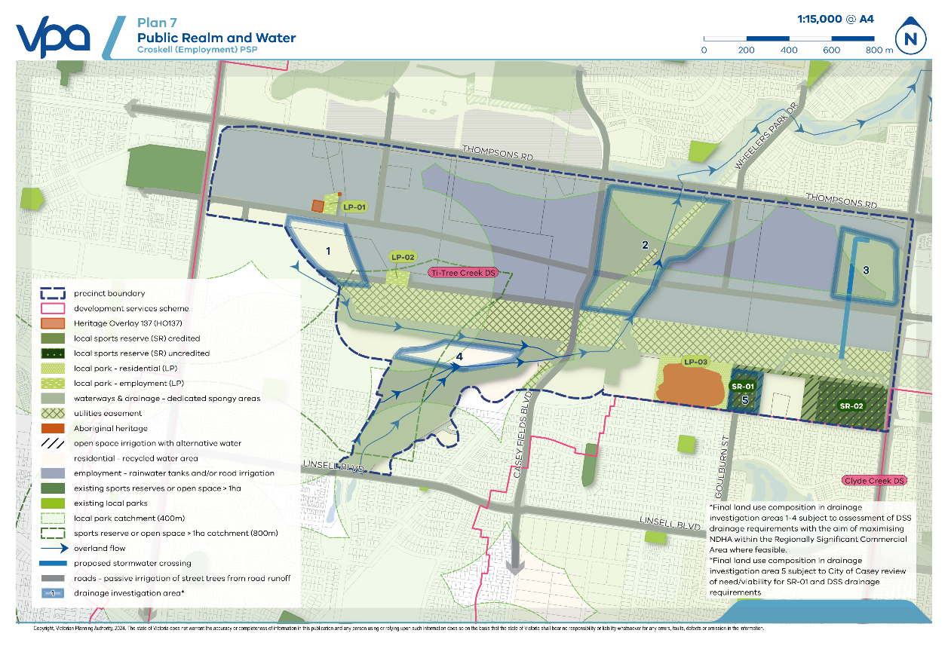

Figure 2 Integrated water management strategic outcomes
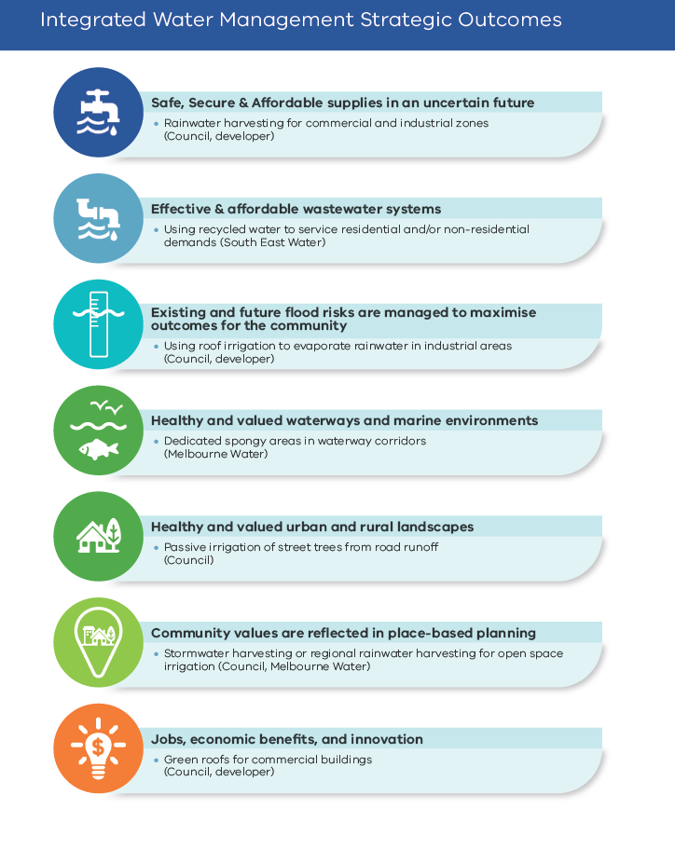

Plan 8 Native vegetation retention and removal
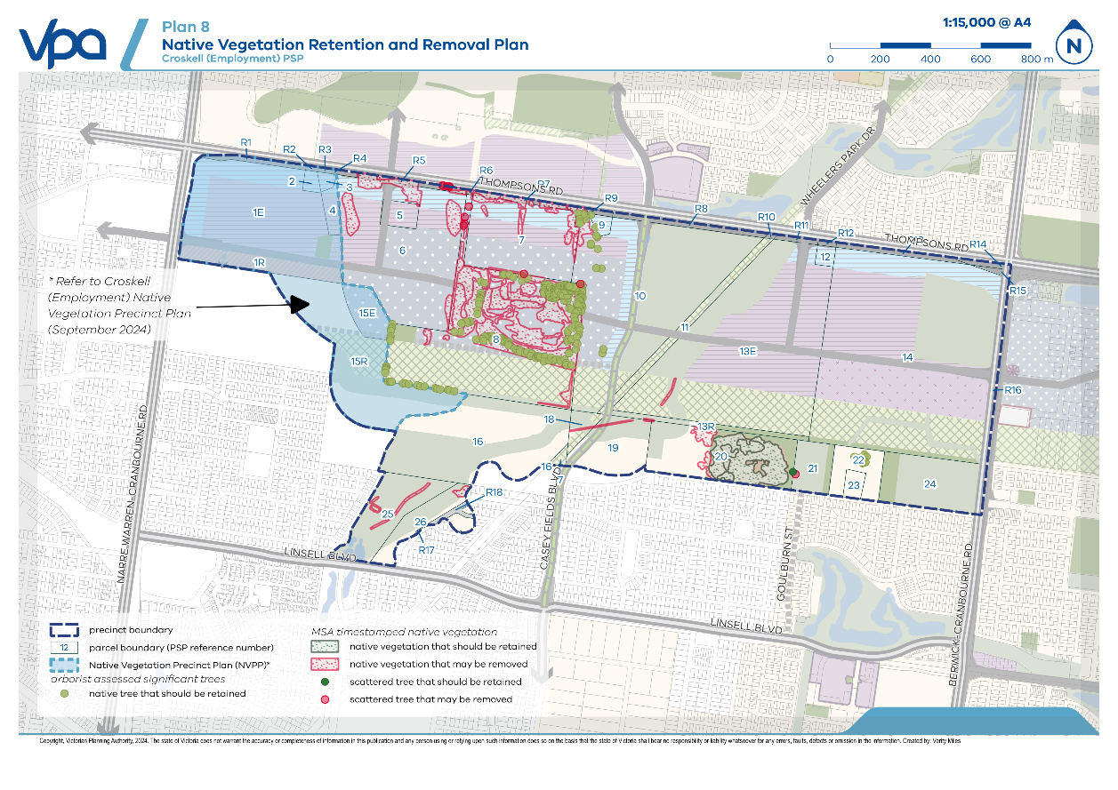
Plan 9 Community infrastructure
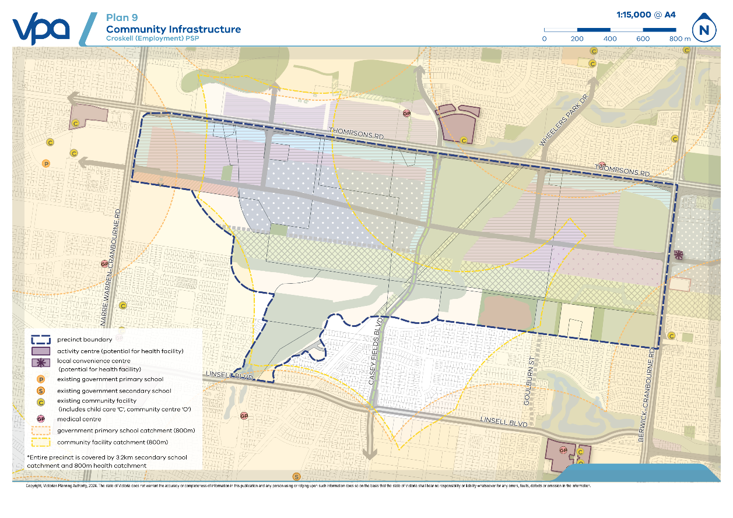

Bushfire management

Objectives
Table 14 Place-based objectives – Bushfire management
OBJECTIVES |  | IMPLEMENTATION TOOLS
 | To appropriately avoid or mitigate potential risk associated with bushfire | R34, R35, G24, G25, G26, G27, G28

Requirements and guidelines
Table 15 Place-based requirements and guidelines – Bushfire management
REQUIREMENTS
Development adjoining bushfire hazards shown on Plan 10 Bushfire must be set back in accordance with Table 16 Bushfire hazard vegetation management and setback requirements unless the bushfire hazard has been removed to the satisfaction of the responsible authority.
Where a setback from a bushfire hazard area is required by Table 16 Bushfire hazard vegetation management and setback requirements, unless otherwise agreed by the responsible authority and relevant fire authority, vegetation within the setback must be managed as follows:
- Grass must be short cropped and maintained during the declared fire danger period.
- All leaves and vegetation debris must be removed at regular intervals during the declared fire danger period.
- Within 10 metres of a building, flammable objects must not be located close to the vulnerable parts of the building.
- Plants greater than 10 centimetres in height must not be placed within 3 metres of a window or glass feature of the building.
- Shrubs must not be located under the canopy of trees.
- Individual and clumps of shrubs must not exceed 5 square metres in area and must be separated by at least 5 metres.
- Trees must not overhang or touch any elements of the building.
- The canopies of trees must be separated by at least 2 metres.
GUIDELINES
All vegetation outside of a bushfire hazard area shown on Plan 10 Bushfire should be managed to ensure a low risk of bushfire.
Subdivision adjoining a bushfire hazard area should include a publicly accessible perimeter road.
Subdivision should include a network of streets that provide multiple evacuation routes away from bushfire risks and areas of bushfire hazard.
Where a setback is required from a bushfire hazard, the setback should be provided on public land where practical.
Landscape design and plant selection in open spaces, including waterways and drainage corridors, should not increase bushfire risk.

Table 16 Bushfire hazard vegetation management and setback requirements
 | Bushfire hazard Area
Vegetation Management Class | Forest | Scrub | Grassland
Setback Distance from Bushfire Hazard Area | 48m | 27m | 19m
Plan 10 Bushfire
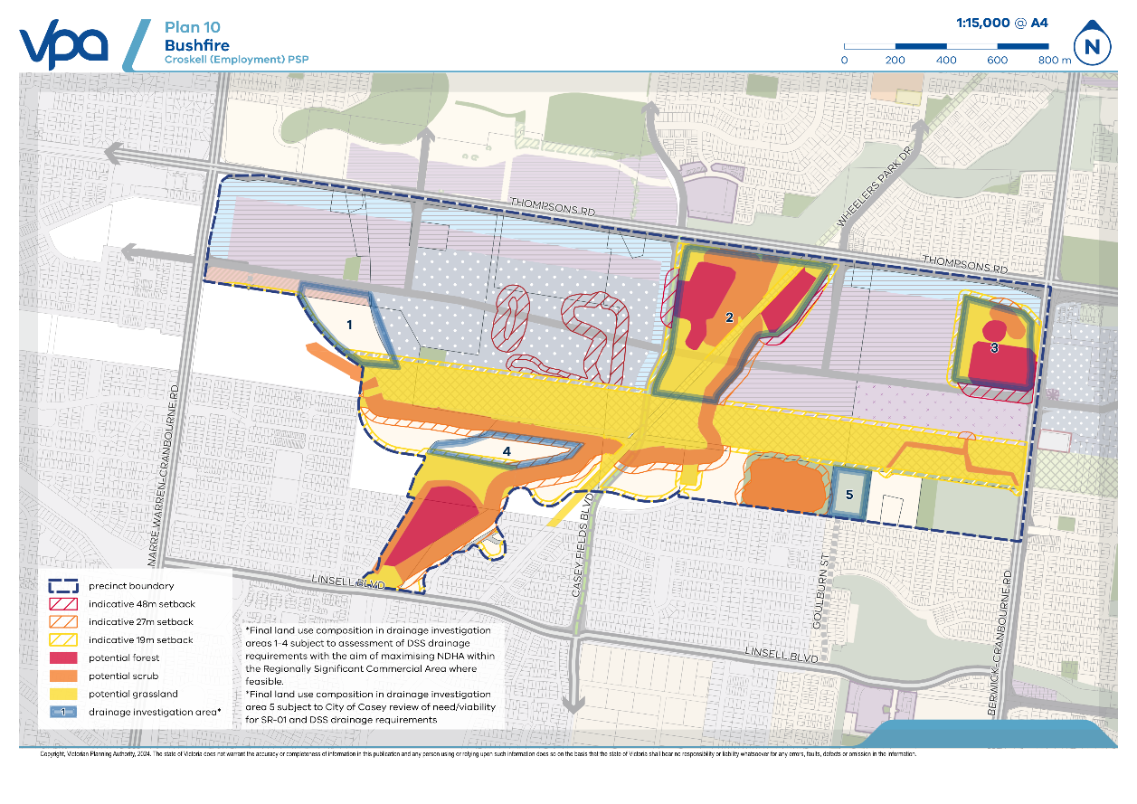

Infrastructure coordination

Objectives
Table 17 Place-based objectives – Infrastructure coordination
OBJECTIVES |  | IMPLEMENTATION TOOLS
 | To sequence the staging of development and the delivery of the relevant Development Service Scheme (DSS) assets to provide flood protection, manage environmental risks and minimise disturbance to the Victorian Desalination Project assets, water supply mains and electricity transmission assets. | R36

Requirements and guidelines
Table 18 Place-based requirements and guidelines – Infrastructure coordination
REQUIREMENTS
Prior to the issue of a statement of compliance for any stage of the subdivision of a PSP parcel or the commencement of development of a PSP parcel, all Development Services Scheme (DSS) assets identified for that PSP parcel within the:
- Plan 11 Infrastructure and development staging
- Table 19 Infrastructure coordination requirements – Development Services Scheme DSS assets and;
- Table 20 Infrastructure coordination requirements – parcels
must be delivered unless otherwise agreed in writing by the responsible authority and Melbourne Water.

Table 19 Infrastructure coordination requirements – Development Services Scheme DSS assets
DSS asset reference | DSS Asset | Sub precinct | PSP parcel #
A | DSS underground pipe | 1A | 5, 6, 7, 8, 10
B | Wetland and retarding basin  WLRB2-west | 1A | 1E, 1R, 2, 3, 4, 5, 6, 7, 8, 9, 10, 15E
C | Wetland  WL2-east | 1A | 12, 13E
D | Wetland and retarding basin  WLRB4 | 1B | 14, 20, 21, 22, 24
E | Diversion underground pipe | 1A | 1E, 1R, 2, 3, 4, 8, 10, 15E
F | Swale | 1A | 1E, 1R, 2, 3, 4, 5, 6, 8, 10, 15E
G1 | Pipe | 1B | 14, 20, 21, 22, 24
G2 | Central swale, culvert | 1B | 14, 20, 21, 22, 24
G3 | East branch swale (eastern PSP catchment) | 1B | 14
G4 | West branch swale (eastern PSP catchment) | 1B | 14, 20, 21, 22, 24
H1 | West-north waterway (including two water supply crossings, two VDP utilities easement crossings, other crossings) | 1A | 1E, 1R, 2, 3, 4, 5, 6, 7 (H1 in 10), 8 (H1 in 10), 9 (H1 in 10), 10 (H1 in 10), 12 (downstream of their catchment), 13E (H1 in 13E and H1 in 10), 15E, 18, 19 (downstream of their catchment), 20 (downstream, goes east and west), 21, 22, 24
H2 | Small swale (western PSP catchment) | 1A
I | South waterway | 1A | 18
J | Sediment basin | 1A | 19, 20
K | Wetland and retarding basin  WLRB3 | 1A
Table 20 Infrastructure coordination requirements – parcels
PSP parcel # | DSS assets required for development
1E, 1R | E, F, B, H1
2 | E, F, B, H1
3 | E, F, B, H1
4 | E, F, B, H1
5 | F, B, H1, A
6 | F, B, H1, A
7 | A, B, H1 in 10
8 | A, E, F, B, H1 in 10
9 | B, H1 in 10
10 | A, E, F, B, H1 in 10
12 | C, H1 downstream of their catchment
13E | C, H1 in 13, H1 in 10
14 | D, G1, G2, G3, G4
15E | H1, E, F, B
18 | I, H1
19 | H1 downstream of their catchment, J
20 | G4, G2, G1, D, J, H1 downstream of their catchment (water goes east and west)
21 | G4, G2, G1, D
22 | G4, G2, G1, D
24 | G3, G2, G1, D

Plan 11 Infrastructure and development staging
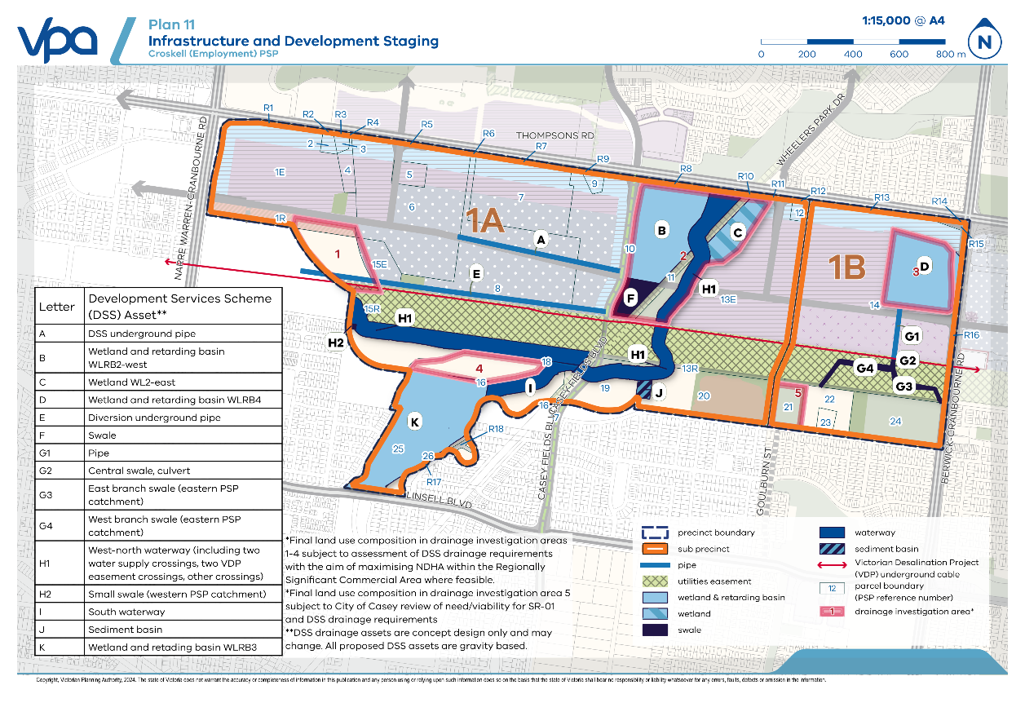

Appendices

- Precinct infrastructure plan
Plan 12 Precinct infrastructure plan
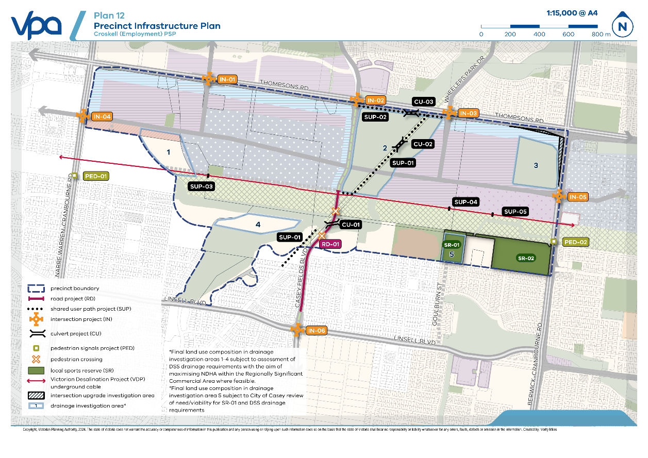

Table 21 Precinct infrastructure

CATEGORY | PIP REF NO. | TITLE | DESCRIPTION | LEAD AGENCY | COMPONENT INCLUDED IN ICP |  |  | TIMING | APPORTIONMENT FUNDING SOURCE | APPORTIONMENT
 |  |  |  |  | ULTIMATE LAND | INTERIM CONSTRUCTION | ULTIMATE CONSTRUCTION | TIMING | APPORTIONMENT FUNDING SOURCE | APPORTIONMENT
Road | RD-01 | Casey Fields Boulevard | Construction of a connector boulevard with one traffic lane in each direction within a 31m road reserve from northern leg of IN06 to PSP boundary | City of Casey | Yes – 22m of 31m road reserve provided as Outer Public Purpose Land from northern boundary of IN06 to the PSP boundary | No | Yes | S | Croskell (Employment) ICP | 100%
Road | RD-01 | Casey Fields Boulevard | Construction of a connector boulevard with one traffic lane in each direction within a 31m road reserve from PSP boundary to southern boundary of central utilities easement | City of Casey | Yes – 31m of road reserve | No | Yes | S | Croskell (Employment) ICP | 100%
Road | RD-01 | Casey Fields Boulevard | Construction of a connector boulevard with one traffic lane in each direction within a 23.75m road from southern boundary of central utilities easement to northern boundary of central utilities easement | City of Casey | Yes – 23.75m of road reserve | No | Yes | S | Croskell (Employment) ICP | 100%
Intersection | IN-01 | Thompsons Road and Industrial Connector Road (southern leg) | Construction of the southern leg of a primary arterial to industrial connector road signalised four-way intersection | City of Casey | Yes | No | Yes | S | Croskell (Employment) ICP | 100%
Intersection | IN-02 | Thompsons Road and Casey Fields Boulevard (southern leg) | Construction of the southern leg of a primary arterial to connector boulevard signalised four-way intersection | City of Casey | Yes | No | Yes | S | Croskell (Employment) ICP | 100%
Intersection | IN-03 | Thompsons Road and Wheelers Park Drive (southern leg) | Construction of the southern leg of a primary arterial to industrial connector road signalised four-way intersection | City of Casey | Yes | No | Yes | S | Croskell (Employment) ICP | 100%
Intersection | IN-04 | Narre Warren Cranbourne Road and Industrial Connector Road (eastern leg) | Construction of the eastern leg of a primary arterial to industrial connector road signalised four-way intersection | City of Casey | Yes | No | Yes | S | Croskell (Employment) ICP | 100%
Intersection | IN-05 | Berwick Cranbourne Road and Industrial Connector Road (western leg) | Construction of the western leg of a primary arterial to industrial connector road signalised four-way intersection | City of Casey | Yes | No | Yes | S | Croskell (Employment) ICP | 100%
Intersection | IN-06 | Linsell Boulevard and Casey Fields Boulevard (northern leg) | Construction of the northern leg of a secondary arterial to connector boulevard signalised four-way intersection | City of Casey | Yes – as outer public purpose land | No | Yes | S | Croskell (Employment) ICP | 100%
Culvert | CU-01 | Culvert along Casey Fields Boulevard over DSS Asset H1 | Construction of box culverts across ultimate road reserve width | City of Casey | No | No | Yes | S | Croskell (Employment) ICP | 100%
Culvert | CU-02 | Culvert along SUP-01 over DSS Asset H1 | Construction of culvert on shared user path over constructed waterway | City of Casey | No | No | Yes | S | Croskell (Employment) ICP | 100%
Culvert | CU-03 | Culvert along SUP-02 (Thompsons Road) over DSS Asset H1 | Construction of culvert on shared user path over constructed waterway | City of Casey | No | No | Yes | S | Croskell (Employment) ICP | 100%
Shared user path | SUP-01 | Shared user path: Melbourne Water pipe track | Construction of a shared user path | City of Casey | No | No | Yes | S | Croskell (Employment) ICP | 100%
Shared user path | SUP-02 | Shared user path: Thompsons Road | Construction of a shared user path | City of Casey | No | No | Yes | S | Croskell (Employment) ICP | 100%
Shared user path | SUP-03 | Shared user path: Victorian Desalination Project assets western crossing | Construction of a shared user path crossing over the VDP assets | City of Casey | No | No | Yes | S | Croskell (Employment) ICP | 100%
Shared user path | SUP-04 | Shared user path: Victorian Desalination Project assets eastern central crossing | Construction of a shared path crossing over the VDP assets | City of Casey | No | No | Yes | S | Croskell (Employment) ICP | 100%
Shared user path | SUP-05 | Shared user path: Victorian Desalination Project assets eastern crossing | Construction of a shared path crossing over the VDP assets | City of Casey | No | No | Yes | S | Croskell (Employment) ICP | 100%
Pedestrian crossing | PED-01 | Pedestrian Signals: Narre Waren Cranbourne Road | Construction of a signalised pedestrian crossing | City of Casey | No | No | Yes | S | Croskell (Employment) ICP | 100%
Pedestrian crossing | PED-02 | Pedestrian Signals: Berwick Cranbourne Road | Construction of a signalised pedestrian crossing | City of Casey | No | No | Yes | S | Croskell (Employment) ICP | 100%
Sports reserve | SR-01 | Sports reserve | Construction of sports reserve* | City of Casey | N/A | No | Yes | M | Croskell (Employment) ICP | 16.5%
Sports Reserve | SR-02 | Sports reserve | Construction of 2 football/cricket ovals, pavilion, cricket nets and 2 netball courts and a multi-purpose pavilion | City of Casey | N/A | No | Yes | M | Croskell (Employment) ICP | 15.5%
Local Park | LP-01 | Local park | Provision of land for a local park | City of Casey | Yes | n/a | No | S | Croskell (Employment) ICP | 100%
Local Park | LP-02 | Local park | Provision of land for a local park | City of Casey | Yes | n/a | No | S | Croskell (Employment) ICP | 100%
Local Park | LP-03 | Local park | Provision of land for a local park | City of Casey | Yes | n/a | No | S | Croskell (Employment) ICP | 100%
*Need/viability of this facility is subject to City of Casey review

- Summary land use budget & parcel-specific land use budget
Plan 13 Land use budget
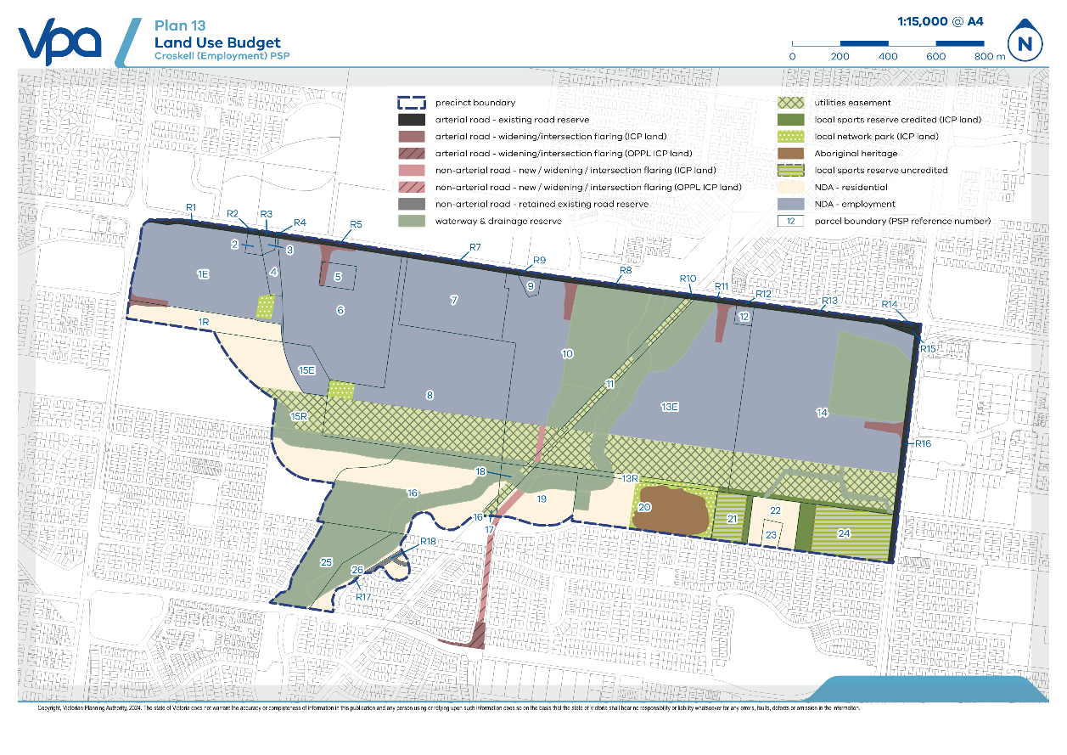

Table 22 Summary land use budget
DESCRIPTION | AREA (HA) | % OF TOTAL | % OF NDA
TOTAL PRECINCT AREA (ha) | 317.24
TRANSPORT
Arterial road - existing road reserve | 8.66 | 2.73% | 4.90%
Arterial road - new / widening / intersection flaring (ICP land) | 3.48 | 1.10% | 1.97%
Non-arterial road - new / widening / intersection flaring (ICP land) | 0.82 | 0.26% | 0.46%
Non-arterial road - retained existing road reserve | 0.47 | 0.15% | 0.27%
SUB-TOTAL TRANSPORT | 13.43 | 4.23% | 7.60%
OPEN SPACE
UNCREDITED OPEN SPACE & REGIONAL OPEN SPACE
Aboriginal heritage | 5.40 | 1.70% | 3.06%
Waterway and drainage reserve | 65.62 | 20.69% | 37.12%
Utilities easements | 40.38 | 12.73% | 22.84%
Local sports reserve uncredited | 9.14 | 2.88% | 5.17%
SUB-TOTAL UNCREDITED OPEN SPACE & REGIONAL OPEN SPACE | 120.54 | 38.00% | 68.18%
CREDITED OPEN SPACE
Local network park (ICP land) | 3.50 | 1.10% | 1.98%
Local sports reserve credited (ICP Land) | 2.96 | 0.93% | 1.68%
SUB-TOTAL CREDITED OPEN SPACE | 6.46 | 2.04% | 3.66%
TOTAL ALL OPEN SPACE | 127.01 | 40.03% | 71.84%
TOTAL NET DEVELOPABLE AREA – (NDA) Ha | 176.80 | 55.73%
NET DEVELOPABLE AREA – RESIDENTIAL (NDAR) Ha | 35.14 | 11.08%
NET DEVELOPABLE AREA – EMPLOYMENT (NDAE) Ha | 141.66 | 44.65%
*Note: Drainage investigation and intersection upgrade investigation areas have not been reflected in the summary land use budget

Table 23 Parcel-specific land use budget
PARCEL ID | TOTAL AREA (HA) | TRANSPORT |  |  | OPEN SPACE |  |  |  |  | TOTAL NET DEVELOPABLE AREA (HA) | TOTAL CONTRIBUTION LAND (HA) | TRANSPORT (HA) | RESIDENTIAL COMMUNITY & RECREATION (HA) | COMMERCIAL & INDUSTRIAL COMMUNITY & RECREATION (HA)
PARCEL ID | TOTAL AREA (HA) | ARTERIAL ROAD – EXISTING ROAD RESERVE | ARTERIAL ROAD – NEW/ WIDENING/ INTERSECTION FLARING (ICP LAND) | NON-ARTERIAL ROAD – RETAINED EXISTING ROAD RESERVE | WATERWAY & DRAINAGE RESERVE | UTILITIES  EASEMENTS | LOCAL SPORTS RESERVE (ICP LAND) | LOCAL NETWORK PARK (ICP LAND) | ABORIGINAL HERITAGE
CK-01E | 19.12 |  | 0.36 | - | - | - | - | 0.59 | - | 18.17 | 19.12 | 0.36 | - | 0.59
CK-01R | 4.96 |  | 0.22 | - | - | - | - | - | - | 4.74 | 4.96 | 0.22 | - | -
CK-02 | 0.50 |  | - | - | - | - | - | - | - | 0.50 | 0.50 | - | - | -
CK-03 | 0.40 |  | - | - | - | - | - | - | - | 0.40 | 0.40 | - | - | -
CK-04 | 1.16 |  | - | - | - | - | - | 0.01 | - | 1.15 | 1.16 | - | - | 0.01
CK-05 | 1.44 |  | 0.25 | - | - | - | - | - | - | 1.20 | 1.44 | 0.25 | - | -
CK-06 | 22.59 |  | 0.63 | - | - | - | - | - | - | 21.96 | 22.59 | 0.63 | - | -
CK-07 | 12.18 |  | - | - | - | - | - | - | - | 12.18 | 12.18 | - | - | -
CK-08 | 32.46 |  | - | - | 1.22 | 11.76 | - | 0.71 | - | 18.78 | 19.49 | - | - | 0.71
CK-09 | 0.54 |  | - | - | - | - | - | - | - | 0.54 | 0.54 | - | - | -
CK-10 | 32.01 |  | 0.73 | 0.27 | 15.33 | 2.53 | - | - | - | 13.15 | 14.15 | 0.99 | - | -
CK-11 | 2.90 |  | - | 0.10 | 0.29 | 2.51 | - | - | - | - | 0.10 | 0.10 | - | -
CK-12 | 0.58 |  | 0.03 | - | - | - | - | - | - | 0.55 | 0.58 | 0.03 | - | -
CK-13E | 39.48 |  | 0.64 | 0.003 | 8.79 | 10.59 | - | - | - | 19.46 | 20.11 | 0.64 | - | -
CK-13R | 1.58 |  | - | - | 0.66 | - | 0.08 | 0.65 | - | 0.19 | 0.92 | - | 0.65 | -
CK-14 | 53.58 |  | 0.64 | - | 11.56 | 9.37 | 1.09 | - | - | 30.91 | 32.64 | 0.64 | - | -
CK-15E | 2.70 |  | - | - | - | - | - | - | - | 2.70 | 2.70 | - | - | -
CK-15R | 15.90 |  | - | - | 3.77 | 2.82 | - | - | - | 9.31 | 9.31 | - | - | -
CK-16 | 18.87 |  | - | - | 10.90 | - | - | - | - | 7.97 | 7.97 | - | - | -
CK-17 | 0.34 |  | - | 0.005 | - | 0.32 | - | - | - | 0.01 | 0.01 | 0.00 | - | -
CK-18 | 1.26 |  | - | - | 0.71 | 0.47 | - | - | - | 0.08 | 0.08 | - | - | -
CK-19 | 5.90 |  | - | 0.44 | 1.94 | - | - | - | - | 3.51 | 3.95 | 0.44 | - | -
CK-20 | 11.84 |  | - | - | 1.36 | - | - | 1.54 | 5.40 | 3.54 | 5.08 | - | 1.54 | -
CK-21 | 3.03 |  | - | - | - | - | 0.47 | - | - | - | 0.47 | - | - | -
CK-22 | 3.23 |  | - | - | 0.001 | - | - | - | - | 3.23 | 3.23 | - | - | -
CK-23 | 0.81 |  | - | - | - | - | - | - | - | 0.81 | 0.81 | - | - | -
CK-24 | 7.91 |  | - | - | 0.003 | - | 1.32 | - | - | - | 1.32 | - | - | -
CK-25 | 6.82 |  | - | - | 6.79 | - | - | - | - | 0.03 | 0.03 | - | - | -
CK-26 | 4.01 |  | - | - | 2.31 | - | - | - | - | 1.70 | 1.70 | - | - | -
SUB-TOTAL | 308.10 |  | 3.48 | 0.82 | 65.62 | 40.38 | 2.96 | 3.50 | 5.40 | 176.80 | 187.56 | 4.30 | 2.19 | 1.31
CK-R01 | 0.80 | 0.80 | - | - | - | - | - | - | - | - | - | - | - | -
CK-R02 | 0.09 | 0.09 | - | - | - | - | - | - | - | - | - | - | - | -
CK-R03 | 0.14 | 0.14 | - | - | - | - | - | - | - | - | - | - | - | -
CK-R04 | 0.02 | 0.02 | - | - | - | - | - | - | - | - | - | - | - | -
CK-R05 | 1.01 | 1.01 | - | - | - | - | - | - | - | - | - | - | - | -
CK-R06 | 0.05 | 0.05 | - | - | - | - | - | - | - | - | - | - | - | -
CK-R07 | 0.81 | 0.81 | - | - | - | - | - | - | - | - | - | - | - | -
CK-R08 | 1.31 | 1.31 | - | - | - | - | - | - | - | - | - | - | - | -
CK-R09 | 0.20 | 0.20 | - | - | - | - | - | - | - | - | - | - | - | -
CK-R10 | 0.07 | 0.07 | - | - | - | - | - | - | - | - | - | - | - | -
CK-R11 | 0.34 | 0.34 | - | - | - | - | - | - | - | - | - | - | - | -
CK-R12 | 0.15 | 0.15 | - | - | - | - | - | - | - | - | - | - | - | -
CK-R13 | 0.99 | 0.99 | - | - | - | - | - | - | - | - | - | - | - | -
CK-R14 | 0.41 | 0.41 | - | - | - | - | - | - | - | - | - | - | - | -
CK-R15 | 0.21 | 0.21 | - | - | - | - | - | - | - | - | - | - | - | -
CK-R16 | 2.07 | 2.07 | - | - | - | - | - | - | - | - | - | - | - | -
CK-R17 | 0.04 | - | 0.04 | - | - | - | - | - | - | - | - | - | - | -
CK-R18 | 0.44 | - | 0.44 | - | - | - | - | - | - | - | - | - | - | -
Sub-Total | 9.14 | 8.66 | 0.47

- Standard road cross sections & functional layout plans
Figure 3 Cross section – Connector street Boulevard (28–31m)
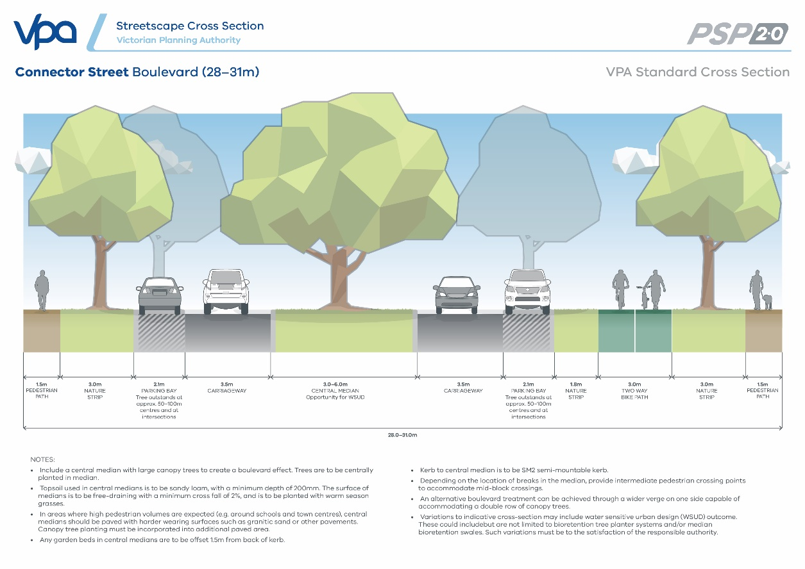
Figure 4 Cross section – Connector street industrial (26m)
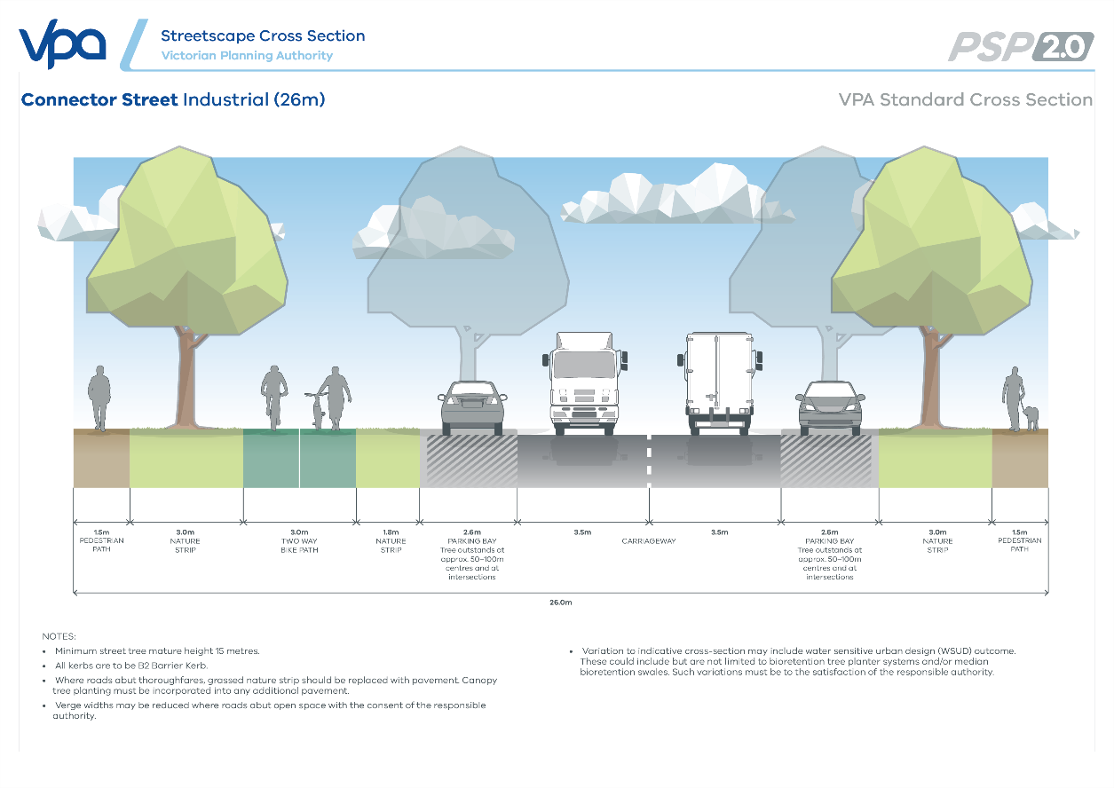

Figure 5 Cross section – Local access street level 2 industrial (22m)
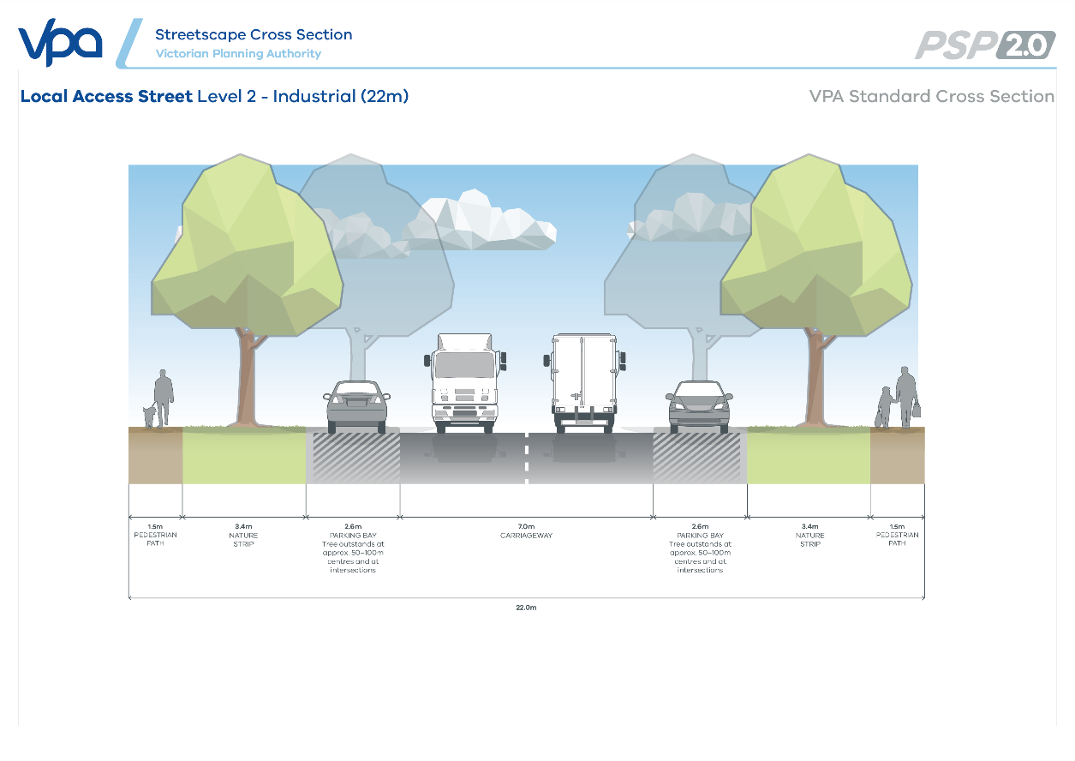
Figure 6 Cross section – Local access street level 2 (20m)
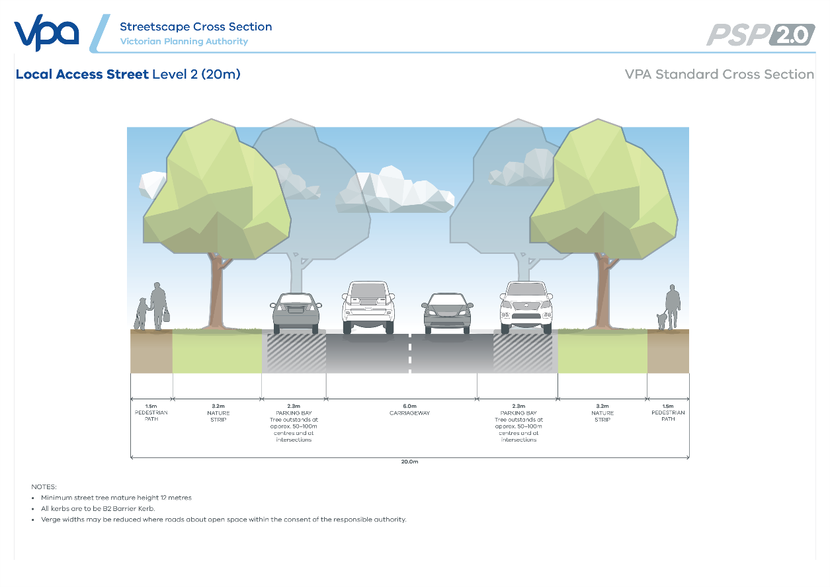

Figure 7 Cross section – Local access street level 1 (16m)
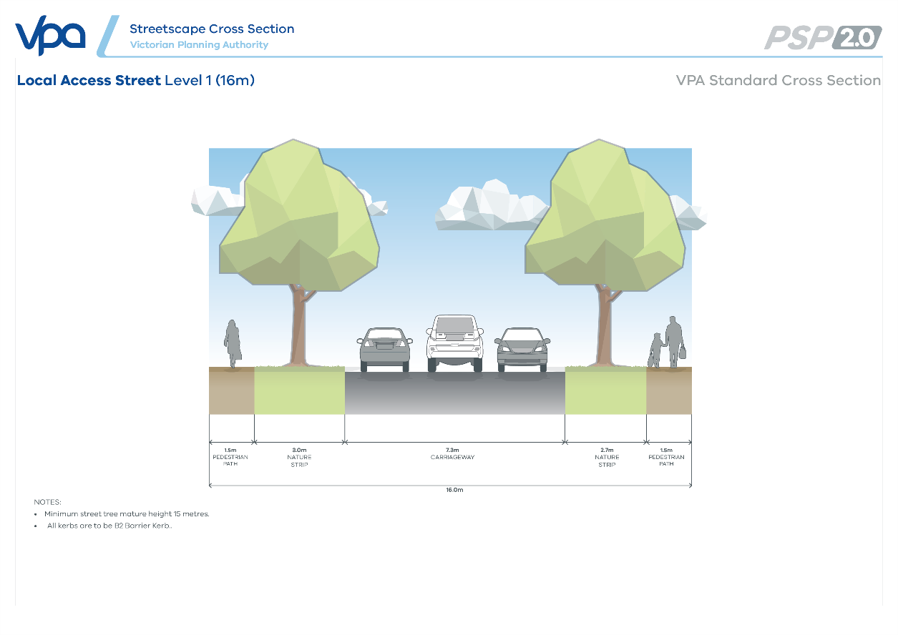
- Place-based road cross sections & functional layout plans
Figure 8 Cross section – Connector street boulevard (23.75m)
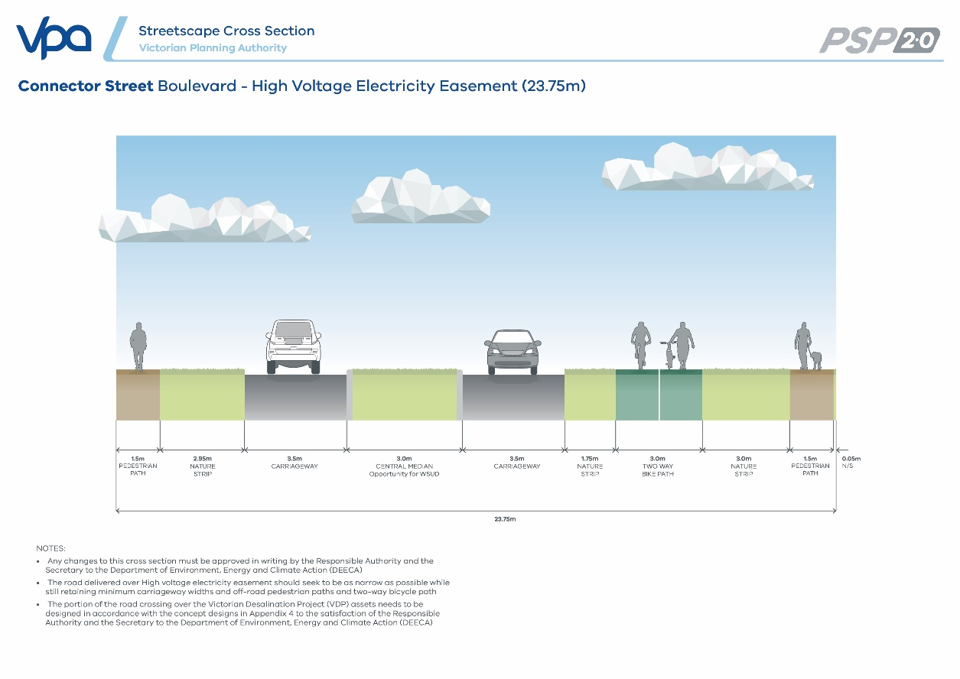
Figure 9 Local access street level 2 – industrial / diversion underground pipe (20m)
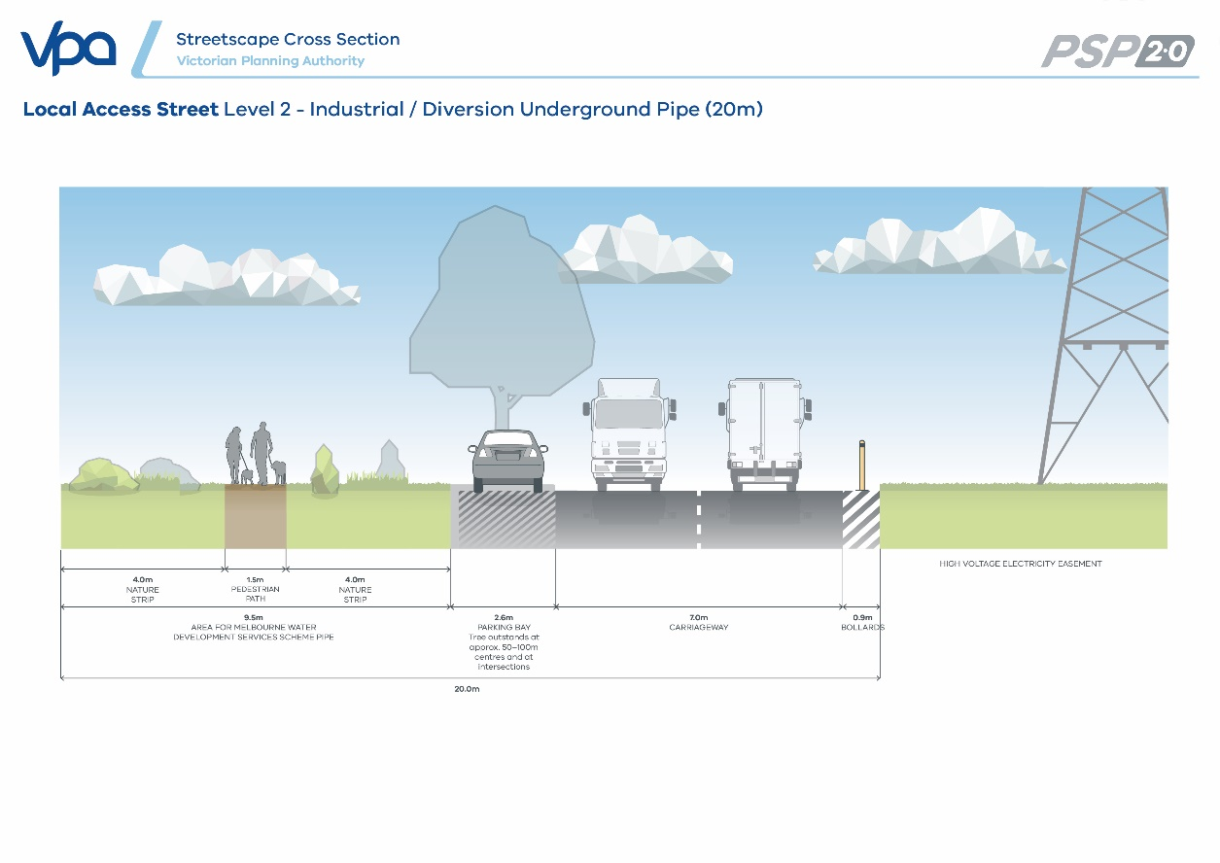
Figure 10 Functional layout plans – Proposed crossings over the Victorian Desalination Project (VDP) assets
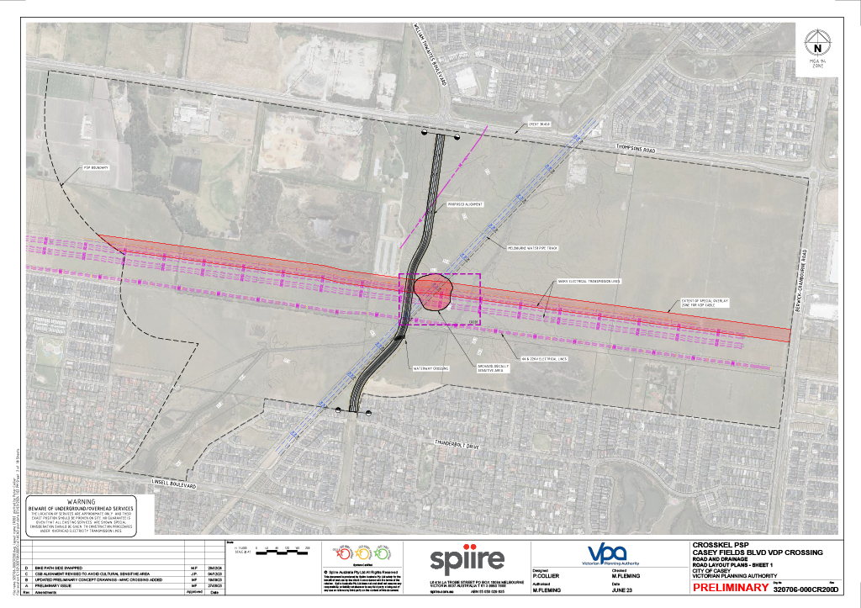
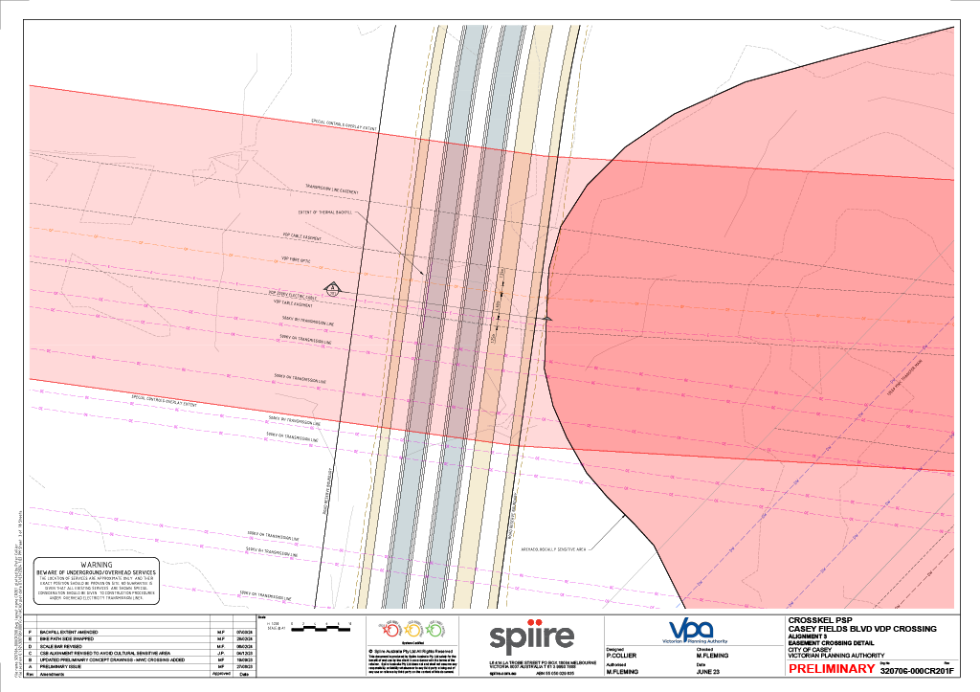
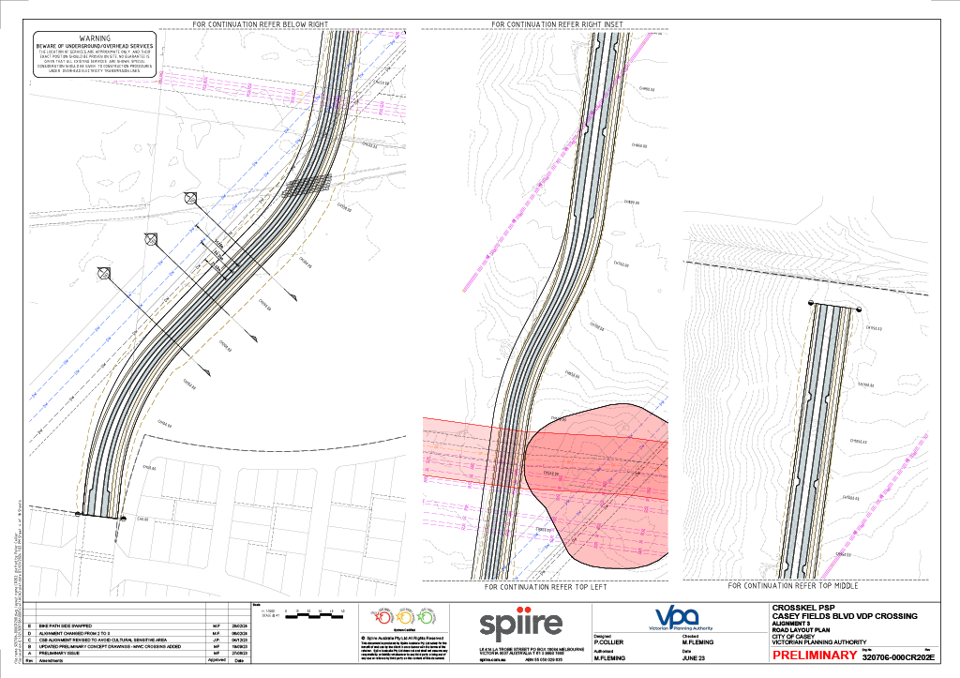
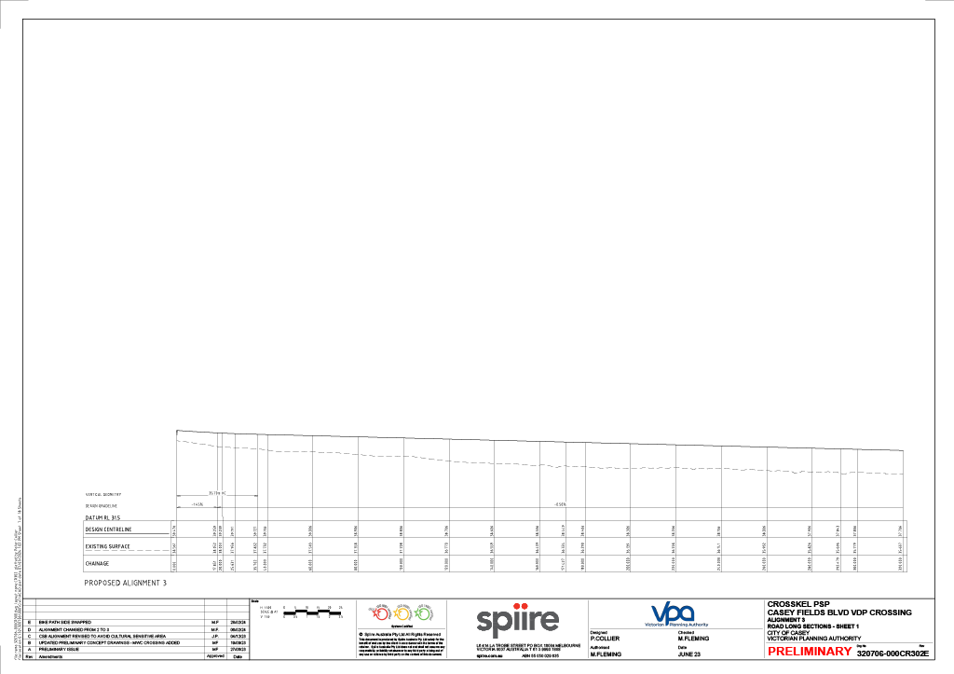
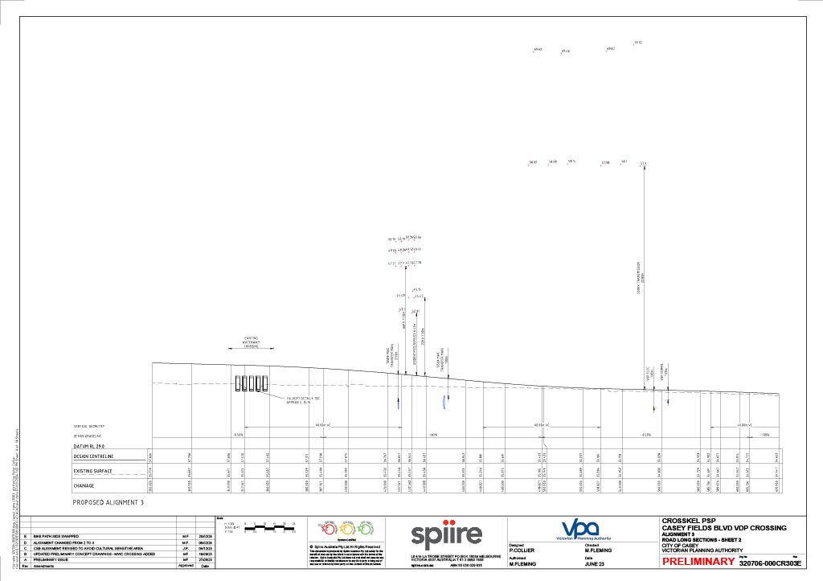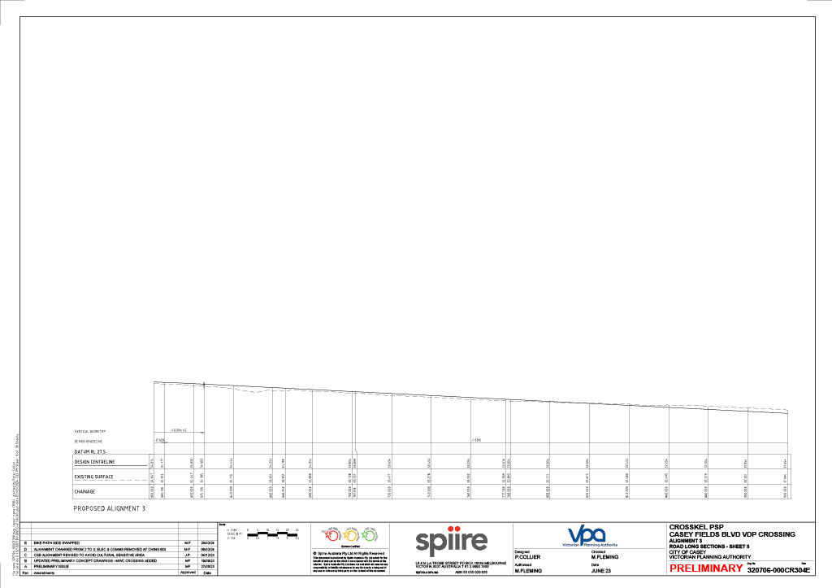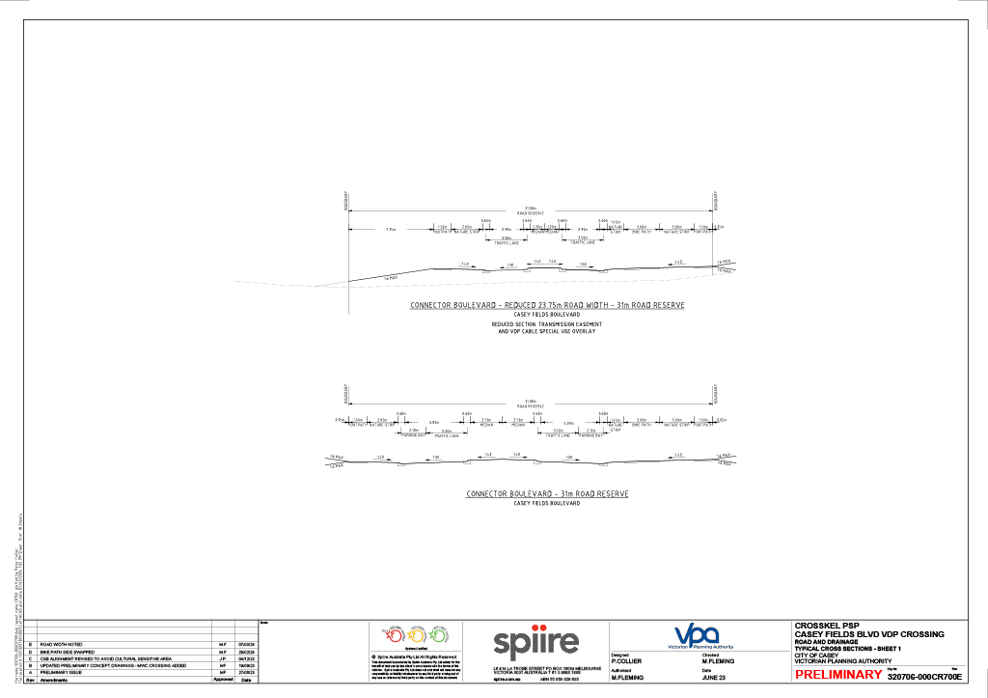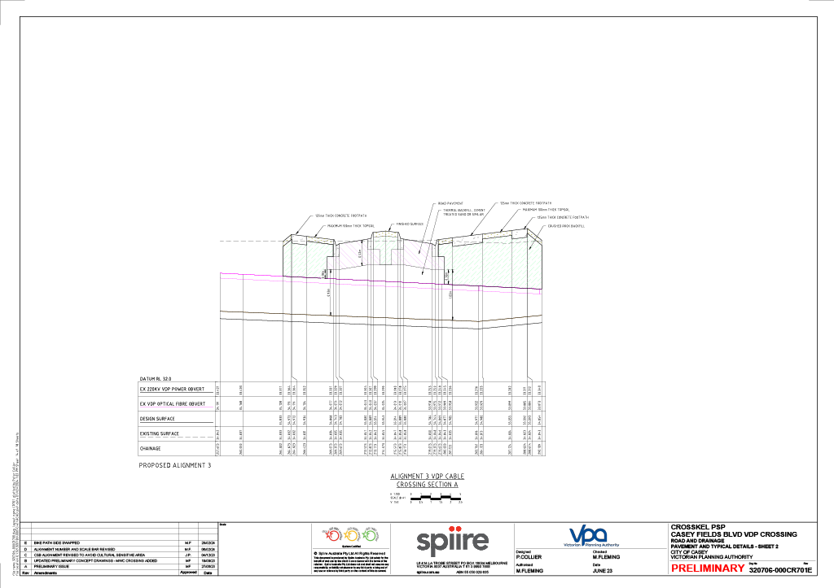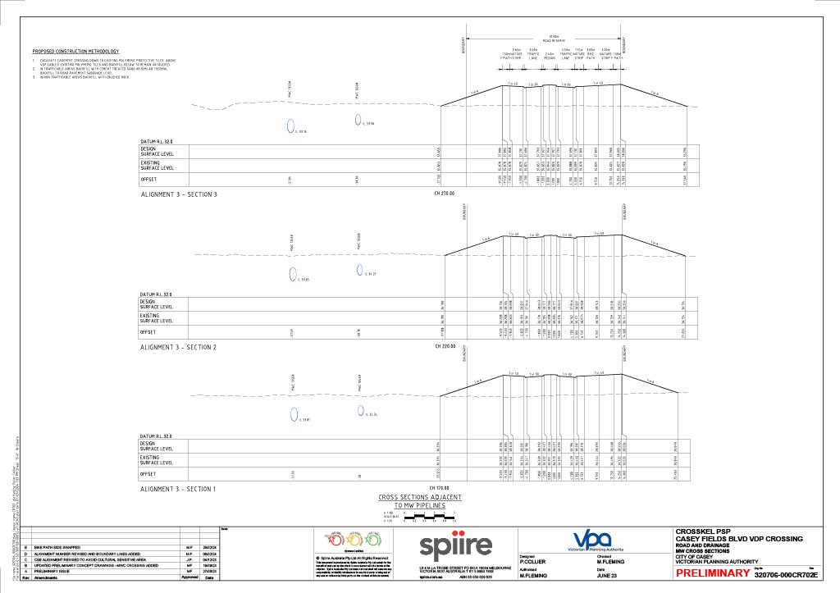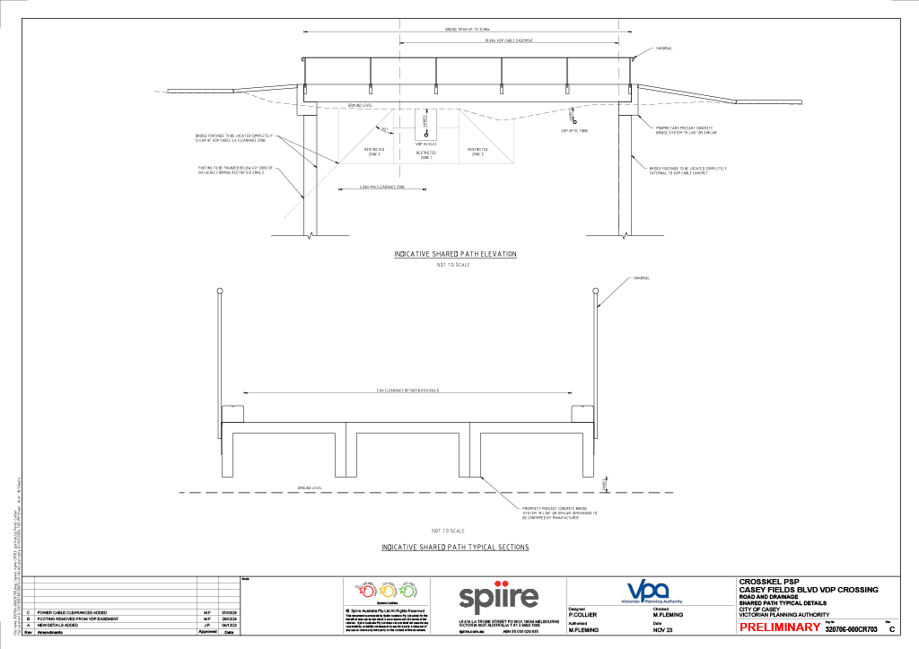
- Glossary of terms
Table 24 Glossary of terms
TERM | DEFINITION
Activity centre | Provides the focus for services, employment and social interaction. They are where people shop, work, meet, relax and live. Usually well-serviced by public transport, they range in size and intensity of use.
Affordable housing | Has the same meaning as Section 3AA of the Planning and Environment Act 1987.
Amenity area | Residential areas within:  - 400m walkable catchment of an activity centre or train station, and/or  - 50m of open space, (both credited and encumbered open space), boulevards and major public transport routes, including but not limited to the Principal Public Transport Network (PPTN) or similar.
Apartment | Several dwellings within the same building footprint. Typically without private grounds and share a common entrance foyer or stairwell (see Casey Housing Strategy 2019 or most recent version).
Biodiversity Conservation Strategy (BCS) | The Biodiversity Conservation Strategy for Melbourne Growth Corridors (State Government of Victoria, 2013).
Canopy tree cover | The total area of a tree’s foliage (which comprises of the layer of leaves, branches, and stems) that covers the ground when viewed from above.
Canopy tree | A tree which has an average potential canopy of foliage of 6.4m in diameter or greater at maturity in the summer months.
Co-location | Adjoining land uses to enable complementary programs, activities, and services as well as shared use of resources and facilities, for example, siting schools and sporting fields together.
Community facility | Infrastructure provided by government or non-government organisations for accommodating a range of community support services, programs, and activities. This includes:  - Facilities for education and learning (e.g. government and non-government schools, universities, adult learning centres)  - Early years (e.g. preschool, maternal and child health, childcare)  - Health and community services (e.g. hospitals, aged care, doctors, dentists, family and youth services, specialist health services)  - Community (e.g. civic centres, libraries, neighbourhood houses)  - Arts and culture (e.g. galleries, museums, performance space)  - Sport, recreation and leisure (e.g. swimming pools)  - Justice (e.g. law courts)  - Voluntary and faith (e.g. places of worship), and  - Emergency services (e.g. police, fire and ambulance stations).
Detached dwelling | A single dwelling on a single lot, separated from other dwellings (see Casey Housing Strategy 2019 or most recent version).
Development services scheme (DSS) | A development services scheme is a master plan for drainage in a specific catchment area. It guides the standards that need to be met for flood protection, water quality and waterway health.
Drainage investigation area | The draft PSP identifies five areas of drainage investigation on Plan 2 Place based plan to highlight potential options to move, expand, or reduce DSS assets with the aim of maximising net developable employment land within the Regionally Significant Commercial Area. All Development Services Scheme (DSS) assets are indicative and subject to further refinement and investigation (including but not limited to these five investigation areas).
Dual occupancy | Two dwellings on a single lot, generally one behind the other (see Casey Housing Strategy 2019 or most recent version).
Duplex | Two dwellings on a single lot, attached side by side (see Casey Housing Strategy 2019 or most recent version).
Encumbered land | Land that is constrained for development purposes, including easements for power/transmission lines, sewer, gas, waterways/drainage; retarding basins/ wetlands; landfill; conservation, protected vegetation and heritage areas. This land may be used for a range of activities (e.g. walking trails, sports fields) and is not credited. However, regard is taken to the availability of encumbered land when determining the open space requirement.
Fire threat edge | The interface between urban development and an area which presents a permanent potential for fire to impact on a community.
Frontage | The road alignment at the front of a lot. If a lot abuts two or more roads, the one to which the building, or proposed building faces
Gateway character | An area delineating the transition between two areas – characterised by an articulated environment with high quality landscaping and built form
Gross developable area | Total precinct area excluding encumbered land, arterial roads and other roads with four or more lanes.
Housing density (gross) | The number of houses divided by gross developable area.
Housing density (net) | The number of houses divided by net developable area.
Infrastructure | Basic facilities and networks (e.g. buildings, roads, and utilities) needed for the functioning of a local community or broader society. Infrastructure can be provided by the private sector (local roads, childcare, shopping centres), or by Government (Kindergartens, schools, railways).
Linear open space network | Corridors of open space, mainly along waterways that link together to form a network.
Land use budget table | A table setting out the total precinct area, gross developable area, net developable area and constituent land uses proposed within the precinct.
Local centre | An activity centre smaller than a neighbourhood activity centre which may include a small limited-line supermarket or convenience store of between 599 square metres and 1,500 square metres, plus non-retail uses.
Main street | A function of an activity centre, where vitality and activity are created by orienting uses towards the street and ensuring that the primary address of all retail stores is the street. This would normally be a connector street rather than an arterial road.
Multi-unit | Several dwellings on a single or consolidated lot with private grounds, detached and generally with a shared area for car parking and access (see Casey Housing Strategy 2019 or most recent version).
Native Vegetation Precinct Plan (NVPP) | A plan, as specified in Clause 52.16 of the Victorian Planning Provisions, relating to native vegetation within a defined area that may form part of the precinct structure plan. Native vegetation precinct plans are incorporated into local planning schemes and listed in the schedule to Clause 52.16. A native vegetation precinct plan can form part of a precinct structure plan.
Neighbourhood activity centre | Activity centres that are an important community focal point and have a mix of uses to meet local needs. They are accessible to a viable user population by walking, cycling and by local bus services and public transport links to one or more principal or major activity centres. This should be of sufficient size to accommodate a supermarket.
Net developable area (NDA) | Land within a precinct available for development. This excludes encumbered land, arterial roads, railway corridors, government schools and community facilities and public open space. It includes lots, local streets, and connector streets. Net developable area may be expressed in terms of hectare units (i.e. NDHa).
Passive open space | Open space that is set aside for parks, gardens, linear corridors, conservation bushlands, nature reserves, public squares and community gardens that are made available for passive recreation, play and unstructured physical activity including walking, cycling, hiking, revitalisation, contemplation and enjoying nature.
Principal public transport network | Incorporated document Principle Public Transport Network 2017 (Victorian Government, 2017), and Principle Public Transport Network Area Maps (Victorian Government, August 2018).
Public open space | Land that is set aside in the precinct structure plan for public recreation that incorporates active and passive open space.
Rear-loaded | Dwellings where the primary vehicle access is from the rear of the lot
Social housing | Social housing as defined by the Housing Act 1983 (Vic) means the following housing (other than under the Victorian Affordable Housing Programs) —  - public housing  - housing owned, controlled or managed by a participating registered agency  - A type of rental housing that is provided and/or managed by the government or by a not-for-profit organisation.  Social housing is an overarching term that covers both public housing and community housing.
Sensitive response | A design or engineered response that does not significantly contrast with the existing landform.
Shop-top | A house attached to a shop, usually above (see Casey Housing Strategy 2019 or most recent version).
Terrace townhouse | Typically attached to one or more dwellings or separated by a small distance (less than half a metre). See Casey Housing Strategy 2019 or most recent version.
Unencumbered | Land that is not constrained by uses required to enable development (including easements for power/transmission lines, sewer, gas, waterways/drainage; retarding basins/wetlands; landfill; conservation protection vegetation and heritage areas).
Water sensitive urban design | A sustainable water management approach that aims to provide water quality, flood management and green landscapes. Key principles include:  - minimising water-resistant areas  - recharging natural groundwater aquifers (where appropriate) by increasing the amount of rain absorbed into the ground  - encouraging onsite reuse of rain and incorporation of rain gardens  - encouraging onsite treatment to improve water quality, and  - removing pollution and using temporary rainfall storage (retarding basins/wetlands) to reduce the load on drains.

