11.01
31/07/2018
VC148

VICTORIA

11.01-1S
02/09/2025
VC283

Settlement Objective
To facilitate the sustainable growth and development of Victoria and deliver choice and
opportunity for all Victorians through a network of settlements.

Strategies
Plan for the delivery of 2.24 million homes across Victoria by 2051. Develop sustainable communities through a settlement framework that:

- Offers a range of housing choices.
- Provides convenient access to jobs, services, infrastructure and community facilities.
- Takes into account regional and municipal contexts and frameworks.
Focus investment and growth in:
- Melbourne Central City.
- Metropolitan Activity Centres and Suburban Rail Loop Precincts in Metropolitan Melbourne.
- Priority Precincts (including the Suburban Rail Loop East Precincts).
- Major regional cities of Ballarat, Bendigo and Geelong.
- Regional cities of Horsham, Latrobe City, Mildura, Shepparton, Wangaratta, Warrnambool and Wodonga.
Manage the expansion of settlements by:
- Creating and reinforcing settlement boundaries. Where no settlement boundary is identified, limit the expansion of a settlement to the extent of existing urban zoned land.
- Promoting and capitalising on opportunities for urban renewal and infill redevelopment.
- Limiting urban sprawl and directing growth into existing settlements.
- Ensuring land that may be required for future urban expansion is not compromised.
Provide for growth in population and development of facilities and services across a regional or sub-regional network in accordance with housing targets.
Plan for development and investment opportunities that make best use of existing and planned transport infrastructure.
Coordinate transport, communications and economic linkages between settlements through the identification of servicing priorities.
Strengthen transport links on national networks for the movement of commodities. Deliver networks of high-quality integrated settlements, suburbs and towns that:
- Are great places with a strong identity and sense of place.
- Are inclusive, prosperous, liveable and sustainable.
- Comprise a form and density that supports healthy, active and sustainable transport.
- Are based around compact existing or planned activity centres to maximise accessibility to facilities and services.
- Concentrate retail, office-based employment, community facilities and services in central locations.

Facilitate environmentally resilient settlements by:
- Integrating the management of water resources into the urban environment in a way that supports water security, public health, environment and amenity outcomes.
- Minimising exposure to natural hazards.
- Contributing to net zero greenhouse gas emissions through renewable energy infrastructure and energy efficient urban layout and urban design.
- Supporting metropolitan and regional climate change adaption and mitigation measures.
- Supporting cooling and greening measures for urban areas.

Policy guidelines
Consider as relevant:
- Any settlement boundary identified in a document incorporated into this planning scheme.

Policy documents
Consider as relevant:
- Plan for Victoria (Department of Transport and Planning, 2025)
- Victoria's housing Statement - The Decade Ahead 2024-2034 (Department of Premier and Cabinet, 2023)

Victoria Settlement Framework Plan
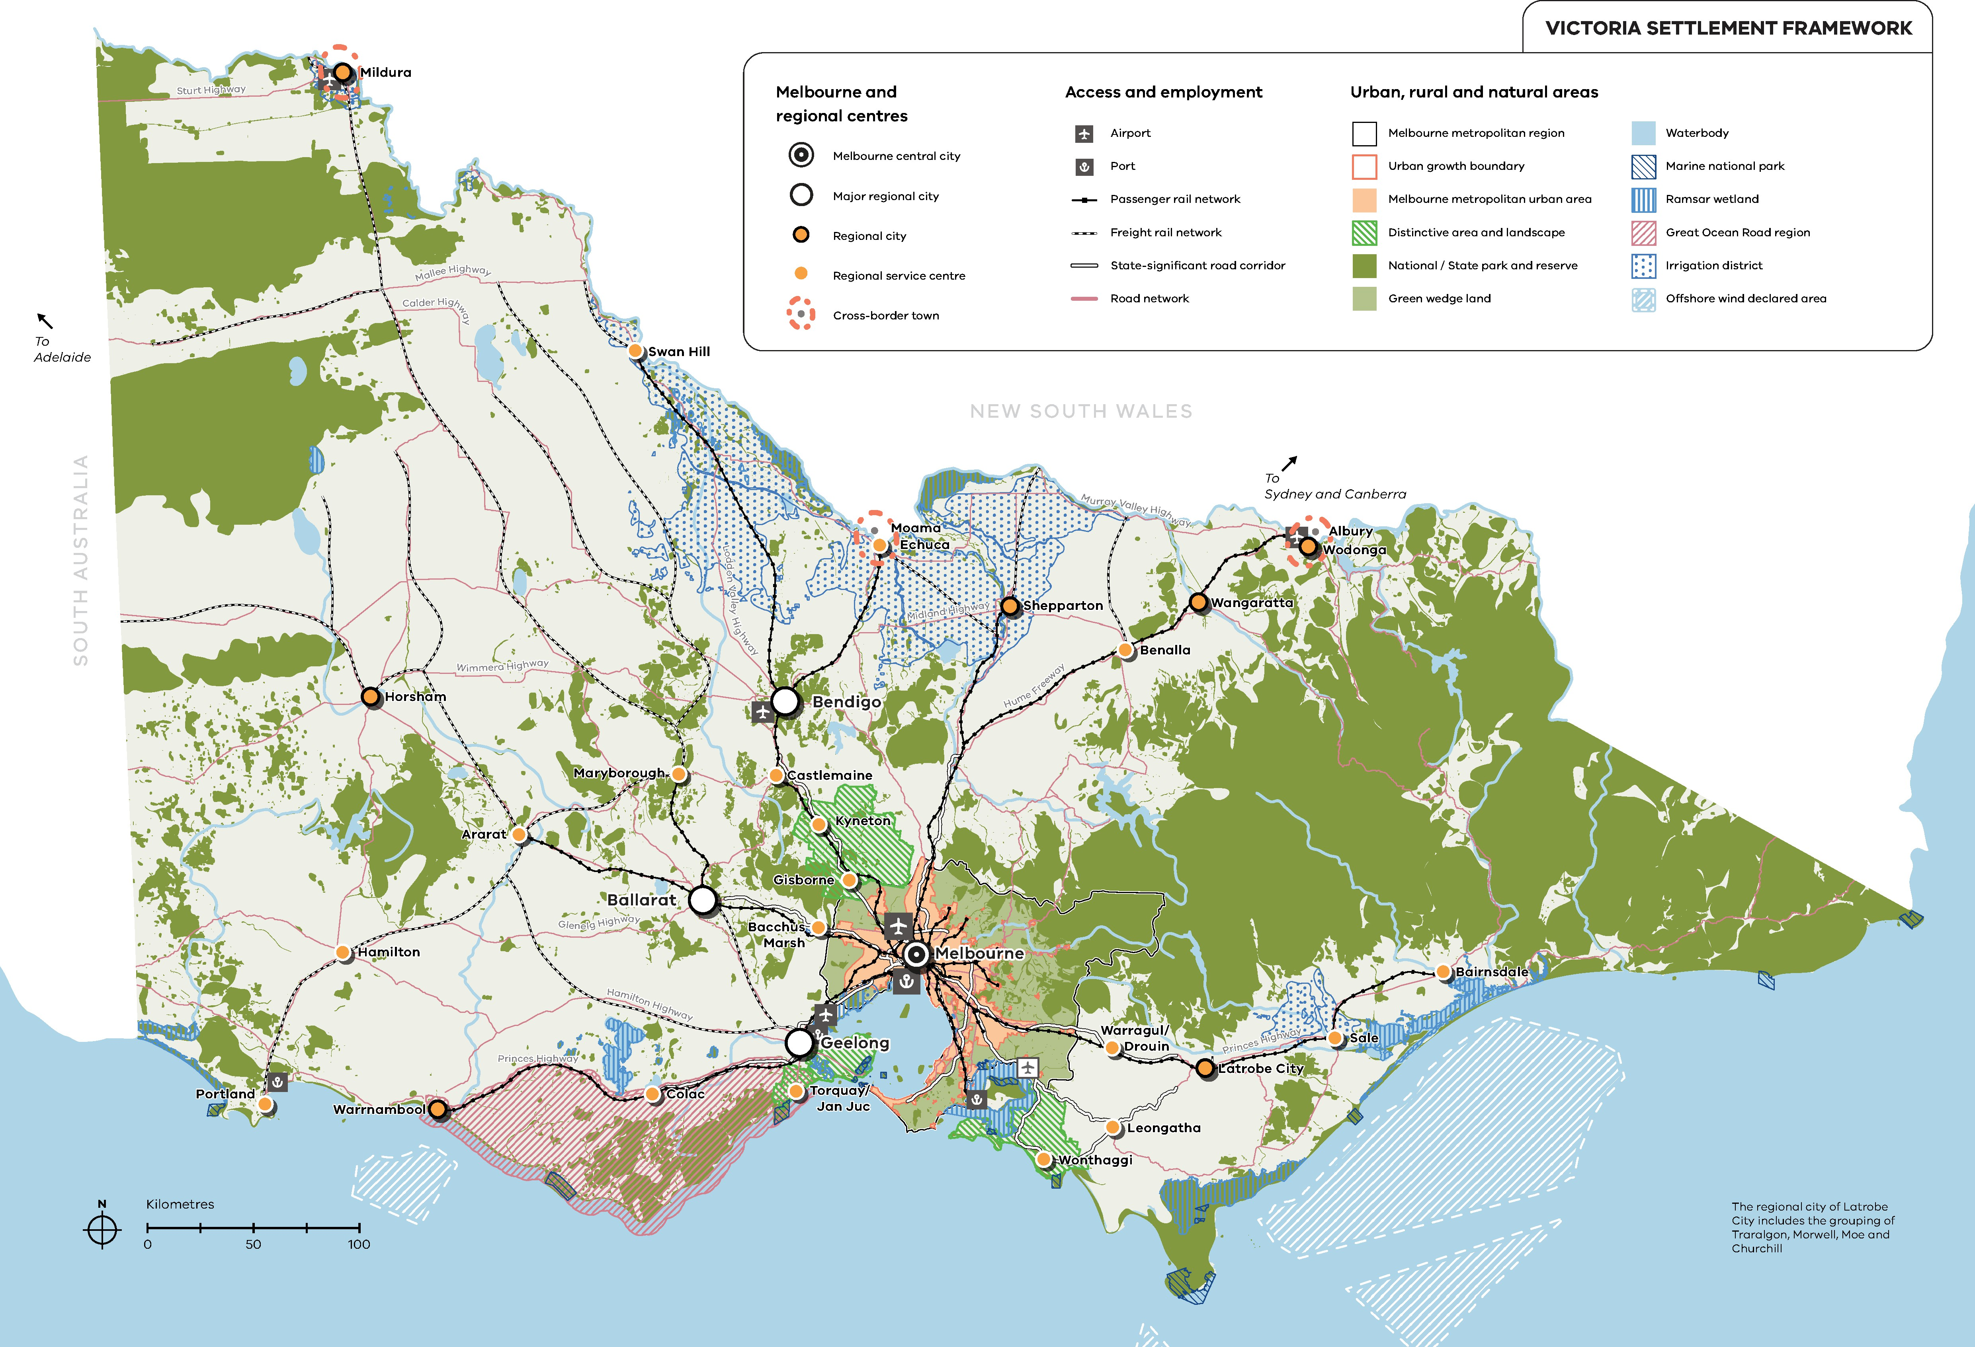

11.01-1R
02/09/2025
VC283

Settlement - Regional Victoria Strategies
Focus regional investment and growth in:

- Major regional cities of Ballarat, Bendigo, Geelong.
- Regional cities of Horsham, Latrobe City, Mildura, Shepparton, Wangaratta, Warrnambool and Wodonga.
Support sustainable development of the Regional service centres of Ararat, Bacchus Marsh, Bairnsdale, Benalla, Castlemaine, Colac, Echuca, Gisborne, Hamilton, Kyneton, Leongatha, Maryborough, Portland, Sale, Swan Hill, Torquay/Jan Juc, Warragul/Drouin and Wonthaggi.
Deliver networks of high-quality integrated regional settlements by:
- Building on strengths and capabilities of each region across Victoria to respond sustainably to population growth and changing environments.
- Developing settlements that will support resilient communities and their ability to adapt and change.
- Balancing strategic objectives to achieve improved land use and development outcomes at a regional, catchment and local level.
- Preserving and protecting features of rural land and natural resources and features to enhance their contribution to settlements and landscapes.
- Encouraging an integrated planning response between settlements in regions and in adjoining regions and states.
- Providing for appropriately located supplies of residential, commercial, and industrial land across a region, sufficient to meet community needs.
- Improving transport network connections in and between Major regional cities, Regional cities and Melbourne.
- Maintaining distinctive breaks and open rural landscapes between settlements.
- Planning for increased seasonal demand on services and infrastructure in towns with significant visitor accommodation and high holiday home ownership or periodic influxes of workers.

11.01-1R
02/09/2025
VC283

Settlement - Loddon Mallee South Strategies
Support Bendigo as the Major regional city and the major population and economic growth hub
for the region, offering a range of employment opportunities and services.
Facilitate increased commercial and residential densities, mixed use development and revitalisation projects for underutilised sites and land in Bendigo.
Manage and support growth in the Regional service centres of Castlemaine, Gisborne, Kyneton and Maryborough as employment and service hubs that reinforce the network of communities in the region.
Support sustainable growth and expansion in Inglewood, Bridgewater, Marong and Harcourt to capitalise on their proximity to Bendigo.

Loddon Mallee South Settlement Framework

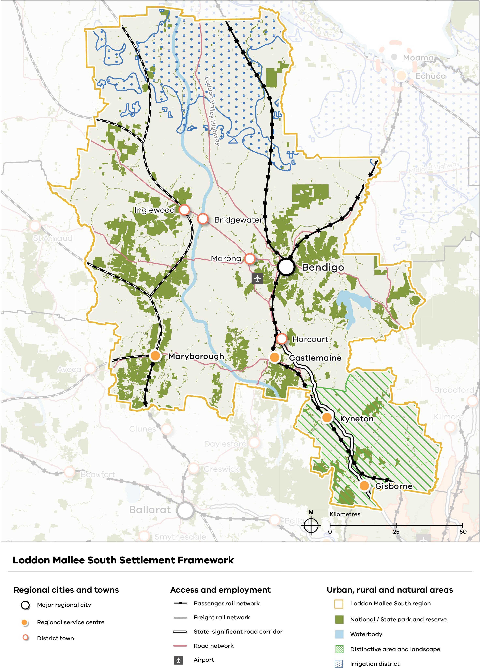

11.01-1L
20/03/2025
C274gben

Settlement - Greater Bendigo Policy application
This policy applies to land identified for residential growth on the Bendigo urban area
residential framework plan that forms part of this clause and the rural townships of Heathcote, Elmore, Goornong, Marong, Redesdale-Mia Mia and Axedale.

Objective
To manage Greater Bendigo’s outward growth and avoid further sprawl by directing growth to identified locations.

Strategies
Direct growth to areas within the Bendigo Urban Growth Boundary, the Bendigo City Centre and other major activity centres, and along main transit corridors.
Direct new residential development into identified residential growth areas within the Bendigo Urban Growth Boundary shown on the Bendigo urban area residential framework plan.
Support compact development within the urban growth boundary by directing new residential development into planned 10 minute neighbourhoods, around large activity centres and neighbourhood activity centres, and on identified key development sites, once development constraints have been addressed, as shown on the Bendigo urban area residential framework plan and listed below:

- Golden Square Chum Street mine site.
- Flora Hill La Trobe University.
- Kangaroo Flat Coliban Water site.
- East Bendigo VicRoads site.
- Maiden Gully South West Neighbourhood Activity Centre.
Support new innovative forms of housing, residential development and community focused neighbourhoods at key development sites.
Avoid rezoning land for residential use outside the Bendigo Urban Growth Boundary unless it abuts the urban growth boundary and all of the following can be met:
- It meets a shortfall in the supply of residential development.
- The land is identified on the Urban strategic framework plan in Clause 02.04 as a future urban investigation area.
- The development of the land will support the 10 minute neighbourhood principles in Clause 02.03-1.
Support residential development in the following rural townships:
- Heathcote.
- Elmore.
- Goornong.
- Marong.
- Redesdale – Mia Mia.
- Axedale.

Avoid rezoning land for sensitive uses within buffer distances of infrastructure with offsite impacts shown on the Urban strategic framework plan in Clause 02.04.

Policy guidelines
Consider as relevant:
- For land rezoning requests for residential, industrial and commercial purposes outside the urban growth boundary:
  - Land supply at a local and municipal level.
  - Whether the site is within walking distance of a proposed or existing railway station (800 metre walking distance) or bus stop (400 metre walking distance).
  - Proximity to and potential impacts on the arterial road network and connections to the public transport system.
  - Accessibility for pedestrians and cyclists within and external to the site.
  - Potential impact of bushfire, including whether the rezoning would require prescribed burning to be undertaken on Crown land in the vicinity.
  - The ecological sustainability of the proposed rezoning.
  - The quality of environmental and agricultural assets on the site and whether these should be protected.

Bendigo urban area residential framework plan
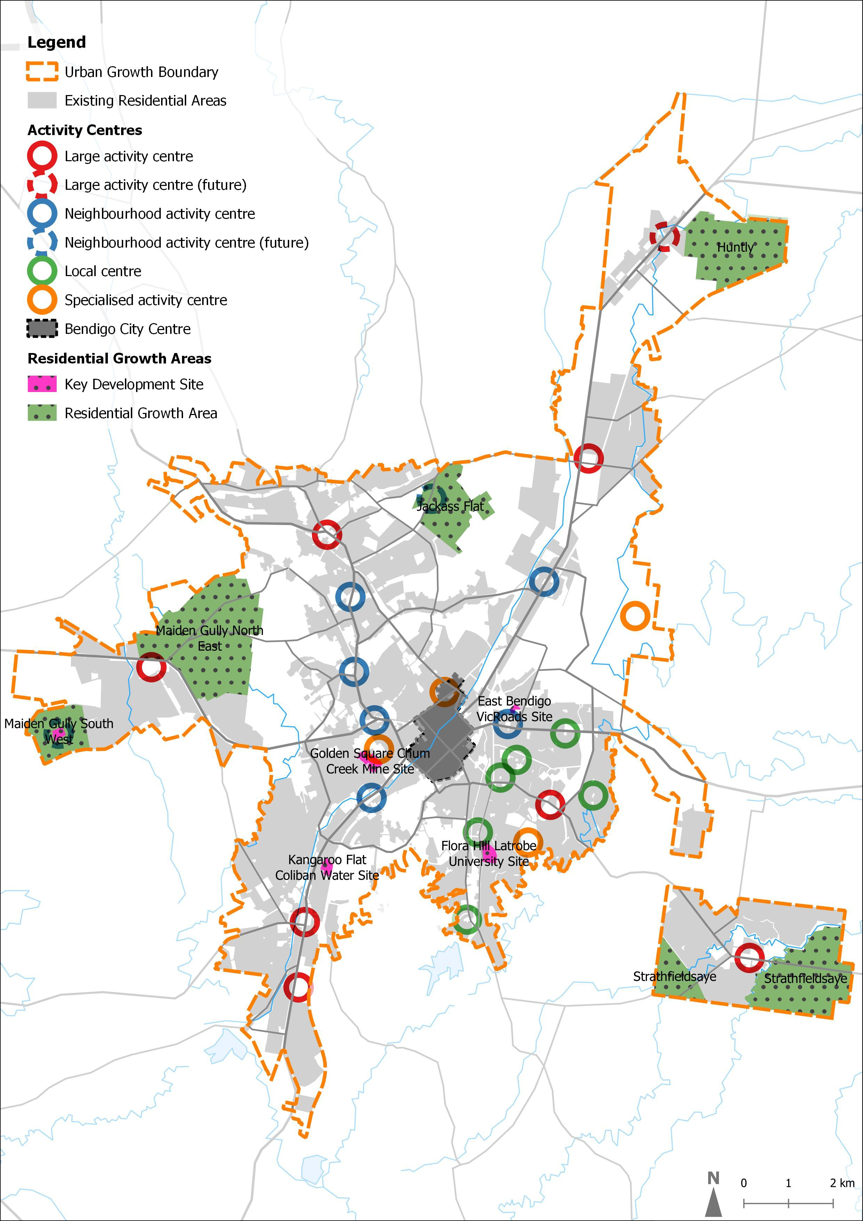

11.01-1L
20/03/2025
C274gben

Settlement - Greater Bendigo Policy application
This policy applies to land identified for residential growth on the Bendigo urban area
residential framework plan that forms part of this clause and the rural townships of Heathcote, Elmore, Goornong, Marong, Redesdale-Mia Mia and Axedale.

Objective
To manage Greater Bendigo’s outward growth and avoid further sprawl by directing growth to identified locations.

Strategies
Direct growth to areas within the Bendigo Urban Growth Boundary, the Bendigo City Centre and other major activity centres, and along main transit corridors.
Direct new residential development into identified residential growth areas within the Bendigo Urban Growth Boundary shown on the Bendigo urban area residential framework plan.
Support compact development within the urban growth boundary by directing new residential development into planned 10 minute neighbourhoods, around large activity centres and neighbourhood activity centres, and on identified key development sites, once development constraints have been addressed, as shown on the Bendigo urban area residential framework plan and listed below:

Golden Square Chum Street mine site. Flora Hill La Trobe University.
Kangaroo Flat Coliban Water site. East Bendigo VicRoads site.
Maiden Gully South West Neighbourhood Activity Centre.
Support new innovative forms of housing, residential development and community focused neighbourhoods at key development sites.
Avoid rezoning land for residential use outside the Bendigo Urban Growth Boundary unless it abuts the urban growth boundary and all of the following can be met:
It meets a shortfall in the supply of residential development.
The land is identified on the Urban strategic framework plan in Clause 02.04 as a future urban investigation area.
The development of the land will support the 10-minute neighbourhood principles in Clause 02.03-1.
Support residential development in the following rural townships:
Heathcote. Elmore.
Goornong. Marong.
Redesdale – Mia Mia. Axedale.

Avoid rezoning land for sensitive uses within buffer distances of infrastructure with offsite impacts shown on the Urban strategic framework plan in Clause 02.04.

Policy guidelines
Consider as relevant:
For land rezoning requests for residential, industrial and commercial purposes outside the urban growth boundary:
- Land supply at a local and municipal level.
- Whether the site is within walking distance of a proposed or existing railway station (800 metre walking distance) or bus stop (400 metre walking distance).
- Proximity to and potential impacts on the arterial road network and connections to the public transport system.
- Accessibility for pedestrians and cyclists within and external to the site.
- Potential impact of bushfire, including whether the rezoning would require prescribed burning to be undertaken on Crown land in the vicinity.
- The ecological sustainability of the proposed rezoning.
- The quality of environmental and agricultural assets on the site and whether these should be protected.

Bendigo urban area residential framework plan

11.01-1L
20/03/2025
C274gben

Settlement - Heathcote Policy application
This policy applies to land within the Heathcote settlement boundary shown on the Heathcote
strategic framework plan attached to this clause.

Strategies
Locate urban development within the defined settlement boundary as shown on the Heathcote strategic framework plan.
Consolidate residential and commercial development in the Heathcote activity centre (town centre) and residential precincts as shown on the Heathcote strategic framework plan.
Create an urban-forest interface between urban development and the forested areas along the eastern and western boundaries of Heathcote to protect the environmental values of the adjoining forested areas as shown on the Heathcote strategic framework plan.
Avoid intensifying development adjoining and within the urban-forest interface as shown on the Heathcote strategic framework plan.
Orientate development along the creek line interface as shown on the Heathcote strategic framework plan towards McIvor Creek to enhance the amenity of the creek environs within the town.

Heathcote strategic framework plan
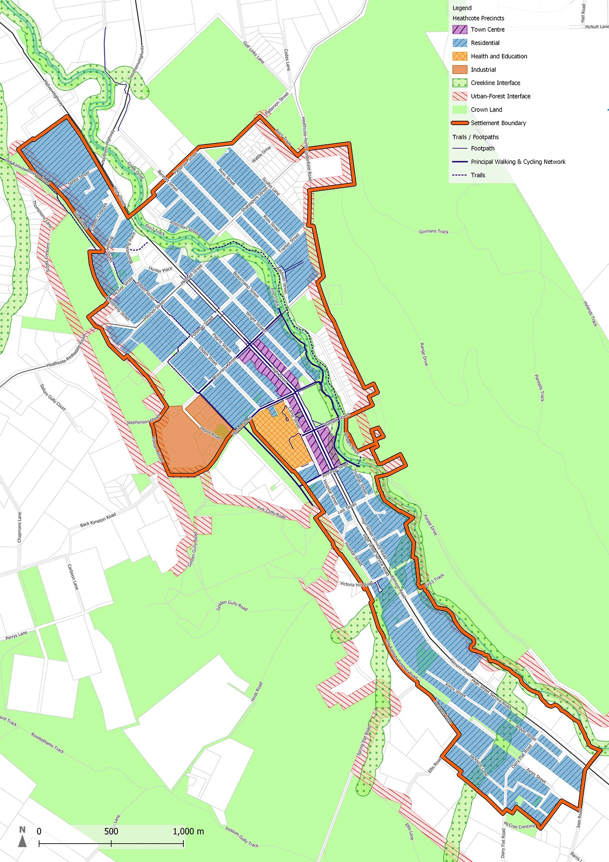

11.01-1L
Proposed
C296gben

Settlement - Marong Policy application
This policy applies to land within the settlement boundary shown on the Marong framework
plan attached to this clause.

Strategies
Maintain Marong as a self-contained settlement by retaining a non-urban break between Marong and the other urban areas of Maiden Gully and Eaglehawk.
Direct development to land within the defined settlement boundary as shown on the Marong framework plan.

Provide for development to the west, south and east of Marong shown as Precincts 1 to 4 on the Marong framework plan, as demonstrated by demand for additional land supply, and subject to bushfire, flooding and biodiversity constraints and the protection of Aboriginal cultural heritage values.
Plan for infrastructure and servicing that supports the Bendigo Regional Employment Precinct, as identified on the Marong framework plan.
Plan new residential development areas shown as Precincts 1 to 4 on the Marong framework plan by:
Supporting upgrades to transport infrastructure that integrate with the proposed Marong railway station.
Retaining significant vegetation in the public realm and on private land. Providing modest building heights.
Orientating buildings to public open space areas and networks. Supporting no or low front fences.
Ensure the development of Precinct 1 shown on the Marong framework plan does not conflict with the planned Marong Western Freight Corridor, includes managed interfaces and integrates with the Bendigo Regional Employment Precinct.
Design subdivision layouts along Bullock Creek in Precincts 2 and 3 as shown on the Marong framework plan to create a new public open space corridor.
Encourage residential development in Precinct 4 as shown on the Marong framework plan to transition to lower densities where the residential area interfaces with rural areas.

Policy documents
Consider as relevant:
Marong Township Structure Plan (City of Greater Bendigo, June 2024)

Marong framework plan

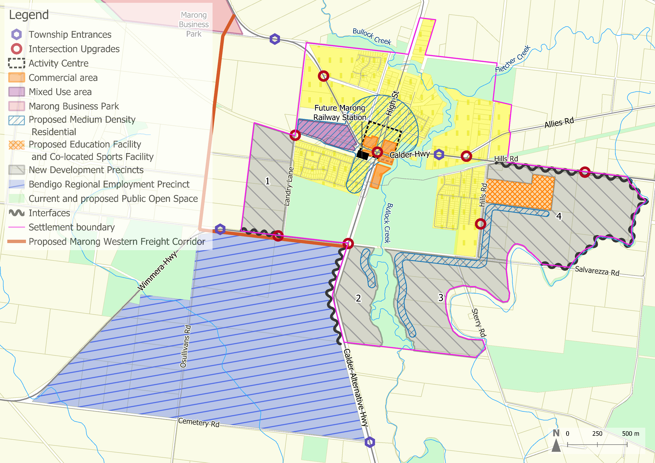

11.01-1L
20/03/2025
C274gben
Note: The proposed upgrades to transport infrastructure shown on this plan have not been endorsed by the Head, Transport for Victoria.

10 minute neighbourhoods - Greater Bendigo Objective
To develop a network of attractive neighbourhoods that allow most people to access local facilities and services within 10 minute walking or cycling from their home.

Strategies
Manage growth in accordance with the 10 minute neighbourhood principles identified in Clause 02.03-1 to create identifiable communities where people can access many of their daily needs within a 10 minute walk or cycle trip from where they live.
Support residential development that is within 10 minutes walking or cycling distance from activity centres, or other community and commercial facilities.
Support proposals for uses such as convenience shops, food and drink premises, child care centres, schools, home offices and other uses that are consistent with 10 minute neighbourhood principles in residential areas.

Policy documents
Consider as relevant:

Greater Bendigo Housing Strategy (City of Greater Bendigo, January 2018)
Walk, Cycle Greater Bendigo (City of Greater Bendigo, September 2019)

