11.03-6L-04 Bendigo Regional Employment Precinct
Proposed
C296gben

Policy application
This policy applies to land within the Bendigo Regional Employment Precinct local area map that forms part of this clause.
Objective
To support the development of the Bendigo Regional Employment Precinct as the key industrial and employment area for the municipality and broader region.
Strategies
Facilitate the coordinated growth of the Bendigo Regional Employment Precinct to provide for the region’s future industrial employment needs.
Ensure that industrial development is sequenced to supply demonstrated regional economic and employment needs.
Ensure that sufficient undeveloped land is set aside in the Bendigo Regional Employment Precinct for the planned Marong Western Freight Corridor.
Encourage the coordination and consolidation of shared infrastructure and open space to maximise developable land and support the precinct’s industrial and employment functions.
Coordinate the sequencing of industrial land supply with delivery of the required infrastructure and services including potable water, sewer, drainage, electricity, telecommunications and roads integrated into existing and future networks.
Sequence and prioritise industrial land use and development in the Bendigo Regional Employment Precinct where access to the planned Marong Western Freight Corridor is provided.

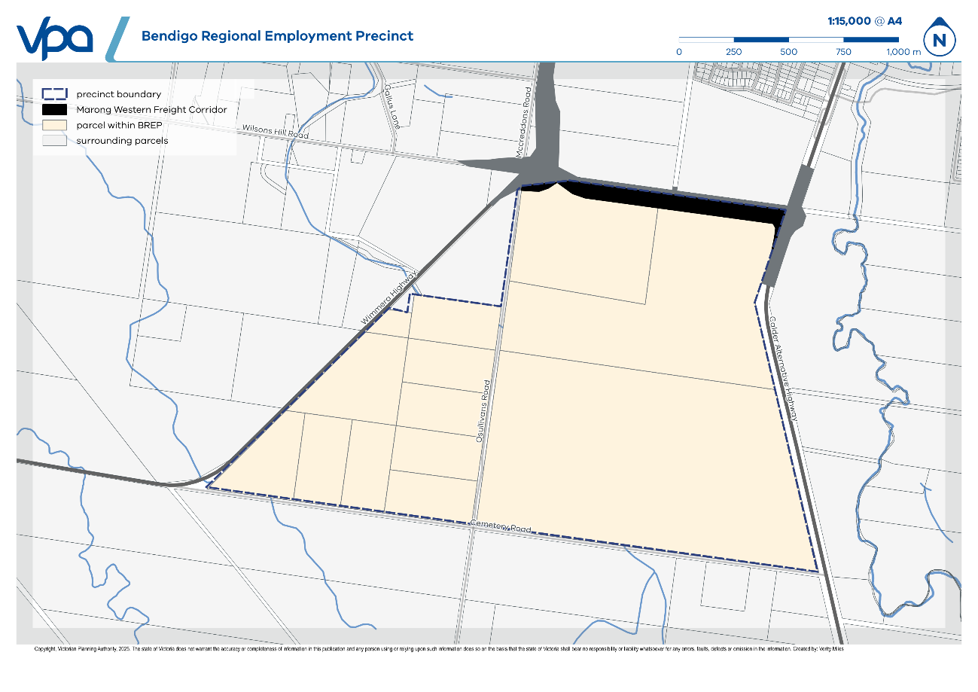
Policy document
Consider as relevant:
- Bendigo Regional Employment Precinct Guideline for Preparing Shared Infrastructure Plan for State Transport Infrastructure (Victorian Planning Authority, November 2025)

