Planning and Environment Act 1987

Hobsons Bay Planning Scheme
Maribyrnong Planning Scheme

Amendment GC276

Explanatory Report

Overview
The amendment rezones land in the Hobsons Bay Planning Scheme and Maribyrnong Planning Scheme from Industrial 1 Zone (I1Z) to Industrial 3 Zone (I3Z) within the Western State Significant Industrial Precinct.
The rezoning will encourage the transition of the two precincts from heavy industrial land uses towards industrial / commercial uses that will have less impact on the surrounding areas by the transition to less heavy vehicle transport and provide opportunities for uses which have less impact on the environment.

Where you may inspect this amendment
The amendment can be inspected free of charge at the following places:
Hobsons Bay City Council
115 Civic Parade, Altona, VIC, 3018
https://www.hobsonsbay.vic.gov.au/Home
Maribyrnong City Council
61 Napier Street, Footscray VIC 3011
https://www.maribyrnong.vic.gov.au/Home
The amendment can also be inspected free of charge at the Department of Transport and Planning website at http://www.planning.vic.gov.au/public-inspection or by contacting the office on 1800 789 386 to arrange a time to view the amendment documentation.

Details of the amendment

Who is the planning authority?
This amendment has been prepared by the Minister for Planning who is the planning authority for this amendment.

Land affected by the amendment
The amendment applies to land in the Western State Significant Industrial Precinct identified as the Sunshine Road and Brooklyn Precincts in Map 1. The amendment area includes 73 hectares of land within the Maribyrnong local government area (LGA), and 96 hectares of land within the Hobsons Bay LGA.
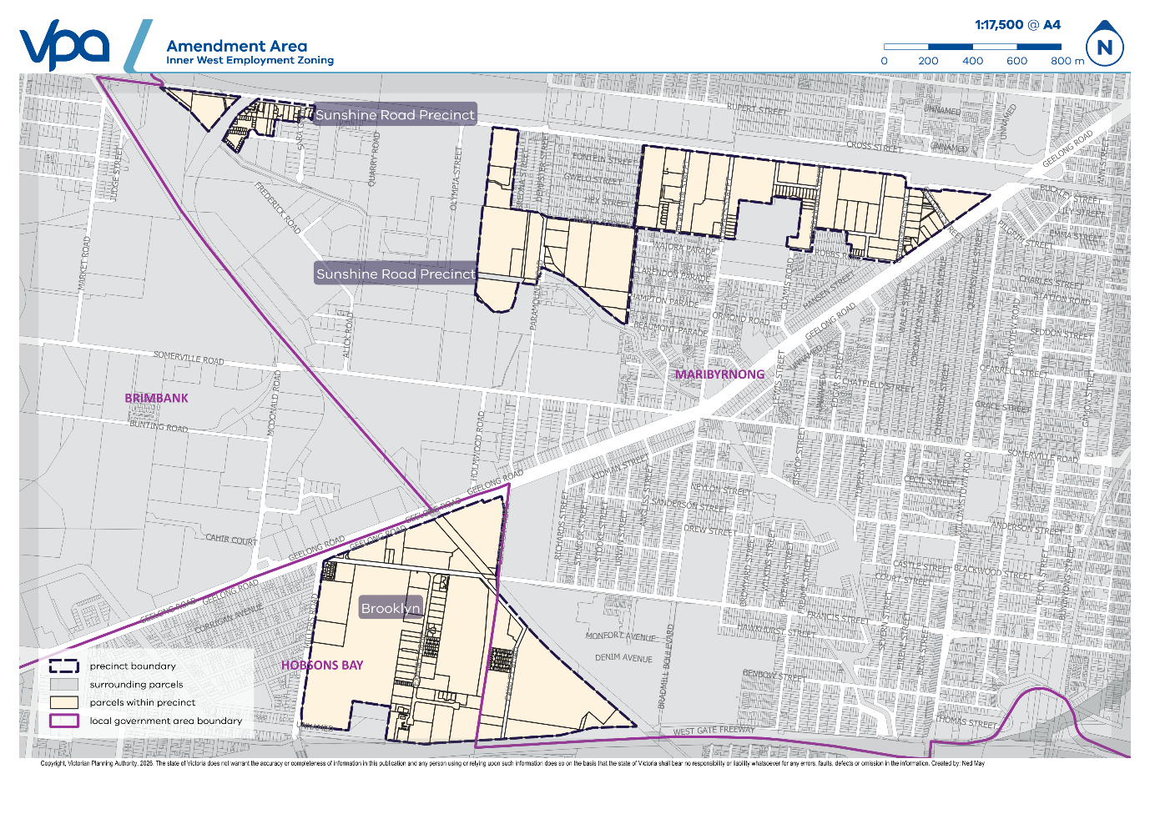
Map 1 – Amendment Area Map

What the amendment does
The amendment rezones land within the amendment area identified in Map 1 from Industrial 1 Zone (IN1Z) to Industrial 3 Zone (IN3Z).
Specifically, the amendment:
- Replaces Hobsons Bay Planning Scheme Zone Map No. 3ZN to rezone land in the Amendment Area Map from Industrial 1 Zone (IN1Z) to Industrial 3 Zone (IN3Z).
- Replaces Maribyrnong Planning Scheme Zone Maps 6, 7, 8, 10 and 11ZN in the Amendment Area Map from Industrial 1 Zone (IN1Z) to Industrial 3 Zone (IN3Z).

Strategic assessment of the amendment

Why is the amendment required?
The amendment implements, in part, the State government’s A 10-year plan for industrial land. The strategy includes actions for enabling development on existing industrial land including to “rezone inner west industrial land in Brooklyn, Tottenham and West Footscray to an alternative employment zone to support the relocation of container businesses part of the West Gate Tunnel Project, alongside unlocking land better suited for freight business in the west, such as Altona North and Derrimut Fields.”
The rezoning INZ1 land to IN3Z rezoning will facilitate the transition of land uses in the precinct to a lighter form of industry that are less reliant on heavy vehicles and provide opportunities for uses which have less impact on the environment. This will also improve the amenity of adjoining areas and safety of roads in the inner west as land uses gradually transition in conformity with A 10-year plan for industrial land.
The transition will also be assisted by the recent opening of the West Gate Tunnel which provides an alternative to the West Gate Bridge and provides for stronger transport connections to Altona and Derrimut.

How does the amendment implement the objectives of planning in Victoria?
The amendment implements the objectives in section 4(1) of the Act. In particular, supporting the following objectives:
- to provide for the fair, orderly, economic and sustainable use, and development of land;
- to secure a pleasant, efficient and safe working, living and recreational environment for all Victorians and visitors to Victoria;
- to facilitate development in accordance with the objectives set out in paragraphs (a), (b), (c), (d) and (e); and
- to balance the present and future interests of all Victorians.
The rezoning of land to a better-suited employment zone based on the changing road transport conditions in the surrounding area enables the achievement of the above objectives.

How does the amendment address any environmental, social and economic effects?
Environmental
The amendment is not anticipated to have substantial environmental effects as it is a rezoning of land that is already zoned for employment purposes and does not permit any additional sensitive uses.
The rezoning may have the benefit of improved air quality on inner west streets as road transport movements will transition to areas such as Altona North and Derrimut Fields.
Social
The rezoning will facilitate the transition of land uses in the two precincts to a lighter form of commercial / industry uses that it is expected in the longer term to result in a reduction of heavy vehicle movements in the precincts and adjoining areas and better integration with the surrounding areas.
The key social benefits for residents in surrounding areas is the potential for safer streets with higher amenity and the reduction of off site impacts of noise, traffic and potential for additional employment and commercial opportunities as it is expected that the two precincts will attract advanced manufacturing, logistics, research and development and clean industries.
Economic
The State Government’s A 10-year plan for industrial land includes actions for enabling the transition of industrial land including: “rezone inner west industrial land in Brooklyn, Tottenham and West Footscray to an alternative employment zone to support the relocation of container businesses part of the West Gate Tunnel Project, alongside unlocking land better suited for freight business in the west, such as Altona North and Derrimut Fields.”
The two precincts are within the Western Region as defined in the Melbourne Industrial and Commercial Land Use Plan (MICLUP). This region comprises six LGAs in Melbourne’s western suburbs. In Melton and Wyndham take-up of IN3Z land remains strong and the supply of available land continues to diminish. In the Melton and Wyndham LGAs:
- Consumption of IN3Z land averaged 70 hectares per annum between 2019-2024; and
- Zoned vacant supply of IN3Z land was 241 hectares at the end of 2024.
Based on this, it is expected that the rezoning will encourage IN1Z uses to progressively transition to areas that have locational attributes that suit freight-related activities.
It is also expected that the rezoning area would gradually transition the two precincts to light industrial / commercial activities with increased employment diversity, lower intensity of heavy vehicle movements, higher land values, investment attraction, better integration and amenity with surrounding communities and reduced land-use conflict.

Does the amendment address climate change?
Ministerial Direction No. 22 Climate Change Consideration specifies the matters relating to climate change a planning authority must have regard to in preparing a planning scheme or amendment to a planning scheme in accordance with section 12(2A) of the Planning and Environment Act 1987 (the Act).
The requirements of Ministerial Direction 22 Climate Change Consideration do not apply to this amendment as the amendment does not rezone land from a non-urban zone to an urban zone or have the effect of enabling:
  - a significant change to, or intensification of, the use and development of urban land; or
  - a new use and development of land (whether or not subject to the grant of a planning permit) that may be exposed to a natural hazard that arises from, or is likely to arise from, the impacts of climate change.
The amendment is limited in scope to the rezoning of land. As the land is already zoned for urban purposes, and the rezoning is not expected to enable a significant change or intensification of the use and development of land and does not introduce new uses that may be exposed to natural hazards arising from climate change.

Does the amendment address relevant bushfire risk?
The amendment involves the rezoning of land within an existing urban area, and the zoning change will not influence the susceptibility of the precinct to bushfire hazard.

Does the amendment comply with the requirements of any other Minister’s Direction applicable to the amendment?
Ministerial Direction 1: Potentially Contaminated Land
Ministerial Direction 1: Potentially Contaminated Land applies to the amendment as the land has potentially been used for industry.
The rezoning from IN1Z to IN3Z does not allow any additional sensitive use specified in section 1 or 2 of the Table of Uses to the Zone and the Direction is satisfied.
Ministerial Direction 11: Strategic Assessment of Amendments
The amendment is consistent with this direction which ensures a comprehensive strategic evaluation of a planning scheme amendment and the outcomes it produces. The preparation and considerations of this explanatory report appropriately satisfy this direction.
Ministerial Direction 19: Amendments that may result in impacts on the environment, amenity and human health
Environment Protection Authority (EPA) comments were sought on the amendment. The EPA agreed that the amendment proposes a minor land use transition to less intense forms of industrial development, and the potential for uses with negative environmental impacts is subsequently reduced. The EPA further stated that the absence of any new or intensified sensitive uses resulting from the change in zone indicates that the opportunities of exposure to pollution or waste remain unchanged, and therefore the amendment does not create a significant impact on human health or the environment.
Ministerial Direction 20 – Major Hazard Facilities
Ministerial Direction 20 (MD20) applied to the draft amendment area at the time of agency validation and consultation. The rezoning area was located proximate to a registered Major Hazard Facility (FBT Transwest Pty Ltd located at 1 Amanda Road, Tottenham). The draft amendment was referred to WorkSafe and the Minister for Economic Growth and Jobs as prescribed. WorkSafe objected to the draft amendment on the basis that rezoning of land immediately surrounding the Major Hazard Facility, within 500m of the FBT Transwest Facility would allow for the introduction of an array of commercial land uses increasing the population and changing the land use sensitivity from ‘normal working population’ to ‘general public.’
After further consultation, WorkSafe advised that removal of land parcels affected by the 500m outer buffer area from the draft amendment would be an acceptable outcome. As the Industrial 3 Zone schedule does not allow for bespoke land use permissions, approximately 68 hectares was removed from the amendment area. As the remaining land to be rezoned is no longer within the threshold distance to a Major Hazard facility MD20 no longer applies.

How does the amendment support or implement the Planning Policy Framework?
The amendment helps implement the Planning Policy Framework through the following objectives and strategies:
- Clause 15.03-2S (Aboriginal Cultural Heritage) – The amendment supports the objectives of Clause 15.03-2S (Aboriginal Cultural Heritage) by working in partnership with the Bunurong Land Council Aboriginal Corporation (BLCAC), the Registered Aboriginal Party (RAP) for the precinct. BLCAC’s Cultural Values and Research Unit (CVRU) has prepared a Cultural Values Statement to identify and share areas of cultural and environmental significance within the precinct, including Stony Creek. This statement provides important insights into pre-colonial and contemporary cultural values and is available on the project webpage to promote understanding and respect for Bunurong culture and heritage.
- Clause 17.01-1R Diversified Economy – Metropolitan Melbourne identifies the need to plan for industrial land in suitable locations to support employment and investment opportunities. While the site is existing industrial land, the rezoning will continue to support employment and investment opportunities while encouraging further diversification.
- Clause 17.03-3S Significant industrial land identifies the need to protect state significant industrial precincts from incompatible land uses to allow for future growth. The rezoning to an appropriate industrial zone in response to changed transport conditions will enable a mix of employment uses that will prevent future pressure to rezone the land for other purposes as land uses change and transition over time.
- Clause 18.01-1S Land use and transport integration identifies the need to plan the use of land adjacent to the transport system having regard to the current and future development and operation of the transport system.

How does the amendment support or implement any relevant strategic plan or policy statement adopted by a Minister, government department or public authority?
A 10-year plan for industrial land.
The strategy includes actions for enabling development on existing industrial land including to “rezone inner west industrial land in Brooklyn, Tottenham and West Footscray to an alternative employment zone to support the relocation of container businesses part of the West Gate Tunnel Project, alongside unlocking land better suited for freight business in the west, such as Altona North and Derrimut Fields.”
The rezoning INZ1 land to IN3Z rezoning will facilitate the transition of land uses in the precinct to a lighter form of industry that are less reliant on heavy vehicles. This will also improve the amenity and safety of roads in the inner west as land uses gradually transition in conformity with A 10-year plan for industrial land.
Melbourne Industrial and Commercial Land Use Plan (MICLUP)
MICLUP provides an overview of current and future needs for industrial land across metropolitan Melbourne and puts in place a planning framework to support state and local government to plan more effectively for future employment and industry needs and better inform future strategic directions.
The amendment area is included within the Western State Significant Industrial Precinct (SSIP) under MICLUP. A series of principles and strategies are included, and the proposed amendment helps implement many of these such as:
- Ensuring the attributes of planned industrial areas will support their intended strategic function and user needs. As external factors have the potential to affect the strategic function of the land, the proposed rezoning aims to provide an alternative land use mix and function that is better suited to its new transport conditions.
- Ensuring that state, regional and local policies are aligned to support industrial areas.
- Planning for land use transition by identifying areas of expected change – in this case, the area has been identified for land use transition as a result of changing transport conditions of nearby streets that may affect the typical range of uses expected in the Industrial 1 Zone.
- Protect state-significant industrial precincts from incompatible uses to allow for future growth.
The zone guidance for State-significant industrial precincts in MICLUP identifies the IN1Z as the typical zone and states the IN3Z can be applied to provide a buffer between industry and local communities where required. The use of the IN3Z is consistent with MICLUP guidance given the contextual factors of the broader precinct, which include the recent introduction of no truck zones on local roads as part of the opening of the West Gate Tunnel project, which aimed to support residential community safety.
Plan for Victoria
The precinct’s State Significant Industrial Precinct (SSIP) status is reflected in Plan 12: Melbourne and Geelong in the Future in Plan for Victoria, with the SSIP identified as land to be protected from encroachment by sensitive or incompatible land uses to allow continual growth. The amendment is not in conflict with Plan 12.
Beyond this, there are no pillars or actions in Plan for Victoria that are directly relevant to the amendment, as the land is already zoned for urban / employment purposes. The amendment helps enable ‘Transport infrastructure’ and ‘More jobs close to homes’ by revising the zoning of employment land to better suit its changing transport conditions and location.

Is the amendment consistent with the delivery of the relevant housing target set out in the Planning Policy Framework?
Not applicable – the proposal involves the rezoning of land where accommodation (other than Caretakers house) is prohibited.

How does the amendment support or implement the Municipal Planning Strategy?
The amendment is consistent with the Municipal Planning Strategies of both Maribyrnong and Hobsons Bay Planning Schemes.
Maribyrnong Planning Scheme
Clause 02.03-6 Economic development of the Maribyrnong Planning Scheme states it is important to protect and revitalise the existing employment and economic activity areas and prevent Maribyrnong from becoming predominantly residential in nature. The proposed rezoning retains an industrial zone for a State Significant Industrial Precinct that is better suited to the evolving transport context of the locality. The rezoning to IN3Z retains valuable employment land and may represent a value uplift and contribute towards the revitalisation of existing industrial land.
The areas of West Footscray, Tottenham and Yarraville Cawley area each identified as one of eight Core Employment Areas within the Maribyrnong LGA which are noted as key industrial and commercial areas that need to be protected and enhanced to ensure the City’s economic future. The amendment seeks to protect economic feasibility by rezoning to an employment zone better suited to the changing transport conditions.
Hobsons Bay Planning Scheme
Clause 02.03-7 Economic development of the Hobsons Bay Planning Schemes states that Council seeks to support the continued operation of industry by protecting the role of the Western Industrial Precinct in attracting and developing industry, encouraging employment growth, and attracting industries that contribute towards a greater diversity of economic activity.
The amendment implements this objective by rezoning the land to the IN3Z, to support a transition to employment land uses that are better suited to the changing transport conditions of the area following the opening of the West Gate Tunnel.

How does the amendment balance any competing policy objectives or strategies?
Clause 17.03-3R Regionally significant industrial land – Metropolitan Melbourne of the Maribyrnong Planning Scheme talks to protecting industrial land of regional significance to facilitate continual growth in freight and logistics. This competes with the intent of the amendment which seeks to rezone land to discourage land uses associated with heavy freight vehicles.
The amendment is considered to appropriately balance this policy objective given it is consistent with more recent land use policy relating to this land, most notably an action in the 10-year plan for industrial land about supporting the relocation of shipping container parks and works in tandem with rezoning of alternative land in Altona for freight and logistics.

Does the amendment make proper use of the Victoria Planning Provisions?
The amendment appropriately utilises the Victoria Planning Provisions through its use of a standard zone, IN3Z, to achieve its intended outcome of facilitating a long-term land use transition to lighter forms of industrial / commercial development.

How does the amendment address the views of any relevant agency?
Relevant agencies including the EPA, WorkSafe Victoria, the Hobsons Bay and Maribyrnong City Council’s and Department of Transport and Planning were consulted regarding the draft planning scheme amendment between December 2025 and February 2026.
Where agencies provided feedback and requests aligned with the limited scope of the amendment, these were incorporated into the amendment.
The views of WorkSafe Victoria have resulted in the retention of the area in an INZ1 zone that is impacted by the 500m buffer from the Major Hazard facility of FBT Transwest.

Does the amendment address relevant requirements of the Transport Integration Act 2010?
The amendment adheres to the relevant requirements of the Transport Integration Act 2010. Principally, the rezoning seeks to align transport and land use by responding to the significant transport network changes following the opening of the West Gate Tunnel Project and introduction of the no-truck zones on select roads in Melbourne’s inner west.

How does the amendment have regard to the principles set out in the Yarra River Protection (Wilip-gin Birrarung murron) Act 2017 in relation to Yarra River land and other land, the use or development of which may affect Yarra River land?
The amendment area does not include Yarra River land.
The area to be rezoned is outside the boundary of the Yarra Strategic Plan Inner City Reach and Birrarung (Yarra River) Catchment.

Resource and administrative costs

What impact will the new planning provisions have on the resource and administrative costs of the responsible authority?
The amendment will have a minor impact on the administrative costs of the Responsible Authorities.
The rezoning is not anticipated to result in a significant increase in planning permit applications as it is expected a land use transition will happen gradually over time.
The amendment also does not introduce any new provisions (e.g. an overlay) for permit applications to be assessed against and only replaces the zone – therefore not increasing the complexity of assessment of permit applications in the area.

